Course title: Atomic and Nuclear Physics

Week # 4

Main Topics: X-rays - nature, production and uses

Lecturer: Jojo Panakal John

Lecture Learning Outcomes:
At the end of the lecture, you will be able to:
- Explain origin of x-rays
- Comprehend the production of x-rays
- Describe scattering of x-rays from crystals

X-rays

The broad spectrum of electromagnetic waves, their uses, approximate wavelengths and frequencies are shown below. Each section has several subdivisions. For example, visible light comprises of 7 colours (means 7 range of frequencies/wavelengths). In the following sections we discuss about X-rays in detail.
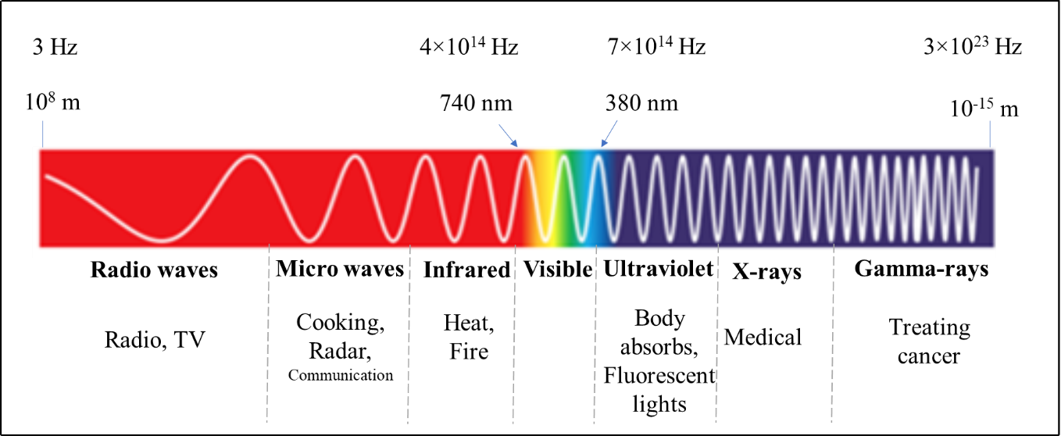
Figure 1 Electromagnetic spectrum
X-rays
We are familiar with X-rays as a very common tool for medical diagnostics. It has several industrial applications as well. We are more familiar with the scanning machines in the airports and other strategic places.
In 1895 Wilhelm Konrad Roentgen found that a highly penetrating radiation of unknown nature was produced when fast electrons impinged on certain matter. He invented X-rays accidentally while he was testing whether cathode rays could pass through glass. Through experimentation, he found that the mysterious light would pass through most substances but leave shadows of solid objects. Roentgen quickly found that X-rays would pass through human tissue rendering the bones visible. Within a year, doctors in Europe and the United States started using X-rays to locate gun shots, bone fractures, kidney stones and swallowed objects. Roentgen was honoured with several titles including the first Nobel Prize in physics in 1901.

Properties of X-rays: X-rays are electromagnetic radiations of extremely short wavelength (10⁻⁸ to 10⁻¹² m) and high frequency (10¹⁶ to 10²⁰ Hz). These rays were found to travel in straight lines, to be unaffected by electric and magnetic fields, to pass readily through opaque materials, to cause phosphorescent substances to glow, and to effect photographic plates. The faster the original electrons, the more penetrating the resulting x-rays, and the greater the number of electrons producing x-rays, the greater the intensity of the beam. X-rays are ionizing radiations. When interacting with matter, they are energetic enough to cause neutral atoms to eject electrons and ionize. In this process the energy of the X-rays is deposited in the matter. When passing through living tissue, X-rays can cause harmful biochemical changes in genes, chromosomes, and other cell components. The biological effects of ionizing radiation, which are complex and highly dependent on the length and intensity of exposure. X-ray radiation therapies take advantage of these effects to combat the growth of malignant tumours.
Production and uses of X-rays
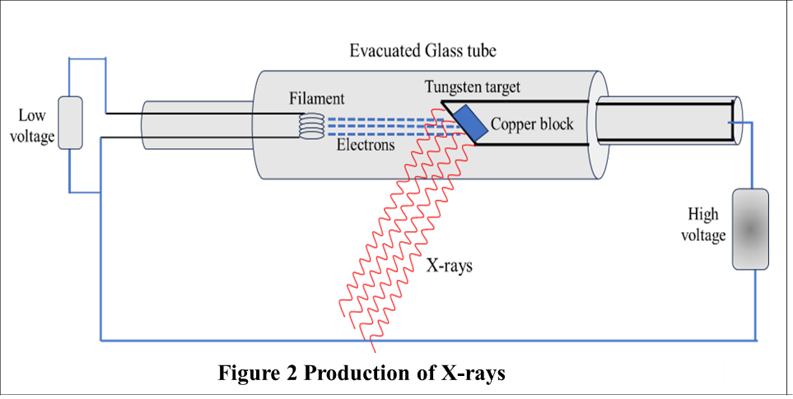
There are three common mechanisms for the production of X-rays. (1) Through the acceleration of a charged particle (2) atomic transitions between discrete energy levels (3) and the radioactive decay of some atomic nuclei. Each mechanism leads to a characteristic spectrum of X-ray radiation.
A beam of high-energy electrons impinges on a solid target, interact with the electrons and nuclei of the target atoms and they are repeatedly deflected and slowed down. During this abrupt deceleration, the beam of electrons emits bremsstrahlung—a continuous spectrum of electromagnetic radiation. Along with the continuous spectrum certain peaks of high intensity are also emitted (Characteristic X-rays).
Radiation produced when rapidly moving electron suddenly decelerated produce bremsstrahlung (“braking radiation”). Energy loss due to bremsstrahlung is more important for electrons than for heavier particles because electrons are more violently decelerated when passing near nuclei in their paths. Greater energy of an electron and the greater atomic number target nuclei, more energetic will be the bremsstrahlung radiation. High intensity peaks occur indicate the enhanced production of x-rays at specific wavelengths. The peaks differ in wavelengths for each target material and originate in rearrangements of the electron structures of the target atom. Following observations are important:
- The x-rays produced at a given accelerating potential V vary in wavelength, but none has a wavelength shorter than a certain value λ_{min}. Increasing V decreases λ_{min}. At a particular V, λ_{min} is the same for both the tungsten and molybdenum targets. It was found experimentally that λ_{min} is inversely proportional to V.
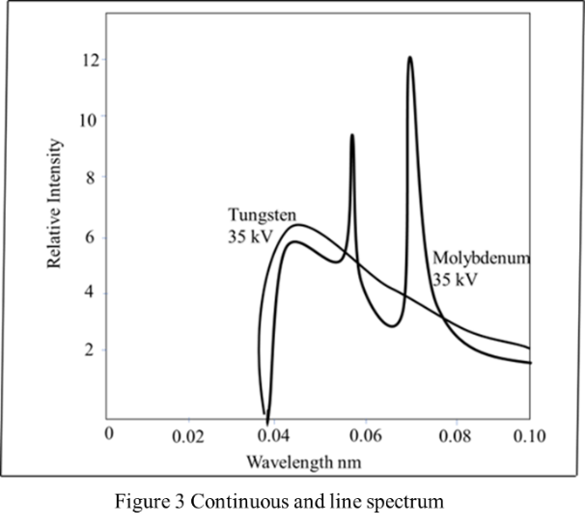
- The second observation was that electrons that strike the target undergo numerous glancing collisions, with their energy going simply into heat. (This is why the targets in x-ray tubes are made from high melting-point metals such as tungsten and a means of cooling the target is usually employed.) A few electrons, though, lose most or all of their energy in single collisions with target atoms. This is the energy that becomes x-rays producing peaks as seen in the graph.

X-ray production represents an inverse photoelectric effect. Instead of photon energy being transformed into electron KE, electron KE is being transformed into photon energy. A short wavelength means a high frequency, and a high frequency means a high photon energy h$.$
Since work functions (energy required to release an electron from metal) are only a few eVs, whereas the accelerating potentials in x-ray tubes are typically tens or hundreds of thousands of volts, we can ignore the work function and assume that the entire eV is equal to the kinetic energy.
eV = KE of electrons = energy of X-ray photons
eV = h${}_{max}$ = $\frac{hc}{{}_{min}}$
Therefore, ${}_{min}$ = $\frac{hc}{eV}$
Substituting the constants, ${}_{min}$ = $\frac{6.626×{10}^{-34}×3×{10}^{8}}{1.6×{10}^{-19 }×V}$ = $\frac{1.240×{10}^{-6}}{V}$ m
${}_{min}$ = $\frac{1.240×{10}^{-6}}{V}$ m

Diffraction of x- rays
Light waves can change direction due to reflection and refraction at boundary between two media. Diffraction is the change in direction of a wave that passes close to an object and changes its direction. Change in direction due to diffraction occurs at an angle less than 90º. A crystal consists of a regular array of atoms, each of which can scatter em waves. A monochromatic (single wavelength) beam of x-rays that falls on a crystal will be scattered inside the crystal and due to the regular arrangement of the atoms, the scattered waves will interfere constructively in certain directions and will interfere destructively in some other directions. The atoms in a crystal can be thought to constitute parallel planes. In 1913 W. L Bragg, showed that constructive interference takes place only between those scattered rays that are parallel and with path difference by exactly λ, 2λ, 3λ, and so on. That is, the path difference must be nλ, where n is an integer. Let us have an experiment with a monochromatic source of X-ray diffracted from a crystal. An x-ray detector can detect the scattered (diffracted) rays from the crystal in 360 degrees.

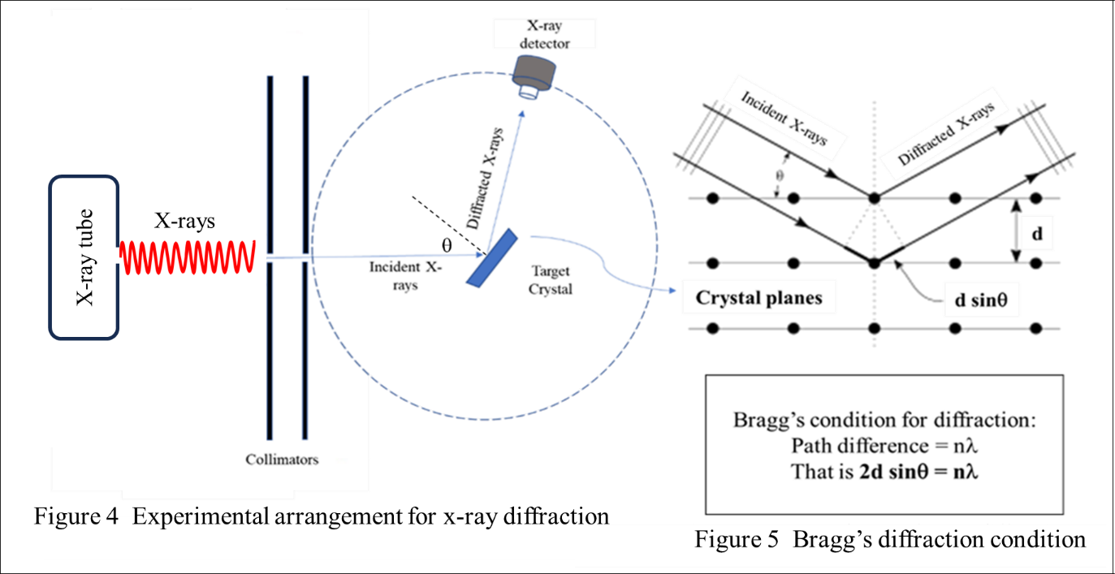

The schematic design of an x-ray spectrometer based upon Bragg’s analysis is shown above. A narrow beam of x-rays falls upon a crystal at an angle θ, and gets scattered (diffracted) from the crystal. At certain angles of incidence at the crystal plane the x-ray beam will have constructive interference which can be observed with the movable detector. An x-ray beam showing high intensity in the detector obey the Bragg condition. That is the path difference will be an integral multiple of wavelength. Therefore, 2dsinθ = nλ. If the spacing between the adjacent crystal planes is d, the x-ray wavelength λ can be determined. The method very useful in studying the crystal structure and planes.
Moseley's work on x-rays and its significance
We have seen that in x-ray spectra there are narrow spikes at wavelengths characteristic of the target material along with continuous spectra. The continuous x-ray spectrum is the result of the inverse photoelectric effect. That is, kinetic energy of electrons being transformed into all possible photon energies. The line spectrum, on the other hand, comes from electronic transitions within atoms that has taken place by the incident electrons.
The transitions of the outer orbital electrons of atoms usually involve only a few electron volts (eV) of energy. Such transitions produce photons whose wavelengths lie in or near the visible region of the electromagnetic spectrum. As we move to inner orbital electrons, of heavier elements the energy involved increases to a few tens or hundreds of eVs. In sodium, for example, only 5.13 eV is needed to remove the outermost 3s electron, whereas for the inner electrons the energy required are 31 eV for each 2p electron, 63 eV for each 2s electron, and 1041 eV for each 1s electron. Transitions that involve the inner most electrons in an atom give rise to x-ray line spectra because of the high photon energies.
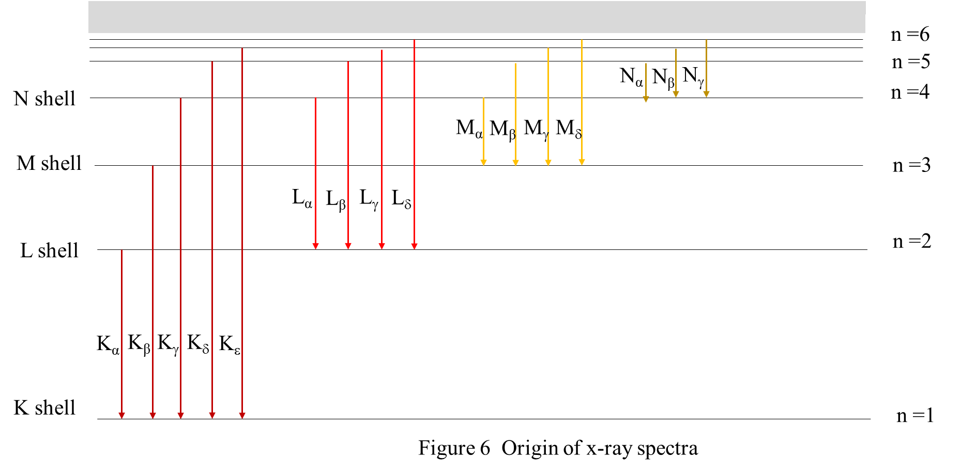

Above figure shows the energy levels (not to scale) of a heavy atom emitting x-rays when electrons transition take place in the inner electronic orbitals (K, L, M, …). The energy differences between angular momentum states within a shell are minor compared with the energy differences between shells.
Let us see what happens when an energetic electron knocks out one of the K-shell electrons.
An atom with a missing K electron gives up most of its considerable excitation energy in the form of an x-ray photon when an electron from an outer shell drop into the “hole” in the K shell. As indicated in the figure above, the K series of lines in the x-ray spectrum of an element consists of wavelengths arising in transitions from the L, M, N, . . . levels to the K shell. Similarly, the longer-wavelength L series originates when an L electron is knocked out of the atom, the M series when an M electron is knocked out, and so on. The two spikes in the x-ray spectrum of molybdenum are the K_{α} and K_{β} lines of its K series.
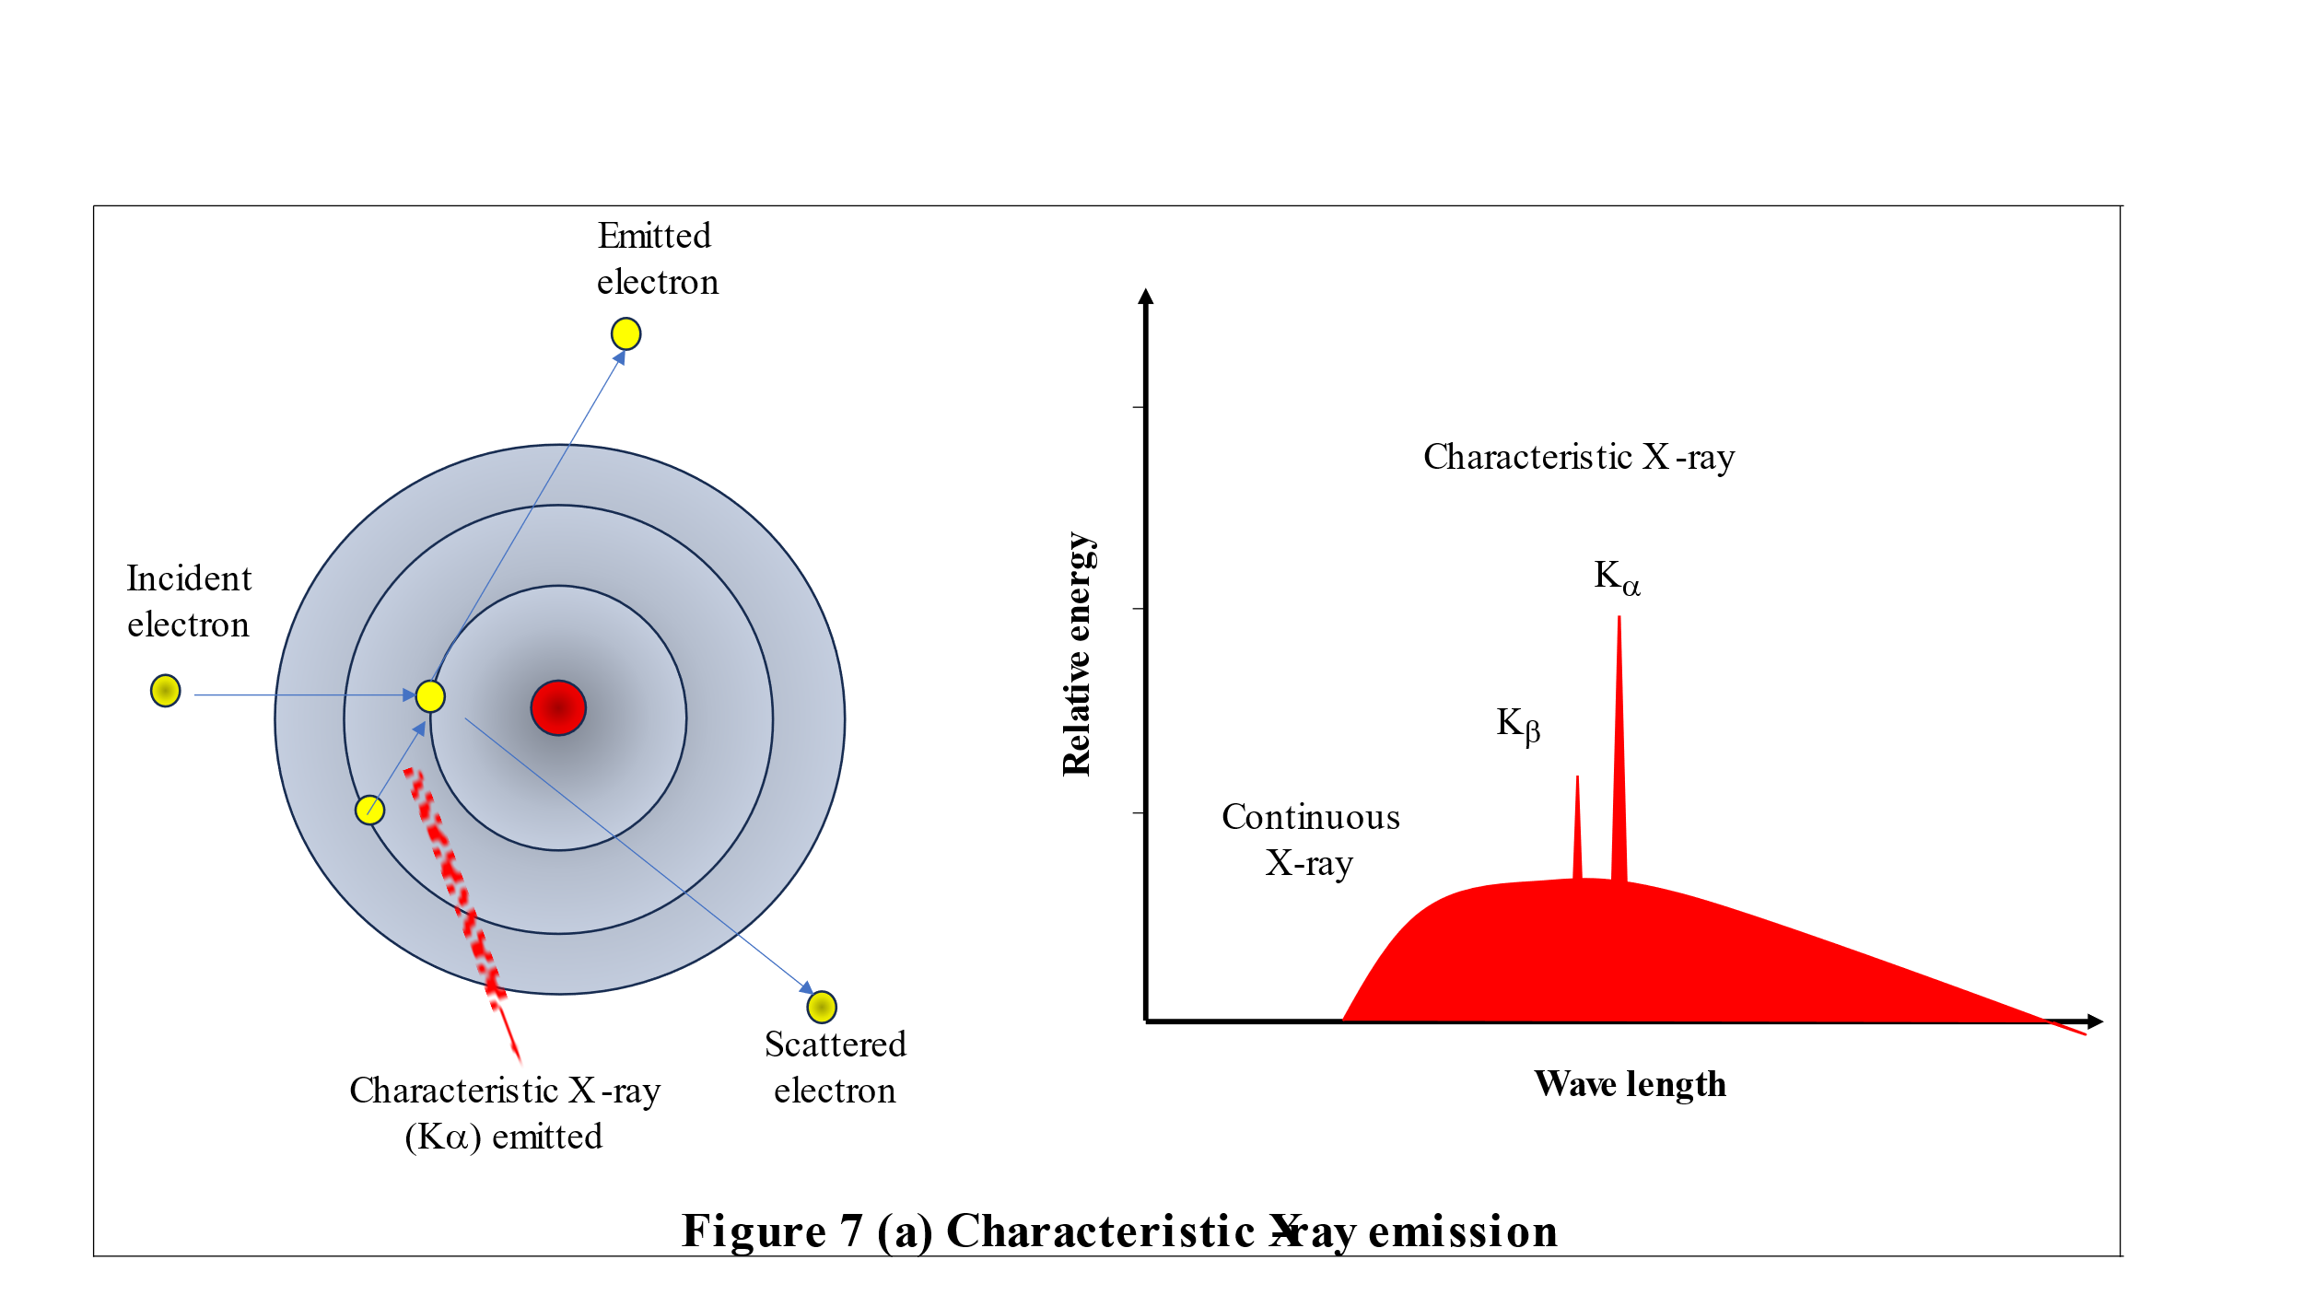
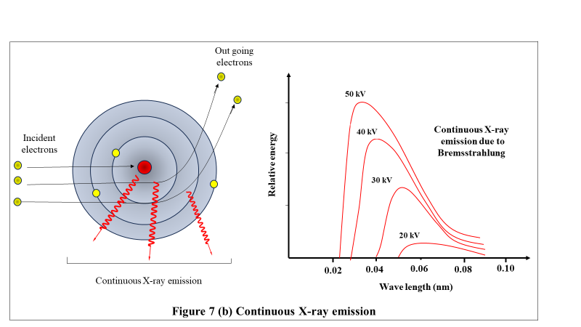
It is easy to find an approximate relationship between the frequency of the K_{α} x-ray line of an element and its atomic number Z. A K_{α} photon is emitted when an L (n=2) electron undergoes a transition to a vacant K (n=1) state.
For n^{th} state of an atom, energy of an electron is given by:
E_{n} = - $\frac{m{\left(z-1\right)}^{2}e^{4}}{8ε_{o}^{2}h^{2}}$ $\left(\frac{1}{n^{2}} \right)$ (1)
Therefore, for transition from n_{i} = 2 to n_{f} =1 will involve energy:
hν = $\frac{m{\left(z-1\right)}^{2}e^{4}}{8ε_{o}^{2}h^{2}}$ $\left(\frac{1}{n_{f}^{2}}- \frac{1}{n_{i}^{2}} \right)$ (2)
Then the frequency of the transition, ν = $\frac{m{\left(z-1\right)}^{2}e^{4}}{8ε_{o}^{2}h^{3}}$ $\left(\frac{1}{n_{f}^{2}}- \frac{1}{n_{i}^{2}} \right)$ = c R${\left(z-1\right)}^{2}$ $\left(\frac{1}{n_{f}^{2}}- \frac{1}{n_{i}^{2}} \right)$

For K_{α} series, ν = c R${\left(z-1\right)}^{2}$ $\left(\frac{1}{1^{2}}- \frac{1}{2^{2}} \right)$ = $\frac{3cR{\left(z-1\right)}^{2}}{4}$

Here R = $\frac{me^{4}}{8cε_{o}^{2}h^{3}}$ = 1.097× 10⁷ m⁻¹, the Rydberg constant.
The energy of a K_{α} x-ray photon is given in electron volts in terms of (Z - 1) by the formula:
E(K_{α}) = (10.2 eV) ${\left(z-1\right)}^{2}$ (3)
The significance of the experiments was that, in addition to supporting Bohr’s newly formulated atomic model, Moseley’s work provided a way to determine experimentally the atomic number Z of an element for the first time. As a result, the correct sequence of elements in the periodic table could be established. The ordering of the elements by atomic number is not always the same as their ordering by atomic mass, which until then was the method used.
In addition, Moseley found gaps in his data that corresponded to Z = 43, 61, 72, and 75, which suggested the existence of hitherto unknown elements that were later discovered. The first two, technetium and promethium, have no stable isotopes and were first produced in the laboratory many years later. The last two, hafnium and rhenium, were isolated in the 1920s.
Uses of X-rays
X-rays are widely used in a several applications in science, technology and industry. Their ability to penetrate substances and hence to provide images of internal structure in a non-invasive manner is the reason for most of their applications. Some of the common uses of X-rays are described here.
Medical imaging : Normal x-ray, Computed Tomography , Fluoroscopy, dental radiography are the major uses of x-rays in medical applications. While ordinary x-ray images are used for orthopaedic purposes, computed tomography creates cross-sectional images of the body for diagnosis and monitoring conditions like cancer, lung infections and neurological disorders. Real time x-ray imaging, Fluoroscopy helps in procedures like angioplasty, endoscopy and the like.
Industrial Testing and Inspection: Non-destructive testing to inspect the quality and structure of materials and machine parts are being used in automotive and aerospace machine components production. X-ray is also used widely for the quality check of welding in pipelines and machineries.
Research and Development: X-ray diffraction, crystallography, spectroscopy are major tools for characterisation and property studies of materials. X-ray diffraction (XRD) is used to determine the atomic and molecular structure of materials, including crystals and polymers, which is crucial in material science and chemistry It is difficult to enumerate the applications of x-rays in research.
Security screening: X-ray scanners are used very extensively in airports, seaports, institutions of importance, business installations mainly to inspect the luggage and cargo. Food Inspection: X-ray inspection is used in the food industry to detect foreign objects, such as metal or glass, in packaged foods.
Environmental Monitoring: X-ray fluorescence (XRF) studies are used to analyze the elemental composition of natural samples of soil, water, and air samples, aiding in environmental studies and pollution monitoring.
Astrophysics: X-rays from celestial objects provide valuable information about the universe. Observatories and telescopes equipped with X-ray detectors study phenomena such as black holes, neutron stars, and high-energy particles.
Security and Forensics: X-rays are used to inspect suspicious packages, identify concealed weapons or contraband, and analyse evidence in forensic investigations.
Archaeology and Art Conservation: X-rays are employed to examine the inner structures of archaeological artifacts and artworks non-invasively. This helps in restoration and preservation efforts.
In general, it is difficult to list out all the applications of x-rays. The above mentioned applications are just a few of numerous applications of X-rays, highlighting their versatility and importance in various scientific, medical, industrial, and security-related fields.

Problem 1 : Find the shortest wavelength present in the radiation from an x-ray machine whose accelerating potential is 50,000?
Shortest wavelength, , ${}_{min}$ = $\frac{1.240×{10}^{-6}}{V}$ m = = $\frac{1.240×{10}^{-6}}{50000}$ m
${}_{min}$ = 0.0248 nm
Problem 2 Which element has a K_{α} x-ray line whose wavelength is 0.180 nm?
The frequency corresponding to a wavelength of 0.180 nm = 1.80 ×10⁻¹⁰ m is given by:
ν = $\frac{c}{}$ = $\frac{3×{10}^{8}}{1.8×{10}^{-10}}$ = 1.67 × ${10}^{18}$ Hz
For K_{α} x-ray line we have: ν = c R${\left(z-1\right)}^{2}$ $\left(\frac{1}{1^{2}}- \frac{1}{2^{2}} \right)$ = $\frac{3cR{\left(z-1\right)}^{2}}{4}$
Therefore, ${\left(z-1\right)}^{2}$ = $\frac{4}{3cR}$ = $\frac{4×1.67×{10}^{18}}{3×3×{10}^{8}×1.097× {10}^{7}}$ = 676
z-1 = $\sqrt{676}$ = 26. Therefore, z = 27
The element with atomic number 27 is Cobalt.

References:

Nuclear Physics: Experimental and Theoretical, 2nd Revised edition by H S Hans. New Academic Science, 2011.

Littlefield, T.A. & Thorley, N., Atomic and Nuclear Physics, 3rd edition, (ELBS and van Nostrand Reinhold Co., 1979).

Noz, M.E., & McGuire, G.O., Radiation Protection in the Radiologic and Health Sciences, Lea & Fibiger (2005).

