Course title: Atomic and Nuclear Physics

Week # 5

Main Topics: Interaction of x-rays with matter and atomic nucleus

Lecturer: Jojo Panakal John

Lecture Learning Outcomes:
At the end of the lecture, you will be able to:
- Explain interaction of x-rays with matter (Compton scattering)
- Comprehend the basics of atomic nucleus
- Describe nuclear force
- Explain the abundance of nuclear isotopes
Compton scattering
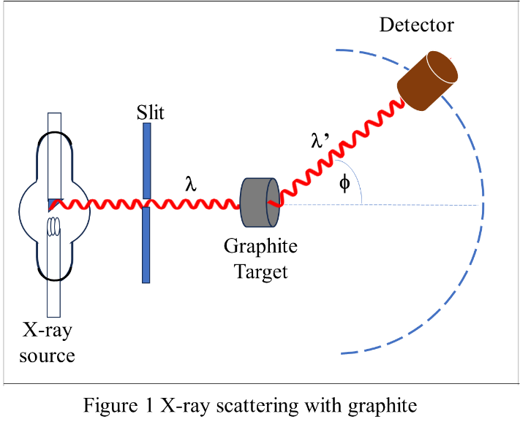
Scattering of X-rays from materials was one of the several efforts to study the interaction of x-rays with matter. The experiment was carried out by A H Compton in 1922. Intense characteristic x-rays from a Molybdenum Target were were allowed to fall on a graphite block to scatter in all directions. The scattered x-rays from graphite were analyzed using a crystal spectrometer detector movable in a semi-circle. Compton observed that the scattered x-rays were less penetrating than the incident K∞ x-rays and had two wavelengths. One was the incident wavelength and the other one with a longer wavelength depending on the scattering angle, φ.
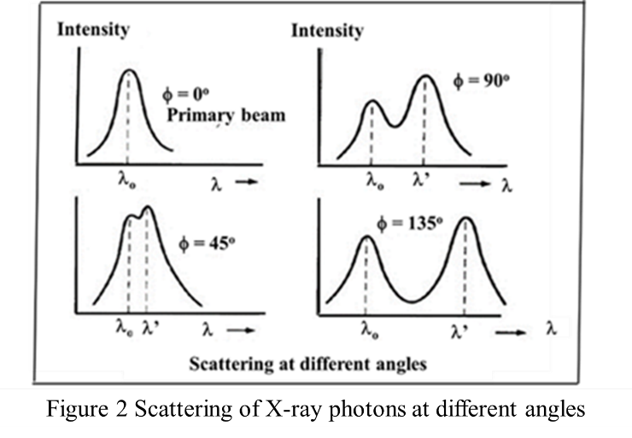
Compton measured the intensity of scattered x-ray for various scattering angles. He found that one wavelength is same as the incident wavelength, λ and other one is shifted to a larger wavelength, λ’. It can also be seen that the Compton shift Δλ = λ’ - λ varies with the angle.
Compton interpreted his experimental results by postulating that the incoming x-rays are photons of energy E = hν and these photons collide with free electrons in the graphite. Incident photons transfer some of its energy to the electrons with which they collide.

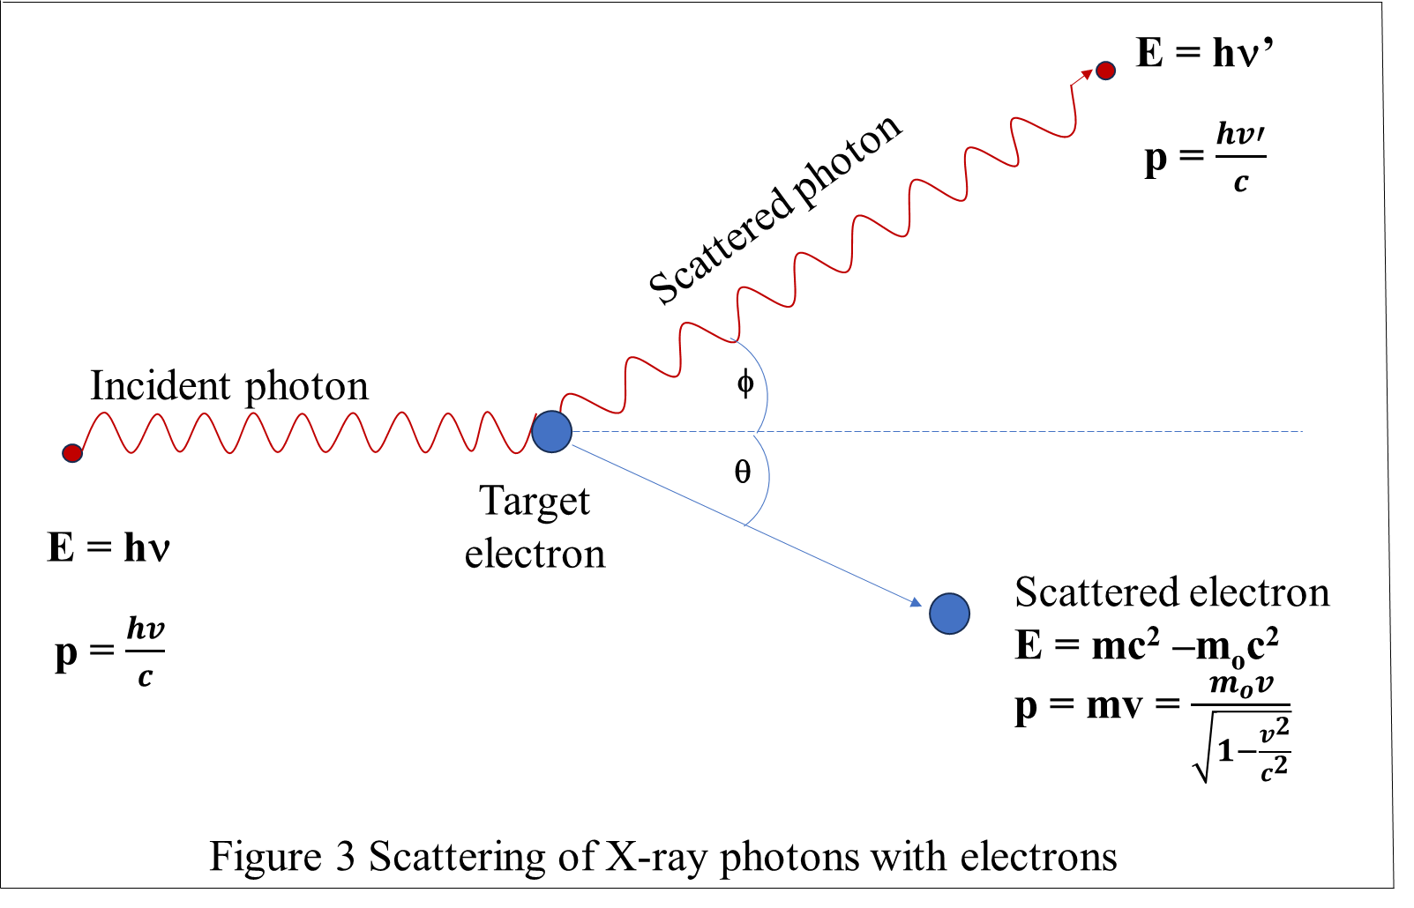
Therefore, the scattered photons will have a little energy less than the incident photon. This causes quantitatively for the wavelength shift. In Compton Effect we are dealing with high energy photons and corresponding high velocity recoil electrons. Therefore, we need to take relativistic relations into account. Taking photon as a particle of energy E and momentum p, total relativistic energy of the particle in terms of its rest mass, m_{o} and velocity v is: E² = p²c² + m_{o}²c⁴
From the principle of conservation of energy, loss of energy of photon has to be equal to the gain of energy of electron. It follows that:
hν-hν’ = mc²-m_{o}c² = KE = pc (1)
Applying the principle of conservation of linear momentum in horizontal and vertical directions:
$\frac{h}{c}$ - $\frac{h'}{c}$ cosφ = mv cosϕ = $\frac{m_{o}}{\sqrt{1-\frac{v^{2}}{c^{2}}}}$ v cosϕ = p cosϕ
hν - hν’ cosφ = pc cosϕ (2) and
$0$ - $\frac{h'}{c}$ sinφ = mv sinϕ = $\frac{m_{o}}{\sqrt{1-\frac{v^{2}}{c^{2}}}}$ v sinϕ = p sinϕ
0 - hν’ sin φ = pc sinϕ (3)
By squaring and adding equations (5) and (6), we can eliminate the recoil angle, ϕ.
(2)² ⇒ (hν)² + (hν’ cosφ)² - 2 h²νν’ cosφ = (pc cosϕ)²
(3)² ⇒ (hν’ sin φ)² = (pc sinϕ)²
(2)² + (3)² ⇒ (hν)² + (hν’ cosφ)² - 2 h²νν’ cosφ +(hν’ sin φ)² = (pc)²
(hν)² + (hν’)² - 2 h²νν’ cosφ = (pc)² = ($\frac{m_{o}}{\sqrt{1-\frac{v^{2}}{c^{2}}}}$ v c)²
÷ by c² ⇒ $\frac{h^{2}{}^{2}}{c^{2}}$ + $\frac{h^{2}{}^{ '2}}{c^{2}}$ -2 $\frac{h^{2}}{c^{2}}$ νν’ cosφ = $\frac{m_{o}^{2}v^{2}}{1-\frac{v^{2}}{c^{2}}}$
$\frac{h^{2}}{c^{2}}$ [${}^{2}+ {}^{ '2}- 2’ cos] = \frac{m_{o}^{2}v^{2}}{1-\frac{v^{2}}{c^{2}}}$ (4)
Equation (1) ⇒ (hν-hν’) = (m-m_{o})c² [ Recoil energy of the scattered electron]
⇒ (hν-hν’ + m_{o}c²) = mc²
Squaring the above relation:
⇒ (hν)² + (hν’)² + (m_{o}c²)² -2(hν)(hν’) + 2(hν) m_{o}c² - 2(hν’) m_{o}c² = [mc²]²
⇒ (hν)² + (hν’)² - 2(hν)(hν’) + (m_{o}c²)² +2(hν) m_{o}c² - 2(hν’) m_{o}c² = [mc²]²
⇒ (hν)² + (hν’)² - 2(hν)(hν’) + 2(hν) m_{o}c² - 2(hν’) m_{o}c² = [m²c⁴] - (m_{o}²c⁴)
÷ by c² ⇒ $\frac{h^{2}}{c^{2}}$ ${}^{2}$ + $\frac{h^{2}}{c^{2}}$ ${}^{ '2}$ -2 $\frac{h^{2}}{c^{2}}$ νν’ + $\frac{2h}{c^{2}}$ m_{o}c² - $\frac{2h '}{c^{2}}$ m_{o}c² = $\frac{m_{o}^{2}}{1-\frac{v^{2}}{c^{2}}}$c² - m_{o}²c² = m_{o}²c² $\left[\frac{1}{1-\frac{v^{2}}{c^{2}}}-1\right]$
$\left[\frac{1}{1-\frac{v^{2}}{c^{2}}}-1\right]$ = $\left[\frac{1}{\frac{c^{2}-v^{2}}{c^{2}}}-1\right]$ = $\left[\frac{c^{2}}{c^{2}-v^{2}}- \frac{c^{2}-v^{2}}{c^{2}-v^{2}}\right]$ = $\left[\frac{v^{2}}{c^{2}-v^{2}}\right]$
Therefore, m_{o}²c² $\left[\frac{1}{1-\frac{v^{2}}{c^{2}}}-1\right]$ = m_{o}²c²$\left[\frac{v^{2}}{c^{2}-v^{2}}\right]$ = $\frac{m_{o}^{2}v^{2}}{1-\frac{v^{2}}{c^{2}}}$
Therefore, $\frac{h^{2}}{c^{2}} [$ ${}^{2}$ +${}^{ '2}$ - 2νν’ + $\frac{2}{h}$ m_{o}c² - $\frac{2 '}{h}$ m_{o}c² ] = $\frac{m_{o}^{2}v^{2}}{1-\frac{v^{2}}{c^{2}}}$ (5)
Equating (4) and (5) $\frac{h^{2}}{c^{2}}$ [${}^{2}+ {}^{ '2}- 2’ cos]$ = $\frac{h^{2}}{c^{2}} [$ ${}^{2}$ +${}^{ '2}$ - 2νν’ + $\frac{2}{h}$ m_{o}c² - $\frac{2 '}{h}$ m_{o}c² ]
[${}^{2}+ {}^{ '2}- 2’ cos]$ = $[$ ${}^{2}$ +${}^{ '2}$ - 2νν’ + $\frac{2}{h}$ m_{o}c² - $\frac{2 '}{h}$ m_{o}c² ]
[-$2’ cos]$ = $[$ - 2νν’ + $\frac{2}{h}$ m_{o}c² - $\frac{2 '}{h}$ m_{o}c² ]
[-$’ cos]$ = $[$ - νν’ + $\frac{}{h}$ m_{o}c² - $\frac{ '}{h}$ m_{o}c² ] or [νν’ - $’ cos]$=$\frac{m_{o}^{2}c^{2}}{h}$ [ν-ν’]
÷ by $’$⇒ [1- $cos]$ = $\frac{m_{o}^{2}c^{2}}{h} [ \frac{1}{ ^{'} }$ - $\frac{1}{}$ ] = $\frac{m_{o}^{2}c}{h}$ $[ \frac{c}{ ^{'} }$ - $\frac{c}{}$ ] = $\frac{m_{o}^{2}c}{h}$ [ ${}^{'}$ - λ]
[ ${}^{'}$ - λ] = Δλ = $\frac{h}{m_{o}^{2}c}$ [1- $cos]$ (6)
The term on the right-hand side, $\frac{h}{m_{o}^{2}c}$ is a constant and is equal to 0.0242 ºA at φ = 90º, called the Compton wavelength. Compton wavelength represents the wavelength of light that would be produced if the rest mass energy of electron were instantaneously converted into a simple light quantum. If the impact of photon is on a bound electron, the whole atom will take the recoil momentum. Therefore, the energy change will be small causing no change in the wavelength of the photon.
The atomic nucleus
The atom consists of a dense nucleus of protons and neutrons surrounded by an equal number of electrons moving in discrete circular orbits (stationary states) at fixed distances from the nucleus, retaining their motion under the influence of the Coulomb force without emission of radiation.
The total number of protons in the nucleus of an atom is called the atomic number of the atom and is given the symbol Z. The number of electrons in an electrically neutral atom is the same as the number of protons in the nucleus. The number of neutrons in a nucleus is known as the neutron number and is given the symbol N. The mass number of the nucleus is the total number of protons and neutrons (called nucleons) in the nucleus. The mass number is given the symbol A and can be found by the sum of Z + N = A. Each type of atom that contains a unique combination of protons and neutrons is called a nuclide. Not all combinations of numbers of protons and neutrons are possible, but a large number of specific nuclides with unique combinations of neutrons and protons have been identified.
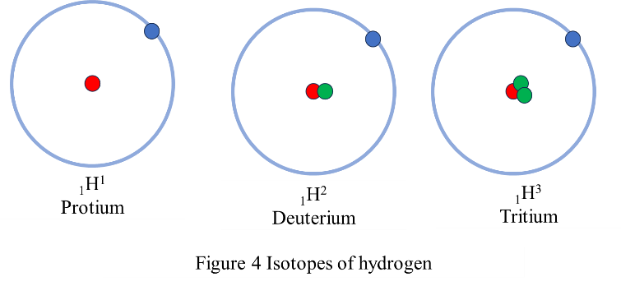
Isotopes are nuclides that have the same atomic number (same number of protons) and are therefore the same element but differ in the number of neutrons. Most elements have a few stable isotopes and several unstable, radioactive (unstable) isotopes. For example, oxygen has three stable isotopes that can be found in nature (oxygen-16, oxygen-17, and oxygen-18) and eight radioactive isotopes. Another example is hydrogen, which has two stable isotopes (hydrogen-1 and hydrogen-2) and a single radioactive isotope (hydrogen-3). These isotopes are called hydrogen (₁H¹), deuterium (₁H²) and tritium (₁H³).

Isobars are nuclides with the same mass number (A), but different numbers of protons and neutrons (Z & N). Examples are ₁₈Ar⁴⁰, ₁₉K⁴⁰ and ₂₀Ca⁴⁰. A special case is when two isobars have proton and neutron numbers interchanged. They are called mirror nuclides, e.g.,₁H³ and ₂He³, ₇O¹⁵ and ₈N¹⁵.
Isotones are nuclides with the same number of neutrons (N), but different numbers of protons and mass numbers (Z & A). ₁₆S³⁶, ₁₇Cl³⁷, ₁₈Ar³⁸, ₁₉K³⁹ and ₂₀Ca⁴⁰(20 neutrons each).

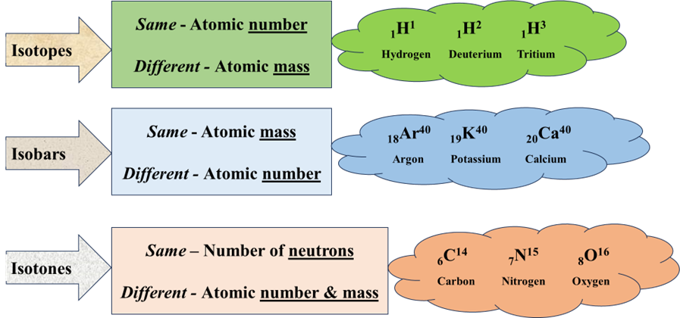
Figure 5 Isotopes, isobars and Isotones

Experiments have shown that the nucleus has a sphere-like shape with a radius that depends on the atomic mass number of the atom. Nucleons do not seem to congregate near the center of the nucleus, but instead have a fairly constant distribution out to the surface. Thus, the number of nucleons per unit nuclear volume is roughly constant. Therefore, nuclear size is proportional to mass number A and we may have V (= 4/3πR³) proportional to A, which means that R³ proportional to A or R α $A^{\frac{1}{3}}$or R = $R_{o}A^{1/3}$. Here R_{o} is constant ≈ 1.4 Fermi (1Fermi=10⁻¹⁵m).
Therefore, the nuclear density = $\frac{Nuclear mass}{nuclear volume}$ = $\frac{A}{4/3πR^{3}}$
= $\frac{A}{4/3π{\left(R_{o}A^{1/3}\right)}^{3}}$ = $\frac{A}{4/3πA{\left(R_{o}\right)}^{3}}$ = $\frac{1}{4/3π{\left(R_{o}\right)}^{3}}$ is a constant.
2. Nucleons and nuclear forces.
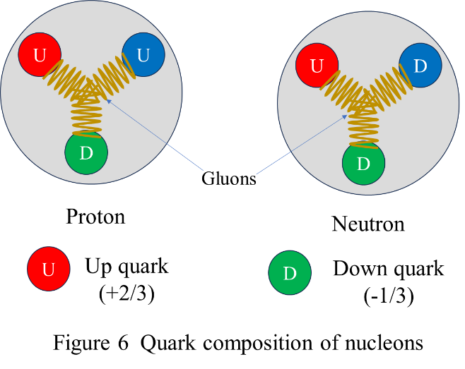
It is known that a large number of nuclei, available in nature, are stable. Except for hydrogen, all nuclei have more than one proton – the positively charged particle in the atom. Therefore, there is a strong force in the nucleus that is strong enough to overpower the coulomb repulsion and hold the nucleons together. The forces which hold the nucleons together are commonly called nuclear forces and are short-range forces.
Apart from the electrostatic Coulomb force, there are two types of nuclear forces acting in the nucleus. Strong Nuclear Force and Weak Nuclear Force. Strong nuclear force is responsible for holding the nuclei of atoms stable. The magnitude of Strong Nuclear Force is far greater than the electromagnetic and gravitational force. Weak nuclear force acts between the particles where radioactive decay occurs. They change neutrons into protons in the process of nuclear decay and the weak force is neither attractive nor repulsive. The exact nature of the forces can be detailed with quantum chromodynamics. It describes the source of the strong interaction. Following are the characteristics of nuclear force:
- Nuclear force is strongest of all fundamental forces.
- The nuclear force is short range. They are most effective only up to a distance of order of femtometre (fm) or less. Where 1fm = 10⁻¹⁵ meter. Nuclear forces become negligible beyond this distance. The distance is called nuclear range.
- Not all the particles are subjected to the nuclear force (a notable exception are electrons)
- The nuclear force does not depend on the particle charge (force is same for protons and neutrons).
- Nuclear force is attractive in nature when separation between nucleons is more than 1 fm and repulsive in nature when separation is less than 1 fm. That is it shows saturation.
- The nuclear force does depend on spin of nucleons (as in the case of the deuteron).
Nuclear force is caused by the exchange of particles known as mesons. The modern perception of the nuclear force is that it is a residual interaction strong force between quarks, which is mediated by the exchange of gluons and holds the quarks together inside a nucleon.

3. Nuclear mass
A nucleus consists of protons (Z) and neutrons (N). If we assume the nuclear mass to be a simple collection of Z protons and N neutrons, the mass of the nucleus M (Z, N) would be just the sum of the masses of these constituent nucleons.
M (Z, N) = Z×m_{p} + N×m_{n}
Where m_{p} is the mass of proton and m_{n} is that of neutron.
However, a nucleus is not a simple collection of protons and neutrons (nucleons), but they strongly combine with each other through a strong interaction named the nuclear force. According to nuclear particle experiments, the total mass of a nucleus M (Z, N) is less than the sum of the masses of its constituent nucleons (protons and neutrons).
The mass of an individual nucleus is often expressed in atomic mass units (amu or simply u), where u = 1.66054 × 10⁻²⁷ kg. (Here, it may be reminded that atomic mass unit is defined as (1/12)^{th} the mass of a ₁₂C¹² C nucleus.) In atomic mass units, the mass of a helium nucleus (A = 4) is approximately 4 u.
4. Nuclear abundance
We have already seen that Isotopes are nuclides having the same atomic number (same number of protons) and but differ in the number of neutrons in the nucleus. Isotopes of a given element exist in different proportions.
For example, Mercury, has seven naturally occurring isotopes: ₈₀Hg¹⁹⁶, ₈₀Hg¹⁹⁸, ₈₀Hg¹⁹⁹, ₈₀Hg²⁰⁰, ₈₀Hg²⁰¹, ₈₀Hg²⁰², ₈₀Hg²⁰⁴ having percent natural abundances of 0.146%, 10.02%, 16.84%, 23.13%, 13.22%, 29.80%, and 6.85%, respectively. It is clear that ₈₀Hg²⁰² occurs with greatest abundance (29.80%) and ₈₀Hg²⁰⁰ (23.13%) is the next most abundant. Other isotopes occur in small traces only. Another example is ₂He⁴ and ₂He³ having abundance 99.999866% and 0.000134% respectively. Yet another example is ₈O¹⁶, ₈O¹⁷, ₈O¹⁸ having abundance ratio 99.757 %, 0.038% and 0.205% respectively.
When we name a nuclide, we generally mean the most abundant isotope. Therefore, Mercury means ₈₀Hg^{202,} Helium means ₂He⁴ and Oxygen means ₈O¹⁶. However, in certain cases, isotopic abundance ratios may vary with samples.
Problem 1 Calculate the Compton wavelength of a beam of x-rays of 0.1ºA at a scattering angle of 90º.
The Compton Shift, ${}^{'}$ - λ = $\frac{h}{m_{o}^{2}c}$ [1- $cos]$ = 0.0242 (1- cos90) = 0.0242ºA
Therefore, the Compton wavelength of X-ray is, 0.1 + 0.0242 = 0.1242 ºA
Problem 2 What is the percentage shift in the wavelength of x-rays (λ=0.1ºA) scattered at 60º with the normal.
The Compton Shift, ${}^{'}$ - λ = $\frac{h}{m_{o}^{2}c}$ [1- $cos]$ = 0.0242 (1- cos60)
= 0.0242 (1- 0.5) = 0.0121ºA
Therefore, the percentage shift = $\frac{{}^{'} - }{}$ × 100 = $\frac{0.0121}{0.1}$ × 100 = 12.1%
Problem 3: Determine the radius, volume and density of ₂₆Fe⁵⁶ nucleus? Compare it with those of ₉₂U²³⁸ nucleus? Assume mass a nucleon = 1.6726×10⁻²⁷ kg

For, ₂₆Fe⁵⁶ nucleus, R = $R_{o}A^{1/3}$ = 1.4 ×10⁻¹⁵ × ${56}^{1/3}$ = 5.355 × 10⁻¹⁵ m
Nuclear volume, V = 4/3πR³ = 4/3π (5.355 × 10⁻¹⁵ )³ = 643 × 10⁻⁴⁵ m³
Nuclear density, D = $\frac{Nuclear mass}{nuclear volume}$ = $\frac{56×1.6726×{10}^{-27}}{643×{10}^{-45}}$ = 0.1457×10¹⁸ kg m⁻³

For, ₉₂U²³⁸ nucleus, R = $R_{o}A^{1/3}$ = 1.4 ×10⁻¹⁵ × ${238}^{1/3}$ = 8.68 × 10⁻¹⁵ m
Nuclear volume, V = 4/3πR³ = 4/3π (8.68 × 10⁻¹⁵ )³ = 2731 × 10⁻⁴⁵ m³
Nuclear density, D = $\frac{Nuclear mass}{nuclear volume}$ = $\frac{238×1.6726×{10}^{-27}}{2731×{10}^{-45}}$ = 0.1431×10¹⁸ kg m⁻³
Comments: Look at the size and mass of nucleus. So small. But the density is unimaginable and are comparable. Average density of earth is only 5520 kg m⁻³ and that of sun is only 1402 kg m⁻³. Mass of earth is about 6× 10²⁴ kg.

References:

Nuclear Physics: Experimental and Theoretical, 2nd Revised edition by H S Hans. New Academic Science, 2011.

Littlefield, T.A. & Thorley, N., Atomic and Nuclear Physics, 3rd edition, (ELBS and van Nostrand Reinhold Co., 1979).

Thayal D. C. Nuclear Physics, Himalaya Publishing House, India, 1956.

