Course title: Atomic and Nuclear Physics

Week # 6

Main Topics: Mass defect, binding energy and liquid drop model

Lecturer: Jojo Panakal John

Lecture Learning Outcomes:
At the end of the lecture, you will be able to:
- Explain Mass defect of atomic nuclei
- Comprehend the source of binding energy of nucleus
- Describe the liquid drop model of atomic nucleus
1. Mass defect
We know that the total mass of a nucleus M (Z, N) is less than the sum of the masses of its constituent nucleons (protons and neutrons). In general, if two or more nucleons interact to combine together, then the total mass of the system would be less than the sum of the masses of the individual particles. The stronger the interaction results in more mass decrease. This decrease of the mass of the system is called the mass defect.
The mass defect of a nucleus of proton number Z and neutron number N is defined by :
ΔM = [ZM_{p} + NM_{n} – _{Z}M^{A}]
Binding Energy of a nucleus can be defined as the energy required to separate all nucleons of the nucleus. It is also equal to energy required to put them together. While forming a nucleus a fraction of the mass is found to be missing. Energy corresponding to this is taken as nuclear binding energy.
i.e., E_{B} =ΔMc² ; ΔM = [ZM_{p} + NM_{n} – _{Z}M^{A}]
When ΔM is represented in amu, Binding Energy is = ΔMx931MeV. For very light nuclei and very heavy elements, the mass defect is positive. Nucleus with more E_{B} is more stable. If the Binding Energy is less than zero, the nucleus is unstable and will disintegrate by itself.
The ratio of mass defect, ΔM to the mass number A is called the Packing fraction (f). Therefore, f = ΔM/A
The ratio of Binding Energy (E_{B}) to the mass number A is called the Binding Fraction (f_{B}). Therefore, f_{B}= E_{B}/A
= {[ZMp + NMn – _{Z}M^{A}]c²} / A

Binding fractions (also called binding energy per nucleon or binding energy per particle) of different nuclei represent the relative strengths of their binding. Binding fraction for different mass numbers are graphically shown below:
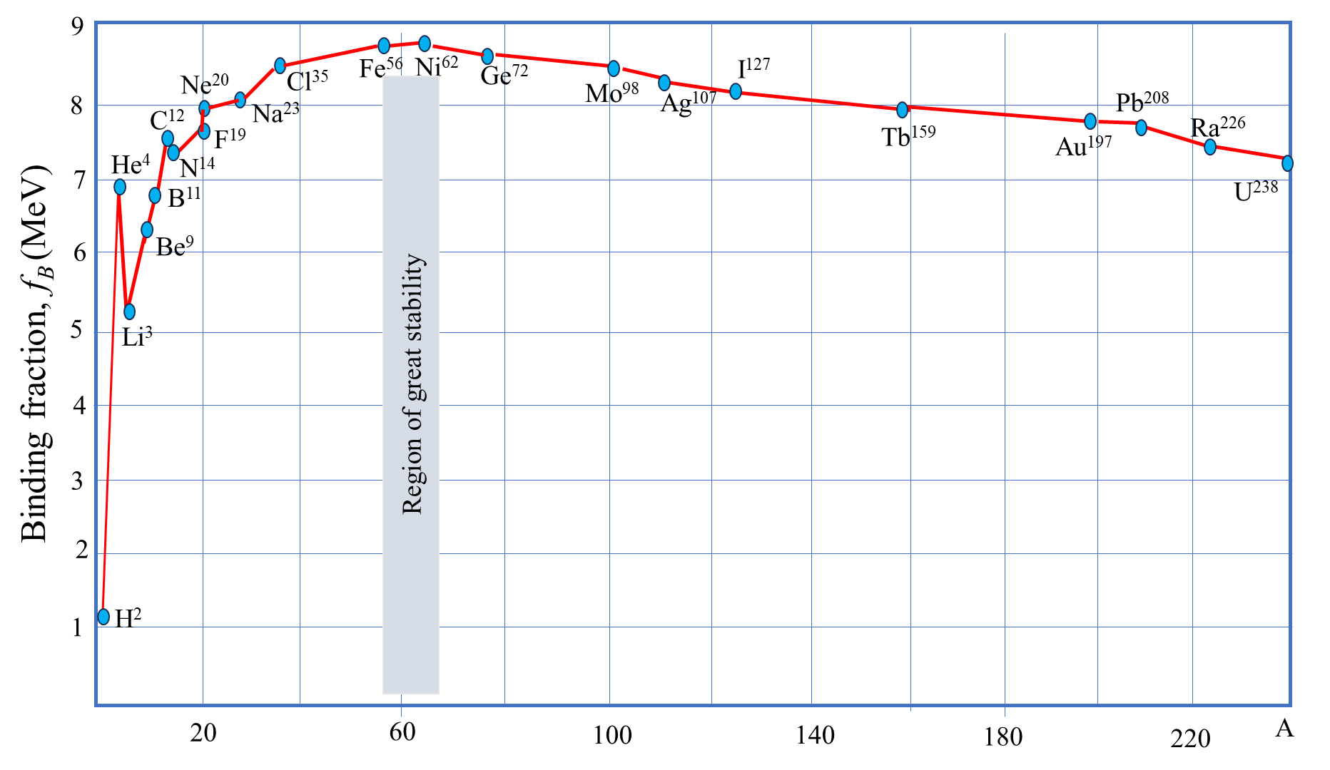
Figure 1 Variation of binding fraction (E_{B}) with mass number (A)
From the figure it can be seen that the value of binding energy per nucleon rises as the mass number, A increases until it reaches a maximum value of 8.8 MeV for A = 56 (iron) and then it slowly decreases. The average binding energy per nucleon is about 8.5 MeV for nuclei having mass number between A= 40 and 120. This means that the nuclei with intermediate masses (A ~ 40 to 120) are the most stable compared with the light and heavy nuclei. The figure suggests that we can convert mass to energy by combining lighter nuclei to make nuclei of intermediate size (fusion) or breaking apart heavy nuclei into nuclei of intermediate size (fission). That is, when two light nuclei combine to form a heavier nucleus (fusion) the product has a higher binding energy (means higher mass defect) releasing the energy. Similarly, when a heavy nucleus breaks into two lighter nucleus (fission) the product has a higher binding energy (means higher mass defect) releasing the energy corresponding to the mass defect.
For example, during the fusion reaction between deuteron (₁H²) and triton (₁H³) to form helium (₂He⁴), a rough calculation of energy release is as follows:
The reaction is ₁H² + ₁H³ = ₂He⁴ + ₀n¹
Binding fraction E_{B} for hydrogen is approximately 1.1MeV and that for helium is about 7 MeV. Therefore, total binding energy of reactants is about 1.1× 5 = 5.5 MeV. The product nucleus has binding energy nearly 7× 4 = 28 MeV. Therefore, this rough estimate shows that 28 – 5.5 = 22 MeV of energy will be released in the process.
Like this, fission of uranium:
₀n¹ + ₉₈U²³⁵ = ₉₈U²³⁶ = ₃₆Kr⁸⁹ + ₅₆Ba¹⁴⁴ + 3 ₀n¹
Binding fraction E_{B} for uranium is approximately 7.5MeV and that for Krypton is about 8.5 MeV and for Barium is about 8.3 MeV. Therefore, total binding energy of reactant is about 7.5 × 235 = 1762 MeV. The product nuclei have total binding energy 8.5 × 89 + 8.3 × 144 = 1951MeV. Therefore, this rough estimate shows that 1951 – 1762 = 189 MeV of energy will be released in the process.
The above two examples prove that, with the help of binding fraction curve, there is energy release in fusion and fission reactions. There are several other significances for the binding energy curve in nuclear physics.
In addition to the above observation, following facts can also be deduced from the binding fraction graph.
- The binding energy per nucleon increases sharply with mass number A up to 20. It increases slowly after A = 20.
- For A< 20, there exists recurrence of peaks corresponding to those nuclei, whose mass numbers are multiples of four and they contain not only equal but also even number of protons and neutrons. Example: ₂He⁴, ₄Be⁸, ₆C¹², ₈O¹⁶, and ₁₀Ne²⁰.
- The curve becomes almost flat for mass number between 40 and 120. Beyond 120, it decreases slowly as A increases.
- The binding energy per nucleon reaches a maximum of 8.9 MeV at A=56, corresponding to the iron nucleus (₂₆Fe⁵⁶). Hence, iron nucleus is the most stable.
- The average binding energy per nucleon is about 8.5 MeV for nuclei having mass number ranging between 40 and 120. These elements are comparatively more stable and non-radioactive.
- For higher mass numbers the curve drops slowly and the BE/A is about 7.6 MeV for uranium. Hence, they are unstable and radioactive.
- The lesser amount of binding energy for lighter and heavier nuclei explains nuclear fusion and fission respectively. A large amount of energy will be liberated if lighter nuclei are fused to form heavier one (fusion) or if heavier nuclei are split into lighter ones (fission).
Magic Numbers
From the binding energy curve, it was found that nuclei that have 2, 8, 20, 28, 50, 82 and 126 nucleons (protons or neutrons), called magic numbers, are more abundant than other nuclei. The nuclei having any one of these magic numbers of protons or neutrons or both show more stability than the other nuclei. Nuclei which have both neutron number and proton number equal to one of the magic numbers can be called "doubly magic", and are found to be particularly stable.

Nuclear Models and Stability
Nucleus has a complex nature in terms of force, spin, stability, and the like. Generally, the nucleus is a many-body system and it is difficult to give a complete theoretical solution of the interactions among its constituents. Nuclear models are the theoretical concepts to explain nuclear properties in a semi-quantitative manner. Nuclear models are of two kinds. (1) Independent-particle models are based on the motion of a single nucleon studied in terms of a stable, average force field produced by all the other nucleons. The best-known independent-particle model is the shell model. It assumes nucleons to be in “shells" analogous to electrons in atomic structure. (2) Collective models assume nucleons move collectively just as the molecules in a liquid drop. The best-known collective model is the liquid-drop model. It is based on analogies with the behavior of an ordinary drop of liquid.
- The Liquid drop model
The liquid drop model of the nucleus was proposed in 1936 by Frenkel and George Gamow which was later elaborated by Bohr and Wheeler. It is based on the analogy between the atomic nucleus and a charged liquid drop.
The liquid-drop model can be efficiently used to study various properties of nuclear physics. This model considers the nucleus of an atom as a liquid drop. Nuclear properties, like binding energy, are associated with a liquid drop such as volume energy, compressibility, and surface energy. The model was also used to explain how a nucleus performs when it undergoes fission.
The liquid drop model of the nucleus explains forces in atomic nuclei as if they were created by a tiny liquid drop (made up of nucleons - protons and neutrons).
Similarities between Liquid drop and a Nucleus:
1. Nuclear forces are analogous to the surface tension of a liquid.
2. The nucleons behave in a manner similar to that of molecules in a liquid drop.
3. The density of the nuclear matter is almost independent of A, showing resemblance to liquid drop where the density of a liquid is independent of the size of the drop.
4. The constant binding energy per nucleon is analogous to the latent heat of vaporization.
5. The disintegration of nuclei by the emission of particles is analogous to the evaporation of molecules from the surface of liquid.
6. The absorption of bombarding particles by a nucleus corresponds to the condensation of drops.
7. The energy of nuclei corresponds to internal thermal vibrations of drop molecules.
Based on these similarities, Bohr and Wheeler developed liquid drop model. They ignored the finer features of nuclear forces but strong internucleon attraction is stressed. Assumptions of the Liquid Drop Model:
1. The atomic nucleus consists of incompressible nuclear matter.
2. The nuclear force is identical for every nucleon. That is the force is charge independent
3. The nuclear force saturates so that the density of the nucleus is constant. (Unlike gravitational force, the density of earth increases with depth)
4. In an equilibrium state, the nuclei of atom remain spherically symmetric under the action of strong attractive nuclear forces.
Calculation of binding energy on the basis of the Liquid Drop Model:
We will treat the nucleus as an assembly of interacting particles similar in some way to a drop of liquid. But here we introduce (i) the presence of Coulomb forces (ii) the effects of Pauli’s exclusion principle and (iii) the quantum principle.
The analogy between nucleus and liquid drop has been used to set up a semiempirical formula for the mass (or binding energy) of a nucleus in its ground state. The formula has been obtained by considering different factors of the nucleus binding. The mass of the nucleus can be expressed in terms of the total binding energy B and the masses of Z protons and N neutrons as: M = Z M_{p} + N M_{n}- B (1)
We can therefore treat the binding energy of a nucleus as a combination of many terms, i.e., B = E_{V} - E_{S} - E_{C} - E_{Sym} - E_{P} where E_{V}, E_{S}, E_{C}, E_{Sym,} and E_{P} are the volume, surface, Coulomb, symmetry, and pairing terms, respectively. Therefore, the total binding energy has contributions from all these.
(i) Volume term (E_{V})
The volume term is equivalent to the binding energy of a liquid drop, i.e. the energy required to evaporate a liquid drop (called latent heat of evaporation). This energy is directly proportional to the volume of the liquid drop. Similarly, the volume term of the nuclear binding energy is proportional to the volume of the nucleus which is also proportional to the mass number A.
Therefore, E_{V} = c_{v} A where c_{v} is a proportionality constant
Further, this term reflects the short-range nature of the strong forces. If a nucleon interacted with all other nucleons we would expect an energy term of proportional to A (A − 1). But the fact that the binding energy is proportional to only A indicates that a nucleon only interacts with its nearest neighbours.

(ii) Surface term (E_{S})
We can assume that every nucleon in the nucleus is surrounded by all sides by neighbouring nucleons. i.e., they all experience equal attraction. This is not true, those on the surface interact with fewer nucleons compared to those close to the center. Therefore, it can be said that the presence of a surface reduces the binding energy from what it would have been if the nucleus were to have no surface.
This surface energy term is related to the surface area, i.e. E_{S} α R² (since the surface area is proportional to the square of the radius). Nuclear radius is proportional to A^{1/3}.
Therefore, surface area E_{S} α R² α (A^{1/3})² α A^{2/3}.
Therefore, E_{S} = c_{s} A^{2/3}, where c_{s} is a proportionality constant.
(iii) Coulomb term (E_{C})
Certain energy is required to overcome the repulsive Coulomb forces in order to bind the nucleus. The Coulomb energy term is proportional to the square of the atomic number (Z), and can be written as : E_{c} = $\frac{3}{5}$ $\frac{1}{4πε_{o}}$ $\frac{Z(Z -1 )e^{2}}{r}$ = $\frac{3}{5}$ $\frac{1}{4πε_{o}}$ $\frac{Z(Z -1 )e^{2}}{R_{o}A^{1/3}}$
Taking all the constants together, c_{c} = $\frac{3}{5}$ $\frac{1}{4πε_{o}}$ $\frac{e^{2}}{R_{o}}$
i.e., E_{C} = c_{c} $\frac{Z(Z -1 )}{A^{1/3}}$
(iv) Symmetry or asymmetry term (E_{sym})
The inequality of the numbers of protons and neutrons in the nucleus gives rise to a decrease
in the binding energy. Pauli’s exclusion principle makes it more expensive in energy for a nucleus to have more of one type of nucleon than the other. It explains the difference in stability between nuclei containing unequal numbers of protons and neutrons. Nuclear stability is directly related to energy, and the most stable system is one having the lowest energy, i.e., the most stable nuclei are found with the highest binding energy per nucleon and
they contain equal numbers of protons and neutrons. The difference between N and Z is called
neutron excess. The deficit in the binding energy resulting from the neutron excess is proportional to the neutron excess (N - Z) and to the neutron excess ratio = $\frac{(N-Z)}{A}$
i.e., E_{sym}α (N - Z) and E_{sym}α $\frac{(N-Z)}{A}$
This means that, E_{sym} α $\frac{(N-Z)(N-Z)}{A}$ But A = N+Z or N = A-Z
Therefore, E_{sym} α $\frac{(A-Z-Z)(A-Z-Z)}{A}$ E_{sym} α $\frac{{(A-2Z)}^{2}}{A}$ or E_{sym} = c_{sym} $\frac{{(A-2Z)}^{2}}{A}$

(v) Pairing term (E_{P})
In the binding energy versus A curve, there are several discontinuities, particularly when N or Z becomes equal to 2, 4, 8, 20, 28, 50, 82 or 126. These values correspond to shell closure for N or Z. It is interesting to classify all the stable nuclei into four groups, first having even Z–even N, second even Z–odd N, third odd Z–even N and last having odd Z–odd N. Interactions between nucleons depend on their relative spin orientation. Stability of nucleus is maximum for nuclei containing an even number of protons and neutrons (i.e. even-even nuclei), and minimum for nuclei containing odd numbers of protons and neutrons, (i.e. odd-odd nuclei).
Z (No of Protons) | N (No of Neutrons) | No of stable nuclei
Even | Even | 165
Even | Odd | 55
Odd | Even | 50
Odd | Odd | 5
It is clear that even Z–even N nuclei, being most stable, are most abundant. Accordingly, odd Z–odd N nuclei are least abundant and hence least stable. The remaining nuclei have intermediate stability. Therefore, the binding energy also depends upon whether the number of protons and neutrons are odd or even.
This pairing effect was incorporated by putting the empirical relation for this component of the binding energy is given by Fermi as:
E_{p} = +c_{p} A^{(-3/4)} for even - even nuclei
E_{p} = -c_{p} A^{(-3/4)} for odd - odd nuclei
E_{p} = 0 for even - odd nuclei
Here c_{p} = 33 MeV.
Therefore, the total binding energy can be written as the combination of the five terms:
B = E_{V} - E_{S} - E_{C} - E_{Sym} + E_{P}
B = c_{v} A - c_{s} A^{2/3} - c_{c} $\frac{Z(Z -1 )}{A^{1/3}}$ - c_{sym} $\frac{{(A-2Z)}^{2}}{A}$ + c_{p} A^{(-3/4)}
Therefore, the semi empirical mass formula can be written as: (M = Z M_{p} + N M_{n}- B)
M(Z,A) = Z M_{p} + N M_{n}- c_{v} A + c_{s} A^{2/3} + c_{c} $\frac{Z(Z -1 )}{A^{1/3}}$ + c_{sym} $\frac{{(A-2Z)}^{2}}{A}$ - c_{p} A^{(-3/4)} (2)

The constants in the equation are:
c_{v} = 15.56 MeV; c_{s} =16.8 MeV; c_{c} = 0.697 MeV c_{sym} = 23 MeV c_{p} = 33 MeV

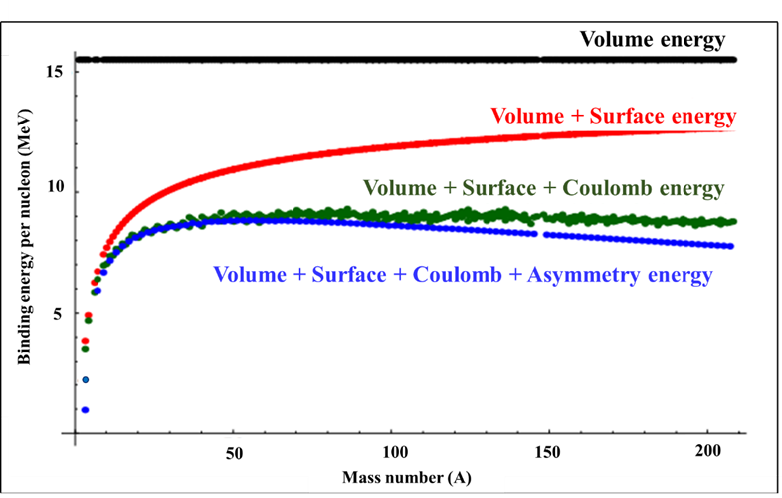
Figure 2 Binding energy curve based on Semi-empirical formula

Problem 1 Estimate the binding energy per nucleon of ₃₅Br⁸⁰ (Bromine)?

Volume term: (15.56 × 80) = 1244.8 MeV
Surface term: (−16.8 × (80)^{2/3}) = −319.9 MeV
Coulomb term: (0.697 × (35×34)) / (80)^{1/3} = −198.2 MeV
Asymmetry term: [23 × (80 − 2×35)²] / 80 = −29.1 MeV
Pairing term: −33.0 (80)^{-3/4} = −1.3 MeV
Note that we subtract the pairing term since both (A-Z) and Z are odd.

This gives a total binding energy of 696.3 MeV. The measured value is 694.2 MeV.
Problem 2 Calculate the binding energy of deuterium (₁H²).
The deuterium nucleus consists of a proton and a neutron. Binding energy can be calculated from the sum of the masses of the proton, neutron and the mass of the deuterium nucleus (deuteron) :
ΔM = [M_{p} + M_{n} –M_{d}] = [ (1.007825 u +1.008665 u) – 2.014102 u]
= (0.002388 u × 931.49 MeV/c²/u) = 2.224 MeV/c²
Therefore, binding energy of deuteron = E_{B} = ΔM c² = 2.224 MeV
Problem 3 Calculate the binding energy per nucleon of deuterium (₁H²).
Packing fraction (f) for deuteron f = ΔM/A = ([ (1.007825 u +1.008665 u) – 2.014102 u]) / 2
= 0.002388 u / 2 = 0.001694 u
Binding Fraction (f_{B}). Therefore, f_{B}= E_{B}/A
E_{B} = (0.002388 u × 931.49 MeV/c²/u) = 2.224 MeV/c²
f_{B} = E_{B}/A = (2.224 MeV) /2 = 1.112 MeV
----------------------------------------------------------------------------------------------------------------

Problem 4 Determine the binding energy, Packing fraction and Binding fraction for ₆C¹²?
ΔM = [6M_{p} + 6M_{n} –M_{C}] = [ (6×1.007825 u + 6×1.008665 u) – 12 u]
= (0.09894 u × 931.49 MeV/c²/u) = 92.16 MeV/c²
Therefore, binding energy of ₆C¹² = E_{B} = ΔM c² = 92.16 MeV
Packing fraction (f) for ₆C¹², f = ΔM/A = (92.16 MeV/c²)/ 12 = 7.68 MeV/c²
Binding Fraction (f_{B}). Therefore, f_{B}= E_{B}/A = (92.16 MeV) /12 = 7.68 MeV
---------------------------------------------------------------------------------------------------------------
Problem 5 Determine the binding energy, Packing fraction and Binding fraction for Alpha particle: ₂He⁴ ; Z=2, N=2
E_{B} = 2Mp +2Mn – M(α)
= (2x1.007825 + 2x1.008665 – 4.002603) x 931 MeV
= 28.3 MeV
f_{B} = 28.3/4= 7.075 MeV/nucleon
---------------------------------------------------------------------------------------------------------------
Problem 6 Determine the binding energy, Packing fraction and Binding fraction for Oxygen ₈O¹⁶ ; Z=8, N=8
E_{B} = 8Mp +8Mn – M(O)
= (8x1.007825 + 8x1.008665 – 15.994915) x 931 MeV
= 127.65 MeV
f_{B} = 127.65/16= 7.98 MeV/nucleon
Problem 7 Calculate the energy released in the fusion reaction of ₁H² + ₁H³ → ₂He⁴ + _{o}n¹
Given: m(₁H²) = 2.0135 u, m(₁H³) = 3.016 u,
m(₂He⁴) = 4.0026 u, and m(n) =1.008665 u.
Energy released = Δmc² Mass of reactants = 2.0135 u + 3.016 u = 5.0295
Mass of products = 4.0026 u + 1.008665 u = 5.011265 u
Therefore, Δm = (5.0295 - 5.011265) u = 0.018235 u
Therefore, energy release = 0.018235 × 931.5 MeV = 16.99 MeV ≈ 17 MeV
----------------------------------------------------------------------------------------------------------------
Problem 8 Based on the above estimate, calculate the energy released by the fusion of a 1.00kg mixture of deuterium and tritium, which produces helium?
The atomic mass of deuterium (₁H²) is 2.014102 u, and that of tritium (₁H³) is 3.016049 u, making a total of 5.032151 u per reaction.
Therefore, one mole of reactants has a mass of 5.032151 g
Then in 1.00 kg there are (1000 g)/(5.03 g/mol)=198.8 mol of reactants.
The number of reactions that take place is therefore = (198.8 mol) × (6.02 × 10²³ mol⁻¹)
= 1.20 × 10²⁶ reactions.
Therefore, energy release = 1.20 × 10²⁶ × 17 MeV = 20.4 × 10²⁶ MeV
[To represent the results in SI units: We know 1.6× 10⁻¹⁹ J = 1eV or 1.6× 10⁻¹³ J = 1 MeV]
Therefore, energy release = 20.4 × 10²⁶ MeV × 1.6× 10⁻¹³ = 32.64 × 10¹³ J
----------------------------------------------------------------------------------------------------------------
Problem 9 Calculate the energy released in the following spontaneous fission reaction:
₉₂U²³⁸ ⇒ ₃₈Sr⁹⁵ + ₅₄Xe¹⁴⁰ + 3 _{o}n¹
Given: m(₉₂U²³⁸) =238.050784 u, m(₃₈Sr⁹⁵) = 94.919388 u,
m(₅₄Xe¹⁴⁰) = 139.921610 u, and m(n) =1.008665 u.
Energy released = Δmc²
Mass of reactant = 238.050784 u
Mass of products = 94.919388 u + 139.921610 u + 3 × 1.008665 u = 237.866993 u
Therefore, Δm = 238.050784 u - 237.866993 u = 0.183791 u
Therefore, energy release = 0.183791u × 931.5 MeV = 171.2 MeV
----------------------------------------------------------------------------------------------------------------Problem 10 Based on the previous solution calculate the amount of energy produced by the fission of 1.00 kg of ²³⁵U?
Energy release per fission is 171.2 MeV
According to Avogadro’s principle, 235 grams of uranium will contain 6.02× 10²³ atoms.
Number of ₉₂U²³⁵ atoms in 1 kg uranium = $\frac{1000×6.02×{10}^{23}}{235}$ = 0.025617 × 10²⁶ atoms
Therefore, total energy release = 171.2 MeV × 0.025617 × 10²⁶ atoms = 4.386 × 10²⁶ MeV
[To represent the results in SI units: We know 1.6× 10⁻¹⁹ J = 1eV or 1.6× 10⁻¹³ J = 1 MeV]
Therefore, total energy release = 4.386 × 10²⁶ × 1.6× 10⁻¹³ = 8.21× 10¹³ J
Note: This is an impressive result. This large amount of energy is equivalent to about 14,000 barrels of crude oil or 600,000 gallons of gasoline.
But, comparing with the fusion of a kilogram mixture of deuterium and tritium this is only one-fourth the energy produced by the fusion!

References:

Nuclear Physics: Experimental and Theoretical, 2nd Revised edition by H S Hans. New Academic Science, 2011.

Littlefield, T.A. & Thorley, N., Atomic and Nuclear Physics, 3rd edition, (ELBS and van Nostrand Reinhold Co., 1979).

Thayal D. C. Nuclear Physics, Himalaya Publishing House, India, 1956.

