Course title: Atomic and Nuclear Physics

Week # 7

Main Topics: Shell and collective models and nuclear stability

Lecturer: Jojo Panakal John

Lecture Learning Outcomes:
At the end of the lecture, you will be able to:
- Explain the nuclear stability of isobars using the mass parabola
- Understand the Nuclear shell model and shell closure.
- Describe the magic number formation with spin orbit interactions

Stability of nuclei
Based on Bethe-Weizsacker’s empirical mass formula we have:
M(Z,A) = [Z M_{p} + N M_{n}] - c_{v} A + c_{s} A^{2/3} + c_{c} $\frac{Z(Z -1 )}{A^{1/3}}$ + c_{sym} $\frac{{(A-2Z)}^{2}}{A}$ - c_{p} A^{(-3/4)} (1)
Neglecting 1 in comparison to Z in the Coulomb term and rewriting the above equations as:
M = Z M_{p} + N M_{n}- c_{v} A + c_{s} A^{2/3} + c_{c} $\frac{Z^{2}}{A^{1/3}}$ + c_{sym} $\frac{{(A-2Z)}^{2}}{A}$ - c_{p} A^{(-3/4)}
= Z M_{p} + N M_{n}- c_{v} A + c_{s} A^{2/3} + c_{c} $\frac{Z^{2}}{A^{1/3}}$ + c_{sym} $\frac{A^{2}+4Z^{2}-4AZ}{A}$ - c_{p} A^{(-3/4)}
= Z M_{p} + (A-Z) M_{n}- c_{v} A + c_{s} A^{2/3} + c_{c} $\frac{Z^{2}}{A^{1/3}}$ + c_{sym} $\left\{A+\frac{4Z^{2}}{A}-4Z\right\}$- c_{p} A^{(-3/4)}
= - c_{v} A + c_{sym} A +A M_{n} + c_{s} A^{2/3} - Z M_{n}+Z M_{p} - c_{sym} 4Z + c_{c} $\frac{Z^{2}}{A^{1/3}}$ + c_{sym} $\left\{\frac{4Z^{2}}{A}\right\}$ - c_{p} A^{(-3/4)}
M(Z,A) = A[- c_{v} + A +M_{n} + c_{s} A^{-1/3}] – Z[M_{n}+ M_{p} - c_{sym} 4] +Z²[ $\frac{C_{c}}{A^{1/3}}$ + c_{sym} $\frac{4}{A}$ ] - c_{p} A^{(-3/4)} (2)
This equation can be written as: M(Z,A) = a A + b Z + cZ² - δ (3)
Here, a = [- c_{v} + A + M_{n} + c_{s} A^{-1/3}]
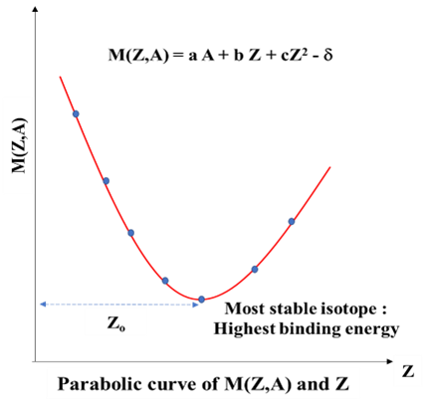
b = - [M_{n}+ M_{p} - 4c_{sym}]
c = [ $\frac{C_{c}}{A^{1/3}}$ + c_{sym} $\frac{4}{A}$ ] and δ = ± c_{p} A ^{(-3/4)}
Equation 3 is a quadratic over Z for a given A. Differential of this equation ${\left(\frac{∂M}{∂Z}\right)}_{A}$can give us the minimum of z for a given A. The atomic number z_{o} will represent the most stable isotope for the given A. Taking the partial derivative of Equation 3 with respect to Z keeping A as constant and equating the result of the equation to zero (for minimum) we have: Figure 1 Nature of mass parabola
${\left(\frac{∂M}{∂Z}\right)}_{A}$ = b + 2cZ = 0 (4)
Therefore, for minimum value of Z we have: Z_{o} = - $\frac{b}{2c}$ = $\frac{[M_{n}+M_{p}-4C_{sym}]}{[\frac{C_{c}}{A^{\frac{1}{3}}}+ C_{sym}\frac{4}{A}]}$
Since all the quantities of this expression are known, atomic number for most stable isobar of a given mass number, A can be calculated. Making substitutions for known values,
Z_{o} ≈ $\frac{A}{2+0.0154A^{2/3}}$ (5)
The stability of nuclides in radioactivity is based on their binding energy. The binding energy formula explains some of the important features of stability of nuclei, in particular the ꞵ - activity and stability of isobars. We have already seen that a plot between M(Z,A) and Z would be a parabola. The bottom of the curve represents the most stable nucleus of series, with highest binding energy.
When the mass number (A) is odd, the pairing energy term Ep=0. Therefore, there can only be a single parabola. When A is even, there are two cases possible. (1) Eve-even nucleus for which Ep is +ve (= +c_{p} A^{(-3/4)}) and odd-odd nucleus for which Ep is -ve (= -c_{p} A^{(-3/4)}).
Let us consider the two cases separately.
Odd A Isobars
Odd A isobars have either odd Z or odd N but not both odd simultaneously. Being an odd A isobar, the pairing energy vanishes for such isobars. Ep = δ = 0. Then the equation (3) becomes: M(Z,A) = a A + b Z + cZ²
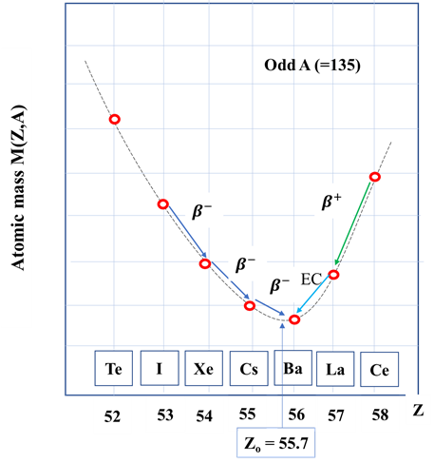
All the isobars with binding energy less than the most stable one will lie at the arms of the parabola. They will decay by ꞵ emission of electron (e⁻) or positron (e⁺) or by K electron capture. During a ꞵ decay either electron is released (ꞵ-) or a positron is emitted (ꞵ+) from the nucleus.
During the process total nucleons (A) remains the same. This is because while positron emission (ꞵ+) a proton is converted into neutron and in electron emission (ꞵ-) a neutron is converted into proton, thereby Z and N changes. The positron emission process can be represented as: Figure 2 Parabola for odd isobar
${zX}_{N}^{A}$ $\underset{→}{β^{+ }decay}$ _{(Z-1)}Y^{A}_{(N+1)} + $β^{+ }$+ ν + $E_{β^{+}}$
Here Z is reduced by 1 hence the isobar moves left in the mass parabola.
The electron emission process can be represented as:
${zX}_{N}^{A}$ $\underset{→}{β^{- }decay}$ _{(Z+1)}Y^{A}_{(N-1)} + $β^{- }$+ + $E_{β^{-}}$
Here Z is increased by 1 hence the isobar moves right in the parabola.
In both cases, ν and are neutrino and anti-neutrino are particles released during the decay. $E_{β^{+}}$ and $E_{β^{-}}$ are the kinetic energies of emitted particles.
Electron capture:
There is one more process called electron capture (EC) where an atomic electron is captured by the nucleus to convert one proton to neutron as:
_{Z}X^{A}_{N} + e⁻ $\underset{→}{electron capture}$ _{(Z-1)}Z^{A}_{(N+1)} +ν
To the left of the minimum value of atomic number (low Z) in the mass parabola, the β - decay will be favored, while to the right the β + decay and EC processes will be favored.
Even A Isobars
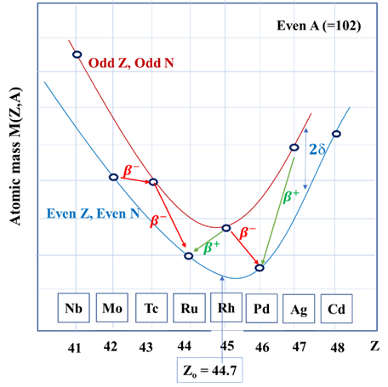
While we consider an even A isobar, the outcome is different from odd A nuclei. For even A-nuclei pairing energy is not zero. Since both odd-odd and even-even nuclei have even A, we have two different values of pairing energy. Therefore, we have two parabolas in binding energy curve displaced by the pairing energy, 2δ.
The isobaric mass parabolas for even A nuclei are shown in the Figure. The odd-odd nuclei lie on the upper curve is unstable with respect to even-even nuclei. Nuclear event in which two Figure 3 Parabolas for even isobars
protons simultaneously decay to become two neutrons or vice-versa is known as double ꞵ decay. This is the reason why for even-even nuclei have two or more stable nuclei. As seen in the figure, the A = 102 isobaric family has two stable nuclei.
Problem 1 Deduce the probable value of Z for stability in the case of isobar with A = 135?
For the stability we have: Z_{o} ≈ $\frac{A}{2+0.0154A^{2/3}}$ = $\frac{135}{2+0.0154 {(135)}^{2/3}}$ ≈ 56.1 ≈ 56
The stable isotope in the isobaric family with A=135 is ₅₆Ba¹³⁵

Nuclear Shell Model

Analogous to the model of the orbital structure of atomic electrons in atoms we can have a nuclear shell model. Liquid drop model of nucleus was successful for several years in spite of no idea of the internal structure or distribution of the nucleons in the nucleus. There were numerous reasons to believe that the nucleons in the nucleus are arranged in a shell structure.
The binding energy curve showed that certain nuclei with a magic number have remarkably higher binding energy with respect to their neighbouring elements. The existence of magic numbers (2,8,20,28,50,82 and 126) suggests closed shell configurations, like the shells in atomic structure. Similar to the atomic transitions with specific energy, nuclear alpha decay also has specific energy. Such ideas embodied the way to the development of a shell model of the nucleus. Some other arguments suggesting the shell structure are:
- Enhanced stability and abundance of those elements for which Z or N is a magic number.
- The stable elements at the end of the naturally occurring radioactive series all have a "magic number" of neutrons, protons or both.
- The neutron absorption cross-sections for isotopes where N = magic number are much lower than neighbouring isotopes.
- The binding energy for the last added neutron is a maximum for a magic neutron number and drops sharply for the next neutron added.
- Electric quadrupole moments are near zero for magic number nuclei, confirming the spherical symmetry of the nucleus.
- The excitation energy from the ground nuclear state to the first excited state is greater for closed shells.
Based on the above observations, a nuclear shell model was proposed with the following assumptions:
- It is assumed that the nucleons in the nucleus move independently in a common potential determined by the average motion of all other nucleons.
- Proton and neutrons separately fill energy levels in the nucleus.
- Majority of the nucleons are paired. Paired nucleons contribute no spin and magnetic moment to the nucleus.
- The properties of odd mass number nuclei are characterized by the unpaired nucleon and odd-odd nuclei by the unpaired proton and neutron.

Shell model goes with the limited number of allowed energy states of each nucleon. This leads to energy quantization in a manner similar to the square well and harmonic oscillator potentials. In terms of Schrodinger's equation, each nucleon is assumed to move in the same potential. The potential is spherical in the simplest case, but there is good evidence that for nucleon numbers far from closed shells the potential should have an ellipsoidal shape.
The shell model primarily depends on two quantum numbers, the radial (total) quantum number, n and the orbital quantum number, l. Also, for l = 0, 1, 2, 3, 4, 5, we use the spectroscopic denotations s, p, d, f, g, h, respectively. A state denoted by 2p therefore means that n = 2, l = 1. The simplest potentials that can be assigned to nucleus is an infinite square well potential of radius R. The potential V = 0 for r < R and V = α (infinite) for r > R. The harmonic Oscillator potential can be of the form: V = ½ m_{o}ω²r². Here ω is the frequency of oscillation of the particle of mass m_{o}. Following figure shows the filling of nucleons in the shells.
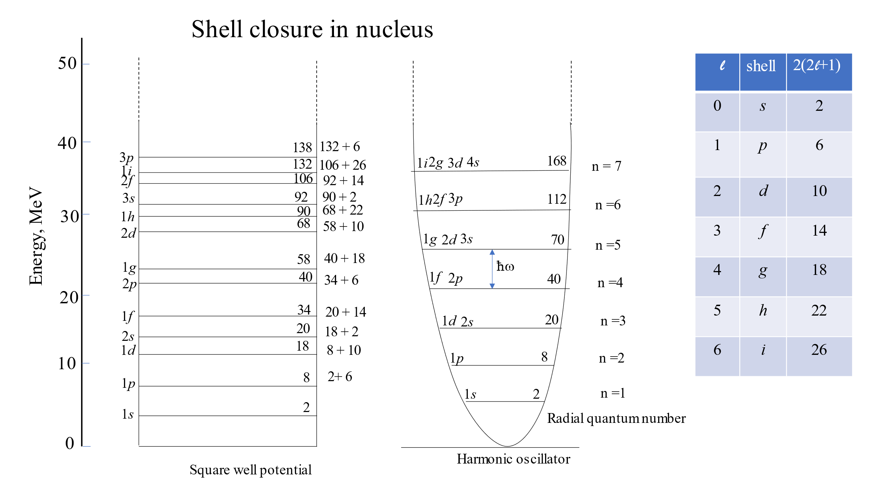
Figure 4 Filling of nucleons in the shells giving magic number shell closures
Although these potentials can give explanation for the lowest magic numbers, they do not work for the higher magic numbers.
In this simple nuclear shell model, nucleons (protons and neutrons) occupy quantized energy levels or shells within the nuclear potential generated by the strong nuclear force in a spherically symmetric potential. However, the nuclear potential is not purely central nor spherically symmetric. There are additional interactions beyond the simple central potential due to the spin-orbit interaction. By the analogy with atomic physics there should also be a spin–orbit interaction so that we may express the potential as:
V_{total} = V_{central}(r) + V_{l .s}(r) L.S
Where L and S are the orbital and spin angular momentum operators for a single nucleon and V _{l s} (r) is an arbitrary function of the radial coordinate. The coupling between L and S will result in the total angular momentum, J =L+S.
The energy levels are split into two states, denoted by j = l ± ½, where j is the total angular momentum quantum number of the nucleon. This leads to the overlapping levels as shown in the energy level illustration. The subscript indicates the value of the total angular momentum j, and the multiplicity of the state is 2j+1. There is a contribution of protons to the energy is somewhat different from that of a neutron because of the coulomb repulsion.
Energy of a nucleon with total angular momentum, J is E_{J} = $\frac{ħ^{2}}{2I}$ [J(J+1)].
It has been proved experimentally that V _{l s} (r) is negative, which means that the state with j = 2l +1 has a lower energy than the state with j = 2l −1. This is opposite to the situation in atoms. Also, the splitting is substantial and increase linearly with l. Hence for higher l, crossings between levels can occur. For large l , the splitting of any two neighbouring degenerate levels can shift the j = 2 l −1 state of the initial lower level to lie above j = 2 l +1 level of the previously higher level.
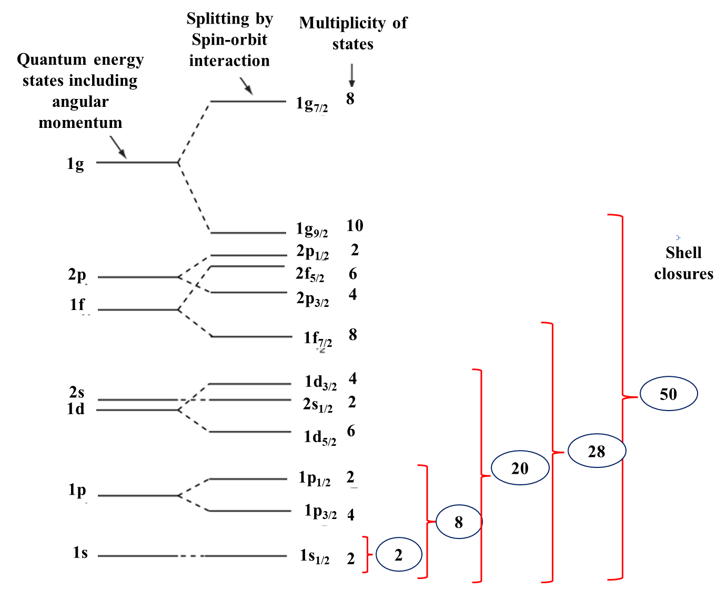
Figure 5 Energy levels and shell closure of nucleons with spin orbit interaction
Achievements of the Shell Model
- Shell model explains the ground state spin and parities of all even-even nuclei.
- It explains the ground state spin and parities of most of odd A (even-odd or odd-even) nuclei.
- Shell model explains the spin and parities of odd-odd nuclei.
- It explains the extra stability of magic nuclei.
- The modle also explains the qualitative features of magnetic dipole and electric quadruple moment of different nuclei.
Shell model could also make certain predictions.
- This scheme clearly reproduces all the magic numbers.
- The shell model has been very successful in predicting the ground state spin of a large number of nuclei.
- The shell model also makes predictions about the electric quadruple moment of the odd A and Z nuclide.
At the same time there are a few lacuna for Shell Model, which are listed below.
- Shell model fails to explain spin values for certain nuclei.
- Shell model is unable to explain the energy of first excited states in even-even nuclei.
- It is unable to explain magnetic moments of some nuclei.
- This model is also unable to explain quadruple moments of many nuclei.
In summary, the shell model of the nucleus provides a valuable understanding of nuclear structure and stability, especially for nuclei magic numbers. However, it does not account for all nuclear interactions. Modern theoretical models, such as the nuclear shell model with residual interactions or the nuclear shell model within the framework of quantum chromodynamics, aim to improve upon these limitations and provide a more comprehensive picture of atomic nuclei.
Problem 2 The single particle energy difference between 1p-orbitals (1p_{½} and 1p_{3/2}) of nucleons of ₅₀Sn¹¹⁴ is 3MeV. Find the energy difference between the 1d and 1f orbitals?
For p orbital, l=1 and s = ½ Therefore, j = ½ and 3/2
ΔEp = 3MeV ΔEp = $\frac{ħ^{2}}{2I}$ [(Ep)_{3/2} – (Ep)_{1/2}]
3MeV= $\frac{ħ^{2}}{2I}$ [3/2(3/2+1) -1/2 (1/2+1)]
= $\frac{ħ^{2}}{2I}$ [$\frac{3×5}{2×2}$ - $\frac{1×3}{2×2}$]= $\frac{ħ^{2}}{2I}$ $\frac{12}{4}$ = $\frac{ħ^{2}}{2I}$ $×$3 3MeV= $\frac{ħ^{2}}{2I}$ $×$3
Therefore, $\frac{ħ^{2}}{2I}$ = 1MeV
Similarly, for d orbital, l=2 and s = ½ Therefore, j = 3/2 and 5/2
ΔE_{d} = ? ΔE_{d} = $\frac{ħ^{2}}{2I}$ [(E_{d})_{5/2} – (E_{d})_{3/2}]
ΔEp = $\frac{ħ^{2}}{2I}$ [5/2(5/2+1) -3/2 (3/2+1)]
= $\frac{ħ^{2}}{2I}$ [$\frac{5×7}{2×2}$ - $\frac{3×5}{2×2}$]= $\frac{ħ^{2}}{2I}$ $\frac{20}{4}$ = $\frac{ħ^{2}}{2I}$ $×$5 ΔE_{d} = $\frac{ħ^{2}}{2I}$ $×$5 = 5MeV
Same way, For f orbital, l=3 and s = ½ Therefore, j = 5/2 and 7/2
ΔE_{f} = ? ΔE_{f} = $\frac{ħ^{2}}{2I}$ [(E_{f})_{7/2} – (E_{f})_{5/2}]
ΔE_{f} = $\frac{ħ^{2}}{2I}$ [7/2(7/2+1) -5/2 (5/2+1)]
= $\frac{ħ^{2}}{2I}$ [$\frac{7×9}{2×2}$ - $\frac{5×7}{2×2}$]= $\frac{ħ^{2}}{2I}$ $\frac{28}{4}$ = $\frac{ħ^{2}}{2I}$ $×$7 ΔE_{f} = $\frac{ħ^{2}}{2I}$ $×$7 = 7MeV
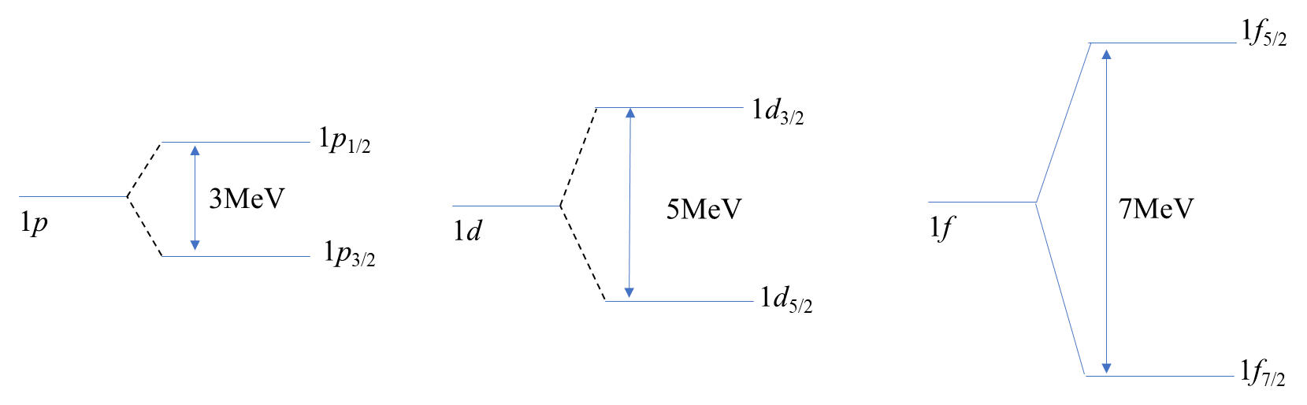

Collective Model of nucleus (Unified model)

The Collective Model was developed as a response to the limitations of the shell model. Although the shell model successfully described the nature of individual nucleons within the nucleus, it had difficulties in explaining certain nuclear properties and reactions involving a large number of nucleons.

The Collective Model designed to address these challenges and provided a balancing description on nuclear structure and nuclear dynamics. The model treats the nucleons (protons and neutrons) in the nucleus as a collective system rather than individual particles. This means that the nucleons interact with each other collectively, giving rise to collective motion.

The collective model introduces coordinates, which characterize the collective motion of nucleons within the nucleus. These coordinates describe the shape, vibration, and rotation of the nucleus as a whole. For the Collective Model, the potential energy surface is a critical concept. It represents the total potential energy of the nucleus as a function of the collective coordinates. The shape of this surface determines the equilibrium shape and possible deformations of the nucleus. Collective model assumes that the nucleus undergo vibrational changes as in a quantum mechanical harmonic oscillator and rotational motion similar to a rigid rotor.
According to the collective model, the time varying radius or the shape of the nucleus can be expressed as : R(t) = R_{avr} + $\sum{\sum_{μ=-}{α_{}\left(t\right)+Y_{}(,)}}$
The heft hand side of the equation represents the radius of the oscillating nucleus at a given time. The first term on the right-hand side is the spherically symmetric nucleus behaving like a monopole. The other two terms represent the amplitude of oscillation and the deviation from sphericity in two directions θ and ϕ. The oscillations are demarked by two variables λand μ. The nucleus can be a dipole or a quadrupole or an octupole depending on $.$
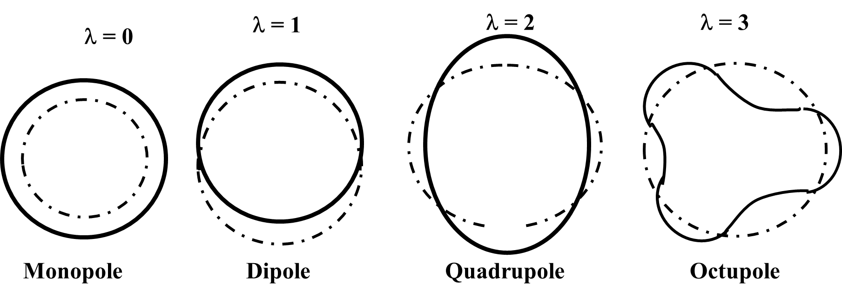
Figure 6 Deformations of nuclei due to oscillations
The Collective Model has been successful in explaining various nuclear phenomena:
The model predicts that certain nuclei exhibit vibrational motion, where the nucleons oscillate around their equilibrium positions. These vibrations result from the interplay of nuclear forces and provide insights into nuclear structure and excitation spectra.
Just as a spinning top, some nuclei undergo rotational motion, leading to rotational bands in their energy spectra. The Collective Model explains the quantized angular momentum states observed in these bands. The model provides a framework to understand electromagnetic transitions, such as gamma-ray emission, between nuclear states. It helps to explain selection rules and transition probabilities. The Collective Model has been applied to study nuclear reactions involving fission and fusion processes. It provides valuable insights into the behavior of heavy and highly excited nuclei.
Whereas the Collective Model has been successful in many aspects, it also has limitations. It primarily applies to medium and heavy nuclei and might not be as accurate for light nuclei. The model does not account for specific details of the fundamental nuclear forces and interactions
References:

Nuclear Physics: Experimental and Theoretical, 2nd Revised edition by H S Hans. New Academic Science, 2011.

Littlefield, T.A. & Thorley, N., Atomic and Nuclear Physics, 3rd edition, (ELBS and van Nostrand Reinhold Co., 1979).

Thayal D. C. Nuclear Physics, Himalaya Publishing House, India, 1956.

