Course title: Atomic and Nuclear Physics

Week # 8

Main Topics: Radioactivity, transmutations and decay equations

Lecturer: Jojo Panakal John

Lecture Learning Outcomes:
At the end of the lecture, you will be able to:
- Understand the process of radioactivity
- Explain different modes of radioactive decay
- Apply law of radioactivity to solve problems related to radioactive decay

Radioactivity

Radioactivity is a nuclear phenomenon by which an unstable nucleus releases subatomic particles or radiations naturally. Radioactivity is a fundamental property of certain unstable atomic nuclei, leading to the emission of radiation in the form of alpha particles, beta particles, and gamma rays. When a radioactive nucleus emits radiation spontaneously, it transforms into a more stable form. This process is called radioactive decay. The rate of decay is unique to each radioactive element. Numerous naturally occurring radioactive isotopes are available in nature. These isotopes are typically produced through various processes such as nucleosynthesis and geophysical and geochemical processes in the nature. There are radioactive chains in which one radioactive isotope decays to another successively till a stable isotope. Apart from these, there are stand-alone radionuclides in the biosphere. Several isotopes have extremely long life while many radioactive isotopes have very short half-lives and are not stable enough to be found in significant quantities in nature.

Radiations from radioactive substances
Among the naturally occurring isotopes some nuclei are stable, some are not. A stable nucleus may remain so until and unless an external agent interacts with it to destabilise. It can be noticed that stable nuclei have approximately equal number of neutrons as protons in the nucleus and are bound by strong nuclear force. The ratio of neutrons to protons of stable nuclei are 1:1 for small nuclei (Z < 20). The neutrons to protons ratio increases gradually up to about 1.58 for high Z nuclides. There are only two naturally occurring stable nuclei with Z > N (more protons than neutrons). They are ₁H¹ (Hydrogen – no neutrons) and ₂He³ (Helium- 2 protons and only one neutron).
Radioactive decay involves the transformation (decay) of an unstable nucleus into a more stable one with emission of particle(s) and/or gamma rays. The radioactive decay is the spontaneous emission of particles (such as alpha and beta particles) or gamma rays (electromagnetic radiation). In general there are three modes for the radioactive decay.
Alpha Radiation (α): Alpha particle is a system of two protons and two neutrons (completely ionised helium atom: that is helium nucleus). Alpha particles are relatively heavier and has double positive charge. They have low penetration power in materials (as they ionise the medium faster) and can be stopped by a sheet of paper or even human skin. However, if alpha-emitting materials are ingested or inhaled, they can cause significant health risks due to their potential to damage living tissue at close range.
Beta Radiation (β): Beta particles are high-energy electrons (β-) or positrons (β+), emitted when a neutron decays into a proton or vice versa respectively in side a nucleus. They have greater penetration power as compared with alpha particles. Beta particles can be stopped by materials like plastic, glass, or a few millimetres of aluminium. Beta radiation can also cause tissue damage if they interact with living cells.
Gamma Radiation (γ): Gamma rays are high energy electromagnetic waves with no mass or charge. They have the highest penetration power among the three types of radiation and require dense materials like a block of lead or several centimetres of concrete to attenuate their energy. Gamma radiations pose significant health risk as it can penetrate deep into the body. Depending on the quantum of radiation, they can damage cells, leading to potential radiation sickness or long-term health effects. When an unstable nucleus decays by emitting an alpha or a beta particle (electron or positron), it is followed by the emission of a gamma radiation. A nucleus followed by an alpha and a beta decay is in an excited state, and they emit gamma rays to get a stable state.
There are diverse and numerous applications for radiation from radioactive substances. In nuclear medicine, radioactive isotopes are used for diagnostics (like in PET scans) and cancer treatment (as in radiotherapy). In industry, radiations are useful for quality control and to sterilize medical equipment and food. Above all, radioactive decay plays a crucial role in nuclear power generation.
Alpha Decay
Alpha decay is a common radioactive decay process generally seen in very heavy elements. Each emission of alpha can be expresses symbolically as:
_{Z}X^{A} ⇒ _{(Z-2)}Y^{(A-4)} + ₂He⁴ (1)
Note that the mass number A reduces by 4 and the atomic number Z reduces by 2 for the daughter product by the emission of an alpha particle as compared with the parent nuclide. The atomic number (Z) of the parent is same as the sum of the atomic numbers of the daughter and the by product. Similarly, the mass number (A) of the parent will be equal to the sum of the atomic numbers of the daughter and the by product. An example of alpha-decay is the decay of radium-226 into radon-222.
₈₈Ra²²⁶ ⇒₈₆Rn²²² + ₂He⁴ (2)
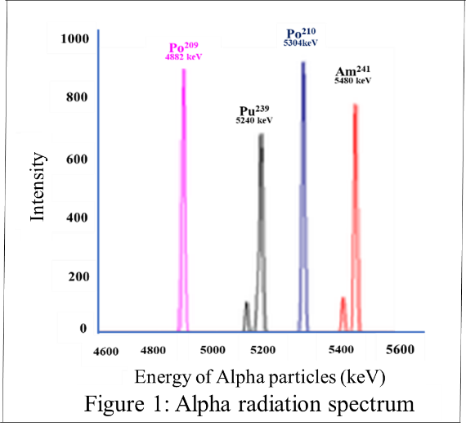
The energy released in the radioactive decay process is shared by the products obeying law of conservation of energy and linear momentum.
The energy spectrum of alpha particles is discrete. That is, while the emission of alpha particles the energy spectrum that we get is a sharp line spectrum for a specific radio-isotope. The sharp lines in the energy spectrum of alpha radioactivity are a consequence of the discrete energy levels within atomic nuclei and the conservation of energy in nuclear decay processes. Each line represents a specific energy transition associated with the emission of an alpha particle.
For example: Alpha decay of ₈₄Po²⁰⁹ have the decay scheme: ₈₄Po²⁰⁹ ⇒ ₈₂Pb²⁰⁵ + ₂He⁴
The energy of the alpha particle in the emission is well defined and is 4884 keV.
Problem 1: Calculate the energy released in the alpha decay of radium ₈₈Ra²²⁶ to ₈₆Rn²²².
Given mass of radium = 226.025402 u; Mass of radon = 222.017571 u;
Mass of alpha particle = 4.002602 u.
Mass defect, Δm = m(Ra) – [m(Rn) + m(α)]
= 226.025402 – [222.017571 + 4.002602] u.
Energy = 0.005229 u
= 0.005229 u × 931.5 MeV/u
= 4.97 MeV
Applying law of conservation of linear momentum and energy, we can see that the alpha particle being much lighter than the radon nucleus, most of the released energy appears as the kinetic energy of the alpha particle and this energy is characteristic for the radio-isotope.
Beta Decay
In beta radioactive decay, an electron is emitted by the parent nucleus. There are three types of beta decay. First one is the electron emission (β⁻). One of the neutrons in the parent nucleus gets divided into a proton and an electron (_{o}e⁻¹ called beta particle). Therefore, number of protons in the nucleus increases by 1. Since there is a new proton in the nucleus, the mass number remains same. Since one neutron changes to proton in the process, the neutron to proton ratio (a vital factor for stability) reduces considerably. Apart from the electron, there is an electron anti-neutrino also emitted in the process as a bye product. Beta decay can be expressed as:
_{Z}X^{A} ⇒ _{(Z+1)}Y^{(A)} + ₋₁eº + (3)
An example of beta-decay is the decay of carbon-14:
₆ C¹⁴ ⇒ ₇N¹⁴ + ₋₁eº + (4)
Beta radioactivity results in a continuous spectrum of emitted beta particles. The energy available by the decay process is constant. But the share of this energy for these particles varies continuously due to the characteristics of the decay process and the transformation of neutrons into protons within the atomic nucleus. This is in contrast to alpha radioactivity, where the emitted alpha particles have discrete and well-defined energy.
For example:
₈₃Bi²¹⁰ ⇒ ₈₄ Po²¹⁰ + ₋₁eº + (5)
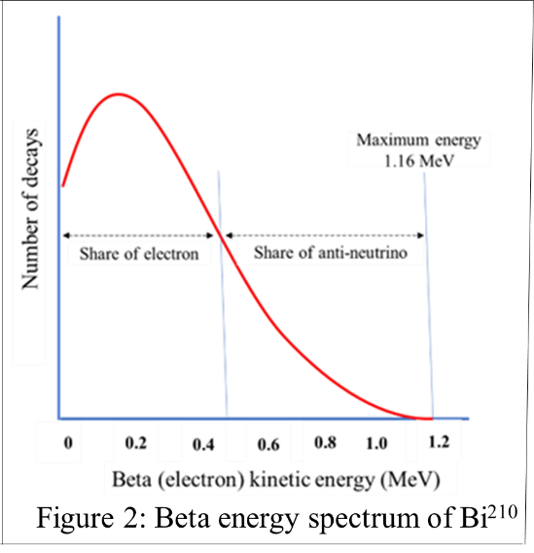
When ₈₃Bi²¹⁰ nucleus decay through beta emission, the total energy available is 1.12 MeV of which the emitted electron takes its share as kinetic energy and the remaining energy is carried away by the anti-neutrinos emitted during the process. Neutrinos and antineutrinos in beta decay have very low mass and interact weakly with matter, making it difficult to detect. Similar to negative beta decay, there can be positron emission in beta radioactive decay. The positive beta decay or positron emission (β⁺) can be expressed as:
_{Z}X^{A} ⇒ _{(Z-1)}Y^{(A)} + ₊₁eº + ν (6)
Note that the mass number (A) doesn’t change in beta decay. But the nuclear charge increases for electron emission and the nuclear charge decreases for positron emission. The emission of an electron from nucleus (even if there is no electron inside the nucleus explicitly) is explained as the decay of a neutron into a proton and an electron:
₀n¹ ⇒ ₁p¹ + ₋₁eº + (7)
Similarly, the emission of a positron is equivalent to the conversion of a proton in the nucleus into a neutron and a positron.
₁p¹ ⇒ _{o}n¹ + ₊₁eº + ν (8)
Another process related to beta decay is K-capture. In this process a nucleus ‘captures’ an orbital electron in the K-shell which combines with a proton to form a neutron. This may be expressed as:
_{Z}X^{A} + ₋₁eº ⇒ _{(Z-1)}Y^{(A)} + ν (9)
Example: ₁₉K⁴⁰ + ₋₁eº ⇒ ₁₈Ar⁴⁰ + ν (10)

Problem 2: Calculate the energy released in the beta decay of ₆C¹⁴ to ₇N¹⁴.
Given mass of C¹⁴ = 14.003242 u; Mass of N¹⁴ = 14.003074 u
The decay scheme is: ₆C¹⁴ ⇒ ₇N¹⁴ + ₋₁eº +
We can take electron and anti-neutrino is massless and therefore,
Δm = 14.003242 – (14.003074 + 0.000549) u = 0.000168 u × 931.5 = 0.156MeV
This energy is primarily shared by the emitted electron and the antineutrino.
Neutrinos: If the electron was the only particle emitted in this decay process, then essentially all of this energy would be taken away by electron since its mass is small compared to the mass of the nitrogen nucleus. However, it is observed that most of the time the electron’s kinetic energy is significantly less than this amount. This led to the idea of emission of a third particle. The difference in kinetic energy is carried away by the third particle. It was also required to have such a particle with a spin angular quantum number of ½ to account for conservation of angular momentum. This particle was expected to have no charge and a very small mass, called neutrino. Neutrino was eventually discovered experimentally in 1956.
In + beta decay (positron emission) process, a neutrino (ν) is emitted. It has been shown that there are several types of neutrinos and that they have a finite, but small mass. Because of their small mass they travel very near to the speed of light. Neutrinos are extremely abundant (the sun produces a large flux of neutrinos). However, they are extremely difficult to detect.
Gamma Decay
Mostly in alpha or beta decay or in nuclear reactions a nucleus is left in an excited state, after the process. The excited nucleus then decays to its ground state by emitting one or more high energy electromagnetic waves (gamma rays). This process is described as
_{Z}X^{A*} ⇒ _{Z}X^{A} + γ (11)
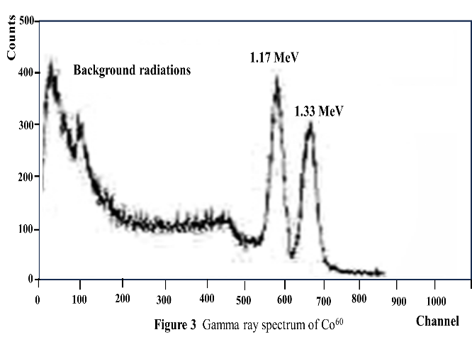
Example: ₂₈Ni^{60*} ⇒ ₂₈Ni⁶⁰ + γ (12)
The photons emitted by the excited nucleus has several MeVs of energy and are generally called gamma rays. Most excited nuclei decay through gamma emission. But in certain cases, the excited nucleus has half-life as long as several hours. A long-lived excited nucleus is called an isomer of the same nucleus in its ground state. The excited nucleus ₃₈Sr⁸⁷* has a half-life of 2.8 h and is accordingly called an isomer of ₃₈Sr⁸⁷.
Radioactive decay relations
Radioactivity is a random process on subatomic level, and it is impossible to predict precisely when a particular nucleus will decay. However, the average nature of decay can be predicted using statistical means. We can find a time interval for the decay of a particular radioactive nuclide. The probable rate of decay of a parent nuclide to its daughter is represented by a constant, λ. The unit for the decay constant is inverse time (per second, s⁻¹).
Two common units to measure the activity of a substance are the Curie (Ci) and Becquerel (Bq). One curie is the unit of measure of the rate of radioactive decay equal to 3.7 x 10¹⁰ disintegrations per second. It is equivalent to the number of disintegrations in one second from one gram of radium (₈₈Ra²²⁶). Becquerel is a more fundamental unit of measure of radioactivity than Curie. One Becquerel means one disintegration per second. The conversion between Curie and Becquerel is:
1 Currie = 3.7× 10¹⁰ Becquerel (13)
There is another sparingly used unit for radioactivity called Rutherford. One Rutherford is equal to 10⁶ disintegrations per second.
Therefore, 1 Currie = 3.7× 10¹⁰ Becquerel = 3.7× 10⁴ Rutherford
Note that the activity tells us only the rate of disintegrations (per second). The specific activity of a radioactive source is defined as the activity per unit mass of the radioactive sample and is expressed in Bq/kg. The effect of radiation on a biological system, depends on the type of radiation, the energy of radiation, exposure time and the tissue to which the radiation is exposed.
Law of radioactivity: Suppose a radioactive sample has N active nuclides in a sample at an instant. According to the law, the rate of radioactive decay, dN/dt is proportional to the number of radioactive nuclei N present in the sample at that time. That is:
dN/dt α N (14)
The quantity dN/dt is called the activity (A) of a sample. The rate of decay is usually expressed as the number of disintegrations that occur per second.
Therefore, A = - (dN/dt) (15)
The minus sign on right hand side indicate that the number of radioactive nuclides (N) decreases with time (t). The relationship between the activity A, number of atoms N, and decay constant λ is given by:
A= Nλ (16)
Since λ is a constant, the activity, A and the number of atoms, N are always proportional.
Combining (15) and (16) we have: - $\frac{dN}{dt}$ = Nλ
- $\frac{dN}{N}$ = λ dt (17)
When we integrate the above equation, for a period of time from t = 0 to any later time t, the number of radioactive nuclei will decrease from N_{o} to N_{t} so that:
$\int_{N_{o}}^{N_{t}}{\frac{dN}{N}}$ = - $\int_{o}^{t}{dt}$ or Exp $\left[\frac{N_{t}}{N_{o}}\right]$ = -λt
N_{t} = N_{o} e^{-λt} (18)
This expression is known as the Radioactive Decay Law. It tells us that the number of radioactive nuclei N_{o} at time t = 0 will decrease in exponentially to N_{t} with time. The rate of decrement being controlled by the decay constant λ. The decay constant is characteristic of individual radionuclide. i.e., has different values for each radio isotopes. The exponential radioactive decay is shown in graphical form in the figure.
The graph plots the number of radioactive nuclei at any time, N_{t} against time, t. It may be noted that as the decay rate (λ) is larger, number of radionuclides remaining becomes smaller. Since the activity A and the number of atoms N are always proportional, they may be used interchangeably to describe the activity of a radionuclide at any time. Therefore,
A_{t} = A_{o} e^{-λt} (19)
Radioactive Half-life: One of the easy methods to find how quickly a radionuclide decay is to find its radioactive half-life. The radioactive half-life is defined as the time by which the activity of a specific radionuclide decreases to one-half of its original value. The half-life can be calculated by solving equation (19). Half-life is the time t, when the current activity reduced to one-half its initial activity.
That is A_{o} reduces to ½ A_{o}.
½ A_{o} = A_{o} e^{-λT}_{1/2} or $\frac{1}{2}$ = e^{-λT}_{1/2} or 2 = e^{λT}_{1/2}
Taking the logarithm: ln($2)$ = ln(e^{λT}_{1/2})
Therefore, 0.693 = T_{1/2}
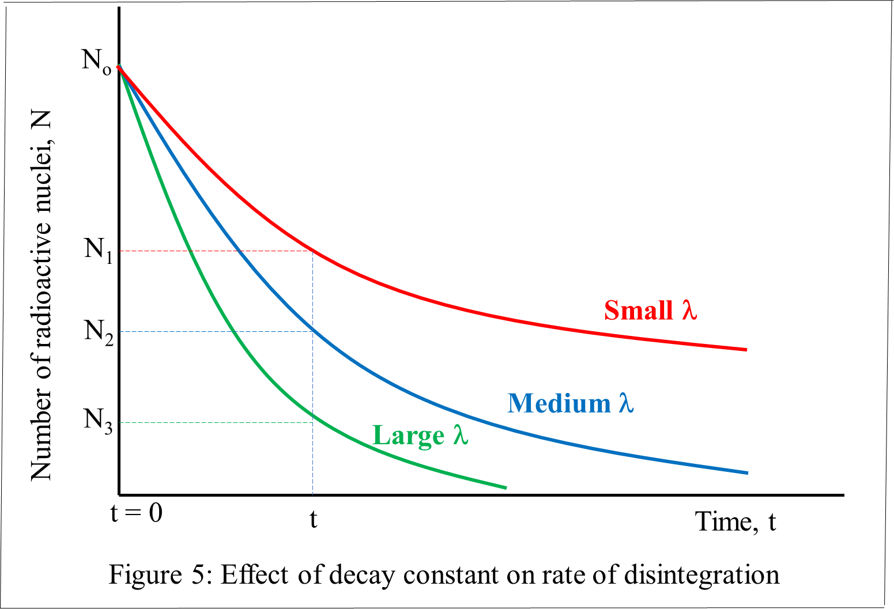
T_{1/2} = $\frac{0.693}{}$ (20)
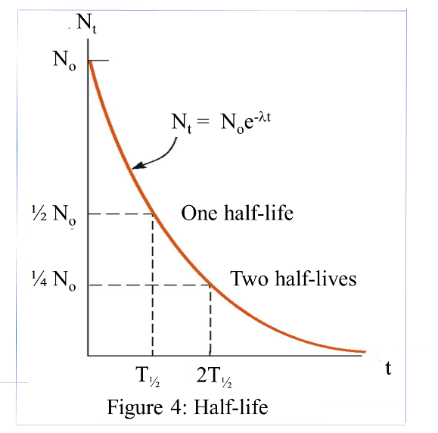

Problem 3: Tritium (₁H³) decays into helium-3 by beta decay with a half-life of 12.3 yrs: What is the activity (decay rate) of 1 mg of tritium?
The radioactive decay is : ₁H³ ⇒ ₂He³ + ₋₁eº +
The decay constant, λ = $\frac{0.693}{12.3×365×24×3600}$ = 1.79$×$ 10⁻⁹ s⁻¹
Number of atoms in 3g of Tritium = one Avogadro’s number = N_{A} = 6.02×10²³
Number of atoms in 1g of Tritium = $\frac{1}{3}$ × 6.02×10²³
Number of atoms in 1mg of Tritium, N = $\frac{0.001}{3}$ × 6.02×10²³ = 3.33×10⁻⁴ × 6.02×10²³
= 2.01×10¹⁹
∴ the activity of 1 mg of tritium, A = Nλ = (2.01×10¹⁹)× (1.79$×$ 10⁻⁹ s⁻¹) = 3.6×10¹⁰ Bq
[In the unit Curie, A = (3.6×10¹⁰ Bq)/(3.7×10¹⁰) = 0.97 Ci]
Problem 4: A curie is a very large and dangerous amount of radioactivity. How long would one have to wait for the tritium activity to reduce to 1 mCi in the previous problem?
We have: A_{t} = A_{o} e^{-λt} Here, 1 mCi = 0.97 Ci e^{-λt}
∴ e^{-λt} = $\frac{1 mCi}{0.97 Ci}$ = $\frac{{10}^{-3}Ci}{0.97 Ci}$ or e ^{λt} = $\frac{0.97 Ci}{{10}^{-3}Ci}$ = 970
λt = ln(970) 1.79$×$ 10⁻⁹ s⁻¹ × t = 6.8773
t = $\frac{6.8773}{1.79×{10}^{-9}}$ s = 3.84$×{10}^{9}$ s ≈ 122y
Apart from the alpha, beta and gamma decay modes of nuclei, there are a couple of radioactive rearrangements towards attaining better stability for nuclei.
Internal Conversion
Internal conversion is a process that can occur during radioactive decay, where an excited atomic nucleus transfers its energy to one of its inner electrons instead of emitting a gamma ray photon. This process is called internal conversion because the conversion of energy takes place within the atom itself, involving the transfer of energy to an electron within the atom's orbital electron. Upon absorption of energy from nucleus, electron is ejected from the atom, becoming a high-energy electron, also known as a beta electron. The emitted beta electron can have a wide range of energies, depending on the energy initially possessed by the excited nucleus.
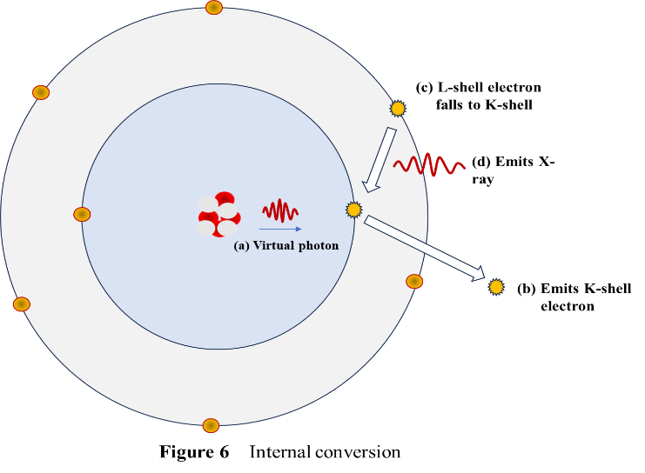
The beta electrons can then interact with other atoms or molecules in its neighbourhood, causing ionization or other chemical reactions. Internal conversion is one of several possible decay modes for excited atomic nuclei. The choice between emitting a gamma ray photon, undergoing internal conversion, or emitting other types of particles (such as alpha or beta particles) depends on the specific nuclear properties and energy levels involved. Internal conversion is different from beta decay (emission of beta particles), which involve the emission of particles (electrons) from the nucleus rather than the transfer of energy within the atom's electron cloud.
Auger Electrons: Auger electrons are low-energy electrons that are emitted from an atom as a result of electron-electron interaction in the inner electron shells of an atom. This process is named after the French physicist Pierre Auger (Au-je).
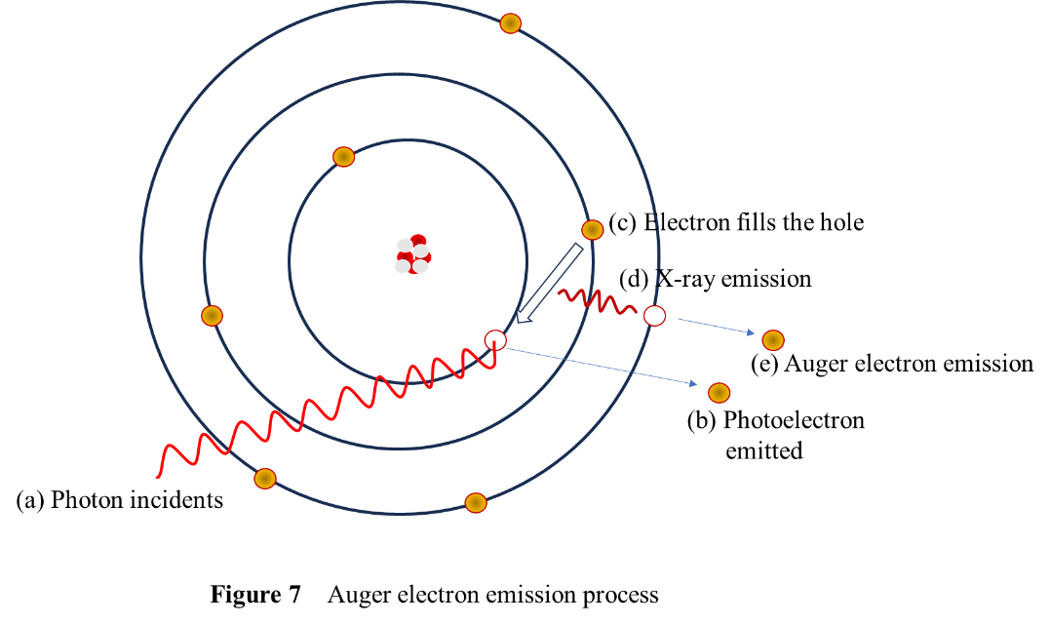
When an atom is ionized or excited, often by external sources such as X-rays or electron beams, the excitation can lead to the promotion of one of the atom's inner electrons to a higher energy level, leaving a hole in one of the inner electron shells. In an attempt to reach a lower energy state and fill the hole created in the inner electron shell, an electron from an outer shell drops down to fill this vacancy. As it does so, it releases energy in the form of a photon. In some cases, instead of emitting an X-ray photon, the energy released during the relaxation process is transferred to another inner-shell electron. This electron is then ejected from the atom with kinetic energy, called an Auger electron.
Spontaneous Fission: Spontaneous fission is in principle a form of radioactive decay. The energy emitted is large compared to some of the other mechanisms described here. Spontaneous fission occurs only when the starting nucleus can by a straightforward mechanism split into two roughly equal fragments with more favorable binding-energy properties than the starting nucleus. Relatively few nuclei do this, and none of them is therapeutically or diagnostically useful.

References:

Nuclear Physics: Experimental and Theoretical, 2nd Revised edition by H S Hans. New Academic Science, 2011.

Littlefield, T.A. & Thorley, N., Atomic and Nuclear Physics, 3rd edition, (ELBS and van Nostrand Reinhold Co., 1979).

Thayal D. C. Nuclear Physics, Himalaya Publishing House, India, 1956.

