Course title: Atomic and Nuclear Physics

Week # 9

Main Topics: Radioactive equilibrium and carbon dating

Lecturer: Jojo Panakal John

Lecture Learning Outcomes:
At the end of the lecture, you will be able to:
- Explain the naturally occurring radioactive series
- Understand possible equilibria between radioactive elements
- Describe the method of carbon dating of fossils and other materials
Radioactive Decay Series
Radioactive sires refer to any of four independent sets of unstable heavy atomic nuclei that decay through a series of alpha and beta decays until a stable nucleus is achieved. All elements for which Z > 83 are radioactive, disintegrating nucleus. The decaying nucleus is called the parent nucleus, and the new born nucleus is daughter nucleus.
The radioactive elements decay through alpha or beta decay into lower Z elements which may also be radioactive. Each decay of the parent isotope produces one or more daughter isotopes, which may themselves be radioactive. These daughter isotopes can also decay further to produce their own daughter isotopes, and so on, creating a chain of radioactive decay reactions. Eventually, they decay into an element which is stable.
The various radioactive elements that are produced in this process can be classified into four series depending on the starting and ending nuclei. These four radioactive series are given listed as follows:

Series | Starting isotope | Half-life (years) | Stable end product
Uranium (4n+2) | ₉₂U²³⁸ | 4.47 x 10⁹ | ₈₂Pb²⁰⁶
Actinium (4n+3) | ₉₂U²³⁵ | 7.04x10⁸ | ₈₂Pb²⁰⁷
Thorium (4n) | ₉₀Th²³² | 1.41x10¹⁰ | ₈₂Pb²⁰⁸
Neptunium (4n+1) | ₉₃Np²³⁷ | 2.14x10⁶ | ₈₃Bi²⁰⁹

The series beginning with ₉₂U²³⁸ and ending with ₈₂Pb²⁰⁶ is known as the 4n+2 series because all the mass numbers in the series are 2 greater than an integral multiple of 4 (e.g., 238=4×59+2, 206=4×51+2). In the thorium series ₉₀Th²³², the mass number of each member can be expressed in the form 4n, while in the actinium series ₉₂U²³⁵, 4n+3.
The first three series are called natural or classical series. The fourth series, Neptunium-237 (4n+1series) exists only with man-made isotopes, but probably existed early in the life of the earth.
Radioactive equilibrium
Radioactive equilibrium of a decay series occurs when the rate of decay of one radioactive element is equal to the rate of its production from the decay of its parent isotope. It is a condition where the amount of a radioactive isotope remains relatively constant over time. The rate of production of the daughter isotope is equal to the rate of decay of it (daughter isotope). Radioactive equilibrium could exist in radioactive decay chains, like the uranium and thorium decay series, where multiple radioactive isotopes are produced through a series of radioactive decay. Each nuclide in the decay series has its own characteristic decay rate or half-life, which determines the rate at which it decays. Shorter-lived isotopes will reach equilibrium faster than longer-lived ones.
Transmutation relations for decay series
While radioactive equilibrium, the activity of the parent and the daughter nuclei are equal. The production and decay rates are equal and the number of atoms present remains constant over time. Radioactive equilibrium of an isotope with its daughter takes place typically after a transition period. This period is the order of a few half-lives of the longest-lived nucleus in the decay chain. For radioactive decay chains, a radioactive equilibrium may be established between each member of the decay chain. When a radioactive nuclei decays into daughter nuclei, the resulting element may also be radioactive. In this case, it further decays successively till a stable nucleus is formed. It is like: A ⇒ B ⇒ C ⇒ ……… X (Stable)
Let N₁, N₂, N₃, …. be the number of radioactive nuclei and λ₁, λ₂, λ₃ ….. be their decay constants respectively for the series at any time, t. By the of radioactive law disintegration, we can write:
$\frac{dN_{1}}{dt}$ = - λ₁ N₁ (1)
Obviously, λ₁ N₁ is the rate of formation of second nucleus and λ₂ N₂ is the rate of decay of the second nucleus (B). Therefore, the net rate of growth of the second nucleus will be:
$\frac{dN_{2}}{dt}$ = λ₁ N₁- λ₂ N₂ (2)
If N_{o} was the initial number of nuclei (at t = 0) of the first element, at any time, t the number of first nucleus will be, N₁ = N_{o} $e^{-_{1}t}$. Then, equation (2) can be written as:
$\frac{dN_{2}}{dt}$ = λ₁ N_{o} $e^{-_{1}t}$- λ₂ N₂
$\frac{dN_{2}}{dt}$ + λ₂ N₂ = λ₁ N_{o} $e^{-_{1}t}$ (3)
Multiplying both sides by $e^{{}_{2}t}$ we get:
$\frac{dN_{2}}{dt}$ $e^{{}_{2}t}$+ λ₂ N₂$e^{{}_{2}t}$ = λ₁ N_{o} $e^{{(_{2}-}_{1})t}$
[ $\frac{d}{dt}\left(N_{2} e^{{}_{2}t}\right)$] = N₂ λ₂ $e^{{}_{2}t}$ + $e^{{}_{2}t}\frac{dN_{2}}{dt}$ = $\frac{dN_{2}}{dt}$ $e^{{}_{2}t}$+ λ₂ N₂$e^{{}_{2}t}$ is the left-hand side of the above.]
$\frac{d}{dt}\left(N_{2} e^{{}_{2}t}\right)$= λ₁ N_{o} $e^{{(_{2}-}_{1})t}$ (4)
Integrating the above equation, over time:
$N_{2} e^{{}_{2}t}$ = $\left[\frac{{}_{1}N_{o}e^{({}_{2}-{}_{1})t}}{({}_{2}-{}_{1})}\right]$ + C (5)
Now to evaluate the constant of integration, C we take the boundary conditions:
At, t = 0, N₁ = N_{o} and N₂ = 0. Applying these in the equation (5):
0 = $\left[\frac{{}_{1}N_{o}}{({}_{2}-{}_{1})}\right]$ + C or C = - $\left[\frac{{}_{1}N_{o}}{({}_{2}-{}_{1})}\right]$
∴ $N_{2} e^{{}_{2}t}$ = $\left[\frac{{}_{1}N_{o}e^{({}_{2}-{}_{1})t}}{({}_{2}-{}_{1})}\right]$ - $\left[\frac{{}_{1}N_{o}}{({}_{2}-{}_{1})}\right]$ =
$N_{2} e^{{}_{2}t}$ = $\left[\frac{{}_{1}N_{o}{\{e}^{({}_{2}-{}_{1})t}-1\}}{({}_{2}-{}_{1})}\right]$
∴ the number of second nuclide (daughter) at any time, t is:
$N_{2}$ = $\left[\frac{{}_{1}N_{o}}{({}_{2}-{}_{1})}\right]\left[e^{-{}_{1}t}{- e}^{-{}_{2}t}\right]$ (6)
It can be seen that for both cases of λ₂ > λ₁ and λ₁ > λ₂ the number of daughter nuclei, N₂ will be positive. But in no case of production the daughter nucleus can exceed the rate decay of its parent.

Each radioactive parent nucleus can initiate a series of decays, with each decay product having its characteristic decay constant. After several decays, the number of nuclei of each member of the series becomes constant, called the equilibrium state. Assume there are n number of radionuclides in a chain of radioactive series such as:
A ⇒ B ⇒ C ⇒ ……… X (Stable)
N₁ N₂ N₃ …. …… N_{n}
When there is radioactive equilibrium, we have activity of the parent equals activity of the daughter. The decay rate of the parent, $\frac{dN_{1}}{dt}$ = - λ₁ N₁ and that of the daughter will be :
$\frac{dN_{2}}{dt}$ = λ₁ N₁- λ₂ N₂
When there is equilibrium between the parent and the daughter, the number of daughter, N₂ will remain constant. Therefore, $\frac{dN_{2}}{dt}$ = λ₁ N₁- λ₂ N₂ = 0
∴ λ₁ N₁ = λ₂ N₂ (7)
is the condition called radioactive equilibrium.
Similarly, $\frac{dN_{3}}{dt}$ = λ₂ N₂- λ₃ N₃ = 0 [⸪ while equilibrium, the number of daughter, N₃ will remain constant]
∴ λ₂ N₂ = λ₃ N₃
Therefore, λ₁ N₁ = λ₂ N₂ ; λ₂ N₂ = λ₃ N₃ ………. λ_{(n-1)} N_{(n-1)} = λ_{n} N_{n}
The proportionality of half-lives (or decay constant) is the key parameter that determines the type of radioactive equilibrium between the radionuclides.
Secular radioactive equilibrium exists when the parent nucleus has an extremely long half-life. This type of equilibrium is very important in the biosphere. Over the Earth’s history, especially U²³⁸, U²³⁵, and Th²³² members of their decay chains have reached radioactive equilibria between its daughter products, naturally.
Number of second element in a decay series can be represented as (Equation 6):
$N_{2}$ = $\left[\frac{{}_{1}N_{o}}{({}_{2}-{}_{1})}\right]\left[e^{-{}_{1}t}{- e}^{-{}_{2}t}\right]$
Let us assume that λ₁ << λ_{2.} In simple terms this means N₁ decays much slower than N₂. It also follows that for a very long time the quantity $e^{-{}_{1}t}$is much larger than ${ e}^{-{}_{2}t}$. In this case we can approximate the relation as:
$N_{2}$ = $\left[\frac{{}_{1}N_{o}}{({}_{2})}\right]\left[e^{-{}_{1}t}\right]$ This leads to the condition: λ₁ N₁ = λ₂ N₂
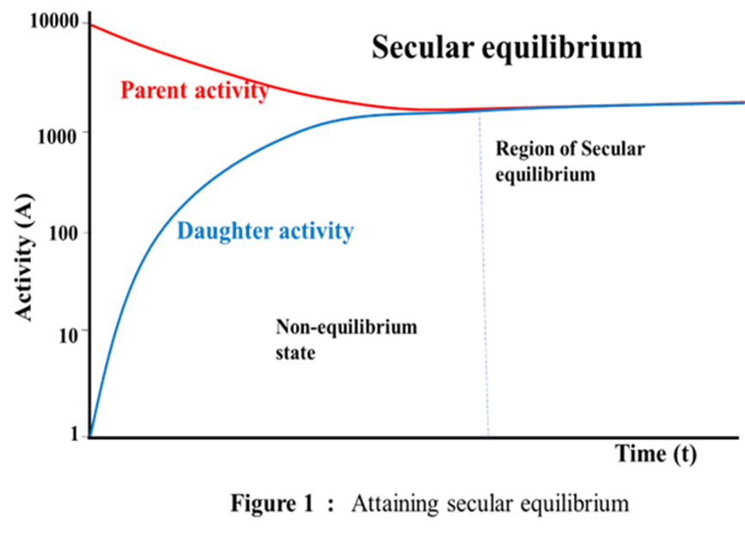
This means that the activities (or decay rate) of parent and daughter nuclei are equal. The process of growth and decay can be represented as an asymptotic state. This type of equilibrium is called the secular equilibrium and is illustrated schematically in Figure 10. Secular equilibrium is another way of saying a system has reached steady-state. And the decay rate will no longer a change in the decay rates of each nuclide. When a sample contains a long-living nuclide with a short-living daughter, the activity may grow and attain equilibrium as shown in Figure 10. For example, the activity determination of Si³² with a half-life of about 140 years, which decays through a low β⁻ energetic decay to P³² with a half-life of 14.3 days and a high-energetic β⁻ decay. Another example is decay of Ra²²⁶ to Rn²²². Radium has a half live equal to 1620 years approximately. Radon has a half life 5.8 days. A secular equilibrium between Ra²²⁶ and Rn²²² will exist after approximately seven half-lives of Rn²²². As a result, Rn²²² gas will remain in equilibrium with its parent Ra²²⁶ after a few weeks (in principle after 27 days).
Transient radioactive equilibrium: Another scenario of radioactive series decay happens when the parent nuclide N₁ decays only slightly slower than N₂. That is λ₁ < λ₂. We have equation (6) as: $N_{2}$ = $\left[\frac{{}_{1}N_{o}}{({}_{2}-{}_{1})}\right]\left[e^{-{}_{1}t}{- e}^{-{}_{2}t}\right]$
Multiplying both sides by ${}_{2 }$ $N_{2}{}_{2 }$ = $\left[\frac{{}_{1}{}_{2 }N_{o}}{({}_{2}-{}_{1})}\right]\left[e^{-{}_{1}t}{- e}^{-{}_{2}t}\right]$
But N₁ = N_{o}$e^{-{}_{1}t}$
$N_{2}{}_{2 }$ = $\left[\frac{{}_{1}{}_{2 }N_{o}}{({}_{2}-{}_{1})}\right]\left[e^{-{}_{1}t}{- e}^{-{}_{2}t}\right]$
= $\left[\frac{{}_{1}{}_{2 }N_{o}}{({}_{2}-{}_{1})}\right]e^{-{}_{1}t}\left[{1-e^{{}_{1}t} ×e}^{-{}_{2}t}\right]$
$N_{2}{}_{2 }$ = $\left[\frac{{}_{1}{}_{2 }N_{o}e^{-{}_{1}t}}{({}_{2}-{}_{1})}\right]\left[{1-e}^{({}_{1}-{}_{2)}t}\right]$
= $\left[\frac{{}_{1}{}_{2 }N_{1}}{({}_{2}-{}_{1})}\right]\left[{1-e}^{-({}_{2}-{}_{1)}t}\right]$
∴$\frac{N_{2}{}_{2}}{N_{1}{}_{1}}$ = $\left[\frac{{}_{2 }}{({}_{2}-{}_{1})}\right]\left[{1-e}^{-({}_{2}-{}_{1)}t}\right]$ (8)
For a very long time, the exponential term goes to zero such that the ratio of the activities of parent and daughter approaches a limiting constant.
$\frac{N_{2}{}_{2}}{N_{1}{}_{1}}$ = $\frac{A_{2}}{A_{1}}$ = $\left[\frac{{}_{2 }}{({}_{2}-{}_{1})}\right]$ (9)
This situation is known as transient equilibrium.
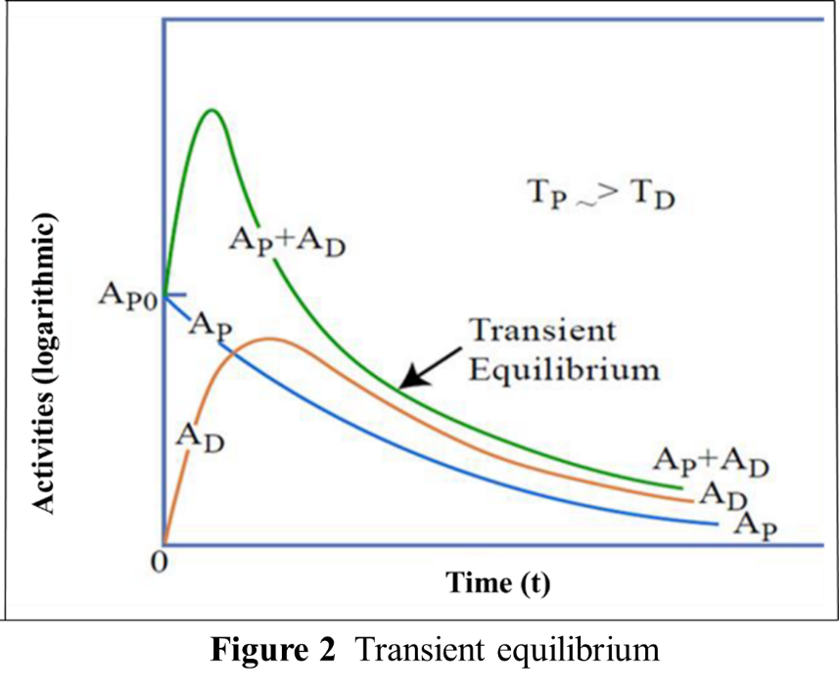
Another situation is when λ₁ > λ₂ (Half-life of the parent is shorter) where N₁ decays faster than N₂. For long time, the contribution from N₁ becomes insignificant and the abundance of N₂ rises to a maximum and decays with its characteristic decay constant.
∴$N_{2}$ = $\left[\frac{{}_{1}N_{o}}{({}_{2}-{}_{1})}\right]\left[e^{-{}_{1}t}{- e}^{-{}_{2}t}\right]$ becomes:
$N_{2}$ = $\left[\frac{{}_{1}N_{o}}{({}_{2}-{}_{1})}\right]\left[{- e}^{-{}_{2}t}\right]$
$N_{2}$ = - $\left[\frac{{}_{1}N_{o}}{({}_{2}-{}_{1})}\right]\left[{ e}^{-{}_{2}t}\right]$ (10)
For this case, the daughter nuclei decays with its own rate of decay. The parent decays faster and daughter decays at its own rate and no equilibrium take place in this case.

Carbon Dating
Radiocarbon dating (Carbon-14 dating) is a radiometric dating method, extensively used for determining the age of an object containing organic material. It uses the naturally occurring radioisotope carbon-14 (₆C¹⁴) to estimate the age of carbon-bearing materials up to about 58,000 to 62,000 years old. Natural carbon has two stable isotopes (₆C¹² and ₆C¹³). There are also trace amounts of the unstable radioisotope carbon-14 (₆C¹⁴). C¹⁴ has a relatively short half-life of 5,730 years, meaning that the fraction of carbon-14 in a sample is halved in 5,730 years due to radioactive decay to nitrogen (₇N¹⁴). Due to the constant influx of cosmic rays interacting with molecules of nitrogen in the stratosphere the decayed carbon-14 is replaced regularly.
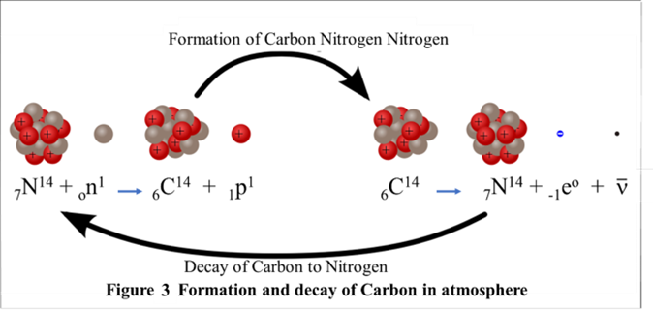
Age determination: Carbon-14 is absorbed by living organisms through processes like photosynthesis and consumption of other organisms in animals. As long as an organism is alive, it maintains a constant level of carbon-14 in its body, as it continuously exchanges carbon with its environment. When an organism dies, it stops taking in carbon from its environment. From this point forward, the carbon-14 in its body begins to decay into nitrogen-14 at the decay rate of Carbon-14 with a half-life of 5,730 years. This means that after 5,730 years, only half of the initial C¹⁴ will remain; a quarter will remain after 11,460 years; an eighth after 17,190 years; and so on. One can measure the amount of carbon-14 remaining in a sample and compare it to the initial amount of carbon-14 assumed to have been present when the organism was alive. By using the known half-life of carbon-14, they can calculate how long it has been since the death of the organism. The method is commonly used in archaeology, anthropology, and geology to determine the ages of organic remains, such as ancient bones, wood, and coal. However, it becomes less accurate for dating very very old materials because the amount of remaining carbon-14 becomes too small to measure accurately.
The decay constant of C¹⁴ will be, λ = $\frac{0.693}{T_{1/2}}$ = $\frac{0.693}{5730 y}$ ∼ 1.21× 10⁻⁴ y⁻¹.

Problem 1: Fossils from the Dead Sea Scrolls were analyzed by carbon dating. It was found that the carbon-14 present had an activity (rate of decay) of 7 disintegration/min.g in contrast to the living material exhibiting an activity of 14 d/min.g. Determine the age of the fossil?
We have, A_{t} = A_{o} e^{-λt} Therefore, 7 = 14 e^{-λt}
Therefore, ln $\frac{14}{7}$ =0.693 = λt = 1.21× 10⁻⁴ y⁻¹× t
Therefore, t = $\frac{0.693}{1.21 {10}^{-4}}$ = 5727 years (approximately)
Problem 2: The half-life of ₃₀Zn⁷¹ is 2.4 minutes. If we have 100.0 g of ₃₀Zn⁷¹ at the beginning, how much would it be left after 7.2 minutes elapsed?
Decay constant of Zn, λ = $\frac{0.693}{2.4 minuts}$
Using, A_{t} = A_{o} e^{-λt}: A_{t} =100 e^{-[}$\frac{0.693 7.2]}{2.4}$
= $\frac{100}{e^{0.693×3}}$
= $\frac{100}{8}$
= 12.5 gms
Alternate Method: Determine the number of half-lives that have passed = $\frac{7.2}{2.4}$ = 3
Isotope, ₃₀Zn⁷¹ remaining = ${\left[\frac{1}{2}\right]}^{3}×$ 100.0 gm
= $\frac{100}{8}$
= 12.5 gms
Assignment:
- A natural sample was found to the contain the following three isotopes. Calculate the activity of the sample in Bq and Ci.
1) 1x10⁶ atoms of Fe⁵⁹ of T_{1/2} = 44.51 days (λ=1.80 x 10⁻⁷s⁻¹)
- 1x10⁶ atoms of Mn⁵⁴ of T_{1/2} = 312.2 days (λ=2.57x10⁻⁸s⁻¹)
- 1x10⁶ atoms of Co⁶⁰ of T_{1/2} = 1925 days (λ=4.17x10⁻⁹s⁻¹).
- A sample of soil was found to contain 1 gram of radium-226. If the T_{1/2 of} Radium-226 = 1620 years. Calculate:
- The number of Ra²²⁶ atoms initially present
- The activity of the Ra²²⁶ in curies
- The number of Ra²²⁶ atoms that will remain after 12 years
- The time by which the activity will reach 0.01 curies
- In the thorium series, ₉₀Th²³² loses a total of six α particles and four β particles in a 10-stage radioactive decay process. What isotope is finally produced in this series?
- The activity of 1 g of ₈₈Ra²²⁶ is used to define the unity of activity of 1 Curie (Ci). The
half-life of ₈₈Ra²²⁶ is 1600 yr. What mass of a ₂₇Co⁶⁰ source (T_{1/2} = 5.26 yr), to measure
an activity of 10 Ci?

References:
1. Nuclear Physics: Experimental and Theoretical, 2nd Revised edition by H S Hans. New Academic Science, 2011.
2. Littlefield, T.A. & Thorley, N., Atomic and Nuclear Physics, 3rd edition, (ELBS and van Nostrand Reinhold Co., 1979).
3. Thayal D. C. Nuclear Physics, Himalaya Publishing House, India, 1956.

