Course title: Atomic and Nuclear Physics

Week # 10

Main Topics: Natural background radiation, radioisotopes and applications

Lecturer: Jojo Panakal John

Lecture Learning Outcomes:
At the end of the lecture, you will be able to:
- Have awareness about natural background radiation
- Understand the modes of radiation exposures to human beings
- Explain the uses and applications of major radio-isotopes used in medicine.
Natural background Radiation

Natural Radiation is unavoidable and ubiquitous ever since the creation of the universe. Natural radiation is present in the air we breathe, the water we drink, the food we eat, and in the building materials used to build our dwellings. This of course is supplemented by the man-made sources of radiation. Environmental radioactivity originates primarily from the radioactive materials naturally occurring in the biosphere. Over 340 nuclides found in the nature, of which about 80 are radioactive contributing to the environmental radiation. In general all nuclides with atomic number greater than 80 have radioactive isotopes and all isotopes of elements with atomic numbers greater than 83 are radioactive. Natural radiation can be broadly divided into two major classes namely non-ionizing radiation and ionizing radiation according to their interaction with matter. According to their sources, we can classify them as terrestrial and extraterrestrial.
Radiations those can move atoms in a molecule to rotate or cause them to vibrate, but not have enough energy to remove electrons, are "non-ionizing radiation". Visible light, ultraviolet rays, microwaves and radio waves are examples of non ionizing radiation. The ionizing radiation has enough energy to create charged ions by displacing electrons from atoms.
By the nature of the particles involved in the radiation, ionizing radiation may be grouped as directly or indirectly ionizing radiations. Charged particles (such as alpha particles and electrons) with have sufficient kinetic energy can directly disrupt the atomic structure of the interacting medium through which they pass and produce chemical and biological changes by way of displacing electrons, called directly ionizing. But electromagnetic radiations such as x-rays, gamma rays and particle like neutrons, are absorbed in the medium through which they pass giving up their energy to produce fast-moving charged particles, mainly electrons, causing indirect ionization.
Individuals on the globe are exposed to various amount of radiations every moment in the life time. Figure 1 shows average contributions from various sources of radiation to which we are exposed during a human lifetime. Approximately 82% of the radiation dose is from natural sources of which 55% is from radon which is produced in the decay of radium-226 in the soil, 8% from cosmic radiation (from the sun and stars), another 8% from terrestrial sources (radioactive material in rocks and soil), and 11% from internal sources consists primarily potassium-40, from food and water consumed in the daily diet.
Terrestrial radiation - originates mainly from earth, accounts for more than three-quarters of the overall dose from natural sources of radiation. Primordial radionuclides (radioactive isotopes which were present when the earth formed about 4.5 billion years ago) are found around the globe in pyrogenous and alluvial rock. The primordial radionuclides are usually divided into two groups:
- Non-series: These occur singly and decay directly to a stable nuclide
- Series: Those occur in decay chains and decay to a stable isotope of lead through a sequence of radio nuclides of varying half-lives.

Two primary non-series radionuclides (Potassium and Rubidium) contribute to background dose, ⁴⁰K and ⁸⁷Rb. Potassium-40 is a beta (87.3%) and gamma (10.67%) emitter and contributes to both internal and external doses. Series radionuclides are three naturally occurring decay series, headed by the radionuclides ²³⁸U, ²³⁵U, and ²³²Th. These series are commonly called the uranium series, the actinium series, and the thorium series respectively.

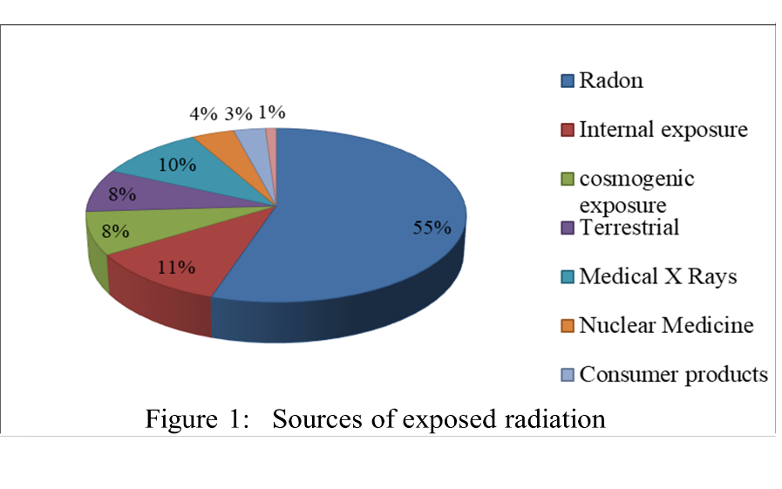
Human beings are also exposed to ionizing radiation from man-made sources. Major contribution in this class belong to medical procedures. Radiation therapy, can reach levels several fold higher than natural background radiation. Small amounts of man-made background radiation are attributable to consumer products like color televisions, smoke detectors, mining and agriculture products, such as coal, granite and potassium salt. Nuclear weapons derive their explosive power from the uncontrolled radioactive break-up of plutonium and uranium. Table 1 depicts the major anthropogenic radionuclides, their half lives and sources.

Table 1 Important anthropogenic radionuclides
Nuclide | Half-life | Main source
³H | 12.3 years | Nuclear weapon testing, fission reactors, reprocessing facilities, nuclear weapon manufacturing
¹⁴C | 5,730 years | Atmospheric nuclear weapon tests, nuclear Industry, other
³⁶C | l 3.01×10⁵ years | Atmospheric nuclear weapon tests
¹³1I | 8.04 days | Fission product from nuclear weapon tests and fission reactors, medical applications
¹²⁹I | 1.57×10⁷ years | Fission product from nuclear weapon tests and fission reactors
¹³⁷Cs | 30.17 years | Fission product from nuclear weapon tests and fission reactors
⁹⁰Sr | 28.78 years | Fission product from nuclear weapon tests and fission reactors Applications
⁹⁹Tc | 2.11×105 years | Decay product of ⁹⁹Mo, used in medical Applications
²³⁹Pu | 2.41×104 years | Produced by neutron bombardment of U²³⁸
⁸⁵Kr | 10.73 years | Nuclear weapon testing, fission reactors, reprocessing facilities, nuclear weapon manufacturing

Sources of radiation exposure
We can categorize radiation exposure to human beings as external and internal (Ingestion and inhalation) exposures according to their pathways.
Internal Radiation Exposure
Internal exposures occur by the uptake of radionuclides through one of the three routes of entry: inhalation, ingestion and skin. When airborne radioactive material is inhaled and deposited in lungs, ingested through food, drink or other consumable items of downed through skin or enter through cuts or scratches there will be internal exposure. Cosmogenic radio nuclides like ³H, ⁷Be, ²²Na and ¹⁴C contribute to internal exposure through inhalation. Internal exposure has small contributions from terrestrial radio nuclides like ²³⁵U series, ⁸⁷Rb, ¹³⁸La, ¹⁴⁷Sm, and ¹⁷⁶Lu by inhalation and ingestion. Short lived decay products of radon lead to the main contribution of exposure due to inhalation. Radio nuclides taken into the body will continue to irradiate tissues until they have been fully excreted or have fully decayed.

External Radiation Exposure
External radiation exposure results mainly due to X-rays and gamma rays (including cosmic contribution), along with neutron. Gamma radiation dose from natural sources is of particular importance because it is the largest contributor to the external dose of the world population. The level of the natural radioactivity in soil, in the surrounding environment and associated external exposure depends primarily on the geological and geographical conditions of the region.
Man-made radionuclides enter environment from human activities such as medical procedures those use radionuclides to image the body, nuclear weapon test, major nuclear accidents, radiological accidents and electricity generation that uses radioactive uranium as fuel.
Radiations originating beyond the solar system are named cosmic radiation and have enough energy to generate additional radiation as it passes through earth’s atmosphere, creating radionuclides in upper atmosphere and the air. Cosmogenic radionuclides created by cosmic radiations produced in the earth’s atmosphere are : ¹⁸F, ²⁴Ne,²²Na,²⁴Na, ²⁸Mg,²⁸Al, ³¹Si, ³²Si,³⁰P, ³²P,³³P, ³¹S,³⁵S, ³⁷S, ³⁸S, ³⁴Cl, ³⁸Cl,³⁹Cl, ³⁷Ar,³⁹Ar, ⁸⁰Kr, and ⁸⁵Kr. Concentrations of cosmogenic radio nuclides differ in the atmosphere with time and location. Variations are day-to-day, seasonal, longitude and sunspot-cycle related.
Naturally the exposure of an individual to cosmic rays is greater at higher elevations than at sea level. The total effective dose equivalent to human body by the primary cosmogenic radio nuclides has an average value of 270µSvy⁻¹.
Table 2 gives the average annual effective dose (mSvy⁻¹) from different natural sources to the world population reported by United Nations Scientific Committee on the Effects of Atomic Radiation (UNSCEAR). The average annual effective dose equivalent from all natural sources combined is approximately 3 mSvy⁻¹ ie 0.39 mSvy⁻¹ is due to cosmic radiation ,0.48 mSvy⁻¹ due to terrestrial gamma rays ,0.29 mSvy⁻¹ due to ingestion and 1.26 mSvy⁻¹ due to inhalation.

Table 2 Public exposure to natural radiation (UNSCEAR 2008)
Source of exposure |  | Annual effective dose (mSvy⁻¹)
 |  | Average | Range
Cosmic radiation | Directly ionizing and photon -component  Neutron component  Cosmogenic radio nuclides | 0.28  0.10  0.01
Cosmic radiation | Total cosmic and cosmogenic | 0.39 | 0.3-1.0ª
External terrestrial radiation | Outdoors  Indoors | 0.07  0.41
External terrestrial radiation | Total external terrestrial radiation | 0.48 | 0.3-1.0^{b}
Inhalation | Uranium and thorium series  Radon (²²²Rn)  Thoron (²²⁰Rn) | 0.006  1.15  0.1
Inhalation | Total inhalation exposure | 1.26 | 0.2-10^{c}
Ingestion | ⁴⁰K  Uranium and thorium series | 0.17  0.12
Ingestion | Total ingestion exposure | 0.29 | 0.2-1.0^{d}
Total |  | 2.42 | 1.0-13
ª Range from sea level to high ground elevation.
^{b} Depending on radionuclide composition of soil and building material.
^{c} Depending on indoor accumulation of Radon gas.
^{d} Depending on radionuclide composition of foods and drinking water

Biological effects of radiation
When an ionizing radiation passes through a tissue, water molecules in it becomes ionized. Typically, tissues contain about 80% water. As a result of the interaction of radiations the water molecule become H₂O⁺, and this ion radical reacts with another water molecule to form the highly reactive hydroxyl radical (OH⁻) radical. OH⁻ is a highly reactive free radical and can diffuse through the cell to reach a critical target DNA. It is one of the main contributors of the nucleus of the cell, which controls structure and functions of a cell.
Radiation damage may occur in DNA in two ways. (1) Radiation may directly ionize the DNA producing chemical change. (2) DNA may change indirectly, through interaction with the free radicals produced in the water molecule. This chemical change may lead to harmful health effects like cancer, genetic defects etc.
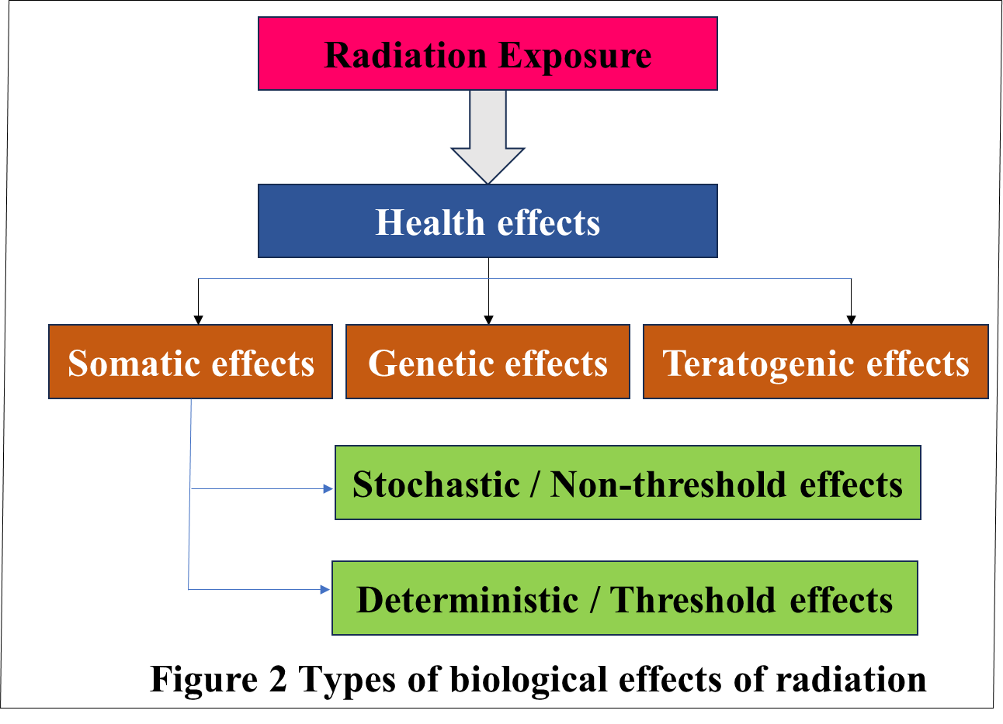
Biological effects of radiation are dose related. At certain radiation dose, human cells are so severely damaged resulting in “somatic effects”. These effects observe when the exposure is above 1Gy (1Gray is equivalent to one Joule per kilogram). At lower doses, the cell can repair the damage by itself and survive. If the repair is not efficacious, it can damage the reproductive cells which show the genetic defects in the descendants called “genetic effects”. “Teratogenic effects” are observed in children who are exposed in the fetus or embryonic stage. Effects like cancer and congenital malformation are due to the exposure above 0.02 Gy. Types of biological effects of radiation are briefed in the Figure 2.
Generally, there are two broad classes of somatic effects of radiation: “deterministic effects” (Threshold) and “stochastic effects” (non-Threshold). Deterministic effects occur only if the dose or the dose rate is greater than some threshold.
An increase of risk may occur due to the low dose over a long period of exposure due to the cell damage called “stochastic effects”. Stochastic effects often show up years after exposure. Stochastic effects increase the probability of occurrence with increase in dose. It is assumed that there is no threshold dose value for these effects.
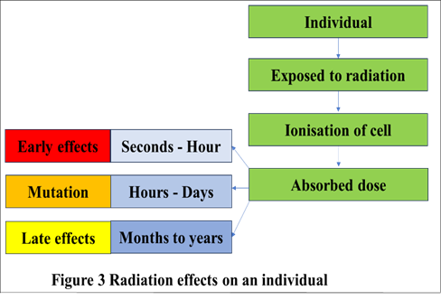
The “deterministic effects” occur at high doses of radiation received in a short period of time and the change is observable soon after exposure and severity depend on the absorbed dose. These effects include radiation sickness and death, cataracts, sterility, loss of hair, reduced thyroid function and skin burns. The radiation damage occurs soon after the exposure called “acute effects” and the delayed radiation damage concerns the “late effect”.

Uses of radioisotopes in industry and research

Natural and artificially produced radioisotopes have numerous applications in industry as well as in research. Industries make use of the radiations which can be employed for various applications.
Applications in Industry
- Radiography: Radioisotopes, such as iridium-192 and cobalt-60, are used for non-destructive testing of machines and machine parts. Radioisotopes can check the integrity and perfection of machine parts and joints in machines and structures by exposing them to radiation and capturing the resulting images using detectors.
- Quality Control: Radioisotopes are being used to monitor and control various processes in industries. Radioisotope gauges can determine the thickness, density, or composition of materials precisely during production ensuring quality and consistency of the product.
- Radioactive tracers: Radioactive tracers are used to track the transport mechanism of substances in industrial and agriculture processes. This method can investigate fluid flow rate and dynamics, identifying obstructions, and even optimize chemical reactions. Tracers are very important in the study of micronutrient uptake and biomechanisms in modern agriculture. Radioisotopes like technetium-99 are also used as tracers in medical imaging.
- Sterilization: Radioisotopes, mainly cobalt-60 and cesium-137, are used for the sterilization of medical equipment, food products, and packaging materials. They effectively kill bacteria, pathogens, and insects without the need for heat or use of harmful chemicals.
- Petrochemical exploration: Radioactive sources are used widely in oil well logging. In oil and gas industry radioactive tracers are used to measure properties of rock formations and other materials deep within earth. The information helps in locating and evaluating hydrocarbon reserves during drilling operations.
Applications in research
- Nuclear Physics: Applications of radioisotopes play a vivacious role in nuclear physics experiments. Radioisotopes are used to investigate the characteristics of atomic nuclei, dynamics of nuclear reactions, and study fundamental interactions between subatomic particles. Particle accelerators and heavy ion generators produce beams of high-energy particles for the research in Nuclear Physics.
- Carbon Dating: Radioactive carbon-14 is used in archaeology and geology to determine the age of organic materials. The method is being widely used to determine the age of fossils, ancient artifacts, and geological samples. The content of carbon-14 remaining in the sample can provide information about the age of the materials.
- Development of nuclear medicines: Radioisotopes are used for medical imaging and diagnosis in techniques like Single Photon Emission Computed Tomography (SPECT) and Positron Emission Tomography (PET). Radioactive tracers are introduced into the body to visualize organ function, detect diseases, and monitor treatment effectiveness.
- Environmental Monitoring: Radioisotopes can be used to trace and study the movement of pollutants and chemicals in the environment. This is important for assessing the impact of industrial processes and identifying sources of contamination.

References:

UNSCEAR 2000. United Nations Scientific Committee on the Effects of Atomic Radiation, UNSCEAR 2000 Report to the General Assembly, with Scientific Annexes VOLUME I: SOURCES

UNSCEAR 2008. Sources of ionising radiations, United Nations Scientific Committee on the Effects of Atomic Radiation, Report to the General Assembly.

NCRP Report No. 160, Ionizing Radiation Exposure of the Population of the United States.
- Information-library, World Nuclear Association, England and Wales, London, United Kingdom.

