Course title: Atomic and Nuclear Physics

Week # 11

Main Topics: Radiation detection, ionization and excitations

Lecturer: Jojo Panakal John

Lecture Learning Outcomes:
At the end of the lecture, you will be able to:
- Understand the methods of radiation detection
- Explain the mechanism of ionization due to radiations
- Describe excitations of atoms
Radiation measurement

Radiation can be detected using a variety of methods and instruments. Primarily, the process of detection and measurement is based on the interaction of radiation with matter. The measuring method and device dependent upon the type of radiation and the type of measurement needed. The three basic approaches employed involve the use of survey instruments, liquid scintillation counters and dosimetry.
The principles of nuclear radiation detection can be broadly subdivided into three groups:
(a) Methods based on the detection of free charge carriers: During the passage of an ionizing radiation through a medium (solid, liquid or gas) both positive and negative ions are produced. Since ionizing radiation comprises, charged particles moving with high velocity, the method is primarily applicable in the case of charged particle detection. Uncharged radiation like gamma rays or neutrons can also be detected by instruments based on this method since they usually eject charged particles which then cause ionization in the medium.
Instruments based on this method include ionization chambers, proportional counters, Geiger-Muller counters and semi-conductor detectors.
(b) Methods based on light sensing: These are also applicable for both charged particle detection and detection of uncharged radiation.
Instruments based or this method includes scintillation counters and Cerenkov detectors.
(c) Methods based on the visualization of the tracks of the radiation: These are applicable for the detection of charged particles and include instruments like the Wilson cloud chamber, bubble chamber, nuclear emulsion plates, spark chamber and solid-state track detectors. Hybrid detectors combining both ionization method and light sensing method have been used for special purposes.
Detectors of ionizing radiation consist of two inter-connected parts. The first part consists of a sensitive material (gaseous, liquid or solid), that experiences changes when exposed to radiation. The other part is a device that converts these changes into measurable signals.

Ionisation and excitation of gases due to radiations
When an atomic radiation is allowed to pass through a gaseous medium, the radiation may interact with the atoms of the gas. Due to the interaction, atomic electrons may get energy from the radiation and can jump from lower energy level to a higher atomic energy level. Excitation is the result of energy given to an electron so that it can mode to a higher energy level. The electron remains in the atom and orbit the nucleus, unless the electron energy level is greater than the ionisation energy level of the atom.
If enough energy given to the electron is sufficiently high to remove it from the atom, ionisation occurs. In gas filled tubes interaction of radiations cause electrons to become excited and if energy is enough atom becomes ionised. During excitation when electrons return to the ground state, they lose energy and the energy is emitted as a photon, normally a uv radiation.
During ionisation, if the emitted electron has high energy, these electrons can further interact with the atoms in the medium to make further ionisations called the secondary ionisations. In gas filled tubes, the emitted electros may further get accelerated depending on the potential applied between the electrodes. The accelerated electrons can produce secondary, tertiary and higher ionisations resulting in what is called ‘avalanche’. Depending on the nature of the gas and its ionisation potential, number ions produced by a radiation will vary.

Gas-Filled Detector

Gas filled detectors are radiation detection instruments used in various applications including radiation protection applications. The instruments are used to detect the presence of ionizing particles and to measure them. These detectors are designed to measure the current resulting from the ionization produced when an incident particle traverses through the medium. The kinetic energy of particles namely charged particles, gamma rays etc are sufficient to produce ionisation are utilised. Ionizing radiations can knock electrons from an atom of the gas filled in the detector tube. The ions and electrons produced produce a current pulse in the external circuit indicating the passage of the ionising radiation through the gaseous medium.
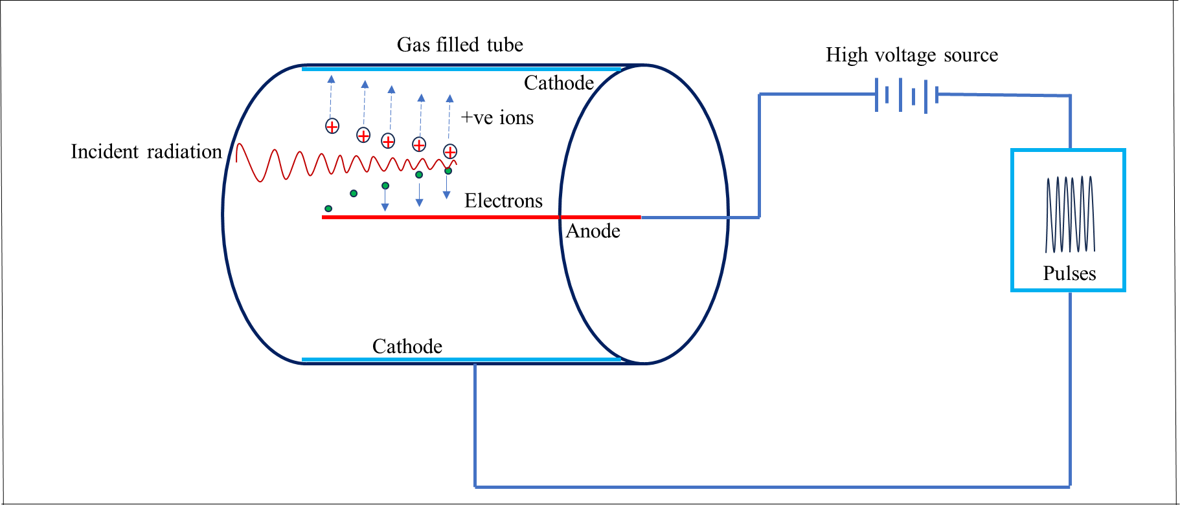
Figure 1 Working of a gas filled tube

The gaseous detector consists of a chamber filled with a suitable gas (air or a gas) filled at a sub-atmospheric pressure that can be easily ionized. The most widely used detectors are based on the ionisation produced when a charged particle or radiation passes through the gas. The gaseous medium should be chemically stable (or inert) so that the moving ionization electrons are not easily captured by the molecules of that medium. It should have a low ionization potential (I) value to maximize the amount of ionization produced per energy deposited by any incident particle and should not be very sensitive to radiation damage so that its response to incident particles does not change markedly with use.

Typically, argon and helium are the gas filled in the detector tube. When neutrons are to be detected, boron-trifluoride (BF₃) is utilized. Gaseous ionization detectors are widely used to measure alpha and beta particles, neutrons, and gamma rays. The detectors operate in the ionization, proportional, and Geiger-Mueller regions, with an arrangement most sensitive to the measured radiation type. Neutron detectors utilize ionization chambers or proportional counters of appropriate design.

Basic Principle of Gas filled Detectors
The relationship between the applied voltage and pulse height in a detector is very intricate. Pulse height of the output signal and the number of ion pairs collected at the electrodes are directly related. Depending on the applied voltages the response of the detectors varies widely depending upon the detector geometry, gas type, and pressure. The figure 2 schematically indicates the different applied voltage regions and the pulse heights obtained for alpha, beta, and gamma rays. There are six distinct operating regions, where three (ionization, proportional, and Geiger-Mueller region) are useful for detection of ionizing radiations. The curve for alpha particles is higher than the beta and gamma curves from the recombination region. This disparity continues till the voltage reaches the GM region.

The figure 2 schematically indicates different voltage regions for alpha, beta, and gamma rays. Therefore, more current is produced in the ion chamber by alpha than beta and gamma rays. Alpha particles produce more current in the proportional counting region than beta. Nevertheless, by the nature of proportional counting, it is possible to differentiate alpha, beta and gamma pulses. In the Geiger Muller region, we cannot differentiate between alpha and beta as any single ionization, in the gas filled tube there results a current output.

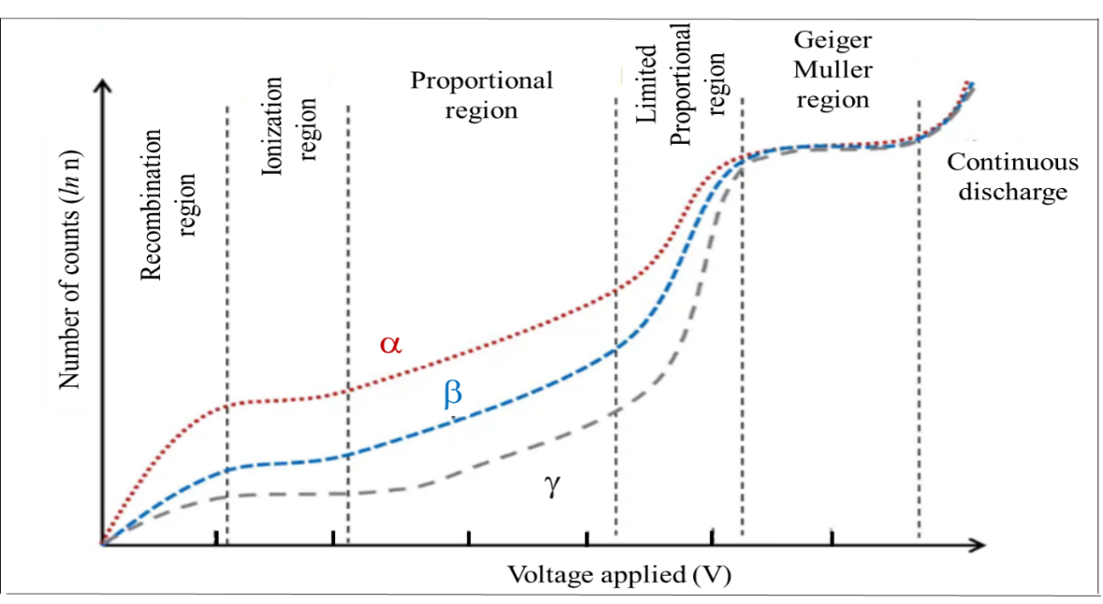

Figure 2 Response of gas filled tubes for varying potential
- Recombination Region. The electric field applied in this region is not large enough to accelerate electrons and ions produced through primary ionisation to be collected by the electrodes. The electrons and ions produced by the incoming radiations can recombine soon after they are produced, and only a small fraction of the produced electrons and ions reach their respective electrodes. As the detector voltage increases an increasing fraction of the ions produced will reach the electrodes. This increase continues until a specific voltage is attained. The operating voltage range where this occurs is referred to as the recombination region. Detectors are not operated in this region because neither the number of recombination nor the number of ion pairs initially produced can be determined from the pulse height.
- Ionization Region. In ionization region, an increase in voltage does not cause a substantial increase in the number of ion pairs collected. The number of ions collected by the electrodes equals the number of primary ionisations produced by the incident radiation. It is dependent on the type and energy of the particles or rays in the incident radiation. Therefore, in this region, the curve is flat. Here the voltage applied is higher than not ion pairs can recombine. At the same time, the voltage is not high enough to produce gas secondary ionizations. Technically it is said that no gas multiplication occurs, and their current is independent of the applied voltage. This operation is preferred for high radiation dose rates as they have no “dead time”. That is the detector is sensitive although the operation.
- Proportional Region. In the proportional region, increasing the voltage provides the primary electrons with sufficient acceleration and energy to ionize additional atoms of the medium (secondary ionisation) causing ‘gas amplification’. The number of ion pairs collected divided by the number of ion pairs produced by the primary ionization provides the gas amplification factor (denoted by A). These secondary ions formed are proportional to the number of primary events. It is very important because the primary ionization is dependent on the type and energy of the particles or rays in the intercepted radiation field. At a constant voltage, the gas amplification factor does not change. Proportional counters are very sensitive to low levels of radiation and are capable of particle identification and energy measurement of incident particles.
- Limited Proportional Region. In the limited proportional region, the gas amplification factor does not vary proportionally to the applied voltage. Additional ionizations and nonlinear effects results in disproportional output signal. Free electrons are much lighter than the positive ions; thus, they are drawn toward the positive central electrode much faster than the positive ions are drawn to the chamber wall. This region is not used for detection or measurement of radiations.
- Geiger-Mueller Region. In the Geiger-Mueller region, the voltage and thus the electric field are so high that secondary avalanches take place. The avalanches trigger and propagate although the gas filled tube. In other words, entire Geiger tube is ionised in the process resulting in a high signal (Amplification factor up to 10¹⁰) output by these avalanches. The signal height will be independent of the primary ionization and energy of the detected radiation. Geiger-Mueller counter can detect gamma rays and all charged particles that can enter the detector volume. Since the pulse hight is high Geiger counters usually require no signal amplifiers. As with proportional counters, there is no energy resolution since the output signal is independent of original ionization.
- Continuous Discharge Region. When the applied voltage exceeds beyond GM region, the electric field produces continuous discharge in the tube and the gas filled tube is no longer sensitive to any incident ionization. Therefore, this region is not used for the detection or measurement of radiations.
Therefore, there are three basic types of gaseous ionization detectors, which are named according to the voltage applied to the detector:
- ionization chambers,
- proportional counters and
- Geiger-Müller tubes.
Ionization chambers can be operated in current or pulse mode, while Proportional counters or Geiger counters work in pulse mode. All these detectors are used both for radioactivity measurements as well as for radioactive dose measurements. The dose can be obtained with knowledge of energy needed for ionisation of the gas used in the detector.
Geiger Muller Counter
In its simplest form, the G M counter consists of a cylindrical sealed glass tube enclosing a coaxial metal cylinder serving as the cathode, as shown in the figure 1. Along the axis of the cylinder, there is a very thin metal wire, usually of tungsten wire of diameter 0.1 mm, which acts as the anode. The tube is filled with an inert gas like argon mixed with the vapour of ethyl alcohol (quenching agent) in the ratio of 10:1 at a total pressure of ~ 10cm of mercury. The voltage between the electrodes is between 300 to 1000volts typically. In certain cases, neon gas mixed with traces of a halogen (Bromine) as the quenching vapour is used. The ionizing radiation enter the counter through the glass wall of the counter. For counting less penetrating radiations ( α or β-rays) a thin window made of mica or other material must be used.
In the Geiger tube, a single ionization produced initially produces repeated avalanches within a very short time. For a given voltage on the anode, the voltage pulse produced at the anode is determined by the space charge collected around the anode wire to stop the discharge. It does not depend on the size of the primary ionization and is determined by the applied voltage. The pulse size thus depends upon the excess voltage above the threshold for initiating the Geiger discharge. The voltage pulse produced at the anode rises very rapidly during the time the electrons are collected. The positive ions being heavy move away slowly towards the cathode. In the process, u.v. photons liberated in the tube may cause repeated Geiger discharges which must be quenched for the counter to operate properly.
For this purpose, to quench the repeated discharges, the quenching agent in the tube (ethyl alcohol), neutralize the ions by collisions and the neutral alcohol molecules become ionized in the process. This happens because ethyl alcohol has a lower ionization potential than the inert gas in the tube. In the halogen quenched counters, the halogen molecules (e.g., Br₂) dissociate into the halogen atoms which again recombine. So these counters have very long lives.
Scintillation (NaI) Probe / Survey Meter
A scintillation detector is based on the detection of light flashes produced when a radiation interacts with the detecting substances (like NaI). These light flashes are amplified by a photomultiplier tube. These scintillating materials are encased in a magnetically shielded, light tight aluminum shell. An incident gamma ray passes through the detector scintillation crystal, converts the gamma energy into light (scintillates). The emitted light strikes the photocathode which produces electrons. These electrons result in an amplification and the electric pulse which can be scaled and analysed.
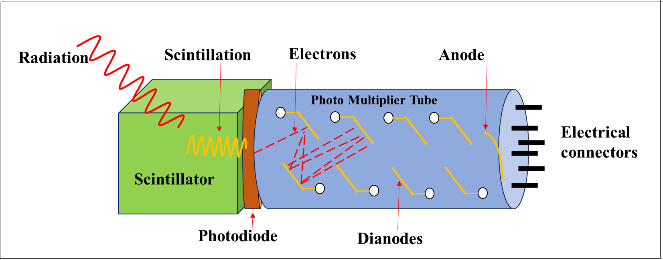
Figure 3 Schematic diagram of a scintillation detector coupled to a photomultiplier tube.
When a high energy radiation passes through the crystal lattice, it transfers a small fraction of its energy to an electron in the valence band as a result of which the latter will be raised to the conduction band which is normally empty in an insulator. The electron now moves through the crystal till it comes across an electron trap or a crystal imperfection due either to a structural defect in the crystal or due to an added impurity. The hole left in the valence band (which behaves like a positively charged particle) also moves through the lattice. The electron trapped in the conduction band may subsequently return to the lower valence band. In the process, light is emitted in the form of fluorescence radiation. The whole process occurs in times of the order of 10⁻⁸ s or less.
Semiconductor detectors
A semiconductor detector is a device that uses a semiconductor (usually silicon or germanium) to measure the effect of incident charged particles or photons. A semiconductor detector is a silicon or Germanium diode of the p-n type operated in the reverse bias mode. As the applied voltage is in the same direction as the diffusion field potential, the resultant potential drop across the transition region is increased. The width of the depletion layer further increases. A very high field of the order of 10,000 V/cm is developed at the diode Junction.
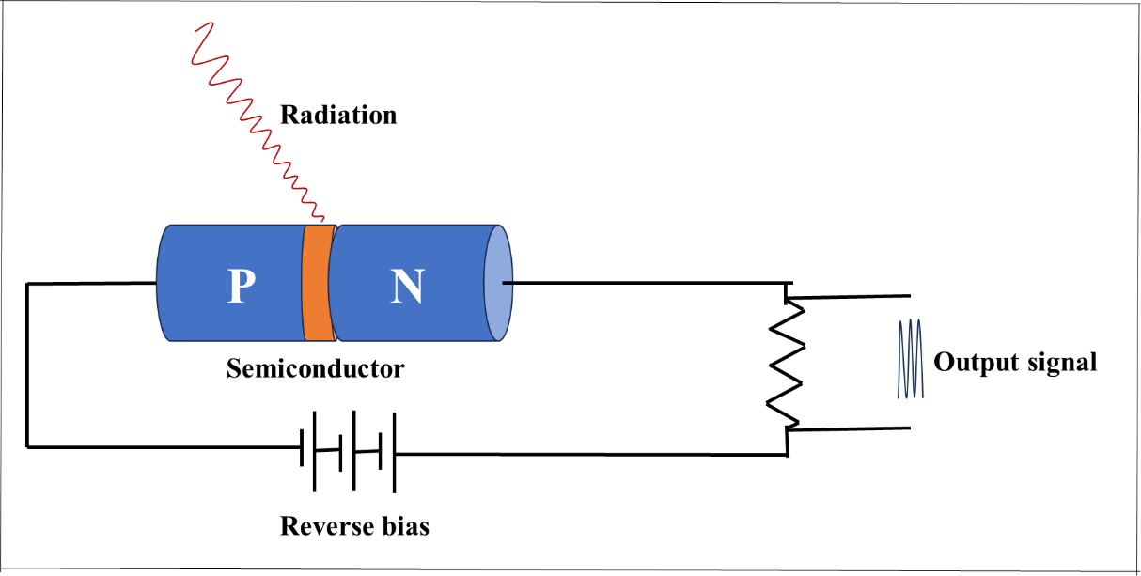

Figure 4 Semiconductor detector

Suppose an α particle is absorbed in the p-n junction, it will lose nearly all its energy in producing electron-hole pairs in the semiconductor. The high electric field in this region sweeps the electrons towards the positive side and holds them toward the negative side. They move with the drift velocities of the order of 10⁻⁵ ms⁻¹approximately thereby registering a pulse of the order of a millivolt with a very short rise time of the order of 10⁻⁹ to 10⁻¹⁰ seconds. The rising pulse appears across the resistance, R.

- Knoll, Glenn F., Radiation Detection and Measurement 4th Edition, Wiley, 8/2010. ISBN-13: 978-0470131480.
- Stabin, Michael G., Radiation Protection and Dosimetry: An Introduction to Health Physics, Springer, 10/2010. ISBN-13: 978-1441923912.
- Martin, James E., Physics for Radiation Protection 3rd Edition, Wiley-VCH, 4/2013. ISBN-13: 978-3527411764.
- U.S.NRC, NUCLEAR REACTOR CONCEPTS
- U.S. Department of Energy, Instrumantation and Control. DOE Fundamentals Handbook, Volume 2 of 2. June 1992.

