Course title: Atomic and Nuclear Physics

Week # 14

Main Topics: Short and long terms effects of radiation

Lecturer: Jojo Panakal John

Lecture Learning Outcomes:
At the end of the lecture, you will be able to:
- Understand health effects of radiation
- Explain pathways of radiation exposure
- Describe the short- and long-term effects of radiation
Health effects
Ionizing radiations has enough energy to remove tightly bound electrons from atoms, leading to the formation of ions. This process can damage living tissues and cells. The health effects of ionizing radiation depend on factors such as the type of radiation, the dose received, and the duration of exposure. There are two main types of ionizing radiation: electromagnetic (e.g., X-rays and gamma rays) and particulate (e.g., alpha and beta particles).

Acute Radiation Syndrome (ARS) is a collection of health effects that occur within a short period following high-dose exposure to ionizing radiation. The severity of ARS depends on the dose received. Symptoms may include nausea, vomiting, diarrhea, weakness, and, in severe cases, damage to the central nervous system.

Cancer is a long-term effect of chronic exposure to ionizing radiation. Prolonged exposure to even low doses of ionizing radiation increases the risk of developing cancer, as it can damage DNA and lead to mutations. The types of cancer associated with radiation exposure include leukemia, thyroid cancer, breast cancer, lung cancer, and others.

Genetic effects can also result from the radiation exposure. Ionizing radiation can cause mutations in the DNA of germ cells (sperm and egg cells), which may be passed on to forthcoming generations. However, the risk of transmissible effects from radiation exposure is generally much lower than the risk of cancer.

Long-Term Tissue Effects or chronic exposure to ionizing radiation may lead to long-term damage to organs and tissues. For example, exposure to radiation can damage blood vessels, leading to cardiovascular disease. The thyroid gland is particularly sensitive to radiation, and exposure can result in thyroid disorders.

Cataract is one of the radiation effects effecting eyes. High doses of ionizing radiation, particularly to the eyes, can increase the risk of developing cataracts.

It's important to note that the cells in human body can repair radiation damage to a good extent. The effects of radiation exposure may vary based on individual factors such as age, overall health, and genetic susceptibility. The use of ionizing radiation in medical procedures is typically carefully controlled to minimize exposure, and safety measures are implemented in occupational settings where radiation is used. Public exposure to ionizing radiation is also regulated to ensure that it remains within safe limits.

Excessive exposure to radiation might damage living cells, tissues and organs, depending on the amount of radiation received. The amount of the probable impairment depends on several factors. This includes the type of radiation, the sensitivity of the affected tissues and organs, the length of exposure, the route of exposure, the radioactive nuclide involved and the characteristics of the exposed individual such as age, gender and basic health conditions.

The risk of developing adverse health impacts depends primarily on the amount of energy left by the radiation in the tissue or organ, quantified by the dose. The higher the dose, the higher the risk of hazardous effects. If the radiation dose is low but delivered over a long period of time, the risk is significantly lower because the damage to cells and tissues will be repaired by the biomechanisms.

In the event of a nuclear emergency, first responders will be the workers of the affected nuclear power plant facility. They are at a larger risk of being exposed to high radiation doses high enough to cause acute effects. In the such a case, the general population may not be exposed to doses high enough to cause the deleterious effects of an acute exposure.
Children are more likely to get effected to develop adverse health effects from radiation exposure. This is because the children have their cells dividing more rapidly than adults. Nascent cells are more sensitive to radiation and vulnerable to damage, leading to cancer in future. Their longer lifespan ahead gives more time for cancers to develop and manifest.

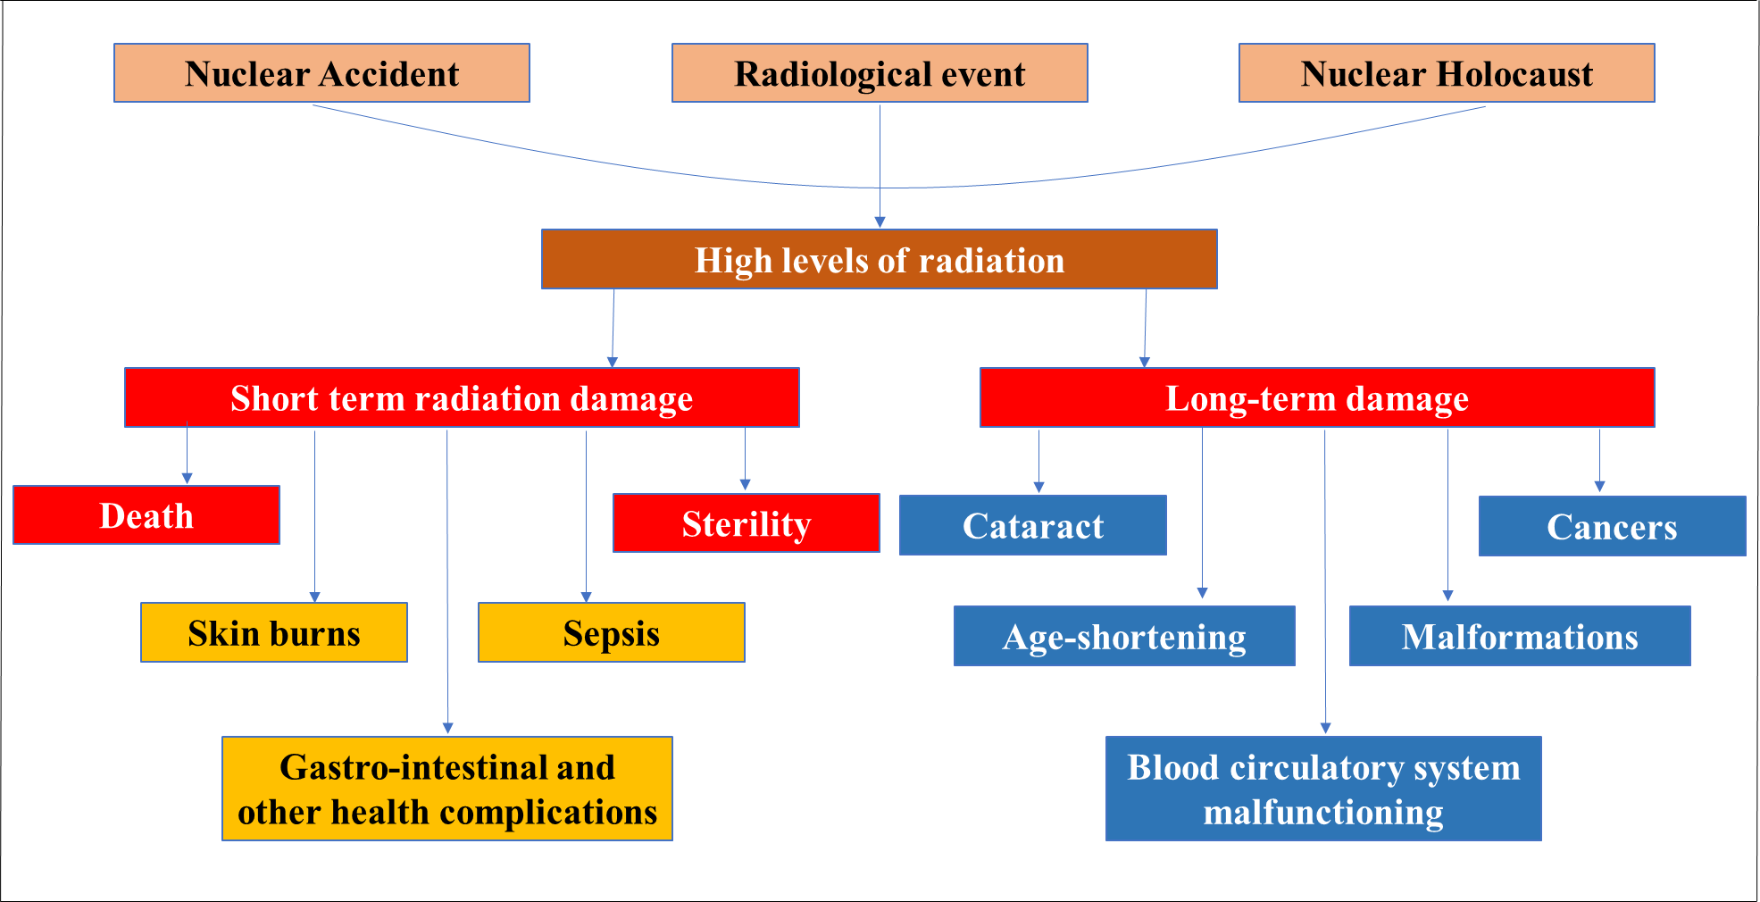
Figure 1 High dose radiation exposure pathways and probable health effects

Major pathways of radiation exposure
According to the nature of exposure, the major pathways of radiation exposure are ‘external’ and ‘internal’ exposures. In external or direct radiation exposure, radiations or radioactive substances come in contact with the skin and eye. Internal exposure can be further classified as inhalation and ingestion exposures. Exposure due to inhalation occurs through breathing radioactive gases, smoke, dust or particles into the lungs). Exposure through ingestion is due to eating or drinking substances that contain radioactive elements.
At the same time, according to the sources, the major pathways of radiation exposure can be classified as natural and man-made (artificial) sources.
Natural sources, comprises of terrestrial and extra-terrestrial sources. Terrestrial sources of radiation are due to the radioactive materials present in the earth’s crust, soil, rocks, and building materials emit radiation. Extraterrestrial sources of cosmic radiations originate from outer space, cosmic rays interact with the Earth's atmosphere, leading to exposure at ground level.
Major component of the artificial or man-made sources of radiation is due to medical procedures for diagnostics and treatments. Diagnostic Imaging methods like X-rays, CT scans, fluoroscopy, and nuclear medicine procedures involve ionizing radiation used for diagnostic purposes. Exposure depends on the type and frequency of these procedures. Radiation therapy, is useed in cancer treatment, focused radiation is used to destroy cancerous cells, leading to potential exposure during treatment.
Apart from medical applications, other man-made Sources also contribute to the radiation exposure to living objects. Emissions from Nuclear Power Plants, nuclear fallout due to accidental leaks or routine operations of nuclear installations can release radiation into the environment. Certain industries like mining, manufacturing, and research involving radioactive materials can result in elevated radiation exposure to the public.
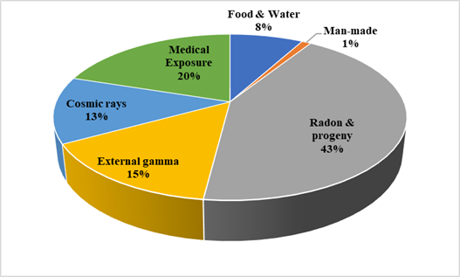
Figure 2 Typical nature of radiation exposure to human beings from various sources
Building Materials, ceramics, and consumer products (like smoke detectors containing radioactive materials) emit low levels of radiation. Radioactive Contamination of food and water due to nuclear accidents or nuclear testing can lead to ingestion of radioactive materials, causing exposure. Above all, workers in radiation-related activities in nuclear power plants, radiographers, nuclear medicine technicians, and researchers handling radioactive materials face occupational exposure.
Each of these pathways varies in the extent of exposure and potential health risks associated with radiation. Monitoring and limiting exposure to radiation sources, whether natural or man-made, are crucial to minimizing health risks. Regulatory bodies and safety measures exist to mitigate exposure in various industries and settings.
The following table summarises the probable health effects of ionising radiation to human beings. The health effects listed in Table 1 are for a radiation dose to the entire body.
Table 1. Probable effects of radiation when the whole body is exposed to certain dose rates
Dose rates (mSv) | Period | Probable effects
0 - 50 | Over a long period | we don’t expect observable health effects
50 - 100 | Short or long period | we don’t expect observable health effects.
100 - 500 | Short or long period | >100 mSv chances of getting cancer
500 - 1,000 | Short period | Above 500 mSv we may see some changes in blood cells, but the blood system quickly recovers.
1,000 - 2,000 | In a short period  over a long period | Will cause nausea and fatigue. will Increase chances of getting cancer.
2,000 - 3,000 | In a short period | Will cause nausea and vomiting within 24-48 hours.  Medical attention should be sought.
3,000 - 5,000 | In a short period | Will cause nausea, vomiting, and diarrhea within hours.  Loss of hair and appetite occurs within a week.  Medical attention must be sought for survival  Half of the people exposed to radiation at this level will die if they receive no medical attention.
5,000 - 12,000 | In a short period. | Will likely lead to death within a few days
>100,000 | In a short period will lead to | Death within a few hours.

If the radiation is given to a smaller area of the body, say a specific organ, there are other effects that may occur, but illness or death is not expected.
Table 2. Probable effects of radiation when a specific organ is exposed to certain dose rates
Dose rates (mSv) | Organ | Probable effects
400 or more | Locally to the eyes | Can cause cataracts
1,000 - 5,000 or more | For a section of the body that has hair. | Can cause hair loss
2,000 or more | Skin | Locally to the skin can cause skin reddening (similar to a sunburn).
10,000 or more | Intestinal lining, | Breakdown of the intestine leading to internal bleeding, which can lead to illness and death when the dose is to the abdomen.
>15,000 mSv or more. | skin | skin reddening and blistering

References:
- International Commission on Radiological Protection (ICRP), https://www.icrp.org/
- United states Nuclear regulatory commission (USNRC), Exposure (radiation) | NRC.gov
- World Health Organisation Radiation and health (who.int)
- Let’s talk about radiation Effects of Radiation (radiationanswers.org)

