Feasibility Study

Lecture 8: Technical, Manufacturing (Production), or Operations Study Part 2

Lecturer: Fidela R. Balajadia
Associate Professor 2
University of the Assumption, Philippines

Lecture Learning Objectives:
At the end of the lecture, you will be able to:
- Discuss the product(s) or service(s) and how they will be produced using the proponent’s own choice of location, production size (capacity) and layout

- Identify the machineries and equipment, raw materials, and manpower requirements as
well as a detailed civil engineering and lay-outing of the project

- Discuss project’s utilities, waste management methods and the production system’s
designs and forms

- Prepare the total production cost based on the actual business
The Technical Study identifies whether the process is capable of
producing the product at the desired quality level with reasonable cost. To accomplish this, a detailed study of the following is essential. Where applicable and necessary, charts, plans, drawings, and layouts, drawn to scale, must be presented.
Machinery, equipment, and tools
This section of the technical study presents the type of machinery, equipment and related auxiliary tools needed in producing the goods, including the estimated acquisition and maintenance cost. It answers the following questions:
- What is the model of the machinery and related equipment to be purchased, including the required specifications?
- Who are the suppliers of these machineries and equipment?
- Will the business buy a brand-new unit or a secondhand unit?
- How much is the total acquisition cost?
Following are the factors to be considered in selecting the necessary machinery
and equipment:
- Plant capacity and size of the machine
- Model of the machinery and equipment
- Production within the required time
- Availability of spare parts and repair service
- Cost and terms of payment
- Plant location and layout
This section usually consists of schedules that show the different available machinery and
equipment with the following additional information:
- Machine capacity
- Model and specifications
- Name of supplier
- Cost
Page 01
- Terms of payment
- Estimated productive life
- Annual depreciation

Building structures and other facilities

This section on buildings and other structures that need to be constructed should answer the following questions:

- What is the size of the building to be constructed?
- What type of building will be constructed?
- Will it be a two-storey building?
- How much is the estimated cost?

Buildings and related structures to be constructed include:
- An administrative building
- A manufacturing plant
- Warehouse or storage facilities
- Road network and pathways
- A drainage and disposal system
- A parking space
The different schedules should be included in this section, in tabular form, showing the following information:
- Estimated cost of building structures and land improvement
- Estimated useful life
- Estimated annual depreciation
Raw materials requirement

This section on the different types of raw materials or ingredients needed in manufacturing the product should answer the following questions:
- What are the raw materials needed to produce the goods?
- Who are the existing and prospective suppliers of these raw materials?
- Are there enough available raw materials for the product?
- What is the proximity of the source of raw materials to the processing plant?
- Are there raw materials to be imported?
- Are there alternative raw materials?
- What is the estimated cost of the raw materials?
- What is the trend in the world market in terms of raw materials for the proposed product?

Page 02
Direct labor requirement

One important concern that must be addressed squarely in a feasibility study is the availability of skilled workers. This section presents the direct labor requirements to produce the goods or to render the proposed services. It should answer the following questions:

- What specific direct labor requirements are needed to produce the goods or deliver the services?
- Are there enough direct laborers to produce the goods?
- How long will it take, in terms of the number of hours, to produce the goods?
- How many workers are involved to produce the goods?
- How much is the wage of every worker per day or per hour?
- How much is the prevailing daily wage in the community?
- How much is the minimum wage in the region where the business is located?

Utilities and other overhead requirements

This section on utilities and other overhead costs to manufacture the goods addresses the following questions:

- Who are the utility providers (light and water)?
- How much is the expected consumption for utilities?
- Are there ways to reduce utility consumption?
- What are the other types of overhead costs that have a material effect on the manufacture of the product?

Waste disposal system

This section describes the waste disposal system that may be adopted based on the type of waste it produces. However, it does not focus on the social responsibility of the business towards the community. Rather, it emphasizes the estimated cost that may be incurred relative to the disposal of waste matter.

This section of the technical study should answer the following questions:
- What type of waste disposal system should be adopted?
- What is the prevalent practice of the community in disposing of waste or trash?
- What is the expected volume of waste to be produced by the plant in a month?
- Is the industrial waste to be produced by the business recyclable?
- How much is the estimated cost of disposing the garbage?
Page 03

Total Production Costs

In this section of the technical study, the total requirement for production cost can be determined. This includes the costs of the following items:

- Direct Labor (Wages + Workers’ Benefits)
- Raw Materials (Direct and Indirect Materials)
- Manufacturing Overhead
Rental Expense
Taxes
Depreciation of Machineries and Equipment
Utilities (water, electricity, gasoline, telephone, gas cylinder)
Factory/Manufacturing Supplies
Leasehold Improvement
Advertising

System and Forms Design
Inventory Slips or Records - used to determine your stocks of inventories
Bill of Materials – lists of all the component parts of an assembly i.e., the quantity requirements for each unit of the assembly and the source of each part
Manufacturing Requisition Slip – identifies the item/s to be produced and stipulates the quantities needed to be replenished
Machine Load Charts – contain a list of the operational details and requirements (capacity, use and schedule) of each of your machineries and equipment

In Summary, you have to prepare the following:
- Introduction

- Product or Service Description
This section describes the product(s) and their specifications
in terms of their physical, mechanical, and chemical properties and quality. The uses of the product(s) are also presented. For service projects, the specific service you intend to do is elaborately described. Present some drawings, pictures, or photocopies of your intended products/services.

- Standard Recipe/ Materials use to produce the product

- Nutritional Facts or Product Benefits

Page 04
- Procedure (from step 1 to end)

- Process Flow Chart
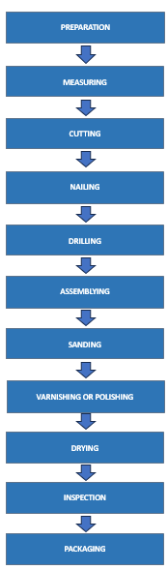
Figure 9. Process Flow Chart (Indicate the Company Name)
- Production / Manufacturing Process
- Intermittent
- Continuous

- Production Design Symbols

Page 05
Table 9

Production Design Symbols

Activity | Symbol | Definition/Action
Transportation |  | Purchase the necessary materials to use in producing the product
Inspection |  | Preparation of all materials to be used
Operation |  | Measuring the palochina woods and cutting them
Operation |  | Applying stickwell
Operation |  | Nailing the woods
Operation |  | Drilling the wood
Operation |  | Assembling the t-faucet
Operation |  | Applying putty to the holes and cracks
Operation |  | Making front cover and handle
Operation |  | Sanding the surface of the wood
Operation |  | Varnishing the wood
Delay |  | Letting the wood to get dried
Inspection |  | Inspecting the product
Operation |  | Packaging the finished product
Storage |  | Storing the packed finished product

- Raw Materials and Supplies
The description of raw materials and supplies, annual
quantities to be used, unit cost and annual values to be purchased, and current, prospective, or alternative sources are detailed in this section.

Page 06
Table ___
Raw Material Requirements
Raw Materials | Description & Uses | Sources | Unit Cost | Quantity | Total

Table ____
Supply Requirements
Supplies | Description & Uses | Sources | Unit Cost | Quantity | Total

Note: Supplies should be divided into three: office, kitchen and janitorial
- Machinery and Equipment
Table ___
Machines and Equipment Requirements
Items | Description | Sources | Unit Cost | Quantity | Total

Page 07
- Furniture and Fixtures
Table ___
Furniture and Fixtures Requirements
Items | Description | Sources | Unit Cost | Quantity | Total

- Plant size and Production Schedule
This section provides the rated annual and daily capacity per
shift, the number of operating days per year and the factors used in determining plant size/capacity. It also presents the projected production volume for the next five years.
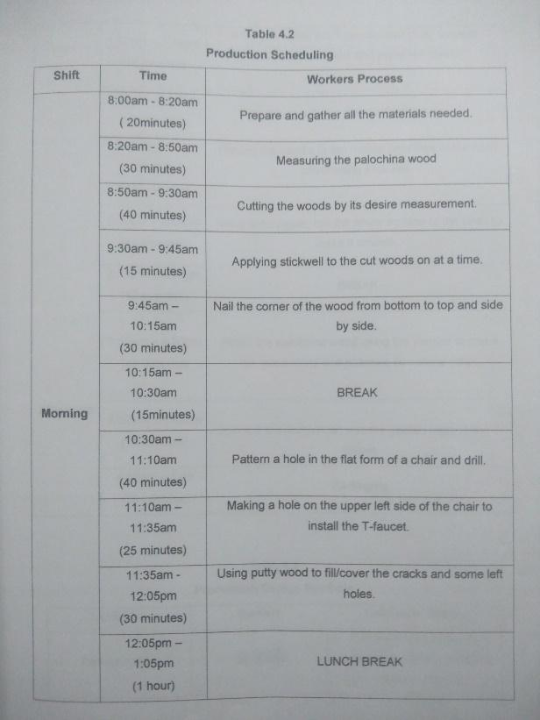
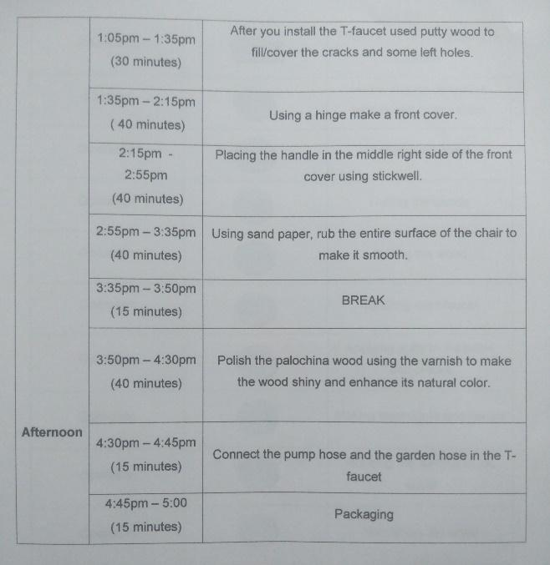

Quilala (2020)

Page 08
- Plant location/ Project Site
This section shows the location map of the plant and the
desirability of the location/s in terms of distance to sources of raw materials and
market, and other factors.
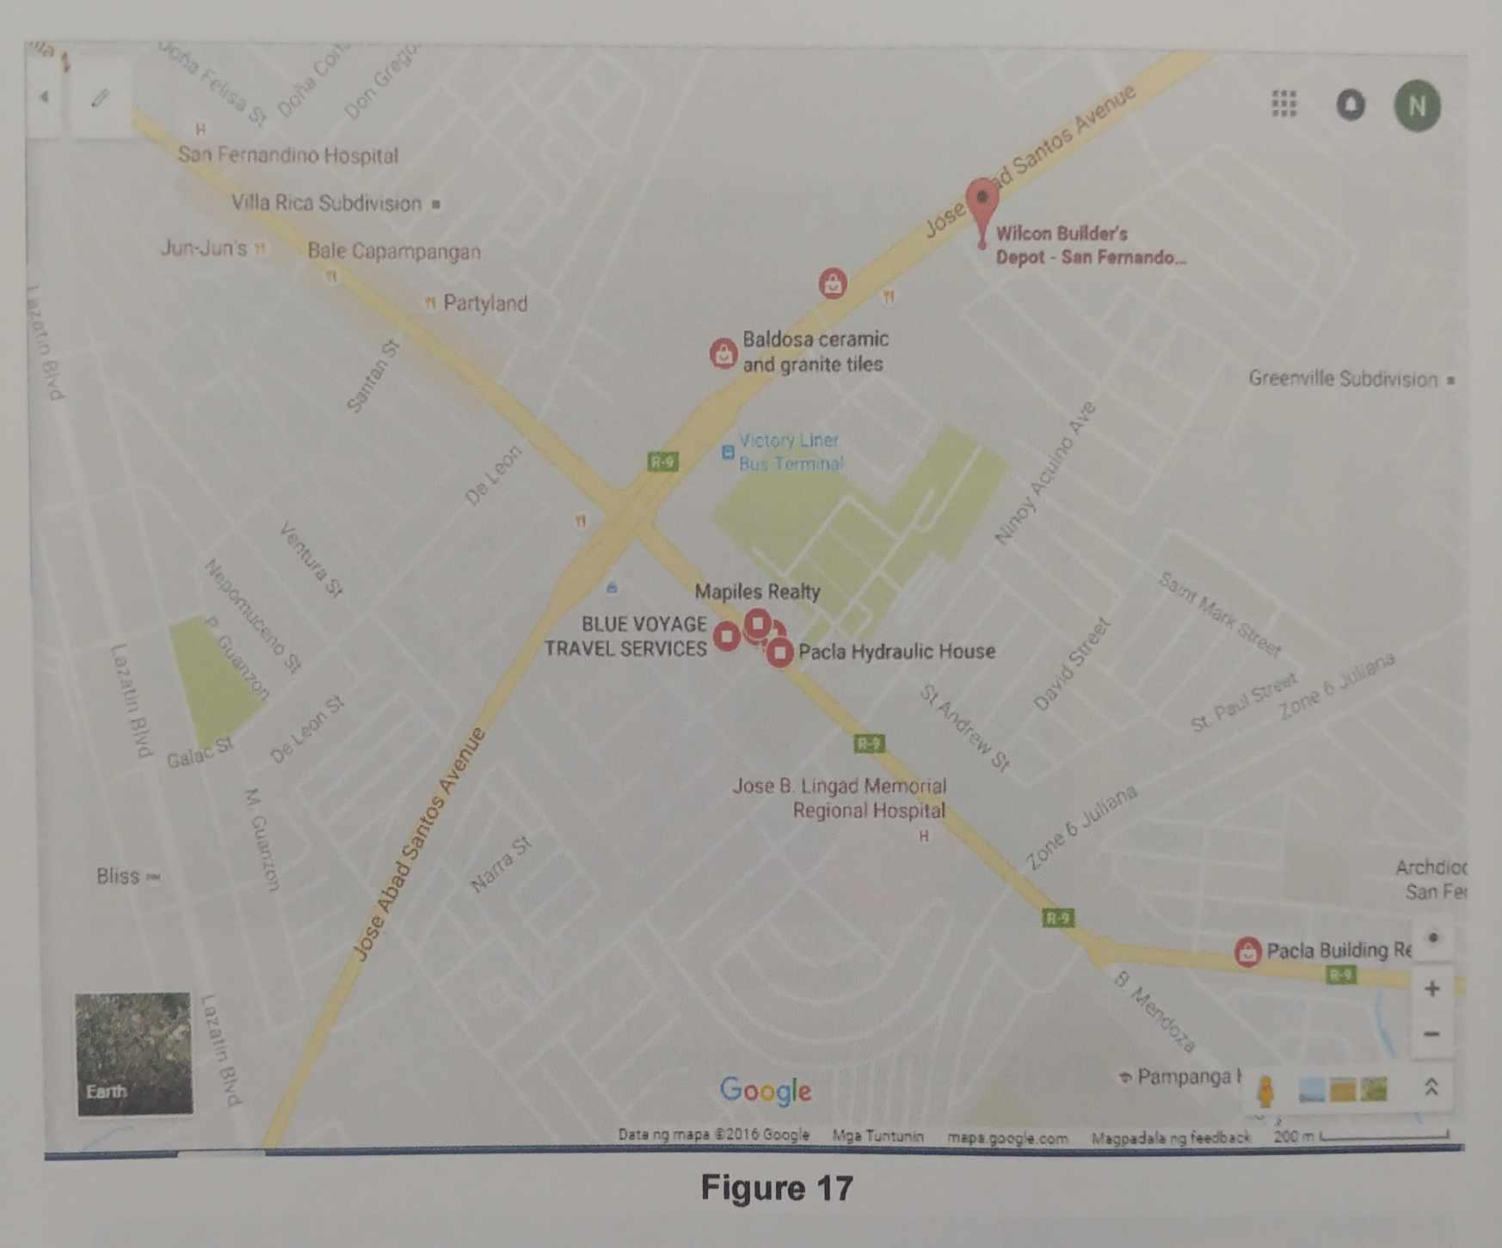
Quilala (2020)
- Floor Plan
This section describes in detail your project’s floor plan for each section and if possible, include a detailed drawing for each of your flow plans

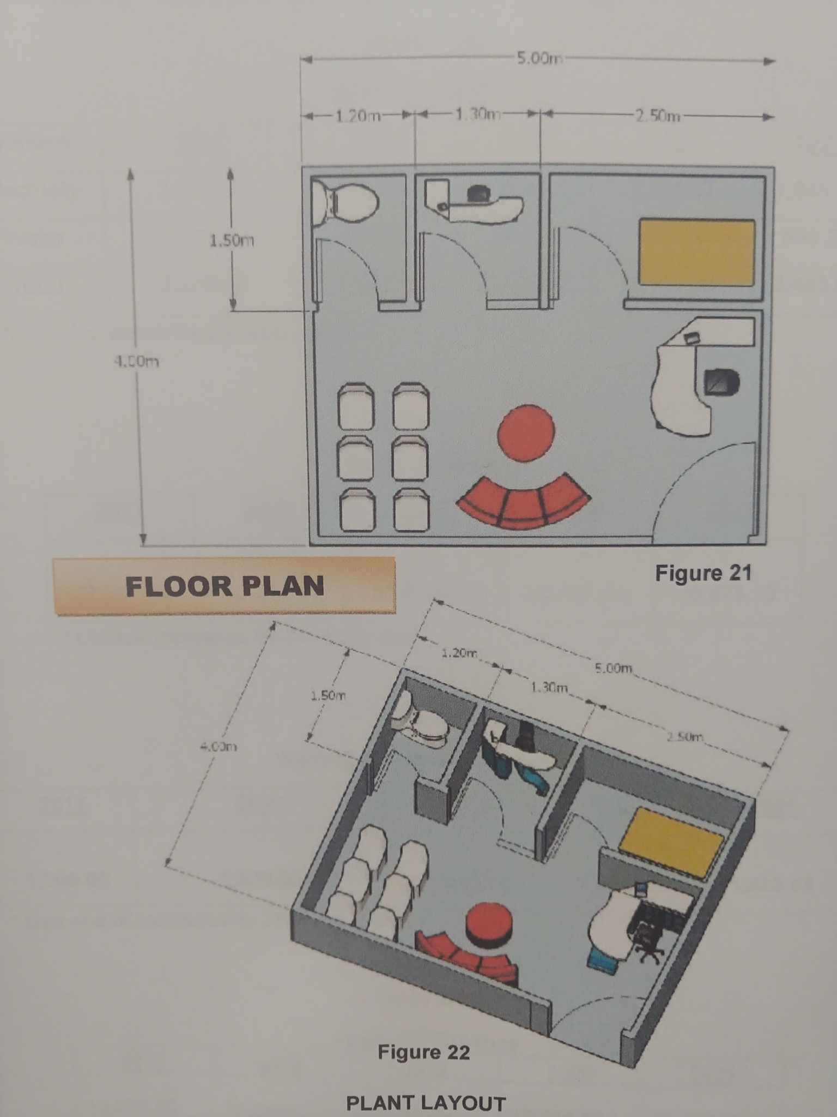
Quilala (2020)
Page 09
- Plant layout

This section presents the general description of the plant
layout and the layout chart. It shows how the layout affects the materials flow,
materials handling and storage. Provisions for expansion are also specified.
Note: Draw the office area, production area, display area, etc.

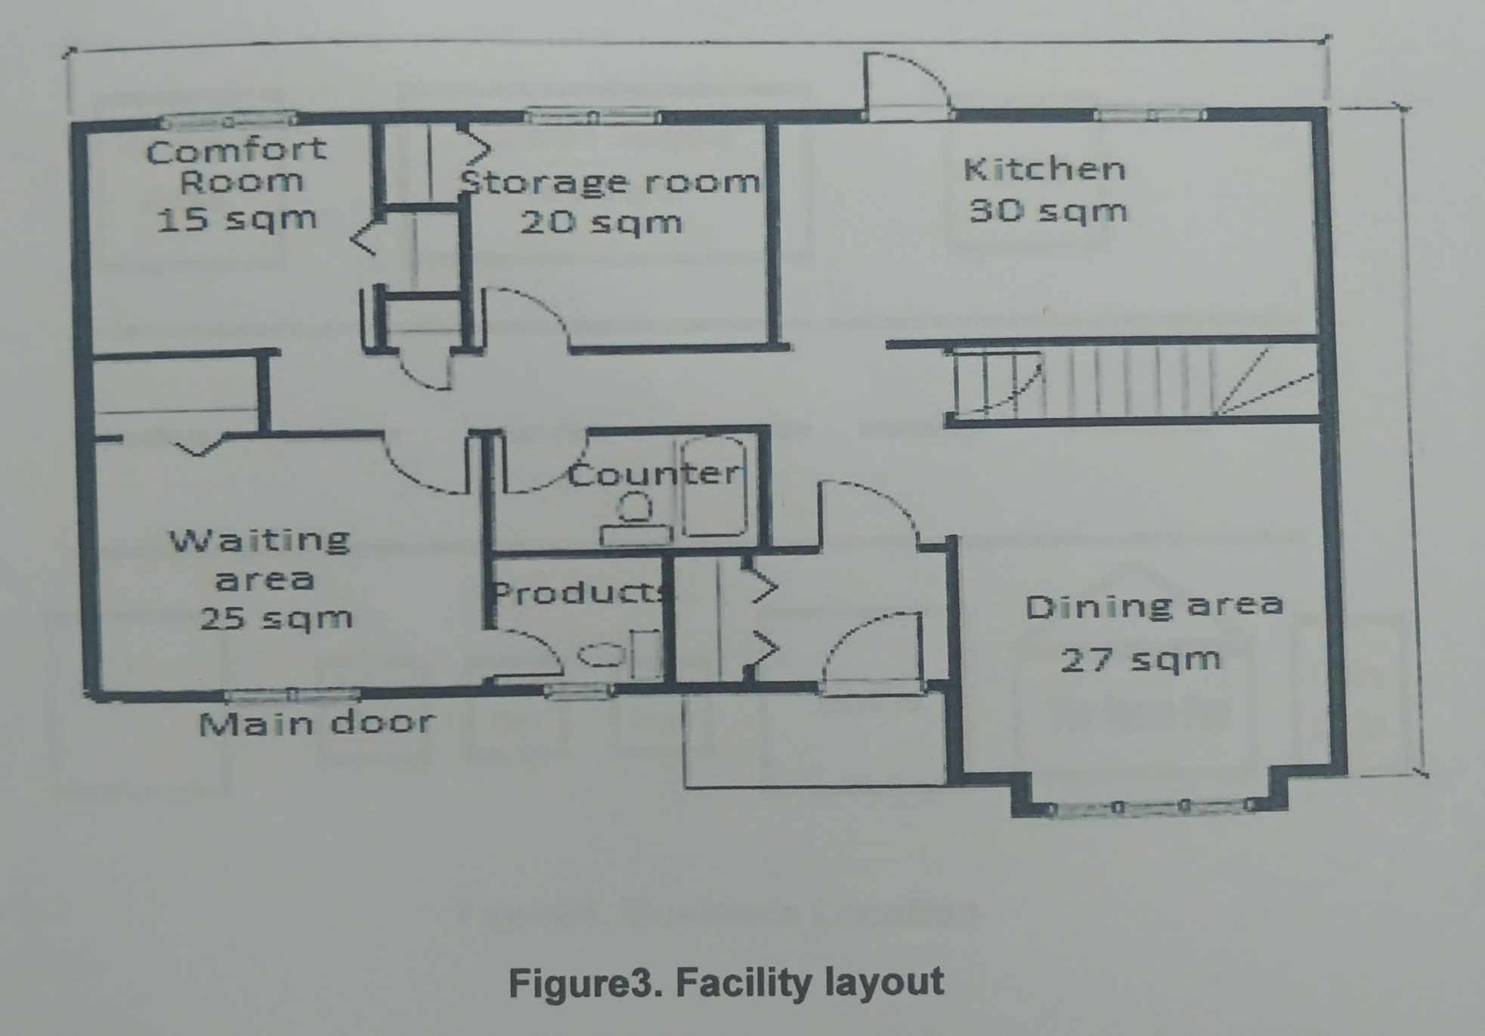
Quilala (2020)

- Structure/Building

Building and costs of erection are the main parts of this section. Other
structures and land improvements such as roads, drainage facilities, etc., and their respective
costs are also included.

Note: front elevation, rear elevation (back view), right side elevation and left side elevation
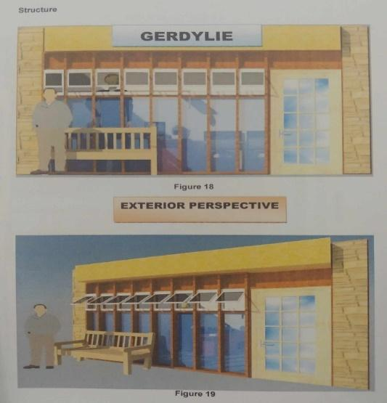
Quilala (2020)
Page 10
- Labor Requirements

This section details total labor requirements from start of
operations until normal production capacity is attainable. It indicates the required number of workers according to skill, sex, and whether full-time / part-time / seasonal, at normal production capacity. Wage rates, salaries, fringe benefits, etc. are specified and details of special training programs, including costs, are set out.
Table ___
Job Requirements or Manning Complement
Position | Number of Employees
Total

Table ___
Compensation Package with Benefits
Employees | Monthly  Salary | 13th  ^{Month} | Annual  Salary | SSS | Pag-ibig | Philhealth | Net Salary
Total

Page 11
- Job Description
An organized, factual statement of the duties and responsibilities of a specific job. It tells us what is to be done, how it is done, and why it is done. It defines the appropriate and authorized contents of a job.
- Job Specification
A statement of the minimum acceptable human qualities necessary to perform a job properly. It is a standard of personnel and designates the qualities required for acceptable performance.
- Utilities
Electricity, fuel, water, steam, and supplies specifying the uses, quantity required, balance of utilities, availability, sources, and alternative sources and costs are detailed in this section.
Table _____
Utilities Requirements
Utilities | Description | Source/s | Unit Cost | Consumption Rate | Total

Utility | Year 1 | Year 2 | Year 3 | Year 4 | Year 5

- Waste disposal

This section provides a description and the quantity of the waste to be disposed of, a
description of the waste disposal methods vis-à-vis methods used in other plants and costs of waste disposal. Waste disposal methods must comply with legal requirements.

Page 12
- Total Production Costs
Present a breakdown of all your projected Production Costs
itemized per department/section as summarized from all your past topics.

Direct Raw Materials xxxxxx
Palochina wood
Chamber pot
Wood nails
Putty
Varnish
Stickwell
Sandpaper, Air pump hose, Garden hose, hinge, T-faucet, round ring cabinet knobs
Direct Labor xxxxxx
Salary/Wages
SSS
Philhealth
Pag-ibig
Factory overhead/ Expenses xxxxxx
Indirect Materials(packaging, etc.)
Utilities (water, electricity, telephone, gas, etc.)
Depreciation(machines and equipment)
Amortization (leasehold improvement)
Rent
Kitchen Utensils
Kitchen Supplies
Total Production Cost xxxxxxx

- Forms Design

- Inventory Slips or Records
- Bill of Materials
- Manufacturing Requisition Slip
- Machine Load Charts

Page 13

KEY TAKE AWAYS
In conclusion, the technical study should answer the basic question: Is the project technically feasible?
It should be able to state whether the amount of cash to be generated from the project will provide the maximum rate of return on investment. An important element in determining the rate of return on investment is the net income. Another important element is the expected cash flow to be generated by the project. This information is determined in the financial aspect of the study. Therefore, a conclusion cannot be made until such a time that the data on net income and cash flow are already available.
Once the data on net income and cash flow have been computed, the proponent can then test the technical feasibility of the project by determining the rate of return and benchmark the same with other investments. Usually, the minimum rate of return is equal to the cost of investment capital. The conclusion, therefore. As to whether the project is technically feasible or not, should be stated following this line of reasoning. The proponent may work closely with an accountant in defining the conclusion.
Textbooks:

A feasibility study guidebook for Students and Entrepreneurs, Jorge H. Cuyugan, Bright Concepts Printing House, 2020

Manual of standards for research, Balajadia, R. and Pangilinan, D. University of the Assumption 2016

Writing Project Feasibility Study, Nick L. Aduana, C & E Publishing, Inc. 2021
Pot De Chambre, Ardy E. Quilala, UA, 2020

Page 14

