[Organizing vehicle transportation and traffic safety] week11 - Work calculation of one-way shuttle pendulum route.

MAVZU-11: Bir tomonlama mayatnik marshrutining ish hisobi.
Rеja:
11.1. Mayatnik marshrutlar turlari.
11.2. Bir tomonlama yukli qatnovchi mayatnik marshrutda transport vositalari ish hisobi.
11.3. Ikki tomonlama yukli qatnovchi mayatnikli marshrutda transport vositalari ish hisobi.

Tayanch so‘z va iboralar: nolinchi qatnov, yuk hajmi, ikki tomonlama yukli qatnovchi mayatnikli marshrut, teskari yoʻnalish, harakat tezligi, avtomobilning ish vaqti, yuk ortish vaqti, yoʻldan foydalanish koeffitsiyenti, avtomobillar saroyi, shaxarlararo tashish, xalqaro tashish.

11.1. Mayatnik marshrutlar turlari
Mayatniksimon marshruti - bu ikki nuqta orasidagi harakat ko‘p marta takrorlanadigan marshrut. Mayatniksimon marshrutlari uch xil: teskari bo‘shashmasdan; teskari to‘liq yuklanmagan kilometr bilan; ikki tomonga ham yuklangan masofa bilan.
1-jadval
Bir tomonlama mayatniksimon marshruti | 
Ikki tomonlama mayatniksimon marshruti | 
Nursimon-mayatnik marshruti | 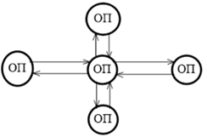
Xalqasimon marshruti | 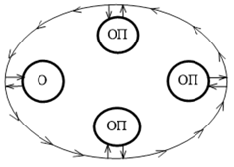

Orqaga bo‘sh harakat bilan qaytish oddiy mayatniksimon marshrut deb ataladi (1-rasm).
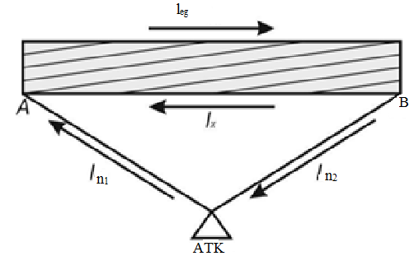
1-rasm. Orqaga bo‘sh harakat bilan mayatniksimon marshrut diagrammasi.
Oddiy mayatnikli marshrutda ishlaganda mashina A nuqtada yuklanadi va yukni B nuqtaga masofadan l_{eg} masalan. B nuqtasida mashina yukni tushiradi va 1-sonli bo‘sh harakatni A nuqtasiga qaytaradi. Bunday marshrut maqsadga muvofiq emas, chunki u ustida ishlaganda bitta aylanada yuk bilan bitta sayohat amalga oshiriladi. Qatnashlardan foydalanish koeffitsienti oddiy mayatniksimon marshrutida 0,5 ga teng, chunki l_{eg} = l_{X}.
Qaytib to‘liq yuklanmagan yurish bilan mayatniksimon marshruti bo‘ylab transport vositalarining harakatini tashkil qilishda, yo‘lning bir yo‘nalishida (qoida tariqasida, teskari yo‘nalishda) bir qismi transport vositasi yuk bilan, bir qismi esa yuksiz harakatlanadi. Shu munosabat bilan ushbu yo‘nalish turli xil sxemalarga ega bo‘lishi mumkin.
Bunday marshrutda ishlaganda bitta aylanishda ikkita sayohat qilinadi. Ushbu yo‘nalishda harakatlanuvchi tarkibning yurish masofasidan foydalanish 50% dan ortiq, ammo 100% dan kam, ya'ni. 0,5 < s < 1.
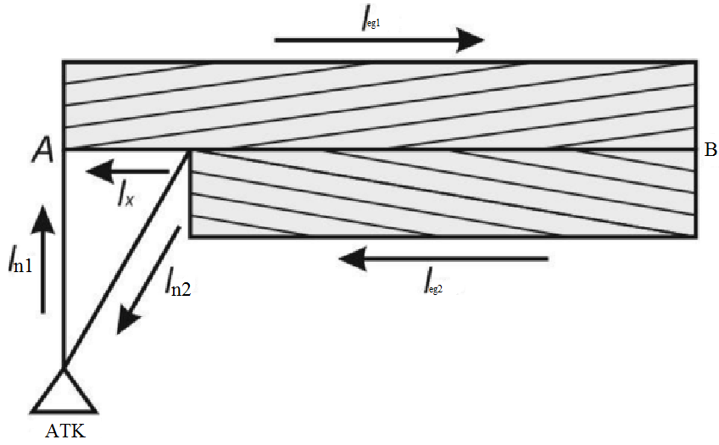
3-rasm. Orqaga to‘liq yuklanmagan mayatniksimon marshrutining sxemasi
Orqaga yuklangan marshruti harakatlanuvchi tarkibning to‘liq ishlatilishini ta'minlaydi: yuk marshrutda ham A nuqtadan B nuqtaga va orqaga, ya'ni A va B nuqtalar bu holatda ham yuklash joylari, ham tushirish punktlari hisoblanadi. Oldinga va teskari yo‘nalishdagi masofa bir xil, bu harakatlanuvchi tarkibning yurish masofasidan to‘liq foydalanishni ta'minlaydi, ya'ni. s = 1. Bitta aylanishda ikkita sayohat amalga oshiriladi.
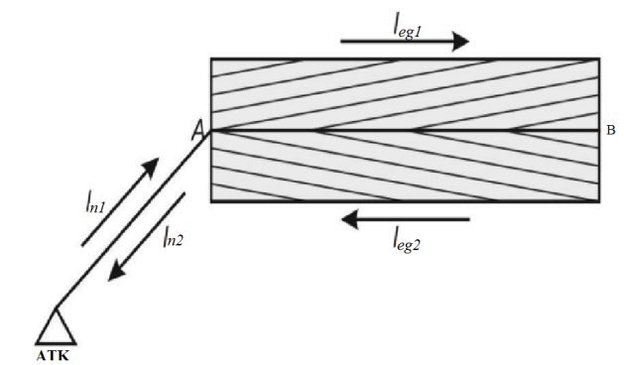
4-rasm. Ikkala yo‘nalishda ham yuklangan
harakatlanuvchi mayatniksimon marshrutining sxemasi

11.2 Bir tomonlama yukli qatnovchi mayatnik marshrutda
transport vositalari ish hisobi
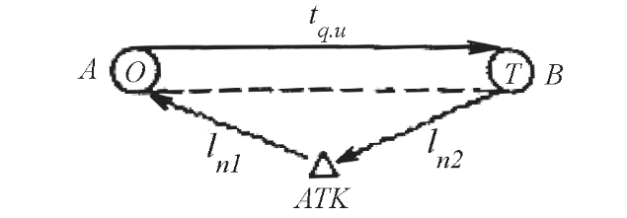
6 - rasm.
Yuk tashish tasviri
Berilgan:
l_{n1} = 4 km, l_{n2} = 8 km, l_{qu} = 10km
Q_{reja} = 30000 t, tashish muddati K_{t} = 30 kun, yuklar ISUZU avtomobilida tashiladi, v_{t} = 20km/soat, t_{o-t} = 0.8 soat, γ_{s} = 1,0, T_{i} = 14 soat, β_{q} = 0,5 soat
Yechish:
1. Qatnov vaqtini aniqlaymiz:
$T_{q} = \frac{l_{qu}}{b_{q}u_{t}}+ t_{o-t}= \frac{l_{y}}{{bu}_{t}}+t_{o-t}= \frac{10}{0.5*20}+0.3=1.8$
Bunda: l_{qu} = l_{yu}
2. Yo‘nalish vaqtini aniqlaymiz.
$T_{y}=T_{i}-\frac{l_{n1}+l_{n2}}{u_{t}}=14-\frac{4+8}{20}-14-0,6-13,4$
3. Bir ish kunidagi qatnоvlar sоnini aniqlaymiz.

$n_{q}= \frac{T_{y}b u_{t}}{l_{y}+b u_{t}t_{o-t}}= \frac{T_{y}}{t_{q}}= \frac{13,4}{1,8}$$n_{q}= \frac{T_{y}b u_{t}}{l_{y}+b u_{t}t_{o-t}}= \frac{T_{y}}{t_{q}}= \frac{13,4}{1,8}$ = 7,44
Bu sоnni yaхlitlaymiz. n_{q ≈} 7
4. Avtоmоbilning yo‘nalishdagi va ish vaqtidagi qatnоvlar sоnini yaхlitlash оrqali qaytadan aniqlaymiz:
$T_{i}^{`}=t_{q}*n_{q}^{`}=1,8*7=12,6$
$$T_{i}^{`}=T_{y}^{`}+ \frac{l_{n1}+l_{n2}}{u_{t}}-12,6+\frac{4+8}{20}- \frac{10}{20}=12,7$$
5. Bir kunlik tashilgan yuk hajmi va yuk aylanishini aniqlaymiz:
$$Q_{k}=q_{n}γ_{s}{n`}_{q}=4*1*7=28 t$$
$$P_{k}=q_{n}γ_{d }l_{qu}{n`}_{q}=Q_{k}l_{qu}=28*10=280 t*km$$
6. Tashish rеjasini bajarish uchun zarur avtоmоbillar sоnini aniqlaymiz.
$$A_{c}= \frac{Q_{reja}}{K_{t }Q_{k}}=\frac{30000}{30*28}=36 avtomobil$$
7. Avtоmоbilning sutkada yurish masоfasini aniqlaymiz:
$l_{y}$ = $\frac{n_{q}*l_{qu} }{b_{q}}$ - $l_{b}+\left(l_{n1}+l_{n2}\right)= \frac{7*10}{0,5}-10+\left(4+8\right)=142 km$

8. Ish kunida avtоmоbilning masоfadan fоydalanish kоeffitsiеntini aniqlaymiz.
$$b= \frac{l_{yu}}{l_{u}}= \frac{n_{q}*l_{qu} }{l_{u}}= \frac{7*10}{142}=0,49$$

11.3. Ikki tomonlama yukli qatnovchi mayatnikli
marshrutda transport vositalari ish hisobi
Orqa yo‘nalishda ham yuk bilan qatnaydigan mayatnikli marshrut (8-rasm) dagi yuk tashuvchi transport vositalari ishini hisoblashda quyidagi birlamchi ko‘rsatkichlarni olamiz: l_{yuq}=10km, nolinchi qatnovlar l_{o}¹=l_{o}¹¹=4km, transport vositasining ishda bo‘lish vaqti T_{ish} = 16 soat, A nuqta (joy)dan B nuqtagacha tashiluvchi yuklar hajmi Q_{AB}=20000t. B nuqtadan A nuqtagacha (orqaga) tashiluvchi yuklar hajmi Q_{BA}=20000t. ikkala tomonga ham tashiluvchi yuklar 1-sinfga mansub, ya`ni γ_{st} =1.0 ga teng. tashish muddati 20 kun. Ishlovchi avtomobil ISUZU (q_{n}=4t). Harakat tezligi V_{T} =25km/soat, har bir yukli qatnovda ortish-tushirishda turish vaqti t_{o-t} =0.6soat.
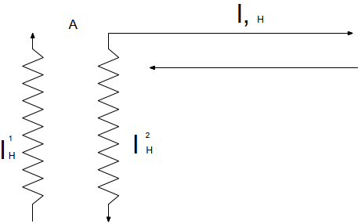
7-rasm. Orqa yo‘nalishda ham yuk bilan qatnaydigan mayatnikli marshrut
Hisoblash tartibi:
1.Marshrut ichi yoʻldan foydalanish koeffitsiyenti β_{m} =1,0 ekanligini nazarda tutib, avtomobilning marshrutda ishlash vaqtini aniqlaymiz:
T_{M}=T_{ish}-t_{o}=T_{ish} - $\frac{l_{o}^{1}+l_{o}^{11}}{V_{T}}$= 16-$\frac{4+4}{25}$=15.68
2.Avtomobilning bir kundagi yukli qatnovlarini hisoblaymiz:
Z_{yuq} = $\frac{T_{M}β_{M}V_{T}}{l_{yuq}{+β}_{M}V_{T}t_{o-t}}$ = $\frac{15.68∙1.0∙25}{10+1.0∙25∙0.6}$ = 15.68
Qatnovlar sonini yaxlitlab (16 ga keltirib), marshrutdagi vaqtni qayta hisoblaymiz:
$T_{M}^{1}$= $\frac{Z_{yuq }^{1}(l_{yuq}{+β}_{M}V_{T}t_{o-t})}{β_{M}V_{T}}$ = $\frac{16(10+1.0∙25∙0.6)}{1.0∙25}$ = 16 soat
Ish vaqti esa:
$T_{ish}^{1}$ = $T_{M}^{1}$ +t_{o} = 16+0.32=16.32 soat bo‘ladi
3.Avtomobilning bir kunlik ish unumi:
tonnada
Q_{K} = q_{n} γ_{st} Z_{yuq} = 4*1.0*16 = 64 t
tonna kilometrda:
P_{K} = q_{n} γ Z_{yuq} l_{yuq} = 4.0*1.0*16*10 = 640tkm
Tashish rejasini bajarish uchun zarur avtomobillar soni:
A_{E}=$\frac{Q_{AB}+Q_{BA}}{K_{ish}Q_{K}}$= $\frac{20000+20000}{2*64}$ = 31
4. Avtomobilning kunlik qatnov masofasi:
L_{sut} = $Z_{yuq }^{1}$ l_{yuq} + ($l_{o}^{1}+l_{o}^{11}$) = 16*10+(4+4) = 168 km
Kun davomida avtomobilning yo‘ldan foydalanish koeffisienti:
$β$= $\frac{Z_{yuq }^{1}l_{yuq}}{L_{sut}}$ = $\frac{10*16}{168}$ = 0.95
Agar ikkala yoʻnalishdagi yukli qatnovlarda ham har xil sinfga mansub yuklar tashilsa, yaʼni yuk koʻtaruvchanliklardan foydalanish koeffitsiyentlari birlamchi va orqa yoʻnalishda oʻzaro teng boʻlmaganda transport vositasining tonnada oʻlchanuvchi ish unumi quyidagicha aniqlanadi:
Q_{K} = (q_{n} γ_{AB +} q_{n} γ_{BA}) = $\frac{Z_{yuq }^{1}}{2}$, (53)
bunda q_{n} ni qavsdan chiqarsak,
Q_{K} = q_{n} (γ_{AB +} γ_{BA}) = $\frac{Z_{yuq }^{1}}{2}$, (54)
Ayni shartga koʻra transport vositasining tonna-kilometrdagi ish unumi quyidagicha:
P_{K} = (q_{n} γ_{AB} l_{yuq +} q_{n} γ_{BA} l_{yuq}) = $\frac{Z_{yuq }^{1}}{2}$* l_{yuq} (55)
yoki P_{K} = Q_{K} l_{yuq} bo‘ladi. Qolgan hisoblarda o‘zgarishlar bo‘lmaydi.

Orqa yo‘nalishda qisman yukli mayatnik
marshrutda transport vositalari ish hisobi
Mazkur mayatnikli marshrutda yuk tashuvchi transport vositalarini hisoblashda quyidagi birlamchi ko‘rsatkichlardan foydalanamiz.
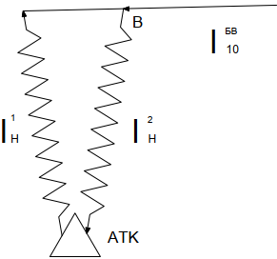
8-rasm. Orqaga to‘liq bo‘lmagan yukli mayatnikli qatnov
Avtomobilning ishda bo‘lish vaqti T_{ish}=12 soat AB birlamchi (toʻgʻri) yoʻnalishda tashiluvchi yuklar hajmi 200 000 t, birinchi sinfli yuk ($γ$=1,0 ), marshrutning teskari yoʻnalishdagi BV boʻlagida tashiluvchi yuklar hajmi 180 000 t boʻlib, yuk koʻtaruvchanlikdan foydalanish koeffitsiyenti β_{BV}=0,9. Tashiluvchi yuklar uyulib tashiluvchi va sochiluvchan boʻlganligi uchun ularni yuk koʻtaruvchanligi 4,5t li samosval avtomobillarda tashish moʻljallangan. Yukni ortish uchun zarur vaqt t_{o} = 0,15 soat, tushirish vaqti t_{T}= 0,1 soat. Tashish muddati 120 kun. Avtomobilning harakat tezligi V_{T} = 24 km/soat.
Hisoblash tartibi:
1 . Avtomobilning marshrutda ishlash vaqtini topamiz:
T_{M} = T_{ish} - $\frac{l_{o}^{1}+l_{o}^{11}}{V_{T}}$= 12 - $\frac{5+5}{24}$ = 11.58
avtomobilning marshrutdagi bir aylanish vaqtini aniqlaymiz:
t_{ayl} = ∑t_{x} + ∑_{to-t} = $t_{o}^{A}$ + $t_{h}^{AB}$ + $t_{t}^{B}$ + $t_{o}^{B}$ + $t_{h}^{BV}$ + $t_{t}^{V}$ + $t_{h}^{VA}$ ;
t_{ayl} = $t_{o}^{A}$+ $\frac{l_{yuq}^{AB}}{V_{T}}$ + $t_{t}^{B}$ + $t_{o}^{B}$ + $\frac{l_{yuq}^{BV}}{V_{T}}$ + $t_{t}^{V}$ + $t_{bq}^{VA}$ = 0.15+$\frac{12}{24}$ +0.1+.015+ $\frac{8}{24}$ + 0.1 + $\frac{4}{24}$ = 1.5 soat
2. Avtomobilning marshrutdagi bir kunlik aylanishlar soni:
Z_{ayl} = $\frac{T_{M}}{t_{ayl}}$ = $\frac{11.58}{1.5}$ = 7.7
Aylanishlar sonini yaxlit 8 ga keltirib, vaqtlarni qayta hisoblaymiz:
marshrutdagisi
$T_{M}^{1}$ = $Z_{ayl}^{1}$ t_{ayl} = 8 1.5=12 soat
Ishdagisi
$T_{ish}^{1}$ = $T_{M}^{1}$ + t_{o} = 12+0.42 = 12.42 soat
3. Avtomobilning bir kunlik ish unumini hisoblaymiz:
tonnada
Q_{K} = (q_{n} γ_{AB} + q_{n} γ_{BV} ) Z¹_{ayl} = q_{n} (γ_{AB} + γ_{BV} ) = 4.5 (1.0+0.9) 8 = 64.6 t
tonna – kilometrda
P_{K} = (q_{n} γ_{AB} $l_{yuq}^{AB}$+ q_{n} γ_{BV} $l_{yuq}^{BV}$ ) Z¹_{ayl} tkm
yoki
P_{K} = (q_{n} γ_{AB} $l_{yuq}^{AB}$+ q_{n} γ_{BV} $l_{yuq}^{BV}$ ) Z¹_{ayl} =4.5 (1.0*12+.9*8) 8 = 584.8 tkm
Yuklarni tashish uchun zarur bo‘lgan avtomobillar soni:
L_{sut} = (l_{AB}+l_{BV}+l_{BA})*Z + (l_{o}¹+l_{o}¹¹)-l_{BA} = (12+8+4)*8 + (5+5) – 4 = 198 km
Kun davomida avtomobilning yo‘ldan foydalanish koeffisienti
$β$ = $\frac{{(l}_{yuq}^{AB}+l_{yuq}^{BV}) Z_{ayl}}{L_{sut}}$ = $\frac{\left(12+0.8\right)*8}{198}$ = 0.81

Halqasimon marshrutda transport vositalari ish hisobi
Halqasimon marshrutda yuk tashuvchi avtomobilning ishini hisoblashda (19-rasm) quyidagi birlamchi koʻrsatkichlardan foydalanamiz.
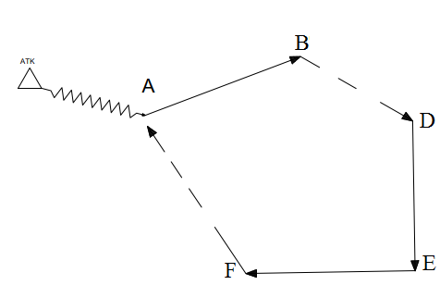
9-rasm. Halqasimon marshrut
Qatnov masofalari oraligʻi
$l_{yuq}^{ AB}$ = 10 km
$l_{bq}^{ BV}$ = 4.0 km
${ l}_{bq}^{ DA}$ = 6 km
$l_{yuq}^{ VG}$ = 14.0 km
$l_{yuq}^{ GD}$ = 12 km
l_{o} = 6 km
Avtomobilning ish vaqti T_{ish} = 16 soat. Qatnovning AB bo‘lagida tashiluvchi 1-sinfga mansub yukning (γ_{AB} = 1.0) hajmi 200000 t, VG boʻlagida 2-sinfga mansub yukning (γ_{VG} = 0,8) hajmi 160 000 t va GD boʻlagida 3-sinfga mansub yukning (γ_{GD} = 0,6) hajmi 120 000 t. Tashish muddati K_{E} =360 kun.Yuk tashishda ISUZU avtomobillaridan foydalaniladi. Yuk ortish vaqgi t_{o} = 0,5 soat, tushirish vaqti t_{t} = 0,3 soat. Qatnov sharoitlari ayrim yoʻl boʻlaklarida bir xil emasligi uchun, harakat tezliklari quyidagicha: yoʻlning AB va VD boʻlaklarida V_{T} = 20 km/soat, BV va VG boʻlaklarida V_{T} = 22 km/soat va DA boʻlagida va nolinchi qatnovda V_{T} = 20 km/soat
Hisoblash tartibi:
1. Avtomobilning marshrutda ishlash vaqtini topamiz:
T_{M}=T_{ish} - $\frac{l_{o}^{1}+l_{o}^{11}}{V_{T}}$= 16-$\frac{6+6}{20}$=15.4

Avtomobilning marshrutda toʻliq bir aylanishida harakatlanish va ortish-tushirishda turish vaqtlarining jami:
t_{ayl} = $∑t_{x}$+ $∑t_{o-t}$ , soat (56)
jumladan,
$∑t_{x}$ = $t_{h}^{AB}$ + $t_{h}^{BV}$+$t_{h}^{VG}$+$t_{h}^{GD}$+ $t_{h}^{DA}$ = $\frac{l_{yuq}^{AB}}{V_{T}}+ \frac{l_{yuq}^{BV}}{V_{T}}+ \frac{l_{yuq}^{VG}}{V_{T}}+ \frac{l_{yuq}^{GD}}{V_{T}}+\frac{l_{yuq}^{DA}}{V_{T}}$ = $\frac{10}{24}+\frac{4}{22}+\frac{14}{22}+\frac{12}{24}+\frac{6}{20}$ = 2.04 soat
$∑t_{o-t}$ = $t_{o}^{A}$+${ t}_{t}^{B}+t_{o}^{V}+t_{t}^{G}+t_{o}^{G}+t_{G}^{D}$ = 0.5 + 0.3 + 0.5 + 0.3 + 0.5 + 0.3 = 2.4 soat
U holda:
t_{ayl} = 2.04+2.4=4.44soat
2. Avtomobilning marshrutdagi bir kunlik aylanishlar soni:
Z_{ayl} = $\frac{T_{M}}{t_{ayl}}$ = $\frac{15.4}{4.44}$ = 3.4
Aylanishlar sonini yaxlit 3 ga keltirib, vaqt sarflarini qayta hisoblaymiz:
marshrutdagi vaqt
$T_{M}^{1}$ = t_{ayl} $Z_{ayl}^{1}$ = 4.44 3.0=13.32 soat
ishda bo‘lish vaqti
T_{ish} = $T_{M}^{1}$ + t_{o} = 13.32+0.6=13.92 soat
3. Avtomobilning bir kunlik ish unumini hisoblaymiz:
tonnada
Q_{K} = (q_{n} γ_{AB +} q_{n} γ_{VG}+ q_{n} γ_{GD} ) $Z_{ayl }^{1}$= q_{n} (γ_{AB +} γ_{VG}+ γ_{GD} ) $Z_{ayl }^{1}$ = 5 (1+0.8+0.6)*3=36 t
tonna-kilometrda
P_{K} = (q_{n} γ_{AB} $l_{yuq}^{AB}$ ₊ q_{n} γ_{VG} $l_{yuq}^{VG}+$q_{n} γ_{GD} $l_{yuq}^{GD}$ ) $Z_{ayl }^{1}$= q_{n} (γ_{AB} $l_{yuq}^{AB}$ ₊ γ_{VG} $l_{yuq}^{VG}+$γ_{GD} $l_{yuq}^{GD}$ ) $Z_{ayl }^{1}$= 5 (1*10+0.8*14+0.6*12)*3 = 426 tkm
Yuklarni tashish uchun zarur bo‘lgan avtomobillar soni
A_{E} = $\frac{Q_{AB}+Q_{VG}{+Q}_{GD}}{K_{E}Q_{K}}$ = $\frac{200000+160000+120000}{360*36}$ = 37
4. Avtomobilning bir kunlik umumiy qatnov masofasi:
L_{sut} = L_{ayl} $Z_{ayl }^{1}$ + l_{o} + l_{bq} =( $l_{yuq}^{AB}$+$l_{bq}^{BV}$+$l_{yuq}^{VG}$+$l_{yuq}^{GD}$+$l_{bq}^{DA}$)$Z_{ayl }^{1}$ + l_{o} + l_{bq} =
=(10+14+12+4+6)*3+(6+6)-6=144km
Yo‘ldan foydalanish koeffisienti:
β = $\frac{l_{yuq.ayl}Z_{ayl}^{1}}{L_{sut}}$ = $\frac{\left( l_{yuq}^{AB}+l_{yuq}^{VG}+l_{yuq}^{GD}\right)Z_{ayl}^{1}}{L_{sut}}$ = $\frac{\left(10+14+12\right)*3}{144}$ = 0.75

Nazorat uchun savollar
1. Ikki tomonlama yukli qatnovchi mayatnikli marshrutda transport vositasining tonna-kilometrdagi ish unumi qanday hisoblaniladi?
2.Ikki tomonlama yukli qatnovchi mayatnikli marshrutda transport vositasining kunlik qatnov masofasi qanday hisoblaniladi?
3. Orqa yo‘nalishda qisman yukli marshrutda transport vositalarining bir kunlik ish unumini hisoblang.
4. Orqa yo‘nalishda qisman yukli marshrutda yuklarni tashish uchun zarur bo‘lgan avtomobillar sonini hisoblang.
5. Halqasimon marshrutda transport vositalarining bir kunlik ish unumini tonna-kilometrda hisoblang.
6. Halqasimon marshrutda transport vositalarining bir kunlik umumiy qatnov masofasini hisoblang.

