Lecture Notes
BUILDING SERVICES III
Chapter 11
Case Study (Natural Ventilation/HVAC Systems)
Lecturer: Assoc. Prof. Manchan Tiwari
11-15-2023

The Pantheon

Introduction
The Pantheon, is a structure located in Rome's business district, which is one of the oldest example of building design incorporating natural ventilation. It has stood for 18 centuries despite facing various challenges such as wars. The building possess unique features which are not even seen in modern buildings. Recent studies have uncovered significant cracks in the dome, but the ancient concrete building, lacking steel reinforcing rods, continues to function impressively. It is quite impressive that the building of such architectural design is built without any reinforcements which would not be possible in today’s world.
Originally dedicated to all gods, the Pantheon (The Pantheon is a Greek god) has endured wars and is now held in high regard by the Church. Agrippa (son in law of Roman Emperor Augustus) built the first temple in 27 B.C., which suffered major damages over the course of time, leading to Emperor Hadrian's reconstruction in 118-128 A.D. Disputes surround the construction timeline, yet the Pantheon's enduring strength and unique architectural features remain captivating. The pantheon is a great structure for case study for structural elements as well as its passive lighting and cooling system (Moore, 1995).
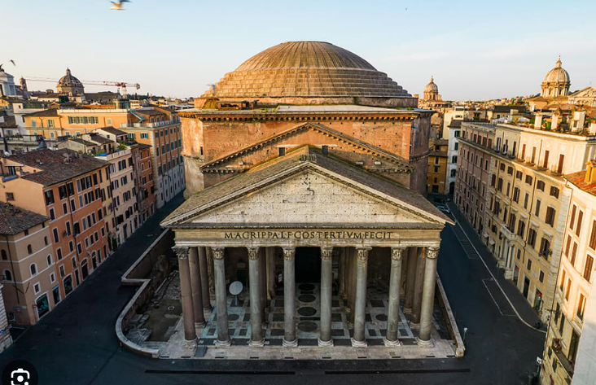
Figure 1: The Pantheon (Moore, 1995)
The Pantheon's architectural design is characterized by a large, round shape resembling a barrel, topped with a dome. A central light-well is situated in the dome's center, allowing natural light into the interior. The outer walls are adorned with exquisite thin brickwork, occasionally featuring small access holes used during construction. The main entrance boasts impressive double bronze doors, standing at 21 feet high and protected by a broad porch supported by 16 granite columns and a gable-styled roof with wooden beams. Roman surveyors meticulously located the inlaid marble floor to create a convex contour, facilitating rain drainage from the oculus. The rotunda, with an inner diameter of 142.4 feet, is predominantly made of concrete and is comparable to half the length of a football field. This unique design, though found in other Roman buildings, distinguishes itself with an unusually large size. Notably, the Pantheon's dome still holds the record for the longest span constructed before the 19th century.

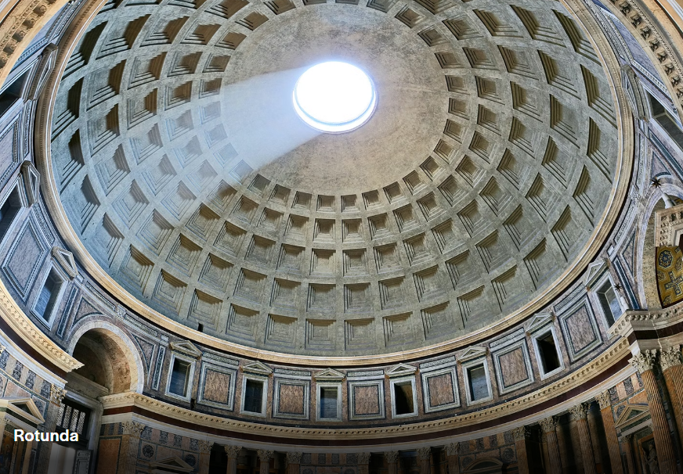
Figure 2: Oculus in The Pantheon (Moore, 1995)

The Dome
The Pantheon has a remarkable hemispherical dome that remains one of the largest unreinforced concrete domes in the world. The dome of the Pantheon stands as a timeless testament to ancient Roman architectural ingenuity. What distinguishes the Pantheon's dome is its innovative design, featuring a central oculus—an open, circular aperture at the crown of the dome. The oculus not only introduces an element of celestial symbolism but also serves a practical purpose. The oculus acts as a natural skylight and ventilation system, allowing sunlight and air to pass through it. This intentional opening serves as a natural ventilation mechanism, allowing air circulation and creating a cooling effect within the Pantheon. This sophisticated blend of form and function showcases the Romans' mastery in creating monumental structures that harmonize with both aesthetic and environmental principles, making the Pantheon a timeless marvel that continues to inspire awe and admiration.
The oculus acts as a vent, facilitating the exchange of air between the interior and the external environment. As warm air rises, it is drawn out through the oculus, creating a convection current. Simultaneously, fresh air is drawn in from the lower parts of the building, ensuring a continuous flow of air. This natural ventilation system helps regulate the temperature and air quality inside the Pantheon. The use of the oculus for natural ventilation also contributes to the building's overall sustainability and energy efficiency. By harnessing the principles of convection and utilizing the prevailing winds, the Pantheon's designers achieved a harmonious balance between the need for ventilation and maintaining a comfortable interior environment.

Analysis of the natural ventilation
Bernoulli's principle is a fundamental concept in fluid dynamics that describes the relationship between the pressure and velocity of a fluid in a flowing stream. It is named after the Swiss mathematician and physicist Daniel Bernoulli, who formulated it in the 18th century.
According to the principle, in a streamline flow of fluid (i.e., a flow without turbulence), an increase in the speed of the fluid is accompanied by a decrease in pressure, and vice versa.
The principle can be explained using the law of conservation of energy, which states that the total energy of an isolated system remains constant over time. In the context of fluid flow, we can consider the different forms of energy involved:
Kinetic Energy (KE): This is the energy associated with the motion of an object. In the case of fluid flow, it is related to the velocity of the fluid particles.
Potential Energy (PE): This is the energy associated with the position of an object in a gravitational field. In fluid dynamics, it is often the gravitational potential energy.
Pressure Energy (PE): This is the energy associated with the pressure of the fluid.
According to Bernoulli's principle, the total energy per unit volume of a fluid particle (the sum of kinetic energy, potential energy, and pressure energy) remains constant along a streamline in a steady, idealized flow. As the fluid moves through different regions with varying velocities and pressures, the distribution of energy may change, but the sum remains constant. It's important to note that Bernoulli's principle is a simplified model that assumes idealized conditions and does not account for factors like viscosity, turbulence, or compressibility. The Venturi effect is a fluid dynamics phenomenon where a fluid's speed increases as it passes through a narrowed section of a pipe, resulting in a decrease in pressure. Named after Giovanni Battista Venturi, this principle is based on Bernoulli's theorem. As the fluid accelerates in the constriction, its kinetic energy rises, causing a drop in pressure.
The interaction between air and the oculus in the Pantheon induces airflow through two mechanisms: convection and the venturi effect. Convection, governed by the principles of fluid dynamics, states that warm air rises above while the cool air falls down. The oculus, serving as a natural convection vent, creates a vacuum by lowering the pressure, which draws in cooler air through the portico entrance, establishing an upward airflow. Simultaneously, the venturi effect, influenced by the dome's shape, increases the velocity of airflow over the oculus, resulting in increased velocity and decreased pressure. This pressure difference generates a flow from the higher pressure near the portico to the lower pressure over the oculus. Another passive system studied is the Pantheon's use of thermal mass, employing materials like lime-pozzolana concrete which has the ability to store thermal energy for longer duration of time. During the day, the non-insulated concrete at the outer part gets heated due to solar radiation, which contributes to lesser heat reaching the interior hence reducing the heat reaching the interior space. However, its efficacy in heating is limited during winter due to the open oculus. Considering Rome's variable climate, integrating insulation and closing the oculus could potentially provide year-round temperature regulation.

Traditional Chinese Courtyard Houses
The Courtyard, known as 'Siheyuan' in Chinese, is a traditional folk house with a rich history in Chinese architecture. Its layout forms a square with four sides, creating a box with a central garden. The design promotes tranquility and family unity, with only one gate connecting to the outside world. Most existing courtyards are relics from the Ming and Qing Dynasties, featuring ancient furniture, fish ponds, and traditional architectural elements. These courtyards, hidden in the midst of modern structures, exude a nostalgic beauty, inviting exploration of Beijing's past. Courtyard owners often decorate with flowers and trees, favoring date trees and pomegranates for their cultural significance. Living in this harmonious environment, residents are believed to enjoy a peaceful life (Hui, 2023).
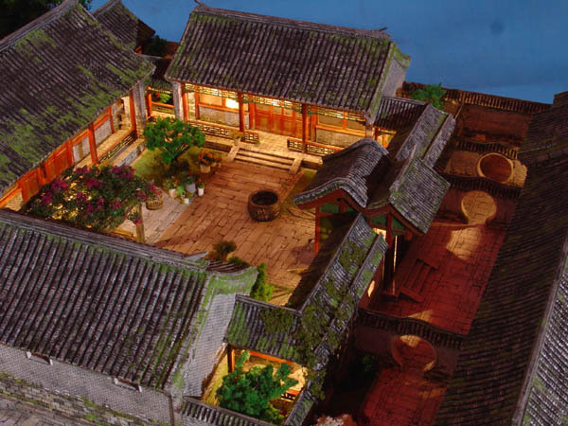
Figure 3: Chinese Courtyard House (Hui, 2023)
Traditional Chinese courtyard houses are also designed with features that promote natural ventilation, providing a sustainable and effective way to cool the interiors. The key elements contributing to natural ventilation in Chinese courtyard houses include:
Open Courtyards: The central open courtyard serves as a focal point for natural ventilation. Hot air rises, and by having an open space in the center of the house, warm air can escape upward, creating a natural upward draft. This design allows for the removal of hot air and facilitates the intake of cooler air from the surroundings.
Cross-Ventilation: Chinese courtyard houses are often designed with rooms opening onto the courtyard and windows on multiple sides. This arrangement facilitates cross-ventilation, allowing prevailing winds to pass through the interior spaces. The orientation of windows and doors is carefully planned to maximize airflow, promoting a refreshing breeze throughout the house.
Shading Devices: Traditional Chinese courtyard houses incorporate architectural elements to provide shade. Overhanging eaves, covered walkways, and strategically positioned elements like carved screens help shield the building from direct sunlight, preventing excessive heat buildup.
Ventilation Corridors: Some designs include corridors that connect different sections of the house, acting as ventilation corridors. These pathways guide and funnel air through the building, enhancing the overall natural ventilation.
Thermal Mass: Courtyard houses often use materials with high thermal mass, such as brick or stone. These materials absorb heat during the day and release it slowly at night, contributing to a more stable and comfortable indoor temperature.
Adaptability to Seasonal Changes: The design of Chinese courtyard houses is often responsive to seasonal variations. For example, during colder months, windows and doors can be closed to retain warmth, while in warmer months, they can be opened to encourage airflow and cooling.
Privacy Screens and Louvers: Wooden screens and louvers are commonly used in Chinese courtyard houses to allow for privacy while still permitting airflow. These adjustable features enable residents to control the amount of sunlight and air entering the living spaces.
By integrating these design principles, Chinese courtyard houses harness natural ventilation effectively. This sustainable approach not only promotes thermal comfort but also aligns with the cultural and climatic considerations that have shaped traditional Chinese architecture for centuries.

Dolat Abad Windcatcher
The ancient city of Yazd in Iran, is renowned for its windcatchers, traditional Persian architectural elements designed to capture and direct prevailing winds into buildings. The Dowlat Abad Windcatcher, built in the 18th century, is an excellent example (Mariellen, 2018).
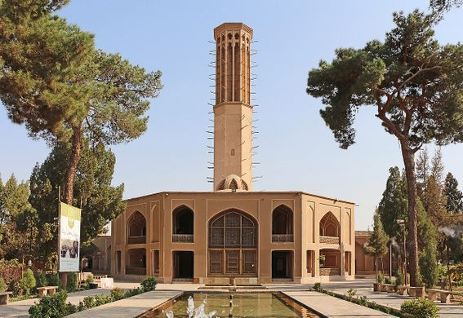
Figure 4: Dolat Abad Windcatcher (Mariellen, 2018)
The Dolat Abad Garden's tower, dating back to the 18th century, hosts the tallest existing windcatcher in Iran, standing as a testament to the city's rich heritage. Yazd's architectural ingenuity also extends to its extensive network of qanats, underground channels facilitating water transfer from wells to the surface. The synergy between windcatchers and qanats enhances the cooling effect in these structures.
Windcatchers, functioning in various ways, are designed to cool interiors by harnessing natural airflow. When facing prevailing winds, they "catch" the wind, inducing airflow within buildings. In conjunction with qanats, air is drawn into the tunnels, cooling as it encounters the subterranean environment. This cooled air then ascends through the windcatcher, further lowering temperatures inside. In windless conditions, windcatchers operate as solar chimneys, facilitating the escape of lighter, hot air. With their effectiveness heightened by thick walls, windcatchers continue to adorn not only Yazd but also various regions in Iran and the Middle East, providing a timeless and efficient cooling solution.
The elements that provide cooling effect in the Dolat Abad can be summarized as:
Air Circulation: The windcatcher is essentially a tower with multiple openings or vents at the top. When the wind blows, these openings catch the breeze from different directions.
Airflow Inside the Building: The caught wind is directed down into the building through a series of channels or ducts. These ducts bring the outside air into the interior spaces.
Cooling Effect: As the wind moves through the ducts, it creates a natural ventilation effect, exchanging the warm air inside the building with the cooler outside air. This process helps to reduce the overall temperature inside the structure.
Combined with Qanats: The cooling effect can be further enhanced when the windcatcher is used in conjunction with qanats, which are underground channels that bring water to the surface. In this collaboration, the windcatcher draws air down into the qanat, where it comes in contact with the cool earth and water. The cooled air is then drawn up through the windcatcher, effectively cooling the interior spaces.
Solar Chimney Effect: In the absence of wind, the windcatcher can also operate like a solar chimney. In this mode, hot air inside the building, being lighter, rises and escapes through the openings at the top of the windcatcher. This creates a natural upward flow of air, facilitating the removal of warm air from the building.

The Alahambra
The Alhambra, a medieval palace and fortress complex in Granada, Spain, incorporates passive cooling strategies in its architectural design to create a comfortable interior environment (Alcala, 1999).
The water features in the Alhambra play a pivotal role in passive cooling by harnessing the cooling properties of water and enhancing the overall comfort of the interior spaces. The strategic incorporation of fountains, pools, and channels within the complex exploits the principles of evaporative cooling.
Water has a high thermal mass, enabling it to absorb and store heat. As air circulates over or near these water features, it undergoes a cooling process through evaporation. The water absorbs heat from the surrounding environment, causing it to evaporate and transform into cooler vapor. This cooled air then circulates throughout the adjacent spaces, effectively lowering the temperature.
Additionally, the reflective surfaces of the water features contribute to the overall cooling effect by mitigating solar heat gain. The sun's rays are partially absorbed by the water and its surroundings, reducing the amount of heat that would otherwise be absorbed by the building's surfaces. The combination of evaporative cooling and solar reflection creates a microclimate that enhances the thermal comfort of the Alhambra, showcasing a sophisticated integration of water elements as a passive cooling strategy in medieval Islamic architecture. The strategic location of the water features in Alahambra contribute to the passive cooling.
Courtyard Design: Many of the water features are located within courtyards, the central open spaces of the Alhambra. These courtyards act as focal points for the distribution of cooling effects. Water in the courtyards creates a microclimate by inducing evaporative cooling, reducing the ambient temperature in the immediate surroundings.
Airflow Enhancement: Water features are often positioned to maximize airflow and promote natural ventilation. Fountains and pools in open areas allow for the circulation of cooler air, enhancing the overall cooling effect. As air passes over the water surfaces, it picks up moisture, leading to a more comfortable and refreshed atmosphere.
Reflective Surfaces: Water features, especially reflective pools, are strategically placed to reflect sunlight. This reflective quality helps in reducing solar heat gain by bouncing back a portion of the sun's rays. This, in turn, prevents excessive heating of adjacent surfaces and contributes to the passive cooling of the surrounding spaces.
Integration with Architectural Elements: Water features are integrated into the architectural design, often complementing elements like arcades, columns, and decorative motifs. This integration not only adds to the aesthetic appeal but also ensures that the cooling effects of water are seamlessly woven into the overall design strategy.
Strategic Placement in Gardens: Water features are commonly found within gardens or green spaces. The combination of water and vegetation enhances the cooling effect through transpiration and shading. The greenery further contributes to the overall cooling of the area.
Other features that has led to passive cooling in Alahambra are:
Courtyards and Openings: The design of the Alhambra includes numerous courtyards and open spaces. These areas facilitate natural ventilation by allowing air to circulate freely. The strategic placement of openings, such as windows and doors, encourages the flow of cool breezes through the complex.
Use of Shade: The architecture incorporates elements like arcades, galleries, and strategically placed vegetation to provide shade. This helps to minimize direct sunlight exposure and reduces solar heat gain, keeping the interior spaces cooler.
Ventilation Towers: The Alhambra features towers with intricate latticework known as "mashrabiya" or "jalis." These structures serve as ventilation towers, allowing hot air to rise and escape while preventing direct sunlight from entering. The intricate patterns also create dappled sunlight, adding to the aesthetic appeal.
Clever Use of Materials: The materials used in the construction of the Alhambra, including stone and tile, have high thermal mass. This means they can absorb heat during the day and release it slowly at night, contributing to a more stable and comfortable temperature inside the buildings.
Cross-Ventilation: The layout of the Alhambra takes advantage of prevailing winds to facilitate cross-ventilation. This allows cooler air to enter the complex and hot air to exit, promoting a natural cooling effect.

The Pearl Academy Jaipur
The Pearl Academy in India has implemented several passive cooling techniques to create a sustainable and energy-efficient campus. Some of the techniques used in the academy are: (Khan, 2021).
Shading:
The building benefits from a double-skin façade that shields it from the harsh external environment. This design creates a thermal buffer space between the building and its surroundings. The outer skin takes the form of a traditional Rajasthani “jaali,” positioned four feet away from the building. Furthermore, the jaali allows diffused light to enter, reducing direct heat gain. Essentially, the jaali serves the dual purpose of filtering light and air, along with providing privacy. The diffused light brightens studios and classrooms while mitigating direct heat gain, thus regulating internal temperatures.
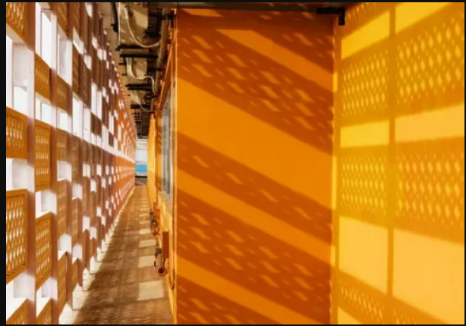
Figure 5: Double Facade in Pearl Academy (Khan, 2021)
Materials:
Locally available materials like stone, glass, and concrete were utilized in the construction, with earthen pots sourced from local potters. Concrete jaalis were also crafted on-site.
Ventilation & Daylighting:
An open-to-sky central courtyard facilitates cross ventilation and unifies the surroundings. Stack ventilation and evaporative cooling techniques contribute to the campus's energy efficiency. The courtyard allows indirect sunlight into classrooms, creating naturally ventilated and lit corridors. For 80% of the operational hours, the campus maintains a comfortable temperature.
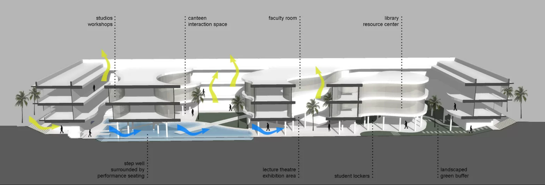
Figure 6: Building Section (Khan, 2021)
The campus, features a single bay design, ensuring natural lighting and cross ventilation. This grid configuration enables daylighting, ventilation, and a flexible partitioning system for future adaptability. Daylight illuminates 90% of the gross floor area.
Insulation:
Traditional earthen pots, used for thermal insulation in India, are employed in the Pearl Academy campus. Placed on the flat roof with a 2.5cm gap in between, these 35cm diameter earthen pots are filled with sand and broken bricks, covered with a thin layer of concrete. The air in the pots acts as insulation for the structure.
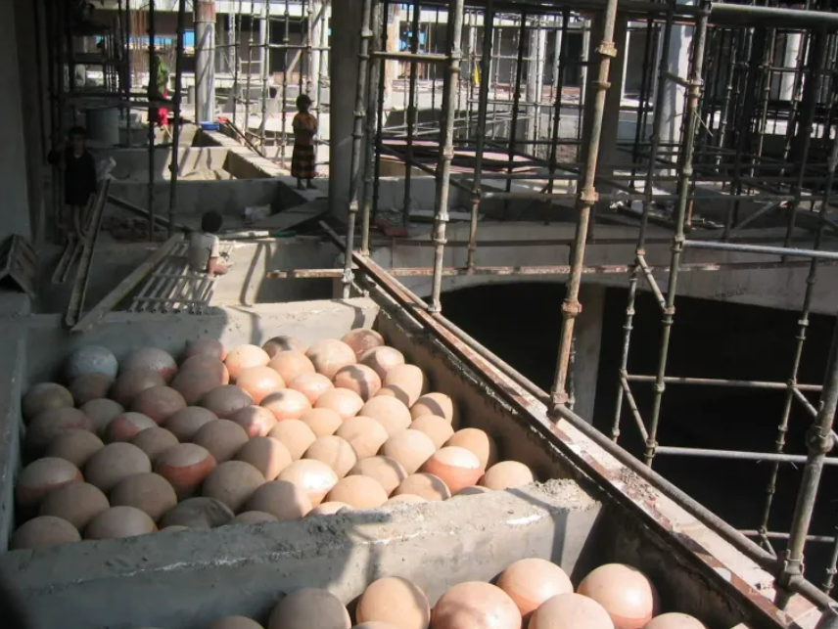
Figure 7: Use of earthern pot for insulation (Khan, 2021)
Landscaping:
30% of the total site area is dedicated to landscaping, creating a thermally comfortable microclimate within the building. A water body, fed by recycled water from the sewage treatment plant, contributes to this microclimate. Green spaces and the water body, mostly shaded, reduce water evaporation and aid in evaporative cooling. During the night, the building dissipates heat to create a thermally comfortable environment. Rainwater harvesting and wastewater recycling through the sewage treatment plant are integral features.
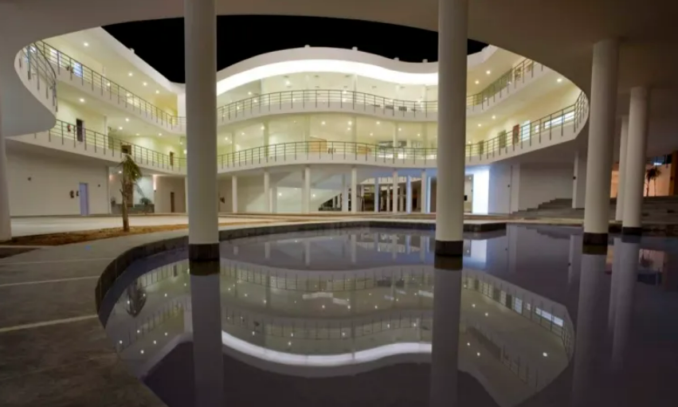
Figure 8: Waterbody in central courtyard (Khan, 2021)
Form Optimization & Orientation:
The building's form is a streamlined rectangle, minimizing exposure to surface area. Classrooms, studios, and offices occupy two stories above in this structure. The thermally banked underbelly features a ramp and serves as a spacious recreation and exhibition area, housing the cafeteria and student spill area. Natural cooling techniques make this area usable throughout the year, even in summers.

References
Alcala, B. J. (1999). Natural Cooling in Hispano-Moslem Residential Architecture: The Case Study of the Court of the Lions and the Court of Comares in the Alahambra (Granada). In S. V. Szokolay (Ed.), PLEA' 99 "Sustaining the Future - Energy, Ecology, Architecture", (pp. 399-406). Brisbane, Australia.
Chadderton, D. V. (2007). Building Services Engineering (5th Edition ed.). New York: Taylor and Francis Group.
Chu, C. (2011). The Pantheon's Passive Systems. Retrieved November 13 2023, from Wordpress: https://cc4jw.wordpress.com/2011/11/10/assignment-4-the-pantheons-passive-systems/
Hui, F. (2023). Beijing Courtyard. Retrieved November 14, 2023, from China Culture: http://en.chinaculture.org/focus/focus/2010expo_en/2010-04/19/content_376827.htm
Joseph B Wujek, F. R. (2010). Mechanical and Electrical Systems in Architecture, Engineering and Construction (5th Edition ed.). New Jersey: Pearson Education Inc.
Khan, A. (2021, July 16). Pearl Academy of Fashion- climate responsive passive habitat. Retrieved November 14, 2023, from Archestudy: https://archestudy.com/pearl-academy-of-fashion-climate-responsive-passive-habitat/
Mariellen. (2018, May 16). Dolat Abad Windcatcher. Retrieved November 14, 2023, from Atlas Obscura: https://www.atlasobscura.com/places/dolat-abad-windcatcher
Moore, D. (1995). The Pantheon. Retrieved November 13, 2023, from Roman Concrete: https://romanconcrete.com/docs/chapt01/chapt01.htm
Pita, E. G. (2002). Air Conditioning Principles and Systems; An Energy Approach (4th Edition ed.). New York: Prentice Hall, Ohio.

