MEC 501 Managerial Economics
Lecture 7
Lecture Topic: Perfect Competition
Lecturer: Dr. Daniel Kungu Njau
Lecture Learning Outcome
- Grasp the concepts around the different market structures.
- Appreciate the nature of a perfectly competitive market.
- Understand the market demand and firms demand under perfect competition.
- Determine the pricing and output decisions of a perfectly competitive firm in the short run and long run.

7.1 Introduction to Markets and Perfect Competition Market Characteristics
Understanding market dynamics is one of the most important critical concepts in economics. A market is an institutional relationship between sellers and buyers. Through mutual interaction, buyers and sellers reach a mutually agreeable price. The interaction can be in person or thorough virtual means like telephone or the internet. A market is therefore key in determining the price at which a particular commodity will be bought or sold at.
It is critical to understand what a market is and its unique characteristics. Market morphology therefore describes the key market structures and characteristics of these structures and help us to understand more about the markets. Based on these, markets can be defined based on the following characteristics.

7.1.1 Nature of the Competition
This generally refers to the distribution, size and number of sellers in the market. A possible market is one with a large number of sellers where each individual seller is small. Think about a large shopping mall with various types of shops in it. Alternatively, there is also a market with one large player without any competitors. This normally applies to large utility firms for water or electricity which are a monopoly.

7.1.2 Nature of the Product
This refers to whether a product is differentiated or homogeneous. A market where sellers produce a similar product can be treated as homogenous while the one where products are different among different sellers is considered differentiated. Homogenous goods can also be treated as perfect substitutes while differentiated goods may differ in packaging, size, quality etc.

7.1.3 Freedom of Entry or Exit
Some markets are difficult to enter because they are specialized. Would be potential players face financial restrictions, legal hurdles and technological constraints. For example, establishing a new telecommunication company is not easy because of the technological constraints, financial hurdles and regulatory hurdles a company has to face. These hurdles create a small group of players in the short run but this can be mitigated in the long run as companies find innovative ways of overcoming these barriers to entry.

7.1.4 Size and Number of Buyers
A typical market consists of two main parties; buyers and sellers. A market can also be defined in terms of number of buyers. A typical market will consist of many small individual buyers but their total sum number is large. A market with many sellers and buyers is considered to be evenly balanced between the two. However, in an exceptional case where the number of buyers is small but their individual size is big, it can be considered to be a buyers’ market since the market is controlled by buyers’ preferences.

Table 1: An Illustration Market Characteristics
Type of Market | Number of Firms | Nature of Product | Number of Buyers | Freedom of Entry and Exit | Examples
Perfect competition | Large | Homogenous | Large | Unrestricted | Agriculture, Unskilled labour
Monopolistic competition | Many | Differentiated | Many | Unrestricted | Retail Stores, Detergents
Oligopoly | Few | Both homogenous and differentiated | Few | Restricted | Cars, computers, universities
Monopoly | Single | Unique | Many | Restricted | Google, Microsoft, Railway Companies
Monopsony | Many | Both homogenous and differentiated | Single | Not applicable | Department of Defense and Military
Source: Author

7.2 Perfect Competition
Perfect competition is the most common type of market that exists in the world today. In a number of markets, the buyers and sellers are usually quite many with none of these controlling the market. The exit or entry of either does not have an impact on the market and remains unnoticeable.
7.2.1 Characteristics of Perfect Competition
Prescence of Large Number of Buyers and Sellers
Generally, there are many suppliers in the market each being of small stature, relative to the overall size of the market. The market has numerous players such that the exit or entry of either a buyer or seller does not impact on the overall composition of the market. Any movement among the players does not exert influence on the market.
Homogenous Products
When products being sold in the market are identical or similar in nature, buyers are unable to discern the product of one buyer firm from another. This normally applies to generic and unbranded products. Therefore, buyers are indifferent to the different products sold by various sellers and will just consider the price and convenience of purchasing the product. For homogenous products, they can be considered to be substitutes.
Freedom of Entry and Exit
In a typical competitive market, there is no barrier to entry and exit. New firms can easily enter the market and old ones can exit. As long as there is a profit to be made, it will continue attracting players into the market while losses and downturns will push players out of the same market. Information asymmetries, where one party takes advantage of the other due to lack of access to information theoretically do not exist.
Perfectly Elastic Curve
We can that the demand curve of a perfectly competitive firm to be perfectly elastic. If a firm decides to charge a higher price than the existing market price, its demand will certainly be zero. This is attributable to buyers who are sensitive to price changes and given that there are many sellers, buyers will opt for a seller whose price is competitive. We can expect the demand curve to be a straight line for a perfectly elastic demand curve.
Perfect Mobility of Factors of Production
Another underlying assumption in perfect competition is the perfect mobility of factors of production. This assumes that resources are free to move from one firm to the other. Resources will be allocated on the basis of returns with resources being channeled to the most viable alternative.

Lack of Government Intervention
In an ideal perfect competition market, there is complete absence of government intervention in the market. There are no taxes, subsidies or regulation to influence the prices in the market. The market has a free reign and the forces of demand and supply are left to act uninterrupted.

The firm is a price taker
In a perfectly competitive market where no single firm is large enough to influence the market price, a single firm therefore becomes the price taker. It has no choice rather than to take the price that is offered by the market and subsequently, it has to conform to the forces of supply and demand as dictated by the market.

7.3 Demand and Revenue of a Firm
For a firm under perfect competition, the concepts of revenue and cost can be expressed in terms of price and quantity. Under the assumption of rationality, we can assume that all firms aim to maximize profits. Additionally, since firms in a competitive market are price takers, then for them to make more profit, they can only adjust the quantity they sell. Therefore, we can safely assume that TR depends on the quantity sold only. The TR is the product of the price and quantity sold. Hence, the Marginal Revenue (MR) can be expressed as follows:

$$MR=\frac{dTR}{dQ}= \frac{d}{dQ}PQ$$
$$=Q. \frac{dP}{dQ}+P. \frac{dQ}{dQ}$$
$$=P$$
Under perfect competition, firms are price takers and can only supply as much as they want at the existing price in the market. This is expressed as follows:
$$AR=MR=P$$
To investigate how much each firm wants to sell, or how much each firm is willing to offer at the prevailing price, we employ the concepts of costs. As illustrated in Figure 1, TR is the total revenue curve which slopes upwards. The total cost (TC) curve in the short run follows the law of variable proportions that we learnt in the previous lecture. Subsequently, profit is derived as the difference between TR and TC. This is illustrated as follows:

Figure 1: An Illustration of Revenue, Cost and Profit Curves of a Firm
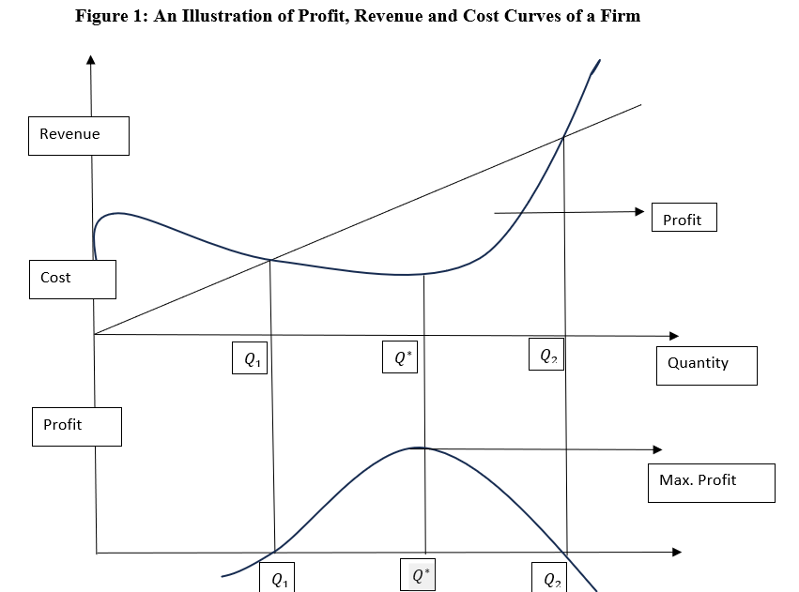
Source: Author
We can observe that in Figure 1, the profit curve starts on the negative axis, implying that as the firms begins operations before reaching point Q1 it starts by making losses. This can be explained by the fact that the firm is yet to reach break even point. Additionally, the initial costs are far much more than the revenues generated. The firms break-even at point Q1. Between points Q1 and Q2, the firm continuously makes a profit. The maximum profit is attained at point $Q^{*}$. Keeping in mind that the objective of every firm is to maximize profits, the relationship between revenues, cost and profit can be expressed algebraically as follows:
$$Max Profit (π)=R \left(Q\right)-C(Q)$$
The first order condition of profit maximization is given as follows:
$$\frac{dπ}{dQ}= \frac{dR(Q)}{dQ}-\frac{dC(Q)}{dQ}$$
$$= 0$$
$$MR-MC=0$$
$$MR=MC$$
The second order condition of profit maximization is given as follows:
$$\frac{dMR}{dQ}= \frac{d(MC)}{dQ}<0$$
The slope of the MR curve < slope of the MC curve. Therefore, to achieve the profit maximizing, there are the profit and revenue maximizing conditions, there is the necessary condition and the sufficient condition. The necessary condition is that marginal revenue is equal to marginal cost. The sufficient condition is that the MC curve cuts the MR curve from below.
Practical Illustration:
Given the following equations: TR = 48Q – Q² and TC =12+16Q+3Q², compute the output that maximizes profit and the amount of the maximum profit.

Solution:
The profit maximizing output can be determined from the condition of profit maximization as follows:
$$MR= \frac{dTR}{dQ}=48-2Q$$
$$MC= \frac{dTC}{dQ}=16+6Q$$
Profit is maximized when:
$$MR=MC$$
$$48-2Q=16+6Q$$
$$Q=4$$
Second order condition:
$$\frac{d^{2}π}{dQ^{2}}= -8<0$$

The profit equation is:
$$π=R\left(Q\right)-C\left(Q\right)=48Q-Q^{2}-\left(12+16Q+3Q^{2}\right)$$
$= -12+32Q-4Q^{2}$
Substituting Q =4:
$$= -12+32*4-4{\left(4\right)}^{2}=52$$

LIST OF REFERENCES
Brian T, ShorFroeb, L. M., McCann, M., & Ward, M. R. (2014). Managerial Economics; A Problem Solving Approach, Third Edition. In Angewandte Chemie International Edition, 6(11), 951–952.
Connelly, B. L., Certo, S. T., Ireland, R. D., & Reutzel, C. R. (2011). Signaling theory: A review and assessment. Journal of Management, 37(1), 39–67. https://doi.org/10.1177/0149206310388419
Thomas, C. R., Maurice, S. C., Viera Valencia, L. F., & Garcia Giraldo, D. (2016). Managerial economics : foundations of business analysis and strategy. In Angewandte Chemie International Edition, 6(11), 951–952. (Vol. 2).
Samuelson, W. F., Marks, S. G., & Zagorsky, J. L. (2021). Managerial economics. John Wiley & Sons.
Calvet, L., de la Torre, R., Goyal, A., Marmol, M., & Juan, A. A. (2020). Modern optimization and simulation methods in managerial and business economics: a review. Administrative Sciences, 10(3), 47.
Balogh, A., Baranyi, D. M., & Trautmann, L. (2022). New Challenges in the Education of Managerial Economics. Köz-gazdaság-Review of Economic Theory and Policy, 17(3), 19-38.
Coles, J. L., & Li, Z. (2020). Managerial attributes, incentives, and performance. The Review of Corporate Finance Studies, 9(2), 256-301.s

