Disaster Management & social Work
Lecture 2
Impacts of Disaster
Lecturer: Victor J B Rana

Introduction
Disaster in any country naturally impedes the development process. But disaster is also seen as a blessing in disguise as it gives us a chance to build back a better nation. But before building back a better nation it is necessary to understand critically, what are the after effects of the disaster in terms of the physical, economic, social, & ecological fabric of the nation. In order to have a deeper understanding of that, it is imperative we understand pre disaster conditions that might give some insight on where we were lacking in our preparedness.
Once we can identify clearly the impacts of the disaster in the various sectors, we can get an in-depth knowledge not only on our reconstruction & rehabilitation efforts, but also focus on our mitigation & preparedness process for the next big happening. Studying major disasters will help us in identifying the various socio-economical & ecological impact & its consequences.
Topic Objectives
Understanding the major impacts of disaster in terms of social, productive, infrastructure, & cross cutting sectors.
General understanding of the impact of the 2004 Tsunami.
Micro Impacts of Disaster
Impacts on Vulnerable Groups
Question for Discussion
What are the major impacts of disaster?
What were the impacts of the 2004 Tsunami?
What are the micro impacts of disaster?
Who are vulnerable groups & how are they affected?

Model of Disaster Impact
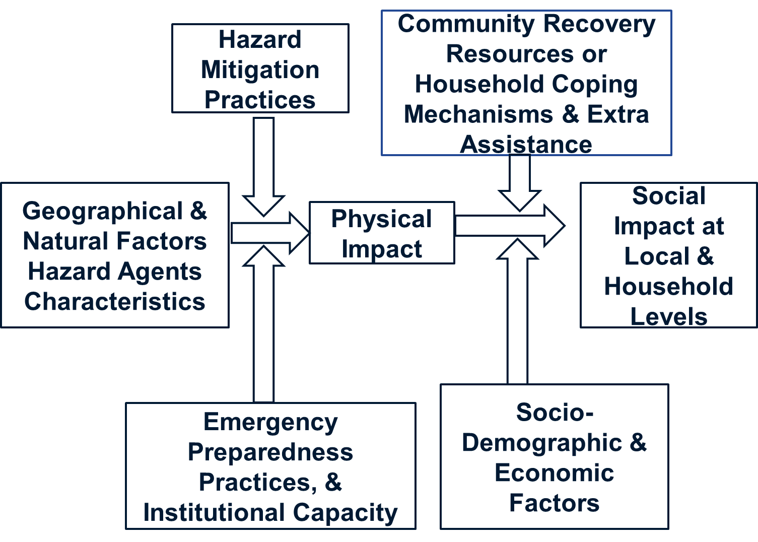
In this model, the first factor that has to be analyzed is the geographical & natural hazard characteristics. Geographical factors deal with factors like where we are situated, the type of terrain, slope configuration, & hydrology. For example, if the country is situated in a fault line, earthquakes can occur. Similarly hazard characteristics will tell us when previous earthquakes have occurred, the time duration, the impact, & the time period it has not reoccurred. The more time duration it has not occurred, it can be more devastating.
Hazard mitigation practices is the understanding of the first factor & plans to reduce or minimize the impact of a hazard. Institutional capacity & emergency preparedness will help us understand how a nation is prepared to manage the impact of disaster once it occurs. The aim is to minimize the loss in lives & properties. So, if a nation has well-established & functional institutional mechanism from the national to the local level & a well-prepared response plan, the impact of disaster will be minimized & the resiliency maximized.
After analyzing the first three factors will give us a picture of the physical impact of a disaster like loss of lives, injuries, infrastructure damage. The fourth factor community & individual coping resources will produce outputs like the resiliency, recovery, & coping mechanism of the community or individuals. The more prepared & resilient they are, they can recover fast otherwise they will need external assistance. The fifth factor socio-demographic & economic factors will give us a picture of total population, disaggregated data, livelihood, & income status which will determine the vulnerability of the impact
The analysis of the physical impact, the coping capacity, economic, & vulnerability factors will give an estimate of the social impact of the disaster at the local & household levels. For example, if the community is poor & vulnerable the disaster will have destroyed their homes & livelihood, rendered them homeless, & will need financial assistance to rebuild their homes & livelihood.
Vicious Cycle of Disaster Impact
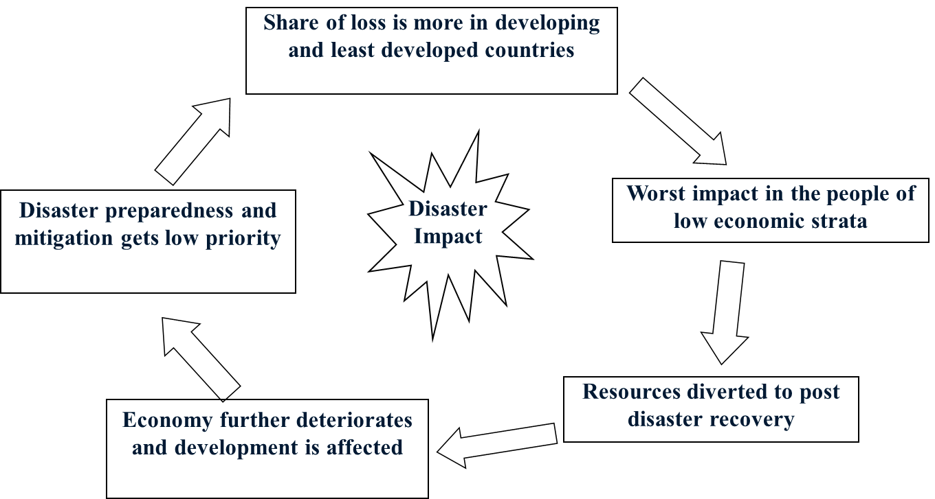
Less developed countries bear the brunt of disaster loss because as its’ GDP is relatively small where minor impacts of a disaster can have greater percentage of economic losses. People living below the poverty level are impacted more because they have difficulty in recovering because of limited resources low resiliency. Furthermore, should a disaster occur, the focus of government spending will be diverted to rebuild the disaster affected infrastructure. Once the limited budget that would have been spend on development gets diverted to post disaster recovery, economic activities & GDP will decline. Government will have to focus on post disaster recovery which means less attention & resources will be allocated for mitigation & preparedness activities. A next disaster could be more damaging & the cycle continues.
Impact/Effects of Disaster
Social Sector
Productive Sectors
Infrastructure Sectors
Cross Cutting Sectors
Social Sector Impact
Housing & Human Settlements- People’s housing, apartments, & villages may be destroyed or damaged. Deaths, injuries, disabilities can impact the population. Government administrative buildings may be affected.
Health- Hospitals, nursing homes, health posts, & pharmacies may not be functional depriving the population with required health services. Various diseases may spread.
Education- Schools, colleges, & vocational training centers may be destroyed or damaged barring students from continuing their education.
Nutrition- Pregnant mothers & lactating children may not get the proper diet & food.
Cultural Heritage- Temples, churches, & masjids may have been destroyed or damaged which will have sentimental value on the population.
Productive Sector Impact
Agriculture- Farms, crops, agriculture equipment, & livestock can be destroyed by the disaster & it may take long to recover.
Irrigation- Canals & pipes may be damaged preventing essential nutrients for the plants.
Commerce- People may not be able buy food as the market may be destroyed or delivery of essential goods has been obstructed by damaged roads. Therefore, there is no buying & selling of goods.
Industry- Factories may have been damaged or destroyed or raw materials may not be available. Production will be limited or closed.
Tourism- Due to destroyed hotels, transportation system, or trekking routes, the flow of tourists will be limited endangering the tourism sector.
Finance- With limited commerce, industrial production, & tourism, government will receive less revenue, banking sector will shrink, & the overall economy decline.
Infrastructure Sector Impact
Electricity- Power generation plants, dams, & transmission lines may be damaged or destroyed.
Transport- Road, rail, & air transport may be affected. Roads, bridges, railway lines, & airports may not be functional.
Community Infrastructure- Age old homes & recreational areas may be destroyed or damaged.
Communication- Telephone lines, tower may be dysfunctional making it difficult to communicate & send information.
Water & Sanitation- Pipe lines, water storage tanks may be disrupted leading to scarcity of drinking & home use water. Debris & carcass could bring epidemics if hygiene practices are not enforced
Cross-Cutting Sector Impact
Governance- Key personnel may have died, offices may have been destroyed, & emergency management practices may be lacking leading to difficulties in response operations.
Communication- Due to damaged communication systems, directives & information cannot be delivered in time.
Environment & Forestry- Forest may be destroyed or landslides may cause environmental damage which can affect the overall recovery strategy.
Employment & Livelihood- Factories closure means workers don’t have a means of livelihood.
Social Protection- People will have difficulties in getting basic services like food, water, health, & education.
Gender & Social Inclusion- Woman & children may be more affected by the disaster. They may face social exploitation, harassment, & trafficking.
Disaster Risk Reduction- With infrastructure, economy, & livelihood affected by the disaster, post disaster recovery will have to factor the DRR in all the sectors.
The seven cross-cutting issues need to be mainstreamed into the recovery strategy to ensure a holistic assessment. Each sector specialist has the responsibility to address the cross-cutting issues. Each cross-cutting specialist needs to integrate information from the productive, social, & infrastructure sector.
How to Address Cross-Cutting Issues?
Standalone cross cutting factors that individually affect the social, productive, & infrastructure sector will have to be analyzed.
Example Gender
In each sector chapter, whenever possible disaggregate sector data by gender. Analyze the different effects and impact in the sector on women and men, girls and boys (e.g. mobility, access and control of resources, influence on decision making, and roles and responsibilities at household and community level).
In a stand-alone chapter, provide context and baseline analysis of gender in affected country. Analyze the different effects and impact across all sectors on women and men, girls and boys
Economic Shocks
- Damage
- Total or partial destruction of buildings, infrastructure, stocks, natural resources
- Occurs during or immediately after
- Measured in physical terms & monetary value assigned
- Losses-Macro-Economic Impact
- Change in economic flows caused by disaster
- Production not obtained & higher production costs
  - Higher operational costs and lower revenues in the provision of essential services
  - Unexpected expenditures (humanitarian assistance, demolition and debris removal, relocation of human settlements)
  - They occur from the time of the disaster until full reconstruction and economic recovery are achieved
- They are measured in monetary terms at current prices
Timings of Disaster Effects
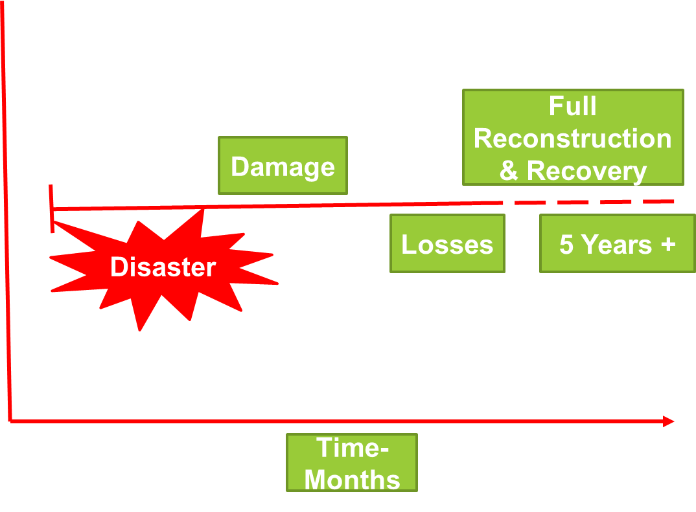
Primary/Secondary Perils
In the present context, many countries have insurance policy coverage for various disasters. In doing so disasters are categorized into primary peril, independent secondary perils, & secondary perils. The effects of primary perils are well established in the insurance industry. They know exactly what the impact of earthquakes or cyclones will be & the damages & losses that will have to be covered. Independent secondary perils like flash flood or landslides don’t have exact modelling to anticipate the damages & loss. Secondary perils are the after effects of a primary peril like tsunami after an earthquake or fire following an earthquake. Secondary perils also do not have an exact damage & loss chart to standardize an insurance policy. Statistics of global insured losses from 2023 reveals that there are more insurance losses from secondary than primary perils.

26th December, 2004 Indian Ocean Tsunami Key Takeaways are as Follows:
8 AM -9 Richter Scale earthquake send waves travelling at 800 Km/Hr, 24 M high, & energy release of 25 Hiroshima Bomb. It affected 10 countries & more than 220,000 people died. A similar tsunami occurred in 1883 in Western Sumatra after an explosion & collapse of Krakatao volcano killing 36417 people. Asia has experienced big disasters in the past century: 1970 cyclone in Bangladesh killing 500000 people & in 1976, a 7.8 magnitude earthquake in China killing 255000 people. In the 2004 Tsunami, the island of Simeule, off Acheh which was only 40 kms from the epicenter only suffered 7 fatalities because the community was well aware & prepared. Whereas, the island of Nias which was 150 kms away suffered 150 fatalities because they were not aware & ill prepared.
The total impact of the tsunami for the five countries, Indonesia, Thailand, India, Sri Lanka, & Maldives was US $ 9930 million. Thailand suffered more losses in its productive sector as its tourism & fishing industries were badly affected. The total damage was US $ 508 million (21%) & losses US $ 1690 million (79%). Indonesia suffered damage of US $ 2920 million (66%) & losses US $ 1531 million (24%)
In the 5 countries the damages & losses were as follows:
- Social sector damage- US $ 2531 million & losses-US $ 122 million
- Productive sector damage- US $ 1559 million & losses-US $ 3342 million
- Infrastructure sector damage- US $ 1136 million & losses-US $ 500 million
- Cross cutting sector damage- US $ 371 million & losses-US $ 403 million.
- Total damages were US $ 5597 million (63%) & losses US $ 4367million (37%).
- Most impact was in the housing sector followed by transport.
- Thailand had the highest per capita impact of US $ 8104 followed by Maldives US $ 2009.
Tsunami was a global disaster affecting 2 continents & presented a huge logistic challenge because of the large number of supplies to be concentrated, transported, managed, & distributed. No Tsunami Warning system was in place in the Indian Ocean then, which initiated the Global Tsunami Monitoring System development. The international community & the affected country realized the importance of reinforcing Early Warning & Public Awareness to lessen the impact of disaster.
Besides the global aid from individual countries & agencies, citizens & corporate houses contribution was large. Previously total aid amounted to US $ 40/Person compared to US $ 1000/Person in this disaster. However, actual aid flow did not match the initial pledge & the institutional mechanism was inefficient leading to delay in reconstruction.
There was duplication of aid efforts due to lack of institutional capacity to manage disaster of that magnitude. Tourist destinations in Thailand, Indonesia, & Sri Lanka were most affected because of infrastructure being built 300 meters inside the coastline against government regulations, extensive coral reef mining, destruction of coastal mangrove trees which provided a shield, & using dynamite to catch fish. Disaster planning was present but with the absence of a matching preparedness, readiness, & policies, the most vulnerable against natural calamity was not protected.
Micro Level Impacts
At the individual and household level, natural disasters can have profound and multifaceted impacts, affecting physical, emotional, and financial well-being. These impacts can be immediate and long-term, depending on the severity of the disaster and the ability of individuals and households to recover. While recovery is possible, it often takes time and resources that many individuals and families may struggle to access. The long-term impacts can perpetuate cycles of poverty, vulnerability, and inequality.
Physical Impacts- The physical micro-level impacts of natural disasters refer to the tangible, direct effects that occur on individuals, households, and small communities. These impacts include damage to physical assets, health, and local infrastructure that directly affect day-to-day living conditions and survival. These impacts often compound one another, making recovery a long and difficult process for those affected. Example of some key physical micro-level impacts:

Damage to Homes and Shelter
•Complete/Partial destruction of homes: Natural disasters such as earthquakes, landslides, & Tsunami can completely destroy buildings & homes. Partial damage may occur where it is unsafe for staying. Rebuilding will cost extra finances.
•Utility failure: Damage to electric poles, internet lines, & gas pipelines may render those services dysfunctional.
Loss of Personal Property
•Destruction of belongings: Individuals may lose personnel belongings like food, clothing, TV, & vehicles. These losses impact their comfort, ability to work, and long-term financial security.
Health Impacts
•Physical injuries: Various disasters can cause physical injuries such as fractures, cuts, burns, and head trauma.
•Death and trauma: Loss of life is one of the most devastating effects of disasters. This will cause emotional & social effect at the household level.
•Illness from poor conditions: After disaster due to bad hygiene & polluted water supply, there is the danger of endemics occurring.
Food Insecurity
•Depleted food stockpiles: Many households will lose stockpiled food or food may be inedible due to lack of refrigeration.
•Disrupted agricultural production: Crops, fishery, & livestock may be destroyed leading to lack of consumption, income, & livelihood.
Loss of Infrastructure
•Damage to roads and transportation: Damaged roads, bridges, airports, & transport system prevent people from accessing critical services like healthcare, education, and markets, isolating communities and delaying recovery efforts.
Environmental Degradation
•Soil erosion and land degradation: Floods and landslides will lead to soil erosion & polluted soil where crops can’t be grown
•Loss of forests and natural resources: Households dependance on fuel, building materials, and food can be destroyed by fire & hurricanes which destroy the forest & ecosystem.
Loss of Community Infrastructure
•Schools and education centers: Schools can be damaged or destroyed leading to interruption in education. Some schools may be used as shelters delaying opening of schools.
•Public services: Damage to government buildings, law enforcement office, & other services will affect the relief effort & recovery will take longer in the absence of governance.
Displacement and Temporary Shelter
•Evacuation and relocation: Many families are forced to evacuate their homes and relocate to temporary shelters, camps, or live with relatives. These shelters often lack adequate facilities for large numbers of displaced people & overcrowded leading to discomfort & health risks.
Disruption of normal life: Living in shelter is uncomfortable leading to lack of essential services.
Economic Impacts- The microeconomic impacts of natural disasters primarily affect individuals, households, small businesses, and local communities. These impacts can disrupt local economies, livelihoods, and financial stability, creating long-term challenges for recovery. Recovery from these impacts can take years, particularly for low-income households and small businesses, as they often lack the resources and safety nets necessary to bounce back quickly. Major examples of microeconomic impacts are:
Loss of Income and Employment
•Job loss: Natural disaster will affect tourism, production units, & other businesses where people are employed.
•Reduced productivity: Due to destroyed factories, lack of raw materials, & reduced workforce productivity will decline
•Impact on informal workers: Many informal workers, such as street vendors, day laborers, or gig workers, often lose their source of income without any social safety nets, exacerbating poverty.
Disruption of Local Markets and Supply Chains
•Supply chain interruptions: Disasters can disrupt transportation networks causing delivery of goods & services difficult & reducing the availability of essential products.
•Price volatility: Disasters can cause supply chain disruptions leading to increased prices for food, water, and other basic goods due to shortages.
•Loss of local businesses: The closure of small businesses and local markets reduces competition and consumer choice, leading to higher prices for goods and services.
Increased Household Expenditure
•Rebuilding and repair costs: Individuals need to spend money on rebuilding or repair costs leading to loss of savings & accumulation of debt.
•Medical expenses: Without health insurance individuals & family will have to pay large amount of health costs.
Social Inequality and Vulnerability
•Disproportionate impact on low-income households: Poorer households often face greater challenges in recovering from disasters due to a lack of savings, insurance, and access to credit. They may also live in more disaster-prone areas, such as floodplains or informal settlements.
•Unequal access to aid: Vulnerable groups, such as low-income families, the elderly, and marginalized communities, may receive less aid or face delays in accessing financial assistance, exacerbating social and economic inequality for individuals, perpetuating cycles of poverty.

Dependence on Aid and Assistance
•Government and NGO aid: External aid is necessary for short-term relief, but over reliance can delay self-sufficiency and economic recovery.
•Remittances: Households may rely on remittances from family members living abroad to cover basic needs and rebuilding costs, increasing dependence on external financial support.
Social Impacts- Refers to the effects on individuals, households, and local communities in terms of social structures, relationships, well-being, and cohesion. These impacts often extend beyond the immediate physical and economic damage, influencing long-term social dynamics and quality of life. Recovery efforts must address not only the physical damage but also the deep social and psychological consequences of disasters to promote long-term resilience and well-being. Here’s an overview of the key social impacts at the micro level:
Displacement and Relocation
Loss of home and community: Individuals and families are often displaced from their homes which can disrupt social ties with families & friends.
- Forced relocation: A sense of non-belongingness can prevail in temporary shelters.
- Overcrowding in shelters: Temporary shelters may become overcrowded, leading to a lack of privacy and heightened tension among displaced individuals, which can strain relationships and create conflict.
Disruption of Social Networks
Fragmentation of communities: Displacement and the destruction of homes and public spaces can break up close-knit communities. When individuals are scattered to different locations, it weakens local support systems that are essential for coping and recovery.
- Loss of informal support systems: Many communities rely on informal support networks, such as friends, neighbors, and extended family, for childcare, financial help, and emotional support. These networks may be disrupted or destroyed by displacement and death.
- Difficulty in re-establishing connections: Rebuilding social networks after displacement or relocation can take time, and individuals may struggle to create new connections in unfamiliar places.
Impact on Family Dynamics
- Role strain: The aftermath of a disaster often leads to role changes within families, with some members taking on more responsibilities, such as caregiving, financial support, or managing recovery efforts. This can create stress and tension within the family unit.
- Gendered impacts: Women and girls may face increased vulnerability and additional caregiving responsibilities, including looking after injured or sick family members. They may also experience greater economic and social hardship, especially in patriarchal societies.
- Strain on marriages and relationships: The stress of losing a home, income, and social structure can lead to increased tension in marital relationships. Financial hardship and emotional strain can result in conflict, separation, or even domestic violence.
- Children’s dependence on caregivers: Children who experience trauma and disruption may become more dependent on their caregivers, placing additional emotional and physical strain on parents or guardians.
Social Inequality and Vulnerability
- Disproportionate impact on vulnerable groups: Marginalized groups such as low-income households, women, children, the elderly, and people with disabilities often experience the greatest social challenges. Their limited access to resources makes recovery more difficult.
- Increased vulnerability for the poor: Poor families often live-in disaster-prone areas (such as informal settlements or floodplains) and lack the resources to rebuild or relocate. Social inequality can worsen as they struggle to access recovery assistance.
- Heightened exposure to exploitation: Vulnerable groups, especially women and children, may face increased risks of exploitation, including human trafficking, abuse, or forced labor, in the aftermath of a disaster due to their precarious social and economic situation.
- Health and Social Well-Being
- Impact on physical health: Disasters often lead to a decline in public health due to the lack of clean water, sanitation, and healthcare services. This can cause outbreaks of diseases, exacerbating social challenges.
- Access to healthcare: Damage to healthcare infrastructure and facilities can prevent individuals from receiving necessary medical care. Vulnerable groups such as the elderly, pregnant women, and people with chronic illnesses may face severe health risks.
- Long-term well-being: Chronic stress, poor living conditions, and lack of access to basic needs (food, clean water, shelter) can lead to long-term declines in health and social well-being, affecting individuals’ ability to work, care for their families, or participate in community life.
Gender-Specific Impacts
- Increased domestic and gender-based violence: Natural disasters often exacerbate gender-based violence. The stress of displacement, financial hardship, and loss of social order can lead to an increase in domestic violence against women and children.
- Women’s caregiving burden: Women often take on the majority of caregiving responsibilities during recovery, such as looking after children, elderly relatives, and the sick. This can limit their ability to engage in paid work, further deepening gender inequalities.
- Barriers to reproductive health services: Disasters often disrupt access to reproductive health services, including prenatal care, contraception, and safe childbirth, placing women and girls at increased risk of maternal mortality and unintended pregnancies.

Cultural and Religious Impacts
- Loss of cultural heritage: Destruction of culturally significant sites, such as religious buildings, historical landmarks, and community spaces, can erode local identity and cultural continuity, especially for indigenous or minority communities.
- Role of religion in recovery: Religious institutions often play a critical role in providing emotional support, organizing relief efforts, and fostering a sense of hope and unity during and after a disaster. For many, faith-based communities serve as a source of strength and resilience.
Psychological Impacts- These impacts can be immediate or long-term, deeply affecting the well-being of survivors, their families, and their communities. the micro-level psychological impacts of natural disasters encompass a wide range of emotional, cognitive, and behavioral effects. Survivors may experience acute stress, anxiety, PTSD, depression, and grief, which can persist for months or years. In the context of natural disasters, certain groups are more vulnerable due to their social, economic, and physical circumstance. The following are key psychological impacts experienced at the individual and household level:
Acute Stress and Anxiety
- Shock and disbelief: In the immediate aftermath of a disaster, individuals often experience shock and disbelief, struggling to comprehend the scale of destruction and loss. This can create intense feelings of helplessness and fear.
- Heightened anxiety: Survivors may experience anxiety about their safety, the well-being of loved ones, and uncertainty about the future. Fears of subsequent disasters (e.g., aftershocks or future storms) may also intensify anxiety.
- Post-Traumatic Stress Disorder (PTSD)
  - Flashbacks and nightmares: Individuals exposed to life-threatening situations or the loss of loved ones during a disaster are at risk of developing PTSD. Symptoms can include flashbacks, intrusive thoughts, nightmares, and emotional numbness.
- Hypervigilance: PTSD sufferers may become hypervigilant, constantly on alert for danger or signs of another disaster, which can interfere with daily functioning and relationships.
- Avoidance behavior: Those affected by PTSD may avoid certain places, people, or activities that remind them of the traumatic event, further isolating them from support systems.
Depression
- Sense of loss and hopelessness: The destruction of homes, livelihoods, and the death of family members or friends can lead to overwhelming feelings of sadness, loss, and despair. Depression may develop as individuals struggle to rebuild their lives.
- Lack of motivation: Survivors experiencing depression may feel exhausted, lack motivation, or lose interest in activities they once enjoyed. This can hinder recovery efforts, such as finding work, rebuilding homes, or engaging in social activities.
- Isolation and withdrawal: Depression often leads to social withdrawal, as individuals may feel they cannot connect with others or that their struggles are unique. This can exacerbate feelings of loneliness and reduce access to emotional support.
Grief and Bereavement
- Loss of loved ones: The death of family members or friends in a disaster can trigger intense grief, which may be complicated by the sudden and traumatic nature of the loss.
- Ambiguous loss: In cases where loved ones are missing or unaccounted for, survivors may experience "ambiguous loss" a type of grief where there is no closure, which complicates the healing process.
- Guilt and survivor’s remorse: Survivors may experience guilt for having lived through the disaster while others did not, leading to feelings of unworthiness or remorse.
Chronic Stress and Fatigue
- Prolonged stress: The lengthy process of recovery, rebuilding homes, and securing financial stability can lead to chronic stress. Ongoing challenges such as dealing with insurance claims, finding new employment, or relocating can extend this stress for months or years.
- Exhaustion and burnout: The physical and emotional toll of disaster recovery can lead to burnout. Individuals may feel mentally and physically exhausted, unable to continue efforts toward recovery, leading to a sense of defeat or despair.
Cognitive Impairments
- Difficulty concentrating: After a disaster, individuals often report difficulty focusing or making decisions. This can affect their ability to handle complex recovery tasks, such as navigating relief processes, organizing resources, or planning for the future.
- Memory problems: Trauma and stress can impair short-term memory, making it difficult to remember appointments, tasks, or important information needed for recovery efforts.
Sleep Disturbances
- Insomnia: Survivors often experience trouble sleeping due to anxiety, fear, and stress. The lack of a safe and comfortable environment, particularly for those displaced or living in temporary shelters, can exacerbate sleep problems.
- Nightmares and flashbacks: Individuals may experience nightmares related to the disaster, making it difficult to achieve restful sleep. These recurring thoughts can perpetuate fear and anxiety.

Development of Phobias
- Fear of natural elements: After experiencing a natural disaster, some individuals may develop phobias related to the event, such as a fear of water (after a flood), fire (after a wildfire), or severe weather conditions (after a storm or hurricane).
- Avoidance of certain environments: People may become fearful of returning to disaster-prone areas or participating in activities that remind them of the traumatic event, leading to restricted lifestyles and avoidance behaviors.
Impact on Children and Adolescents
- Behavioral changes: Children are particularly vulnerable to the psychological impacts of natural disasters. They may display regressive behaviors (such as bed-wetting or clinginess), increased irritability, or aggressive tendencies.
- Separation anxiety: Young children may become overly attached to caregivers, fearing separation or loss, particularly if they witnessed the death or injury of a family member during the disaster.
- Academic difficulties: Trauma and stress can impair children’s ability to concentrate and perform in school, leading to academic setbacks. Disruptions in schooling during and after the disaster can exacerbate these issues.
- Long-term emotional development: Exposure to disasters during childhood can lead to long-term emotional challenges, including difficulty managing emotions, forming healthy relationships, or developing resilience.
Impact on Family Relationships
- Increased family conflict: Stress, anxiety, and grief can strain family relationships. Individuals may lash out or become emotionally distant, leading to misunderstandings or conflicts within the family unit.
- Role changes: Disasters often disrupt traditional family roles, with some members taking on more caregiving or financial responsibilities. These shifts can create tension, resentment, or a sense of inadequacy among family members.
- Domestic violence: Stress from the disaster and the recovery process can sometimes exacerbate domestic violence, particularly in households already experiencing tension or conflict.
Stigma and Shame
- Stigma related to seeking help: In some cultures, seeking mental health support may be stigmatized, leading individuals to suppress their emotions or avoid treatment. This can exacerbate psychological distress and delay recovery.
- Shame related to loss: Survivors may feel ashamed or embarrassed by their loss of property, income, or social status, particularly if they had to rely on aid or government support. This can undermine their self-esteem and mental well-being.

Vulnerable Groups
A more vulnerable group is defined as a group which has some special needs in a disaster & cannot comfortably or safely access & use the standard resources offered in disaster preparedness, relief, & recovery. These vulnerable groups often face heightened risks of injury, displacement, loss of livelihoods, and difficulty in recovery. Their vulnerability arises from a lack of resources, mobility, social protection, or resilience. Here are the key groups that tend to be more vulnerable in natural disasters:

Children
- Physical vulnerability: Children, especially infants and toddlers, are more susceptible to injury, malnutrition, and disease in the aftermath of a disaster. They rely heavily on caregivers for protection and sustenance.
- Psychological vulnerability: Disasters can cause severe emotional and psychological trauma in children, leading to anxiety, depression, and behavioral changes. Displacement and the loss of family members or friends further exacerbate these challenges.
- Disruption of education: School closures, destruction of educational infrastructure, and displacement can interrupt children’s education, with long-term impacts on their learning and development.
Women
- Increased caregiving responsibilities: Women, especially in traditional societies, are often responsible for caring for children, the elderly, and disabled family members. This can limit their ability to evacuate or seek safety during a disaster.
- Gender-based violence: Disasters can exacerbate domestic violence and sexual exploitation, particularly in overcrowded shelters or displacement camps. Women and girls are at a heightened risk of sexual violence and trafficking in these vulnerable settings.
- Economic vulnerability: In many regions, women have lower incomes and fewer savings, which make it more difficult for them to recover financially after a disaster. Women in informal employment sectors, like agriculture or domestic work, are particularly vulnerable.
Elderly
- Health and mobility challenges: Older adults often have reduced physical mobility and chronic health conditions that make it difficult for them to evacuate quickly or access emergency services. Their increased susceptibility to heat, cold, and lack of medical care heightens their risk.
- Social isolation: Many elderly people live alone or are socially isolated, making it harder for them to receive timely help. They may also be more reluctant or unable to access relief services due to physical limitations or lack of transportation.
People with Disabilities
- Mobility and access challenges: Individuals with physical, sensory, or cognitive disabilities may struggle to evacuate, access shelters, or receive critical emergency information. Inaccessible infrastructure further limits their ability to receive aid or healthcare.
- Dependency on medical care: Many people with disabilities rely on specific medications, medical equipment, or support services that may be disrupted during a disaster, making it more difficult to survive and recover.
- Communication barriers: Those with hearing or visual impairments may face difficulties in receiving emergency alerts and instructions, further heightening their vulnerability.
Impact on People with Critical Needs
- Dependent on Life Sustaining Medications Such as HIV/AIDS, on Dialysis, Epileptic, Diabetes, or are Dependent on Medications to Control Conditions & Control Quality of Life such as Pain Medications, Seizure Control Medications, etc
- Dependency upon Health Care Facilities & Health Care Professionals
- In Disasters Pre-Existing Medical Conditions Inhibit Ability to Function & Aggravated by
- Loss of Medicine
- Loss of Health Care Facilities – Hospital, Dialysis Centre, Pharmacies
- Loss of Power- Prevents Access to Nebulizers, Oxygen, Therapy, Suction, etc

Reference Materials
The Indian Ocean Tsunami: Economic Impact, Disaster Management and Lessons, Prema-chandra Athukorala and Budy P. Resosudarmo, Division of Economics, Research School of Pacific and Asian Studies, Australian National University (file:///D:/HGU%202024/HGU%20Lecture%20%20Notes%20PPT/Lecture%202/wp-econ-2005-05.pdf)
Natural Catastrophes in 2023: Gearing up for Today’s and Tomorrow’s Weather Risks, Swiss Re Institute Sigma NO1-2024 Pg 30-35 (www.swissre.com/sigma)
Social and Economic Impact of December 2004 Tsunami Pg 1-49 (Disaster/SW%20575-24/T%202%20Impacts%20of%20 Disaster/social and economic december 2004 tsunami apdc.pdf)

