Disaster Management & Social Work
Lecture 3
Global Initiatives for Disaster Risk Reduction
Lecturer: Victor J B Rana

Introduction
Disaster management traditionally has been understood as to prepare all the agencies of government in an integrated manner to respond to a disaster should it occur & provide relief & rehabilitation in the short term & in the mid & long term. Over the years, although this mechanism worked to prevent additional loss of lives & property, it really did not address the underlying causes of risk during disasters or means to minimize them. At the end of the 20th century, many nations & the UN had come to a realization that this reactive methodology of disaster management did not reduce the causes of disaster, economic cost was rising, & loss of life & property increasing.
The world community at large felt a need to change course from the traditional disaster management cycle to a more forward-looking risk management strategy. Disasters cannot be controlled by human beings, but the scale, intensity, hazard, & risks they pose can be tamed if nations desire to do so. Accordingly, many nations adopted this risk management methodology & have succeeded to a large extent. Accordingly, to materialize the risk management approach, the Hyogo Framework of Action 2005-2015 was formulated. After a review of the Hyogo Framework, the Sendai Framework for Disaster Risk Reduction 2015-2030 was developed & identified reduction of disaster risk as the key outcome by 2030.
Topic Objectives
Historical development of disaster management policies
Understanding the need to change from disaster management to risk management
Scrutinize the Sendai Framework For Disaster Risk Reduction 2015-2030
Understand the UN Office of Disaster Risk Reduction(UNDRR) Strategic Framework 2022
Analyze the paradigm shift from traditional disaster management cycle to disaster risk management continuum.
Understand the institutional mechanism for disaster management.

Question for Discussion
How, historically, disaster management practices & concepts have evolved?
Why was there a need to develop the Sendai Framework for Disaster Risk Reduction?
What major achievements have been made in disaster risk reduction through the Sendai Framework of Action?
What are the objectives & results of the UNDRR Strategic Framework?
How has the traditional disaster management cycle changed to the risk management strategy?
Do you think the approach from disaster management to risk management will be effective in reducing the risks of hazards?
What is the institutional arrangement for disaster management?
Evolution of Disaster Management Practices
UN Gen Assembly Resolution 2034-1965
The resolution covered assistance in case of disasters for response search & rescue & support for rehabilitation & reconstruction. $100,00 emergency fund was also created to support disaster relief.
UN Gen Assembly Resolution 2816-1971
Creation of the United Nations Disaster Relief Office (UNDRO) which advises governments on pre-disaster planning, promote study of prevention & control of disaster, improve national disaster warning systems, & develop disaster contingency plans.
UN Gen Assembly Resolution 44/236- 1989
Develop framework of action for International Decade of Natural Disaster Reduction to disseminate existing & new technical information related to assessment, prediction, & mitigation of natural disasters. All countries to formulate disaster mitigation programs, & establishment of a scientific & technical committee at the UN.
UN Gen Assembly Resolution 49/22A- 1994
Yokohama Strategy for a Safer World calls for promoting and strengthening subregional, regional and international cooperation in activities to reduce natural and other related disasters through prevention, mitigation and preparedness measures. Review of the International Decade of Natural Disaster Reduction (IDNDR), expand technical & financial support for disaster (IDNDR), & increase multi-lateral & bilateral assistance for disaster reduction.
UN Gen Assembly Resolution 54/219- 1999
It was the successor arrangement for the International Decade for Natural Disaster Reduction which emphasized on establishing institutional arrangements for disaster reduction, inter-agency task force at the UN, maximize international cooperation in the field of natural disasters from prevention to early warning, response, mitigation, rehabilitation and reconstruction, including through capacity-building at all levels, & create UN Trust fund for disaster reduction.
Traditional Disaster Management Cycle
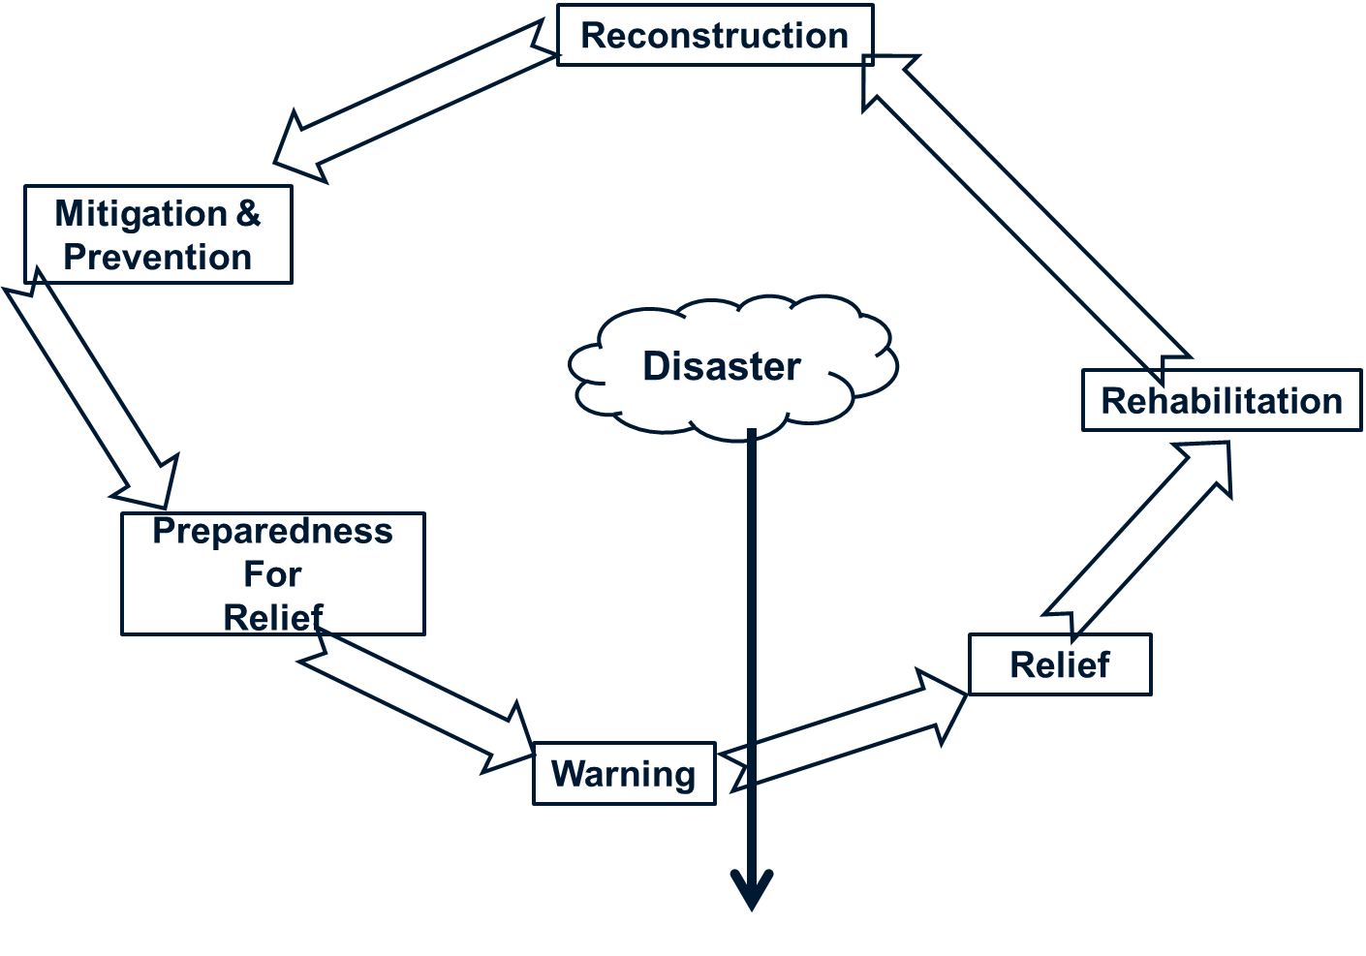
Before the end of the 20th century, disaster management cycle was considered to be linear in nature with each component being carried out one after the other & there was hardly any overlap or synchronization among the components. The major focus of disaster management was to respond to any disaster & conduct rescue & relief activities. Little planning & resources was spent on the other components prior to a disaster.
UN Gen Assembly Resolution 60/195- 2005
International Strategy for Disaster Reduction
It was the International Strategy for Disaster Reduction termed as the Hyogo Declaration and the Hyogo Framework for Action 2005-2015. The main emphasis was on building the resilience of nations and communities to disasters, focus on disaster risk reduction. Similarly, a understanding had been reached that there is a clear relationship between development, disaster risk reduction, disaster response and disaster recovery as well as disaster risk reduction & reducing vulnerability to natural disasters contributes to the achievement of sustainable development.
Paradigm Shift
There was a need to change from the traditional disaster reduction strategy to the disaster risk reduction strategy because economic & human losses were on the rise, disaster risk reduction was a more viable & effective approach than disaster management. The drivers of disaster like unplanned development, climate change, & environmental degradation was increasing the risks of disaster which hampered sustainable development. Additionally, without enhanced capacity development, awareness, & international cooperation, it was difficult to reduce the impacts of disaster.
Hyogo Framework of Action 2005-1015
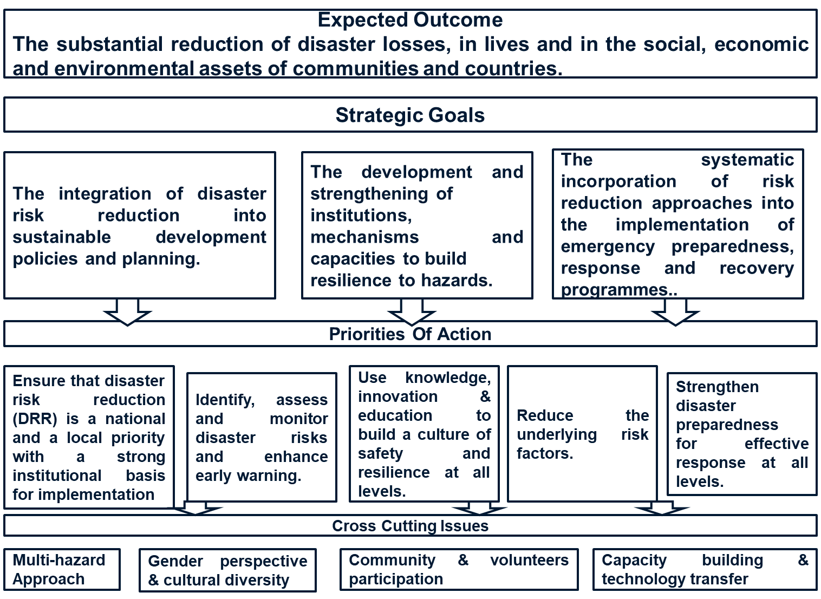
The Hyogo Framework of Action was developed after the Indonesian Tsunami of 2004 when the UN convened a meeting in Japan. Till such times the focus of attention was to respond to disasters & provide rescue & relief services. However, that traditional approach did not prevent disasters & losses of life & property was on the rise. So, a common understanding was reached emphasizing the need to reduce the risk of disasters. In order to achieve this, it was necessary to identify the risks & reduce it, enhance early warning system, strengthen preparedness at all levels. In order to accomplish those objectives three strategic objectives & five priorities of action was developed.
Report Card of HYOGO Framework?
Progress has been achieved in reducing disaster risk at local, national, regional and global levels by countries and other relevant stakeholders, leading to a decrease in mortality in the case of some hazards. Reducing disaster risk is a cost-effective investment in preventing future losses. Effective disaster risk management contributes to sustainable development.
Countries have enhanced their capacities in disaster risk management. International mechanisms for strategic advice, coordination and partnership development for disaster risk reduction, such as the Global Platform for Disaster Risk Reduction and the regional platforms for disaster risk reduction, as well as other relevant international and regional forums for cooperation, have been instrumental in the development of policies and strategies and the advancement of knowledge and mutual learning. Important instrument for raising public and institutional awareness, generating political commitment and focusing and catalyzing actions by a wide range of stakeholders at all levels.
Why HYOGO to SENDAI Framework?
Over the same 10-year time frame, however, disasters have continued to exact a heavy toll and, as a result, the well-being and safety of persons, communities and countries as a whole have been affected. Over 700 thousand people have lost their lives, over 1.4 million have been injured and approximately 23 million have been made homeless as a result of disasters. Overall, more than 1.5 billion people have been affected by disasters in various ways, with women, children and people in vulnerable situations disproportionately affected. The total economic loss was more than $1.3 trillion. In addition, between 2008 and 2012, 144 million people were displaced by disasters.
Evidence indicates that exposure of persons and assets in all countries has increased faster than vulnerability has decreased, thus generating new risks and a steady rise in disaster related losses, with a significant economic, social, health, cultural and environmental impact in the short, medium and long term, especially at the local and community levels.
Recurring small-scale disasters and slow-onset disasters particularly affect communities, households and small and medium-sized enterprises, constituting a high percentage of all losses.
Urgent and critical to anticipate, plan for and reduce disaster risk in order to more effectively protect persons, communities and countries, their livelihoods, health, cultural heritage, socioeconomic assets and ecosystems, and thus strengthen their resilience. Enhanced work to reduce exposure and vulnerability, thus preventing the creation of new disaster risks, and accountability for disaster risk creation are needed at all levels.
Dedicated action needs to be focused on tackling underlying disaster risk drivers, such as the consequences of poverty and inequality, climate change and variability, unplanned and rapid urbanization, poor land management and compounding factors such as demographic change, weak institutional arrangements, non-risk-informed policies, lack of regulation and incentives for private disaster risk reduction investment, complex supply chains, limited availability of technology, unsustainable uses of natural resources, declining ecosystems, pandemics and epidemics.
This conclusion formed the basis for the development of the Sendai Framework, and the subsequent increased emphasis on addressing the underlying drivers of risk, preventing the creation of new risk, reducing the existing stock of risk and strengthening the resilience of nations and communities.
The goal of the framework was to develop resilience of the nation & community by decreasing hazard exposure & vulnerability & increase preparedness. In order to achieve these 4 priorities of action was developed: understanding risk, investing in resilience, strengthening risk governance, & enhancing preparedness & recovery. Certain targets were developed to reduce loss of lives, affected, economic losses, damage to critical infrastructure by 2030 & increase nation with DRR strategies, international cooperation, & multi hazard warning systems & information by 2020.
UN Resolution 72/218- 2015

Sendai Framework of Action 2015-2030
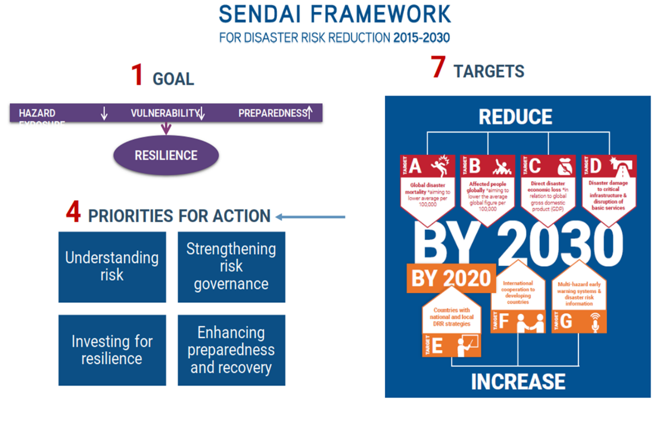

Report Card of Sendai Framework of Action
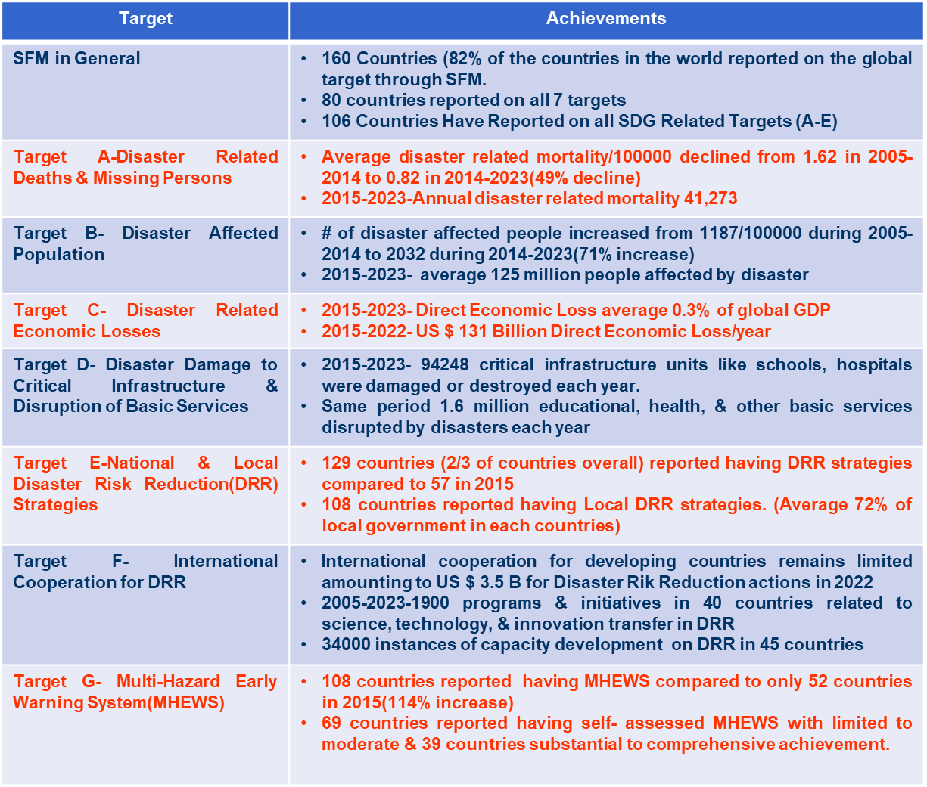
The Sendai Framework of Action has developed a Sendai Framework Monitoring System (SFM) where countries report annually on the progress of the 7 targets as well as the Sustainable Development Goal targets. The global reporting status of 2024, clearly indicates achievements in some targets like nations with DRR strategies & multi hazard early warning system. Other targets like disaster affected people, economic losses, & damage to critical infrastructure requires improvement.
UNDRR Strategic Objectives 2022
UN has developed 4 DRR strategic objectives to supplement the Sendai Framework of Action. The main objectives of the strategy are as follows:
Countries use quality information & analysis to reduce risks & inform development decesions.
Disaster risk reduction governance strengthened at global, regional, national, & local level.
Catalyze investment & action in disaster risk reduction through partnerships & engagement with stakeholders.
Mobilize governments & other stakeholders through advocacy & knowledge sharing to make disaster risk reduction central to sustainable development.
Global Risk Matrix
The figures below depicts the increase in the components of hazard, exposure, vulneranbility & scale of disaster from 2005 to present. This makes it more complex for us to manage disasters. It has to be managed in a holistic way encompassing all the components.
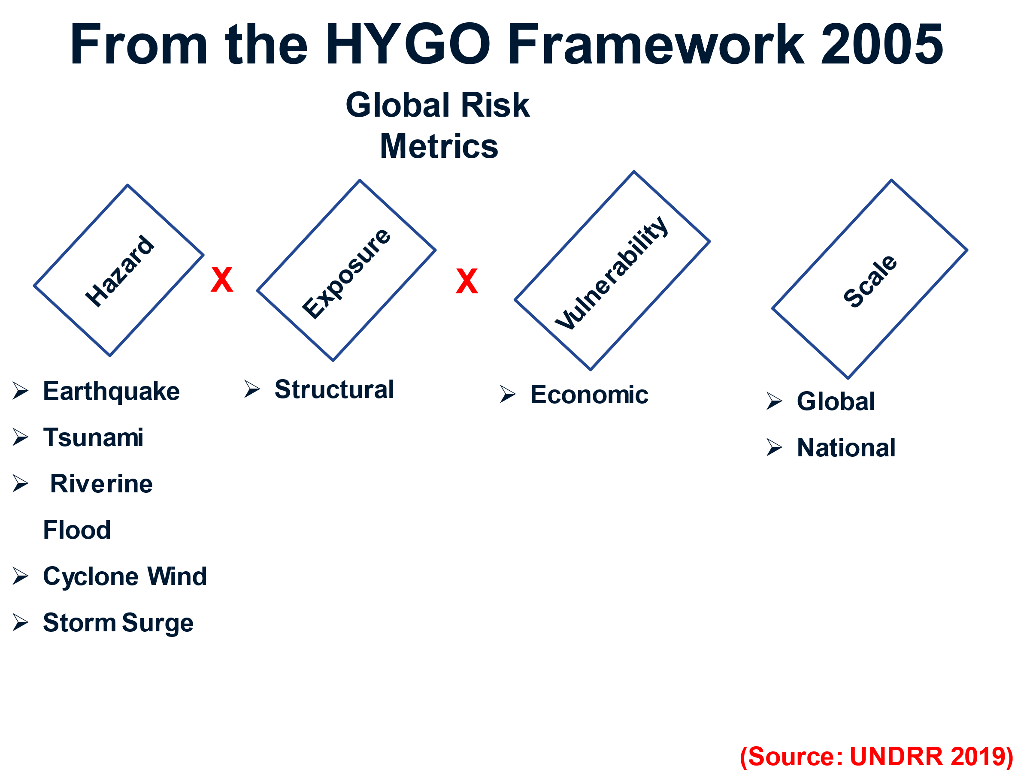

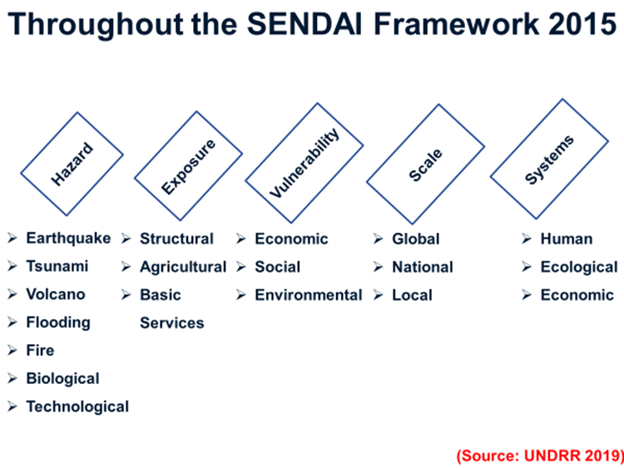
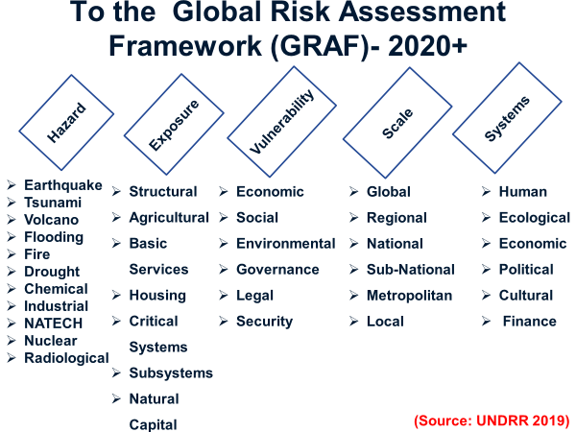
Development of Disaster/Development/ Environment Nexus
Disasters can’t be seen as a phenomenon in isolation. There are other factors like Sustainable Development Goals, urbanization, climate change, environmental degradation that can increase or decrease the level of impact of disaster or for that matter disaster can also create impediments on the progress of the above factors. Therefore, currently in the international arena, various forums, policies, & practices are reviewed & prepared holistically so that all the effects & salient points of all the components are considered leading to a Risk Confirmed Sustainable Development.
Asian Disaster Preparedness Centre (APDC)
The vision of APDC is for safer communities and sustainable development through disaster risk Reduction with the goals of supporting countries in Asia & the Pacific to mainstream disaster risk reduction and climate change adaptation in development. Support communities and countries in to establish systems and capacities that reduce disaster and climate risk impacts. Serve as a pro-active and responsive regional resource center for disaster risk reduction and climate change adaptation. Promote and share disaster risk reduction and climate change adaptation knowledge and experience as a strong partner and networker. Serve as an incubator for innovation to address challenging and emerging issues in disaster risk reduction and climate change adaptation.
Institutional Framework for Disaster Risk Reduction & Management (DRRM)
The Sendai Framework of action envisions that each nation develop policies & plans in their respective countries in accordance with the framework. Respective DRRM policies of each nation should encompass an institutional framework. The structure must be established at the national, provincial, district, & local level. Each level should maintain horizontal & vertical coordination with higher echelons & other government agencies. The main responsibility of the national DRRM is to formulate plans & policies whereas the lower echelon agencies are the implementing agencies. Most nations have this form of structure tailored to their administrative structure.
In every country there is a full-time agency usually termed as National Disaster Risk Reduction & Management Authority (NDRRMA). It is the nerve center & focal point for disaster related activities. It will coordinate & implement the policies, guidelines stipulated by the national authorities. It will also coordinate with all the disaster related stakeholders national or international. For the daily functioning of this authority, a National Emergency Operation Centre (NEOC) is also created which is 24 hours functional. The level of activation of the NEOC is dependent on the type & level of disaster. Emergency Operation Centers are also established at all other levels.

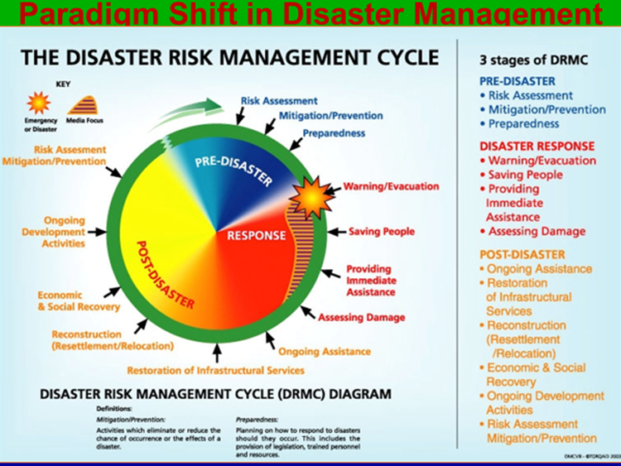
Earlier we discussed about the traditional disaster management cycle. After the Sendai Framework of Action, Disaster Risk Management Continuum has been developed which includes three phases, pre-disaster, response, & post- disaster. The phases are not stand alone but many activities in the response phase will have to be conducted in the post-disaster & pre-disaster activities. We will be learning each phase in the upcoming lessons.

References
APDC Brochure, Pg 1-6
Hyogo Framework of Action 2005-2015 Pg 1-28
Sendai Framework for Disaster Risk Reduction Pg 1-37
SFM Snapshot 2024
UNDRR GAR Special Report 2023, Pg 6-37
UNDRR Annual Report 2022. Pg 1-9

