Disaster Management & Social Work
Lecture 4
Pre-Disaster Vulnerability/Risk Assessment
Lecturer: Victor J B Rana

Introduction
A disaster occurs when an extreme event exceeds a community’s ability to cope with that event. The effects of a disaster are determined by three preimpact conditions- hazard, exposure, & vulnerability. It is important to understand each of these phenomena to understand the risk posed by a disaster. With the absence of any one of these factors, no disaster will occur. It may not be possible to negate any one or all of these factors, but certainly the aim should be to minimize the scale of these factors which in turn will reduce the risks. Therefore, it is important each nation as well as its local bodies conduct Hazard Vulnerability Analysis to understand the risk posed by various disasters. An important international tool that quantifies the amount of disaster risk of any one country is the Index for Risk Management (INFORM) is. It is updated annually.
Topic Objectives
Understanding the connection between hazard, exposure, vulnerability, & risk
Learn about the Index on Risk Management (INFORM)
Demonstrate an understanding of tool used to evaluate hazard, vulnerability, & risk analysis
Question for Discussion
What is the difference among hazard, vulnerability, & risk & their inter- relationship?
What is the INFORM & why is it useful in Disaster Risk Assessment & Management?
What is hazard vulnerability analysis, its usefulness & the process involved?

DRMC
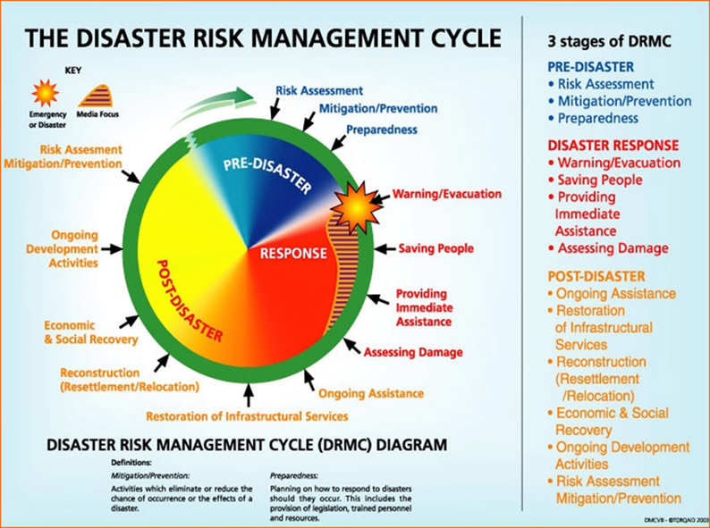
Terminologies
➢ Natural Hazard (H): the probability of occurrence, within a specific period of time in a given area, of a potentially damaging natural phenomenon.
➢ Vulnerability (V): the degree of loss to a given element at risk or set of such expressed on a scale from 0 (no damage) to 1 (total loss).
➢ Elements at Risk (E): the population, buildings and civil engineering works, economic activities, public services, utilities and infrastructure, etc. at risk in a given area.
➢ Specific Risk (S): the expected degree of loss due to a particular natural phenomenon and as a function of both natural hazard and vulnerability. (S= H X V)
➢ Risk (R): the expected number of lives lost, persons injured, damage to property and disruption of economic activity due to a particular natural phenomenon, and consequently the product of specific risk and elements at risk.
➢ From this perspective, risk may be defined as shown-Risk = E X S = E X H X V (given that S = H X V )
Types of Vulnerability
There are various types of vulnerabilities which can affect the degree of impact a hazard will cause to life & property. It could be due to poverty, institutional weaknesses, lack of awareness & education, & social disintegration. Measured on the scale of 0 to 1. Here are some of the examples of vulnerability:
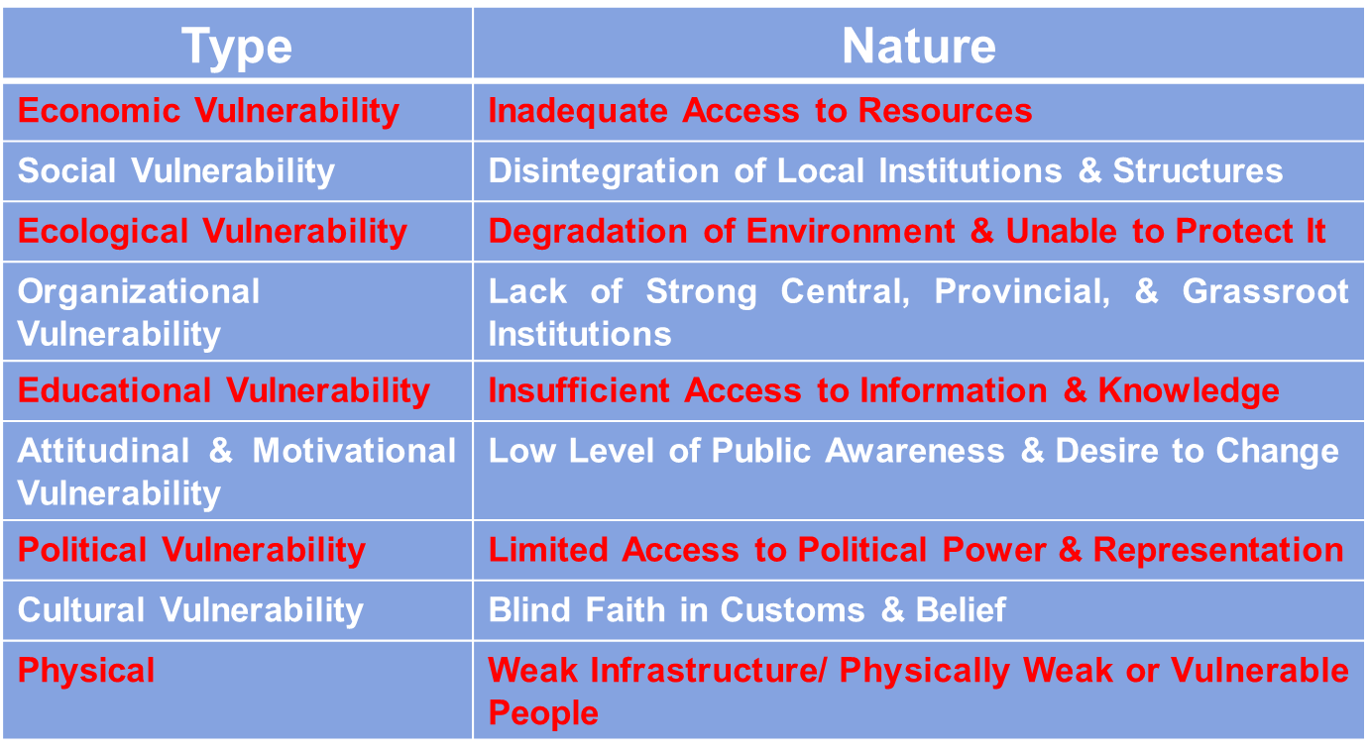
Vulnerability Matrix
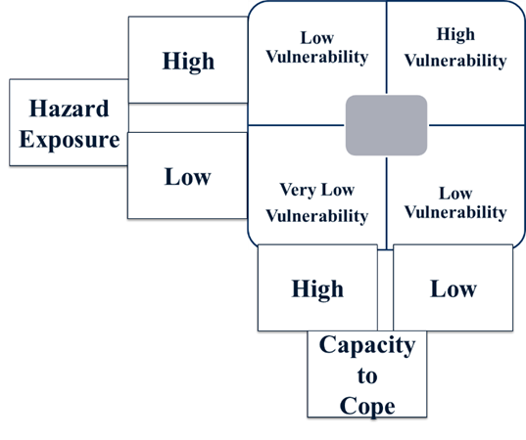
The two main components of vulnerability are hazard exposure & capacity to cope. As you can see in the figure if the hazard exposure is high & the capacity to cope is low then the vulnerability will be the maximum. That is not the quadrant we want to be. Therefore, our effort should be to reduce hazard exposure & maximize coping capacity to place ourselves in the lower right quadrant of low vulnerability.
Elements at Risk
Risks can both tangible & intangible. Risks will be incurred if assets, property, & infrastructure are exposed to a hazard. The total amount of risk incurred will depend on the intensity of the hazard & the amount of exposure. These are few of the risks from exposure to a hazard:
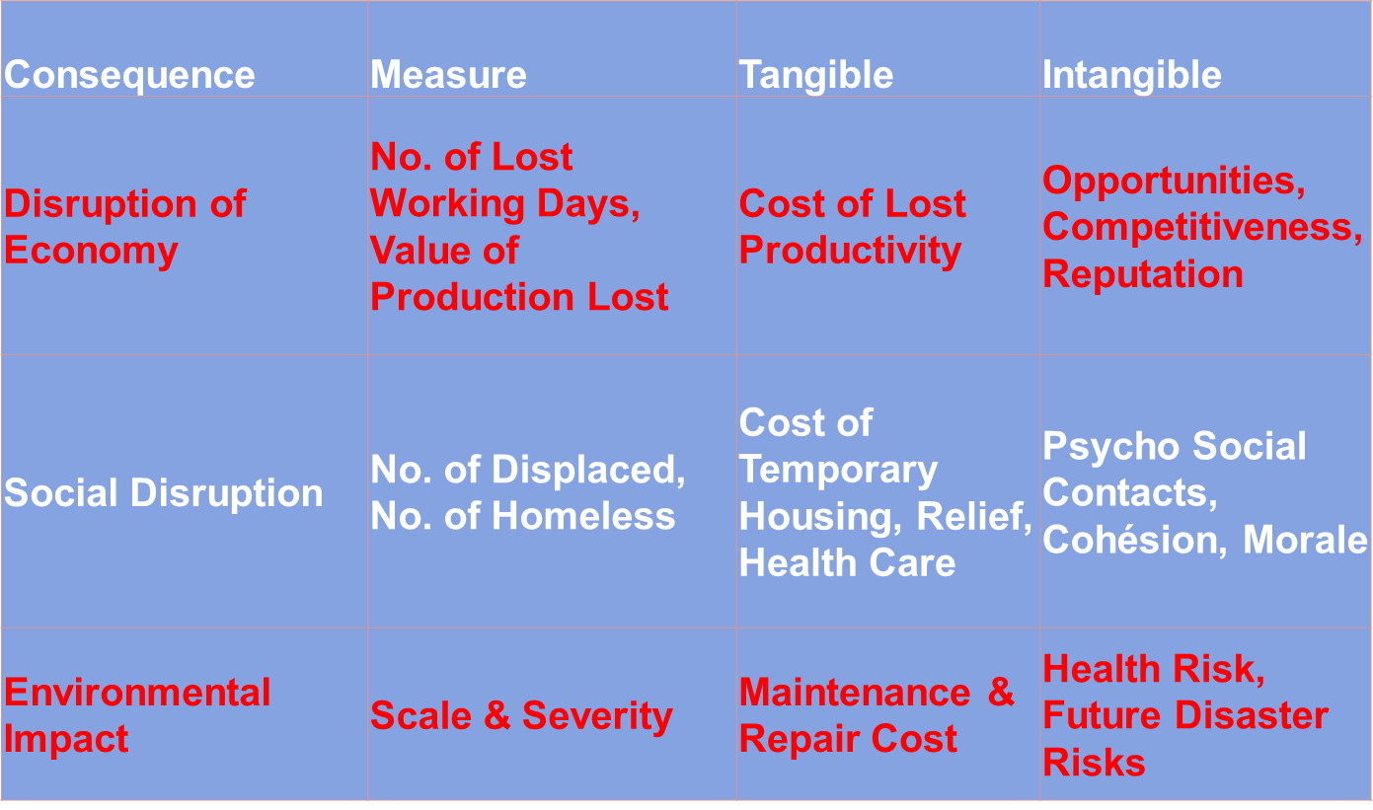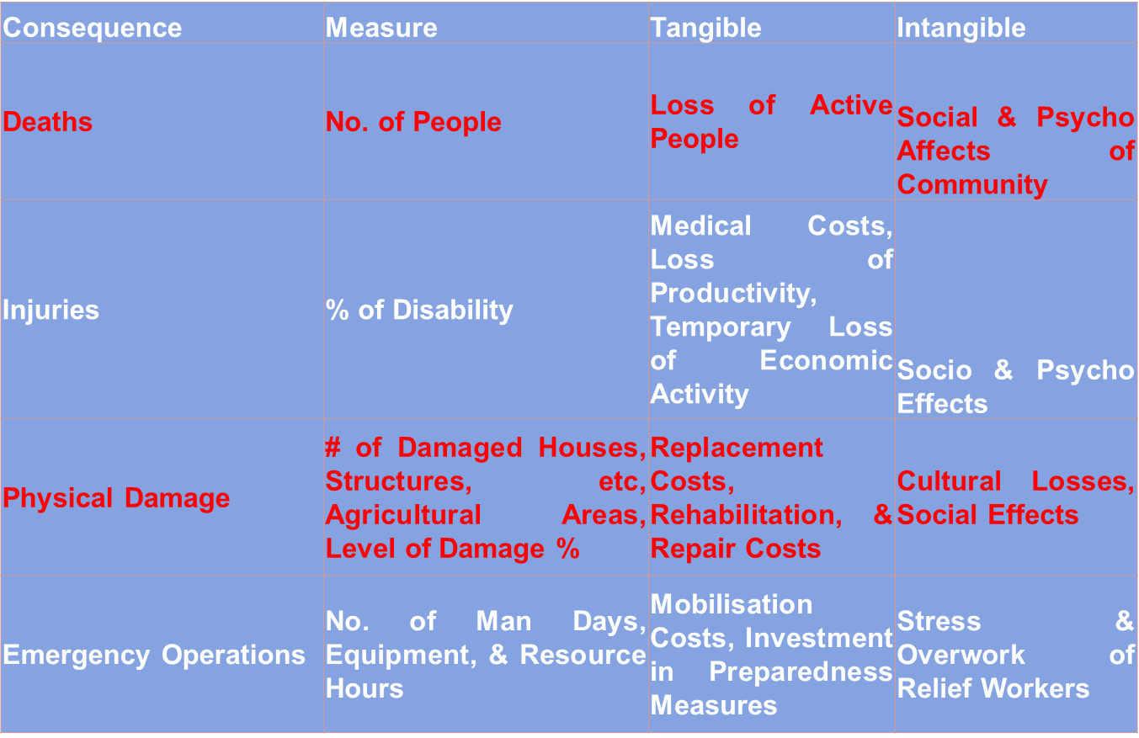
Concept of Risk & Its Analysis
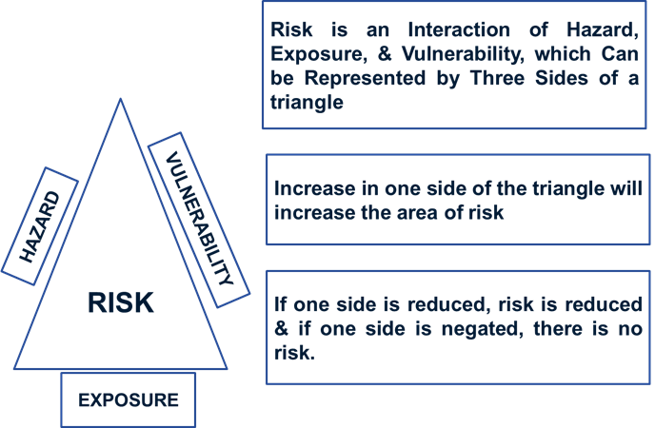
Risk Matrix
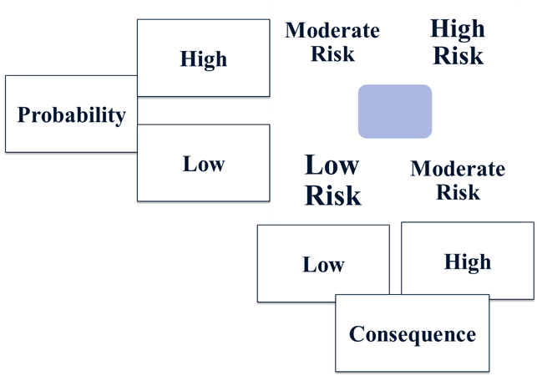
The two main components of risk matrix are probability & consequence. As you can see in the figure if the risk exposure is high & the consequence is high then the risk will be high. That is not the quadrant we want to be. Therefore, our effort should be to reduce risk probability & reduce consequence to place ourselves in the lower left quadrant of low risk.
Index for Risk Management (INFORM)
INFORM is a risk-assessment tool that is designed to support decisions about crisis and disaster prevention, preparedness and response. It is a global, open, & reliable that covers 191 countries which is completely transparent & published using scientific concepts & methods. INFORM cannot predict individual crises, but it is a good way to take account of complex risk information when developing strategies, plans and programmes. Furthermore, INFORM can help develop a shared understanding of risk so that all actors can target their resources in a coordinated and effective manner.
Use of INFORM
Prioritisation -The results of the global INFORM model can be used to prioritise countries by risk, or any of its dimensions or components. This can support decisions on resource allocation, programme location and scale etc. Regional or national versions of INFORM can be used to prioritise areas and risks at sub-national level.
Risk Profiling - The results of INFORM for a single country are a risk profile, which shows the level of individual components of risk. This can support decisions about risks to focus programmes on for greatest impact.
Trend Analysis - The results of the global INFORM model are available and comparable for at least 5 years. This allows for trend analysis, which can be used to understand how risks are changing in a single country and how countries are changing relative to one another. Monitoring risk trends in this way can be used to plan preparedness investments for potential future crises and inform adjustments in resource allocation and focus areas.
Components of INFORM
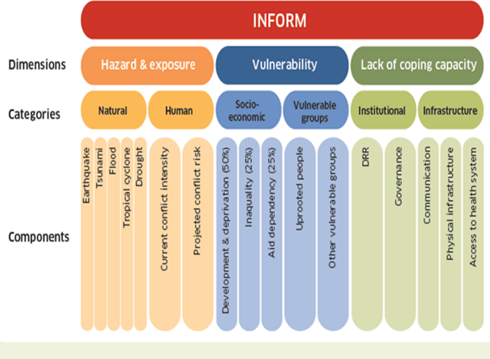
The three main components of INFORM are hazard & exposure, vulnerability, lack of coping capacity. Each of these components have an equal weightage of 33%. Markings for hazard & exposure of a particular country is calculated on the basis of severity of hazards for both natural & man-made that occur in the country. The vulnerability is calculated by assessing the socio-economic & vulnerable group factors inequality, aid dependency, & uprooted people. The lack of coping capacity is measured by the dimension of institutional & infrastructure like governance, disaster risk reduction, communication, & access to health system.
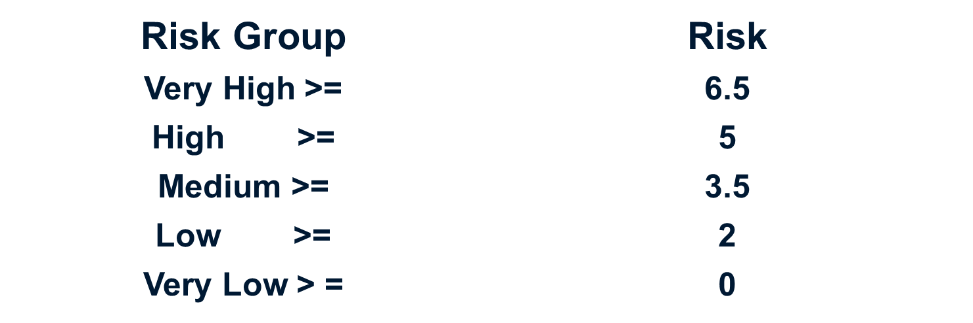
Hazard Vulnerability Analysis
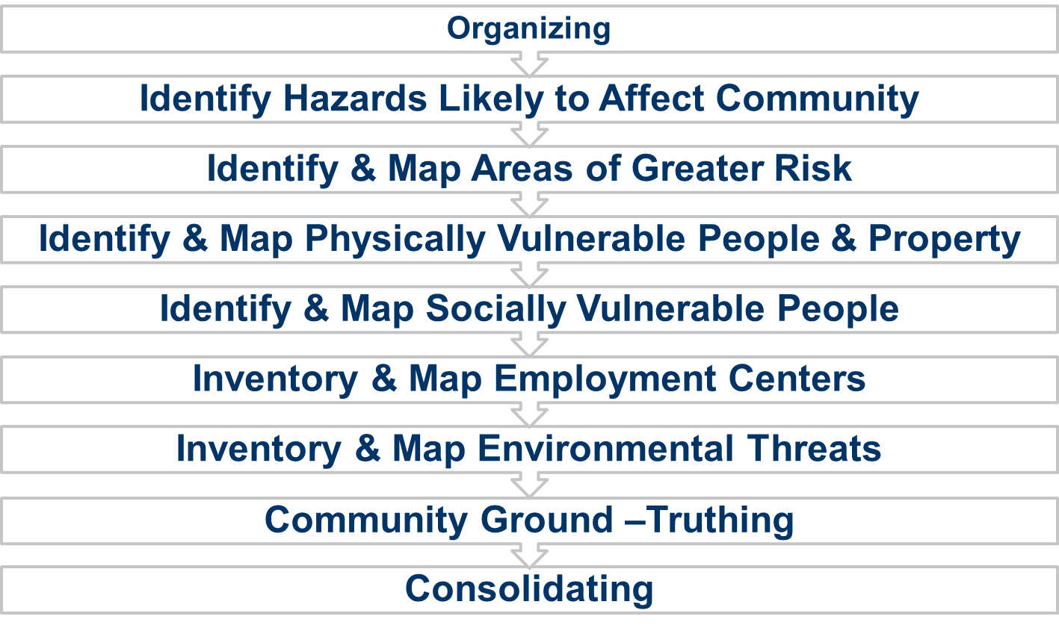
Organizing
Organize a group or team that will be responsible for conducting the assessment which should also consist vulnerable people. They have to be included in the process. Collect relevant plans, studies, reports, and technical information that are available with the local authorities or research organizations.
Identify & Rank Hazards
List the different types of hazards that have occurred, or could occur, in the community. Then rank each hazard based on the frequency and severity of risk
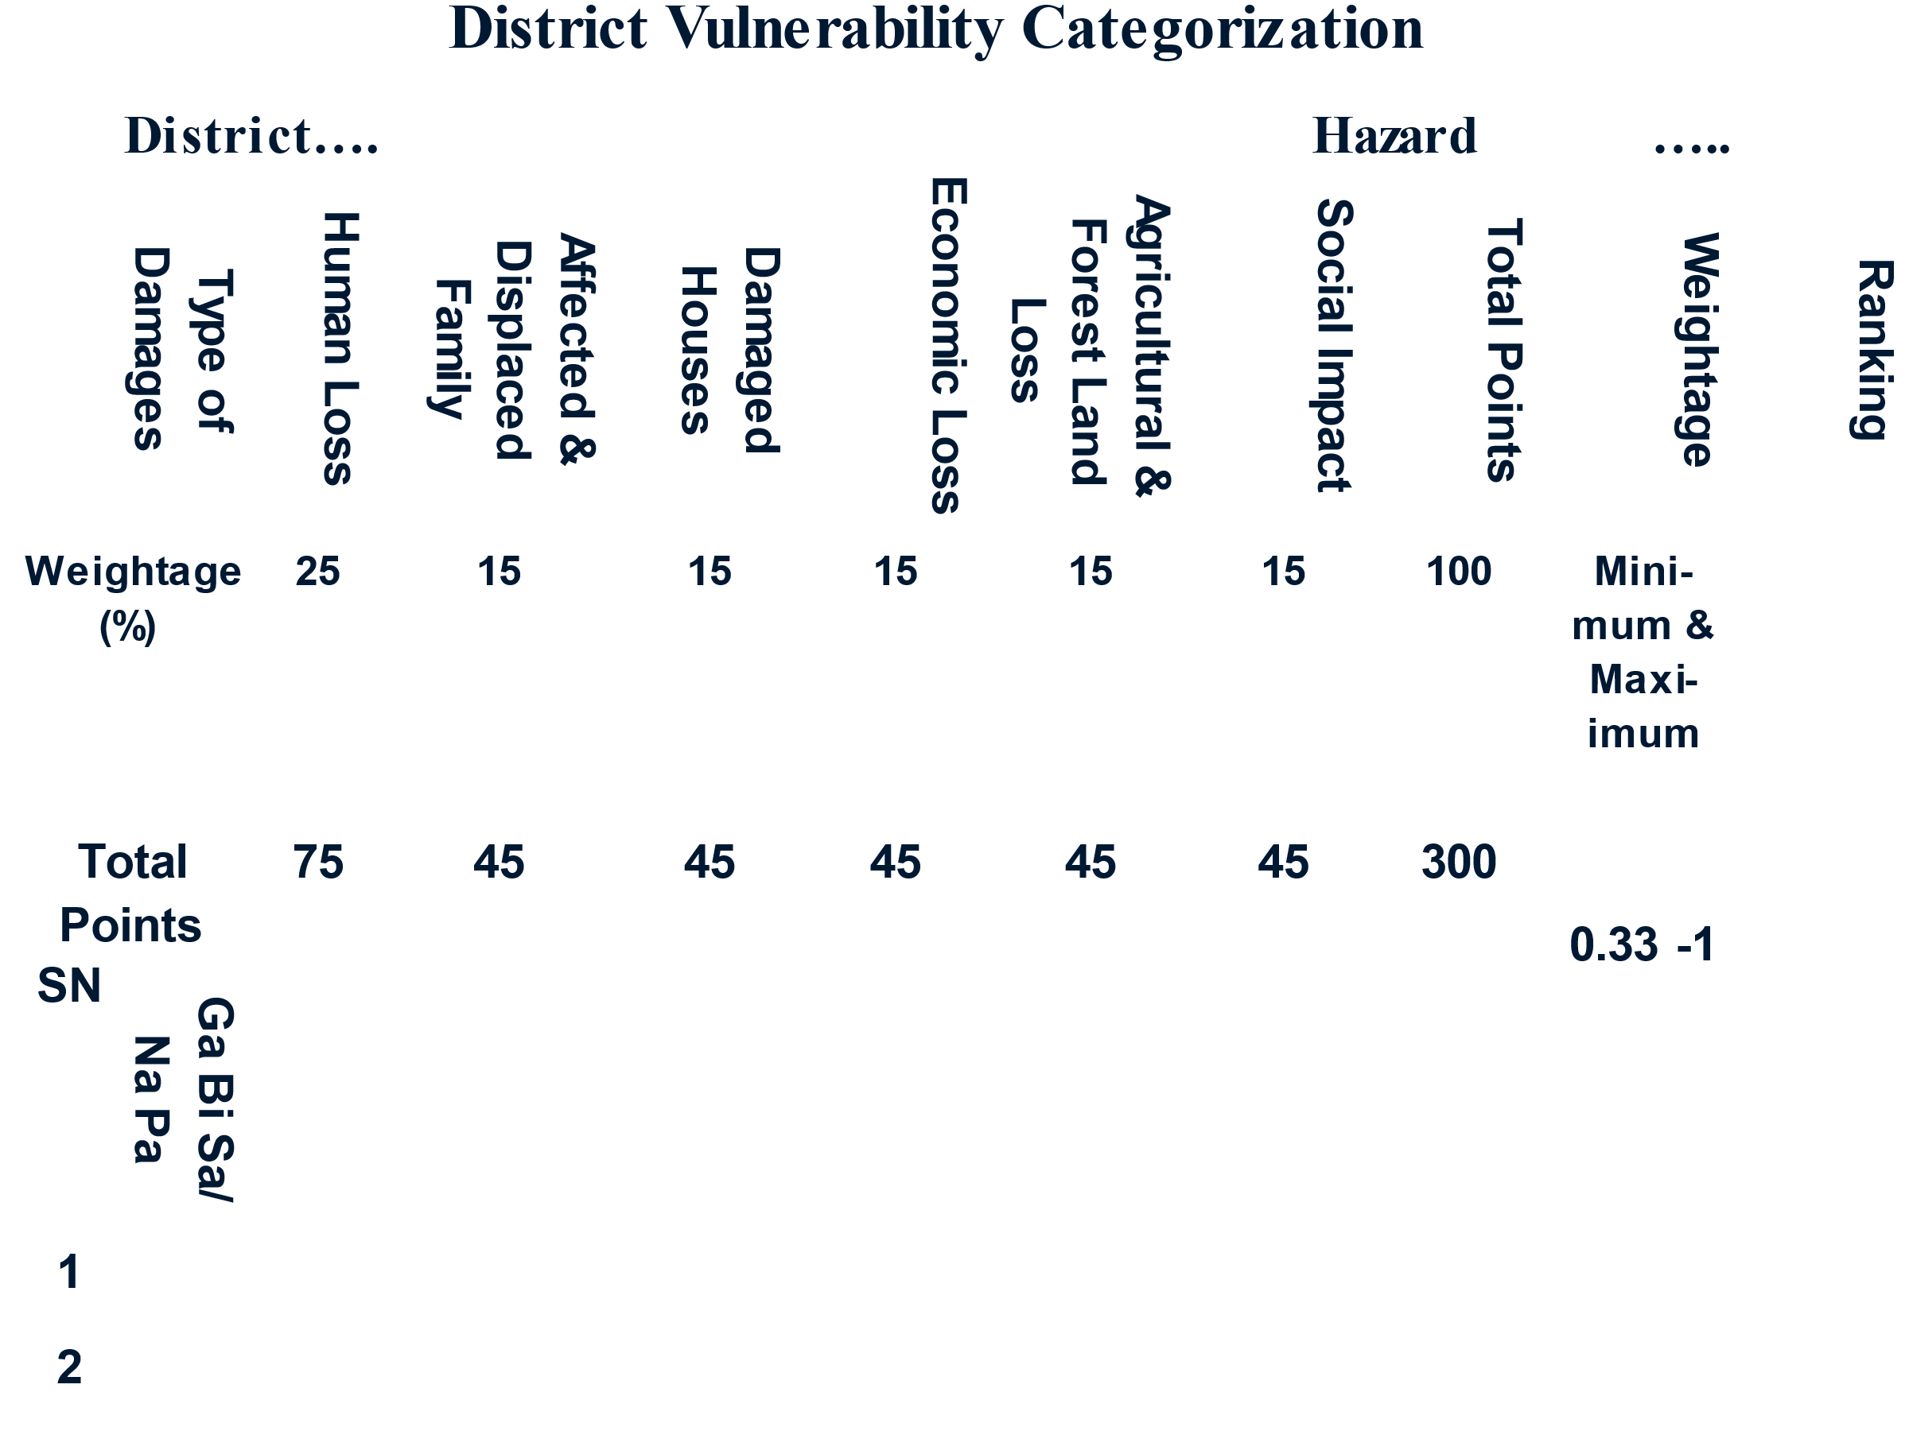
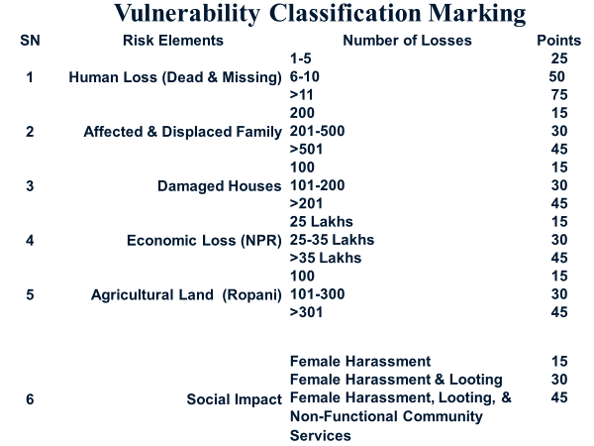
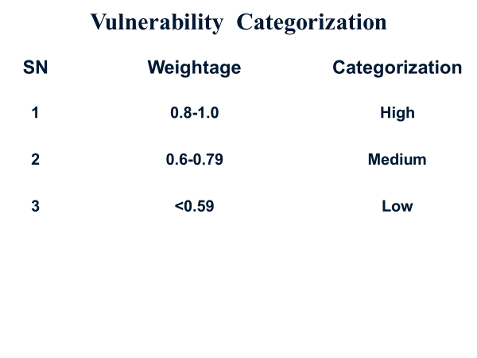
Identify & Map Greater Areas of Risk
After having rank ordered the hazards, mark in a map or sketch the areas which are at high risk of different types of disaster.
Identify & Map Physically Vulnerable People & Property
Inventory and map the critical facilities that are currently located in hazard-prone areas & estimate the number and value of residential structures currently located in hazard-prone areas. Estimate the number of people who live in these structures & estimate the number and value of residential structures that will be located in hazard-prone areas at some time (e.g., 10 years) in the future and the number of people who will live in those structures
Identify & Map Physically Vulnerable People & Property
Prepare a base map for use throughout the vulnerability assessment to include physical people & property. Identify and map specific areas in the community that are vulnerable to disasters, such as floodplains, storm surge areas, steep slopes (landslides) and earthquake-prone areas.
Inventory & Map Employment Centers
In the county or area, you are conducting vulnerability assessment, identify the major areas where there are offices, government services, business centers, hospitals schools, & community & mark in the base map.
Inventory & Map Environmental Threats
List all facilities in or near the community that treat, handle, store, manufacture or transport substances (e.g., chemical wastes) that may pose a threat to health and safety of people. Mark the location of these facilities on the base map. Highlight facilities located in hazard prone areas such as floodplains. Determine the number of people that could be at risk if there were an accident or spill at one of the facilities. Rank the facilities in order of the severity of the threat.
Community Validating
Conduct public forum to validate the information represented on the maps you have prepared in steps 3-8 as part of the vulnerability assessment. Make revisions as necessary, based on participant input. Make preparations to involve interested participants in future taskforce activities.
Consolidating
Consolidate validated information into accessible data base. Produce a final report that identifies the community’s hazards, socially and physically vulnerable populations, and possible strategies for mitigating risks. Present final result to the community & incorporate into comprehensive plans, land use plan, emergency management plans.

References
Community Based Vulnerability Assessment, A Guide to Engaging Communities in Understanding Social and Physical Vulnerability to Disasters, UNC Institute for the Environment, 2009, Pg 1-48 (https://www.mdcinc.org/wp-content/uploads/2017/11/Community-Based-Vulnerability-Assessment.pdf
D 5. Generic Conceptual Framework for Vulnerability Measurement, European Commission DG Environment, Pg 1-27 (https://www.ipcc.ch/apps/njlite/srex/njlite_download.php?id=6116#:~:text=It%20is%20the%20potential%20occurrence,ecological%20system%20exposed%20to%20hazards).
Guidance Note - Interpreting and Applying the INFORM Global Model, Pg 1-27 (www.inform-index.org)
Indicators for Disaster Risk Management, Inter-American Development Bank,2003 Pg 1-21(https://publications.iadb.org/en/indicators-disaster-risk-and-risk-management)
INFORM Report, UNOCHA, 2024 (http://inform-index.org/)
Local Disaster Risk Management Planning Guidelines, Ministry of Local Development, Nepal, 2011(https://www.dpnet.org.np/resource-detail/966)

