Disaster Management & Social Work
Lecture 5
Pre-Disaster Situation
Lecturer: Victor J B Rana

Introduction
The prevention of disasters would reduce untold human suffering and damage to livelihoods and property. Unfortunately, disaster prevention, especially in developing countries, is often overlooked or ignored. This can be due to a variety of reasons such as the lack of resources or political will to invest in prevention activities. Regardless, it is of utmost importance to take disaster prevention activities into consideration in ongoing development programs. While poverty reduction strategies may reduce vulnerability to some disasters, others that are beyond human control will occur.
Mitigation can be defined as strategies or interventions implemented before a disaster strikes or in response to the onset of a disaster event to minimize its impact or to prevent ultimate catastrophe. Unlike ongoing development work, disaster mitigation inherently implies that a definable disaster is expected to occur or does occur rather than the mere presence of chronic food insecurity and poverty. And though some mitigation is responsive in nature, as is the case with emergency relief, the difference between the two is that post catalyst mitigation is an early response which seeks to prevent further deterioration and disaster by dealing with the most immediate causes of insecurity. While development tackles the root causes of vulnerability and relief deals with the acute symptoms, mitigation straddles the two and is both proactive and reactive in nature.
Disaster preparedness can be defined as strategies and capacities developed during non-crisis periods to collect and disseminate relevant information, diagnose the situation, plan for contingencies, and stock necessary emergency inputs
Topic Objectives
Understanding the difference between disaster prevention, mitigation, & preparedness.
Process involved in the disaster prevention, mitigation, & preparedness
Understanding the linkage & continuity of the three
Question for Discussion
Where does disaster prevention, mitigation, & preparedness fall in the disaster management cycle?
What are the key differences in prevention, mitigation, & preparedness & how are they linked?
What is the process involved in disaster prevention, mitigation, & preparedness?
DRMC
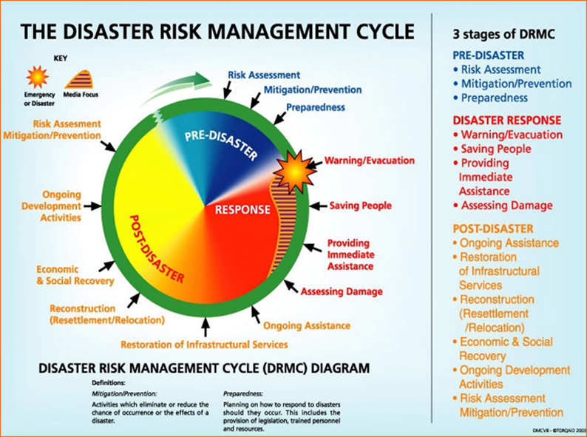
Definition of Disaster Risk Management
The UNISDR defines disaster risk management as the systematic process of using administrative decisions, organization, operational skills and capacities to implement policies, strategies and coping capacities of the society and communities to lessen the impacts of natural hazards and related environmental and technological disasters. This comprises of all forms of activities, including structural and non-structural measures to avoid (prevention) or to limit (mitigation and preparedness) adverse effects of hazards
A continuous and integrated process of planning, organizing, coordinating and implementing measures which are necessary to understanding disaster risk, prevention of danger or threat of any disaster, mitigation or reduction of risk of any disaster or its severity or consequences, capacity building, preparedness to deal with any disaster, prompt response to any threatening disaster situation or disaster, assessing the severity or magnitude of effects of any disaster, evacuation, rescue and relief, rehabilitation and reconstruction/sustainable development

Strategic Framework for Disaster Risk Management
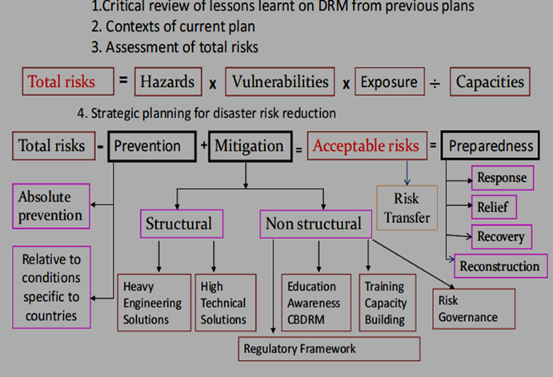
In the risk management process, the total risk from a particular hazard is calculated by multiplying hazard, vulnerability, & exposure & dividing it by the capacity to cope. Once we can anticipate the total risk from a particular natural hazard, we must take preventive & mitigation measures to minimize the risk to lower it to an acceptable level. No matter how much we carry out mitigation or preventive measures, some amount of risk will still remain termed as acceptable risk. To minimize the loss of lives from the acceptable risk we have to conduct preparedness activities prior to occurrence of disaster.
Prevention
Disaster prevention activities aim at totally avoiding adverse effect of hazards & providing means to minimize environmental, technological & biological disasters. Depending on social & technical feasibility & cost-benefit considerations, investing in preventive measures is justified in areas frequently affected by disasters.
Problem Areas in Prevention
Traditional Outlooks- There may be long-standing acceptance of hazards by governments and communities. For instance, a nation may have lived for centuries with a recurring major flood problem. Therefore, the need for preventive measures is not recognized.
Cost- The cost of some preventive measures can be very high; for instance, large public works of similar engineering projects; thus, they tend to be ruled out, perhaps without a detailed analysis of cost–benefit and other factors
Other National Priorities- Higher priorities given to other major national programs sometimes totally preclude consideration of preventive measures
Political Aspects- Political motives may sometimes have an adverse effect on disaster prevention. For instance, measures of prevention may upset the interests of sections of the public by encroaching on land, property, or other aspects
Development Problems- Normal development may cause problems related to prevention.
Balance in Disaster Management-Lack of appropriate preventive measures may often throw heavier loads on other aspects of disaster management when disaster occurs
Public Apathy- Public apathy toward and/or awareness of disaster risks may mean that there is no pressure on governments to consider disaster management measures, least of all prevention.
Mitigation
Mitigation: is permanent reduction of the risk of a disaster. Primary mitigation refers to reducing the resistance of the hazard and reducing vulnerability. Secondary mitigation refers to reducing the effects of the hazard (preparedness). Mitigation includes recognizing that disasters will occur; attempts are made to reduce the harmful effects of a disaster, and to limit their impact on human suffering and economic assets. It can be done before, during, & after disaster.
Objectives
It is to save lives, reduce economic disruption, decrease vulnerability/increase capacity, & decrease chance/level of conflict
Risk Mitigation Measures
Risk mitigation measures are understanding disaster risk, interagency coordination, investing in DRR structural measures, investing in DRR non-structural measures, & capacity development
Disaster Preparedness
Preparedness: Are the measures that ensure the organized mobilization of personnel, funds, equipment’s, and supplies within a safe environment for effective relief. Disaster preparedness is building up of capacities before a disaster situation prevails in order to reduce impacts. Its measures include inter alia, availability of food reserve, emergency reserve fund, seed reserve, health facilities, warning systems, logistical infrastructure, relief manual, and shelves of projects.
Disaster Preparedness minimizes the adverse effects of a hazard through effective precautionary actions, rehabilitation & recovery to ensure the timely, appropriate & effective organization & delivery of relief & assistance following a disaster.

Tools of Disaster Preparedness
- Vulnerability Assessment
- Planning
- Institutional Framework
- Information System
- Resource Base
- Warning System
- Response Mechanism
- Public Education & Training
- Rehearsals
Vulnerability Assessment
We discussed this in detail in lecture 4.
Planning
While planning you should have a clearly stated objectives, systematic sequencing of activities, assign specific tasks and responsibilities, & integrate its activities, tasks and responsibilities to enable the overall objectives.
Purpose of Disaster Preparedness Plan
It is to facilitate the protection of lives, property and the environment in major disasters of any nature & coordinate response to disasters, assess damages, identify mitigation opportunities and implement recovery efforts. At the same time, it serves as a coordinating document for supporting Individual Agency Plans (IAP) (i.e., Policy and Procedures.) Update plans to reflect information collected and decisions made and procedures developed in the planning process and during response and recovery operations. It also provides a link between the local and municipal plans. It should also provide policy for government officials, agency managers and emergency managers during a disaster situation, & conform to the provisions of the NEOC and the National Response Framework (NRFP) to ensure a coordinated and effective response when federal agencies and assets are involved.
Main Components of the Disaster Management Plan
Organization- the stakeholders who will be responsible for planning & implementing the plan.
Authorities- Are the regulations & policies of the central government that guide the basis of the plans.
Assignment & Responsibilities- The task & responsibilities of the various stakeholders will be designated.
Limitations- The resource of the authority may be exhausted by the disaster.
Situation –Emergency Disaster Conditions & Hazards- Identify the types of disasters & the impact it will create.
Planning Assumptions- Any planning considerations that have been included to develop the plan like higher support will be guaranteed or resources will be ample to deal with the threat.
Concept of Operations- General/ Local Government/Province Government/ Federal Government- The various tasks of the levels of government are stipulated & method of coordination.
Phases of Emergency- Mitigation, Preparedness, Response/ Recovery- The various activities that will be conducted in each of the phases & the responsibility.
Level of Activation- 0-3- The classification of the various levels of disaster & the activities to be conducted.
EOC Operations- The manning process & organization of the EOC is described here.
Organization & Responsibility- Emergency Support Function (ESF)- The identification & allocating lead & supporting role of various agencies involved in Emergency Functions
Other Key Documents- Municipality Hazard & Risk Map – Hazard Vulnerability Assessment map, demographical, & topographical data of area of responsibility.
Laws and Regulations – Laws & regulation that are applicable to the plan.
Supporting Operations Plans and Documents- Specific plans of various agencies.
Agency Responsibilities- Allocation of leading & supporting roles of various agencies in each of the Emergency Support Function
Institutional Framework
A coordinated disaster preparedness and response system is an essential condition of any disaster preparedness plan. There is no standard way of ensuring effective coordination. Each design will depend upon the traditions and governmental structure of the country under review. However, a plan will rapidly deteriorate unless there is “horizontal coordination” at central government and sub-national levels among ministries and specialized agencies and “vertical coordination” between central and local authorities. Existing communities and structures should be strengthened & responsibilities should reflect expertise & clearly defined.
Organizational Structure for Disaster Preparedness
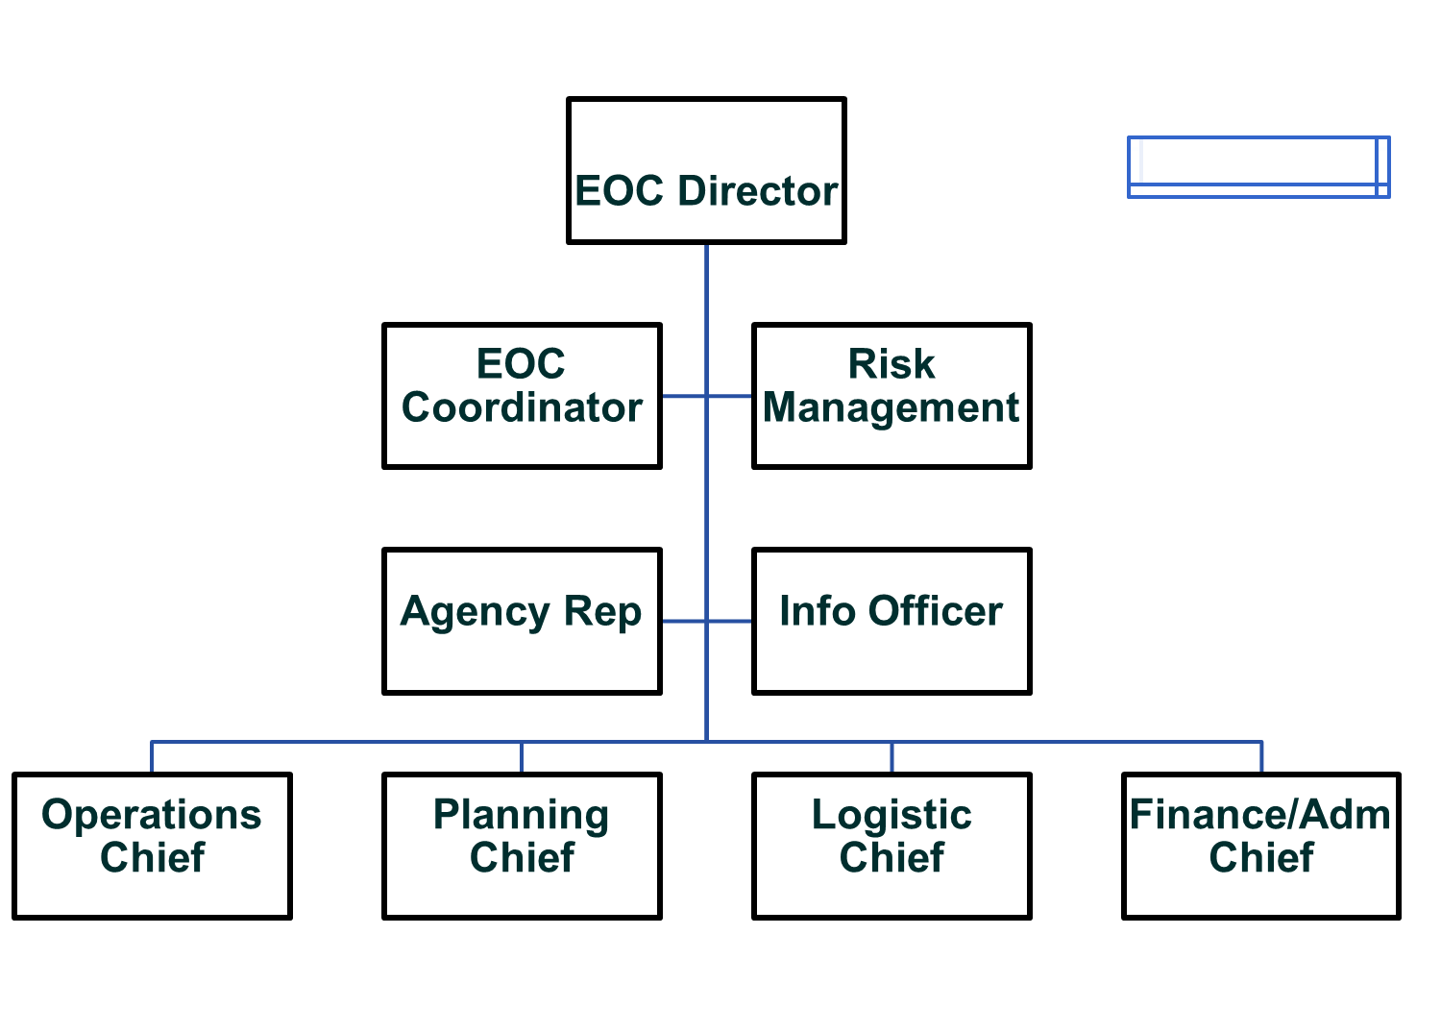
Major Emergency Support Functions-Operations
Transportation- It ensures all roads & exits are open to traffic.
Communication- Develop, maintain, & restore communication services
Public Works & Engineering- Assess the damage to infrastructure, debris removal, & restore emergency services.
Fire Fighting- Task is to prevent fire, detection, & suppression.
Emergency Management- collect, analyze, and share information about a potential or actual emergency or disaster to enhance the response and recovery activities
Mass Care, Housing, & Human Services – Provide shelter, mass care, & human services.
Public Health & Medical Services- Provide rescue services & public health operations.
Urban Search & Rescue- To rescue people from fallen debris & collapsed structure.
Oil & hazardous Material- This function is responsible for the identification of, training on and response to hazardous substances or materials in the jurisdiction
Agricultural & Natural Resources- Assessing & implementing actions with harmful effects upon country’s food & agriculture.
Energy- This function is responsible for restoring electricity & gas.
Public Safety & Security- This function is responsible to maintain law & order.
External Affairs- This ESF is responsible for the provision of information (both general and that which conveys emergency instructions to the public) concerning an actual or impending disaster.
Major Emergency Support Functions-Plan
Emergency Management - It is the function of planning, coordinating, & implementing the response operations.
Long Term Recovery & Mitigation- To plan, implement, & monitor recovery activities.
Mass Care, Housing, & Human Services- Provide shelter, mass care, & human services.
Major Emergency Support Functions-Logistics/Finance
Long Term Community Recovery & Mitigation- To provide required resources & financing for the recovery.
Mass Care, Housing, & Human Services – Provide logistical & financial support.
Resources Support- Provide various logistical, transportation, & manpower to various emergency functions.
Information System
Early warning systems are normally comprised of various elements. They can stem in part from information provided by meteorological offices, by a Ministry of Health (for example, nutritional surveys), or by a Ministry of Agriculture (for example, crop forecasts). One major criterion for an effective plan is an established system to ensure the coordination of all these different inputs. An inter-ministerial information committee can serve this purpose. This sort of committee has to have clear-cut guidelines, reporting formats and mechanisms as well as established reporting procedures. It is essential to link the disaster preparedness focal point to this committee. Perhaps the focal point might serve as the chair organization for this inter-ministerial information committee.
Resource Base
The requirements to meet disaster needs will depend upon the types of disasters the plan anticipates. Such needs should be made explicit, and should cover all aspects of disaster relief and recovery implementation. Specific arrangements should be established whereby each party to written agreements can secure goods and services as required. Critical issues include special internal arrangements for the acquisition and dispersement of funds; policies and agreements for the use of other’s equipment and services; and emergency funding strategies. Disaster relief funding, preparedness funding, mechanism for aid coordination, & stockpiling should be included.
Warning System
You must assume that functioning communications systems, such as telephones and telexes, may not be available in times of a major disaster. Begin to plan a warning system around that assumption. Consider what type of communications equipment will be needed and sustainable if power lines and receiving stations are destroyed. Preparedness plans should include provisions for access to alternative communication systems among police, military and government networks.
Response Mechanism
Various functions like search & rescue, security of affected areas, assessment teams, activation of special installations, activating distribution systems, preparing emergency reception centers and shelters, & activating emergency programs for airports, harbors and land transport should be considered.
Public Education & Training
One emphasis of a disaster preparedness plan should be to anticipate the requirements for a disaster relief operation and the most effective ways of meeting those requirements. The planning process will only be effective if those who are the ultimate beneficiaries know what to do in times of disasters and know what to expect. For this reason, an essential part of a disaster preparedness plan is the education of those who may be threatened by disaster. Such education may take the following forms like public education in schools, special training courses, extension programs, & public information.
Rehearsals
As with most simulations, disaster preparedness rehearsals cannot portray the full dynamics and chaos of a disaster relief operation. However, this is no excuse for avoiding the need to rehearse the disaster preparedness plan. Rehearsals will reemphasize points made in separate training programs, and test the system as a whole. Rehearsals invariably expose gaps that otherwise might be overlooked

References
A Disaster Management Handbook, 275-289 (https://www.adb.org/sites/default/files/publication/27890/disaster-management-handbook.pdf)
GOI National Disaster Management Plan, 2016, Pg 121-129 (https://ndmindia.mha.gov.in/ndmi/images/National%20Disaster%20Management%20Plan%20May%202016.pdf
Post Disaster Needs Assessment Volume A, Government of Nepal, 2015, Pg 21-43(https://www.worldbank.org/content/dam/Worldbank/document/SAR/nepal/PDNA%20Volume%20A%20Final.pdf
Post Disaster Needs Assessment Volume B, Government of Nepal, 2015, Pg5-20 (https://un.org.np/sites/default/files/doc_publication/PDNA-volume-B.pdf
Resilient Mountain Village, ICIMOD, 2018 (www.icimod.org)
Resilient-Recovery-An-Imperative-for-Sustainable-Development, GFDRR, 2015, Pg 9-32 (https://www.gfdrr.org/en/publication/resilient-recovery-imperative-sustainable-development)

