Disaster Management & Social Work
Lecture 6
During Disaster Situation
Lecturer: Victor J B Rana

Introduction
When a sudden onset disaster strikes, a joint needs assessment process, the Multi-Sector Initial Rapid Assessment (MIRA), is one of the first steps in the Humanitarian Country Team’s emergency response. The MIRA is an inter-agency process enabling actors to reach, from the outset, a common understanding of the situation and its likely evolution. Based on its findings, humanitarian actors can develop a joint plan, mobilize resources and monitor the situation. The MIRA is underpinned by an analytical framework that guides the systematic collection, organization and analysis of secondary and primary data. The MIRA informs and supports the design of subsequent needs assessments and analysis which are often more detailed as well as the response strategy and operational in focus.
Response measures are those which are taken immediately prior to and following disaster. Such measures are directed towards saving life and protecting property and to dealing with the immediate damage caused by the disaster. From the above definition, it is clear that the scope of response is usually extensive and that its success must depend vitally on good preparedness. The effectiveness of response also has a considerable bearing on subsequent recovery requirements and activities.
Response operations usually have to be carried out under disruptive and sometimes traumatic conditions. Often, they are difficult to implement and they tend to make heavy demands on personnel, equipment, and other resources. Thus, without a sound basis of planning, organization, and training, response operations are unlikely to achieve optimum success.
Topic Objectives
Develop an understanding of the basic concepts of MIRA.
Process & actors involved MIRA & how it supports response & recovery
Understand the basics of response during disaster.
Understand the actors & process of response
Question for Discussion
Why is MIRA useful once a disaster strikes?
What is the process involved in MIRA & the output provided?
What are the key ingredients of the response process?
Who are the actors involved in the response activity & how it is coordinated?
DRMC
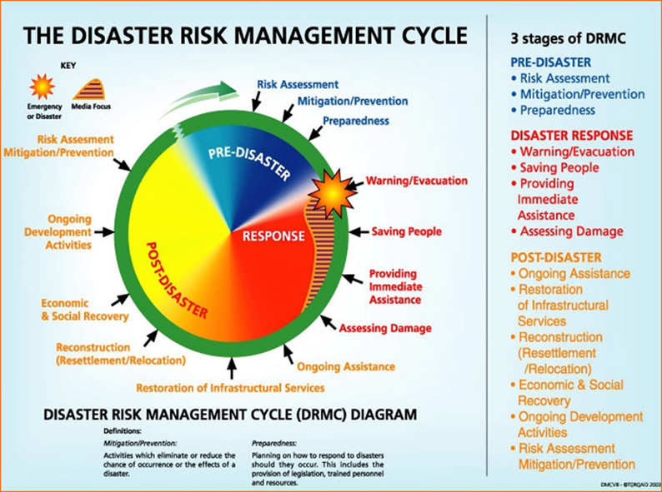
Multi-Cluster/Sector Initial Rapid Assessment (MIRA)
The Multi-Cluster/Sector Initial Rapid Assessment (MIRA) is a joint needs assessment tool that can be used in sudden onset emergencies, including IASC System-Wide level 3 Emergency Responses (L3 Responses). It is a precursor to cluster/sectoral needs assessments and provides a process for collecting and analyzing information on affected people and their needs to inform strategic response planning.
Objectives of MIRA
➢ Reliable and timely collection and analysis of data on humanitarian needs
➢ Provide fundamental initial information on the needs of affected populations
➢ Support the government on initial decision-making with regards to whether local capacity is adequate or external resources are required & and the priorities for international support
➢ To better target immediate humanitarian interventions
➢ To identify and estimate the following
    - What is the geographical extent of the affected area?
    - How many people are affected?
✓ Access:
    - What are the logistic considerations in terms of effects of the emergency and Options for response?
    - What are the security considerations?
✓ Needs:
    - How and to what extent does the crisis affect populations (outcomes)?
    - How and to what extent does the crisis affect livelihoods?
    - How does the crisis affect access to basic services and goods?
    - What are the national/subnational private sector, nongovernmental and government capacities and how have they been affected?
    - Whether there are basic protection concerns for the population and in particular of vulnerable groups
✓ Coverage and Gaps
    - What proportion of the population in need is reached by humanitarian interventions? These will be estimates at this early stage.
    - To what extent are the needs addressed?
✓ Strategic Humanitarian Objectives
    - What are the priority sectors for intervention?
    - Other key issues to be considered (protection, environment, gender etc.)?
What the MIRA Can Deliver
➢ An initial common understanding of the most pressing needs affected areas, and groups
➢ A voice for the affected population
➢ Information to help guide the planning of subsequent assessments which are more detailed and operationally specific
➢ An evidence base for response planning
➢ A light, fast inter-agency process based on global best practices in rapid needs assessment

What the MIRA Does Not Provide
➢ Information to directly inform the design of specific and localized humanitarian interventions
➢ Statistically representative primary data for quantitative analysis on humanitarian needs
➢ A substitute for detailed or in-depth sectoral assessments
Pre-Condition for Successful MIRA
➢ New & Sudden
✓ New Sudden-Onset Emergency
✓ Significant Deterioration in an Ongoing Emergency or New & Sustained Access to a Previously Inaccessible Area
✓ New or Additional Risks to Lives
➢ Stability
✓ Environment Supports Sustained Access to Majority of Affected Population
✓ No Significant Additional Population Movements Anticipated
✓ Safe & Sustainable Access to the Majority of the Affected Population
➢ Urgency
✓ Urgent Information to Support Joint Planning
✓ No or Limited Detailed Cluster/Sector/ or Agency Assessments Available New or Additional Risks to Lives
➢ Joint
✓ Humanitarian Country Team Supports a Joint Analysis & Planning Process
✓ Agencies & Clusters Willing to Share Information for Joint Secondary Data Analysis
✓ Agencies & Clusters Willing to Contribute Resources for Joint Primary Data Collection

Actions Taken in MIRA
➢ Analysis of pre-crisis and in-crisis secondary data and identification of information gaps per cluster/sector.
➢ Agreement on a needs assessment data collection form that addresses the information gaps identified through secondary data analysis.
➢ Joint primary data collection using appropriate sampling approaches and mainstreaming age, gender, diversity and perceived needs of the affected populations into the methodology.
➢ Consultations with community representatives involved in the response.
➢ Joint analysis of primary and secondary needs data.
➢ Dissemination of the analysis to the HC, HCT, and sectors/ clusters informing preliminary and strategic response planning and cluster/sector planning.
➢ Communicating findings to the affected population via the most accessible mechanism and identification, where possible, of ways of receiving feed back
Coordinated Assessment Approaches & Phases
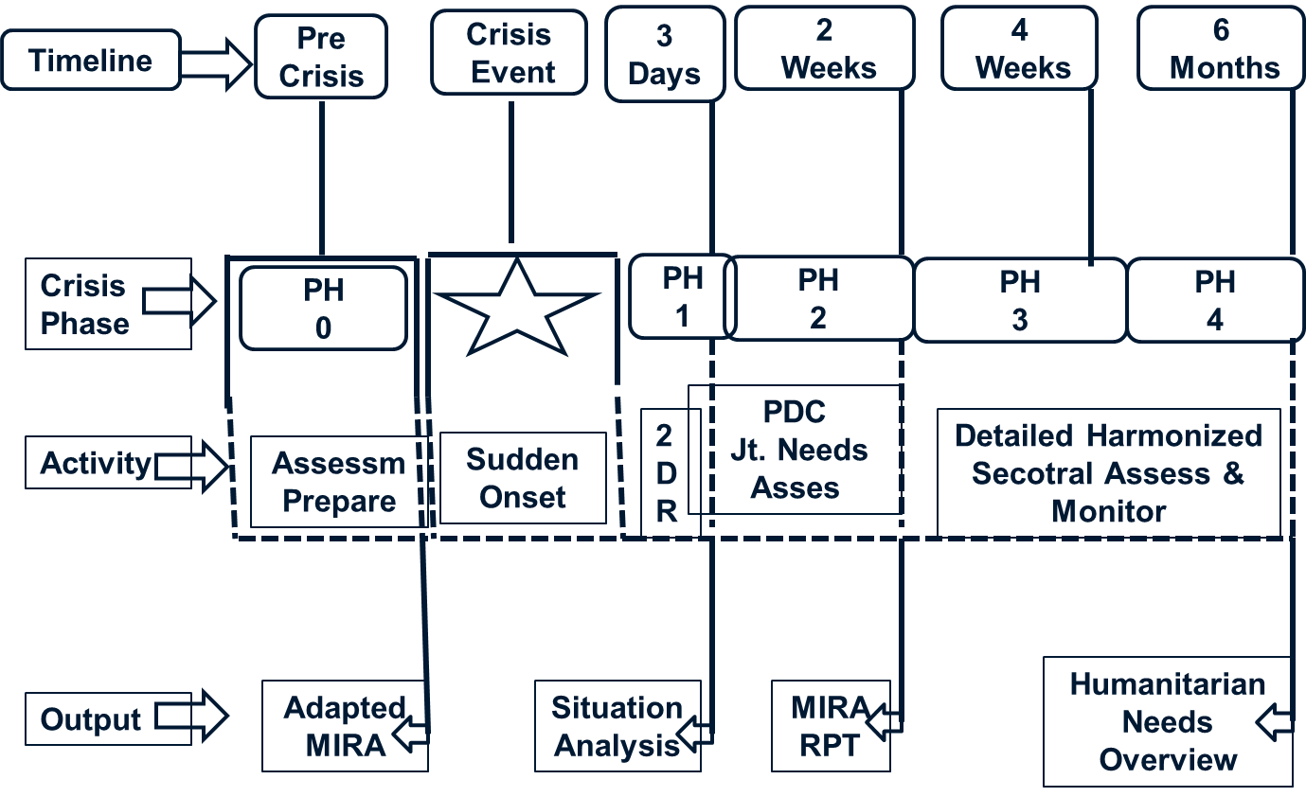
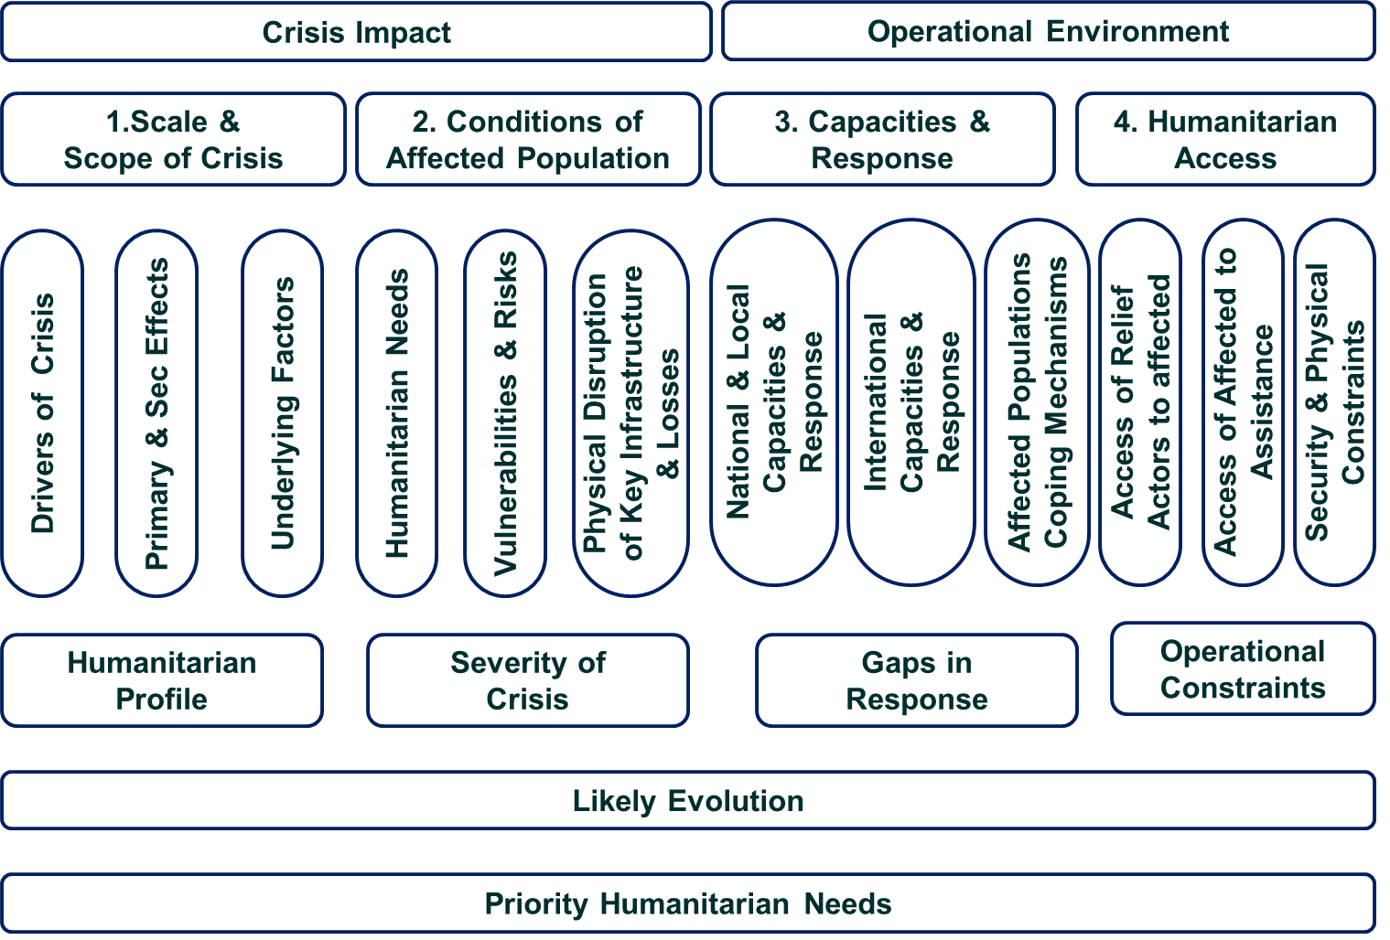
Elements of MIRA
➢ Names of Evaluating Group
➢ Geographical Description of Affected Area & Hazard
➢ Total Health Facilities in the District & Damaged
➢ Demography of Woda- Dead, Wounded, Missing, & Vulnerable Groups
➢ Housing & Non-food Items; Total Households; Damaged & Partially Damaged Houses; Hygiene, Water, & Sanitation; Available Shelters & Number of People it Can House; Required Non-Food Items; Other Local Resources Required for Shelter
➢ Food Items- Percentage of Footstock Destroyed; Type of Fuel Available for Cooking; Vulnerable Groups; Market Nearby & Open; Livestock Destroyed; Shelter for Livestock; Probability of Epidemic through Livestock
➢ Water & Sanitation- Water Supply System; Percentage of People with Access to Clean Water; Sources & Condition of Water; Alternative Source of Water & Distance; Household Water Storage Facility; Availability of Toilet, Washing, & Cleaning Materials
➢ Protection- Number & Location of Displaced Persons; Registration; Age Profile; Pregnant/ Baby; Vulnerable
➢ Nutrition- Milk Feeding Mothers; Type of Nutrition; Number of Dietician: Malnourished Children; Skilled Manpower in the Woda; Nutrients Given to New Born to 5-Year-Old
➢ Health- Type of Diseases Prevalent; Availability of Medicines & Other Equipment’s; Health Facilities Available & Condition; Medical personnel Available; Any Epidemics; Any Toxic Materials
➢ Education- Schools Still Running, Damaged & Partially Destroyed Schools; Types of Educational Institutes; Damaged Water & Toilets; Affected Students/Teachers by Gender; School Being Used as A Shelter
➢ Emergency Communication- Radio, Telephone, HF/VHF, Satellite Phone, Internet; Functional Communication Facility Still Used by the Community
➢ Logistics- Affected Area Accessible to Humanitarian Teams; Affected Male & Female; Availability of Essential Services Like Fuel, Energy, Road, Transportation, Food Depot; Outstanding Logistic Problem; Functioning & Condition of Essential Services
➢ Camp Coordination & Management- Displaced Persons According to Age & Gender, Vulnerable, Disabled, Sick; Location of Displaced Persons; Security Force Nearby; Displaced Camp Organized or Self Made; Ownership; Registration
➢ Available Relief Materials to the Affected Community- Relief Materials Being Provided; By Whom; If Not Any Plans; Affected People Are Informed About Relief; Organization in the Community for Relief
Key Stakeholders
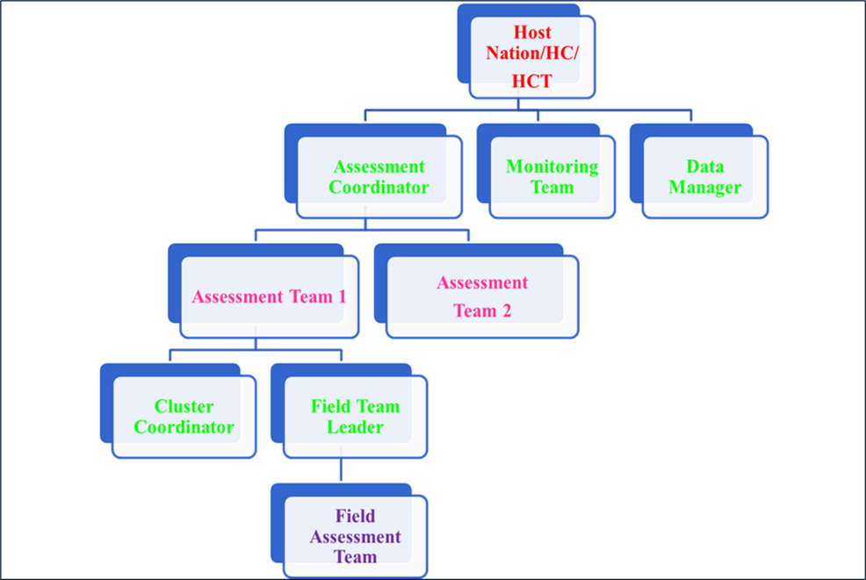➢
Why Response & Emergency Services
➢ Limit casualties,
➢ Alleviate hardship and suffering,
➢ Restore essential life support and community systems,
➢ Mitigate further damage and loss, and
➢ Provide the foundation for subsequent recovery.
Characteristics of Response Effort
➢ Type of Disaster
➢ Severity & Extent of Disaster
➢ Ability to Take Pre-Impact Action
➢ Capability for Sustained Operations
➢ Identification of Likely Response Requirements.
Problems in Response
➢ Background Factors
    - Lack of Adequate Policy Direction
    - Poor Organization
    - Inadequate Planning
➢ Inadequate Preparedness
- Outdated Plans
    - Low Standard Readiness of Agencies
    - Poor Public Awareness
    - Disaster of Unexpected Magnitude
➢ Warning Factors
- Inadequate Lead Time
- Errors in Warning System (Disaster Impact)
Slow activation of response system
- Warning Factors
- Poor System for Activation
- Lack of Functional Readiness(EOC)
- Lack of Testing & Exercising of Response System
- Coincidence With Some National Holiday
➢ Effects of impact & crisis pressure
- Disruption to Or Loss of Communication
- Destruction or Delayed Availability of Planned Resources
- Damage to Key Installations- Electricity, EOC, Communication
- High Damage Levels
- Loss of Key Personnel
➢ Difficulties in Survey of Damage and Assessment of Needs
- Adverse Weather Conditions
- Lack of Suitable Aircraft for Survey
- Difficulties of Ground Survey
- Inadequate Planning & Preparation to Cover this Requirement
- Loss of Vehicles or Vessels
➢ Inaccurate and/or Incomplete Information from Survey
- Homeless
- Without Food & Shelter
- In Need of Medical Assistance
➢ Convergence
- Large Number of People
- Large Number of Vehicles
➢ Poor Information Management
- Gathering & Collation of Information
- Evaluation of Information
- Decision Making
- Dissemination of Decisions & Information
➢ Inadequate Relief Commodities
- Food Supplies
- Water Supplies
- Shelter materials
➢ Logistic problems- Shortage of Air, Sea, Land Transport
➢ Poor coordination of response operations
- Information
- Duplication of Effort
- Unwillingness of Some Private Sector to Work Within a Coordinating System
- Inadequate Training of Personnel
➢ Inadequate public awareness
➢ Problems with media
➢ International assistance
Requirement of Effective Response
➢ General background of preparedness-Policy Direction, planning, organization, & training
➢ Readiness of resource organization
    - Work in Short notice Time
    - Different Response Lead Time
➢ Warning
- Initial Detection
- Early Origination of Warning Process
- Effective Means of Communicating
- Facilities to Receive & Assess Warning System
- Response Decisions
- Dissemination of Response Decisions
➢ Evacuation
- Precautionary
- Post-Impact
➢ Activation of response system
- System for Activating Stakeholders
- Stages of Activation
➢ Coordination of response operations
- Good Coordination Ensures Effectiveness
- Require EOCs
- Disaster Management Committees at All Levels
➢ Communications
- Good Communications Are Essential
- Communications
➢ Survey & assessment
- Aerial
- Field Teams
- Accurate Reporting from Disaster Management Authorities In/Near Disaster Area
➢ Information management
- Acquisition of Information
- Information Assessment
- Decision Making
- Dissemination of Decisions & Information
Major Response Activities
➢ Search & rescue
➢ Treatment & care of victims
➢ Shelter
➢ Food & Temporary subsistence supplies
➢ Communication
➢ Water & power supply
➢ Clearance & Access
➢ Health & sanitation
➢ Public information
➢ Security
➢ Construction requirements
➢ Disaster welfare inquiry
➢ Maintenance of Public Morale

References
A Disaster Management Handbook, Asian Development Bank, 2008, Chapter 17, Pg 231-258 (https://www.adb.org/sites/default/files/publication/27890/disaster-management-handbook.pdf
MIRA Revised, Inter Agency standing Committee, 2015, Pg 1-20 (https://interagencystandingcommittee.org/sites/default/files/migrated/2019-02/mira_manual_2015.pdf)
Prevention, Preparedness, Response, & Recovery Management Guideline, Queensland Fire & Emergency Services, 2017, Pg, 62-75(https://www.disaster.qld.gov.au/disaster-management-guideline)

