Disaster Management & Social Work
Lecture 7
Post-Disaster Situation
Lecturer: Victor J B Rana
Introduction
Recovery is the process by which communities and the nation assisted in returning to their proper level of functioning following a disaster. The recovery process can be very protracted, possibly taking 5–10 years or even more. Recovery is usually taken as including other aspects such as restoration and reconstruction.
An important factor in this transition process is the actual transfer of authority. The transfer is, in fact, one which perforce takes place between two dissimilar processes; one (response) depends on urgency and short-term expediency, while the other (recovery) has to be of a more general, considered, and long-term nature
In sum, therefore, when responsibility is transferred from response to recovery agencies, the latter are not only working within a blurred period; they may also face carryover problems from response and, moreover, be forced to cope with such problems with restricted capability. Further factor in recovery is the need to deal satisfactorily with response activities which continue, or have to be projected, beyond the end of the emergency response period (e.g., continued welfare programs). From an overall recovery viewpoint, these continuation activities need to be expeditiously dealt with.
Topic Objectives
Develop an understanding of the basic concepts of the recovery process.
Understand the process of linkage between recovery & longer-term rehabilitation
Think on how risk management & mitigation can be incorporated in the recovery & rehabilitation process
Understanding of the Post Disaster Needs Assessment (PDNA) for recovery & rehabilitation.
Question for Discussion
What are the major impediments of the recovery process & how does it transition from the response phase?
What is the process of the recovery & rehabilitation?
How can risk reduction & mitigation be incorporated in the recovery & rehabilitation process?
What is the utility of the Post Disaster Needs Assessment Process?
DRMC
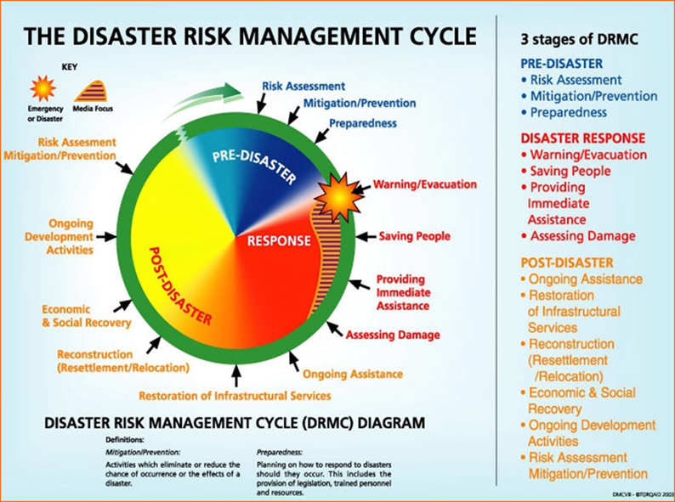
Source- DRM Cycle-Adopted from the Disaster Risk Management Handbook, Malawi
Definition of Recovery
The process of restoring, rebuilding, and improving the physical, social, economic, and environmental conditions of a community or region that has been affected by a disaster. It involves both short-term actions, such as restoring essential services, and long-term efforts, including reconstruction, economic recovery, and addressing the emotional and psychological needs of affected populations. The goals of disaster recovery:
Restoration of Normalcy: Bringing life back to pre-disaster conditions as much as possible, or improving overall community resilience.
Improvement of Resilience: Implementing policies and infrastructure changes to ensure that communities are better prepared for future disasters.
Economic Stabilization: Restoring jobs, commerce, and trade to ensure long-term sustainability and prosperity.
Psychosocial Recovery: Helping individuals and communities heal emotionally and psychologically from the trauma of the disaster.
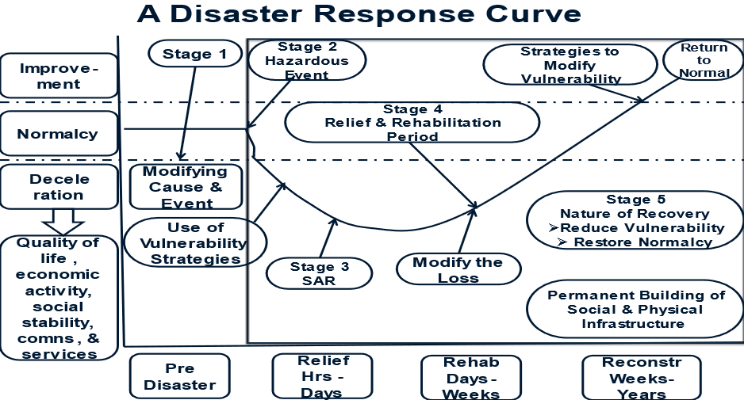
Source: Internet Geography, Edexcel IGCSA, Disaster Response Curve
Usually prior to a disaster, we try to lessen the impact through prevention, mitigation, & preparedness. When disaster strikes, usually the situation will deteriorate & we try to minimize the loss through response efforts. Then we conduct short term recovery efforts to bring the situation towards normalcy. Finally, through recovery efforts we intend to go beyond the level of normalcy to Build Back Better which takes time & resources.
Problem Areas in Recovery
Response action is usually dealing with urgent problems which will not wait; they will only get worse unless urgent solutions are applied. Response action often takes place under extraordinary powers (e.g., a state of emergency or a declared national disaster). It can therefore go beyond normal day-to-day limits of authority. Such freedom of action does not apply to recovery. Response action must sometimes be taken without consideration of longer-term repercussions (e.g., effects on recovery programs). Some response actions may have direct implications for recovery programs (e.g., large-scale evacuation movement, the need to accept outside assistance which upsets the balance of the local economy). Response action may have lowered the capability of key government departments (by using up financial allotments, fuel allocations, etc., and by lowering vehicle serviceability). Thus, when these departments are called upon to participate in recovery programs, this necessarily downgrades overall recovery capability. Recovery action may also have to operate within a changed community attitude. Emergency response action is usually accepted and supported by stricken communities because, basically, it is relieving their immediate problem(s). However, when the urgency of such problems has passed, communities tend to be more questioning, and perhaps demanding, concerning action being taken.
Ministerial responsibilities may arise because recovery requirements overlap from one department to another & restrictions on availability of finance (and/or uncertainty concerning international assistance funding) may hinder the formulation of recovery programs. Political problems can sometimes arise if certain areas/communities appear to not be the same priority of attention as others in regard to recovery programs. Similarly inadequate attention may be given by governments to public information programs and public relations generally, so that false impressions or perceptions arise concerning recovery measures. Some major and vital reconstruction programs may take a long time (e.g., reconstruction of bridges, roads, and rail systems). This may cause economic loss, further hardship, and other problems for disaster-affected communities. Limitations may apply to the implementation of recovery programs; for instance, in materials, equipment, specialist and skilled personnel. The time process of some recovery programs cannot be hastened; for instance, those which apply to the natural recovery Some recovery programs may necessitate substantial reorientation in national activities. For instance, disaster may affect an export market commodity (such as agricultural produce). The vacant market may then be taken over by another country and may be lost to the disaster-affected country for the foreseeable future.
Major Steps in the Recovery Process
Post-Disaster Needs Assessment and Credible Damage Assessment
Firstly, preliminary assessment reports should be collected & compile & transmit damage & loss data. Disaster damage assessments should be led by government and assisted by humanitarian response agencies. Quantitative and qualitative baseline for damage, loss, and needs across sectors, blocks (WODA) and districts. Results monitoring and evaluation plan for recovery program & select the most appropriate and achievable processes and methodology for conducting early and credible damage and needs assessments.
Developing a Vision for Build-Back Better (BBB)
High level meetings as well as broad-based, wider consultations with experts, civil society, and key stakeholders & build consensus among the range of stakeholders within and outside government.
Ensure Coherence of BBB with the Development Programs & Goals
Discussions at top level to align the recovery vision with the government’s broader, longer term development goals and growth and poverty reduction strategies.
Incorporating Resilience & BBB in Recovery Vision
Consultations and background studies on: disaster resistant physical recovery, options for fast economic recovery, gender and equity concerns, vulnerability reduction, natural resource conservation and environmental protection, & social recovery.
Balancing Recovery Across Sectors
Balance public and private sectors BBB programs & promote norms for non-discriminatory and equitable asset disbursement among individuals and communities. Prioritize infrastructure reconstruction & address the recovery of the lives and livelihoods of disaster-affected communities. Show sensitivity to the needs of the affected population with regard to public expectations from recovery.
Priotrizing Sectors for Recovery
Determine relative importance of various sectors such as housing, water and sanitation, governance, transport, power, communications, infrastructure, environment, livelihoods, tourism, social protection, health, and education.

Recovery Stages
Recovery Stage | Duration | Description
Early | 3- 18 Months | Cash for work, resumption of markets, commerce and trade, restoration of social services, transitional and temporary shelters
Mid-Term | Up to 5 years  (Concurrent with early recovery) | Recovery plans for assets and livelihoods, reconstruction plans for housing, infrastructure, public buildings. &- cultural heritage buildings
Long-Term | Within 10 Years | Implemented along with developmental plans: infrastructure strengthening, environmental, urban and regional planning
Elements of Recovery
Physical- Reconstruction of physical infrastructure such as houses, buildings, railways, roads, communication network, water supply, electricity, & short-term and long-term strategies towards watershed management, canal irrigation, social forestry, crop stabilization, alternative cropping techniques, job creation, employment generation and environmental protection. Rehabilitation of agriculture, artisan work and animal husbandry. Adequate provision for subsidies, farm implements, acquisition of land for relocation sites, adherence to land-use planning, flood plain zoning, retrofitting or strengthening of undamaged houses, and construction of model houses. Avoid secondary displacement as far as possible & gain consent of the affected communities. Clearly define land acquisition process & take into consideration urban/ rural land use planning before moving ahead. Provide customized relocation packages & decentralize powers for undertaking the relocation process.
Social- Revival of educational activities by giving regular counselling to teachers and children. Encourage children to attend the schools regularly & provide writing material, and work books to children. Make children participate in all activities pertaining to resurrection of normalcy in the school. Try to inculcate conducive attitudes to enable the students to play a positive role in self - development. Establish village level education committees identify local groups that could conduct smooth functioning of education activities.
Rehabilitation of elderly, woman, & children in familiar environs. Make efforts to attach destitute, widows and orphans with their extended family, if that is not possible then identify foster families. Organize regular counselling to strengthen the mental health of women and children & initiate various training programmes to make the women economically self-sufficient. Give due attention to health, nutrition and hygiene in the long-term rehabilitation package for women and children. Activate/reactivate the day-care centres, and old-age homes within the shortest possible time. Set up vocational training camps to improve the skills of orphans and children & promote self-help groups.
Economic- Analysis of existing livelihood strategies and sustainability of businesses & comprehensive analysis of existing and future risks. The vulnerabilities of the affected families & access to functioning markets
Psychological- Psycho-therapeutic health programmes & occupational therapy. Debriefing and trauma care. Practice of tradition, values, norms, beliefs, and practices of disaster-affected people.
Disaster Risk Reduction: Integrating measures to reduce vulnerability to future disasters, such as enforcing stronger building codes, relocating communities from hazard-prone areas, and educating people on disaster preparedness.
Environmental Recovery: Restoring natural ecosystems that may have been damaged by the disaster, such as replanting forests, cleaning polluted water bodies, and addressing environmental degradation.
Fund Mobilization
Estimation of funds required based on the detailed damage assessment reports and consolidation of the same under sectoral and regional heads. Contracting with funding agencies and evolving detailed operating procedures for fund flow and corresponding covenants. Funds Disbursement & Monitoring by prioritizing resource allocation across approved projects, establishing mechanisms for disbursement of funds to the beneficiaries, & strengthen the monitoring mechanisms for fund utilization and progress of implementation. Recovery of reconstruction costs through special tax, imposing local taxes, & issuing tax free government bonds.
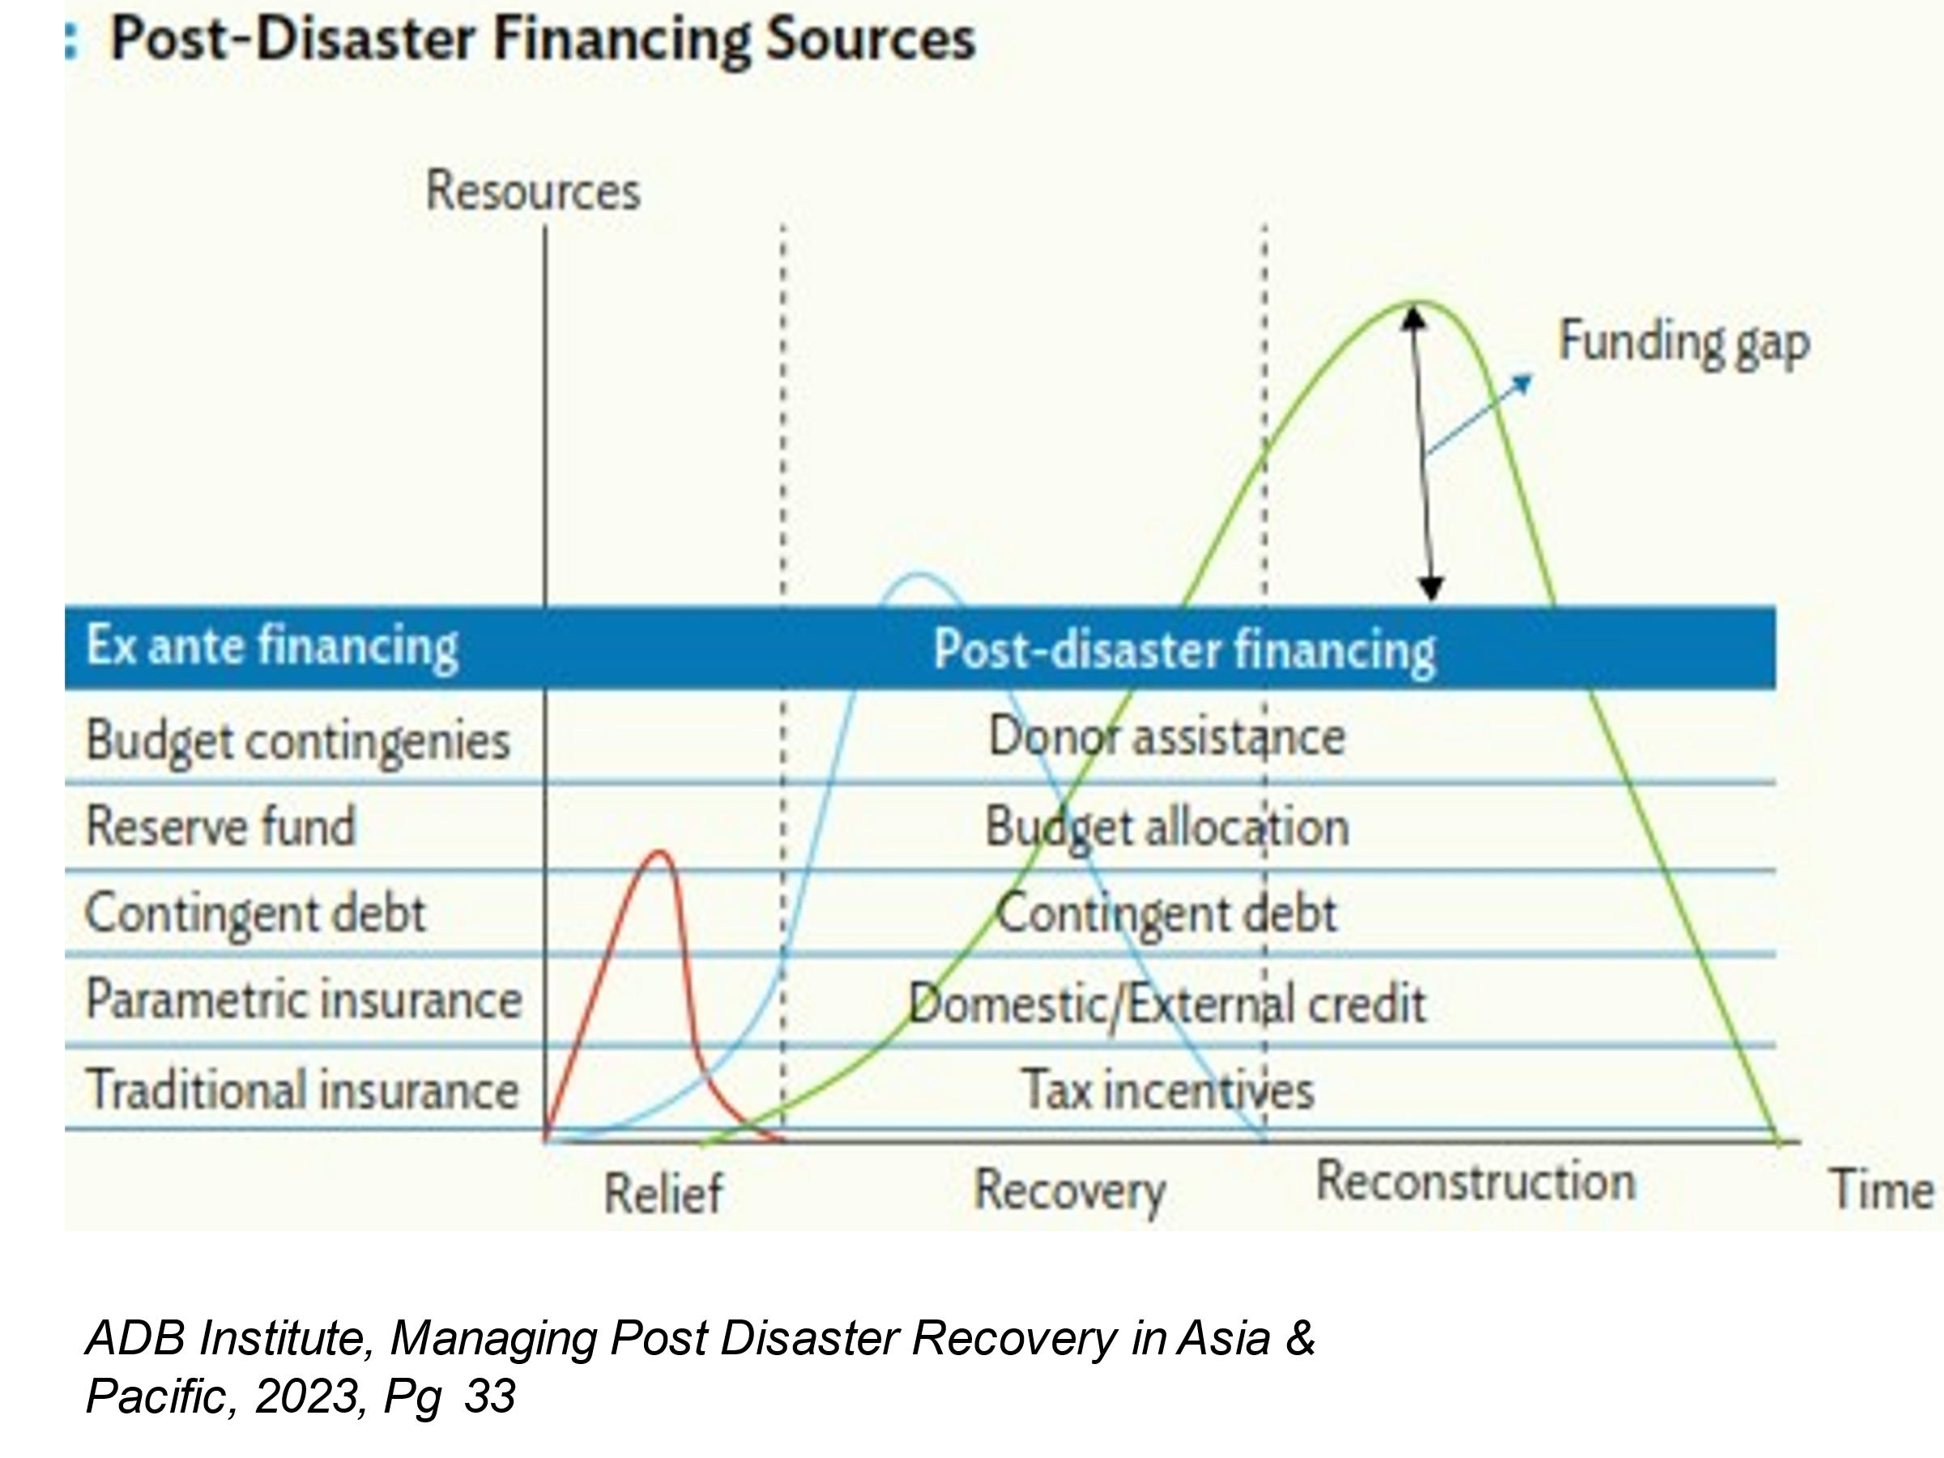
This figure provides a summary of different instruments that are suitable at distinct stages of disaster recovery. Two important factors that the figure highlights are the need for funding increases with time and stage of recovery, & the different sources of finance depending on their risk appetite that can be leveraged. The other key point that the figure makes is that there still is a gap in available funding, particularly to meet the requirements that arise in later periods.
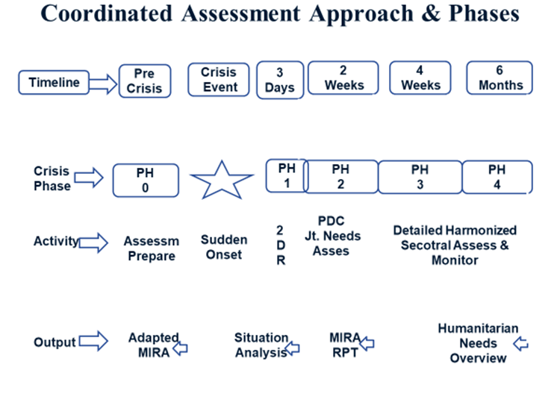
Core Elements of Post Disaster Needs Assessment
Pre-Disaster context and baseline information. - Social, economic, cultural, financial and political status -- which serve as a baseline to compare with post-disaster conditions in the affected country.
The Assessment of Disaster Effects- Damage to infrastructure and assets destroyed in the disaster & disruption of access to goods and services. Effect to governance and decision-making processes. Increased risks and vulnerabilities & assessment of disaster impacts. Estimating the value of disaster effects in terms of total and partial destruction of infrastructure and assets. Value of changes on service delivery, production of goods and services and access to goods and services. Value of changes to governance processes & value of changes to risks.
Assessment of Disaster Impact- Economic impact at macro and micro levels, human development impact, the impacts of the disaster on the quality of human life in the medium and long term.
The Recovery Strategy- Basis for determining early, medium and long-term recovery and reconstruction.
Coordination of Disaster Recovery
Federal government has to coordinate with various stakeholders & manage donated resources. Coordinate with various stakeholders & provide resources on need basis. Lead in and support need and damage assessment operations.
Provincial government provides data regarding the severity of the disaster and assessment of individual needs. It also participates in and supports public information and education programmes regarding recovery efforts. It should also coordinate with the Federal Government and other stakeholders.
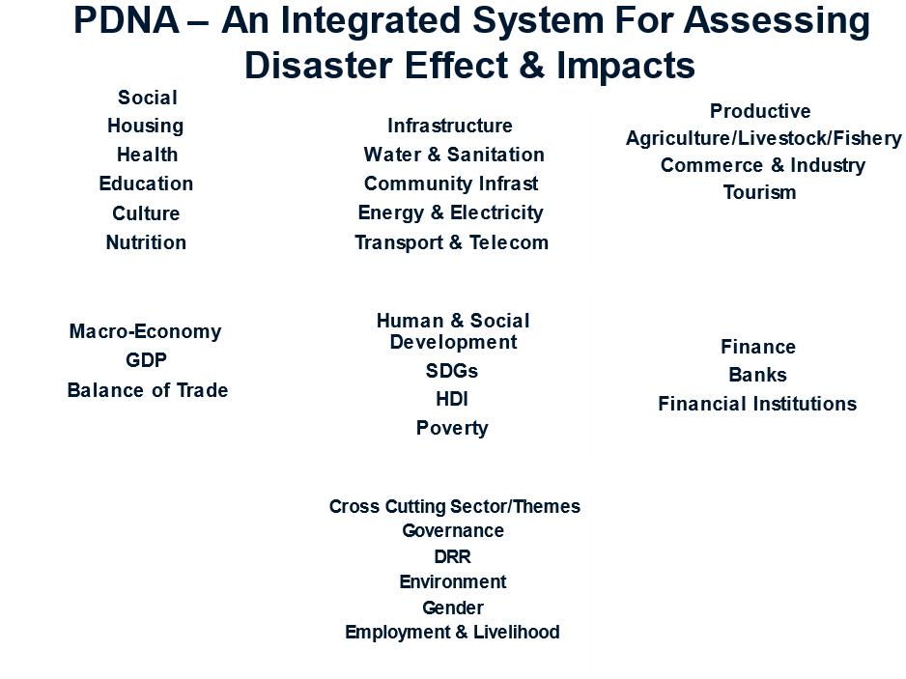
Lessons for Recovery
Recovery efforts must be risk-informed, with comprehensive management strategies put in place that acknowledge concurrent threats. This includes translating climate projections and real-time scientific data into forward-looking recovery efforts so that communities have the knowledge and tools needed to face present and evolving climate hazards. An institution should be established as soon as possible after a disaster so that it can develop a framework for resilient recovery.
They must also be multi-dimensional, encompassing social, human, natural, financial, and physical factors that collectively enhance resilience to climate threats. Recognizing the interconnectedness of these factors is essential for a truly effective resilient recovery.
Bilateral donors, humanitarian and development organizations, international financial institutions, and the private sector all have their part to play – primarily by improving both the quality and quantity of finance climate. An increase in the use of grants and other finance mechanisms designed to limit growing debt levels will ensure that recovery efforts are not hindered by avoidable debt crises. Furthermore, supporting countries with technical assistance and improved data can deliver recovery plans designed to be as future-proof as possible. Resilient recovery must be prioritized.
Recovery requirements must evolve from the affected community & local leaders should ensure that their voices are heard & plans implemented. Reconstruction that involves relocation should not be detrimental for households in securing income opportunities. Housing should respond to the requirements of households. Resettling households should be done in a way that does not disadvantage them through social stratification or affect their self-identity. In this context, it is important that the community is involved in the process of designing their living environment. During post-disaster reconstruction, it is crucial to avoid disrupting social systems that are based on trust and care for each other and particularly for children. Post-disaster reconstruction must take an inclusive approach that addresses the needs of all women, men, and children affected, particularly the most marginalized and vulnerable, and empowers them to actively participate in locally-led recovery decision-making. Mechanisms should be devised for protection of assets/houses and income of low-income households through public insurance or other safety nets. This implies that as far as possible, reconstruction should be in place or, if relocation is necessary, it should not be at a distant location.

References
A Disaster Management Handbook, 275-289 (https://www.adb.org/sites/default/files/publication/27890/disaster-management-handbook.pdf)
ADB Institute, Managing Post Disaster Recovery in Asia & Pacific, 2023, Pg 1-10 (https://www.adb.org/publications/navigating-resilient-post-disaster-recovery-in-asia-and-the-pacific)
GOI National Disaster Management Plan, 2016, Pg 121-129 (https://ndmindia.mha.gov.in/ndmi/images/National%20Disaster%20Management%20Plan%20May%202016.pdf
Post Disaster Needs Assessment Volume A, Government of Nepal, 2015, Pg 21-43(https://www.worldbank.org/content/dam/Worldbank/document/SAR/nepal/PDNA%20Volume%20A%20Final.pdf
Post Disaster Needs Assessment Volume A, Guidelines, GFDRR, 2013, Pg 17-31 (https://www.who.int/docs/default-source/documents/publications/post-disaster-needs-assessment-guidelines.pdf?sfvrsn=ce5059ab_1)
Resilient Mountain Village, ICIMOD, 2018 (www.icimod.org)
Resilient-Recovery-An-Imperative-for-Sustainable-Development, GFDRR, 2015, Pg 9-32 (https://www.gfdrr.org/en/publication/resilient-recovery-imperative-sustainable-development)

