Disaster Management & Social Work
Lecture 9
Mainstreaming Disaster Risk Reduction in Development Programme
Lecturer: Victor J B Rana

Introduction
The development process does not necessarily reduce vulnerability to natural hazards. Instead, it can unwittingly create new forms of vulnerability or exacerbate existing ones, impeding efforts to reduce poverty and promote growth, sometimes with tragic consequences. ‘Win-win’ solutions for securing sustainable development, reducing poverty and strengthening hazard resilience, therefore, need to be explicitly and actively sought, particularly as climate change looks set to increase the incidence of droughts and floods and the intensity of windstorms. Such solutions are best derived by integrating disaster risk reduction strategies and measures within the overall development framework, viewing disaster risk reduction as an integral component of the development process rather than as an end in its own right.
Since the late 1990s, there has been increasing recognition of this need to ‘mainstream’ disaster risk reduction into development – that is, to consider and address risks emanating from natural hazards in medium-term strategic frameworks and institutional structures, in country and sectoral strategies and policies and in the design of individual projects in hazard-prone countries. A number of development organizations have begun efforts to mainstream disaster risk reduction into their work, undertaking various related institutional, policy and procedural changes and adjusting operational practice.
This shift in perspective from a previously widely entrenched view of disasters as unpredictable, unavoidable events to be dealt with by emergency specialists has, in part, reflected increasing understanding of disasters as unresolved problems of development. Development initiatives do not necessarily reduce vulnerability to natural hazards. Instead, they can unwittingly create new forms of vulnerability or exacerbate existing ones, sometimes with tragic consequences. The rising importance attached to poverty reduction has been particularly instrumental in contributing to this enhanced understanding. Exposure to risk and income shocks, including those emanating from natural hazards, has been widely acknowledged as one of the fundamental dimensions of poverty. This acknowledgement has triggered considerable focus on the analysis of forms and underlying causes of vulnerability and related initiatives to strengthen resilience.
Topic Objectives
Understand why nation development leads to risk in disaster.
Understanding the need to mainstream disaster risk reduction into development
Analyze the process involved in mainstreaming disaster risk reduction into development
Question for Discussion
Does development increase the risk of hazards?
How can development & disaster risk reduction be harmonized?
What is the process of mainstreaming disaster risk reduction in development?
Introduction
- 3.3 million people killed
- 50% of deaths occur in poor countries, but they accounted for only 9% of disasters
- Economic cost of disasters has tripled. Over US $ 1.2 trillion of economic loss occurred in developing countries
- Disasters push people into poverty
- Poverty level increased by 2% after the Nepal Earthquake
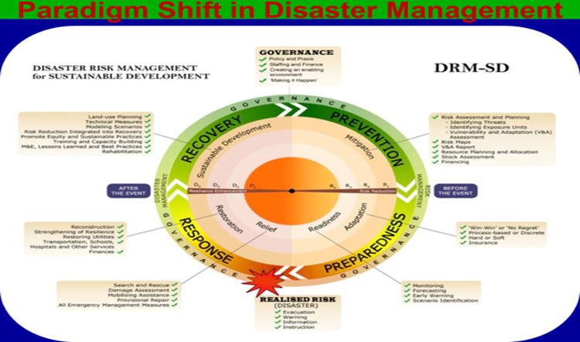
Source: Learning Lab on Disaster Risk Management for Sustainable Development (DRM-SD), 2017, Pg 609
Currently, we are moving from the Disaster Risk Management Continuum to Disaster Risk Management -Sustainable Development. In each phase of the Disaster Management Continuum, we have aspects of how development should contribute to the reduction of current disaster risk & future risks. For example, in recovery phase, we are talking about integrating risk reduction into recovery as well as modelling scenarios.

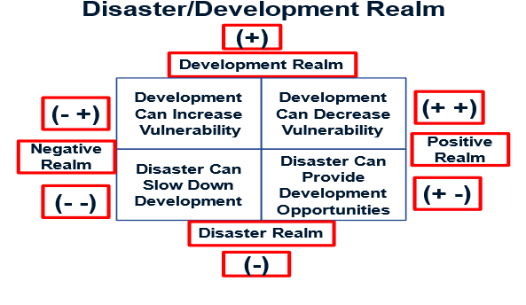

- - Disasters set back development programming destroying years of development initiatives. Infrastructure improvement e.g. transport and utility systems are destroyed by a flood.
+ - Rebuilding after a disaster provides significant opportunities to initiate development programs. A self-help housing program to rebuild housing destroyed by an earthquake teaches new skills, strengthens community pride and leadership and retains development dollars that otherwise would be exported to large construction companies
-+ Development programs can increase an area’s susceptibility to disasters. A major increase in livestock development leads to overgrazing, which contributes to overgrazing, which contributes to desertification and increases vulnerability to famine.
++ Development programs can be designed to decrease the susceptibility to disasters and their negative consequences. Housing projects constructed under building codes designed withstand high winds result in less destruction during the next tropical storm.
What is DRR Mainstreaming
A Dynamic process with a dual purpose: Ensuring that development is protected through DRR elements & ensuring that development does not increase people's vulnerability to disasters. Mainstreaming disaster management into the development planning process essentially means looking critically at each programme, activity and project that is being planned, not only from the perspective of reducing the existing risks disaster disasters, but also from the perspective of minimizing its potential contribution to creation of new risks of disasters.
Why DRR Mainstreaming
Disasters set back development can impact various sectors like Agriculture, Health, Education, Infrastructure, Housing etc. This causes diversion of resources to rehabilitation and reconstruction and sometime postponement/ cancellation of development programs. Development can also create disaster risks. DRR considerations not featuring into project design, thus increases the risks, and increasing the negative impact of disasters on the socio- economic set up of the country.
Sustainable Development
A managed process of continuous innovation and systemic change in the direction of sustainability. Creating systems that can endure (i.e. resilient, transformative, flourishing). Sustainable development refers to a framework for growth that seeks to meet the needs of the present without compromising the ability of future generations to meet their own needs. It is a concept that integrates environmental health, economic growth, and social well-being to ensure long-term prosperity and ecosystem viability.
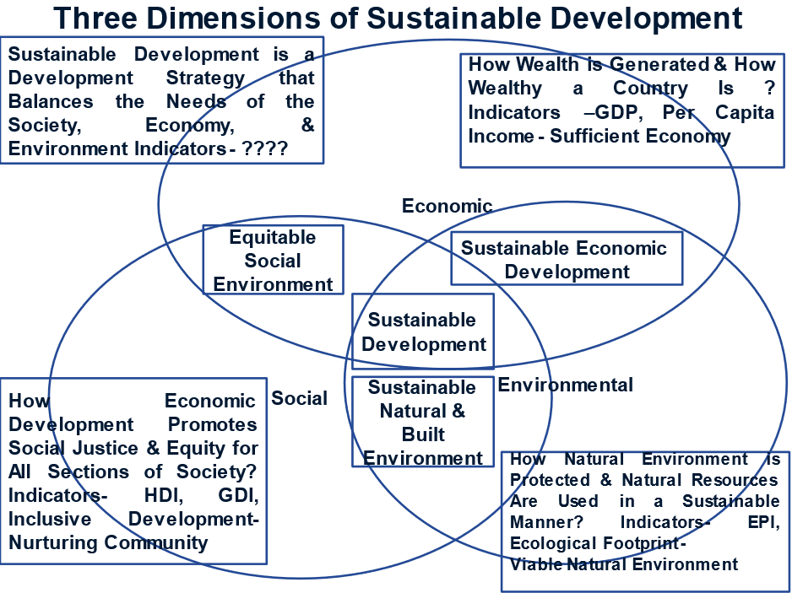
Source: Economiesuisse Dossier Politik, # 6/20 20, 2020, Pg 3
Three Dimensions of Sustainable Development
Environmental Sustainability- Protecting ecosystems, reducing pollution, conserving natural resources, and promoting biodiversity & ensuring that human activities do not degrade the environment beyond its ability to regenerate.
Economic Sustainability- Supporting long-term economic growth that benefits all sectors of society & ensuring economic practices that avoid depleting natural resources or creating excessive waste. Promoting innovation and efficiency to create sustainable markets and industries.
Social Sustainability- Ensuring equity, fairness, and inclusion, particularly for marginalized or vulnerable groups & improving quality of life by providing access to basic needs such as food, water, healthcare, and education. Promoting social cohesion, justice, and human rights.

Principles of Sustainable Development:
Intergenerational Equity: Ensuring that development does not harm the prospects of future generations.
Precautionary Principle: Acting to prevent harm to the environment, even if some cause-and-effect relationships are not fully established scientifically.
Holistic Approach: Integrating economic, environmental, and social factors in decision-making.
Resource Efficiency: Using natural resources wisely and minimizing waste.
Sustainable development is crucial for creating a future where economic growth, environmental conservation, and social well-being can coexist harmoniously, ensuring the health of our planet and the prosperity of all its inhabitants.
Resilent Development
People/Social- The ability of a system, community or society exposed to hazards to resist, absorb, accommodate, adapt to, transform and recover from the effects of a hazard in a timely and efﬁcient manner.)
The ability of individuals, households, communities, cities, institutions, systems and societies to prevent, resist, absorb, adapt, respond and recover positively, efﬁciently and effectively when faced with a wide range of risks, while maintaining an acceptable level of functioning and without compromising long-term prospects for sustainable development, peace and security, human rights and well-being for all.
Planet/Environment- The capacity of social, economic, and environmental systems to cope with a hazardous event or trend or disturbance, responding or reorganizing in ways that maintain their essential function, identity, and structure, while also maintaining the capacity for adaptation, learning, and transformation.
Prosperity/Economy- Economic resilience has two components: instantaneous resilience, which is the ability to limit the magnitude of immediate production losses for a given amount of asset losses, and dynamic resilience, which is the ability to reconstruct and recover.
Sustainable Development Goals (SDGs)
The United Nations established 17 Sustainable Development Goals (SDGs) in 2015 as part of the 2030 Agenda for Sustainable Development. These goals address global challenges such as poverty, inequality, climate change, environmental degradation, and peace. Some key SDGs include: No poverty, zero hunger, quality education, clean water and sanitation, affordable and clean energy, climate action, life below water and on land, decent work and economic growth.
Challenges to Sustainable Development:
Climate Change: Increasing temperatures, extreme weather events, and rising sea levels are major threats.
Inequality: Disparities in wealth, access to resources, and opportunities hinder sustainable progress.
Resource Depletion: Overconsumption of natural resources such as forests, water, and fossil fuels.
Biodiversity Loss: Human activities leading to habitat destruction, species extinction, and ecological imbalance.
Resilience Deficit 1.-Increasing Drought Risk and Food Insecurity
70% Percentage employment in low-income countries reliant on agriculture as source of income (World Bank Group, 2017). 60% Increase in incidents of drought by the end of the century (IPCC, 2014). 80% Percentage of global population at risk of crop failure and hunger in sub-Saharan Africa and south and south-east Asia. (The World Bank, 2022)
Resilience Deficit 2-Forced Displacement and Negative Education Outcomes
330 million children exposed to climate and environmental hazards in 2020 (UNICEF, 2021). 920 million number of children exposed to water scarcity in 2020 (UNICEF, 2021). 820 million Number of children exposed to heatwaves in 2020 (UNICEF, 2021). 2 billion Number of people affected by armed conflict in 2023 (United Nations, 2023b)
Resilience Deficit 3- Increasing Water Stress and Population Growth
12% Global improvement in water-use efficiency between 2015 and 2019 (FAO, 2022b) (SDG indicator 6.2.4). 74% global population that uses safe drinking-water services in 2020 (UN Water, n.d.). 54% countries that developed integrated water strategies in 2020 (UNEP, 2021). 19% amount of global water resources used sustainably in 2020 (FAO and UN-Water, 2021)
Resilience Deficit 4- Increased Land Degradation and Biodiversity Loss
1% Increase in global proportion of forest area within protected areas, between 2010 and 2020(FAO, n.d.d). 7% Increase in forest area under management between 2010 and 2020 (FAO, n.d.d). 5-20% amount of carbon emissions that can be offset through the better management of soils (IPCC, 2019b). 90% Loss of forest due to agriculture between 2000 and 2018 (FAO, n.d.b). -9.2% Red List Index overall extinction of species between 2000 and 2022 (SDG indicator 15.5.1) (UN DESA, 2022). 37% number of countries on track to meet their national biodiversity targets (UN DESA, 2022)
Resilience Deficit 5 -Increased Heat Stress and Energy Consumption
$5.9 trillion global expenditure on fossil fuel energy subsidies in 2020, (SDG indicator 12.c.1) (International Monetary Fund, 2022). 91% Population with access to electricity in 2020; up from 83% in 2010 (SDG indicator 7.1.1) (UN DESA, 2022). 2% Increase in modern renewable-energy use in final energy consumption (2010-2019) (SDG indicator 7.2.1) (UN DESA, 2022). -3.2% Amount of yearly energy-efficiency improvement needed to reach target by 2030 (SDG indicator 7.3.1) (UN DESA, 2022)
Resilience Deficit 6.-Increasing Flood Risk and Urbanization
60% Percentage of loss in the agricultural sector out of total working hours, projected to be lost due to heat by 2030 (International Labor Organization, 2019). 5.3% and 4.8% loss of working hours in south-east Asia and West Africa by 2030 due to heat stress (International Labor Organization, 2019). 80 million -this is 2.2 per cent of total working hours worldwide – a loss equivalent to 80 million full-time jobs (International Labor Organization, 2019). 49% vs 10% ` Percentage of labor loss in Africa compared to in the Americas under a scenario of 3.0°C warming (Dasgupta et al., 2021)
Resilience Deficit 7- Increasing Heat and Poverty
60% Percentage of loss in the agricultural sector out of total working hours, projected to be lost due to heat by 2030 (International Labor Organization, 2019). 5.3% and 4.8% Loss of working hours in south-east Asia and West Africa by 2030 due to heat stress (International Labor Organization, 2019). 80 million -this is 2.2 per cent of total working hours worldwide – a loss equivalent to 80 million full-time jobs (International Labor Organization, 2019). 49% vs 10% ` Percentage of labour loss in Africa compared to in the Americas under a scenario of 3.0°C warming Dasgupta et al., 2021)
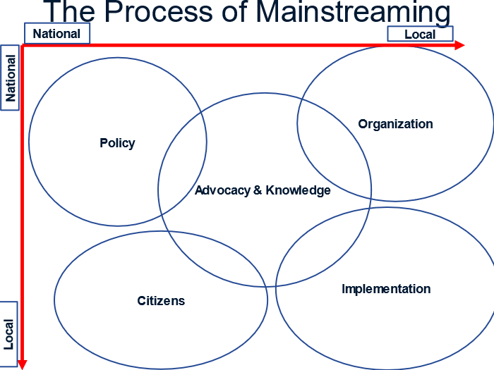
Source:https://www.slideserve.com/wren/mainstreaming-of-disaster-risk- reduction#google_vignette, Slide 5
Policy- At the national level formulate strategies, policies & planning & legislation & regulation for implementation of policies. Resource mobilization & allocation will be required to implement plans which must be backed by political commitment & leadership.
Organization- At the local level, organization should be developed, responsibility should be delegated & capacity developed according to the responsibility.Internal procedures should be formulated & incentives should be provided to mange the tasks. Fulfilling the objectives will require coordination & partnerships.
Implementaion- The local levels should ensure investments are risk proofed. Before the start of any major project, pilot projects may have to be considered. Once the project is underway local level must ensure compliance & enforcement as well asmonitoring & evaluation.
Citizens- Local level bodies must have political accountability towards the citizens. Civil societies must consist of all communities & they with their leaders must presurize the government for sustainable development.
Advocacy & Knowledge- Both at the national & local level awareness on sustainable development must be propagated. Method & tools for development must be developed through research & education. Good practices must be followed.

Reference
GAR Special Report, UNDRR, 2023, Pg 1-51 (http://www.undrr.org/gar2023sr)
Learning Lab on Disaster Risk Management for Sustainable Development (DRM-SD), An Evaluation, Ahmad Firdaus & Ahmad Shabudin, 2017, Pg 1-26 (http://www.emeraldinsight.com/1756-8692.htm)
Sustainable Development: Issues & Challenges, The Politics of Global Environmental Policies, Ateret Clifford and Kingdom Sunday Mboho, University of Calabar Press, 2024, Pg. 165-185 (https://www.researchgate.net/publication/378215918_SUSTAINABLE_DEVELOPMENT_ISSUES_AND_CHALLENGES)
Tools for Mainstreaming Disaster Risk Reduction: Guidance Notes for Development Organizations Charlotte Benson and John Twigg, 2007, Pg. 5-15 (https://www.preventionweb.net/files/1066_toolsformainstreamingDRR.pdf)

