Disaster Management & Social Work
Lecture 11
Role of Key Actors
Lecturer: Victor J B Rana

Introduction
UN agencies, NGOs, INGO’s are involved in all phases of the disaster management cycle. At the same time there are also other national actors involved as well as national & international security forces. These civilian & military actors have a wide variety of skills & capabilities. Yet, they come with different work culture, chain of command, resources, funding means & ethics. Coordinating & synchronizing the activities of all these various actors to achieve the desired end state is indeed a herculean task.
Predetermined coordinating mechanism is in place which does synchronize the focus & activities of the various actors. However, different work ethics & culture makes it extremely difficult to implement the activities in the ground. This is where disparity exists with relief not being delivered timely, redundancy, & competition between various actors on the field.
Nevertheless, NGOs/ INGOs & both the national & international militaries have developed their own code of conduct for humanitarian response. These guidelines do provide some form of integrity among the various actors to conduct their business. At the same time lot of joint & multinational planning & exercises are conducted to refine planning & to understand each other’s work culture & capabilities.
Topic Objectives
Understand the difficulties of coordinating the activities of various NGOs/INGOs & military actors during disaster response.
Get a knowledge of the various capabilities & work culture of humanitarian actors
The factors that could lead to better success in the field by various actors during disaster response.

Question for Discussion
Why there is difficulty in coordination the activities of various actors involved in humanitarian response?
What are the capabilities & limitation of humanitarian actors during disaster response?
How could better coordination & implementation be achieved among the various actors?
What are the capabilities of ICRC & RC in disaster management?
What is INGO/NGO- NGOs are organizations that operate internationally and are not established by an intergovernmental agreement. INGOs are non-governmental and are not subject to any governmental influence or control.
Not for Profit, Voluntary- Are organizations that are not-for-profit and are focused on creating social impact rather than profit. Example would be OXFAM or CARE.
Registered Charities- These are organizations different from regular not-for-profits in a number of ways. For example, registered charities may be eligible for tax rebates and exemptions from charging HST for many services. Some examples of registered charities include: Food banks, Low-cost housing units, Colleges, Universities, & research institutes. Example would be Bill & Melina Gates Foundation.
Local, National, International- NGOS/ INGOs can work at the local, national, or international level depending on their type of focus & capability.
Narrow / Wide Issue Based- NGOs/INGOs will focus their work on a single field like health or can be multi-dimensional working on various humanitarian relief. CARE is a wide issue-based INGO which deals with food, sanitation, education, etc. Whereas, Doctors Without Borders deals with health issue only.
Religious / Secular Institutions- These NGOs/INGOs mainly deals with religious support & are based on certain religions like Catholic Relief Service.
Political / Social Reformers- These NGOs/INGOs are mainly focused on & reforming the social & political sphere. Environmental organization like Greenpeace or political like Government-organized non-governmental organization.
Private- They can be created through private philanthropy, such as the Carnegie, Rockefeller, Gates, and Ford Foundations.
Government Backed- These INGOs are directed & funded by a particular nation like DFID by UK & USAID by USA.
Who controls them? - It is difficult to ascertain whether they are controlled by the host government, country of origin, or the donors.
Registration & Inspection by Host Country- They are regulated by the host nation in terms of registration & sphere of work & annual reporting only.
Independence-Code of conduct insists on independence. They are legally not bound by national or international regulations.
Report Card on Their Work- Although many INGOs provide many benefits to the society, still people view them as the better beneficiaries as they spend more than 50% finance on administrative & salary.
Do NGOS/INGOs Have Common Standards
SPHERE Handbook is a guideline for NGOs/INGOs providing humanitarian relief. It is also a system of quality & accountability & sets guidelines for aid agencies.
INGOs Strength
International Non-Governmental Organizations (INGOs) have several strengths that allow them to address global challenges effectively. These strengths enable INGOs to address a wide range of global challenges, from poverty alleviation to environmental conservation, making them vital players in international development and humanitarian efforts. Here are some of their key strengths:
Global Reach and Presence- They have wide networks operating across multiple countries, giving them the ability to tackle cross-border issues such as human rights, climate change, and global health. Local partnerships enable them to form partnerships with local NGOs, governments, and communities, allowing them to understand local contexts and respond to specific needs more effectively.
Expertise and Specialized Knowledge- They possess technical expertise in various fields like healthcare, education, environmental science, and human rights. This expertise allows them to implement effective programs and provide valuable insights. Many INGOs conduct in-depth research and advocacy efforts, influencing global policies and raising awareness on critical issues like poverty reduction, social justice, and environmental sustainability.
Flexibility and Innovation- Unlike government agencies, INGOs can often operate with more flexibility, allowing them to adapt to rapidly changing conditions or crises. Their ability to experiment with new models and methods, such as community-driven development or technology-based solutions, can lead to more effective ways of addressing challenges.
Humanitarian Assistance and Crisis Response- INGOs are often among the first to provide aid during humanitarian crises, such as natural disasters, conflicts, or pandemics. Their ability to mobilize resources quickly makes them crucial in emergency relief efforts. In addition to short-term relief, INGOs frequently engage in long-term recovery efforts, helping communities rebuild and develop resilience after crises.
Advocacy and Awareness Raising - INGOs can leverage their international platforms to advocate for policy changes at a global level, influencing institutions like the United Nations or the World Bank. Similarly, through campaigns and media engagement, INGOs bring attention to underreported issues, mobilizing public opinion and resources towards important causes.
Resource Mobilization- INGOs often have robust fundraising capabilities, accessing diverse funding sources such as donations, grants from governments, and partnerships with private corporations. Many INGOs rely on a large base of volunteers, which helps them scale their efforts and implement programs more efficiently.
Impartiality and Trust- INGOs are often seen as impartial actors, especially in conflict zones or politically sensitive areas. This neutrality helps them gain access to populations that might be wary of state actors. By focusing on community needs and acting independently of political agendas, INGOs can build strong relationships with local communities, increasing the impact of their work.
INGOs Weaknesses
They also face some challenges in balancing their global influence with the need for locally tailored, sustainable, and inclusive approaches. Addressing th weaknesses is essential for INGOs to achieve greater impact and build trust with the communities they serve:
Dependence on Donor Funding- INGOs often rely heavily on external funding from donors, governments, and private entities. This dependence can make their programs vulnerable to shifts in donor priorities or reductions in funding. Due to this reliance on external funds, INGOs may prioritize projects that align with donor interests rather than the actual needs of the communities they serve, leading to a potential misalignment between goals and outcomes.
Lack of Local Knowledge- Despite their global presence, some INGOs may struggle to understand the cultural and social dynamics of the local communities they aim to help. This can lead to interventions that are not well-suited to the local context. INGOs are sometimes criticized for adopting a top-down approach, where programs are designed by headquarters rather than involving local communities in decision-making, which can limit the effectiveness and sustainability of their interventions.
Bureaucratic Structure- As INGOs grow, they can develop complex internal structures that slow down decision-making processes and reduce their ability to respond quickly to crises. The administrative and operational costs of maintaining large, international organizations can sometimes consume a significant portion of their budgets, reducing the funds available for direct program delivery.
Accountability and Transparency -While INGOs are often accountable to donors, their accountability to the communities they serve can be weaker. This can result in programs that do not fully align with the needs or priorities of those they aim to assist. Transparency in how funds are spent and decisions are made can sometimes be lacking, which may lead to criticisms regarding misuse of funds or inefficiency.
Competition with Local NGOs- INGOs sometimes compete with local NGOs for funding, leading to tensions and potentially undermining the growth and sustainability of local civil society organizations. By implementing their own programs, INGOs might inadvertently overshadow or undermine local initiatives and capacity-building efforts, making communities more dependent on external assistance rather than fostering local solutions.
Political Constraints- INGOs can face challenges in accessing certain areas due to political restrictions or resistance from host governments, especially in authoritarian contexts. Governments may perceive INGOs as interfering or undermining their authority. Political pressures from donor governments can sometimes influence the operations and strategies of INGOs, potentially leading them to align with certain political agendas rather than maintaining impartiality.
Short-Term Focus- Donor demands for measurable outcomes can push INGOs towards implementing short-term projects rather than focusing on long-term sustainable development. This can hinder their ability to create lasting change. Communities may experience project fatigue due to the short-term nature of many interventions, where initiatives are discontinued or abandoned once funding cycles end, leaving long-term needs unmet.
Power Imbalances- The unequal distribution of power and resources between INGOs and local partners can strain relationships, reducing the effectiveness of collaboration and reinforcing global inequalities.
Military Strengths
The military can play a significant role in humanitarian operations, especially during emergencies and crises. Their strengths in such situations often complement the work of humanitarian organizations like INGOs, local NGOs, and international bodies. The strengths make the military a valuable partner in the immediate aftermath of a crisis, particularly when speed, logistics, and security are critical for saving lives and stabilizing affected areas. However, it's important for military forces to coordinate closely with humanitarian organizations to ensure that their involvement is appropriate and aligned with humanitarian principles. Here are some of the key strengths of the military in humanitarian operations:
Rapid Deployment and Mobility- One of the military’s key strengths is its ability to deploy quickly to crisis zones. This rapid response is crucial in the aftermath of natural disasters, conflicts, or other emergencies where immediate aid is needed. The military’s access to aircraft, ships, and other transport vehicles allows them to deliver aid supplies and personnel to remote or hard-to-reach areas, where civilian organizations may lack the necessary logistics.
Logistical Expertise and Capacity- The military excels in managing large-scale logistics, including the transportation, storage, and distribution of supplies. This is especially important in humanitarian operations where managing the flow of aid is critical. Militaries can quickly establish temporary infrastructure such as roads, airstrips, and bridges to facilitate the delivery of aid. This capability is vital in situations where existing infrastructure is damaged or inadequate.
Security and Stability- In volatile environments, the military can provide security and stability, protecting aid workers, civilians, and critical infrastructure. This is particularly crucial in conflict zones or areas with a high risk of violence. The presence of military forces can help secure access to dangerous areas, allowing humanitarian organizations to reach populations in need while minimizing risks to their staff.
Specialized Equipment and Technology- The military often has access to advanced communication equipment, including satellite technology and secure radio systems, which can enhance coordination between different actors in a crisis. With specialized equipment like bulldozers, cranes, and earth-moving machinery, the military can quickly clear debris, build shelters, or establish water supply systems in affected areas.
Capacity for Large-Scale Operations-The military has a large number of personnel who can be deployed for a range of tasks, from search and rescue operations to medical assistance and distributing relief supplies. Many military units have field hospitals and trained medical staff that can provide critical care in emergency situations, such as treating injuries from natural disasters or providing vaccination campaigns.
Experience in Crisis Management- Militaries are often trained for a variety of crisis scenarios, including natural disasters, complex emergencies, and conflict situations. This experience allows them to handle chaotic environments and coordinate effectively during crises. In many contexts, the military has experience working alongside civilian authorities, international organizations, and other militaries, which can be beneficial in coordinating a comprehensive response to humanitarian crises.
Resource Availability- Militaries often have access to substantial budgets, allowing them to deploy resources without the same fundraising challenges faced by civilian humanitarian organizations. The military’s access to fuel, food, medical supplies, and other resources can be vital, particularly in the initial stages of a humanitarian response when civilian supply chains may be disrupted.
Emergency Shelter and Evacuation Support-The military can rapidly set up temporary camps and shelters for displaced populations, ensuring that affected people have immediate access to shelter, food, and medical care. In situations where civilians need to be evacuated from dangerous areas, the military’s transport and logistical capabilities can facilitate the safe relocation of affected populations.
Military Weaknesses
While the military has notable strengths in humanitarian operations, it also has several weaknesses and challenges that can limit its effectiveness in such contexts. These weaknesses highlight the challenges of using military forces in humanitarian operations. While the military can provide critical support in specific situations, its involvement needs to be carefully coordinated with humanitarian actors to ensure that aid delivery aligns with humanitarian principles and is responsive to the needs of affected communities. Here are some of the key weaknesses of the military in humanitarian operations:
Humanitarian Principles Misalignment - The military is often associated with the strategic and political interests of its home country, which can compromise its perceived neutrality. This can lead to a lack of trust among local communities and conflict parties, as they may view the military's involvement as part of a political agenda rather than a purely humanitarian effort. The presence of military forces in a humanitarian context can lead to challenges in accessing certain areas, as some groups or governments may view the military as a threat. This can limit the ability of humanitarian organizations to operate independently.
Cultural and Contextual Insensitivity- The military may lack the deep cultural understanding that is crucial for effective humanitarian work. This can result in actions that are not sensitive to local customs, norms, or needs, potentially creating tensions or misunderstandings with the affected communities. Military operations are typically structured in a hierarchical manner, which can lead to a top-down approach to decision-making. This can limit collaboration with local communities and humanitarian actors, and it may hinder the identification of locally appropriate solutions.
Short-Term Focus- Military often prioritizes short-term objectives such as immediate security, logistics, and stabilization. While these are important in the early stages of a crisis, they may not address the long-term needs of affected populations, such as sustainable development, rebuilding, and community resilience. Unlike many humanitarian organizations that specialize in long-term development and capacity-building, the military's expertise is generally oriented toward short-term, tactical goals rather than the systemic issues that underlie humanitarian crises.
Cost Inefficiency - Military operations can be costly due to the use of advanced technology, heavy equipment, and the large number of personnel involved. This high cost can make the deployment of military resources less efficient compared to civilian-led humanitarian efforts. Allocating military resources to humanitarian efforts can divert them from their primary defense and security roles, potentially creating gaps in national security or other missions that require their attention.
Potential for Escalating Conflict- When the military plays a prominent role in delivering humanitarian aid, it can blur the lines between military and humanitarian objectives. This can lead to a perception that aid is being used as a tool of military strategy, which might escalate tensions or provoke hostilities among local actors or armed groups. The presence of military forces in humanitarian operations can make aid workers and their activities appear aligned with military objectives, potentially putting them at greater risk of attacks from parties that oppose military involvement.
Coordination Challenges- The military and humanitarian organizations often have different mandates, operating principles, and approaches. For example, while militaries focus on strategic objectives and command structures, humanitarian organizations prioritize principles like impartiality and community engagement. These differences can create challenges in coordination and collaboration. Differences in terminology, planning processes, and communication styles between the military and civilian humanitarian actors can create misunderstandings and inefficiencies in coordination efforts.
Dependence on Political Decisions- Military involvement in humanitarian operations is often shaped by the political objectives of their home country. This can result in selective engagement, where the military is deployed in areas that align with national interests rather than based on the severity of humanitarian need. The military’s participation in humanitarian operations is often dependent on the political climate. This means that their presence can be withdrawn or reduced if political priorities shift, which can disrupt ongoing relief efforts and leave gaps in aid delivery.
Psychological Impact on Affected Populations- The presence of armed forces, even those engaged in humanitarian tasks, can be intimidating for affected populations, especially in regions that have experienced conflict or have a history of negative interactions with military forces. This can create a barrier to building trust and effective communication with local communities. For populations that have experienced violence or conflict, the sight of military uniforms, weapons, or vehicles can trigger trauma, making it harder for humanitarian efforts to gain acceptance and trust.
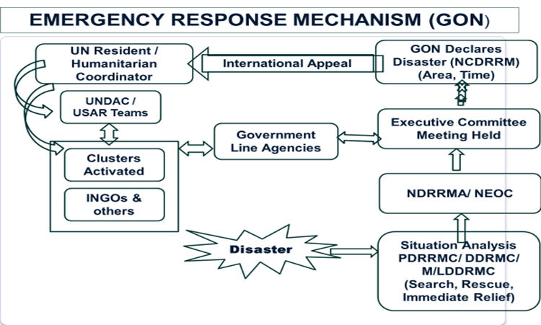
Source: National Disaster Response Framework, Government of Nepal, 2019, Pg 5
This is an example of Government of Nepal Emergency Response Mechanism to request for international assistance. Usually, the local level disaster management organizations provide input on the level & impact of disaster to the National Disaster Management Authority. Should the National Disaster Management Authority feel it is necessary to acquire international assistance, it recommends the same to the Executive Committee. The Executive Committee also recommends the same to the council. The council may decide to declare a state of emergency & then request through the appropriate channel to the Resident Representative (RC)/Humanitarian Coordinator (HC) of the local UN office for international assistance. The RC in turn mobilizes & coordinates funding, expertise, & resources from the UN agencies & INGOs.
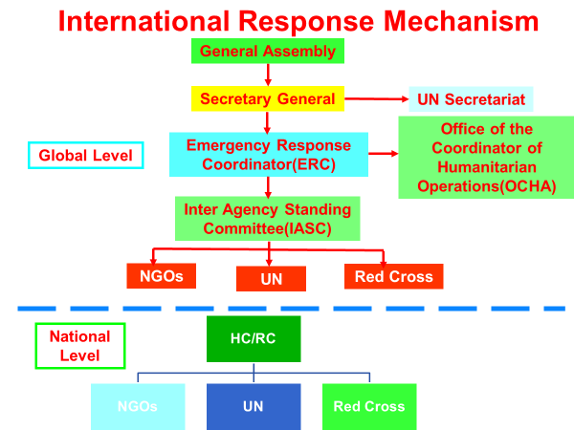
Source: WFP Brief, Nepal, 2011
The main organization at the UN Headquarters on behalf of the Secretary General to supervise & direct humanitarian operations is the ERC & the OCHA. At the global level the ERC & OCHA coordinate with the IASC consisting of various stakeholders like INGOs, UN, & Red Cross to assist in a humanitarian crisis. Accordingly, these global stakeholders direct & supervise their respective agencies at the national level, the coordination & monitoring of which is carried out by the country specific RC/HC. The RC/HC also mobilizes the various clusters designated for humanitarian operations.
Responsibilities of Office of the Coordinator of Humanitarian Affairs (OCHA)
The United Nations Office for the Coordination of Humanitarian Affairs (OCHA) plays a critical role in facilitating effective and coordinated humanitarian response efforts during emergencies and disasters. OCHA’s mandate is to ensure that relief efforts are timely, coordinated, and effective, helping to reduce suffering and save lives. Overall, OCHA’s role is essential for creating a coordinated, effective, and principled humanitarian response during disasters and emergencies. Its focus on coordination, information management, resource mobilization, and advocacy help ensure that aid reaches those most in need in a timely and organized manner. Here are the key roles and responsibilities of OCHA in humanitarian operations:
Coordination of Humanitarian Response- OCHA is responsible for setting up and supporting coordination mechanisms, including the Humanitarian Country Team (HCT) and the cluster system, to ensure that all humanitarian actors work together efficiently. OCHA helps convene meetings and ensures that stakeholders like UN agencies, NGOs, donors, and government bodies are aligned. OCHA supports the activation and coordination of clusters (e.g., food security, shelter, health) in emergencies. Clusters bring together organizations working in specific sectors to plan, coordinate, and implement humanitarian activities. OCHA ensures that each cluster is adequately resourced and that activities are coordinated to avoid duplication of efforts.
Needs Assessment and Information Management- OCHA plays a key role in coordinating rapid assessments of humanitarian needs during the onset of a crisis. This helps determine the scope and scale of the emergency, identifying the most affected populations and priority areas for intervention. OCHA is a central hub for collecting, analyzing, and disseminating information related to the crisis. It provides regular situation reports, maps, and data analysis to ensure that all actors have a common understanding of the needs and the status of the response.
Resource Mobilization and Appeals- OCHA leads the process of creating consolidated funding appeals, such as the Flash Appeal and the Humanitarian Response Plan (HRP), to gather financial resources for humanitarian response. These appeals outline the funding needs of various sectors and help coordinate the contributions of international donors. OCHA manages humanitarian pooled funding mechanisms like the Central Emergency Response Fund (CERF) and country-based pooled funds (CBPFs). These funds provide rapid, flexible financing to address critical gaps and support underfunded emergencies, allowing for a more responsive and coordinated approach to aid delivery.
Advocacy for Humanitarian Needs- OCHA advocates for attention to humanitarian crises, particularly those that are underfunded or overlooked by the international community. It works to ensure that the needs of affected populations are recognized and prioritized by donors and global decision-makers. OCHA is a strong advocate for humanitarian principles such as humanity, neutrality, impartiality, and independence. It ensures that humanitarian operations are guided by these principles, aiming to protect the dignity and rights of affected populations and maintain access to those in need.
Ensuring Humanitarian Access and Security- OCHA plays a critical role in negotiating access with governments, armed groups, and other stakeholders to ensure that humanitarian aid reaches those in need. This is particularly important in conflict zones or areas with restricted access. OCHA works closely with the United Nations Department of Safety and Security (UNDSS) and humanitarian organizations to assess risks and develop strategies to protect humanitarian personnel and facilities. This helps ensure the safety of aid workers in volatile environments.
Developing and Implementing Humanitarian Response Plans- OCHA coordinates the development of the Humanitarian Response Plan (HRP), which outlines the strategic priorities, objectives, and funding requirements for a coordinated humanitarian response. This plan helps align the efforts of all humanitarian actors, ensuring that resources are used efficiently. OCHA monitors the progress of the HRP and other strategic response plans, facilitating adjustments as needed to respond to changing needs and conditions on the ground.
Facilitating Transition to Recovery and Development- While OCHA focuses on emergency response, it also helps ensure that humanitarian efforts are aligned with longer-term recovery and development plans. This involves working with development agencies and national governments to create a smooth transition from relief efforts to recovery and resilience-building. OCHA supports initiatives aimed at improving disaster preparedness and resilience in vulnerable communities. This includes strengthening the capacity of local authorities and communities to respond to future crises.
Supporting National Authorities- OCHA works closely with national and local authorities to build their capacity for disaster management and response. This helps ensure that the response is led by those who best understand the local context and can continue to support recovery efforts after international actors have scaled back. OCHA ensures that international humanitarian efforts align with the priorities and strategies of the host government, respecting their leadership role in disaster response while providing necessary support.
Promoting Accountability to Affected Populations- OCHA emphasizes the importance of accountability to affected populations (AAP), encouraging feedback mechanisms that allow communities to voice their needs, concerns, and satisfaction with aid delivery. This ensures that humanitarian efforts are responsive to the needs and priorities of those affected. OCHA helps monitor adherence to humanitarian standards and principles, ensuring that the aid provided is of high quality and that it respects the dignity and rights of those receiving assistance.
Facilitating International Engagement- OCHA plays a central role in connecting humanitarian actors with international donors, the United Nations Security Council, and other global decision-making bodies. This helps to ensure sustained international attention and support for humanitarian crises. In large-scale crises, OCHA helps galvanize support from international partners, fostering a spirit of global solidarity to ensure that the humanitarian response is adequately resourced and aligned with the needs of affected populations.

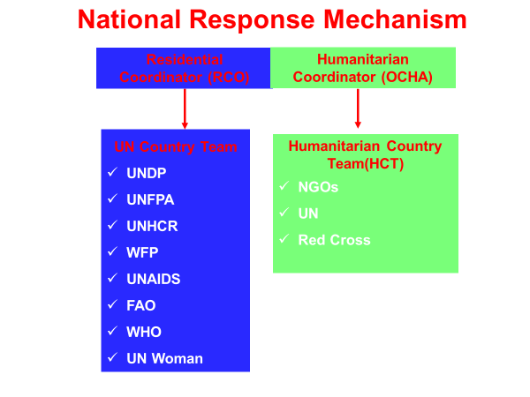
Source: WFP Brief, Nepal, 2011
The National Response Mechanism consists of two components one headed by the RCO-the UN Country Team consisting of various UN bodies operating in the crisis nation. The second one is the Humanitarian Coordinator-OCHA which heads the HCT consisting of INGOs, other UN agencies, & the Red Cross. RCO & the HC usually is the same person, the head of UNDP in the crisis country.
Responsibilities of UN Resident & Humanitarian Coordinator
It leads and coordinates the response efforts of the United Nations and its partners during disasters. These roles are sometimes held by the same person, particularly in countries that experience frequent or large-scale humanitarian crises. Here are the primary responsibilities of each during disaster situations:
UN Resident Coordinator (RC) Responsibilities
The Resident Coordinator (RC) is the highest-ranking UN official in a country, responsible for coordinating the work of the UN system and acting as a liaison between the UN, the national government, and other stakeholders. During a disaster, the RC focuses on coordinating development activities, but their role becomes more integrated with humanitarian response in times of crisis. Key responsibilities include:
Leading UN Country Team (UNCT) - The RC leads the coordination of the UN Country Team, ensuring that all UN agencies operating in the country work together effectively in support of the national government’s disaster response efforts.
Supporting National Authorities- The RC acts as a bridge between the UN system and the national government, providing technical assistance, mobilizing resources, and supporting national disaster response plans. This includes advocating for alignment with national priorities and strategies.
Facilitating Resource Mobilization- In collaboration with the UNCT, the RC supports the mobilization of resources for the response, including through engaging with donors, launching appeals, and coordinating with international funding mechanisms.
Advocacy and Diplomacy- The RC advocates for the needs of the affected populations and engages in diplomatic efforts to ensure access to affected areas, protection of civilians, and respect for humanitarian principles by all parties.
Ensuring Transition to Recovery- The RC focuses on bridging the gap between emergency relief and long-term recovery and development. This involves planning for the recovery phase and ensuring that humanitarian efforts are aligned with sustainable development goals (SDGs).
Humanitarian Coordinator (HC) Responsibilities
The Humanitarian Coordinator (HC) is responsible for coordinating the international humanitarian response in a country experiencing a disaster or complex emergency. The HC’s role becomes critical when the humanitarian needs exceed the capacity of the national authorities and require a coordinated international response. Key responsibilities include:
Leading Humanitarian Country Team (HCT) Coordination- The HC leads the HCT, which includes representatives from UN agencies, international NGOs, and other humanitarian actors. The HC ensures that the response is well-coordinated and that all actors are working towards common goals based on the needs of affected populations.
Developing Humanitarian Response Plans- The HC is responsible for developing the Humanitarian Response Plan (HRP), which outlines the strategy, priorities, and funding requirements for the response. The plan guides the actions of all humanitarian partners and ensures that the response is targeted and efficient.
Coordinating the Cluster System- The HC oversees the cluster coordination system, ensuring that sector-specific clusters (e.g., health, shelter, food security) are activated, properly resourced, and working in harmony to meet humanitarian needs. The HC ensures that the efforts of different clusters are aligned and that gaps are addressed.
Ensuring Adherence to Humanitarian Principles- The HC ensures that the humanitarian response is guided by the principles of humanity, neutrality, impartiality, and independence. This includes promoting protection principles and advocating for the rights and dignity of affected populations.
Mobilizing Resources and Launching Appeals- The HC leads the coordination of funding mechanisms, including the Central Emergency Response Fund (CERF) and country-based pooled funds (CBPFs). The HC also engages with donors and coordinates the development of funding appeals such as the Flash Appeal to secure resources for the response.
Advocating for Humanitarian Access- In contexts where access to affected populations is constrained, the HC is responsible for negotiating with governments, armed groups, and other stakeholders to ensure that humanitarian workers can reach those in need. This involves advocating for the protection of aid workers and facilitating access to conflict or disaster-affected areas.
Monitoring and Evaluating the Response- The HC ensures that the humanitarian response is regularly monitored and evaluated to assess its effectiveness. This includes adjusting strategies as needs change and ensuring that the response remains focused on the priorities of affected populations.
In many countries, the roles of the RC and HC are combined into a single RC/HC position, especially when there is a significant humanitarian component alongside ongoing development efforts. When this is the case, the individual holding this dual role is responsible for ensuring seamless coordination between humanitarian and development activities.
Responsibility of Humanitarian Country Team
The Humanitarian Country Team (HCT) plays a crucial role during a disaster, coordinating the response efforts to ensure that aid is delivered efficiently, effectively, and in alignment with humanitarian principles. The HCT is typically composed of representatives from UN agencies, international NGOs, local NGOs, the Red Cross/Red Crescent Movement, and other relevant humanitarian actors within the country. The HCT's leadership and coordination are essential for a coherent and effective humanitarian response. By leveraging the expertise and resources of various organizations and aligning efforts with national authorities, the HCT aims to ensure that the humanitarian response is timely, efficient, and centered on the needs of those most affected by the disaster. Here are the primary responsibilities of the HCT during a disaster:
Coordination of Humanitarian Response- The HCT is responsible for providing overall leadership and strategic direction to the humanitarian response. This includes setting priorities, identifying the needs of affected populations, and determining the most appropriate response strategies. The HCT ensures coordination between different humanitarian actors, including UN agencies, NGOs, donors, and local partners. This helps avoid duplication of efforts and ensures a cohesive response. The HCT plays a role in activating the cluster system, which organizes humanitarian response into specific sectors such as health, shelter, food security, and water and sanitation. It ensures that each cluster is adequately resourced and functioning effectively.
Needs Assessment and Analysis- One of the first tasks of the HCT during a disaster is to coordinate initial needs assessments to understand the scale and scope of the disaster. This includes gathering data on affected populations, damage, and urgent needs. The HCT monitors the evolving needs of the disaster-affected populations to ensure that the response adapts to changing conditions. This helps in adjusting plans and resource allocations to meet emerging needs.
Resource Mobilization and Advocacy- The HCT is responsible for mobilizing resources, including financial support, from international donors, governments, and other sources. This may involve launching appeals such as the UN's Flash Appeal to gather emergency funds. The HCT plays a role in advocating for the needs of affected populations to the international community, donors, and host governments. This includes highlighting critical gaps in assistance and ensuring that the response remains focused on those most in need.
Ensuring Humanitarian Principles -The HCT ensures that the response is grounded in the core humanitarian principles of humanity, impartiality, neutrality, and independence. This helps maintain the focus on addressing human suffering without discrimination. The HCT is also responsible for promoting the protection of the rights and dignity of affected populations, particularly vulnerable groups such as women, children, and persons with disabilities. This involves advocating for access to protection services and ensuring that protection is integrated across all aspects of the response.
Developing a Humanitarian Response Plan- The HCT develops a comprehensive Humanitarian Response Plan (HRP) that outlines the strategic objectives of the response, key priorities, and the resources required. This plan is essential for guiding the coordinated response of all actors. The HRP clarifies the roles and responsibilities of different actors within the response, ensuring that each agency or organization understands their contribution to the overall strategy.
Information Management and Communication- The HCT is responsible for ensuring that accurate and timely information is shared among humanitarian actors, including data on the evolving situation, needs assessments, and response progress. This helps in maintaining a common understanding of the crisis and coordinating efforts. The HCT may also engage in public communication to inform affected populations about available services, as well as to communicate with donors and the international community about the situation and response progress.
Engagement with National Authorities-The HCT works closely with the national government to support its response efforts, ensuring that humanitarian assistance complements and strengthens local and national capacities. The HCT may need to negotiate with government authorities and other actors to ensure humanitarian access to affected populations, particularly in situations where access may be restricted due to security or political concerns.
Monitoring and Evaluation of the Response- The HCT monitors the implementation of the humanitarian response plan, assessing whether the needs of affected populations are being met and whether the response is achieving its objectives. Based on monitoring and feedback, the HCT may adjust strategies and priorities to address any gaps or changing needs. This ensures that the response remains relevant and effective throughout the disaster.
Disaster Preparedness and Transition Plan- While the primary focus of the HCT during a disaster is response, it also considers disaster preparedness measures, ensuring that affected populations and local actors are better prepared for future risks. As the immediate crisis subsides, the HCT coordinates with development actors to plan for the transition from emergency relief to longer-term recovery and development, ensuring that the gains from humanitarian response are sustainable.
UN On-Site Operations Coordination Centre (OSOCC)
The UN On-Site Operations Coordination Centre (OSOCC) is a key mechanism used by the United Nations for coordinating international relief efforts during sudden-onset disasters, particularly those involving large-scale search and rescue operations. It is often activated following natural disasters like earthquakes, floods, or other emergencies that overwhelm the response capacity of the affected country.
The OSOCC is managed by the United Nations Office for the Coordination of Humanitarian Affairs (OCHA) in close coordination with the International Search and Rescue Advisory Group (INSARAG). Here’s an overview of the OSOCC's responsibilities of On-Site Operations Centre:
Facilitating Search and Rescue Operations -One of the OSOCC's initial functions is to coordinate Urban Search and Rescue (USAR) teams from various countries. It helps ensure that these teams are deployed effectively to the areas of greatest need, avoiding duplication and optimizing their efforts.
Information Management- The OSOCC serves as a central hub for collecting, analyzing, and disseminating information about the situation on the ground. This includes reports on damage, needs assessments, and the status of ongoing operations. It ensures that all responding organizations have access to up-to-date information to guide their activities.
Liaison with National Authorities- The OSOCC acts as a bridge between international responders and the host government’s disaster management structures, such as a National Emergency Operations Centre (EOC). This helps to ensure that international assistance aligns with national priorities and is coordinated with local efforts.
Coordination of Humanitarian Response- Beyond search and rescue, the OSOCC supports the broader humanitarian response, facilitating coordination between various humanitarian actors, including NGOs, UN agencies, and other international organizations. It often serves as a precursor to the establishment of a full Humanitarian Coordination Centre if the crisis extends beyond the immediate search and rescue phase.
Establishing Sectoral Working Groups- The OSOCC may set up and support sectoral working groups or clusters to coordinate activities in key sectors such as health, shelter, logistics, and food security, ensuring that all aspects of the response are organized and that gaps in assistance are identified and addressed.
Cluster System
The Cluster System is a key coordination mechanism in international humanitarian response, used to ensure that different aspects of aid are managed effectively during a disaster or complex emergency. It brings together UN agencies, non-governmental organizations (NGOs), the Red Cross/Red Crescent movement, and other stakeholders to work collaboratively in specific sectors of humanitarian response, such as health, shelter, food security, and water, sanitation, and hygiene (WASH). This approach helps avoid gaps and overlaps in assistance and ensures that the response is more efficient and effective.
Purpose of the Cluster System
Coordination and Collaboration- The primary goal of the cluster system is to facilitate better coordination and collaboration among humanitarian actors working in similar sectors. This ensures that assistance is delivered where it is most needed, and resources are used efficiently.
Improving Response Quality- Clusters help establish standards and best practices within each sector, ensuring that the quality of the aid provided meets international standards and that the response is more consistent across different actors.
Bridging Gaps in Assistance- By coordinating the efforts of different organizations, clusters help identify gaps in the response where aid is insufficient or lacking and work to address those gaps.
Activation of Clusters- Clusters are activated when a disaster overwhelms the ability of national authorities to manage the response and when there is a need for international assistance. The Humanitarian Coordinator (HC), in consultation with the Humanitarian Country Team (HCT) and the United Nations Office for the Coordination of Humanitarian Affairs (OCHA), decides which clusters should be activated based on the needs of the emergency.
Cluster Leads-Each cluster is led by a designated UN agency or organization with expertise in that sector. The cluster lead is responsible for coordinating the activities of all partners within that cluster, managing information, facilitating assessments, and ensuring that assistance is delivered effectively.
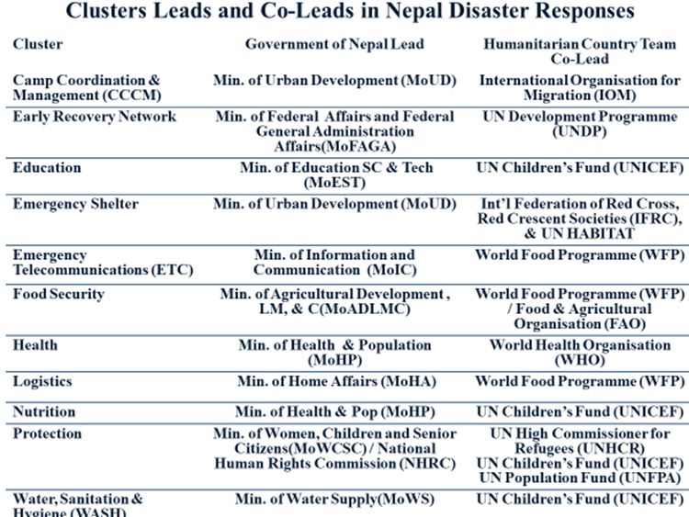
Source: National Disaster Response Framework, Government of Nepal, 2019, Pg 6
Coordination of Response Operations
The coordination of disaster response operations involves various mechanisms designed to ensure effective collaboration among international and national actors, NGOs, UN agencies, donors, and local communities. Coordination is critical for making sure that aid reaches those in need efficiently, resources are used optimally, and efforts are not duplicated.
The coordination of disaster response operations involves multiple actors, mechanisms, and tools to ensure that humanitarian assistance is timely, efficient, and effective. This coordinated effort is essential for addressing the diverse needs of affected populations, preventing duplication of efforts, and ensuring that international support is well-integrated with national and local response efforts.
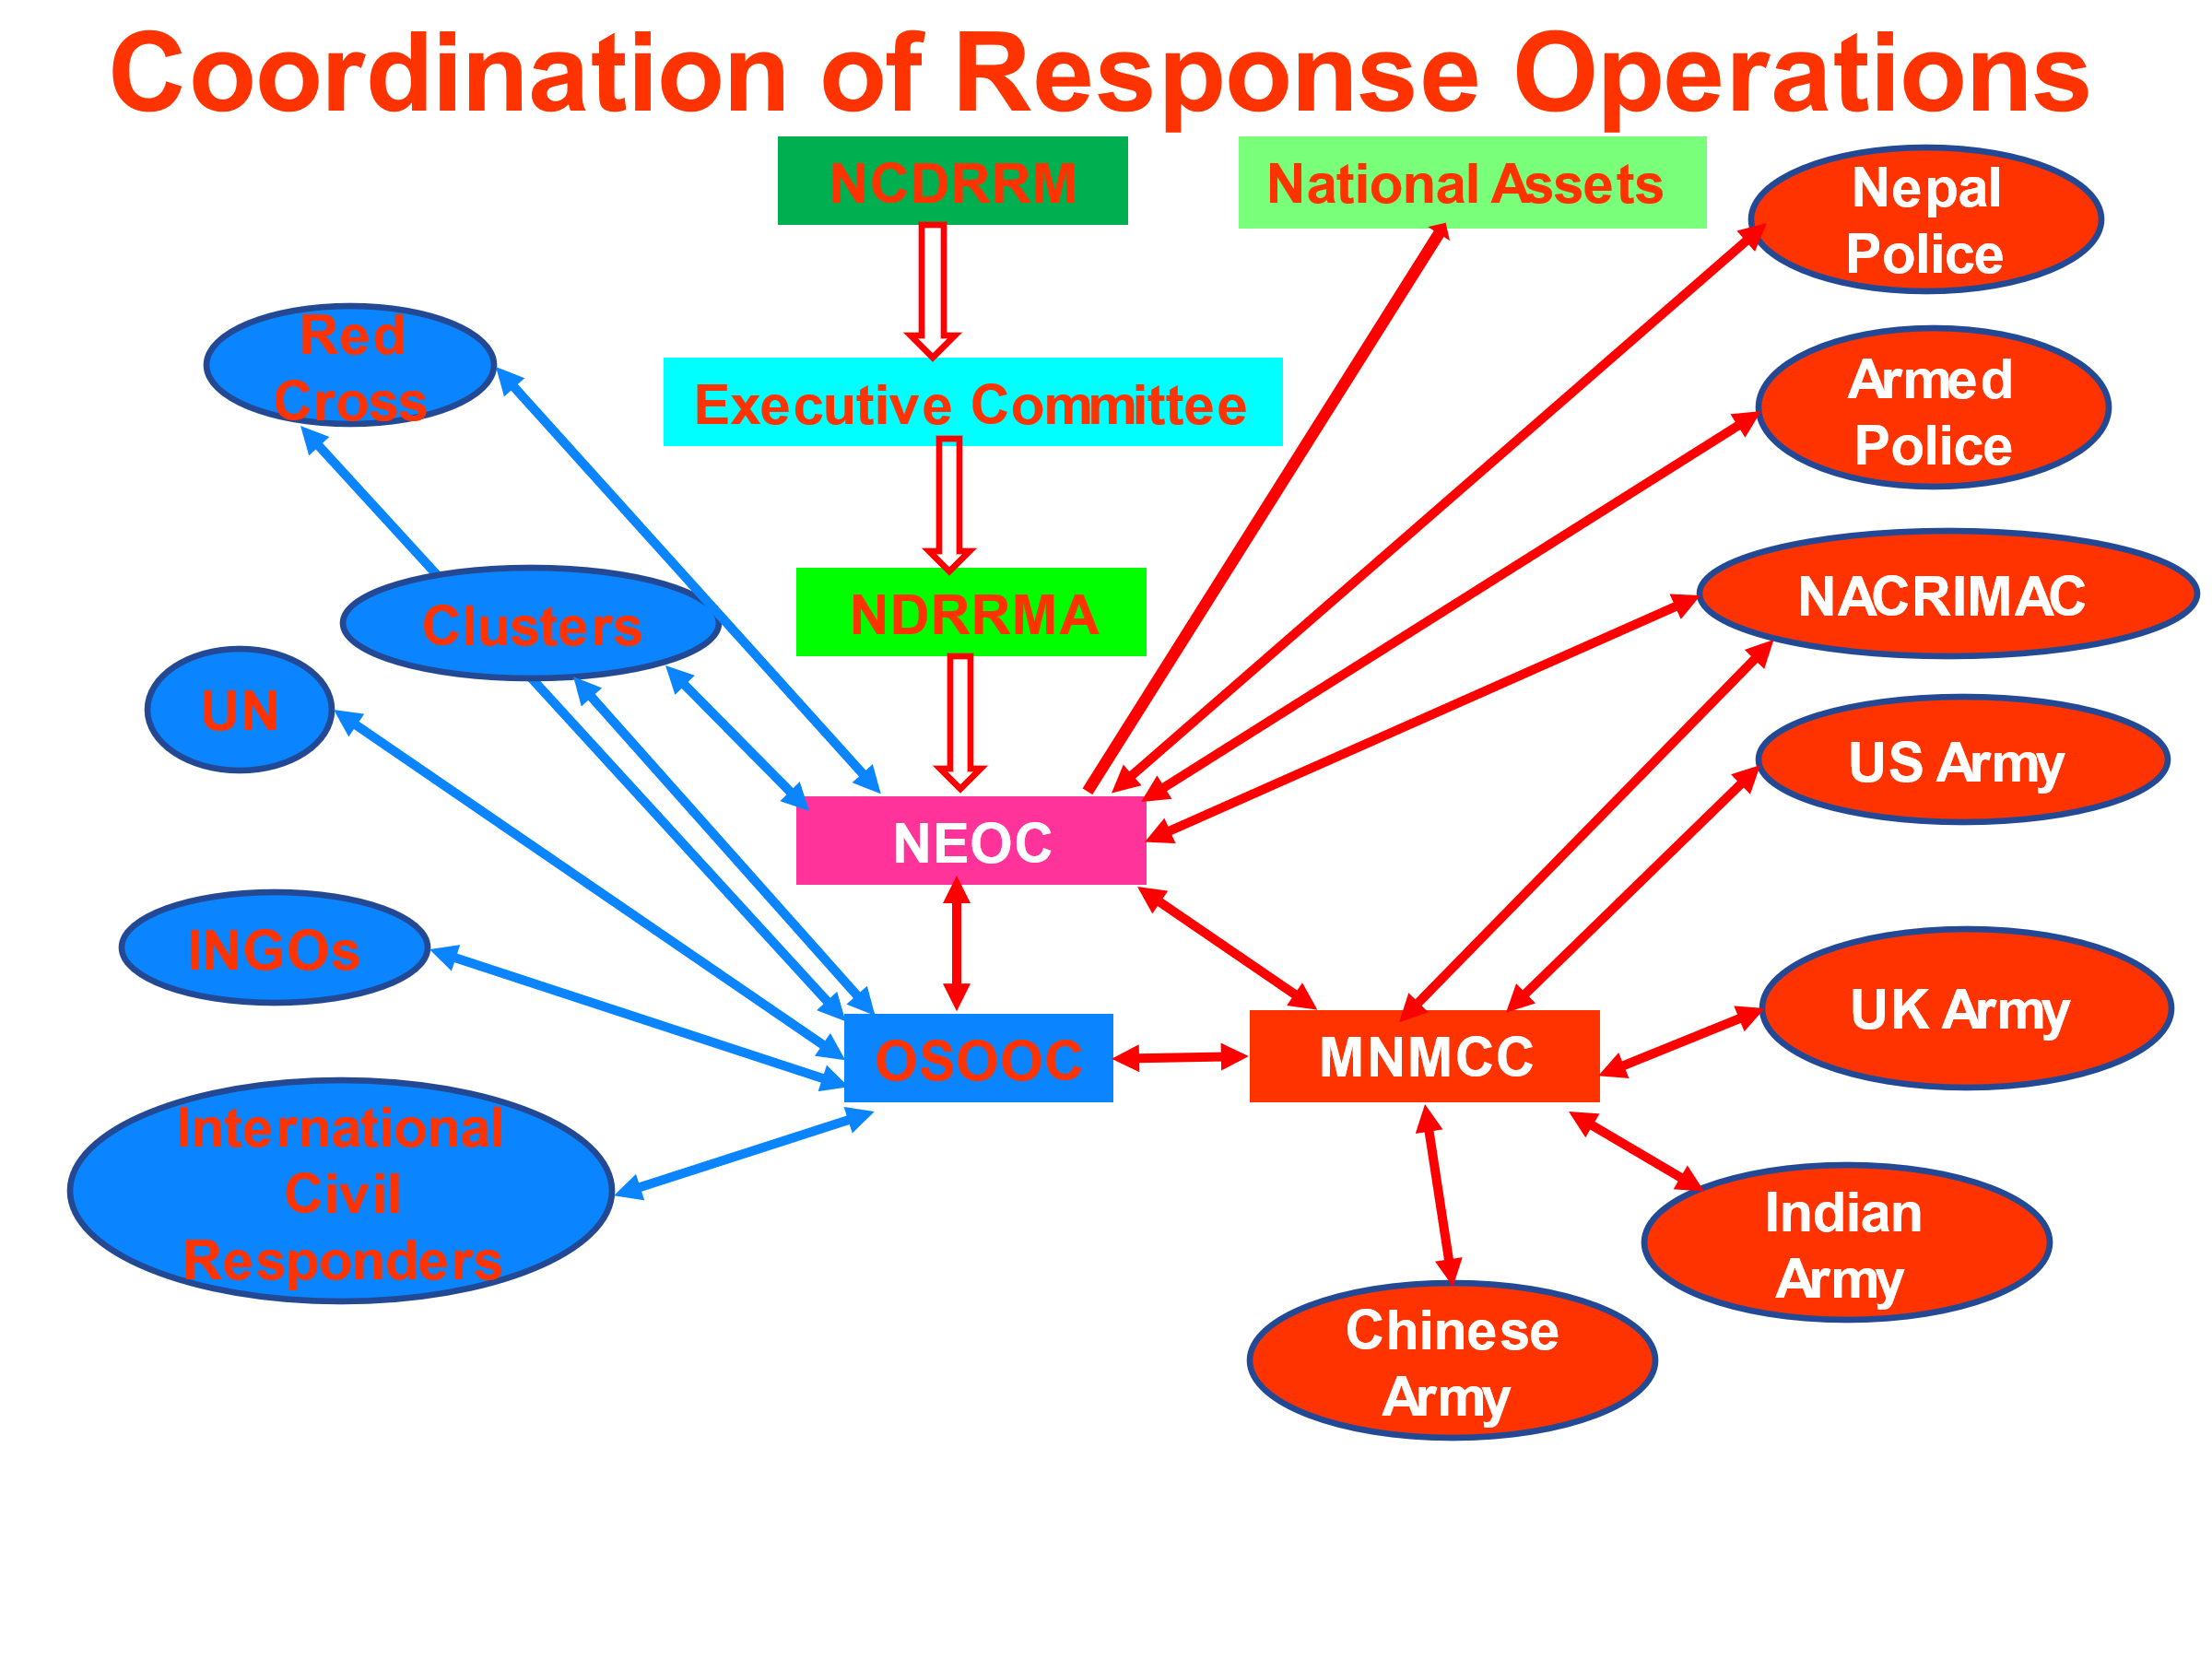
Source: National Disaster Response Framework, Government of Nepal, 2019, Pg 8

References
National Disaster Response Framework, National Disaster Risk Reduction & Management Authority, Nepal, 2019 Pg 1-30 (http://drrportal.gov.np/uploads/document/113.pdf)
National Disaster management Plan, National Disaster Management Authority, India, 2019, Pg 327-328 (https://ndma.gov.in/sites/default/files/PDF/ndmp-2019.pdf)
Humanitarian Charter & Minimum Standards in Humanitarian Response, The Sphere Handbook, Sphere Association, 2018, Pg, 13-30 (https://spherestandards.org/wp-content/uploads/Sphere-Handbook-2018-EN.pdf)

