Disaster Management & Social Work
Lecture 14
Psychology of Disaster
Lecturer: Victor J B Rana

Introduction
Fortunately, for most of us, we learn about disasters through movies or books and not direct experience. These renditions are dramatic snapshots of lives, events, and heroism, but rarely do they show us the long-term impact of disasters on wildlife, psychology, culture, environment or finance. While much has been written in the field of psychology about resilience, the disaster environment provides an active and ongoing opportunity to reframe, reorganize and construct new meaning.
The disruption & challenges they face as a society, their capacities to respond to widespread loss of human life, environmental devastation and infrastructure. The sheer magnitude of the natural and man-made catastrophe boggles the mind. The social & psychological trauma faced by various strata of society could be engraved for the lifetime if timely therapy is not administered. The physical damage of disasters is repaired over a period of few years, but social & psychological damage takes longer to heal or it may not.
Topic Objectives
Understand the psychology of disaster.
Develop an understanding of the social & psychological post disaster effects
Understand the mechanism for addressing social & psychological problems
Question for Discussion
What are the phases of post disaster psychology?
What are the post disaster social & psychological effects?
How can post disaster social & psychological effects be addressed?

Traumatic Stress/Disaster Stress Defined
Traumatic stress refers to the emotional, cognitive, behavioral and physiological experiences of individuals who are exposed to, or who witness, events that overwhelm their coping and problem solving abilities” -Lerner & Shelton, 2001
Traumatic Stress Reactions
Traumatic stress disables people, causes disease, precipitates mental disorders, leads to substance abuse, and destroys relationships and families. Additionally, traumatic stress reactions may lead to posttraumatic stress disorder (PTSD
Key Concepts
The psychology of disaster focuses on understanding how individuals and communities react to, cope with, and recover from disasters. These concepts provide a framework for understanding how disasters impact human psychology and guide strategies for mental health interventions and community resilience-building. Here are some key concepts:
Stress and Coping Mechanisms- Immediate psychological and physiological reactions to a disaster, such as shock, disorientation, or anxiety. A long-term mental health condition that can develop after exposure to a traumatic event, including natural disasters. Methods individuals use to manage stress, including problem-focused coping (addressing the source of stress) and emotion-focused coping (managing emotional responses).
Resilience- Refers to the ability to adapt and recover from adversity. It can be influenced by personal characteristics (e.g., optimism, self-efficacy) and external factors (e.g., social support). Community resilience is the collective ability of a group to recover, rebuild, and maintain social cohesion after a disaster.
Risk Perception and Preparedness- How individuals perceive the likelihood and severity of a disaster affects their behavior, including their willingness to prepare and respond to warnings. Efforts to prepare for potential disasters can vary based on awareness, previous experiences with disasters, and cultural factors.
Social Support and Community Response- Social Support is critical in the aftermath of a disaster, influencing the psychological well-being of affected individuals. Collective Behavior during disasters includes spontaneous acts of helping, community organization, and the formation of temporary social networks to cope with challenges.
Trauma and Grief- Collective Trauma is the shared psychological impact of a disaster on a community, which can affect cultural narratives and collective identity & grief and loss involves the loss of loved ones, homes, and livelihoods, leading to grief that can range from normal to complicated grief, where the mourning process becomes prolonged and debilitating.
Psychological First Aid (PFA)- A set of principles and actions aimed at reducing initial distress and promoting short-term and long-term adaptive functioning. PFA involves providing emotional support, ensuring basic needs are met, and connecting people to social support networks and resources.
Behavioral Responses to Warnings and Evacuations- How individuals respond to warnings (e.g., evacuation orders) can depend on trust in authorities, understanding of the danger, and previous experiences. Some people may exhibit risk-taking behavior or denial, leading them to resist evacuation orders, while others might overreact or experience panic.
Psychological Impact on First Responders- First responders, including firefighters, police officers, and medical personnel, often face secondary trauma due to repeated exposure to distressing scenes and experiences during disaster response. They are at risk for burnout and compassion fatigue, necessitating support structures and mental health interventions.
Recovery and Post-Traumatic Growth- Recovery is a complex, non-linear process that involves both psychological healing and the rebuilding of affected communities. Post-Traumatic Growth (PTG) refers to positive psychological changes that some individuals experience as a result of struggling with a disaster, such as increased appreciation for life, improved relationships, and a sense of personal strength.
Types of Traumatic Events
Traumatic events are experiences that cause intense physical or emotional harm, often leading to long-lasting effects on an individual's mental health. These traumatic events vary in their impact based on factors like an individual's resilience, social support, prior experiences, and personal coping mechanisms. The psychological aftermath of such events can include anxiety, depression, PTSD, and other stress-related conditions. Here are various types of traumatic events:
Natural Disasters- Examples are earthquakes, hurricanes, tsunamis, wildfires, floods, volcanic eruptions. These events can result in loss of life, displacement, and widespread destruction, leading to feelings of helplessness and fear.
Accidents- Examples are car accidents, plane crashes, industrial accidents, building collapses. Such events can cause sudden injury or death, leading to trauma for survivors, witnesses, and even first responders.
Violence and Abuse- Examples are physical assault, domestic violence, sexual abuse, emotional abuse, child abuse, elder abuse. These experiences often cause deep psychological harm and can lead to long-term mental health issues like PTSD, depression, and anxiety.
Terrorism and Mass Violence- Examples are bombings, mass shootings, hostage situations. These events can result in widespread fear, feelings of vulnerability, and collective trauma, affecting both direct victims and broader communities.
War and Armed Conflict- Examples are military combat, civil wars, ethnic violence, genocide. Experiences of war can lead to trauma for soldiers and civilians alike, often resulting in PTSD, displacement, and loss of loved ones.
Sudden or Violent Death- Examples are homicide, suicide, sudden death of a loved one. These events can leave survivors grappling with intense grief, guilt, and a sense of helplessness, especially if they witness the event or find themselves unable to intervene.
Serious Illness or Injury- Examples are diagnosis of life-threatening illnesses (e.g., cancer, heart attacks), traumatic brain injury, severe burns. These events can cause fear of death or permanent disability, leading to emotional distress and a crisis of identity or purpose.
Interpersonal Loss or Abandonment – Examples are divorce, separation from loved ones, losing a child, being abandoned by caregivers. Such losses can result in emotional trauma, especially if the separation or abandonment is sudden or accompanied by other forms of adversity.
Witnessing or Learning About Traumatic Events- Examples are seeing a car accident, witnessing a crime, hearing about a traumatic event involving a loved one. Being a witness to trauma can cause vicarious trauma, where the individual feels distress from the event even though they were not directly harmed.
Displacement and Forced Migration- Examples are refugee experiences, being displaced due to conflict or natural disasters, human trafficking. These experiences often involve loss of home, cultural dislocation, and exposure to violence, leading to complex trauma.
Childhood Traumatic Events -Examples are exposure to domestic violence, neglect, loss of a caregiver, experiencing or witnessing abuse. Childhood trauma can have a profound impact on a child’s development, potentially leading to difficulties with trust, emotional regulation, and interpersonal relationships in adulthood.
Occupational Traumas- Examples are trauma experienced by first responders (e.g., firefighters, paramedics, police officers), healthcare workers during pandemics, humanitarian workers in conflict zones. Repeated exposure to distressing events can lead to compassion fatigue, secondary traumatic stress, and burnout.
Impacts of Trauma
The impact of trauma can be profound, affecting individuals and communities in both unique and interconnected ways. Understanding both dimensions is crucial for effective interventions, whether providing psychological first aid, building community resilience, or supporting long-term recovery Here's a breakdown of the individual and collective impact of trauma:

Individual Impact of Trauma
Emotional and Psychological Effects-Traumatic experiences can lead to chronic anxiety, depression, and feelings of sadness, fear, or helplessness. Symptoms include flashbacks, nightmares, severe anxiety, and intrusive thoughts related to the traumatic event. Difficulty in controlling emotions like anger, sadness, or fear, often leading to outbursts or emotional numbness.
Behavioral Changes- Individuals might avoid places, people, or activities that remind them of the trauma. Some may turn to drugs, alcohol, or other addictive behaviors as a way to cope with trauma. Constantly being on guard or feeling unsafe, even in secure environments.
Physical Symptoms- Insomnia, nightmares, and disrupted sleep patterns are common after trauma. Unexplained physical symptoms like headaches, stomach issues, or chronic pain can arise. Chronic stress from trauma can lower immunity, making individuals more susceptible to illnesses.
Cognitive Impacts- Trauma can impair concentration and memory, affecting daily functioning and productivity. Feelings of guilt, shame, or self-blame related to the traumatic experience. Trauma can lead to a negative worldview, including beliefs like the world is unsafe or I am powerless.
Social and Interpersonal Effects- Individuals may withdraw from relationships and social activities due to difficulty trusting others or fear of being hurt again. Trauma can strain personal relationships, leading to conflicts, miscommunications, and emotional distance from loved ones. Especially if trauma occurred in childhood, individuals may struggle to form healthy emotional bonds.
Collective Impact of Trauma
Community-Wide Grief and Mourning- When a community experiences a traumatic event (e.g., natural disaster, mass violence), it can lead to collective grief, where a sense of loss is shared among the community members. This mourning can impact community rituals, cultural practices, and the overall atmosphere, often resulting in a period of sadness and low morale.
Social Cohesion and Disruption- Traumatic events can either strengthen or weaken social bonds. In some cases, communities come together for mutual support and recovery. Alternatively, trauma can create division, mistrust, and conflict within a community, especially if there are feelings of blame or resource competition during recovery.
Economic and Structural Impact- Traumatic events like natural disasters or conflict can destroy homes, businesses, and infrastructure, resulting in economic hardship. Strain on resources, such as housing, healthcare, and education, can affect the community’s ability to recover and function. Trauma can force people to leave their homes, resulting in population displacement, loss of cultural continuity, and challenges in integrating into new communities.
Cultural and Collective Identity- Traumatic events can become part of a community's narrative or identity, influencing how they perceive themselves and their history. Communities may use the trauma as a point of resilience, fostering a sense of strength and unity. Conversely, collective trauma can also lead to a shared sense of victimization and a worldview centered on loss and suffering, which can impact inter-group relations and community outlook.
Impact on Community Mental Health Services- Traumatic events can lead to a surge in the need for mental health services, straining existing resources. Initiatives like community support groups, mental health outreach programs, and collective healing practices may become more prevalent as a response to collective trauma.
Intergenerational Effects- Collective trauma can be passed down through generations, affecting the children and grandchildren of those who experienced the trauma directly. Communities with a history of violence, oppression, or displacement (e.g., indigenous communities, descendants of enslaved people) often carry the emotional and cultural impacts of past traumas, influencing present-day mental health and social dynamics.
Interplay Between Individual and Collective Impact- The individual and collective impacts of trauma are deeply interconnected. As individuals heal, their renewed capacity for connection and support can strengthen community ties. A strong community with shared resources and social support can significantly help individuals process and recover from trauma. In some cases, the shared experience of trauma can lead to greater empathy and understanding within a community, promoting collective resilience.
Psychological Phases of a Disaster
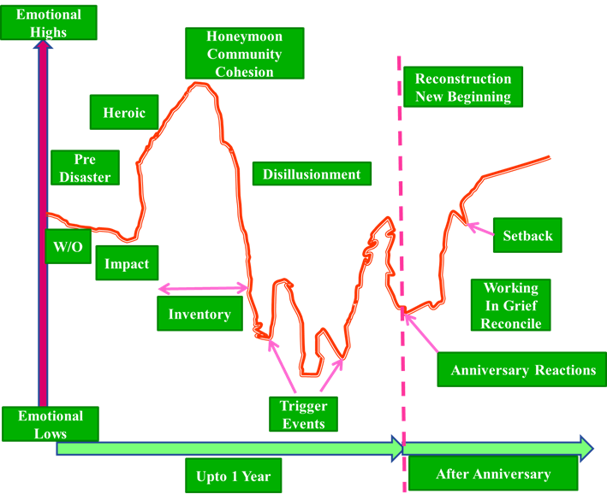
Source-The Psychology of Disaster Pg 3
Pre-Disaster- The psychological effect depends on the amount of warning & perceived threat depends on many factors.
Impact Phase- Greater damages & losses of life & property has higher psychological impact.
Heroic Phase- There is high altruism among survivors & emergency responders. Search & Rescue Operations, direct assistance & resources will be adequate. People struggle to stay alive & try to prevent loss of life & minimize property damage
Honeymoon Phase – There is a short-lived sense of optimism that lasts from 2 weeks to 2 months where survivors morale is maintained & appreciate the relief being provided. Survivors feel they will recover quickly & normalcy returns.
Disillusionment Phase- After more than 2 months, there will be limit on disaster assistance & survivors feel disappointed, express resentment anger, & frustration. Survivors now will experience the hardships of disaster which could last up to a year. Anniversary can trigger negative emotions & recovery may be delayed.
Reconstruction Phase- Survivors reconcile & experience the new reality. Setbacks are there but have to adjust to the new situation. Grief & anger replaced by acceptance & think about solving problems and rebuild their shattered lives. This will continue for several years as the new normal
Factors Influencing Response to Trauma
Pre-Trauma Factors – It depends on many factors like number of times the victim has been exposed to traumatic events & history of mental illness. Poor people are subject to more trauma than others. Intensity and duration of traumatic exposure can also determine the amount of trauma experienced. Factors like gender & age can also play a part in the amount of trauma experienced. Example woman & children can have more impacts
Post-Trauma Factors – The amount of psychological support received by the victim & opportunity to share the events can be a factor in the impact of the trauma. Sometimes survivors may not be able to find their deceased ones which does not lead to sense of closure leading to more sorrow & grief. Too much of media exposure of events can lead to severe traumatization. If survivors cannot withstand the pressure of the impact it may lead to substance abuse which can further deteriorate the health of the survivor. Finally, re-exposure or revictimization can also lead to increased effects of trauma.
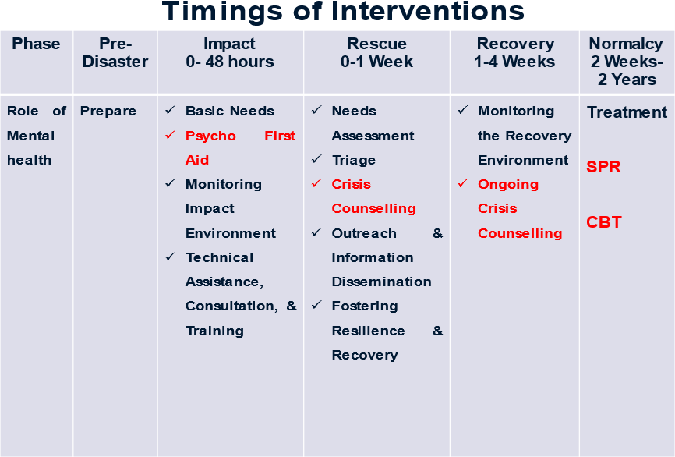
Source-Introduction to Trauma & Disaster Counseling Disaster Mental Health and Crisis Counseling, Department of Human Services, New Jersey, Pg 66
Developing Mental Health Practices During the Preparedness Phase of a Disaster
Developing mental health practices during the preparedness phase of a disaster is crucial for building resilience, reducing anxiety, and enhancing the ability of individuals and communities to cope with potential traumatic events. By incorporating these mental health practices into the disaster preparedness phase, individuals and communities can build psychological resilience, improve their ability to cope with stress, and ensure a more effective response when faced with a disaster. This proactive approach can help mitigate the psychological impact of disasters and enhance overall recovery and well-being. Here are strategies for fostering mental health practices during this phase:
Educating on Mental Health and Stress Management- Provide workshops that teach coping strategies, stress management, and how to recognize signs of distress. These can include mindfulness practices, relaxation techniques, and breathing exercises. Educate communities about common psychological reactions to disasters, such as anxiety and stress, and emphasize that these responses are normal. Promote Psychological First Aid techniques to community members so they can support themselves and others in the immediate aftermath of a disaster.
Building Social Support Networks- Encourage the formation of community support groups where people can share their concerns, prepare together, and discuss mental health openly. Implement a buddy system where individuals pair up with a neighbor, family member, or friend to check in on each other during and after a disaster. Train community leaders, volunteers, or local groups in peer support skills to assist others with emotional challenges.
Developing Individual and Family Preparedness Plans- Include mental health in family emergency plans. For example, create a list of calming activities or grounding exercises that can be used during times of stress. Ensure that families have clear plans for staying in touch during a disaster, which can reduce anxiety and increase a sense of safety. Include items in emergency kits that support mental well-being, such as comforting objects, written reminders of coping strategies, and contact information for crisis hotlines.
Strengthening Resilience Skills- Teach and practice mindfulness exercises, meditation, or progressive muscle relaxation, which can help individuals maintain calm during stressful situations. Empower individuals with skills for managing stress through problem-solving and decision-making, so they feel more in control during a disaster. Physical exercise is known to reduce stress and anxiety. Promote simple physical activities like walking or stretching that can be continued even in a disaster scenario.
Providing Access to Mental Health Resources- Establish or publicize existing mental health hotlines that people can access before, during, and after a disaster. Prepare and distribute lists of local mental health providers, counselors, and community organizations that can provide support. If possible, ensure access to telehealth services, which can be particularly valuable during a disaster when in-person services may be disrupted.
Reducing Stigma and Promoting Open Conversations- Host forums or community meetings where mental health can be discussed openly, emphasizing that it’s okay to seek help and that everyone may feel anxious or scared during a disaster. Share messages that normalize seeking mental health support, such as posters, social media posts, or community announcements.
Incorporating Cultural and Spiritual Practices- Integrate culturally relevant practices into preparedness activities, such as traditional healing methods, prayer, or community rituals that promote collective resilience. Engage local religious or cultural leaders who can provide support and comfort, reinforcing community bonds and providing spiritual guidance during stressful times.
Training for First Responders and Emergency Personnel- Mental Health Training for Responders: Provide training on recognizing signs of trauma, stress, and anxiety in themselves and others, as well as self-care strategies to manage their own mental health. Train first responders in debriefing techniques that can help them process their experiences and reduce the risk of secondary trauma.
Building Community Resilience Programs- Engage communities in resilience-building activities such as community gardening, neighborhood watch programs, or collaborative preparedness drills. These activities promote a sense of togetherness and empowerment. Involve community members in emergency drills and simulations that include mental health scenarios, helping to reduce fear and increase a sense of competence.
Identifying and Supporting Vulnerable Populations- Develop specific plans to support individuals who may be more vulnerable during a disaster, such as children, the elderly, and those with pre-existing mental health conditions. Create outreach programs to connect with those who might be isolated or less likely to seek help, ensuring they have access to both physical and mental health resources. Ensure that information on mental health and disaster preparedness is available in multiple languages and formats to reach diverse populations.
Developing Safe Spaces for Emotional Expression- Identify or create physical spaces within the community where people can gather safely to share their experiences, seek comfort, and support each other during high-stress periods. Promote activities like art, music, or journaling as ways for people to process their emotions before a disaster, which can serve as helpful coping mechanisms when stress levels are high.
Addressing Myths and Misconceptions About Disasters- Misinformation about disasters can increase anxiety and panic. Ensure that the community has access to accurate, clear, and timely information about the risks and preparedness steps. Use trusted community channels to address rumors and fears, reducing panic and fostering a calm, informed approach to preparedness.
Psychological First Aid
Psychological First Aid (PFA) is an evidence-informed approach aimed at providing immediate emotional and practical support to individuals experiencing distress following a traumatic event. It is designed to reduce initial distress, foster short-term and long-term adaptive functioning, and promote a sense of safety, calm, and hope. PFA is often used in the aftermath of disasters, accidents, or other traumatic experiences and can be delivered by trained professionals as well as community members.
Key Principles of Psychological First Aid
PFA focuses on providing a supportive, non-intrusive response that respects the individual's needs and encourages a sense of empowerment. Here are its main principles, often summarized as the "5 PFA Elements":
Safety- Ensure that the individual feels physically and emotionally safe & help them move to a safe environment if needed, away from danger or harm. Offer reassurance that they are in a secure place and that further risks are being managed.
Calming- Help individuals manage their emotional reactions, such as panic, anxiety, or agitation & encourage deep breathing or simple relaxation exercises to promote calm. Use a calm and reassuring tone when speaking, allowing them to feel more settled.
Connectedness- Facilitate connections with loved ones and social support systems & encourage individuals to reach out to friends, family, or other sources of support. In group settings, foster a sense of belonging and community.
Self- and Community-Efficacy- Help individuals regain a sense of control by encouraging them to focus on practical steps they can take to improve their situation & support them in identifying their own strengths and the resources available to them. Provide information about where to access further help or services, empowering them to make decisions about their own well-being.
Hope- Offer a message of hope and positivity, without making unrealistic promises & encourage positive thoughts and remind individuals that their distress is a natural reaction to an abnormal situation. Support them in looking toward the future and taking small steps toward recovery.
Crisis Counselling Programme(CCP)
Crisis Counseling Program (CCP) is a structured, short-term intervention aimed at providing immediate support to individuals and communities who are experiencing intense distress due to a crisis or disaster. The goal of CCPs is to help people understand their reactions, access available resources, develop coping strategies, and work through the emotions and challenges they are facing. These programs are typically implemented after large-scale disasters or traumatic events, such as natural disasters, terrorist attacks, or other community-wide crises. A well-implemented Crisis Counseling Program can play a critical role in helping individuals and communities recover from the emotional aftermath of disasters and traumatic events, building a pathway toward healing and renewal.
Key Components of a Crisis Counseling Program
Immediate Emotional Support-Focuses on providing emotional support to individuals and families affected by the disaster, helping to alleviate feelings of fear, anxiety, or hopelessness. Offers opportunities for individuals to express their thoughts and feelings about the crisis in a safe, non-judgmental environment. Aims to reduce stress and emotional turmoil, helping people regain a sense of stability.
Psychoeducation- Provides information on common reactions to trauma and stress (e.g., grief, anxiety, depression), helping individuals understand that their feelings are normal in the context of the crisis. Educates people on coping strategies, stress management, and ways to take care of their mental and physical well-being. Offers guidance on when and how to seek additional professional help if their symptoms persist or worsen.
Problem-Solving and Practical Assistance- Assists individuals in identifying their most pressing needs and prioritizing steps to address them, such as finding temporary housing, reconnecting with family members, or accessing medical care. Helps people navigate systems of assistance, such as relief services, healthcare providers, or financial aid programs. Supports people in developing practical action plans that can empower them to regain control over their situations.
Linking to Resources and Referrals- Connects individuals with appropriate services, such as longer-term mental health counseling, social services, medical care, or community support groups. Ensures that people know where to access critical services like food, shelter, and medical care. Provides referrals to specialized services for individuals who may need more intensive support, such as those experiencing suicidal thoughts or those with pre-existing mental health conditions.
Strengthening Community and Social Support- Encourages individuals to reach out to their social networks, fostering connections with family, friends, and community groups. Helps re-establish social support systems that may have been disrupted by the disaster, such as local organizations or cultural and religious groups. Promotes community-based activities that support collective healing and resilience.
Goals of a Crisis Counseling Program- The overarching goals of CCPs include:
Promote Resilience- Helping people recover by fostering resilience and self-efficacy, both on an individual level and within the community.
Reduce Distress- Alleviating symptoms of distress, such as anxiety, confusion, and despair, to prevent the development of long-term psychological issues.
Normalize Reactions- Helping people understand that their emotional and physical reactions to trauma are normal and that many others are experiencing similar feelings.
Encourage Healthy Coping- Supporting individuals in adopting healthy coping strategies, such as seeking social support, engaging in self-care, and managing stress constructively.
Who Provides CCP Service?
Trained Counselors and Mental Health Professionals- These individuals often provide the core counseling services in a CCP, offering expertise in trauma response and mental health care.
Paraprofessionals and Trained Volunteers- In some programs, trained community volunteers or paraprofessionals (individuals with basic training in crisis intervention) provide initial support, particularly in the outreach component.
Community Leaders and Social Workers-These professionals may help coordinate services, offer cultural insights, and support the broader goals of community rebuilding and recovery.
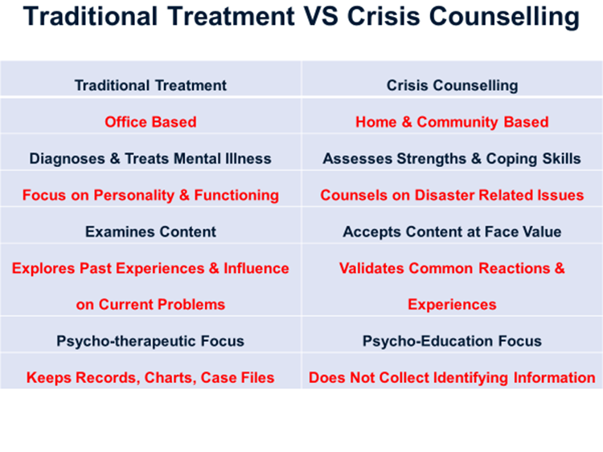
Source-Introduction to Trauma & Disaster Counseling Disaster Mental Health and Crisis Counseling, Department of Human Services, New Jersey, Pg 81

References
Introduction to Trauma & Disaster Counseling Disaster Mental Health and Crisis Counseling, Department of Human Services, New Jersey, Pg 21-81 (https://www.nj.gov/humanservices/dmhas/home/disaster/credentialing/DRCC_Training_Materials/Intro_Disaster_MH_Crisis_Counseling.pdf)
Psychological Impacts of Natural Disaster, James M Schultz, ResearchGate, 2014, Pg 1-14 (https://www.researchgate.net/publication/237012116_Psychological_Impacts_of_Natural_Disasters?enrichId=rgreq-3036d27d800cd7c44dfa7eb9195f370e-XXX&enrichSource=Y292ZXJQYWdlOzIzNzAxMjExNjtBUzoxMDM0MjAwNjEwMjgzNTJAMTQwMTY2ODY3MjI2MQ%3D%3D&el=1_x_2&_esc=publicationCoverPdf )
The Psychology of Disaster Pg 1-10

