Disaster Management & Social Work
Lecture 15
School Disaster Management Plan (SDMP)
Lecturer: Victor J B Rana

Introduction
A School Disaster Management Plan (SDMP) is a comprehensive approach to prepare, respond, and recover from potential disasters, whether natural or human-made, in a school setting. It involves steps to protect students, staff, facilities, and ensure continuity of education. It is essential for creating a safe, prepared learning environment that can respond effectively to unexpected events. Through proactive planning, schools can protect lives, minimize disruption, and foster a resilient community. By implementing an SDMP, schools ensure they are better equipped to minimize harm, save lives, and maintain a safe learning environment. Regular evaluation and adaptation to emerging threats or changes in best practices are also key to maintaining an effective plan.
Schools are responsible for the safety of students and staff during school hours. A well-prepared disaster management plan can save lives by ensuring swift, organized, and effective actions during emergencies. Having trained staff and students who know what to do in an emergency can prevent injuries and limit chaos, leading to a calmer, more controlled response. Preparedness can help mitigate trauma, as students and staff feel safer and more confident when they understand emergency procedures and know what to expect. Schools that prepare for disasters can recover faster and return to normal operations more quickly, ensuring that students' learning is disrupted as little as possible. An SDMP promotes a culture of preparedness and resilience, teaching students valuable skills in risk management and personal responsibility. Regular drills and training help foster a sense of community and collaboration as students, staff, and families work together to prepare for potential risks.
Topic Objectives
Understand components & purpose of Comprehensive School Safety Framework
Get a knowledge of preparing guidelines for School Disaster Management Plan
Understand & apply the eight steps of school safety.
Conducting mock drills & evacuation in school.
Question for Discussion
What are the components& purpose of Comprehensive School Safety Framework?
What is the process of preparing a School Disaster Management Plan?
How is mock drill & evacuation carried out in schools?
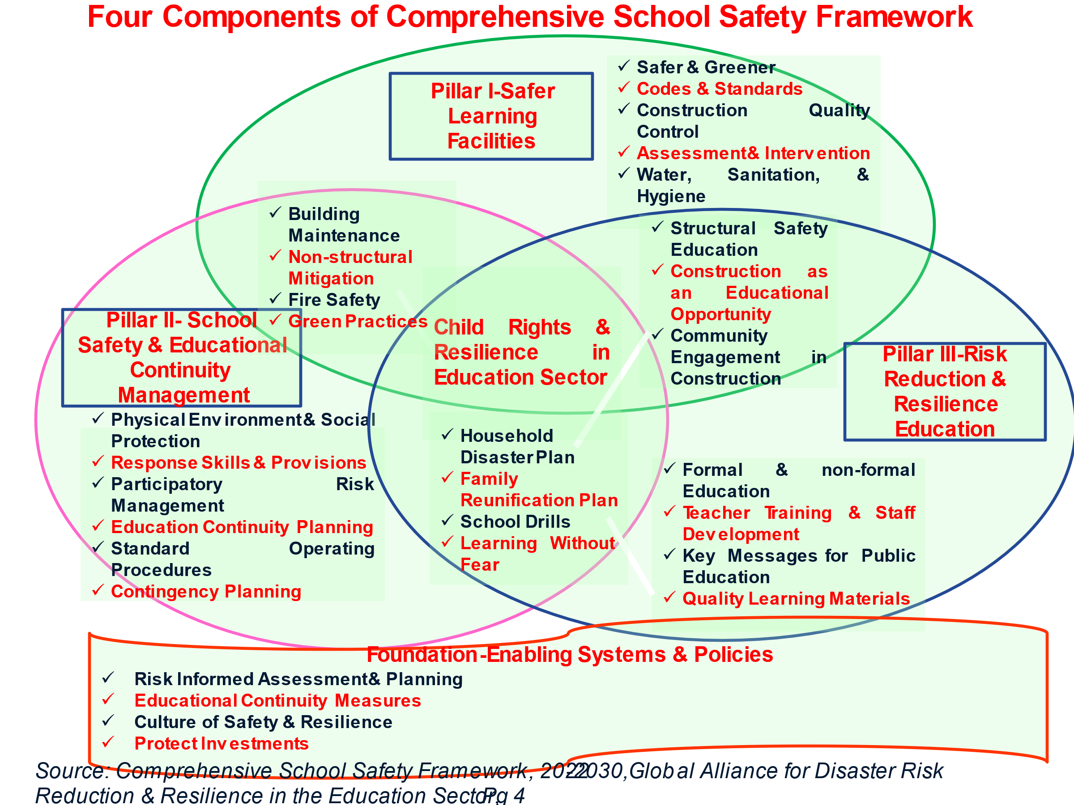
Comprehensive School Safety Framework
The CSSF outlines that risk reduction and resilience building requires all the stakeholder’s involvement & multi-hazard approach. It is of vital importance that educated children are the future planners. This is the most ideal way of identifying and sustainably addressing the barriers that can interfere with children’s equitable access to safe, continuous, and quality education. The education sector is one of the most affected by multiple hazards, including natural and technological threats, climate change, epidemics and pandemics (such as COVID-19), violence, conflict, and everyday threats. This can have serious implication & development problems in children’s education. These impacts are felt differently due to gender, disability, and social inequalities. It is important that all stakeholders of the education sector focus on the need of a safe & resilient school.
Foundation-Enabling System & Policies: The foundation of the CSSF focuses on strengthening system-level resilience. This includes to protect the safety, health, and well-being of the entire school community; provide effective educational continuity measures; protect education sector investments; and promote a culture of safety and resilience. Risk-informed policy and planning approaches are used to improve equity, prevent and reduce risks, and increase capacities.
Pillar I- Safer Learning Facilities: It focusses on both new & old schools to make it safer & environmentally sustainable. While constructing new educational facilities, the focus is on proper site selection, design, & construction to protect from all forms of hazards whether it be natural or man-made. For older schools the focus is on repair, retrofitting, & better learning environment. This pillar supports the goals of resilient education systems and environmental sustainability. The safety of the learning environment consists strong structure, enforcement of building codes, evacuation procedures & safe routes for evacuation, disability friendly, sufficient WASH facilities, equipment and services to support safety and learning continuity, & early warning systems.
Pillar II- School Safety & Educational Continuity Management: School safety management addresses equity-focused planning for children’s health, safety, and well-being for educational continuity in relation to all-hazards and risks to children and staff in the education sector. The focus is on developing anticipatory, absorptive, adaptive, and transformative capacities for resilience through meaningful participation of and accountability to affected populations. This includes planning and operationalizing comprehensive all-hazards risk-assessment, risk prevention and reduction, response preparedness, recovery.
Pillar III- Risk Reduction and Resilience Education: It focuses on steps to be taken by the school management, student, & parents to be aware & educated about the hazard risk to develop individual and community level resilience in relation to the risks they face. This includes disaster risk management, climate change, health promotion and pandemics, child protection, violence and conflict prevention, conflict resolution, strengthening social cohesion, and psychosocial well-being.
Purpose of Comprehensive School Safety Framework
Foundation for Safety: Establish a system whereby the school management, students, & parents understand the necessity of a safe educational environment.
Cost-Effective Interventions: The CSSF initially may look costly, but with government & international finances & technical support, it is achievable & in the long run will be cost-effective.
Enhance Quality Education: Once the physical & social environment of the school is improved, parents will be confident in enrolling their children.
Improvement of Social Security: Addressing the child protection issues as part of school safety program within the school premise enhances a sense of social security among parents & their children (especially girls, children from underprivileged families, children with different abilities), thus contributing to equity access to education.
Enhance Resilience in Education: Engagement of School Disaster Management Committee & parents in the informal and non-formal school activities will help in raising their awareness, knowledge & skill to manage disaster risks within the school, family, & community.
Builds Confidence of Parents: It will contribute to build up the confidence & engagement of parents to support & enrol their children in the school activities.
Institutional Accountability of all Stakeholders: It will ascertain institutional accountability by all stakeholders involved in the education sector to ensure the minimum school safety in their respective areas of work.
Government Can Monitor & Implement School Safety Programme: Government can implement and monitor minimum school safety in an objective & comparable manner thereby identifying remaining needs and gaps to fulfil its commitment to nationwide school safety.
Need of Awareness and Preparedness for Disaster Safety in Schools:
The impacts of natural and human-induced hazards are increasing with population growth and climate change, causing immense losses to the society. Besides their impact on the society and infrastructure, disasters are also one of the biggest challenges to the goal of ‘Safe Education for All’. In the past couple of decades, a number of disasters killed thousands of school children and severely disrupted the normal education in many countries.
The rights of all children, to both education and safety, must be safeguarded simultaneously. Disaster–resilient education and safe schools are within reach. It requires sincere efforts to assess local risks and institutional capacities and to develop a well-planned and self-sufficient mechanism of preparedness.
Considering the fact that external help may reach to the school very late, it is important that school teachers, staff and students learn about the key aspects of school safety and preparedness. It is critically required that the school administration take proactive measures to increase awareness about disaster preparedness and also test their preparedness plans through conducting mock drills at regular intervals.
Safe School is important for any society and required due to following:
Vulnerable Group: Children are among the most vulnerable groups during disasters. Also, they are future of any society, hence their safety is paramount.
Change Agent: Children are the most suitable ‘Change Agent’ and they can help in bringing disaster preparedness, mitigation and prevention in the society at large.
Three-Generation Impact: It is often said ‘Educating a child leads to educating three generations’ as, an educated child shares the knowledge with his parents at home and also with his kids when he becomes parent.
Centre of community: Schools especially in rural areas are nucleus of community and a number of community activities including livelihood revolve around the school.
Relief/ Safe Shelter: Traditionally, in many countries including Nepal, small school buildings act as a relief or safe shelter during a disaster. Damage to school building complicates the relief activities or evacuation activities.
Loss of academic calendar: Damage to education sector is linked to the loss of academic calendar/ session.
Psycho-social support: Children are among the worst affected during a disaster and need psycho-social support. Quick reopening of school after disaster has been proved to be an important psychosocial support as children get engaged in education and with their classmates.
What is Safe School
Safe School’ is a process which attempts to ensure physical and psychological safety of students, teachers and supporting staff in the event of any disaster. It includes policy level interventions, multi-hazard resistant school infrastructure, continuous disaster preparedness, mitigation and prevention initiatives by students, teachers and other stakeholders.
Framework of School Safety
How Safe School
The Safe School requires three-pronged approach which include policy measures, structural and non-structural measures.
Policy Measures: It covers national or local level rules, regulations, policies, etc such as inclusion of disaster risk reduction in syllabus, legal requirement to install fire fighting equipment’s in schools and statutory requirement to make funding provision for school safety. It is useful in terms of wide coverage, statutory requirement and setting up enabling environment for structural as well as non-structural interventions.
Structural Measures: It include strengthening or constructing multi-hazard resistant school building, provision of open space in school campus, installation of fire safety equipment in building and construction of ramp for the physically challenged.
Non-structural Measures: It include preparation of school disaster management plan, training and capacity building of teachers and students on disaster management, awareness generation on Do’s and Don’ts of various disasters, organising mock drills to check preparedness and identify areas of improvement.
Eight Steps of School Safety
Step 1: Orientation of teachers, students and others on disaster management and mass awareness in school.
Step 2 : Constitution of the School Disaster Management Committee.
Step 3 : Vulnerability and capacity assessment of the school.
Step 4 : Preparation of the School Disaster Management Plan (SDMP)
Step 5 : Formation and training of Disaster Management Teams.
Step 6 : Dissemination of the School Disaster Management Plan.
Step 7 : Conducting regular mock drills to check preparedness and identify areas of improvement.
Step 8 : Evaluating and updating of the SDMP based on mock drill findings or past disasters.
Stakeholders of Safe School
In order to achieve ‘Safe School’, involvement of a number of stakeholders is important. Following are the key stakeholders of ‘Safe School’:
• School principal
• Teachers
• Supporting Staff
• Parents
• Basic Education Department
• Community leaders
• Students
• Fire Services Department/ Auxiliary Fire Brigade
• Police Force/APF/Army
• Nepal Red Cross Organization (NRCS)
• Engineers
• Doctors
• Local Government/ NGOs
• Priests
Creating awareness about School Safety
In order to create an enabling environment for school safety, it is important to spread awareness among the school staff, teachers and students and make them prepared to deal with any kind of catastrophic event. Concentrated efforts are needed to be taken to engage students in activities which enhance their understanding of disasters and relevant aspects. Some activities to create awareness about disaster preparedness are:
- Film Shows on Disaster Preparedness
- Quiz Competitions on Disasters
- Practical Projects (Presentations)
- Models on Disaster-related topics
- Thematic Debates / Discussions
- Poster Making Competitions
- Thematic Skits and Plays
- Photography Competitions
- Essay Writing Competitions
- Slogan Writing Competitions
- Students March / Rally
- Study tours to the sites of disaster-related significance
Conducting Mock Drills:
Mock Drill is the testing of the efficacy of Disaster Management Plan. Lot of homework needs to be put in to prepare a plan and then conduct a mock drill which may last only a few minutes. It is a participatory method to practice the safety-related measures and evacuation of a building during an emergency situation. For fire-related evacuation mock drills, the fire-alarm is activated and the building is evacuated as though a real fire had occurred. Generally, the time it takes to evacuate is measured to ensure that it occurs within a reasonable length of time.
To ensure proper execution of a mock drill exercise, the roles and responsibilities of the concerned staff, teachers and students as well as coordination with departments like fire services, army, civil police, & armed police force should be precisely defined and the standard operating procedures (SOPs) should be clearly understood by everyone.
The objectives of conducting Mock Drills in Schools:
Educating and training staff, teachers and students to react for any unforeseen emergency situations specifically like Earthquake & Fire, mainly because they have a quick onset and hardly have any warning signs.
Mock exercises and evacuation to build up courage and confidence in staff, teachers and students.
To teach Life Saving and Rescue techniques to school staff, teachers and students and to enable them to be life savers at the time of emergencies.
Testing the efficacy of School Disaster Management Plan and improving it further so that it becomes do-able.
To have clarity and better understanding of the roles and responsibility of all stakeholders.
The mock drills can be classified into two types:
Pre-announced Drills: When the staff, teachers and students are expecting a mock drill, it is called as Pre-announced Drills. The objectives of Pre-announced Drills are:
- To ensure everyone has read and understand new evacuation procedures.
- To test how everyone reacts to a more specific hazard (like a predetermined blocked exit route).
- To determine people’s ability to locate and operate fire extinguishers.
Unannounced Drills: Unannounced drills are a good way to test people’s ability to react to a hazardous situation they weren’t expecting. Schools should conduct unannounced drills once the understanding about mock drills is clear and a certain level of proficiency has been attained. The objectives of Unannounced Drills are:
- To ensure everyone in the school premises can clearly hear the alarms.
- To discover if the staff, teachers and students know the exit routes to take.
- To determine whether staff and teachers with special roles (in the case of an emergency) know what steps to take and
- To find out how long it takes to get everyone out of the building.
Model Steps for Organization for Fire & Evacuation Drill
Distinctive Alarm Bell
Activation of all Teams
Evacuation Under Supervision
Assembling at the Designated Place
Report by Team Members to Management Team & Rescue Carried Out
Head Count & Debriefing
Emergency Evacuation Plan
Identifying the evacuation assembly area and the evacuation route is critical in a School Emergency and Disaster Preparedness Plan.
School Emergency Evacuation Plan-East Block-I FLOOR
Class

Class

Class

Class

Class

Class

Class
Class
Class

Stairs

Ground FLOOR
Class

Class

Class

Class

Class

Class
Class

Class
Class

Class

Stairs
Evacuation Area
Teachers/Staff
Evacuation Area II-Students
Teachers
Evacuation Area I-Students
Teachers

- An Evacuation Route Map showing the site and neighbourhood map with identified evacuation routes and locations should be posted in strategic and conspicuous places (preferably in each room with the room marked on the map).
- Depending on the hazard, the school should identify safe evacuation areas.
- Open areas for earthquake and fire
- Shelter for heavy rainfall etc.
- Higher ground for floods and flash floods
- Evacuation routes should avoid potentially hazardous conditions and elements.
- Avoid routes where there are no objects like toppled cabinets, broken glass, fallen trees, cut electrical wires) which may hinder evacuation.
- Avoid flooded areas.
- Avoid storage areas of combustible or hazardous chemicals.
- Simple rules for building evacuation which teachers must stress upon the students:
- Do not push, run, talk or go back during the evacuation. Everyone walks briskly
Create a Buddy System to ensure safety of the children with disabilities
If the school has anybody who fall in this category then the School Administration must pay attention to the needs of children with physical disabilities (especially during an emergency situation). Persons with disability may not be able to evacuate without any assistance. Therefore, it is strongly advised that each student with disability is accompanied by a physically-fit student. This practice is known as Buddy System.
Mock Drills Calendar
Emergency drills and exercises should be conducted regularly in schools to test the plan and to develop the capacity of students, teachers and staff to respond to a disaster. Drills offer the opportunity to identify training needs, establish new reflexes, and teach through action, repetition and change in plan. It is advisable to conduct mock drills at least 1 or 2 times a month at different times of the day.
Emergency Mock Drills & Exercises
There are various drills that can be conducted in schools depending on the hazard. After conducting a drill, an evaluation should be made to determine any lapses in the drill / plan. Here is a list of drills that are appropriate to both sudden disasters (e.g. earthquakes, fires) and early warning situations:
- Drop, cover and hold (for earthquake) in case of big tremors.
- Building evacuation and evacuation assembly (for fire, earthquake)
- Stop, drop and roll (when on fire)
- Administering mass casualty non-medical triage and first aid
- Emergency communications
- Assisting the disabled during emergencies
- Public relations, communications and documentation
- Relief operations
- Conducting light search and rescue (there should be no student in the Search & Rescue Team)
School Earthquake Drill Procedure
Alarm Operation
A pre-arranged distinctive signal such as a siren or bell is set off indicating earthquake shaking. Pupils and teachers will be alerted by this signal.
Response
- While the signal is ongoing, move away from windows, glass and unfastened objects.
- Teachers prepare students for orderly evacuation.

- Class Teacher/Students of higher grades should hold the door open to prevent it from locking the people inside.
- If outside, get clear of buildings, power lines, trees, light poles and other dangers, drop down to your knees and cover your head and neck.
Evacuation and Assembly
- Once the shaking stops, students must be instructed to leave the building in single file and in a calm, orderly manner. (Two files if staircase is wide)
- The class teacher must instruct the students to follow the pre-determined route and everyone must move to pre-identified evacuation areas.
- The class teacher must make specific arrangements for pupils with physical or mental disabilities to ensure that they are assisted during evacuation. They might have arranged assistance from other staff in school.
- No running is to be permitted to avoid panic and stampede.
- On staircases, everyone must descend in disciplined file. Overtaking of classes or individuals must not be permitted.
- Watch out for potential falling objects.
- Anyone who is not in class when the “shaking” signal went off must stop and observe the surroundings for potential hazardous objects & then proceed immediately to the evacuation point.
- At the Assembly Point, students should stand according to their Roll No. for easy counting.
- At the assembly point, a roll call or body count must be made to ascertain that no one remains in the building.
- Each teacher must report whether everybody is accounted for or if there are missing students.
Annexure I: General Steps in Evacuation
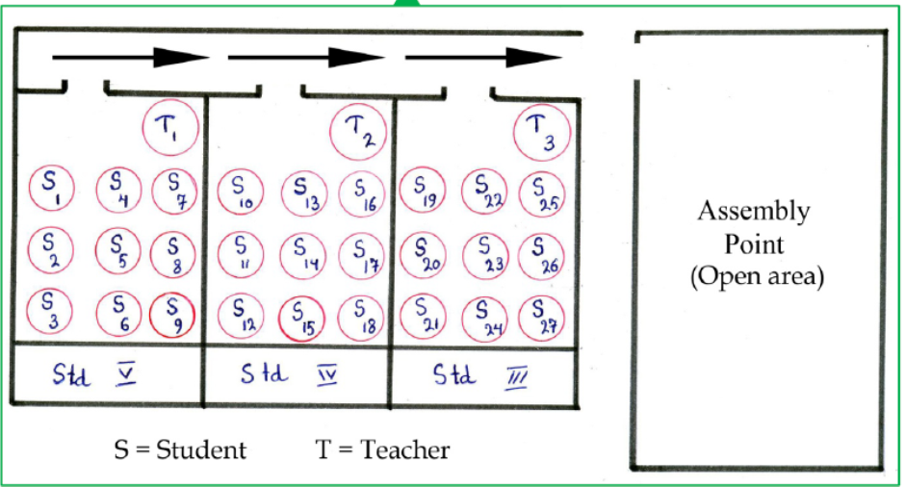

Annexure II- Key Contacts for More Information
Annexure III: Response Teams: Composition, Roles & Responsibilities
Annexure IV- Fire & Evacuation Drill Reporting Format
Annexure V- Building -Wise Details
Annex VI- Details of Open Spaces
Annex VII- Details of School Disaster Management Committee Members
Annex VIII- Details of Mock Drill

References
Comprehensive School Safety Minimum Package, Ministry of Education, Government of Nepal, May 2018, Pg 1-16 (https://www.dpnet.org.np/uploads/files/65464_comprehensiveschoolsafetyminimumpac%202019-07-25%2010-51-41.pdf)
Comprehensive School Safety Framework, 2022-2030, Global Alliance for Disaster Risk Reduction & Resilience in the Education Sector, Pg 1-29
(https://inee.org/sites/default/files/resources/The-Comprehensive-School-Safety-Framework-2022-2030-for-Child-Rights-and-Resilience-in-the-Education-Sector.pdf)

