Chemical Reaction Engineering II- Reactor Design (ChEg 4101)
Lecture 1: Introduction to Reactor Design
Week 1
Prerequisite: Chemical Reaction Engineering I-Reaction Kinetics (ChEg3104)
Lecturer: Adamu Esubalew (PhD, ChEg)
Lecture learning outcomes
At the end of the lecture, you will be able to:
- define the principles of reaction engineering,
- identify type of reactors and their classification modes,
- describe the cases why do you design, when do you design and how to design reactors, and
- Explain the basic equations of materials and energy balances for reactors design.
  - Overview of reaction engineering
In most chemical manufacturing processes, chemical plants are combinations of both physical operations and chemical process.
Physical operations: Physical operations or treatments involve heat transfer, fluid flow, mass transfer, size reduction and separation processes.
Chemical process: Process in which a chemical reaction occurs and reactants are converted into products in the reactor.
The study of chemical reaction engineering combines the study of chemical kinetics with the reactors design. Chemical kinetics is the study of chemical reaction rates and reaction mechanisms. Chemical kinetics and reactor design are at the heart of producing almost all industrial chemicals. The selection of a reaction system that operates in the safest and most efficient manner can be the key to the economic success or failure of a chemical plant. For example, if a reaction system produces a large amount of undesirable product, subsequent purification and separation of the desired product could make the entire process economically unfeasible. The chemical reaction engineering can also be applied in many areas, such as wastewater treatment, microelectronics, nanoparticles and biochemicals.
The rate of reaction tells us how fast the number of moles of one chemical species are being consumed to form another chemical species. The term chemical species refers to any chemical component or element with a given identity. The identity of a chemical species is determined by the kind, number, and configuration of that species’ atoms. Chemical reaction has taken place when a detectable number of molecules of one or more species have lost their identity. It assumed a new form by a change in the kind or number of atoms in the compound and/or by a change in structure or configuration of these atoms.
In this classical approach to chemical change, it is assumed that the total mass is neither created nor destroyed when a chemical reaction occurs. The mass referred to is the total collective mass of all the different species in the system. However, when considering the individual species involved in a particular reaction, we do speak of the rate of disappearance of mass of a particular species. The rate of disappearance of a species, say species A, is the number of A molecules that lose their chemical identity per unit time per unit volume through the breaking and subsequent re-forming of chemical bonds during the course of the reaction.
There are three basic ways a species may lose its chemical identity. These are decomposition, combination, and isomerization.
Decomposition: in which the molecule loses its identity by being broken-down into smaller molecules, atoms, or atom fragments.
Combination: In which the molecule loses its identity by combining molecules or atom to form another molecules or atoms.
Isomerization: in which the molecule loses its identity through a change in configuration although the molecule neither adds other molecules to itself nor breaks into smaller molecules.
A given number of molecules (i.e., moles) of a particular chemical species have reacted or disappeared when the molecules have lost their chemical identity. The rate at which a given chemical reaction proceeds can be expressed in different ways by referring it to different chemical species in the reaction. The four things about the reaction rate:
- The rate of formation of species j (mole/time/volume),
- An algebraic equation,
- Independent of the type of reactor (e.g., batch or continuous flow) in which the reaction is carried out,
- Solely a function of the properties of the reacting materials and reaction conditions (e.g., species concentration, temperature, pressure, or type of catalyst) at a point in the system.
  - Chemical Reactors and their classifications
    - Chemical reactors
Chemical reactors are vessels/containers in which chemical reactions take place. They are combinations of sizes of reactors and their auxiliaries. The sizes of reactors range from laboratory to industrial scales. A homogeneous batch reactor is depicted in Figure 1.1 (Fogler, 2015).
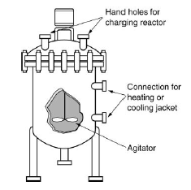
Figure 1. 1 Homogeneous batch reactor (Fogler, 2015)
Reactor auxiliaries: Some of the auxiliaries are stirrer, heat exchanger/coils, temperature detector, conductivity meter, pressure gauge and flow meter.
- Stirrer: It is a mixer that is used to keep the composition and temperature as uniform as possible in the reactor.
- A stirrer presents in some reactors: batch, semi-batch and continues stirred tank reactor (CSTR).
- Heat exchanger/coils: Heat exchange devices that facilitates internal or external heat exchange, based on the absorption or evolution of the heat of reaction.
- Temperature detector: It is used to detect the temperature of reactor systems.
- Conductivity meter: It is used to determine the progress of the reaction in real time.
- Pressure gauge: It is used to measure/ regulate the pressure.
- Flow meter: It is used to control the flow rate of feed/ product.
    - Classification of Reactors
Reactors can be classified based phase involved, method of operation and thermal operation in the process.
      - Reactors classification based on phase involved
Based on phases involved, reactors are classified into two broad categories. These are: homogeneous reactors and heterogenous reactors.
Homogeneous reactors: Reactors which contain all reactants and products that have the same phase. Homogenous reactors are further classified into three types, such as batch reactors, continuous stirred tank reactors (CSTR), and plug flow reactors (PFR).
Batch reactors: Batch reactors (BRs) are type of chemical reactors where the reactants are fed into the reactors at once and mixed thoroughly, allowing for a uniform composition throughout the reactor volume, and the products are withdrawn at once from them after chemical reaction. Batch reactors are primarily used for the production of specialty chemicals and to obtain reaction rate data in order to determine reaction-rate laws and rate-law parameters such as rate constant (k), the specific reaction rate (r_{i}). They are used to scale-up laboratory experiments to pilot-plant operation or to full-scale production.
Continuous stirred tank reactors (CSTRs): CSTRs are type of reactors where the reactants are continuously fed into reactors and mixed thoroughly, allowing for a uniform composition throughout the reactors volume, and products are continuously withdrawn from them. They are versatile and efficient systems for carrying out continuous chemical reactions, offering both advantages and challenges that must be managed for effective operations. CSTRs are typically used for liquid-phase reactions.
Plug flow reactors (PFRs): PFRs operate on the principle of plug flow, where the reactants move through the reactors as a plug with minimal mixing in the axial direction. All elements of fluid entering the reactors move through the reactors without mixing with each other. The fluid moves in a uniform manner along the length of the reactors. This results in a gradient of concentration and temperature along the length of the reactors. PFRs are typically used for gas-phase reactions.
i.e. C= f(L), and T= f(L)
where: C is concentration, L is size/length of PFR and T is temperature of PFR.
Heterogeneous reactors: Reactors which contain reactants and products that have two or more phases. Heterogeneous reactors are further classified into two categories, such as Catalytic reactors (CRs) and non-catalytic reactors (NCRs).
Catalytic reactors: CRs are specialized chemical reactors that utilize catalysts to accelerate chemical reactions, allowing them to occur at lower temperatures and pressures than would otherwise be required. Example, fixed bed, movable bed, and fluidized bed reactors.
Non-catalytic reactors (NCRs): NCRs are types of reactors where the reactants exist in different phases, but no catalyst is involved in facilitating the reaction. They play a crucial role in various industrial applications where solid-phase reactions are involved. In NCRs, the reaction occurs between solid and gas or solid and liquid phases, and the reaction rates are influenced primarily by mass transfer and chemical kinetics rather than catalytic effects. For NCRs, the overall rate equation is determined by the slowest step.
      - Reactors classification based on mode of operation
The classifications of reactors based on modes of operations are batch reactors, semi-batch reactors and continuous reactors (CSTRs and PFRs).
Batch reactors: Reactants are fed into the reactors at once and products withdraw from reactors after completion of the reaction process. They are commonly used to produce products in the laboratory or small-scale production.
Semi-batch reactors: Some reactants are fed into the reactors at once and some reactants are fed in a continuous manner; and withdrawal of products can be either continuous or in batch process. i.e. the intermediate of batch reactors and CSTRs.
Continuous flow reactors (CSTRs and PFRs): The reactants are fed into the reactors and products are withdrawn from the reactors in the continuously.
      - Reactors classification based on thermal operations
Based on thermal operations, reactors are classified into isothermal reactors and non-isothermal reactors.
Isothermal reactors: Reactors in which the operating temperatures are constant with chemical reactions.
Non-isothermal reactors: Reactors in which operating temperatures vary with chemical reactions.
For thermal operation, reactors operation can also be considered either adiabatic or non-adiabatic reactors.
Adiabatic reactors: They are reactors in which there are no heat exchanges between reactors and the surroundings. i.e. there are no heat additions into reactors or heat removals from reactors.
Non-adiabatic reactors: They are reactors in which there are heat exchanges between reactors and the surroundings. i.e. there are heat additions into reactors or heat removals from reactors. For endothermic reactions, heat is added into the reactor, and for exothermic reactions heat is removed using heat exchangers.
  - Reactor design
Reactor design is required to produce a specified product at a given rate from the given reactants at maximum profit and low production cost. The Performance of reactor is the most important factor in design of the whole plant (industry). Therefore, good reactor design determines the profit of a plant.
Reactor design is required when there is development of a new chemical process (development of a new plant), and modification of an existing chemical process. When there is new product development and unable to produce it by the existing reactors, it is mandatory to design a new reactor. i.e. design of a reactor is required for development of a new chemical process or plant. Modification of an existing chemical process is implemented when the performance of the existing chemical process is reduced or unable to fulfill the production capacity. The modification is implemented for expanding an existing plant (adding a new reactor tie with old reactor), or replacing an existing reactor by a new reactor.
    - Basic knowledge requirements in reactor design are the followings:
The basic knowledge required to design reactors are the followings:
- Basic chemical Engineering principles (chemical reaction kinetics, mass & heat transfers, fluid flow properties and thermodynamics)
- Design tools and data,
- Chemical process type
- Mathematics
- Materials engineering
- Economics
- Engineering judgment
Designing of reactors considers standard procedures. The design procedures are essentially the same for both homogeneous and heterogeneous reactors. The only difference in heterogeneous reaction is finding the appropriate rate of equation can be more complicated. The basic standard procedures to design reactors are the followings:
- Step 1: Develop an appropriate rate equation,
- Step 2: Develop a material balance equation,
- Step 3: Develop an energy balance equation,
- Step 4: Combine them and evaluate,
- Step 5: Make mechanical design & check its performance, and
- Step 6: Evaluate its economic feasibility.
A complete reactor design involves two types of design:
- Process design, and
- mechanical design
Process design: The process design includes: sizing of the reactor and its general configurations, identifying operating conditions (T, P, composition), optimizing operating condition for the required output, and determining pressure drop associated with the flow of reaction mixtures. This course focuses on process design.
Mechanical design: The mechanical design includes: design dimensions of internal structures of the reactor, Size & dimensions of auxiliary equipment and electrical devices. e.g. stirrer, heat exchanger, temperature senor, composition sensor. The mechanical design part is outside the scope of this course.
    - Basics to be considered for reactor design
Reactor type selection
The criteria of reactor type choice: it needs an engineering judgment or decision making based on cost of reactor , type of process (batch, Continuous and semi-batch process), mode of operation (flow pattern, contact pattern and mixing pattern), type and nature of reactants and products (immiscible, phase, viscosity, quality, and composition) Type and nature of reaction (exothermic and endothermic reaction, reversible and irreversible reaction, catalytic and non-catalytic reaction, single and multiple reactions and fast and slow reaction) , and production capacity (small scale and large scale). The key criteria for reactor choice are the followings:
- Mode of configuration: single stage and multistage
- Thermal operation: adiabatic, isothermal, non-isothermal
- Process condition: T, P, composition (reactant and product) and product distribution
- Control and stability of operation: steady state or unsteady state
- Requirement of maintenance and manpower: Easy of maintenance, cleaning and small number of manpower requirement
Stirrer (Agitator) selection
Stirrer or agitator is required to mix two or more liquid reactants, solid liquid reactants or immiscible reactants (e.g propeller, turbine, helical ribbon, pitched turbine, paddle, magnetic). Stirrers are not required for the following reaction cases:
- Highly viscosity of reactants: The reactants are highly viscous we cannot provide agitation at high rates.
- Gas phase reactions: Gases are easily expanded, can be easily distributed.
- Biological (pharmaceutical) reactions: If the mechanical agitator is rotated at high speed (high RPM), then it can have cause damage to the cells.
- Catalytic reactions: Agitation causes catalyst particle breakdown.
Modes of process operations
Steady-state condition: In the reactor the concentration of the reactants and products, the reaction temperature and the reaction rate remain unchanged with the time. i.e. There is no accumulation, and the operation is simple to model. Example, CSTRs, PFRs
Unsteady-state condition: The spatial variables such as concentration, temperature and reaction rate change with time. There is accumulation of materials and the process is complicated to model. Example Batch & Semi-batch reactors.
Conversion calculations
The basic calculations of reaction engineering begin with stoichiometric reaction. Consider the following general stochiometric chemical reaction equation.
aA + bB -------------> cC + dD (1.1)
Where: A & B are reactants, C& D are products; a, b, c & d are stoichiometric coefficients.
Conversion: It measures how much reactants are transformed into products. It can be determined in terms of mole or concentration basis.
Consider the above chemical reaction (Equation 1.1). The reactants A and B are converted into the products C and D. If reactant A is the limiting reactant, then conversion is determined based on reactant A. The conversion of reactant A for batch and continuous flow processes can be obtained in terms of mole and concentration basis. For batch and continuous processes, the conversion of reactant A is expressed in terms of mole and concentration as shown in Equations (1.2 -1.5) (Levenspiel, 2011).
For batch process:
- In terms of mole $X_{A}=\frac{n_{A0}-n_{A}}{n_{A0}}$ (1.2)
- In terms of concentration
constant density $X_{A}=\frac{C_{A0}-C_{A}}{C_{A0}}$ (1.3)
variable density $X_{A}=\frac{C_{A0}-C_{A}}{C_{A0}+{εC}_{A}}$ (1.4)
For continuous process: $X_{A}=\frac{F_{A0}-F_{A}}{F_{A0}}$ (1.5)
Where: X_{A} is conversion of reactant A, n_{Ao} is initial mole of reactant A, n_{A} is the final mole of A, F_{Ao} is initial molar flow rate of A in the feed stream, F_{A} is final molar flow rate of A in the product stream, C_{Ao} is initial concentration of A, C_{A} is final concentration of A after chemical reaction, and Ɛ is compressibility factor of fluids.
  - Material and energy balances
Materials and energy balances are used to determine the quantity of materials and energy flows across reactors boundary. A reactor is designated to represent materials and energy flows in Figure 1.2.
In flows
Reactor
Out flows

Figure 1.2 Materials and energy flows across a reactor
    - Materials balance
Material balance: It quantifies flow of materials across reactors boundary. A material balance on a reactor constitutes an application of the law of conversation of mass. However, number of moles is not conserved. For a component j at any instant time t, the general materials balance Equation for any species j is given by:
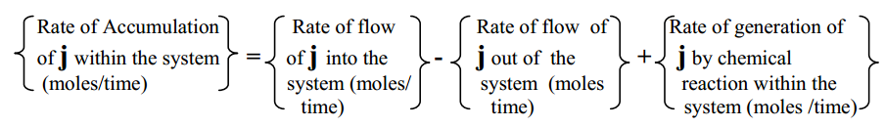
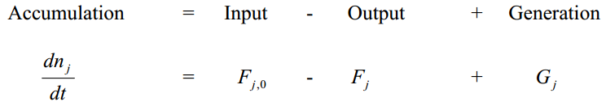 (1.6)
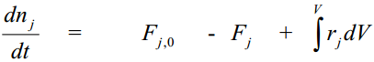 (1.7)
Where: n is number of moles, F is flowing rate of species j, G is rate of generation, V is volume of a mixture, r is rate of reaction, and t is reaction time. The materials balance equations for batch, CSTR and PFR reactors are summarized as follows in Table 1.1.
Table 1. 1 materials balance equations for batch, CSTR and PFR reactors
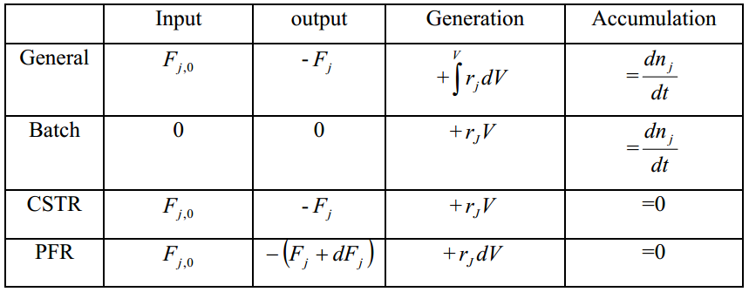
    - Energy balance
Energy Balance: It quantifies flow of energy across reactor boundary. For the following general energy balance equation, it is assumed that heat (Q) is added to the reactor, and work done by the system(W). The general energy balance for unsteady state open system is given by :
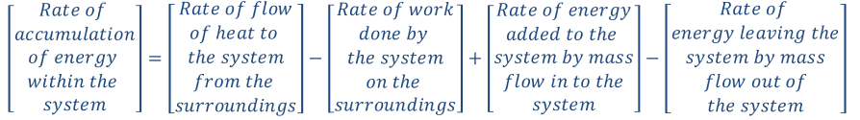
$\frac{{dE}_{sys}}{dt} = \dot{Q} - \dot{W} + F_{in}E_{in} - F_{out}E_{out}$ (1.8)
Where: E is sum of energies, Q is heat addition, W is work done by the system, and FE flow energy,
$F_{in}E_{in}=\sum_{i=1}^{n}{F_{i}E_{i}}│_{in}$ (1.9)
${ F}_{out}E_{out}=\sum_{i=1}^{n}{F_{i}E_{i}}│_{out}$ (1.10)
$\frac{{dE}_{sys}}{dt} = \dot{Q} - \dot{W} +\sum_{i=1}^{n}{F_{i}E_{i}}│_{in}-\sum_{i=1}^{n}{F_{i}E_{i}}│_{out}$ (1.11)
The total energy $E_{i}$is the sum of internal energy $(U_{i})$, kinetic energy ${(u_{i}}^{2}/2)$, potential energy ${(gz}_{i})$, and other energies, such as electric or magnetic energy or light
$E_{i}=U_{i}+\frac{{u_{i}}^{2}}{2}+{gz}_{i}+other$ (1.12)
In almost all chemical reactors situations, kinetic, potential, and “other” energy terms are negligible in comparison with the enthalpy, heat transfer and work terms. i.e. the total energy will be equal to internal energy.
$E_{i}=U_{i}$ (1.13)
Hence, substitute $U_{i}$ by $E_{i}$ in the main energy balance equation, then the general energy balance equation becomes:
$\frac{{dE}_{sys}}{dt} = \dot{Q} - \dot{W} +\sum_{i=1}^{n}{F_{i}U_{i}}│_{in}-\sum_{i=1}^{n}{F_{i}U_{i}}│_{out}$ (1.14)
From enthalpy ($H_{i}$) definition, $H_{i}$ is the sum of the internal energy ($U_{i}$) and the flow work ($P{\tilde{V}}_{i})$.
$H_{i}=U_{i}+P{\tilde{V}}_{i}$ (1.15)
$U_{i}=H_{i}-P{\tilde{V}}_{i}$ (1.16)
Substitute $U_{i}$ by $H_{i}-P{\tilde{V}}_{i}$, the energy balance equation becomes:
$\frac{{dE}_{sys}}{dt} = \dot{Q} - \dot{W} +\sum_{i=1}^{n}{F_{i}{(H}_{i}-P{\tilde{V}}_{i})}│_{in}-\sum_{i=1}^{n}{F_{i}{(H}_{i}-P{\tilde{V}}_{i})}│_{out}$ (1.17)
The rate of work term ($\dot{W}$) is the sum of shaft work and flow work. It is given by:
Flow work $=F_{i}P{\tilde{V}}_{i}$ (1.18)
Shaft work $={\dot{W}}_{S}$
$\dot{W}={\dot{W}}_{S}+F_{i}P{\tilde{V}}_{i}$ (1.19)
The flow work for mass into and out of the system is given by:
$\dot{W}={\dot{W}}_{S}+\sum_{i=1}^{n}{F_{i}}P{\tilde{V}}_{i}│_{out}-\sum_{i=1}^{n}{F_{i}}P{\tilde{V}}_{i}│_{in}$ (1.20)
Substitute equation (1.20) in to equation (1.17), the energy balance becomes:
$\frac{{dE}_{sys}}{dt} = \dot{Q} - {\dot{W}}_{S}+\sum_{i=1}^{n}{F_{i}H_{i}}│_{in}-\sum_{i=1}^{n}{F_{i}H_{i}}│_{out}$ (1.21)
(This is general energy balance equation of flow reactors)
For unsteady state closed system, batch reactors- No inputs and outputs,
$\sum_{i=1}^{n}{F_{i}H_{i}}│_{in}=\sum_{i=1}^{n}{F_{i}H_{i}}│_{out}=0$ (1.22)
$\frac{{dE}_{sys}}{dt} = \dot{Q} - {\dot{W}}_{S}$ (1.23)
For steady state open systems (flow reactors) such as CSTRs and PFRs- No accumulation, $\frac{{dE}_{sys}}{dt}=0$ (1.24)
$\dot{Q} - {\dot{W}}_{S}+\sum_{i=1}^{n}{F_{i}H_{i}}│_{in}-\sum_{i=1}^{n}{F_{i}H_{i}}│_{out}=0$ (1.25)
  - Summary
The study of chemical reaction engineering combines the study of chemical kinetics with the reactors design. The rate of reaction tells us how fast the number of moles of one chemical species are being consumed to form another chemical species. There are three basic ways a species may lose its chemical identity: decomposition, combination, and isomerization.
Chemical reactors are vessels/containers in which chemical reactions take place. Reactors can be classified based phase involved, method of operation and thermal operation in the process. Reactor design is required to produce a specified product at a given rate from the given reactants at maximum profit and low production cost. Reactor design is required when there is development of a new chemical process (development of a new plant), and modification of an existing chemical process.
Materials and energy balances are used to determine the quantity of materials and energy flows across reactors boundary.
References
Chemical Reaction Engineering, Levenspiel, O John Wiely& Sons, 3rd edition, 2011.
Elements of Chemical Engineering, Fogler, HS Prentice- Hall Inc Prentice- Hall Inc, 2015.

