Chemical Reaction Engineering II- Reactor Design (ChEg 4101)
Prerequisite: Chemical Reaction Engineering I-Reaction Kinetics (ChEg3104)
Lecture 2: Design of Isothermal Ideal Batch Reactor
Week 2
Lecturer: Adamu Esubalew (PhD, ChEg)
Lecture learning outcomes
At the end of the lecture, you will be able to:
- identify reaction time, auxiliary time, and size or volume reactor required for isothermal ideal batch reactor, and
- design isothermal ideal batch reactor using materials and energy balance equations.
2.1 Introduction to isothermal batch reactor
Isothermal batch reactor: It is a reactor in which reactants are mixed together and the reaction is allowed to proceed at constant temperature for a given time in a closed vessel with no inlet or outlet flows. i.e. the reaction temperature is constant throughout reactor volume. In most batch reactors, the longer a reactant stays in the reactor, the more the reactant is converted to product until either equilibrium is reached or the reactant is exhausted. A batch reactor with mixing patterns is demonstrated in Figure 2.1. A batch reactor has neither inflow nor outflow of reactants or products while the reaction is being carried out. If the reaction mixture is perfectly mixed (Figure 2.1), there will no variation in the rate of reaction throughout the reactor volume.
Batch reactors are frequently used in industry for both gas-phase and liquid-phase reactions. Liquid-phase reactions are frequently carried out in batch reactors when small-scale production is desired or operating difficulties rule out the use of continuous-flow systems.
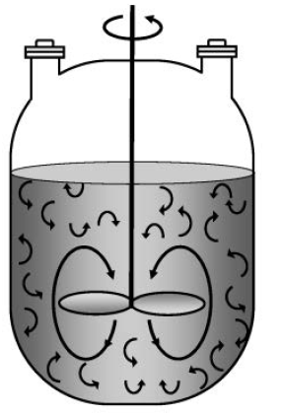
Figure 2. 1 A batch reactor with mixing patterns (Fogler, 2015, pg. 11)

For isothermal batch reactor, concentrations, reaction rate and conversion are functions of reaction time.
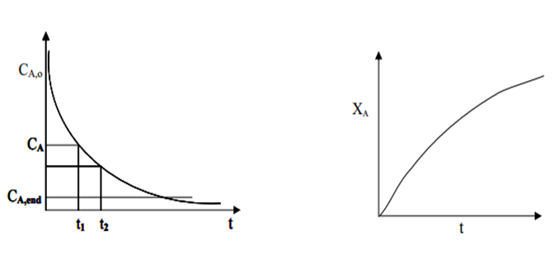
(a)
(b)

Figure 2. 2 Variation of (a) concentration and (b) conversion with time in a batch reactor
To model a batch reactor, it is assumed that at any given time the reactor is well-mixed so that the composition, temperature, and pressure are the same everywhere in the reactor. For liquid-phase reactions, the entire volume of the reactor is not filled by the liquid, and the reaction volume is the volume of the liquid which is less than the reactor volume.
The advantage is that high conversions can be achieved due to leaving the reactants in reactor. The disadvantages are high labor costs, auxiliary time, variability of products (batch to batch), and they are difficult to operate/automate for large-scale production.
2..2. Reaction time and auxiliary time
Reaction time (t_{r}) is the time required of chemical reaction to reach a particular specified conversion. It is determined by applying material balance equation. Auxiliary time is also determined beside of reaction time.
Total time is sum of reaction time and auxiliary time. Total time is the time elapsed to complete one batch operation. Total time is also called cycle time.
Auxiliary time includes different periods of a batch operation such as raw material preparation time (sample measuring time, solution preparation time, charging time, heating up time), discharging time and washing (cleaning) time.
In general, four types of periods are required to complete one batch process. They are: preparation time, reaction time, recovery time and cleaning time.
Preparation time (t_{ch} ): It is the length of time required for fresh reactants are charged to reactor and made ready them for reaction.
Reaction time (t_{r}): It is the length of time required for the reactants to be converted into products to the desired conversion.
Recovery time (t_{d): It} is the time required for the products completely discharged from the reactor.
Cleaning time (t_{cl} ): It is the duration required to clean a reactor and make it ready for next batch operation.
Total time/ cycle time $(tc$ ): It is the time when one operating cycle of a batch reactor is completed.
$t_{c}=t_{ch}+t_{r}+t_{d}+t_{cl}$ (2.1)
Auxiliary time, $t_{aux}$ , is the sum of charging time, discharging time and cleaning time.
$t_{aux}=t_{ch}+t_{d}+t_{cl}$ (2.2.)
$t_{c}=t_{r}+t_{aux}$ (2.3)
Production capacity of a batch reactor is reduced due to this auxiliary time.The major limitation of a batch reactor when it is used for a large-scale production is the auxiliary time.
Note: Reaction time is represented by t_{r} or t in this lecture material.
2.3. The size or volume of batch reactor
The size or volume reactor required is the main design parameter for batch reactor. Size or volume of a batch reactor required is not directly calculated from material balance. It is determined after calculating the cycle time (total time) required for a batch operation. The size or volume of a batch reactor is determined from the production rate (production capacity) and the amount of product formed per unit volume per total time.
$V=\frac{P_{c}t_{c}}{R_{v}}$ (2.4)
Where: V is volume of a batch reactor, P_{c} is production rate/ production capacity, R_{v} is amount of product formed per unit volume, and t_{c} is total time/ cycle time.
2.4. Isothermal batch reactor design equations
The process design of isothermal reactor can be obtained by using materials and energy balance. Consider the following simple reaction which is take placed in the batch reactor as shown in Figure 2. 3. Heat (Q) is added into the reactor and work (Ws) is done by the stirrer.
A------------------> R (2.5)
Where: A is reactant and R is product.

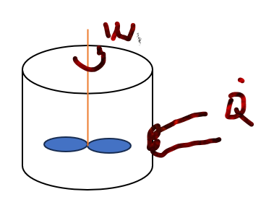
Figure 2. 3 Isothermal batch reactor for design equations
Materials balance
The basic materials balance equation for batch reactor is given by:
Rate of accumulation = ± rate of generation/ consumption
$\frac{-dN_{A}}{dt_{r}}={(-r}_{A}$)V (2.6)
N_{A}= N_{Ao} (1-X_{A}) (2. 7)
If you differentiate equation (2.7), you will get equation (2.8):
-dN_{A}= N_{Ao}dX_{A} (2.8)
Now, substitute equation (2.8) into equation (2.6), and solve for reaction time (tr), you will get equation (2.9):
$t_{r}=N_{ A0}\int_{0}^{X_{A}}{\frac{{dX}_{A}}{V{(-r}_{A})}}$ (2.9)
where: t_{r} is reaction time, X_{A} is conversion of reactant A, -r_{A} is rate of reaction for reactant A, V is volume of reaction mixture, N_{Ao} is initial mole of reactant A, and n_{A} is final mole of reactant A.
For constant volume of reacting fluid, $V=V_{0}$
$t_{r}=\frac{N_{A0}}{V_{0}}\int_{0}^{X_{A}}{\frac{{dX}_{A}}{{(-r}_{A})}}=C_{A0}\int_{0}^{X_{A}}{\frac{{dX}_{A}}{{(-r}_{A})}}=-\int_{C_{A0}}^{C_{A}}{\frac{{dC}_{A}}{{-r}_{A}}}$ (2.10)
Hence, equation (2.10) is used to find the reaction time, and eventually size of a reactor when conversion (concentration) versus (- r_{A}) an experimental data is given. When conversion (concentration) versus rate data is obtained from experiment, then the reaction time is determined by constructing the so called a levenspiel plot. i.e Plot ($\frac{1}{{-r}_{A}}$) as a function of conversion (X_{A}) or Plot ($\frac{1}{{-r}_{A}}$) as a function of Concentration (C_{A}). For ( $\frac{1}{-r_{A}})$versus X_{A} , the time of reaction can be represented by the shaded areas.
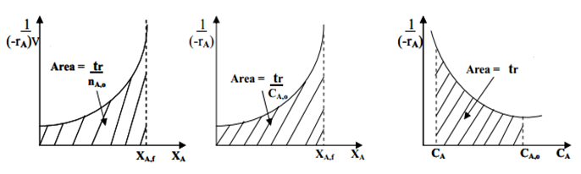
(c)
(b)
(a)

Figure 2. 4 (a) Plot ($\frac{1}{{-r}_{A V}}$ ) vs XA), (b) Plot ($\frac{1}{{-r}_{A }}$ ) vs XA), and (c) Plot ($\frac{1}{{-r}_{A }}$ ) vs CA
(Levenspiel 2011, pg. 92)
The integral also can be evaluated using numerical methods such as, Trapezoidal rule, Simpson's rule, Five-point quadratic formula. For example, the Simpson's one third rule to evaluate the integral is given by equation (2.11) and the plot is shown in Figure 2.5.
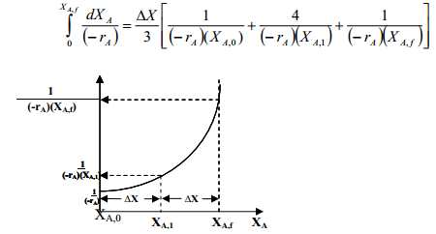 (2.11)
Figure 2. 5 Simpson’s one-third rule plot of ($\frac{1}{{-r}_{A}X_{Af}}$ ) vs XA)
Activity 2.1
Consider an elementary isothermal and constant volume reaction.
A ----------------> P
The laboratory investigation in a batch reactor at 422K and total pressure of 10 atm, and chemical reaction rate as a function of conversion is given below. The initial charge is an equi-molar mixture of A and inert. Calculate the reaction time required to convert 40% A.
X_{A} | 0 | 0.1 | 0.2 | 0.3 | 0.4
-r_{A} (mol/ dm³ h) | 0.0053 | 0.0052 | 0.0050 | 0.0045 | 0.0040
Given: elementary reaction, constant volume, total pressure (P)= 10 atm, T=422K, at the initial the feed is Equi-molar mixture of inert and reactant A, and conversion of reactant A is 0.40.
Required: Determine the reaction time (t_{r})
Assumption: Isothermal Batch reactor.
Solution: From ideal gas law, PV= NRT
Where: P is total pressure, V is volume, N is number of moles, R is universal gas constant, and T is temperature.
The initial partial pressure of A(P_{Ao}) = mole fraction of A * total Pressure
P_{Ao}=y* P= 0.5*10 atm= 5 atm= 506.625 kPa.
For constant volume, C_{Ao}= N_{Ao}/V= P_{Ao}/RT, R=8.314 kPa.m³/mol K=8.314 kPa.dm³/mol.K, T= 422K
C_{Ao}= 506.625 kPa/(8.314 kPa.dm³/mol.K)(422K) = 0.144 mol/dm³.
To find the reaction time use the following equation (2.10).
$t_{r}=\frac{N_{A0}}{V_{0}}\int_{0}^{X_{A}}{\frac{{dX}_{A}}{{(-r}_{A})}}=C_{A0}\int_{0}^{X_{A}}{\frac{{dX}_{A}}{{(-r}_{A})}}=$ (2.10)
To find the integration area of equation (2.10), plot ($\frac{1}{{-r}_{A}}$) as a function of conversion (X_{A}). The data of 1/-r_{A} as a function of conversion is given below. The area under the curve is the ratio of reaction time to initial concentration of reactant A. i.e. Area under the curve= t_{r}/ C_{Ao.} You can plot the following data using appropriate tools to find the area under the curve. For example, here the plot is carried out using origin 18 software (trial version) as shown in Figure 2.6.
X_{A} | 0 | 0.1 | 0.2 | 0.3 | 0.4
1/-r_{A} (dm³ h/mol) | 189 | 192 | 200 | 222 | 250

Figure 2. 6 plot of (1/-r_{A}) vs X_{A}
The reaction time (t_{r}) = C_{Ao} * Area under the curve
Therefore, t_{r}= C_{Ao}* Area= 0.144 mol/dm³* 83.4 dm³.h/mol= 12 h
Energy Balance
The basic energy balance equation for batch reactor is given by:
$\frac{{d\hat{E}}_{sy}}{dt}=\dot{Q}-{\dot{W}}_{S}$ (2.12)
Where: ${\hat{E}}_{sys} \text{ is the total energy of the system}$, Q is addition of heat, t is the reaction time, and W_{s} is work done.
Total energy is the sum of the products of specific energies ($E_{i}$)of the various species in the system volume and the number of moles ($N_{i}$ ) of that species.
${\hat{E}}_{sys}=\sum_{i=1}^{m}{N_{i}E_{i}}$ (2.13)
$E_{i}=U_{i}+{KE}_{i}+{PE}_{i}$ (2.14)
For a batch reactor, kinetic energy and potential energies are negligible as compared with internal energy.
$E_{i}=U_{i}$ (2.15)
From definition of enthalpy
$H_{i}= U_{i}+P{\tilde{V}}_{i}$ (2.16)
By re-arranging equation (2.16), it becomes
$U_{i}=H_{i}-P{\tilde{V}}_{i}$ (2.17)
Where: ${\tilde{V}}_{i}$ is molar specific volume, Hi is specific enthalpy and Ui is specific internal energy.
By substituting equation (2.17) into equation (2.15), you get
$E_{i}=H_{i}-P{\tilde{V}}_{i}$ (2.18)
To find the total energy, substitute equation (2.18) into equation (2.13).
${\hat{E}}_{sys}=\sum_{i=1}^{m}{N_{i}E_{i}=}$ $\sum_{i=1}^{m}{N_{i}H_{i}-}$ $P\sum_{i=1}^{m}{N_{i}{\tilde{V}}_{i}}$ (2.19)
The term $P\sum_{i=1}^{m}{N_{i}{\tilde{V}}_{i}}$ is equal to total pressure times total volume, $PV$. For constant volume, the PV term variation is practically smaller than the other terms, it can be neglected and equation (2.19) is simplified to equation (2.20).
${\hat{E}}_{sys}=\sum_{i=1}^{m}{N_{i}H_{i}}$ (2.20)
By substituting equation (2.20) in to equation (2.12), you get:
$\dot{Q}-{\dot{W}}_{S}=\frac{d{\hat{E}}_{sys}}{dt}$=$\frac{d(\sum_{i=1}^{m}{N_{i}H_{i})}}{dt}$ (2.21)
By differentiating equation (2.21), the energy balance of a batch reactor, it becomes:
$\dot{Q}-{\dot{W}}_{S}=\sum_{i=1}^{m}{N_{i}}\frac{{dH}_{i}}{dt}+\sum_{i=1}^{m}{H_{i}\frac{{dN}_{i}}{dt}}$ (2.22)
When no phase changes involved, specific enthalpy is given by:
$H_{i}={H_{i}}^{o}\left(T_{R}\right)+\int_{T_{R}}^{T}{C_{P_{i}}dT}$ (2.23)
By differentiating $H_{i}$ with respect to time, equation (2.23), you will get:
$\frac{{dH}_{i}}{dt}=C_{Pi}\frac{dT}{dt}$ (2.24)
Where:$H_{i}$ is specific enthalpy of species i at temperature T, C_{Pi} is specific heat capacity, $T_{R}$ is reference temperature, 298K (25ºC).
Recalling the mole balance of species i in a batch reactor
$\frac{{dN}_{i}}{dt}=r_{i}V$ (2.25)
Consider a reaction, $A+\frac{b}{a}B→\frac{c}{a}C+\frac{d}{a}D$ (2.26)
$\frac{{dN}_{i}}{dt}=-{\text{ν}}_{i}r_{i}V$ (2.27)
Where: r_{i} is reaction rate of species i, v_{i} is stochiometric coefficient of species i.
The batch reaction stochiometric values of species A, B, C and D , and inert I am summered in Table 2.1 (Fogler, 2015, pg. 108).
Table 2.1. Stoichiometric table for a batch system
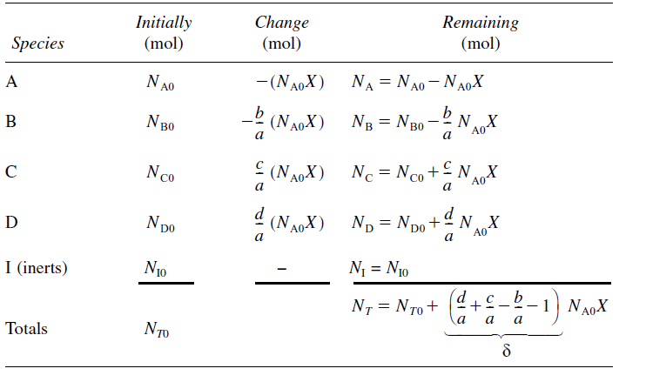
By substituting both equations (2. 24 and 2.27) into equation (2.22), the energy balance becomes:
$\dot{Q}-{\dot{W}}_{S}=\sum{N_{i}}C_{Pi}\frac{dT}{dt}+\sum{H_{i} (}-{\text{ν}}_{i}r_{i}V)$ (2.28)
Further re-arranging equation (2.28), the energy balance of a batch reactor becomes:
$\dot{Q}-{\dot{W}}_{S}=\sum{N_{i}}C_{Pi}\frac{dT}{dt}+\sum{{\text{ν}}_{i}H_{i} }(-r_{i}V)$ (2.29)
Summation of ${\text{ν}}_{i}H_{i}$ for all species at T is the heat of reaction at T
$\sum{{\text{ν}}_{i}H_{i}=∆H_{Rx}}(T)$ (2.30)
The coefficient v_{i} sign is + ve for products and –ve for reactants. The heat of reaction is obtained from chemical reaction enthalpy changes of chemical species, i. Recalling enthalpy of species i at T for no phase change involved, equation (2.23), to correlate it with chemical reaction, equation (2.26).
$H_{i}={H^{0}}_{i}\left(T_{R}\right)+\int_{T_{R}}^{T}{C_{Pi}}dT$ (2.23)
$A+\frac{b}{a}B→\frac{c}{a}C+\frac{d}{a}$ (2.26)
For reactants A & B, and products C & D, the enthalpy of species A, B, C & D for equation (2.23) will be:
$H_{A}={H^{0}}_{A}(T_{R})+\int_{T_{R}}^{T}{C_{PA}}dT$ (2.31)
$H_{B}={H^{0}}_{B}(T_{R})+\int_{T_{R}}^{T}{C_{PB}}dT$ (2.32)
$H_{C}={H^{0}}_{C}(T_{R})+\int_{T_{R}}^{T}{C_{PC}}dT$ (2.33)
$H_{D}={H^{0}}_{D}(T_{R})+\int_{T_{R}}^{T}{C_{PD}}dT$ (2.34)

The change in heat of reaction at temperature T of equation (2.30) is expressed by:
$\sum{{\text{ν}}_{i}H_{i} }=\frac{c}{a}H_{C}\left(T\right)+\frac{d}{a}H_{D}\left(T\right)-\frac{b}{a}H_{B}(T)-H_{A}(T)$ (2.35)
Substituting enthalpies of all species, equations (2.31- 2.34) into equation (2.35), you will get:
$\sum{{\text{ν}}_{i}H_{i} }={∆H}_{Rx}\left(T\right)=\left(\frac{c}{a}{H^{0}}_{C}+\frac{d}{a}{H^{0}}_{D}-\frac{b}{a}{H^{0}}_{B}-{H^{0}}_{A}\right)+\left(\frac{c}{a}\int_{T_{R}}^{T}{C_{PC}}dT+\frac{d}{a}\int_{T_{R}}^{T}{C_{PD}}dT-\frac{b}{a}\int_{T_{R}}^{T}{C_{PB}}dT-\int_{T_{R}}^{T}{C_{PA}}dT \right)$ (2.36)
The first term of equation (2.36) is the change in standard heat of reaction.
$\frac{c}{a}{H^{0}}_{C}+\frac{d}{a}{H^{0}}_{D}-\frac{b}{a}{H^{0}}_{B}-{H^{0}}_{A}={{∆H}^{0}}_{Rx}(T_{R})$ (2.37)
The second term of equation (2.36) is the change in specific heat capacity.
$\frac{c}{a}C_{PC}+\frac{d}{a}C_{PD}-\frac{b}{a}C_{PB}-C_{PA}={∆C}_{P}$ (2.38)
After re-arranging, of the energy balance equation (2.29) will be:
$\frac{dT}{dt}=\frac{\dot{Q}-{\dot{W}}_{S}+(-∆H_{Rx})(-r_{i}V)}{\sum{N_{i}}C_{Pi}}$ (2.39)
For isothermal operation ($T=T_{0}$), $\frac{dT}{dt}=0$
$\frac{\dot{Q}-{\dot{W}}_{S}+(-∆H_{Rx})(-r_{i}V)}{\sum{N_{i}}C_{Pi}}=0$ (2.40)
This is energy balance equation for isothermal ideal batch reactor.
For species i, the number of mole after chemical reaction is given by:
$N_{i}=N_{i0}+ν_{i}N_{A0}X_{A}=N_{A0}\left(\frac{N_{i0}}{N_{A0}}+ν_{i}X_{A}\right)=N_{A0}(Θ_{i}+ν_{i}X_{A})$ (2.41)
$\frac{\dot{Q}-{\dot{W}}_{S}+(-∆H_{Rx})(-r_{A}V)}{\sum{N_{A0}(Θ_{i}+ν_{i}X_{A}) }C_{Pi}}$=0 (2.42)
$\sum{N_{i}C_{Pi}}≅N_{A0}\sum{Θ_{i}C_{Pi}}$ (2.43)
$0=\frac{\dot{Q} -{\dot{W}}_{S}-∆H_{Rx}N_{A0}\frac{{dX}_{A}}{dt}}{N_{A0}[\sum{Θ_{i}C_{P_{i}}+∆C_{P}X_{A}]}}$ (2.44)
$∆H_{Rx}={∆H_{Rx}}^{o}+∆C_{P}(T-T_{R})$ (2.45)
$0=\frac{\dot{Q} -{\dot{W}}_{S}-[{∆H_{Rx}}^{o}+∆C_{P}(T-T_{R})]N_{A0}\frac{{dX}_{A}}{dt}}{N_{A0}[\sum{Θ_{i}C_{P_{i}}+∆C_{P}X_{A}]}}$ (2.46)
For very small $∆C_{P}$, $∆C_{P}≅0$
$0=\frac{\dot{Q} -{\dot{W}}_{S}-{∆H_{Rx}}^{o}N_{A0}\frac{{dX}_{A}}{dt}}{N_{A0}\sum{Θ_{i}C_{P_{i}}}}$ (2.47)
For slow mixing, the work done by stirrer is neglected, ${\dot{W}}_{s}≅0$, the energy equation becomes:
$0=\frac{\dot{Q} -{∆H_{Rx}}^{o}N_{A0}\frac{{dX}_{A}}{dt}}{N_{A0}\sum{Θ_{i}C_{P_{i}}}}$ (2.48)
$\dot{Q} -{∆H_{Rx}}^{o}N_{A0}\frac{{dX}_{A}}{dt}=0$ (2.49)
${∆H_{Rx}}^{o}N_{A0}\frac{{dX}_{A}}{dt}=\dot{Q}$ (2. 50)
But $\dot{Q}=UA(T_{a}-T)$ (2. 51)
${∆H_{Rx}}^{o}N_{A0}\frac{{dX}_{A}}{dt}=UA(T_{a}-T)$ (2.52)
Activity 2.2.
The irreversible elementary reaction is carried out in a batch reactor at 60ºC in an isothermal condition. The feed is a mixture of reactants of A and B with concentration of 4 mol/L. The composition is equimolar of A and B. The reaction is assumed that the volume of mixtures in a batch reactor is constant. The reaction rate is second order with respect to reactant A, and the reaction rate constant is 0.12 L/mol.min. The production capacity rate is 38.4 mol/min. The maximum conversion of reactant A is reached to 96%. The auxiliary time of the batch process is 20 min. The reaction is given in the following stoichiometry equation: A+ B -----------------> 2R
Based on the given data, determine: (a) the reaction time (t_{r}), (b) the concentration of product (R), and (c) the reactor volume (V).
Given: Elementary reaction, Isothermal batch reactor, Equimolar concentration of reactants A& B
A+ B------->2R, C_{Ao}+ C_{Bo}= 4 mol/L, C_{Ao}= C_{Bo}= 2 mol/L
Secord order reaction with respect to reactant A, and the reaction rate constant (k)=0.12 L/mol.min.
Production capacity rate is 38.4 mol/min.
Maximum conversion of reactant A (X_{A})= 96%= 0.96.
Auxiliary time = 20 min.
Assumptions:
The volume of mixtures in a batch reactor is constant.
No initial concentration of product (R).
Solution:
- The reaction time
$t_{r}=C_{A0}\int_{0}^{X_{A}}{\frac{{dX}_{A}}{{(-r}_{A})}}$ (2.10)
For elementary second order reaction the rate is given by:
-r_{A}= kC_{A}C_{B}= kC_{A}²= kC_{Ao}²(1-X_{A})² (2.27)
By substituting the rate equation (2.27) into equation (2.10), and the, integrate it to find reaction time.
$t_{r}=\frac{1}{kC_{Ao}}$($\left.\frac{1}{1-X_{A}})\right| \begin{matrix}0.96 \\ 0\end{matrix}$
CAo= 2mol/L, k=0.12 L/mol.min.
$t_{r}=\frac{1}{0.12*2}(\frac{1}{1-0.96}$-1)=100 min
(b) the concentration of product (R)
$N_{i}=N_{i0}+ν_{i}N_{A0}X_{A}$ (2.41
For constant volume, $C_{R}=C_{R0}+ν_{R}C_{A0}X_{A}$
C_{Ao}=2 mol/L, but C_{Ro}=0, v_{R}=2, X_{A}=0.96
C_{R}= 0 + 2*2*0.96 = 3.84 mol/L
(c) the reactor volume (V).
$t_{c}=t_{r}+t_{aux}$ (2.3)
$$t_{c}=t_{r}+t_{aux}=100 min+20 min=120 min$$
$V=\frac{P_{c}t_{c}}{R_{v}}$ (2.4)
Pc= 38.4 mol/ min, R_{v}= C_{R}= 3.84mol/L
V= (38.4 mol/min *120 min)/ 3.84 mol/L= 1200 L
2.5. Summary
For isothermal batch reactor, concentrations, reaction rate and conversion are functions of reaction time. Conversion, reaction time and size or volume of reactor are main aims of isothermal batch reactor design. The reaction time is determined from reaction rate and materials balance equations. The reactor size or volume is determined from production capacity/ production rate, total cycle time and products formed per unit volume. For isothermal operation, the change in heat of reaction at a temperature of T is equal to the change in standard heat of reaction. Energy transfer across batch reactor boundary is take placed in the form of heat and work done.
References
Chemical Reaction Engineering, Levenspiel, O John Wiely& Sons, 3rd edition, 2011.
Elements of Chemical Engineering, Fogler, HS Prentice- Hall Inc Prentice- Hall Inc,5th edition, 2015.

