Chemical Reaction Engineering II- Reactor Design (ChEg 4101)
Prerequisite: Chemical Reaction Engineering I-Reaction Kinetics (ChEg3104)
Lecture 3: Design of Non-isothermal Ideal Batch Reactor
Week 3
Lecturer: Adamu Esubalew (PhD, ChEg)
Lecture learning outcomes
At the end of the lecture, you will be able to:
- identify the characteristics of non-isothermal ideal batch reactor,
- determine change in heat of reaction at any temperature, and
- design non-isothermal ideal batch reactor using materials and energy balance equations.
3.1. Non-isothermal ideal batch reactor
Non-isothermal Batch reactor: It is a reactor in which reactants are mixed together and the reaction is allowed to proceed for a given time in a closed vessel with no inlet or outlet flows, and the reaction temperature varies with time. A non-isothermal ideal batch reactor is shown in Figure 3.1 (Fogler, 2015, pg. 632). Energy is exchanged across the reactor boundary.
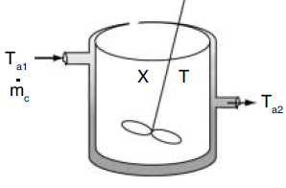
Figure 3.1. Non-isothermal batch reactor
For isothermal ideal batch reactor, the reaction time (t_{r}) is determined using materials balance equation (See Lecture 2). i.e. no need of energy balance equation to find reaction time since reaction rate is independent of reaction temperature. The mixture volume may be variable or constant, which is dependent on the mixture's phases. The non-isothermal batch reactor considers the effect of temperature on the rate of reaction, conversion and concentration progresses for a given reaction time.
For non-isothermal batch reactor, both materials balance and energy balance equations are mandatory to find reaction time (t_{r}). Energy balance is necessary for non-isothermal reaction system to analyze the heat effect. The reaction rate is affected by reaction temperature. The conversion of reactants varies with reaction temperature. For non-isothermal batch reactor, concentrations, reaction rate and conversion are functions of reaction time and reaction temperature.
Non-isothermal ideal batch reactor can be operated either adiabatic or non-adiabatic condition. For adiabatic operation, there is no heat exchange between a reactor and a surrounding. i.e there is no heat addition into a reactor or heat removal from a reactor. However, for non-adiabatic operation, there is heat exchange between a reactor and a surrounding. i.e there is heat addition into a reactor or heat removal from a reactor.
2.2 Reaction time and auxiliary time
Reaction time (t_{r}) is the time required of chemical reaction to reach a particular specified conversion. It is determined by applying both materials balance and energy balance equations. Auxiliary time includes different periods of a batch operation such as raw material preparation time, discharging time and cleaning time. Total time is sum of reaction time and auxiliary time, which is the time elapsed to complete one batch operation.
2.3. The size or volume of batch reactor
The size or volume reactor required is the main design parameter for batch reactor. The size or volume of a batch reactor required is not directly calculated from material balance. It is determined after calculating the cycle time (total time) required for a batch operation. The size or volume of a batch reactor is determined from the production rate (production capacity) and the amount of product formed per unit volume per total time.
$V=\frac{P_{c}t_{c}}{R_{v}}$ (3.1)
Where: V is volume of a batch reactor, P_{c} is production rate/ production capacity, R_{v} is amount of product formed per unit volume, and t_{c} is total time/ cycle time.
2.4. Non-isothermal batch reactor design equations
Material balance equation
$t_{r}=t=N_{A0}\int_{0}^{X_{A}}{\frac{{dX}_{A}}{V{(-r}_{A})}}$ (3.2)
Where: t= t_{r} is reaction time, N_{Ao} initial mole of species A, X_{A} is conversion of species A, V is volume of mixture, and -r_{A} is rate of reaction for species A.
The derivation details are found in isothermal batch reactor (Refer lecture 2). A simple batch reactor is illustrated in Figure 3.2 (Levenspiel, 2011, pg. 84).
.
Figure 3.2. Batch reactor
Energy balance equation
The general energy balance for unsteady state open system is given by:
Rate of accumulation = rate of input - rate of output + heat added ± work done
$\dot{Q}-{\dot{W}}_{S}+\sum_{i=1}^{m}{{F_{i}H_{i}│}_{in}}-\sum_{i=1}^{m}{{F_{i}H_{i}│}_{out}}=\frac{d{\hat{E}}_{sys}}{dt}$ (3.3)
No mass crosses the system boundaries since a batch reactor is closed system.
$\sum_{i=0}^{m}{F_{i0}H_{i0}}=\sum_{i=1}^{m}{F_{i}H_{i}}=0$ (3.4)
The energy balance equation for a batch reactor is reduced to equation (3.5)
$\frac{{d\hat{E}}_{sy}}{dt}=\dot{Q}-{\dot{W}}_{S}$ (3.5)
Where: $\frac{{d\hat{E}}_{sys}}{dt} is the change in total energy$, Q is addition of heat, t is reaction time, and W_{s} is work done by the system.
The total energy of the system is the sum of the products of specific energies ($E_{i}$) of various species in the system and the number of moles ($N_{i}$ ) of that species.
The total energy of the system is given by:
${\hat{E}}_{sys}=\sum_{i=1}^{m}{N_{i}E_{i}}$ (3.6)
$E_{i}=U_{i}+{KE}_{i}+{PE}_{i}$ (3.7)
For a batch reactor, kinetic and potential energies are neglected, hence equation (3.7) is reduced to equation (3.8):
$E_{i}=U_{i}$ (3.8)
Where: Ui is specific internal energy.
Specific enthalpy is the sum of specific internal energy and specific pressure energy.
$H_{i}= U_{i}+P{\tilde{V}}_{i}$ (3.9)
By re-arranging equation (3.9), it becomes:
$U_{i}=H_{i}-P{\tilde{V}}_{i}$ (3.10)
By substituting equation (3.10) into equation (3.8), you get
$E_{i}=H_{i}-P{\tilde{V}}_{i}$ (3.11)
Where: ${\tilde{V}}_{i}$ is molar specific volume, Hi is specific enthalpy, P is total pressure and Ui is specific internal energy.
By substituting equation (3.11) into equation (3.6), the total energy of the system is given by:
${\hat{E}}_{sys}=\sum_{i=1}^{m}{N_{i}E_{i}=\sum_{i=1}^{m}{N_{i}H_{i}-P\sum_{i=1}^{m}{N_{i}{\tilde{V}}_{i}}}}$ (3.12)
The term $P\sum_{i=1}^{m}{N_{i}{\tilde{V}}_{i}}$ is equal to total pressure times total volume, $PV$
$V=\sum_{i=1}^{m}{N_{i}{\tilde{V}}_{i}}$ (3.13)
Where: V is total volume of a mixture.
For constant volume, the PV term variation is practically smaller than the other terms, it can be neglected and equation (3.12) is simplified to equation (3.14).
${\hat{E}}_{sys}=\sum_{i=1}^{m}{N_{i}H_{i}}$ (3.14)
By substituting equation (3.14) in to equation (3.5), the energy balance equation of a batch reactor becomes:
$\dot{Q}-{\dot{W}}_{S}=\frac{d(\sum_{i=1}^{m}{N_{i}H_{i})}}{dt}$ (3.15)
By differentiating the term $\sum_{i=1}^{m}{N_{i}H_{i}},$ the energy balance of a batch reactor it becomes:
$\dot{Q}-{\dot{W}}_{S}=\sum_{i=1}^{m}{N_{i}}\frac{{dH}_{i}}{dt}+\sum_{i=1}^{m}{H_{i}\frac{{dN}_{i}}{dt}}$ (3.16)
$\frac{{dH}_{i}}{dt}$ is rate of specific enthalpy of species.
$\frac{{dN}_{i}}{dt}$ is rate of reaction of species.
Two criteria's to be considered in correlating $H_{i}$as function of T are when no phase changes involved and when phase changes involved.
Case 1: When no phase changes involved, enthalpy of specie, i at temperature of T is equal to enthalpy of formation of species, i at T_{R} and the change in enthalpy in heating species i from T_{R} to T.
$$\left[\begin{aligned}\begin{aligned}Ethalpy of \\ species i \end{aligned} \\ at \\ T \\ \end{aligned}\right]=\left[\begin{aligned}Enthalpy of \\ formation \\ of species \\ i at \\ T_{R} \\ \end{aligned}\right]+\left[\begin{aligned}∆H_{Q} in \\ heating \\ species i \\ from \\ T_{R} to T\end{aligned}\right]$$
When no phase changes involved, $H_{i}$as function of T becomes:
$H_{i}={H_{i}}^{o}\left(T_{R}\right)+\int_{T_{R}}^{T}{C_{P_{i}}dT}$ (3.17)
Where:$H_{i}$ is specific enthalpy of species i at temperature T, ${Ho}_{i}$is specific enthalpy of species i at T_{R}, C_{Pi} is specific heat capacity, $T_{R}$ is reference temperature, 298K.
By differentiating $H_{i}$ with respect to time (equation 3.17), you get:
$\frac{{dH}_{i}}{dt}=C_{Pi}\frac{dT}{dt}$ (3.18)

Case 2: When phase changes involved from solid to gas, the enthalpy of species, i in the gas phase at T is equal to the sum of enthalpy of formation of species, i in the solid phase at T_{R}, enthalpy change in heating solid from T_{R} to T_{m}, heat of melting at T_{m}, enthalpy change in heating liquid from Tm to T_{b}, heat of vaporization at T_{b}, and enthalpy change in heating gas from T_{b} to T.
$$\left[\begin{aligned}\begin{aligned}Ethalpy of \\ species i \end{aligned} \\ in the gas \\ phase \\ at T\end{aligned}\right]=\left[\begin{aligned}Enthalpy of \\ formation \\ of species \\ i in the \\ solid phase \\ at T_{R} \end{aligned}\right]+\left[\begin{aligned}∆H_{Q} in \\ heating \\ solid \\ from \\ T_{R} to T_{m}\end{aligned}\right]+\left[\begin{aligned}Heat \\ of \\ melting \\ at T_{m} \end{aligned}\right]+\left[\begin{aligned}∆H_{Q} in \\ heating \\ liquid \\ from \\ T_{m} to T_{b}\end{aligned}\right]+\left[\begin{aligned}Heat \\ of \\ vaporization \\ at T_{b} \end{aligned}\right]+\left[\begin{aligned}∆H_{Q} in \\ heating \\ gas \\ from \\ T_{b} to T\end{aligned}\right]$$
Where: T_{m} and T_{b} are melting and boiling temperatures, respectively.
When phase changes involved from a solid to a gas, then the enthalpy, Hi (T) of species of a gas at temperature T is given by:
$H_{i}(T)={H_{i}}^{o}\left(T_{R}\right)+\int_{T_{R}}^{T_{m}}{C_{{Ps}_{i}}dT+∆H_{mi}\left(T_{m}\right)+\int_{T_{m}}^{T_{b}}{C_{{Pl}_{i}}dT}}+∆H_{vi}\left(T_{b}\right)+\int_{T_{b}}^{T}{C_{{Pg}_{i}}dT}$ (3.19)
By differentiating $H_{i}$ with respect to time, equation (3.19) becomes:
$\frac{{dH}_{i}}{dt}=C_{Ps_{i}}\frac{dT}{dt}+C_{Pl_{i}}\frac{dT}{dt}+C_{Pg_{i}}\frac{dT}{dt}$ (3.20)
Where: C_{ps}, C_{pl} and C_{pg} are specific heat capacity of solid, liquid and gas phases, respectively.
Recalling the mole balance of species i in a batch reactor (see lecture 2).
$\frac{{dN}_{i}}{dt}=r_{i}V$ (3.21)
Consider a reaction, $A+\frac{b}{a}B→\frac{c}{a}C+\frac{d}{a}D$ (3.22) $\frac{{dN}_{i}}{dt}=-{\text{ν}}_{i}r_{i}V$ (3.23)
Where: r_{i} is reaction rate of species i, v_{i} is stochiometric coefficient of species i, A & B are reactants; C & D are products.
By substituting equations (3.18 and 3.23) into equation (3.16), the energy balance equation of a batch reactor becomes:
$\dot{Q}-{\dot{W}}_{S}=\sum{N_{i}}C_{Pi}\frac{dT}{dt}+\sum{{\text{ν}}_{i}H_{i} }(-r_{i}V)$ (3.24)
The summation of ${\text{ν}}_{i}H_{i}$ for all species at temperature of T is the change in heat of reaction at T.
$\sum{{\text{ν}}_{i}H_{i}=∆H_{Rx}}$ (3.25)
The stochiometric coefficient v_{i} sign is + ve for products and –ve for reactants.
To find the heat of reaction at a temperature of T, consider the stochiometric reaction as shown in equation (3.22).
$$A+\frac{b}{a}B→\frac{c}{a}C+\frac{d}{a}D$$
Recalling the specific enthalpy of species i at T for no phase change involved is given in equation (3.17).
$H_{i}={H^{0}}_{i}\left(T_{R}\right)+\int_{T_{R}}^{T}{C_{Pi}}dT$
For species i = A & i = B reactants, and i=C & i=D products, the specific enthalpy of species of each at T is given by:
$H_{A}={H^{0}}_{A}(T_{R})+\int_{T_{R}}^{T}{C_{PA}}dT$ (3.26)
$H_{B}={H^{0}}_{B}(T_{R})+\int_{T_{R}}^{T}{C_{PB}}dT$ (3.27)
$H_{C}={H^{0}}_{C}(T_{R})+\int_{T_{R}}^{T}{C_{PC}}dT$ (3.28)
$H_{D}={H^{0}}_{D}(T_{R})+\int_{T_{R}}^{T}{C_{PD}}dT$ (3.29)
Species A is considered as a limiting reactant. The change in heat of reaction at temperature T, per mole of A, is given by:
$\sum{{\text{ν}}_{i}H_{i} }={∆H}_{Rx}\left(T\right)=\frac{c}{a}H_{C}\left(T\right)+\frac{d}{a}H_{D}\left(T\right)-\frac{b}{a}H_{B}(T)-H_{A}(T)$ (3.30)
Substitute enthalpies of all species, equations (3.26- 3.29) into equation (3.30), you get:
$\sum{{\text{ν}}_{i}H_{i} }={∆H}_{Rx}\left(T\right)=\left(\frac{c}{a}{H^{0}}_{C}+\frac{d}{a}{H^{0}}_{D}-\frac{b}{a}{H^{0}}_{B}-{H^{0}}_{A}\right)+\left(\frac{c}{a}\int_{T_{R}}^{T}{C_{PC}}dT+\frac{d}{a}\int_{T_{R}}^{T}{C_{PD}}dT-\frac{b}{a}\int_{T_{R}}^{T}{C_{PB}}dT-\int_{T_{R}}^{T}{C_{PA}}dT \right)$ (3.31)
The specific heat capacity of species, A, B, C & D is a function of temperature, T.
To determine the change in heat of reaction in equation (3.31), let’s consider two cases for specific heat capacity analysis. i.e. small and wide temperature ranges.
Case 1: For a small temperature range (between $T_{R}$ and $T$)
There is no any significant heat capacity variation of species i with temperature, T. So that $C_{P_{i}}$ is constant or the mean value is constant and take out from integral.
$\sum{{\text{ν}}_{i}H_{i} }=\left(\frac{c}{a}{H^{0}}_{C}+\frac{d}{a}{H^{0}}_{D}-\frac{b}{a}{H^{0}}_{B}-{H^{0}}_{A}\right)+\left(\frac{c}{a}C_{PC}(T-T_{R})+\frac{d}{a}C_{PD}(T-T_{R})-\frac{b}{a}C_{PB}(T-T_{R})-C_{PA}(T-T_{R}\right)$ $=\left(\frac{c}{a}{H^{0}}_{C}+\frac{d}{a}{H^{0}}_{D}-\frac{b}{a}{H^{0}}_{B}-{H^{0}}_{A}\right)+\left(\left\{\frac{c}{a}C_{PC}+\frac{d}{a}C_{PD}-\frac{b}{a}C_{PB}-C_{PA}\right\} (T-T_{R})\right)$ (3.32)
The first term of equation (3.32) is the change in heat of reaction of species at T_{R}.
$\frac{c}{a}{H^{0}}_{C}+\frac{d}{a}{H^{0}}_{D}-\frac{b}{a}{H^{0}}_{B}-{H^{0}}_{A}={{∆H}^{0}}_{Rx}(T_{R})$ (3.33)
The second term of equation (3.32) is the change in specific heat capacity of species, at T.
$\frac{c}{a}C_{PC}+\frac{d}{a}C_{PD}-\frac{b}{a}C_{PB}-C_{PA}={∆C}_{P}$ (3.34)
$\sum{{\text{ν}}_{i}H_{i} }={{∆H}^{0}}_{Rx}\left(T_{R}\right)+{∆C}_{P}\left(T-T_{R}\right)={∆H}_{Rx}\left(T\right)$ (3.35)
This is the change in heat of reaction at any temperature, T, for small temperature range.
Case II: For a wide temperature range (between T and T_{R})
Heat capacities are strong functions of temperature.
Since heat capacities are variable, $C_{P_{i}}$ cannot be taken out from integral, but the quadratic form of the heat capacity relation with temperature is approximated by:
$C_{P_{i}}=α_{i}+β_{i}T+γ_{i}T^{2}$ (3.36)
For species i = A, the heat capacity and specific enthalpy are given by:
$C_{P_{A}}=α_{A}+β_{A}T+γ_{A}T^{2}$ (3.37)
$H_{A}={H^{0}}_{A}(T_{R})+\int_{T_{R}}^{T}{\left(α_{A}+β_{A}T+γ_{A}T^{2}\right)}dT$ (3.38)
where, $α_{A}$, $β_{A}$, $γ_{A}$ are temperature coefficients for species A.
For species i = B, the heat capacity and specific enthalpy are given by:
$C_{P_{B}}=α_{B}+β_{B}T+γ_{B}T^{2}$ (3.39)
$H_{B}={H^{0}}_{B}(T_{R})+\int_{T_{R}}^{T}{\left(α_{B}+β_{B}T+γ_{B}T^{2}\right)}dT$ (3.40)
where, $α_{B}$, $β_{B}$, $γ_{B}$ are temperature coefficients for species B.
For species i = C, the heat capacity and specific enthalpy are given by:
$C_{P_{C}}=α_{C}+β_{C}T+γ_{C}T^{2}$ (3.41)
$H_{C}={H^{0}}_{C}(T_{R})+\int_{T_{R}}^{T}{\left(α_{C}+β_{C}T+γ_{C}T^{2}\right)}dT$ (3.42)
where, $α_{C}$, $β_{C}$, $γ_{C}$ are temperature coefficients for species C.
For species i = D, the heat capacity and specific enthalpy are given by:
$C_{P_{D}}=α_{D}+β_{D}T+γ_{D}T^{2}$ (3.43)
$H_{D}={H^{0}}_{D}(T_{R})+\int_{T_{R}}^{T}{\left(α_{D}+β_{D}T+γ_{D}T^{2}\right)}dT$ (3.44)
where, $α_{D}$, $β_{D}$, $γ_{D}$ are temperature coefficients for species D.
Similarly, ${∆H}_{Rx}\left(T\right)$for variable $C_{Pi}$ becomes:
$H_{Rx}(T)={H^{0}}_{RX}(T_{R})+\int_{T_{R}}^{T}{\left(ɑ+T+T^{2}\right)}dT$ (3.45)
The integration of equation (3.45) becomes:
$H_{Rx}\left(T\right)={H^{0}}_{RX}\left(T_{R}\right)+ɑ\left(T-T_{R}\right)+\frac{}{2}{(T}^{2}-{T^{2}}_{R})+\frac{γ}{3}{(T}^{3}-{T^{3}}_{R})$ (3.46)
Where:
$∆α=\frac{d}{a}$ ${}_{D+}$ $\frac{c}{a}$ ${}_{C}$- $\frac{b}{a}$ ${}_{B}$- ${}_{A}$
$∆β=\frac{d}{a}$ ${}_{D+}$ $\frac{c}{a}$ ${}_{C}$- $\frac{b}{a}$ ${}_{B}$- ${}_{A}$ (4.47)
$∆γ=\frac{d}{a}$ ${}_{D+}$ $\frac{c}{a}$ ${}_{C}$- $\frac{b}{a}$ ${}_{B}$- ${}_{A}$
The change in specific heat capacity at a temperature of T is equal to the difference between products and reactants at a temperature of T.
Hence, energy balance equation of a batch reactor can be simplified into equation (3.48).
$\frac{dT}{dt}=\frac{\dot{Q}-{\dot{W}}_{S}+(-∆H_{Rx})(-r_{i}V)}{\sum{N_{i}}C_{Pi}}$ (3.48)
This is the general energy balance equation for non-isothermal ideal batch reactor.
After chemical reaction, the remaining number of moles for species, i on the basis of limiting reactant (species A) is given by:
$N_{i}=N_{i0}+ν_{i}N_{A0}X_{A}$ $=N_{A0}\left(\frac{N_{i0}}{N_{A0}}+ν_{i}X_{A}\right)=N_{A0}(Θ_{i}+ν_{i}X_{A})$ (3.49)
Where: X_{A} is conversion of species A, Θi is initial mole ratio of species, i to species A.
The temperature rate is simplified by substituting equation (3.49) into equation (3.48), and you get the following equations:
$\frac{dT}{dt}=\frac{\dot{Q}-{\dot{W}}_{S}+(-∆H_{Rx})(-r_{A}V)}{\sum{N_{A0}(Θ_{i}+ν_{i}X_{A}) }C_{Pi}}$ (3.50)
$\frac{dT}{dt}=\frac{\dot{Q}-{\dot{W}}_{S}+(-∆H_{Rx})(-r_{A}V)}{N_{A0}(\sum{Θ_{i}C_{P_{i}}+\sum{ν_{i}C_{P_{i}}}X_{A})}}$ (3.51)
Where: $\sum{ν_{i}C_{P_{i}}}=∆C_{P}$
$\frac{dT}{dt}=\frac{\dot{Q}-{\dot{W}}_{S}+(-∆H_{Rx})(-r_{A}V)}{N_{A0}(\sum{Θ_{i}C_{P_{i}}+∆C_{P}X_{A}})}$ (3.52)
Where: -r_{A}V= dN_{A}/dt= -N_{Ao}dX_{A}/dt
From materials balance equation (3.2) and energy balance equation (3.52), it is observed that conversion of reactant A is a function of reaction time and reaction temperature. The two equations are interdependent. Both equations must be solved simultaneously to find reaction time, temperature and conversion of reactants.
Design of non-isothermal ideal batch reactor with adiabatic operation
For adiabatic operation (Q = 0) and if the work done by stirrer is neglected, ${\dot{W}}_{s}≅0$, the energy equation (3.52) becomes:
$\frac{dT}{dt}=\frac{-∆H_{Rx}N_{A0}\frac{{dX}_{A}}{dt}}{N_{A0}[\sum{Θ_{i}C_{P_{i}}+∆C_{P}X_{A}]}}$ (3.53)
By re-arranging equation (3.53), you get the following equations:
$-∆H_{Rx}N_{A0}\frac{{dX}_{A}}{dt}=N_{A0}[\sum{Θ_{i}C_{P_{i}}+∆C_{P}X_{A}]}\frac{dT}{dt}$ (3.54)
$-∆H_{Rx}{dX}_{A}=[\sum{Θ_{i}C_{P_{i}}+∆C_{P}X_{A}]}dT$ (3.55)
For small temperature range, $∆H_{Rx}={∆H_{Rx}}^{o}+∆C_{P}(T-T_{R})$ (3.35)
Substitute equation (3.35) into equation (3.55) , and solve for conversion (X_{A}), you get:
$X_{A}=\frac{[\sum{Θ_{i}C_{P_{i}}+∆C_{P}X_{A}]}(T-T_{0})}{-[{∆H_{Rx}}^{o}+∆C_{P}\left(T-T_{R}\right)]}$ (3.56)
If $∆C_{P}$ is $=0, X_{A}=\frac{\sum{Θ_{i}C_{P_{i}}}}{-{∆H_{Rx}}^{o}}(T-T_{0})$ (3.57)
This is a linear equation with slope: m= $\frac{\sum{Θ_{i}C_{P_{i}}}}{-{∆H_{Rx}}^{o}}$ and intercept: b= $\frac{\sum{Θ_{i}C_{P_{i}}}}{-{∆H_{Rx}}^{o}}T_{0}$
$X_{A}=mT+b$ (3.58)
Activity 3.1
A researcher wants to produce ethanol from glucose using fermentation process which is carried out in an adiabatic batch reactor. In the reaction, glucose (C₆H₁₂O₆) is converted in to ethanol (C₂H₅OH) and carbon dioxide (CO₂). The initial feed temperature is 25ºC. The initial concentration of glucose is 6 mol/ L. The overall reaction can be represented as:
2C₆H₁₂O₆ → 4C₂H₅OH + 4CO₂.
2 A 4 B + 4 C
Rate Law: -r_{A} = k${C_{A}}^{2}$
Additional data are given below. Determine: (a) the temperature of the reactor when 80% of glucose is converted to ethanol, and(b) the concentration of produced ethanol.
Additional data
Standard heat of formations (${H^{0}}_{i}$​) for each component at 298K: ${H^{0}}_{A}$ (C₆H₁₂O₆) = -1273 J/mol; ${H^{0}}_{B}$ (C₂H₅OH) = -277 J/mol; ${H^{0}}_{C}$ (CO₂) = -394 J/mol
Specific Heat Capacities ($C_{P_{i}}$) at 298K: $C_{P_{A}}$(C₆H₁₂O₆) = 13.2 J/mol·K; $C_{P_{B}}$(C₂H₅OH) = 4.88 J/mol·K; $C_{P_{C}}$(CO₂) = 1.72 J/mol·K
The energy balance equation for non-isothermal ideal batch reactor is given by:
$\frac{dT}{dt}=\frac{\dot{Q}+(-∆H_{Rx})(-r_{A}V)}{N_{A0}(\sum{Θ_{i}C_{P_{i}}+∆C_{P}X_{A}})}$ (3.52)
Solution
The batch reactor operation is adiabatic, Q=0
ΔC_{p}= 4C_{PC}+4C_{PB}-2C_{PA}=4*(4.88+1.72)- 2*13.2= 0
$∆H_{Rx}={∆H_{Rx}}^{o}+∆C_{P}(T-T_{R})$= ${∆H_{Rx}}^{o}=4{ *(H_{C}}^{o}+$ ${∆H_{B}}^{o})$-2* ${H_{A}}^{o}$
$$∆H_{Rx}=\text{4*(-394-277)-2*(-1273)=-}\text{138J/mol}$$
$-∆H_{Rx}{dX}_{A}=[\sum{Θ_{i}C_{P_{i}}+∆C_{P}X_{A}]}dT$ (3.55)
$$-∆H_{Rx}{dX}_{A}=[\sum{Θ_{i}C_{P_{i}}]}dT$$
$\sum{Θ_{i}C_{P_{i}}={}_{A}C_{PA}}$+ ${}_{B}C_{PB}+{}_{C}C_{PC}$
${}_{A}C_{PA}=C_{PA}$=13.2 J/mol. K since ${}_{A}=\frac{NAo}{NAo}=1,$
${}_{B}=\frac{NBo}{NAo}=$0 since N_{Bo}=0, ${}_{C}=\frac{NCo}{NAo}=$0 since N_{Co}=0
$$-∆H_{Rx}X_{A}=C_{PA}(T-T_{0})$$
T=$\frac{-∆H_{Rx}X_{A}}{C_{PA}}$+ $T_{0}$= (138*0.8) J/mol/(13.2 J/mol. K) +298 K= 306.36 K≈307 K
Design of non-isothermal ideal batch reactor with non-adiabatic operation
For non- adiabatic operation, the energy balance equation (3.52) is simplified by substituting –r_{A}V by –N_{Ao} dX_{A}/dt as follows:
$\frac{dT}{dt}=\frac{\dot{Q} -{\dot{W}}_{s}-∆H_{Rx}N_{A0}\frac{{dX}_{A}}{dt}}{N_{A0}[\sum{Θ_{i}C_{P_{i}}+∆C_{P}X_{A}]}}$ (3.59)
$∆H_{Rx}={∆H_{Rx}}^{o}+∆C_{P}(T-T_{R})$
$\frac{dT}{dt}=\frac{\dot{Q} - {\dot{W}}_{s}-[{∆H_{Rx}}^{o}+∆C_{P}(T-T_{R})]N_{A0}\frac{{dX}_{A}}{dt}}{N_{A0}[\sum{Θ_{i}C_{P_{i}}+∆C_{P}X_{A}]}}$ (3.60)
For very small $∆C_{P}, ∆C_{P}≅0$, $\frac{dT}{dt}=\frac{\dot{Q} -{\dot{W}}_{s}-{∆H_{Rx}}^{o}N_{A0}\frac{{dX}_{A}}{dt}}{N_{A0}\sum{Θ_{i}C_{P_{i}}}}$ (3.61)
If the work done by stirrer is not significant and neglected, ${\dot{W}}_{s}≅0$, equation (3.61) becomes:
$N_{A0}\sum{Θ_{i}C_{P_{i}}}\frac{dT}{dt}=\dot{Q} -{∆H_{Rx}}^{o} N_{A0}\frac{{dX}_{A}}{dt}$ (3.62)
The heat generation ($Q_{g}$) and heat removal ($Q_{r}$) can be accounted by.
$Q_{g}=-∆H_{Rx}\left({-r}_{A}V\right)$ (3.63)
$Q_{r}=UA(T_{a}-T)$ (3.64)
Where ${-Q}_{r}=\dot{Q}$
$\frac{dT}{dt}=\frac{Q_{g}{-Q}_{r} }{\sum{N_{i}C_{P_{i}}}}$ (3.65)
Where: $\sum{N_{i}C_{P_{i}}}=N_{A0}[\sum{Θ_{i}C_{P_{i}}+∆C_{P}X_{A}]}$ (3.66)
For very small, $∆C_{P}$, $∆C_{P}≅0, \sum{N_{i}C_{P_{i}}}=N_{A0}\sum{Θ_{i}C_{P_{i}}}$ (3.67)
Energy balance for non-isothermal multiple reactions
$\frac{dT}{dt}=\frac{\dot{Q} -{\dot{W}}_{S} + \sum_{i=1}^{q}{r_{ij}}V∆H_{Rx i} }{\sum_{j=1}^{m}{N_{j}C_{Pj}}}$ (3.68)
Where: q = number of multiple reactions
m = species occurring in batch reactor
Activity 3.2
A chemical engineer wants to produce ethanol from glucose using fermentation process which is carried out in an adiabatic batch reactor. In the reaction, glucose (C₆H₁₂O₆) is converted in to ethanol (C₂H₅OH) and carbon dioxide (CO₂). The overall reaction can be represented as:
C₆H₁₂O₆ → 2C₂H₅OH + 2CO₂
A 2 B + 2 C
Rate Law: r = k*${C_{A}}^{2}$
Determine the conversion, temperature and concentration profiles as a function of time when the reaction time is reached up to 90 min.
Design Data and information
Standard heat of formations (${H^{0}}_{i}$​) for each component at 298K:
${H^{0}}_{A}$ (C₆H₁₂O₆) = -1273 J/mol; ${H^{0}}_{B}$ (C₂H₅OH) = -277 J/mol; ${H^{0}}_{C}$ (CO₂) = -394 J/mol
Specific Heat Capacities ($C_{P_{i}}$) at 298K:
$C_{P_{i}}$(C₆H₁₂O₆) = 6.6 J/mol·K; $C_{P_{i}}$(C₂H₅OH) = 2.44 J/mol·K; $C_{P_{i}}$(CO₂) = 0.86 J/mol·K
Initial feed temperature (T₀) = 25°C; Rate constant at initial temperature (k at T₀​) = 0.02 L/mol·min; activation energy (E) = 60 J/mol; Initial concentration of glucose = 1.5 mol/L; universal gas constant (R): 8.314 J/(mol·K); Molecular weight for ethanol= 46.08g/mol.
Solution
The energy balance equation for non-isothermal batch reactor is given by:
$\frac{dT}{dt}=\frac{\dot{Q}+(-∆H_{Rx})(-r_{A}V)}{N_{A0}(\sum{Θ_{i}C_{P_{i}}+∆C_{P}X_{A}})}$ (3.52)
Using the given data, simulate the conversion, concentrations (species A, B & C) and temperatures distributions as a function of time using polymath program. Demonstrate the plots and discuss the simulation results.
- Conversion and reaction temperature profiles as a function of reaction time
Polymath program using polymath 6.10- trial version software tool:
d(X_{A}) / d(t) = k*C_{A0}* C_{A0} *(1-X_{A}) *(1-X_{A}) #Reaction of A-----------> 2B+2C
X_{A} (0) = 0 # initial conversion
k=k₀*exp(-E/(R*T)) # L/mol.min
k₀=0.02 # L/ mol.min, E=60# J/mol, C_{A0}=1.5 # mol/L, R=8.314 # J/ mol.K
d(T) / d(t) = (-ΔH_{Rx}*(-r_{A}))/(C_{A0}*(1-X_{A})*C_{PA}+ 2*C_{A0}*X_{A}*C_{PB}+2*C_{A0}*X_{A}*C_{PC}) #Adiabtic system
T(0) = 298 # K
r_{A}=-k*C_{A0}*C_{A0}*(1-X_{A}) *(1-X_{A}) # mol/L.min
ΔH_{Rx}= 2*(H_{C0}+H_{B0})-H_{A0} # J/mol
H_{A0}= -1273 # J/mol
H_{B0}= -277 # J/mol
H_{C0}= -394 # J/mol
C_{PA}= 6.6# J/ mol.K,
C_{PB}= 2.44# J/ mol.K,
C_{PC}= 0.86# J/ mol.K
t(0)=0 # min
t(f)= 90 # min
Simulation results
The simulation results are depicted in Figure 3.3 (a) conversion vs reaction time, (b) reaction temperature vs reaction time.

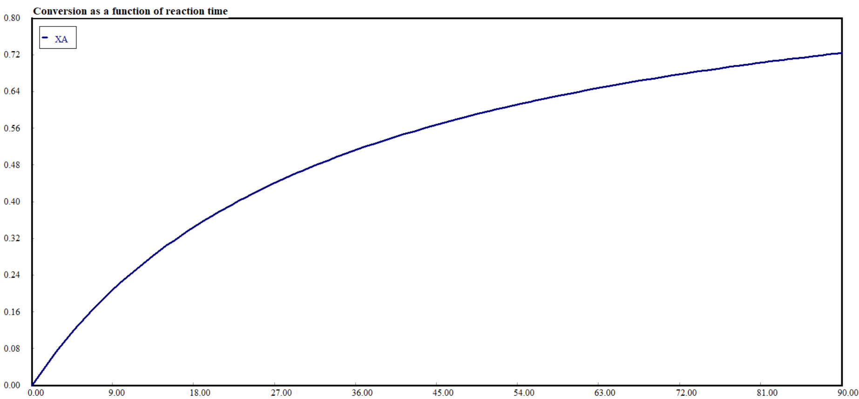
(a)
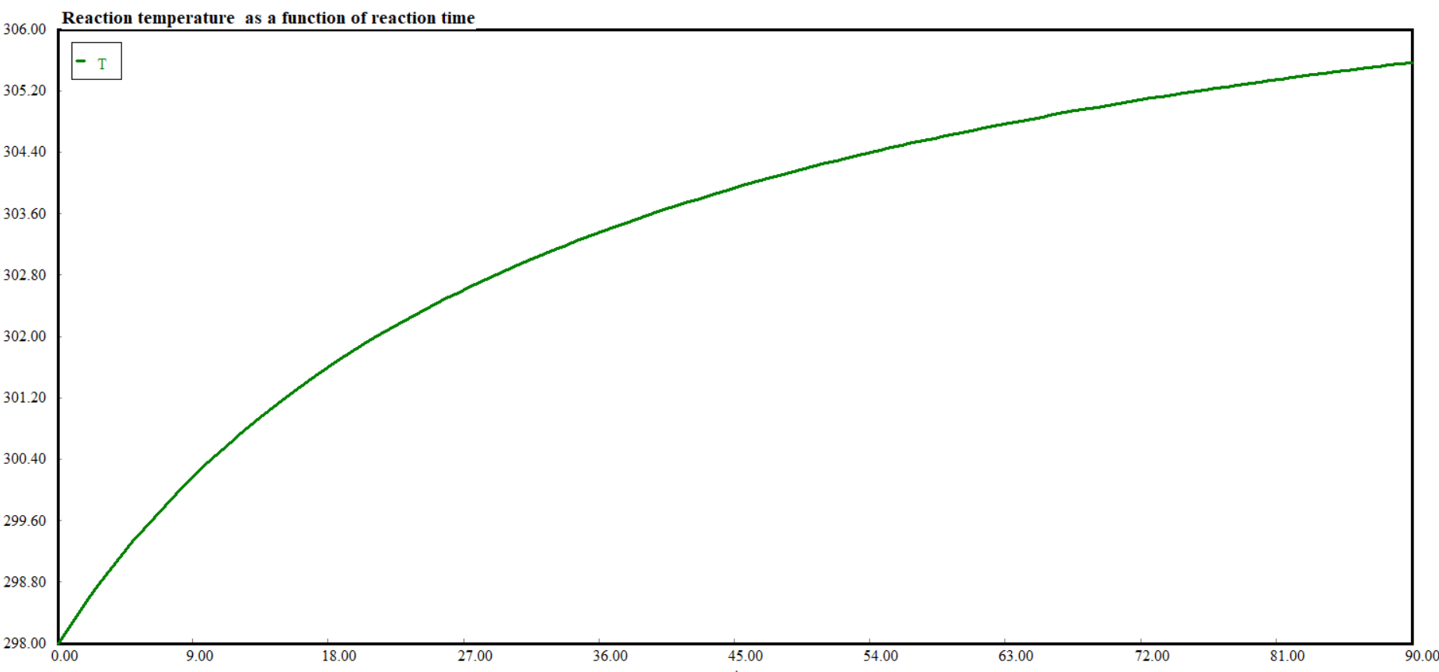
(b)
Figure 3.3 (a) conversion vs reaction time, and (b) reaction temperature vs reaction time
- Simulate concentrations of reactant A, product B & by-product C profiles as a function of reaction time.
Polymath program:
d(C_{A}) / d(t) = -k*C_{A}*C_{A} # Reaction of A-----------> 2B+2C # mol/ L. min
C_{A}(0) = 1.5 # mol/L
d(C_{B}) / d(t) = 2*k*C_{A}*C_{A} # mol/ L. min,
C_{B}(0)=0 # mol/L
d(C_{C}) / d(t) =2* k*C_{A}*C_{A} # mol/ L. min,
C_{C}(0)=0 # mol/L
k=k₀*exp(-E/(R*T)) # L/mol.min
k₀=0.02 # L/ mol.min, E=60 # J/mol,
C_{A0}=1.5 # mol/L,
R=8.314 # J/ mol.K
d(T) / d(t) = (-H_{Rx}*(-r_{A}))/(C_{A}*C_{PA}+ C_{B}*C_{PB}+C_{C}*C_{PC}) #Adiabtic system
T(0) = 298 # K
r_{A}= -k*C_{A}*C_{A} # mol/L.min,
ΔH_{Rx}= 2*(H_{C0}+H_{B0})-H_{A0} # J/mol
H_{A0}= -1273 # J/mol,
H_{B0}= -277 # J/mol,
H_{C0}= -394 # J/mol,
C_{PA}= 6.6# J/ mol.K,
C_{PB}= 2.44# J/ mol.K,
C_{PC}= 0.86# J/ mol.K
t(0)=0 # min
t(f)= 90 # min
Simulation results: Simulation results are depicted in Figure 3.4 concentrations of reactant A, product B and by-product C vs reaction time.
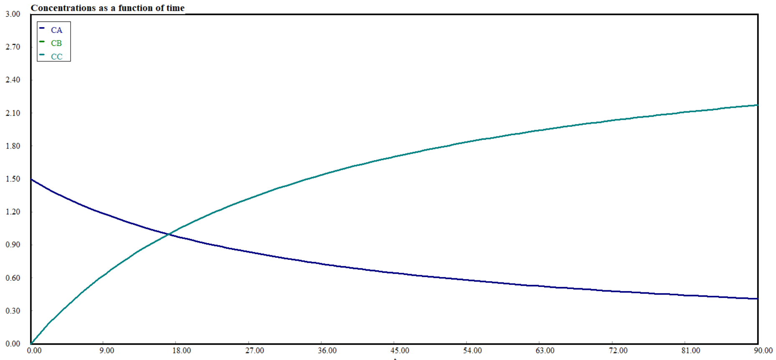
Figure 3.4 Concentrations of reactant A, product B, and by-product C vs reaction time
Observations from simulation results
The fermentation process is an exothermic reaction. The reactant A (glucose) is converted into product B(ethanol) and by-product C (carbon dioxide). The conversion of reactant A is reached to 72% with reaction time of 90 min (Figure 3.3(a). The conversion of reactant A and reaction temperature are increased with reaction time (Figure 3.3). The concentration of the reactant A is decreased with reaction time because some portion of it is converted into product B and by-product C. The concentrations of product B and by-product C are increased with reaction time, with the same quantity (Figure 3.4). The stoichiometric equation also confirms that the production of product B and by-product C are in equal number of moles. Product B and by-product C are plotted along the same line (Figure 3.4).

  - Summary
For non-isothermal batch reactor, concentrations, reaction rate and conversion are functions of reaction time and reaction temperature. Determining reaction temperature, conversion, reaction time and size or volume of reactor are main aims of non-isothermal batch reactor design. For non-isothermal operation, the change in heat of reaction at a temperature of T is sum the change in standard heat of reaction and the change in enthalpy from T_{R} to T. For non-isothermal ideal batch reactor, both materials and energy balance equations must be solved simultaneously since they are mutually dependent.
References
- Chemical Reaction Engineering, Levenspiel, O John Wiely& Sons, 3rd edition, 2011.
- Elements of Chemical Engineering, Fogler, HS Prentice- Hall Inc Prentice- Hall Inc,5th edition, 2015.

