Chemical Reaction Engineering II- Reactor Design (ChEg 4101)
Prerequisite: Chemical Reaction Engineering I-Reaction Kinetics (ChEg3104)
Lecture 4: Design of Semi-batch Reactor
Week 4
Lecturer: Adamu Esubalew (PhD, ChEg)
Addis Ababa, Ethiopia

Lecture learning outcomes
At the end of the lecture, you will be able to:
- describe the characteristics of semi-batch batch reactor,
- identify the reasons why semi-batch reactor is preferred, and
- design semi-batch batch reactor using materials and energy balance equations.
4.1. Introduction to semi-batch reactor
Semi-batch reactor a type of chemical reactor that combines features of both batch and continuous reactors. For batch component, the reactor can be operated with a fixed volume of liquid (or solid) phase, and reactants are added at the beginning. For continuous component, gaseous reactants can be fed continuously during chemical reactions. It is particularly useful for processes that require the addition of reactants during the reaction.
Semi-batch reactor is operated at unsteady state. Semi-batch occurs when some reactants are charged into the reactor at time zero, while other reactants are added during the reaction. The operation of a simi-batch reactor is one reactant or a product either batch or continuous. Figure 4.1 demonstrates various forms of semi-batch reactors (Levenspiel, 2011, pg. 84)
Figure 4.1 Various forms of semi-batch reactors
The reactants can be added at different stages of the reaction, which allows for better control over reaction rates and conversion. It is beneficial for controlling exothermic reactions or for preventing the formation of unwanted by-products. Semi-batch reactor often has mixing mechanisms to ensure uniform distribution of reactants and temperature throughout the reactor. Uniform mixing is essential for achieving consistent reaction conditions and maximizing yield.
The semi-batch reactor is a flexible system but is more difficult to analyze than the other reactor types. It offers good control of reaction speed because the reaction proceeds as reactants are added. Such reactors are used in a variety of applications from the calorimetric titrations in the laboratory to the large open-hearth furnaces for steel production.
4.2. The reasons of semi-batch reactor preference
Semi-batch reactor is preferred for the following reasons:
- to control highly exothermic reaction,
- to react a gas with a liquid,
- to remove one of the products to increase the equilibrium of the reaction, and
- to minimize unwanted side products by maintaining low concentration of one of the reactants. i.e. enhance selectivity.
Consider the following stochiometric reaction.
$A+B\underset{→}{k} P$ (4.1)
Where: A is liquid reactant, B is gas reactant, P is a product, and k is rate constant.
If a liquid reactant A and a gas reactant B to be reacted to form a product P, then semi batch reactor can be preferred to conduct the reaction. Similarly, if the following stochiometric reaction is exothermic, semi-batch reactor will be preferred to carry out the reaction.
C$+D\underset{→}{k} R$ (4.2)
Where: C and D are reactants, R is product, and k is rate constant.
One of the best reasons to use semi-batch reactors is to enhance selectivity in liquid-phase reactions. For example, consider the following two simultaneous reactions:
$2A+B\underset{→}{k_{D}} D$ (4.3)
$A+2B\underset{→}{k_{U}} U$ (4.4)
One reaction produces the desired product D, and the other reaction produces an undesired product U. The rate law for the desired reaction (desired product formation, D) is given by:
$r_{D}=k_{D}{C_{A}}^{2}{ C}_{B}$ (4.5)
The rate law for the undesired reaction (undesired product formation, U) is given by:
$r_{U}=k_{U}C_{A}{C_{B}}^{2}$ (4.6)
The instantaneous selectivity S_{D/U} is the ratio of these two rates (desired/ undesired).
$S_{D/U}=\frac{k_{D}{C_{A}}^{2}{ C}_{B}}{k_{U}C_{A}{C_{B}}^{2}}=\frac{k_{D}C_{A}}{k_{U}C_{B}}$ (4.7)
Large selectivity is required to maximize desired product and suppress undesired one. The selectivity ratio guides us how to produce the most amount of our desired product and the least amount of our undesired product. The instantaneous selectivity confirms that the formation of desired product (D) can be increased and the formation of undesired product (U) can be decreased by keeping the concentration of A is high and the concentration of B is low. This result can be achieved through the use of the semi-batch reactor, which is charged with pure A and to which B is fed slowly to A in the reactor.
Semi-batch reactor offers a versatile platform for conducting chemical reactions with improved control over various parameters, making them valuable in both research and industrial applications. Designing a semi-batch reactor involves several considerations to ensure efficient and safe operations. reactor volume, feed system, mixing mechanism, and temperature control system. It is required to determine the reactor volume based on the desired production rate, reaction kinetics, and the amounts of reactants to be used.
4.3. Semi-batch reactor design equations
Consider the following two reactions:
A+B-------->C (4.8)
A+B-------->C+D (4.9)
For semi-batch reactor, the following three possible cases can be occurred.
Case 1: Reactant A and product C are batch, and reactant B is semi-batch as shown in Figure 4.2 (Fogler, 2015, pg. 228).
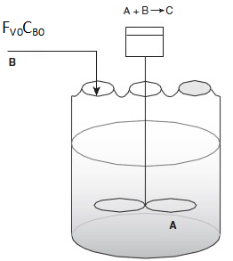
Figure 4.2 Semi-batch reactor
Case 2: Reactant B and product C are batch, and reactant A is semi-batch as described in Figure 4.3.
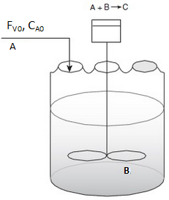
Figure 4.3 Semi-batch reactor
Case 3: Reactant A, reactant B and product D are batch, and product C is semi-batch as depicted in Figure 4.4.
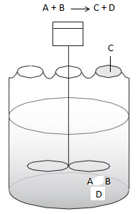
Figure 4.4 Semi-batch reactor
4.3.1. Materials balance equation
Case 1: The species A and C are batch and B is semi-batch (Figure 4.2).
I$n-Out±generation/consumption=Accumulation$
Material balance on species A:
$F_{A0}-F_{A}-r_{A}V=\frac{{dN}_{A}}{dt}$ (4.10)
Since species A is batch, $F_{A0}=F_{A}=0$ (4.11)
For species A of batch reaction, the material balance equation is given by:
-$r_{A}V=\frac{{dN}_{A}}{dt}$ (4.12)
Where: V is volume of a mixture, N_{A} is moles of species A at any time t, r_{A} is reaction rate of species A, and t is reaction time.
Number of moles of species, i = (concentration of species, i) * (volume of mixtures)
$\frac{{dN}_{A}}{dt}=\frac{{d(VC}_{A})}{dt}=\frac{V{dC}_{A}}{dt}+\frac{C_{A}dV}{dt}$ (4.13)
By substituting equation (4.13) into equation (4.12), you get:
${-r}_{A}V=\frac{V{dC}_{A}}{dt}+\frac{C_{A}dV}{dt}$ (4.14)
The term dV/ dt in equation (4.14) shows that the volume of the mixtures varies with time.
To find the volume of mixtures variation, let’s consider the overall material balance of all species, and correlate with density of mixtures.
$In - Out ± Generation/consumption=Accumulation$
$ρ_{0}υ_{0}- 0 + 0 = \frac{d(ρV)}{dt}$ (4.15)
For constant density $, ρ=ρ_{0}$
$υ_{0} =\frac{dV}{dt}$ (4.16)
For constant volumetric flow rate, volume of reacting mixture varies with time.
The integration of equation (4.16) becomes:
$V=V_{0}+υ_{0}t$ (4.17)
This shows that the volume of a mixture in the reactor increases with time.
Where: V is volume of a mixture at any time t, V_{o} is initial volume of a mixture, v_{o} is volumetric flow rate, and t is reaction time.
By substituting equation (4.16) into equation (4.14), you get:
${-r}_{A}V=\frac{V{dC}_{A}}{dt}+C_{A}υ_{0}$ (4.18)
By re-arranging equation (4.18) and solve for concentration of reactant A, you get:
$\frac{{dC}_{A}}{dt}=-r_{A}-{\frac{υ_{0}}{V}C}_{A}$ (4.19)
This is a material balance equation for species A as batch in semi-batch reactor.
Where: C_{A} is concentration of species A, r_{A} is reaction rate of species A, V is volume of a mixture at any time t, v_{o} is volumetric flow rate, and t is reaction time.
Material balance on species B:
Species B is semi-batch, and the material balance equation is given by:
$F_{B0}-0 - r_{B}V=\frac{{dN}_{B}}{dt}$ (4.20)
$N_{B}=C_{B}V$ (4.21)
By differentiate equation (4.21) with respect to time, you get:
$\frac{{dN}_{B}}{dt}=\frac{{d(C}_{B}V)}{dt}=C_{B}\frac{dV}{dt}+V\frac{{dC}_{B}}{dt}$ (4.22)
Where: N_{B} is moles of species B, F_{Bo} is molar flow rate of species B in the feed, V is volume of a mixture at any time t, C_{B} is concentration of species B, r_{B} is reaction rate of species B, and t is reaction time.
By substituting equation (4.22) into equation (4.20), you get:
$F_{B0}-r_{B}V=C_{B}\frac{dV}{dt}+V\frac{{dC}_{B}}{dt}$ (4.23)
The term dV/dt= v_{o}, which is volumetric flow rate.
$F_{B0}=C_{B0}v_{o}$ (4.24)
By substituting equation (4.24) into equation (4.23), and solve for the concentration of species B, you get:
$\frac{{dC}_{B}}{dt}={-r}_{B}+\frac{υ_{0}(C_{B0}-C_{B})}{V}$ (4.25)
This is a material balance equation for species B as semi-batch feed in semi-batch reactor.
Where: C_{B} is concentration of species B at any time t, C_{Bo} is initial concentration of species B v_{o} is volumetric flow rate, V is volume of a mixture at any time t, r_{B} is reaction rate of species B, and t is reaction time.
Material balance on species C:
The martials balance for species C as batch is given by:
$r_{C}V=\frac{{dN}_{C}}{dt}$ (4.26)
N_{C}= C_{C}V (4.27)
By differentiating equation (4.27), you get:
$\frac{{dN}_{C}}{dt}=\frac{{d(C}_{C}V)}{dt}=C_{C}\frac{dV}{dt}+V\frac{{dC}_{C}}{dt}$ (4.28)
By substituting equation (4.28) into equation (4.26), you get:
$r_{C}V=C_{C}\frac{dV}{dt}+V\frac{{dC}_{C}}{dt}$ (4.29)
The term dV/dt=v_{o}, which is the volumetric flow rate.
By re-arranging equation (4.29) and solve for concentration of species C, you get:
$\frac{{dC}_{C}}{dt}=r_{C}-\frac{υ_{0}C_{C}}{V}$ (4.30)
This is a material balance equation for species C as batch fin semi-batch reactor.
Where: C_{C} is concentration of species C at any time t, v_{o} is volumetric flow rate, V is volume of a mixture at any time t, r_{C} is reaction rate of species C, and t is reaction time.
Observations on equations (4.19, 4.25 & 4.30):
If the reaction order is zero, first order and isothermal, the equations can be solved by analytical techniques to determine the conversion as function of time. However, if the reaction is not zero order, first order and isothermal, then use numerical techniques to determine the conversion as function of time.
Case 2: The species A is semi-batch, and species B and C are batch (Figure 4.3).
I$n-Out±generation/consumption=Accumulation$
Material balance on species A:
Species A is semi-batch, and the material balance equation is given by:
$F_{A0}-0 - r_{A}V=\frac{{dN}_{A}}{dt}$ (4.31)
$N_{A}=C_{A}V$ (4.32)
For constant density, ρ= ρ_{o} (4.33)
By differentiate equation (4.32) with respect to time, you get:
$\frac{{dN}_{A}}{dt}=\frac{{d(C}_{A}V)}{dt}=C_{A}\frac{dV}{dt}+V\frac{{dC}_{A}}{dt}$ (4.34)
Where: N_{A} is moles of species A, F_{Ao} is molar flow rate of species A in the feed, V is volume of a mixture at any time t, C_{A} is concentration of species A, r_{A} is reaction rate of species A, and t is reaction time.
By substituting equation (4.34) into equation (4.31), you get:
$F_{A0}-r_{A}V=C_{A}\frac{dV}{dt}+V\frac{{dC}_{A}}{dt}$ (4.35)
The term dV/dt= v_{o}, which is volumetric flow rate.
$F_{A0}=C_{A0}v_{o}$ (4.36)
By substituting equation (4.36) into equation (4.35), and solve for the concentration of species A, you get:
$\frac{{dC}_{A}}{dt}={-r}_{A}+\frac{υ_{0}(C_{A0}-C_{A})}{V}$ (4.37)
This is a material balance equation for species A as semi-batch feed in semi-batch reactor.
Where: C_{A} is concentration of species A at any time t, C_{Ao} is initial concentration of species A, v_{o} is volumetric flow rate, V is volume of a mixture at any time t, r_{A} is reaction rate of species A, and t is reaction time.
Material balance on species B:
For species B of batch reaction, the material balance equation is given by:
-$r_{B}V=\frac{{dN}_{B}}{dt}$ (4.38)
Where: V is volume of a mixture, N_{B} is moles of species B at any time t, r_{B} is reaction rate of species B, and t is reaction time.
Number of moles of species, i = (concentration of species, i) * (volume of mixtures)
$\frac{{dN}_{B}}{dt}=\frac{{d(VC}_{B})}{dt}=\frac{V{dC}_{B}}{dt}+\frac{C_{B}dV}{dt}$ (4.39)
The term dV/ dt=v_{o}, which volumetric flow rate.
By substituting equation (4.39) into equation (4.38) and solve for concentration of reactant B, you get:
$\frac{{dC}_{B}}{dt}=-r_{B}-{\frac{υ_{0}}{V}C}_{B}$ (4.40)
This is a material balance equation for species B as batch in semi-batch reactor.
Where: C_{B} is concentration of species B, r_{B} is reaction rate of species B, V is volume of a mixture at any time t, v_{o} is volumetric flow rate, and t is reaction time.
Material balance on species C:
The martials balance for species C as batch is given by:
$r_{C}V=\frac{{dN}_{C}}{dt}$ (4.41)
N_{C}= C_{C}V (4.42)
By differentiating equation (4.42), you get:
$\frac{{dN}_{C}}{dt}=\frac{{d(C}_{C}V)}{dt}=C_{C}\frac{dV}{dt}+V\frac{{dC}_{C}}{dt}$ (4.43)
By substituting equation (4.43) into equation (4.41), you get:
$r_{C}V=C_{C}\frac{dV}{dt}+V\frac{{dC}_{C}}{dt}$ (4.44)
The term dV/dt=v_{o}, which is the volumetric flow rate.
By re-arranging equation (4.44) and solve for concentration of species C, you get:
$\frac{{dC}_{C}}{dt}=r_{C}-\frac{υ_{0}C_{C}}{V}$ (4.45)
This is a material balance equation for species C as batch in semi-batch reactor.
Where: C_{C} is concentration of species C at any time t, v_{o} is volumetric flow rate, V is volume of a mixture at any time t, r_{C} is reaction rate of species C, and t is reaction time.
Observations on equations (4.37, 4.40 & 4.45):
If the reaction order is zero, first order and isothermal, the equations can be solved by analytical techniques to determine the conversion as function of time. However, if the reaction is not zero order, first order and isothermal, then use numerical techniques to determine the conversion as function of time.
Case 3: The species A, B & D are batch and Species C is semi-batch (Figure 4.4).
Material balance for species A:
Species A is batch, hence, the material balance equation id given by:
-$r_{A}V=\frac{{dN}_{A}}{dt}$ (4.46)
N_{A}= C_{A}V (4.47)
By differentiating equation (4.47) with respect to time, you get:
$\frac{{dN}_{A}}{dt}=\frac{{d(VC}_{A})}{dt}=\frac{V{dC}_{A}}{dt}+\frac{C_{A}dV}{dt}$ (4.48)
By substituting equation (4.48) into equation (4.46), you get:
${-r}_{A}V=\frac{V{dC}_{A}}{dt}+\frac{C_{A}dV}{dt}$ (4.49)
In this case the volume of the mixture decreases since species C is discharged as product.
The overall material balance of all species is given by:
$In - Out ± Generation/consumption=Accumulation$
${0-ρ}_{f}υ_{f} + 0 = \frac{d(ρV)}{dt}$ (4.50)
For constant density $,ρ_{f}=ρ_{0}$
$υ_{f} =-\frac{dV}{dt}$ (4.51)
For constant volumetric flow rate, volume of reacting mixture decreases with time.
$V=V_{0}-υ_{f}t$ (4.52)
This describes that the volume of a mixture decreases with reaction time.
Where: V is volume of a mixture at any time t, Vo is initial volume of a mixture, vf is volumetric flow rate of outgoing stream, t is reaction time.
By substituting equation (4.51) into equation (4.49) and solve for concentration of the species A, you get:
$\frac{{dC}_{A}}{dt}=-r_{A}+{\frac{υ_{f}}{V}C}_{A}$ (4.53)
This is a material balance equation for species A as batch in semi-batch reactor.
Where: C_{A} is concentration of species A, r_{A} is reaction rate of species A, V is volume of a mixture at any time t, v_{f} is volumetric flow rate in the outgoing stream, and t is reaction time.
Material balance on species C:
Species C is semi-batch; the material balance equation is given by:
0$-FC+ r_{C}V=\frac{{dN}_{C}}{dt}$ (4.58)
N_{C}= C_{C}V (4.59)
By differentiating equation (4.59) with respect to time, you get:
$\frac{{dN}_{C}}{dt}=\frac{{d(C}_{C}V)}{dt}=C_{C}\frac{dV}{dt}+V\frac{{dC}_{C}}{dt}$ (4.60)
The term dV/dt=-v_{f}, which is outgoing volumetric flow rate.
By substituting equation (4.60) into equation (4.58) and solve for concentration of species C, you get:
$\frac{{dC}_{C}}{dt}=r_{C}+\frac{υ_{f}C_{C}-FC}{V}$ (4.61)
This is a material balance equation for species C as semi-batch discharge in semi-batch reactor.
Where: C_{C} is concentration of species C, r_{C} is reaction rate of species C, V is volume of a mixture at any time t, v_{f} is volumetric flow rate in the outgoing stream, and t is reaction time.
Material balance on species D:
Species D is batch; the material balance equation is given by:
0$-0 + r_{D}V=\frac{{dN}_{D}}{dt}$ (4.62)
N_{D}= C_{D}V (4.63)
By differentiating equation (4.63) with respect to time, you get:
$\frac{{dN}_{D}}{dt}=\frac{{d(C}_{D}V)}{dt}=C_{D}\frac{dV}{dt}+V\frac{{dC}_{D}}{dt}$ (4.64)
The term dV/dt=-v_{f}, which is outgoing volumetric flow rate.
By substituting equation (4.64) into equation (4.62) and solve for concentration of species D, you get:
$\frac{{dC}_{D}}{dt}=r_{D}+\frac{υ_{f}C_{D}}{V}$ (4.65)
This is a material balance for species D as batch in semi-batch reactor.
Where: C_{D} is concentration of species D, r_{D} is reaction rate of species D, V is volume of a mixture at any time t, v_{f} is volumetric flow rate in the outgoing stream, and t is reaction time.
Activity 4.1
Consider the following elementary chemical reaction of reactants A and B is conducted in isothermal semi-batch reactor to form product C. The species A is semi-batch and species B and C are batch. The initial concentrations of reactant A and reactant B are 2 kmol/m³ and 4 kmol/m³, respectively. The reactor volume is 0.2 m³. The volumetric flow rate and molar flow rate of the continuous feed are 0.02 m³/min and 0.003 kmol/min, respectively. The reaction rate constant is 0.004 m³/kmol.min. Based on the given data, determine (a) concentrations of species and (b) the conversions as a function of time when the reaction time is reached to 48 min.
A+B-----------> C
Given:
A+B-----------> C, Elementary chemical reaction
-r_{A}=-r_{B}=r_{C}= kC_{A}C_{B}
C_{A0}=2 kmol/m^{3,} C_{B0}= 4 kmol/m^{3,} V= 0.2 m^{3,} V₀=0.02 m³/min
F_{A0}= 0.003 kmol/min, k= 0.004 m³/ kmol. min
Solution:
Reactant A is semi-batch, and reactant B and product C are batch (Case 2).
The material balance equation for the three species A, B & C, respectively, are given by:
$\frac{{dC}_{A}}{dt}={-r}_{A}+\frac{υ_{0}(C_{A0}-C_{A})}{V}$ ; F_{Ao}= C_{Ao}*v₀ (4.37)
This is a material balance equation for species A as semi-batch feed in semi-batch reactor.
$\frac{{dC}_{B}}{dt}=-r_{B}-{\frac{υ_{0}}{V}C}_{B}$ (4.40)
This is a material balance equation for species B as batch in semi-batch reactor.
$\frac{{dC}_{C}}{dt}=r_{C}-{\frac{υ_{0}}{V}C}_{C}$ (4.45)
This is a material balance equation for species C as batch in semi-batch reactor.
The reaction is second order reaction, which shows that we can’t solve the above three equations using analytical technique.
Hence, numerical method is required to solve the equations. i.e. use polymath program to solve the equations and simulate the results.
(a). Polymath program to plot concentrations of species A, B& C as a function of reaction time.
d(C_{A}) / d(t) = (F_{Ao}-C_{A}*v_{o})/V+k*C_{A}*C_{B} # A+B-------------> C Elementary chemical reaction.
C_{A}(0) = 2 # kmol/m³
d(C_{B}) / d(t) = -(C_{B}*v_{o})/V+k*C_{A}*C_{B} #Rate of B, kmol/m³.min
C_{B}(0) = 4 #kmol/m³
d(C_{C}) / d(t) = -(C_{C}*v_{o}/V)+k*C_{A}*C_{B} #Rate of C formation, Kmol/m³.min
C_{C}(0) =0 # kmol/m³
F_{Ao}=0.003 # kmol/min
v_{o}=0.02 #m³/min
V=0.2 #m³
k=0.004 #m³/ kmol. min
t(0)=0 # min
t(f) =48 # min
Simulation results:
The concentrations of species A and B are deceased, and concentration of species C (product) is increased with reaction time up to 24 min, then after, the concentrations of all species A, B & C are remains stagnant (Figure 4.5).

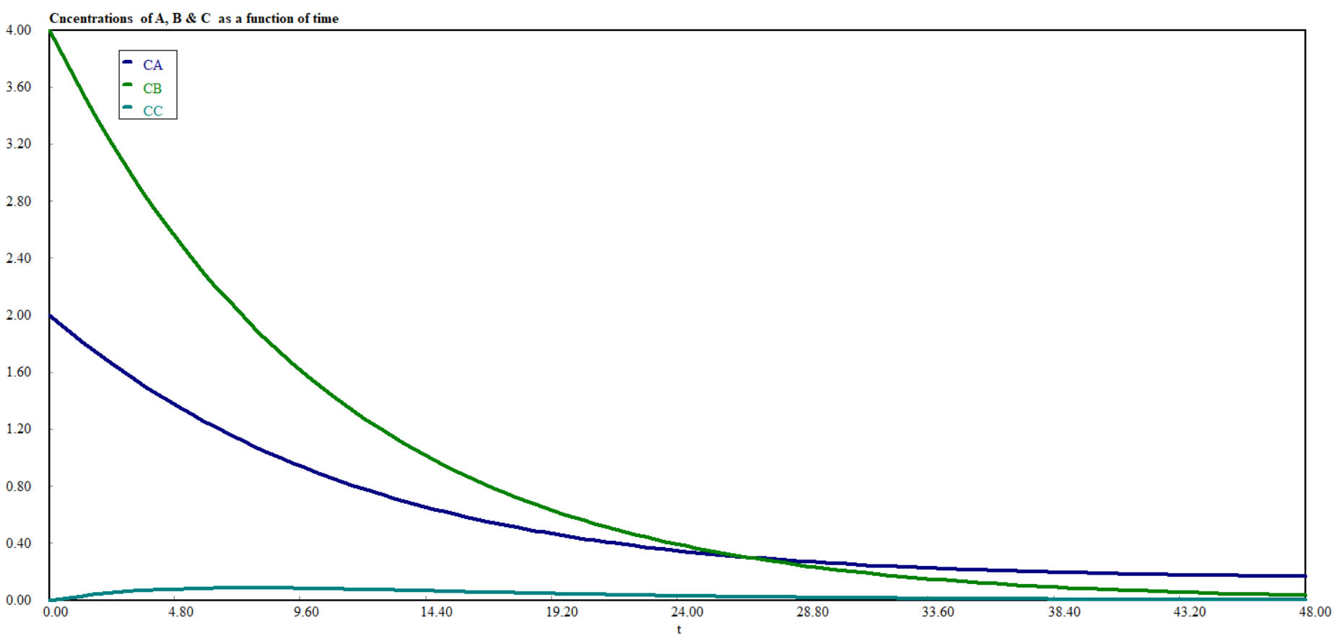
Figure 4.5. Concentrations (species A, B & C) as a function of reaction time
(b). Polymath program to plot conversion of species A& B as a function of reaction time.
A+B-------------> C : Elementary chemical reaction; C_{A}= C_{Ao} * (1-X_{A}); C_{B}= C_{Bo}* (1-X_{B})
d(X_{A}) / d(t) =(C_{A0}*(1-XA)*v_{o}-F_{Ao})/(V*C_{A0})-k*2*(1-X_{A})*C_{B0}*(1-X_{B}) # Conversion of species A
X_{A}(0) = 0
C_{A}(0) = 2 # kmol/m³
d(X_{B}) / d(t) = (C_{B0}*(1-X_{B})*v_{o})/(V*C_{B0})-k*C_{A0}*(1-X_{A})*C_{B0}*(1-X_{B}) # Conversion of species B
X_{B}(0) = 0
C_{B}(0) = 4 #kmol/m³
F_{Ao}=0.003 # kmol/min
v_{o}=0.02 #m³/min
V=0.2 #m³
k=0.004 #m³/ kmol. min
t(0)=0 # min
t(f) =48 # min
Simulation results:
The conversions of species A and B are exponentially increased with reaction time up to 24 min, then after, conversions are increased slowly (Figure 4.6).
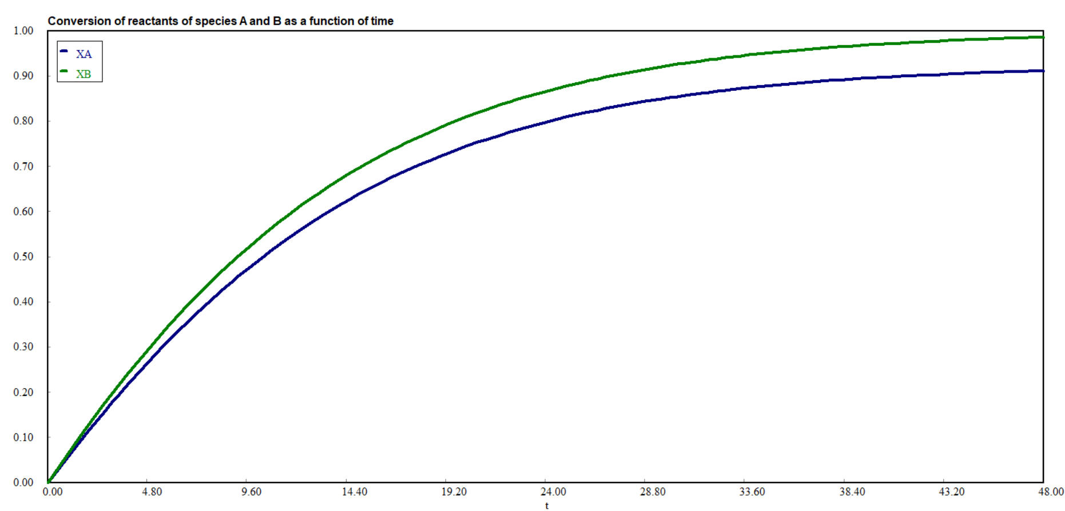
Figure 4.6. Conversions of species A & B as a function of reaction time
4.3.2. Energy balance equation
Energy balance for semi-batch reactor
For isothermal single reaction, the energy balance equation for species i is given by:
0$=\frac{\dot{Q}-{\dot{W}}_{S} + \left(r_{A}V\right)\left(∆H_{Rx}\right) - \sum{F_{i0}C_{Pi}(T-T_{0})}}{\sum{N_{i}C_{Pi}}}$ (4.66)
For isothermal multiple reactions, the energy balance equation for species i is given by:
0$=\frac{\dot{Q} -{\dot{W}}_{S} + \sum_{i=1}^{q}{r_{ij}}V∆H_{Rx i} - \sum{F_{j0}C_{Pj}(T-T_{0})}}{\sum_{j=1}^{m}{N_{j}C_{Pj}}}$ (4.67)
where q = no of reaction, m = no of species
Where: Q is rate of heat addition, W_{s} is work done, r_{A} is rate of species A (limiting reactant), V is volume of a mixture, ΔH_{Rx} is heat of reaction, F_{io/oj} is molar flow rate of species i/j, C_{pi/j} is specific heat capacity of species i/j, N_{i/j} is moles of species i/j, T is final reaction temperature, and T_{o} is initial temperature.
For non–isothermal single reaction, the energy balance equation for species i is given by:
$\frac{dT}{dt}=\frac{\dot{Q}-{\dot{W}}_{S} + \left(r_{A}V\right)\left(∆H_{Rx}\right) - \sum{F_{i0}C_{Pi}(T-T_{0})}}{\sum{N_{i}C_{Pi}}}$ (4.68)
For non-isothermal multiple reactions, the energy balance equation for species j is given by:
$\frac{dT}{dt}=\frac{\dot{Q} -{\dot{W}}_{S} + \sum_{i=1}^{q}{r_{ij}}V∆H_{Rx i} - \sum{F_{j0}C_{Pj}(T-T_{0})}}{\sum_{j=1}^{m}{N_{j}C_{Pj}}}$ (4.69)
where q = no of reaction, m = no of species
Where: Q is rate of heat addition, W_{s} is work done, r_{A} is rate of species A (limiting reactant), V is volume of a mixture, ΔH_{Rx} is heat of reaction, F_{io/oj} is molar flow rate of species i/j, C_{pi/j} is specific heat capacity of species i/j, N_{i/j} is moles of species i/j, T is final reaction temperature, T_{o} is initial temperature, t is reaction time.
Activity 4.2
Consider the following elementary chemical reaction of reactants A and B is conducted in non-isothermal semi-batch reactor to form product C. The species A is semi-batch and species B is batch. The initial concentrations of reactant A and reactant B are 2 kmol/m³ and 4 kmol/m³, respectively. The reactor volume is 0.2 m³. The volumetric flow rate and molar flow rate of the continuous feed are 0.02 m³/min and 0.003 kmol/min, respectively. The reaction rate constant at reference temperature is 0.004 m³/kmol.min.
Based on the given data, determine (a) concentrations of species A & B, (b) the reaction temperature, and (c) the conversions of species A & B as a function of time when the reaction time is reached to 48 min.
A+B-----------> C
Additional design data (Activity4.2)
C_{A0}=2 kmol/m^{3,} C_{B0}= 4 kmol/m^{3,} V= 0.2 m^{3,} V₀=0.02 m³/min, F_{A0}= 0.003 kmol/min, k=0.004*exp(-95/R*T) m³/ kmol. min, Q= 10 kJ/min, W_{s}=6 kJ/min, H_{Rx}= 15 kJ/kmol, C_{pA}= 10 kJ/kmol.K, C_{pB}=12 kJ/kmol.K, R=8.314 kJ/kmol.K, T_{o}=308 K
Given: A+B-----------> C, Elementary chemical reaction
-r_{A}=-r_{B}= kC_{A}C_{B}
Species A is semi-batch and species B is batch.
The reaction time is reached to 48 min.
Materials and energy balance equations for activity 4.2
$\frac{{dC}_{A}}{dt}={-r}_{A}+\frac{υ_{0}(C_{A0}-C_{A})}{V}$ (4.37)
$\frac{{dC}_{B}}{dt}=-r_{B}-{\frac{υ_{0}}{V}C}_{B}$ (4.40)
$\frac{dT}{dt}=\frac{\dot{Q}-{\dot{W}}_{S} + \left(r_{A}V\right)\left(∆H_{Rx}\right) - \sum{F_{i0}C_{Pi}(T-T_{0})}}{\sum{N_{i}C_{Pi}}}$ i for species (4.68)
The above three equations must be solved simultaneously.
Let's apply polymath program to solve the equations to find concentrations of species, temperature and conversion as a function of time.
Polymath program for concentrations of species A & B, and temperature as a function of time.
d(C_{A}) / d(t) = (F_{Ao}-C_{A}*v_{o})/V+k*C_{A}*C_{B} # Rate of A, kmol/m³. min
C_{A}(0) = 2 # kmol/m³
d(C_{B}) / d(t) = -(C_{B}*vo)/V+k*C_{A}*C_{B} #Rate of B, kmol/m³. min
CB(0) = 4 # kmol/m³
d(T) / d(t) = (Q-W_{s}+ (-r_{A}*V)*H_{Rx}-(F_{Ao}*C_{pA}*(T-T₀)))/(N_{A}*C_{pA}+N_{B}*C_{pB}) # K/min
T(0) = 308# K
Q=10 #kJ/min
W_{s}=6 # kJ/min
H_{Rx}= 15 # kJ/kmol
-r_{A}=k*C_{A}*C_{B} # reaction rate # kmol/ m³.min
C_{pA}= 10 # kJ/kmol.K
C_{pB}=12 # kJ/kmol.K
N_{A}=V*C_{A} # kmol
N_{B}=V*C_{B} # kmol
F_{Ao}=0.003 # kmol/min
vo=0.02# m³/min
V=0.2 # m³
k=0.004*exp(-95/R*T) # m³/ kmol.min
R=8.314 # kJ/ kmol.K
t(0)=0 # min
t(f) =48# min
Simulation results:
Concentrations of species A & B are decreased with reaction time exponentially (Figure 4.7). After 28 min, concentration of species A is stagnant.
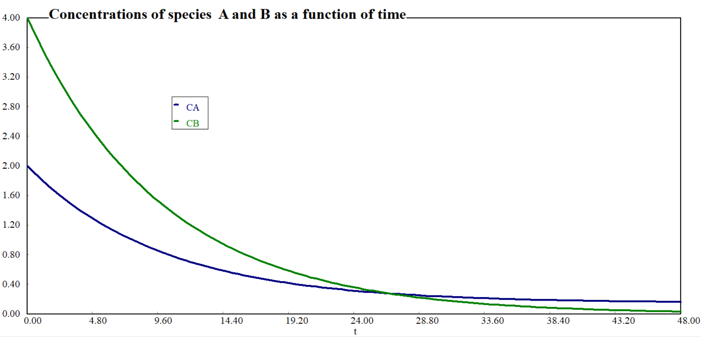
Figure 4.7. Concentrations of species A & B as a function of reaction time
Simulation results:
The reaction temperature is increased with reaction time (Figure 4.8)
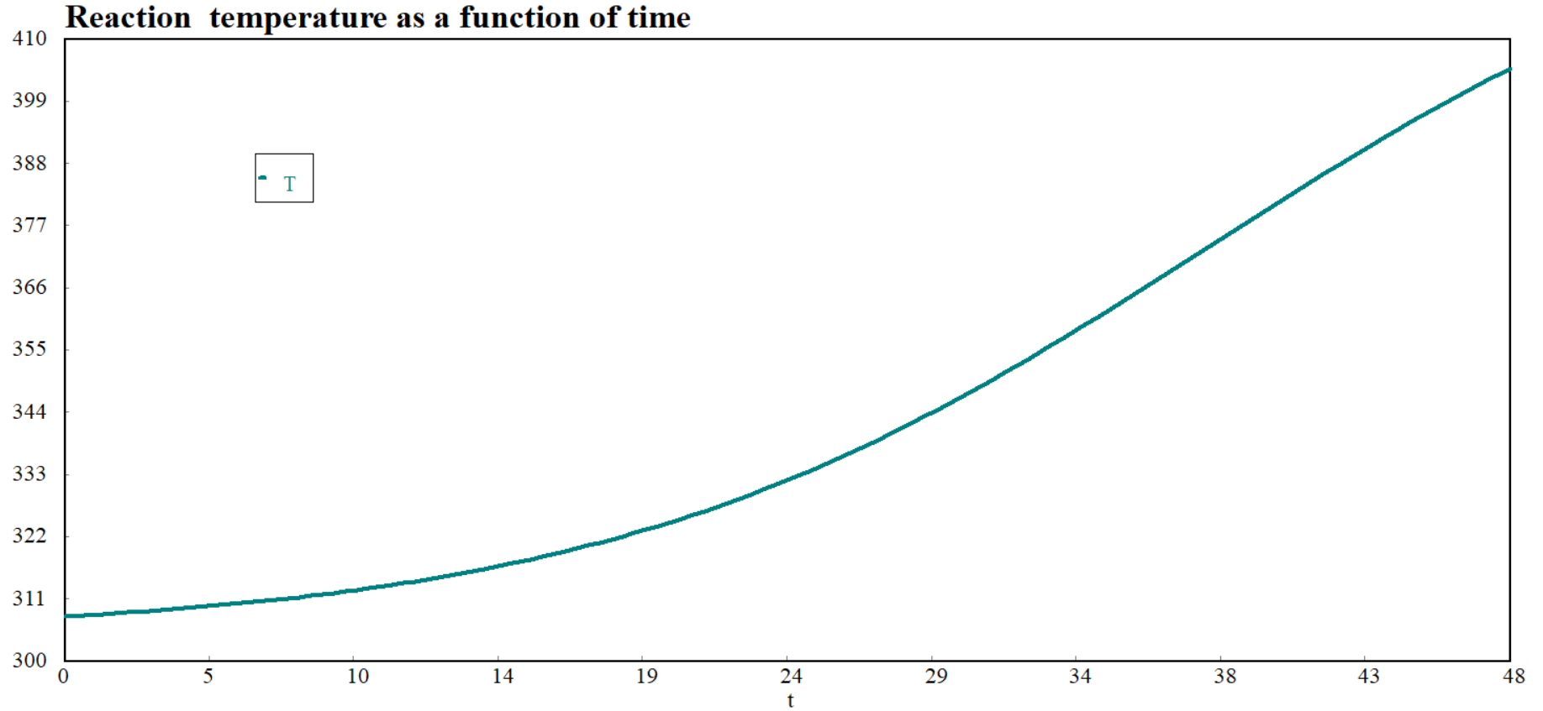
Figure 4.8. Reaction temperature as a function of reaction time
Polymath program of conversions of species A& B as a function of time.
d(X_{A}) / d(t) =(C_{A0}*(1-X_{A})*v_{o}-F_{Ao})/(V*C_{A0})-k*2*(1-X_{A})*C_{B0}*(1-X_{B}) #Conversion of A
X_{A}(0) = 0
C_{B0}=4 # kmol/m³, C_{A0}=2 # kmol/m³
d(X_{B}) / d(t) = (C_{B0}*(1-X_{B})*v_{o})/(V*C_{B0})-k*C_{A0}*(1-X_{A})*C_{B0}*(1-X_{B}) # Conversion of B
X_{B}(0) = 0
d(T) / d(t) = (Q-W_{s}+ (-r_{A}*V)*ΔH_{Rx}-(F_{Ao}*C_{pA}*(T-T₀)))/(N_{A}*C_{pA}+N_{B}*C_{pB}) #
T(0) = 308# K
Q= 10# kJ/min
W_{s}=6 # kJ/min
ΔH_{Rx}= 15# kJ/kmol
r_{A}=-k*C_{A0}*(1-X_{A})*C_{B0}*(1-X_{B}) # kmol/m³. min
C_{pA}= 10# kJ/kmol.K
C_{pB}=12 # kJ/kmol.K
N_{A}=V*C_{A0}*(1-X_{A}) # kmol
N_{B}=V*C_{B0}*(1-X_{B})# kmol
F_{Ao}=0.003 # kmol/min
vo=0.02# m³/min
V=0.2 # m³
k=0.004*exp(-95/R*T) # m³/ kmol.min
R=8.314 # kJ/ kmol.K
t(0)=0 # min
t(f) =48# min
Simulation results:
Conversions of species A and B are increased with reaction time exponentially as depicted in Figure 4.9.
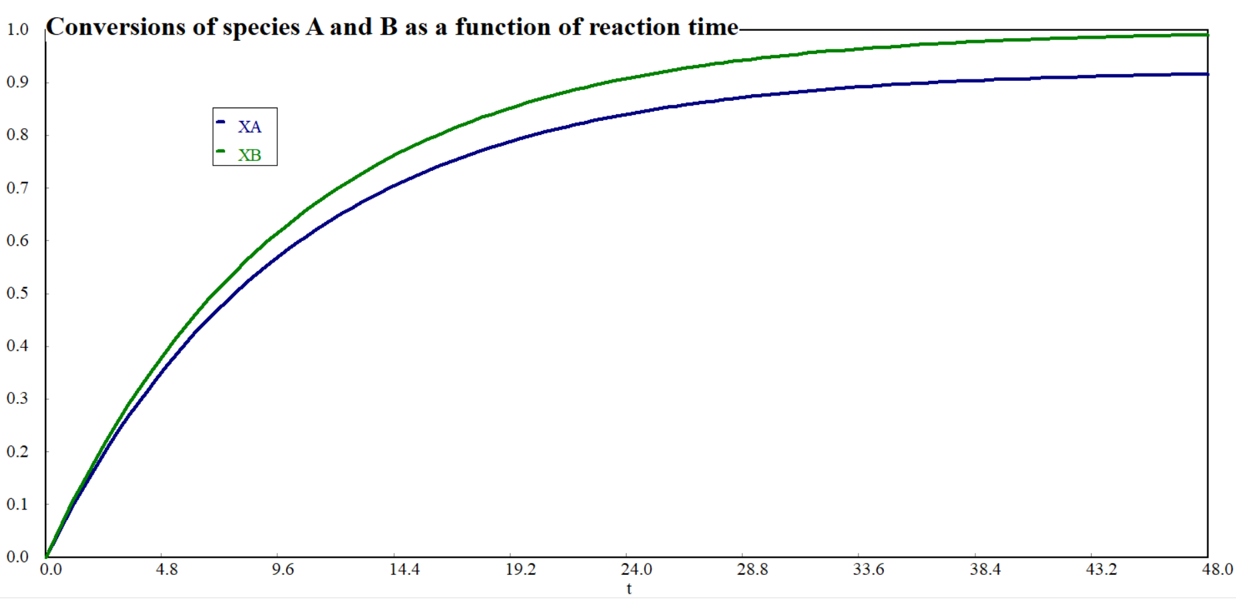
Figure 4.9. Conversion as a function of reaction time
4.4. Summary
Semi-batch reactor a type of chemical reactor that combines features of both batch and continuous reactors. Semi-batch reactor is operated at unsteady state. The reactants can be added at different stages of the reaction, which allows for better control over reaction rates and conversion. Semi-batch reactor is preferred to control highly exothermic reaction, to react a gas with a liquid, to remove one of the products to increase equilibrium of the reaction, and to minimize unwanted side products. i.e. enhance selectivity. For non-isothermal semi-batch reactor, both materials and energy balance equations should be solved simultaneously using numerical techniques.
References
- Chemical Reaction Engineering, Levenspiel, O John Wiely& Sons, 3rd edition, 2011.
- Elements of Chemical Engineering, Fogler, HS Prentice- Hall Inc Prentice- Hall Inc,5th edition, 2015.

