Chemical Reaction Engineering II- Reactor Design (ChEg 4101)
Prerequisite: Chemical Reaction Engineering I-Reaction Kinetics (ChEg3104)
Lecture 6: Design of Non-isothermal Ideal Plug Flow Reactor
Week 6
Lecturer: Adamu Esubalew (PhD, ChEg)

Lecture learning outcomes
At the end of the lecture, you will be able to:
- describe the characteristics of non-isothermal ideal plug flow reactor (PFR),
- identify space time and volume reactor required for non-isothermal ideal PFR, and
- design non-isothermal ideal PFR using materials and energy balance equations.
6.1. Introduction to non-isothermal ideal PFR
Non-isothermal plug flow reactor: It is a type of chemical reactor where the flow of reactants occurs in a plug flow manner, and the concentrations of reactants and reaction temperature varies with reactor length. For PFR, the reactant fluid moves through the reactor as discrete plugs with no mixing in the axial direction as shown in Figure 6.1 (Fogler, 2015, pg.15).
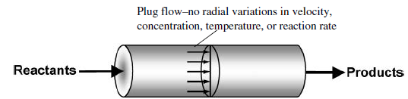
Figure 6.1. Plug flow reactor
Some key characteristics of non-isothermal PFR are the followings:
- The fluid moves through the reactor with a predictable concentration gradient along the reactor length.
- Non-isothermal PFR experiences temperature changes along the length of the reactor due to exothermic or endothermic reactions, which affect reaction rates and equilibria.
- Non-isothermal PFR often involves heat exchange with its surroundings or internal heat transfer mechanisms.
- The kinetics of reactions in a non-isothermal PFR can be complex due to change in temperature along the reactor.
- Temperature affects reaction rates according to the Arrhenius equation. i.e. temperature change impacts conversion and selectivity.
- Non-isothermal PFR model equations typically involve differential equations that account mass transfer, heat transfer, and reaction kinetics.
Non-isothermal PFR is vital in chemical engineering for its ability to handle complex reactions with varying temperatures. Therefore, understanding its design, operation, and modeling is essential for optimizing industrial processes and ensuring safety and efficiency in chemical processing industry.
6.2. Non-isothermal PFR design parameters
Designing a non-isothermal PFR involves several key parameters that influence its performance, efficiency, and safety. Some of the design parameters are the followings:
Size/volume of the reactor: The reactants concentrations and temperature vary with reactor size/ volume. For example, the length of the reactor affects the space time of the reactants, which is crucial for achieving the desired conversion; and the diameter of the reactor influences the flow regime (laminar vs. turbulent) and heat transfer characteristics.
Volumetric flow rate: The volumetric flow rate of the reactants through the reactor determines the space time.
Space time: It is a measure of the time that a volume of fluid spends in the reactor, which is essential for reaction completion.
Reaction kinetics: The temperature-dependent reaction rate constant and reaction order are key parameters, which are crucial for modeling of non-isothermal PFR.
Heat transfer coefficient: It quantifies how effectively heat is transferred between the reactor contents and the surrounding.
Heat transfer area: The surface area available for heat exchange must be sufficient to maintain desired temperature profiles along the reactor length.
Specific heat capacity: The specific heat capacity of reactants and products influences how much temperature changes with heat addition or removal.
Temperature: The temperature of reactants that are entering to the reactor can significantly affect reaction rates and conversion.
Cooling/heating medium: The type of fluid used for temperature control (example, water or oil) and its flow rate can impact the reactor's thermal management.
Operating pressure: The pressure within the reactor can influence reaction kinetics, phase behavior, and safety considerations.
The design of a non-isothermal plug flow reactor requires careful consideration of these parameters to ensure efficient operation, optimal conversion, and safety. Proper modeling and simulation are also essential in predicting performance under various conditions and guiding design choices.
6.3. Space time and volume of non-isothermal PFR
6.3.1. Space time
The space time (τ) of a plug flow reactor (PFR) is a measure of the time that a volume of fluid spends in the reactor. It is an important parameter in reactor design and operation, as it directly relates to the residence time of the reactants within the reactor and, consequently, to the extent of reaction that can occur.
The space time for a plug flow reactor is defined as:
τ = V / υ_{o} (6.1)
where: τ is space time, V is volume of the reactor, and υ_{o} is volumetric flow rate of the reactants entering the reactor.
Volume of reactor: It is the total volume available for the reaction to take place.
Volumetric flow rate: It is the rate at which reactants are fed into the reactor.
The space time affects how long reactants are in contact with each other, which influences conversion, rates and product yields. It can be used to compare different types of reactors regarding their efficiency and performance. It is a critical parameter in the design and operation of plug flow reactors, which influences reaction kinetics and overall reactor performance. Proper understanding of space time can lead to more efficient reactor designs and optimized chemical processes.
6.3.2. Volume of non-isothermal PFR
The volume of a non-isothermal plug flow reactor is determined through a combination of material and energy balances, taking into account the effects of temperature on reaction kinetics and heat transfer. Both material and energy balances equations are mutually dependent on each other. Solving them simultaneously using numerical method/ software tools to find the required volume.
The analysis of materials and energy balance equations requires numerical methods due to the complexity introduced by varying temperature along the reactor length. Optimizing the volume of a non-isothermal PFR involves balancing some factors, including reaction kinetics, heat transfer, and conversion to maximize the desired product. The goal is to achieve the desired conversion of reactants while minimizing the reactor volume and associated costs.
6.4. Performance measures for non-isothermal PFR
The performance of a non-isothermal PFR can be assessed using various measures that reflect the reactor's efficiency, effectiveness, and operational characteristics. Some key performance measures for non-isothermal PFR are the followings:
Conversion: It is a measure of how much of the reactant is transformed into products through the end of the reactor.
Space time: It is the time required that a fluid element spends in the reactor.
Selectivity: It refers to the ratio of the desired product to undesired products formed during the reaction.
Yield: It is a measure of the amount of desired product formed relative to the amount of reactant consumed.
Temperature profile: The temperature profile along the length of the reactor, which affects reaction rates and conversion.
Heat transfer coefficient: It measures how effectively heat is transferred between the reactor contents and any cooling/heating jackets, which is essential for exothermic or endothermic reactions.
Reaction rate: It indicates how quickly reactants are converted into products.
The reaction rate can vary with temperature and concentrations of reactants, which affects the reactor performance. The performance measures for a non-isothermal PFR encompass a variety of factors that are critical for evaluating its efficiency and effectiveness. Therefore, the above-mentioned parameters could be considered to optimize reactor design and its operation for a specific chemical process.
Activity 6.1
- What is non-isothermal PFR?
- Describe some characteristics of non-isothermal PFR.
- What are some of the performance measures for non-isothermal PFR?
- Explain some design parameters for non-isothermal PFR.
- Justify how the volume of non-isothermal PFR is determined.
Answers:
- What is non-isothermal PFR?
Non-isothermal plug flow reactor is a type of chemical reactor where the flow of reactants occurs in a plug flow manner, and concentration of reactants and temperature varies with the length a reactor.
- Describe some characteristics of non-isothermal PFR.
- Fluid moves through the reactor with concentration gradient along the length of a reactor.
- Non-isothermal PFR experiences temperature changes along the length of the reactor due to exothermic or endothermic reactions.
- Non-isothermal PFR often involves heat exchange with its surroundings or internal heat transfer mechanisms.
3. What are some of the performance measures for non-isothermal PFR?
Some of the performance measures for non-isothermal PFR are: conversion, space time, selectivity, yield, temperature profile, heat transfer coefficient and reaction rate.
4. Explain some design parameters for non-isothermal PFR.
- Volume of the reactor: The reactants concentration and temperature vary with reactor volume.
- Volumetric flow rate: determines the space time.
- Space time: It is a measure reaction completion.
- Temperature: It affects reaction rates and conversion.
- Hea transfer area: It determines rate of heat exchange.
5. Justify how the volume of non-isothermal PFR is determined.
The volume of a non-isothermal PFR is determined through a combination of material and energy balances, taking into account the effects of temperature on reaction kinetics and heat transfer. i.e. solving the material balance and energy balance equations simultaneously using numerical method/ software tools to find the required volume.
6.5. Non-isothermal PFR design equations
6.5.1 Materials balance equation
The concentration/ conversion of reactant A varies with reactor volume. The materials balance for PFR is conducted by considering differential volume across the flow of reactant A as shown in Figure 6.2 (Levenspiel, 2011, pg.101).
dV
C_{Ao}
F_{Ao}
X_{Ao}= 0
υ_{ο}
C_{A}
F_{A}
X_{A}
υ
F_{A}
F_{A}+dF_{A}

Figure 6.2. Chemical reaction in differential volume of PFR
Consider the following simple reaction as shown in equation (6.2).
A------------------> R (6.2)
Where: A is reactant and R is product.
The chemical reaction of species A flows across in a differential elemental volume (dV) is depicted in Figure 6.2. The material balance equation of species A for PFR is given by:
$F_{A}V-F_{A}V+dV+r_{A}dV=0$ (6.3)
Let’s re-arrange and take the limit of the differential volume of equation (6.3), you get:
$\lim_{dV→0}{\frac{(F_{A}V-F_{A}V+dV)}{dV}}$ = $\frac{{dF}_{A}}{dV}=$ $r_{A}$ (6.4)
For non-isothermal PFR, the material balance equation describes that the conversion of reactant A varies with a reactor volume. The reaction rate is a function of temperature and concentration. The temperature varies with the volume of a PFR. To determine the volume of a non-isothermal PFR, both materials and energy balance equations are mandatory since temperature varies with volume of PFR. However, in the case of isothermal PFR, material balance is enough to determine the volume of a PFR.
$F_{A}=F_{Ao}(1-X_{A})$ (6.5)
By differentiating equation (6.5), you get:
${dF}_{A}={-F}_{Ao}{dX}_{A}$ (6.6)
By substituting equation (6.6) into equation (6.4), you get:
$\frac{{dX}_{A}}{dV}=$ $\frac{{(-r}_{A})}{F_{Ao}}$ (6.7)
This is materials balance equation for design of a PFR using conversion of reactant A.
Where: V is volume of reactor, F_{Ao} molar flow rate of reactant A at the inlet, X_{A} is conversion of reactant A, and (-r_{A}) is reaction rate of reactant A (Refer Lecture 5).
For non-isothermal PFR, the material balance equation describes that the conversion of reactant A varies with a reactor volume. The reaction rate is a function of temperature and concentration. The temperature varies with the volume of a PFR. To determine the volume of a non-isothermal PFR, both materials and energy balance equations are mandatory since temperature varies with volume of PFR. However, in the case of isothermal PFR, material balance is enough to determine the volume of a PFR.
The molar flow rate is equal to the product of concentration and volumetric flow rate.
$F_{Ao}=C_{Ao}$_{o} (6.8)
$F_{A}=C_{A}o$ (6.9)
The space time is obtained using the basic design equation in terms of conversion for constant volumetric flow rate:
$τ=\frac{V}{υ_{0}}=C_{A0}\int_{0}^{X_{A}}{\frac{{dX}_{A}}{{(-r}_{A})}}$ (6.10)
$C_{A}=C_{Ao}(1-X_{A})$ (6.11)
By differentiating equation (6.11), you get:
${dC}_{A}=-C_{Ao}{dX}_{A}$ (6.12)
The space time is also obtained using the basic design equation in terms of concentration for constant volumetric flow rate:
$τ=\frac{V}{υ_{0}}=\int_{C_{A0}}^{C_{A}}{\frac{{dC}_{A}}{{(-r}_{A})}}$ (6.13)
Where: τ is space time of fluids in PFR, C_{Ao} is initial concentration of species A, C_{A} is concentration of species A at any length of PFR, and r_{A} is reaction rate of species A.
6.5.2. Energy balance equation
In a non-isothermal PFR, the temperature of the reacting mixture can vary along the length of the reactor due to heat generation from the reaction or absorption of heat transfer with the surroundings. This variation in temperature affects reaction rates and conversions, making the design and analysis of non-isothermal PFRs more complex than isothermal systems. The heat balance for a non-isothermal PFR takes into account the heat generated by the reaction, and heat exchange with any cooling or heating jackets.
Let’s consider an energy balance in small differential volume as shown in Figure 6.3 (Fogler, 2015, pg. 499). It is assumed that there is no work done (W_{S} = 0), and no radial gradients in the reactor. To develop energy balance equation for non-isothermal PFR, take a differential section of the reactor volume, ΔV.
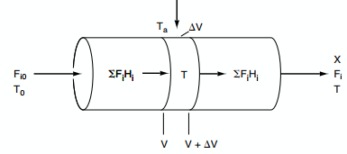
Figure 6.3. Non-isothermal PFR
The energy balance on the differential volume ΔV is given by:
$∆\dot{Q}+\sum{F_{i}H_{i}│_{V}-\sum{F_{i}H_{i}│_{V+∆V}=0}}$ (6.14)
$∆\dot{Q}=U∆A(T_{a}-T)$ (6.15)
$a=\frac{A}{V}=\frac{πDL}{\frac{πD^{2}L}{4}}=\frac{4}{D}$ (6.16)
$dA=adV$ (6.17)
Where: a is the heat exchange area per unit volume of reactor, A is surface area for heat transfer, V is volume of a reactor, Q is rate of heat addition, U is overall heat transfer coefficient, F_{i} is molar flow rate of species i, H_{i} is enthalpy of species i, L is length of a reactor, and D is reactor diameter.
By substituting equations (6.15- 6.17) into equation (6.14), you get:
$Ua∆V\left(T_{a}-T\right)+\sum{F_{i}H_{i}│_{V}-\sum{F_{i}H_{i}│_{V+∆V}=0}}$ (6.18)
Dividing equation (6.18) by ΔV, you get:
$Ua\left(T_{a}-T\right)+\frac{\sum{F_{i}H_{i}│_{V}}-\sum{F_{i}H_{i}│_{V+∆V}}}{∆V}=0$ (6.19)
By taking the limit as ΔV → 0 (equation 6.20), then you get:
$Ua\left(T_{a}-T\right)+\lim_{∆V⟶0}{\frac{\sum{F_{i}H_{i}│_{V}}-\sum{F_{i}H_{i}│_{V+∆V}}}{∆V}}=0$ (6.20)
$Ua\left(T_{a}-T\right)-\frac{d\sum{F_{i}H_{i}}}{dV}=0$ (6.21)
The differential of the enthalpy of flow of species i is given by:
$\frac{d\sum{F_{i}H_{i}}}{dV}=\sum{\frac{dFi}{dV}}H_{i}+\sum{\frac{{dH}_{i}}{dV}}F_{i}$ (6.22)
By substituting equation (6.22) into equation (6.21), you get:
$Ua\left(T_{a}-T\right)-\sum{\frac{{dF}_{i}}{dV}}H_{i}-\sum{\frac{{dH}_{i}}{dV}}F_{i}=0$ (6.23)
The non-isothermal PFR energy balance equation (6.23) has three energy terms: rate of heat addition, heat of reaction and enthalpy of flowing fluid.
The material balance design equation of any species i is given by:
$\frac{{dF}_{i}}{dV}=r_{i}=υ_{i}({-r}_{A})$ (6.24)
The enthalpy of species i at any temperature T is the sum of heat of formation at standard reference temperature and the area under the curve of specific heat capacity and temperature plot.
The enthalpy of species at any T is given by:
$H_{i}={H_{i}}^{o}\left(T_{R}\right)+\int_{T_{R}}^{T}{C_{P_{i}}dT}$ (6.25)
By differentiating equation (6.25) with respect to V, you get:
$\frac{{dH}_{i}}{dV}=C_{P_{i}}\frac{dT}{dV}$ (6.26)
By substituting equations (6.24 & 6.26) into equation (6.23), you get:
$Ua\left(T_{a}-T\right)-\sum{υ_{i}}H_{i}{(-r}_{A})-\sum{F_{i}C_{P_{i}}\frac{dT}{dV}}=0$ (6.27)
The change in heat of reaction for species i is given by:
$\sum{υ_{i}}H_{i}={∆H}_{Rx}$ (6.28)
By re-arranging equation (6.27), and solving for dT/dV, you get:
$\frac{dT}{dV}=\frac{-[{∆H}_{Rx}]{(-r}_{A}) - Ua(T-T_{a})}{\sum{F_{i}C_{P_{i}}}}$ (6.29)
This is the energy balance design equation for non-isothermal ideal plug flow reactor.
Where: T is temperature in the reactor, V is volume of PFR, ΔH_{Rx} is change in heat of reaction, r_{A} is reaction rate of reactant A, U heat transfer coefficient, a is heat transfer surface area per unit volume, v_{i} is stochiometric coefficient of species i, F_{i} is molar flow rate of species i, C_{pi} is specific heat capacity of species i, and T_{a} is temperature of rate of heat addition.
Consider the following chemical reaction, which shows reactants A & B, and products C & D with stochiometric coefficients of a, b, c and d, respectively.
$A+\frac{b}{a}B -→ \frac{c}{a}C+\frac{d}{a}D$ (6.30)
It is assumed that species A is the limiting reactant.
The molar flow rates can be expressed in conversion form for each species:
$F_{i}=F_{A0}(Φ_{i}+υ_{i}X_{A})$ (6.31)
For molar flow rate of species, A, B, C & D can be written as follows:
$F_{A}=F_{A0}(1-X_{A})$ (6.32)
$F_{B}=F_{A0}(Φ_{B}-\frac{b}{a}X_{A})$ (6.33)
$F_{C}=F_{A0}(Φ_{C}+\frac{c}{a}X_{A})$ (6.34)
$F_{D}=F_{A0}(Φ_{D}+\frac{d}{a}X_{A})$ (6.35)
$Φ_{i}=\frac{F_{i0}}{F_{A0}}$ (6.36)
Where: Φ_{i} is molar flow rate ratio of species i to species A (species A is considered as the limiting reactant).
By substituting equation (6.31) into equation (6.29), you get:
$\frac{dT}{dV}=\frac{{∆H}_{Rx}{(r}_{A}) - Ua(T-T_{a})}{\sum{F_{A0}(Φ_{i}+υ_{i}X_{A})C_{P_{i}}}}$ (6.37)
Since $F_{A0}$ is constant, it should be out of summation in equation (6.37); and the energy balance design equation of non-isothermal PFR can be written as:
$\frac{dT}{dV}=\frac{{∆H}_{Rx}{(r}_{A}) - Ua(T-T_{a})}{F_{A0}\sum{ (Φ_{i}C_{P_{i}}+υ_{i}C_{P_{i}}X_{A}) }}$ (6.38)
${υ_{i}C_{P_{i}}=∆C}_{P}=\frac{d}{a}C_{P_{D}}+\frac{c}{a}C_{P_{C}}-\frac{b}{a}C_{P_{B}}-C_{P_{A}}$ (6.39)
By substituting equation (6.39) into equation (6.38), you get:
$\frac{dT}{dV}=\frac{{∆H}_{Rx}{(r}_{A}) - Ua(T-T_{a})}{F_{A0}\sum{ (Φ_{i}C_{P_{i}}+{∆C}_{P}X_{A}) }}$ (6.40)
If ${∆C}_{P}=0$, the energy balance design equation (6.40) can be reduced to:
$\frac{dT}{dV}=\frac{{∆H}_{Rx}{(r}_{A}) - Ua(T-T_{a})}{F_{A0}\sum{ (Φ_{i}C_{P_{i}}) }}$ (6.41)
When the rate of heat generated is greater than the rate of heat removed, the temperature increases in a PFR.
For adiabatic non-isothermal PFR, the term rate of heat addition is zero.
$Q=Ua\left({T-T}_{a}\right)=0$ (6.42)
The energy balance design equation of non-isothermal PFR is reduced to:
$\frac{dT}{dV}=\frac{{∆H}_{Rx}{(r}_{A}) }{\sum{F_{i}C_{P_{i}}}}$ (6.43)
For adiabatic operation, the temperature gradient in PFR is occurred due to heat generation by exothermic reaction.
The rates of heat generation and heat removal can be written as follows:
${Q_{g}=∆H}_{Rx}\left(r_{A}\right)$ (6.44)
$Q_{r}=Ua(T-T_{a})$ (6.45)
Where: Q_{g} is heat generated, and Q_{r} is heat removed.
The energy balance design equation of non-isothermal PFR in terms of heat generation and heat removal is given by:
$\frac{dT}{dV}=\frac{Q_{g}-Q_{r}}{\sum{F_{i}C_{P_{i}}}}$ (6.46)
For exothermic reactions, $Q_{g}$ is a positive number since change in heat of reaction and reaction rate of reactant A both have negative sign.
Energy balance for multiple reactions in PFR
The general energy balance equation for multiple reactions is slightly different from that for a single reaction. A single reaction has one rate equation and one heat of reaction but multiple reactions have more than one rate equations and heat of reactions. For multiple reactions, the energy balance design equation for non-isothermal PFR is given by:
$\frac{dT}{dV}=\frac{\sum_{i=1}^{q}{r_{ij}{∆H}_{Rx i}}-Ua(T-T_{a})}{\sum_{j=1}^{m}{F_{j}C_{P_{j}}}}$ (6.47)
where: i is number of reactions, and j is species.
Activity 6.2.
An irreversible gas-phase reaction is carried out in a plug flow reactor. Pure A enters into a reactor at a temperature of 25ºC. The heat supply per volume of a reactor at rate of 1.5 kJ/dm³.min, and a reactor operation is non- isothermal. The variation of density of the mixtures in a reactor is negligible. The reaction rates in both in the first reaction (i) and second reaction (ii) are first order with respect to A. the volumetric flow rate is 0.1dm³/min. The reactions are given below.
$A\underset{→}{k_{1}}$B (desired reaction) (i)
$A\underset{→}{k_{2}}C$ (undesired reaction) (ii)
Based on the given data, plot the concentrations (A, B & C), temperature and conversion of reactant A gradients as a function of reactor volume.

Additional data
C_{Ao} = 10 mol/dm³, Hº_{A} (298K) = 20 kJ/mol, Hº_{B} (298K) = 35 kJ/mol, Hº_{C}(298K) = 15 kJ/mol, C_{pA} = C_{pB} = C_{pC} = 0.5 kJ/mol K, R=8.314 J/ mol.K, k₁₀ = 0.01 /min, k₂₀ = 0.001/ min, E= 150J/ mol, k₁=k₁₀ exp (-E/ RT), and k₂=k₂₀ exp (-E/ RT)
Given: Non-isothermal PFR, first order reaction, and heat is added to the reactor.
Solution:
From materials balance, the design equation is given by:
$\frac{{dX}_{A}}{dV}=$ $\frac{{(-r}_{A})}{F_{Ao}}$ (6.7)
From energy balance, the design equation is given by:
$\frac{dT}{dV}=\frac{{∆H}_{Rx}{(r}_{A}) - Ua(T-T_{a})}{F_{A0}\sum{ (Φ_{i}C_{P_{i}}+{∆C}_{P}X_{A}) }}$ (6.40)
The above two equations are mutually dependent on each other; hence, both should be solved simultaneously using numerical method/ software tools. For this activity, let’s use polymath software tool to solve the equations.
(a) The polymath program for concentrations and temperature as a function of PFR volume.
d(C_{A}) / d(V) =- (k₁+k₂)*C_{A}/v₀
C_{A}(0)=10 # mol/dm³
d(C_{B}) / d(V) =(k₁*C_{A})/v₀ # Concentration of B per volume, mol/(dm³)²
C_{B}(0) = 0# mol/dm³
d(C_{C}) / d(V) =(k₂*C_{C})/v₀ # Concentration of C per volume, mol/(dm³)²
C_{C}(0) = 0# mol/dm³
X_{A}= 1-(C_{A}/C_{A0})# conversion of reactant A
k₁=k₁₀*exp(-E/ (R*T)) # min⁻¹@T
k₂=k₂₀*exp(-E/(R*T)) # min⁻¹@ T
d(T)/d(V)=(Q-ΔH_{Rx}*(r_{A}))/((F_{A0}*(1-X_{A})*C_{PA} +(k₁₀)/(k₁+k₂)*F_{A0}*X_{A}*C_{PB}+(k₂)/(k₁+k₂)*F_{A0}*X_{A}*C_{PC}))# K/dm³
T(0) = 308# K
v₀=0.1# dm³/min
k₁₀=0.01 #min⁻¹@T_{R}
k₂₀=0.001 #min⁻¹@T_{R}
R=8.314# J/mol.K
E=150# J/mol
r_{A}= -(k₁+k₂)*C_{A0} # mol/dm³.min
ΔH_{Rx}= (k₂/(k₁+k₂))*(H_{C0}+ C_{PC}*(T-T_{R}))+(k₁/(k₁+k₂))*(H_{B0}+ C_{PB}*(T-T_{R}))- (H_{A0}+C_{PA}*(T-T_{R})) # kJ/mol
F_{A0}= v₀*C_{A0} # mol/min; C_{A0}=10 # mol/dm³; H_{A0}=20 #kJ/mol; H_{B0}=35#kJ/mol
H_{C0}=15# kJ/mol; T_{R}=298 #K; C_{PA}=0.5# kJ/mol.K; C_{PB}=0.5# kJ/mol.K; C_{PC}=0.5# kJ/mol.K; Q=1.5 #kJ/dm³.min
V(0) = 0# dm³
V(f) = 45# dm³
Simulation results: Figure 6.4 depicts that concentration of reactant A is decreased, but concentration of product B is increased exponentially with increase of PFR volume. Concentration of undesired product C is negligible.
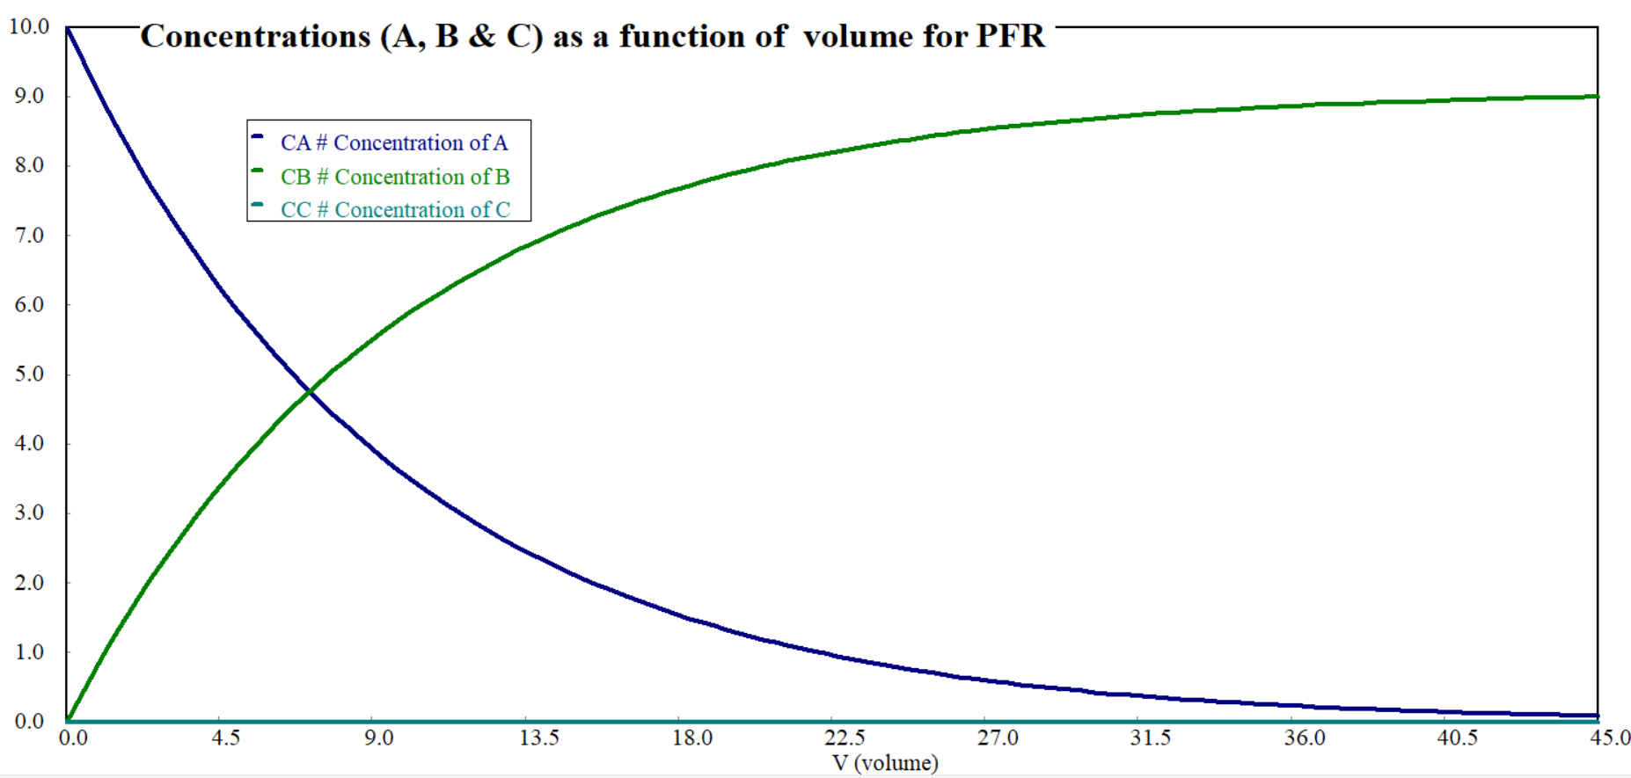
Figure 6.4. Concentrations as a function of PFR volume
Simulation results: Figure 6.5 depicts that the temperature of the reactor is increased with increase of PFR volume. The temperature of PFR is increased by 10K (ΔT=10K) where the PFR volume increases up to 45 dm³.
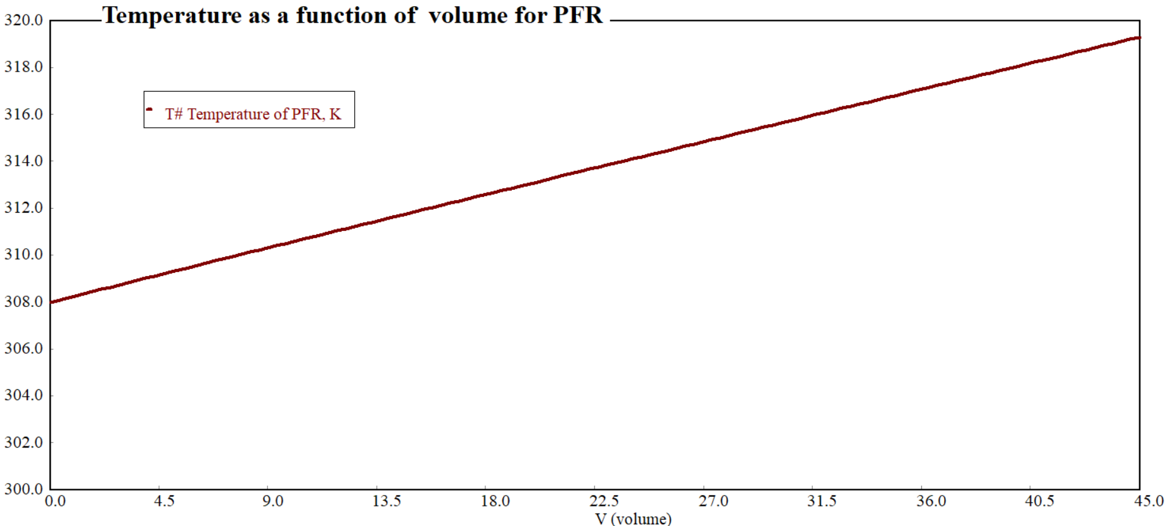
Figure 6.5. Temperature as a function of PFR volume

(b) The polymath program for conversion of reactant A as a function of PFR volume.
d(X_{A}) / d(V) = (k₁+k₂)*(1-X_{A})/v₀# per dm³
X_{A}(0) = 0
k₁=k₁₀*exp(-E/ (R*T)) # min⁻¹@T
k₂=k₂₀*exp(-E/(R*T)) # min⁻¹@T
v₀= 0.1#dm³/min
k₁₀=0.01# min⁻¹
k₂₀=0.001# min⁻¹
R=8.314 #J/mol.K
E=150# J/mol
d(T)/d(V)=(Q-ΔH_{Rx}*(-r_{A}))/((FA0*(1-X_{A})*C_{PA}+ (k₁)/(k₁+k₂)*F_{A0}*X_{A}*C_{PB}+(k₂)/(k₁+k₂)*F_{A0}*X_{A}*C_{PC})) # K/dm³
T(0) = 308# K
r_{A}= (k₁+k₂)*C_{A0}*(1-X_{A})# mol/dm³.min
ΔH_{Rx}=(k₂/(k₁+k₂))*(H_{C0}+C_{PC}*(T-T_{R}))+(k₁/(k₁+k₂))*(H_{B0}+ C_{PB}*(T-T_{R}))- (H_{A0}+C_{PA}*(T-T_{R})) # kJ/mol
F_{A0}=v₀*C_{A0} # mol/min
C_{A0}=10# mol/md³
H_{A0}=20# kJ/mol
H_{B0}=35# kJ/mol
H_{C0}=15# kJ/mol
T_{R}= 298#K
C_{PA}= 0.5 # kJ/mol.K
C_{PB}=0.5# kJ/mol.K
C_{PC}=0.5# kJ/mol.K
Q=1.5# kJ/ dm³. min
V(0)=0# dm³
V(f)=45 #dm³
Simulation results: Figure 6.6 illustrates that the conversion of reactant A is exponentially increased with increase of PFR volume.
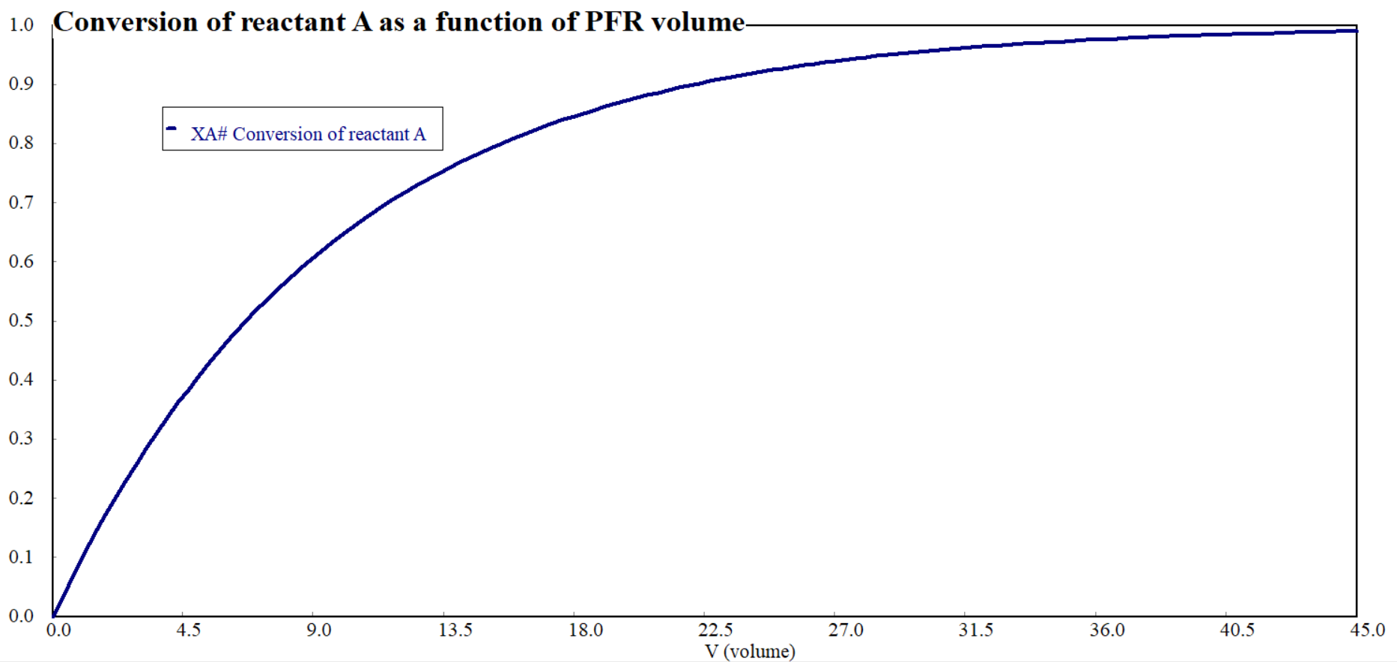
Figure 6.6. Conversion as a function of PFR volume
6.6. Summary
For non-isothermal PFR, the fluid moves through the reactor with concentration gradient along the length of a reactor; and experiences temperature changes along the length of the reactor. Volume, volumetric flow rate, space time, temperature, and heat transfer area are some of the design parameters for non-isothermal PFR. The volume of a non-isothermal PFR is determined through a combination of materials and energy balances, taking into account the effects of temperature. The materials and energy balances equations are mutually dependent on each other; hence, both should be solved simultaneously using numerical method/ software tools.
References
- Chemical Reaction Engineering, Levenspiel, O John Wiely& Sons, 3rd edition, 2011.
- Elements of Chemical Engineering, Fogler, HS Prentice- Hall Inc Prentice- Hall Inc, 5th edition, 2015.

