Chemical Reaction Engineering II- Reactor Design (ChEg 4101)
Prerequisite: Chemical Reaction Engineering I-Reaction Kinetics (ChEg3104)
Lecture 9: Design of Multiple Reactor Systems: Design of Isothermal PFRs in Series and Parallel Arrangements
Week 9
Lecturer: Adamu Esubalew (PhD, ChEg)
Addis Ababa, Ethiopia

Lecture learning outcomes
At the end of the lecture, you will be able to:
- identify characteristics of multiple reactor systems,
- design isothermal ideal PFRs in series arrangement,
- design isothermal ideal PFRs in parallel arrangement, and
- design recycle reactor.
9.1. Introduction to multiple reactor systems
Multiple reactor systems are arrangements of two or more reactors in series, parallel or series-parallel arrangements. The combination or arrangement may be the same type of reactors or different types of reactors. Multiple reactor systems are preferred to minimize the drawbacks of a single reactor.
Advantages and disadvantages of multiple reactor systems
Some of the advantages of multiple reactor systems are the followings:
- enhancing the fractional conversion,
- reducing the size of the reactor for specified conversion,
- enhancing the selectivity/yield of multiple reaction,
- controlling the heat effect in the reaction, and
- maximizing production capacity.
Some of the disadvantages of multiple reactor systems are the followings:
- requiring large construction of materials for reactors manufacturing and reactors accessories,
- Increasing installation cost,
- requiring large space for multiple reactors installation, and
- requiring large amount of energy to run multiple reactors.
9.2. Design of isothermal PFRs in series arrangement
9.2.1. PFRs in series arrangement characteristics
The series arrangement of PFRs is a common configuration in chemical engineering and process design, particularly for reactions that require multiple stages to achieve desired conversion levels or product specifications. For a series arrangement, multiple PFRs are connected end-to-end. i.e. the effluent from one reactor serves as the feed for the next, which allows for sequential processing of reactants. Each reactor can facilitate different reaction stages. The first reactor may handle initial reactants, while subsequent reactors can optimize conditions for intermediate products or final products. Figure 9.1 depicts two PFRs in series (Fogler, 2015, pg. 705).
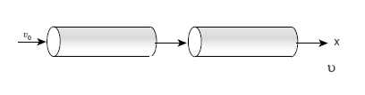
Figure 9.1 Two PFRs in series
Each reactor in the series maintains the plug flow characteristics, with minimal back-mixing within each reactor. However, there can be changes in concentration and temperature from one reactor to the next. The total residence time for reactants is the sum of the residence times in each individual reactor, which allows for better control over reaction kinetics and conversion rates. Each reactor can be operated at different temperatures and pressures, providing flexibility to optimize conditions based on specific reaction requirements.
Series arrangement is preferred due to the benefits described in the following paragraphs:
Provide high conversion rate: By breaking down the reaction into multiple stages, series PFRs can achieve higher overall conversions compared to a single reactor operating under the same conditions.
Optimization of reaction conditions: Different reactors can be optimized for specific parts of the reaction pathway, allowing for adjustments in temperature, pressure, and other parameters to maximize yield and selectivity.
Handling complex reactions: Series arrangements are particularly useful for complex reactions involving multiple steps or intermediate products that need to be processed further.
Improved control over byproducts: By managing conditions in each reactor, it is possible to minimize the formation of undesired byproducts that may occur in a single-stage reaction.
Flexibility in process design: The modular nature of series PFRs allows for easy scaling up or down depending on production needs, as well as modifications to accommodate different reactions.
Series arrangement can cause pressure drops and complexity in modelling. The cumulative pressure drops across multiple reactors must be considered, as this can affect the overall efficiency and operational costs of the system. The mathematical modeling of series PFRs can be more complex than single reactors due to variations in concentration and temperature along the length of each reactor. Hence, operating multiple reactors in series may introduce challenges such as maintenance, monitoring, and control systems that need to be managed effectively.
9.2.2. Design of PFRs in series arrangement
In a series combination of reactors, the exit stream from the first reactor serving as the feed to the second reactor, and so on. The appropriate size and number of reactors must be connected to achieve certain specified conversion. Let us consider N plug flow reactors connected in series as shown in Figure 9.2.
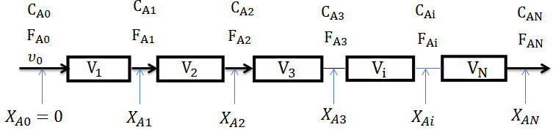
Figure 9.2. PFRs in series arrangement
For isothermal PFR, the materials balance equation derivation details is found in lecture 5
(Refer lecture 5)
Let $X_{A1}, X_{A2},………,X_{AN}$be the conversion of a component A leaving the reactors $1, 2,………,N$
Material balance on i^{th} reactor is given by:
$\frac{Vi}{FA0} =\int_{X_{A(i-1)}}^{X_{Ai}}{\frac{{dX}_{A}}{{-r}_{A}}}$ (9.1)
For Reactor 1
$\frac{V_{1}}{F_{A0}}=\int_{X_{A0=0}}^{X_{A1}}{\frac{{dX}_{A}}{{-r}_{A}}}$ (9.2)
For Reactor 2
$\frac{V_{2}}{F_{A0}}=\int_{X_{A1}}^{X_{A2}}{\frac{{dX}_{A}}{{-r}_{A}}}$ (9.3)
For reactor 3
$\frac{V_{3}}{F_{A0}}=\int_{X_{A2}}^{X_{A3}}{\frac{{dX}_{A}}{{-r}_{A}}}$ (9.4)
For N^{th} reactor, the materials balance equation is given by:
$\frac{V_{N}}{F_{A0}}=\int_{X_{A(N-1)}}^{X_{AN}}{\frac{{dX}_{A}}{{-r}_{A}}}$ (9.5)
For the N reactors in series, the materials balance equation is given by:
$\frac{V_{N}}{F_{A0}}=\frac{V_{1}}{FA0}+\frac{V_{2}}{FA0}+\frac{V_{3}}{FA0}+…+\frac{V_{N}}{FA0}=\int_{X_{A0=0}}^{X_{A1}}{\frac{{dX}_{A}}{{-r}_{A}}}+\int_{X_{A1}}^{X_{A2}}{\frac{{dX}_{A}}{{-r}_{A}}+…+\int_{X_{A(N-1)}}^{X_{AN}}{\frac{{dX}_{A}}{{-r}_{A}}}}$ (9.6)
$\sum_{i=1}^{N}{\frac{Vi}{FA0} =}\int_{X_{A0=0}}^{X_{A1}}{\frac{{dX}_{A}}{{-r}_{A}}}+\int_{X_{A1}}^{X_{A2}}{\frac{{dX}_{A}}{{-r}_{A}}+…+\int_{X_{A(N-1)}}^{X_{AN}}{\frac{{dX}_{A}}{{-r}_{A}}}}$ (9.7)
$\frac{1}{FA0}\sum_{i=1}^{N}{Vi }=\int_{X_{A0 = 0}}^{X_{A1}}{\frac{{dX}_{A}}{{-r}_{A}}}+\int_{X_{A1}}^{X_{A2}}{\frac{{dX}_{A}}{{-r}_{A}}+…+\int_{X_{A(N-1)}}^{X_{AN}}{\frac{{dX}_{A}}{{-r}_{A}}}}$ (9.8)
$\sum_{i=1}^{N}{Vi }= V$ (9.9)
$\frac{V}{F_{A0}} =\int_{X_{A0=0}}^{X_{A1}}{\frac{{dX}_{A}}{{-r}_{A}}}+\int_{X_{A1}}^{X_{A2}}{\frac{{dX}_{A}}{{-r}_{A}}+…+\int_{X_{A(N-1)}}^{X_{AN}}{\frac{{dX}_{A}}{{-r}_{A}}}}$ (9.10)
$\frac{V}{F_{A0}}=\int_{0}^{X_{AN}}{\frac{{dX}_{A}}{{-r}_{A}}}$ (9.11)
(Levenspiel, 2011, pg. 124).
The total volume (V), simply summation of all individual reactors connected in series. Therefore, N plug flow reactors connected in series with total volume, V, gives the same conversion as a single plug flow reactor of volume, V.
Let’s see the following two PFRs in series as shown in Figure 9.3 (Fogler, 2015, pg. 52). From equation (9.11), the total reactor volume is given by:
$V=F_{A0}\int_{0}^{X_{A2}}{\frac{{dX}_{A}}{{-r}_{A}}=F_{A0}}\int_{0}^{X_{A1}}{\frac{{dX}_{A}}{{-r}_{A}}+F_{A0}\int_{X_{A1}}^{X_{A2}}{\frac{{dX}_{A}}{{-r}_{A}}}}$
It is immaterial whether you place two plug-flow reactors in series or have one continuous plug-flow reactor; the total reactor volume required to achieve the same conversion is identical.
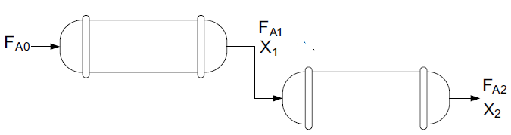Figure 9.3. Two PFRs in series
The Levenspiel plot of equation (9.11) is depicted in Figure 9.4 (Fogler, 2015, pg. 52). The overall conversion of two PFRs in series is the same as one PFR with the same total volume.
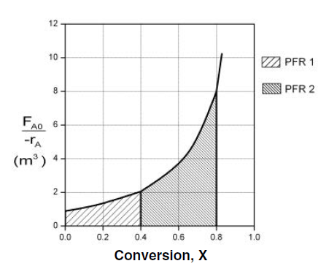
Figure 9.4. Two PFRs in series Levenspiel plot
Activity 9.1
A reactant A is converted to product P using two plug flow reactors connected in series. The reactant inlet mole flow rate in the first reactor is 4 mol/min. The conversion of the reactant is 40 % in the first reactor, and the overall conversion of both reactors connected in series is reached to 80%. The reaction rate and conversion data are given Table 9.1. Based on the given data, determine the volumes of the first reactor, the second reactor, and the two reactors together.
Table 9.1 Reaction rate and conversion data for activity 9.1.
X_{A} | 0 | 0.1 | 0.2 | 0.4 | 0.6 | 0.7 | 0.8
-r_{A}(mol/L. min) | 0.045 | 0.037 | 0.031 | 0.019 | 0.012 | 0.008 | 0.005

Given:
A------> P, Two PFRs in series,
F_{Ao}= 4 mol/min, conversion for first reactor, X_{A1}= 0.4; overall conversion, X_{A}= 0.8
The reaction rate and conversion data are given Table 9.1.
Required:
V₁, V₂ & V=?
Solution:
Plot X_{A} vs 1/-r_{A}, convert the reaction rate data to 1/-r_{A} as shown in Table 9.2.
Table 9.2 1/-r_{A} and X_{A} data for activity 9.1.
X_{A} | 0 | 0.1 | 0.2 | 0.4 | 0.6 | 0.7 | 0.8
1/-r_{A} (L. min/ mol) | 22.2 | 27 | 32.3 | 52.6 | 83.3 | 125 | 200
For the first reactor, the volume of PFR is given by:
$V_{1}=F_{A0}\int_{0}^{X_{A1}}{\frac{{dX}_{A}}{{-r}_{A}}}$
The plot of X_{A1} vs. 1/-r_{A} data to find the area under the curve is given in Figure 9.5.
Figure 9.5. Levenspiel plot of X_{A1} vs 1/-r_{A} for the first PFR
The volume of the first PFR is the product of mole flow rate and area under the curve.
V₁= F_{Ao}* Area = 4*13.9 = 55.6 L
For the second reactor, the volume of PFR is given by:
$V_{2}=F_{A0}\int_{X_{A1}}^{X_{A2}}{\frac{{dX}_{A}}{{-r}_{A}}}$
The plot of X_{A2} vs. 1/-r_{A} data to find the area under the curve is given in Figure 9.6.
Figure 9.6. Levenspiel plot of X_{A2} vs 1/-r_{A} for the second PFR
The volume of the second PFR is the product of mole flow rate and area under the curve.
V₂= F_{Ao}* Area = 4*40.3 = 161.2L
For two PFRs in series, the total volume is given by:
${V=V_{1}+V}_{2}=F_{A0}\int_{0}^{X_{A1}}{\frac{{dX}_{A}}{{-r}_{A}}+F_{A0}\int_{X_{A1}}^{X_{A2}}{\frac{{dX}_{A}}{{-r}_{A}}}}\text{=}F_{A0}\int_{0}^{X_{A2}}{\frac{{dX}_{A}}{{-r}_{A}}}$ (9.11)
The plot of X_{A} vs. 1/-r_{A} data to find the area under the curve is given in Figure 9.7.
Figure 9.7. Levenspiel plot of X_{A} vs 1/-r_{A} for two PFRs in series
The volume of two PFRs in series is the product of mole flow rate and area under the curve.
V= F_{Ao}* Total area = 4*54.2= 216.8 L
The results confirm that the two PFRs in series with a total volume of V provides the same conversion with a single PFR with a volume of V.
9.3. Design of isothermal PFRs in parallel arrangement
9.3.1. PFRs parallel arrangement characteristics
Parallel arrangements of PFRs are another common configuration in chemical engineering, particularly when dealing with reactions that can be conducted simultaneously to improve overall quantity and productivity. The effluents from each reactor can be combined after processing. Each reactor can be operated independently, allowing for variations in operating conditions (temperature, pressure, residence time) tailored to specific reaction kinetics. Each reactor maintains plug flow characteristics, minimizing back-mixing within each unit. However, there can be variability in conversion and selectivity depending on the specific conditions in each reactor. Two PFRs in parallel is shown in Figure 9.8 (Fogler, 2015, pg. 705).
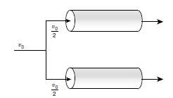
Figure 9.8. Two PFRs in parallel
Parallel arrangements can facilitate scaling up production by simply adding more reactors to handle increased feed rates without significantly altering the existing setup. Parallel arrangements of PFRs offer significant advantages in terms of increased throughput and flexibility in reaction conditions. However, they also introduce complexities related to feed distribution, control systems, and potential variability in performance. Proper design and operational strategies are essential to maximize the benefits of this configuration while mitigating challenges.
9.3.2 Design of PFRs in parallel arrangement
In a parallel arrangement of reactors, the feed stream is split with split ratio and feed to each reactor at the same time. For parallel arrangement, there are four cases.
Case 1: If V₁ = V₂ = … = V_{n} and the flow is split equally between each reactor, the space time is identical for each reactor. The conversion for each reactor will be the same and will, of course, be equal to the conversion achieved by the entire reactor assembly. In this case, the performance of the combination of reactors is the same as that of one reactor of the same total volume. The parallel arrangement of identical N PFRs is depicted in Figure 9.9. The volumetric flow rate is divided equally for each identical reactor. The overall conversion is equal to the individual reactor conversion.
$X_{A}=X_{A1}=X_{A2}=X_{Ai}=X_{An}$ (9.12)
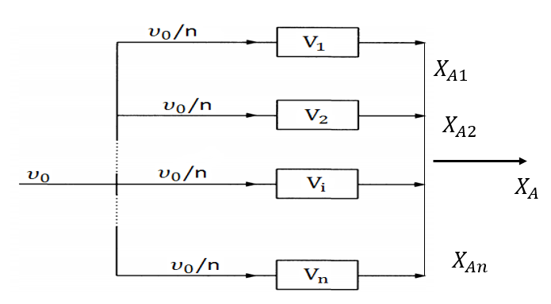
Figure 9.9. PFRs in parallel arrangement with equal flow rate
Case 2: If the PFRs are of different size, and the flow is split in proportion to the volume of the reactors, the space time is proportional to the size of each reactor. The parallel arrangement of N PFRs is depicted in Figure 9.10. The overall conversion is equal to the individual reactor conversion.
$X_{A}=X_{A1}=X_{A2}=X_{Ai}=X_{An}$ (9.13)
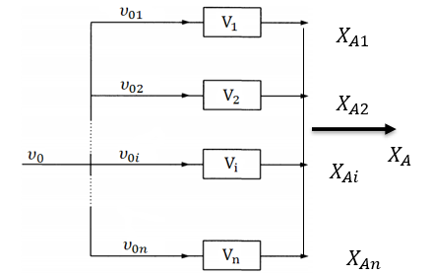
Figure 9.10. PFRs in parallel arrangement with different volume
Case 3: If the reactors are identical in size and flow rate is not equally split, so the space time in each reactor is not equal and conversions achieved are not identical. The parallel arrangement of N PFRs is shown in Figure 9.11, V₁$=$V₂ $=$V_{i} $=$ V_{n} but 𝜐₀₁$≠$ 𝜐₀₂ $≠$𝜐_{0i} $≠$ 𝜐_{0n}. The space time of each reactor is not identical. ($τ_{1}{≠τ}_{2}≠τ_{i}….≠τ_{n})$. The conversions from each reactor are not identical. ($X_{A1}{≠X}_{A2}≠X_{Ai}≠X_{An})$.
The final conversion after mixing of streams from each reactor can be calculated as follows:
$X_{A}=\frac{υ_{01}X_{A1}+υ_{02}X_{A2}+υ_{0i}X_{Ai}+…+υ_{0n}X_{An}}{υ_{01}+υ_{02}+υ_{0i}+…+υ_{0n}} =\frac{υ_{01}X_{A1}+υ_{02}X_{A2}+υ_{0i}X_{Ai}+…+υ_{0n}X_{An}}{υ_{0}}$ (9.14)
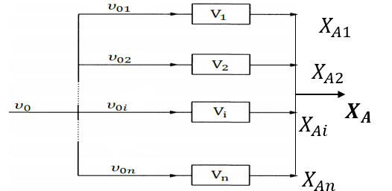
Figure 9.11. PFRs in parallel arrangement with different flow rate
Case 4: If the sizes are not identical and the flow split is not in proportion, so the space time of each reactor is not identical. The parallel arrangement of N PFRs is shown in Figure 9.12, V₁$≠$V₂$≠$V_{i}$≠$V_{n} and 𝜐₀₁$≠$ 𝜐₀₂ $≠$𝜐_{0i} $≠$ 𝜐_{0n}. The conversions from each reactor are not identical.
After mixing of streams from each reactor, the overall final conversion is given by:
$X_{A}=\frac{υ_{01}X_{A1}+υ_{02}X_{A2}+υ_{0i}X_{Ai}+…+υ_{0n}X_{An}}{υ_{01}+υ_{02}+υ_{0i}+…+υ_{0n}} =\frac{υ_{01}X_{A1}+υ_{02}X_{A2}+υ_{0i}X_{Ai}+…+υ_{0n}X_{An}}{υ_{0}}$ (9.15)
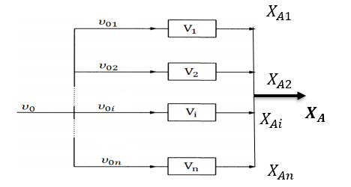
Figure 9.12. PFRs in parallel arrangement with different volume & flow rate
For the PFRs connected in parallel, a single plug flow reactor of volume is equal to the total volume of the individual units if the feed is distributed in such a manner that fluid streams that meet have the same composition. For PFRs in parallel with identical reactors, V/F_{A0} or 𝝉 must be the same for each parallel line. For parallel arrangement, the feed should be divided proportional to the size of the reactors; any other way of feeding is less efficient.
Activity 9.2
Two PFRs are connected in parallel to produce product P from reactant A as shown in the stochiometric equation below. The first PFR has a volume of V₁ and a second PFR has a of volume V₂. The volume of the second PFR is four times that of the first PFR. The two reactors are operated at steady-state in parallel to carry out a liquid-phase reaction with a first-order reaction. The reaction in the first PFR is characterized by kV₁/v_{o}= kτ₁ = 1. It is assumed that the feed rate (ʋ_{o} or F_{Ao}) is split so that 20% passes through the first PFR and 80% passes through the second PFR. Calculate the conversion of each reactor, and overall conversion when the exit streams from the two PFRs are combined.
$$A\underset{→}{k}P$$

Given:
Two PFRs in parallel, first order reaction
PFR₁: V₁, kV₁/υ_{o} = kτ₁=1, PFR₂: V₂
V₂= 4V₁
The feed for PFR₁: 20% F_{Ao} or 20% of υ_{o}, and the feed for PFR₂: 80% F_{Ao} or 80% of υ_{o}
Required
Conversion (X_{A}) = ?
The two PFRs in parallel for activity 9.2 is depicted in Figure 9.13.
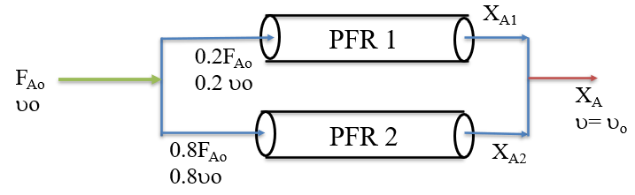 Figure 9.13. Two PFRs in parallel for activity 9.2
Solution:
For PFR1, the rate of the reaction can be written as:
-r_{A1}= kC_{A1}= kC_{Ao} (1-X_{A1})
For PFR 1, the volume of the reactor is given by:
$V_{1}={0.2F}_{A0}\int_{0}^{X_{A1}}{\frac{{dX}_{A1}}{{-r}_{A1}}}$; F_{Ao}= C_{Ao}υ_{o}
$V_{1}=0.2C_{Ao}{}_{o}\int_{0}^{X_{A1}}{\frac{{dX}_{A1}}{\text{kC}\text{Ao}\text{ (1-XA}\text{1) }}}=\frac{0.2{}_{o}}{k}$ $\int_{0}^{X_{A1}}{\frac{{dX}_{A1}}{\text{ (1-XA}\text{1) }}}$
$$\frac{kV_{1}}{{}_{o}}=k1=0.2\int_{0}^{X_{A1}}{\frac{{dX}_{A1}}{\text{(1-XA}\text{1) }}}=-0.2ln\left(1-X_{A1}\right)=1$$
Ln(1-X_{A1}) = -1/0.2 = -5
X_{A1}= 1-exp (-5) = 0.99
For PFR 2, the rate of the reaction can be written as:
-r_{A1}= kC_{A2}= kC_{Ao} (1-X_{A2})
For PFR 2, the volume of the reactor is given by:
$V_{2}={0.8F}_{A0}\int_{0}^{X_{A2}}{\frac{{dX}_{A2}}{{-r}_{A2}}}$; F_{Ao}= C_{Ao}υ_{o}, V₂ = 4V₁
${4V}_{1}=0.8C_{Ao}{}_{o}\int_{0}^{X_{A2}}{\frac{{dX}_{A2}}{\text{kC}\text{Ao}\text{ (1-XA}\text{2) }}}=\frac{0.8{}_{o}}{k}$ $\int_{0}^{X_{A2}}{\frac{{dX}_{A2}}{\text{ (1-XA}\text{2) }}}$
$$\frac{4kV_{1}}{{}_{o}}=4k1=0.8\int_{0}^{X_{A2}}{\frac{{dX}_{A1}}{\text{(1-XA}\text{2) }}}=-0.8ln\left(1-X_{A2}\right)=4$$
ln(1-X_{A2}) = -4/0.8 = -5
X_{A2}= 1-exp (-5) = 0.99
The final conversion after mixing of streams from each reactor can be calculated as follows:
$$X_{A}=\frac{υ_{01}X_{A1}+υ_{02}X_{A2}}{υ_{01}+υ_{02}} =\frac{0.2 υ_{0}X_{A1}+{0.8υ}_{0}X_{A2}}{υ_{0}}$$
X_{A1}=X_{A2}= 0.99
$$X_{A}=0.2 υ_{0}X_{A1}+{0.8υ}_{0}X_{A2}=0.2*0.99+0.8*0.99=0.99$$
The results confirm that the overall conversion is equal to the individual reactor conversion since the feed is divided proportional to the size of the reactors.
9.4. Design of Recycle Reactor
Recycle Reactor: It is a type of PFR operation to recirculate unconverted reactants by dividing a portion of product stream from a PFR and returning (recycling with recycle ratio) it to the entrance of the reactor. Recycle reactor is depicted in Figure 9.14 (Levenspiel, 2011, pg.136 ). The design of recycle reactor is preferred to re-use the catalyst and yeast/ enzyme for catalytic and biochemical reactions, use of excess reactants for some reactions, recirculate unconverted reactants, and promote selectivity and yield.
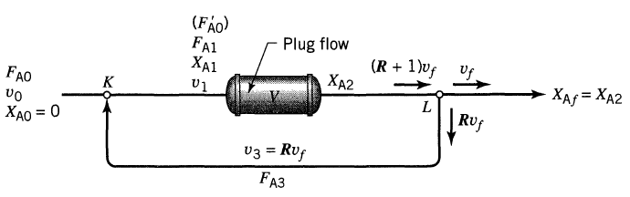
Figure 9.14. Recycle reactor
The recycle ratio R be defined as:
$R=\frac{\text{Volume of fluid returned to the reactor entrance}}{\text{Volume leaving the system}}$ (9.16)
The recycle ratio (R ) can be made to vary from zero to infinity. The recycle ratio is raised the behavior shifts from plug flow (R = 0) to mixed flow (R = ∞). Recycling provides a means for obtaining various degrees of back mixing with a PFR. Recycle reactor is a PFR between mixing and splitting points as shown in Figure 9.14. The performance equation for this recycle reactor is:
$\frac{V}{{F^{'}}_{A0}}=\int_{X_{A1}}^{X_{A2}=X_{Af}}{\frac{{dX}_{A}}{{-r}_{A}}}$ (9.17)
${{\text{F}}^{'}}_{\text{A}\text{0}}$ is the feed rate of A entering the reactor (fresh feed plus recycle /unconverted/). Since ${F^{'}}_{A0}$ and $X_{A1}$ are not known directly, they should be written in terms of known quantities.
The flow entering the reactor includes both fresh feed and the recycle stream (${F^{'}}_{Ao}$).
${{\text{F}}^{'}}_{\text{A}\text{0}}$ = (Unconverted A in a recycle stream + A in a fresh feed)
${{\text{F}}^{'}}_{\text{A}\text{0}}=RF_{\text{A}\text{0}}+F_{\text{A}\text{0}}=(R+1)F_{\text{A}\text{0}}$ (9.18)
$X_{A1}=\frac{1-C_{A1}/C_{A0}}{1+ε_{A}C_{A1}/C_{A0}}$ (9.19)

The streams meeting at point Y may be added directly; and the concentration is given by:
$C_{A1}=\frac{F_{A1}}{υ_{1}}=\frac{F_{A0}+F_{A3}}{υ_{0}+{Rυ}_{f}}=\frac{F_{A0}+{RF}_{A0}(1-X_{Af})}{υ_{0}+{Rυ}_{0}(1+ε_{A}X_{Af})}=C_{A0}(\frac{1+R-RX_{Af})}{1+R+Rε_{A}X_{Af})}$ (9.20)
By substituting equation (9.20) into equation (9.19), and solve for X_{A1}, you get:
$X_{A1}=(\frac{R}{R+1})X_{Af}$ (9.21)
The design equation for recycle reactor, which is good for any kinetics, any $ε$ value and for $X_{A0}$ = 0, is given by
$\frac{V}{F_{A0}}=(R+1)\int_{(\frac{R}{R+1})X_{Af}}^{X_{Af}}{\frac{{dX}_{A}}{{-r}_{A}}}$ (9.22)
Where: V is volume of recycle reactor, R is recycling ratio, F_{Ao} is initial mole flow rate, X_{Af} is final conversion, r_{A} is reaction rate.
For constant density, this equation can be written in terms of concentrations. The space time of the recycle reactor can be written as:
$τ=\frac{C_{A0}V}{F_{A0}}=-(R+1)\int_{\frac{C_{A0}+{RC}_{Af}}{R+1}}^{C_{Af}}{\frac{{dC}_{A}}{{-r}_{A}}}$ (9.23)
Two types of conversions are existing in the recycle reactors namely, the overall
conversion and the conversion per pass. The conversion per pass at the stream intersection can be defined indirectly by using the definition of concentration. For the negligible and infinite recycle, the system approaches plug flow and mixed flow, respectively, as shown in equation (9.24) (Levenspiel, 2011, pg.138).
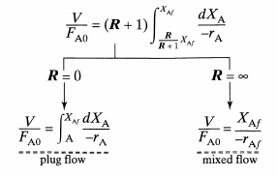
(9.24)

Activity 9.3
An aqueous phase reaction occurs in a recycles reactor. The reactant A is converted into product B is given below. An aqueous feed with mole flow rate of 80 mol/min and initial concentration of 10 mol/L. The reaction is first order with respect to A, and the rate constant is 0.05 min⁻¹. The feed to PFR with portion of the product stream is recycled to the feed stream. Determine the volume of the recycle reactor required to achieve 90% conversion with recycle ratio of 2.
$$A\underset{→}{k}B$$
Given:
Recycle PFR, and first order reaction.
R=2
X_{A} = 90% = 0.9
C_{Ao}= 10 mol/L, k=0.05 min-1
F_{Ao} = 80 mol/min
Required:
Volume of recycle reactor (V) =?
Solution:
The reaction rate is first order, and it is given by:
-r_{A}= kC_{A}= kC_{Ao}(1-X_{A})
The recycle reactor volume (V) is determined using equation (9.22).
$$\frac{V}{F_{A0}}=(R+1)\int_{(\frac{R}{R+1})X_{Af}}^{X_{Af}}{\frac{{dX}_{A}}{{-r}_{A}}}$$
$$V=F_{A0}(R+1)\int_{(\frac{R}{R+1})X_{Af}}^{X_{Af}}{\frac{{dX}_{A}}{{-r}_{A}}}$$
$$V=F_{A0}(R+1)\int_{(\frac{R}{R+1})X_{Af}}^{X_{Af}}{\frac{{dX}_{A}}{{-r}_{A}}=F_{A0}(R+1)\int_{(\frac{R}{R+1})X_{Af}}^{X_{Af}}{\frac{{dX}_{A}}{{kC}_{Ao}{(1-X}_{A})}}}$$
$V= \frac{F_{A0}(R+1)}{{kC}_{Ao}}\int_{(\frac{R}{R+1})X_{Af}}^{X_{Af}}{\frac{{dX}_{A}}{{(1-X}_{A})}=}$ $\frac{F_{A0}(R+1)}{{kC}_{Ao}}*[-ln\left(1-XAf\right)+ln\left(1-\left(\frac{R}{R+1}\right)X_{Af}\right)]$
$$V= \frac{F_{A0}(R+1)}{{kC}_{Ao}}*\left[-ln\left(1-XAf\right)+ln\left(1-\left(\frac{R}{R+1}\right)X_{Af}\right)\right]$$
$$V=\frac{80 \left(2+1\right)}{0.05*10}*\left[-ln\left(1-0.9\right)+ln\left(1-\left(\frac{2}{2+1}\right)*0.9\right)\right]=665 L$$
9.5. Summary
Multiple reactor systems (MRS) are preferred to enhance conversion, reduce size of the reactor for specified conversion, enhance selectivity/yield, control heat effect, & maximize production capacity. However, MRS require large construction of materials, large space for multiple reactors installation, large amount of energy to run multiple reactors, and increase installation cost. Series arrangement of PFRs is preferred for reactions that require multiple stages to achieve desired conversion or product specifications. Series arrangement of PFRs provides high conversion rate, flexibility in process design, optimize reaction conditions, handle complex reactions, improve control over byproducts. Parallel arrangement of PFRs is preferred to increase production quantity. PFRs in parallel arrangement, number of reactors determine the overall production capacity. For parallel PFRs, the feed rates should be divided in proportion to each reactor volume to find the same conversion for all reactors, which is equal to the overall conversion. Recycle reactor in PFR is used to maximize conversion by recycling unconverted reactants, and promote selectivity and yield.
References
- Chemical Reaction Engineering, Levenspiel, O John Wiely & Sons, 3rd edition, 2011.
- Elements of Chemical Engineering, Fogler, HS Prentice- Hall Inc Prentice- Hall Inc, 5th edition, 2015.

