Chemical Reaction Engineering II- Reactor Design (ChEg 4101)
Prerequisite: Chemical Reaction Engineering I-Reaction Kinetics (ChEg3104)
Lecture 10: Design of Multiple Reactor Systems: Design of Isothermal Continuous Stirred Tank Reactors (CSTRs) in Series and Parallel Arrangements
Week 10
Lecturer: Adamu Esubalew (PhD, ChEg)
Addis Ababa, Ethiopia

Lecture learning outcomes
At the end of the lecture, you will be able to:
- identify characteristics of CSTRs in series and parallel arrangements,
- design isothermal ideal CSTRs in series arrangement,
- design isothermal ideal CSTRs in parallel arrangement, and
- design of isothermal PFR- CSTR and CSTR-PFR in series.
10.1. Introduction to CSTRs in series and parallel arrangements
10.1.1. Characteristics of CSTRs in series arrangement
CSTRs in a series arrangement is a design strategy in chemical engineering to improve conversion efficiency and control over reaction conditions. For series arrangement, multiple CSTRs are connected sequentially. i.e. the effluent from one reactor serves as the feed for the next reactor in the series. Each CSTR operates under continuous flow conditions, and the mixtures are well mixed to make uniform concentration and temperature throughout each reactor. Series arrangement of CSTRs increases the total residence time for the reactants, which can enhance conversion.
CSTRs in series are useful for reactions that involve multiple steps or sequential reactions where the product of one reaction serves as the reactant for the next. CSTRs in series arrangement is useful for enhancing conversion for reactions with low single-stage efficiency, improving selectivity, allowing flexibility in operation, and allowing better control over reaction kinetics. Series arrangement can lead to higher overall conversion compared to a single CSTR by increasing the residence time through multiple reactors.
Series arrangement can enhance selectivity towards desired products while minimizing by-products by controlling conditions in each reactor. It allows greater flexibility in process design since each reactor can be tuned independently to optimize specific reaction parameters. The series arrangement also allows for better management of reaction rates and conversion levels, especially in cases where intermediate products may be unstable.
For CSTRs in series arrangement, the following parameters should be considered:
Number of reactors: The number of reactors determine the overall conversion. Large number of CSTRs in series can approximate plug flow behavior, which provides high conversion.
Reactor volume: For CSTRs in series, the reactor volume determines the overall conversion. For series arrangement, equal volume distribution is common but not always optimal. For example, for second-order or autocatalytic reactions, unequal volumes may yield better conversion.
Reaction kinetics: The reaction order determines the volume distribution or arrangement of reactors to achieve high conversion. For example, first order reaction, equal volume distribution often works well to get high overall conversion; but for second order, larger volume should be placed first to maximize conversion.
Conversion: It is affected by the number of reactors. i.e. total conversion increases with the number of reactors.
The flow rate: The flow rate of reactants determines the space time inside the reactor, which affects the overall conversion. High flow rate reduces the space time/ average residence time, which provides low conversion.
Residence time distribution: CSTRs in series arrangement narrows the residence time distribution, which reduces back-mixing and improve performance.
Arrangement decision: If there are reactors with different sizes, use the larger tank first to maximize conversion due to higher initial reactants concentrations in the feed.
Pressure drops: The cumulative pressure drops across multiple reactors can affect the flow rates and overall system performance.
Maintenance challenges: Maintenance of multiple reactors can be more complex than a single reactor system, requiring careful scheduling to minimize downtime.
Therefore, CSTRs in series arrangement provides significant advantages in terms of increased conversion and flexibility in reaction conditions for processes involving sequential reactions or when specific control over reaction kinetics is required. However, they introduce complexities related to design, operation, and maintenance that must be carefully managed to maximize their benefits.
10.1.2. Characteristics of CSTRs in parallel arrangement
CSTRs in Parallel arrangement is another common configuration used in chemical engineering. CSTRs in parallel arrangement is multiple reactors are operated simultaneously, each receiving a portion of the feed stream. CSTRs are connected to a common feed line, and the effluents from each reactor can either be combined or treated separately. Each reactor operates independently but under the same feed conditions, allowing for uniform mixing and reaction conditions within each individual reactor. The feed stream is divided among the reactors, which can be achieved through flow splitters or other distribution methods.
Parallel arrangement can also allow independent operation. Each reactor can be operated under different conditions, allowing for optimization of specific reactions or product yields. Parallel CSTRs can significantly increase overall production capacity by processing larger volumes of feed simultaneously. Parallel arrangement also allows flexibility reaction conditions. i.e. Different reactors can be optimized for different reaction conditions.
Parallel arrangement improves reliability. If one reactor in the parallel arrangement experiences issues or downtime, the others can continue to operate, enhancing overall system reliability and minimizing production losses. Parallel arrangement enhances selectivity and yield. Running multiple reactors under different conditions allows to identify optimal settings for specific products, which leads to improved selectivity and yield.
For CSTRs in parallel arrangement, several key parameters should be taken into account to ensure optimal performance and efficiency. Some of the design parameters to be considered are the followings:
Reactor volume: Each CSTR connected in parallel should have an appropriate volume to achieve the desired residence time and conversion rates for the reactions being conducted.
Feed flow rate: The total feed flow rate should be divided among the reactors in a manner that maintains the desired conversion and residence time.
Reaction kinetics: Understand the kinetics of the reactions taking place in each CSTR and ensure that they are suitable for parallel operation.
Conversion and yield: Compute the expected conversion rates for each reactor and ensure that the overall yield meets process requirements.
Pressure drops: Evaluate the pressure drop across each reactor and ensure that it is manageable within the system.
Therefore, CSTRs in parallel arrangement offers significant advantages in terms of increased throughput, flexibility in operating conditions, and enhanced reliability for processes that benefit from simultaneous operation under varied conditions or for high volume production scenarios. However, careful management of flow distribution, control systems, and maintenance is necessary to maximize the benefits of this configuration while minimizing potential drawbacks.
10.2. Design of Isothermal CSTRs in Series Arrangement
The design objective of CSTR is finding the volume of a reactor required for a specified conversion. The volume of isothermal ideal CSTR is determined using materials balance equation. The derivation details for materials balance equation for isothermal CSTR is found in lecture 7 (refer lecture 7). One of the drawbacks of a single CSTR reactor is resulting low conversion. It needs large reactor volume (space time) to obtain high conversion. Series combination of many smaller CSTR reactors increases the space time.
The reactors size may be identical and different for series arrangements. There are two cases: equal size and different size CSTRs in series arrangement.
Case 1: Identical (equal size) CSTRs in series
Let’s consider the following identical N CSTRs connected in series as shown in Figure 10.1. (Levenspiel, 2011, pg. 126). For identical CSTRs in series, the rate constant and space time for each reactor is the same.
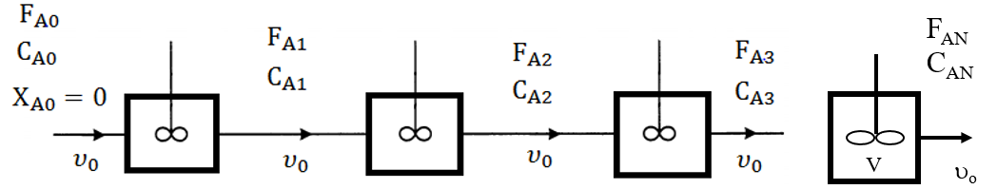
Figure 10.1. N identical CSTRs in series
The material balance equation for reactor 1 is given by:
$C_{A0}=C_{A1}+\left({-r}_{A1}\right)V/υ_{0}=C_{A1}+({-r}_{A1})τ$ (10.1)
For a first order reaction, the reaction rate for reactor 1 is given by:
${-r}_{A1}=kC_{A1}$ (10.2)
By substituting equation (10.2) into equation (10.1), you get:
$C_{A0}=C_{A1}+\left(kC_{A1}\right)τ$ (10.3)
Dividing both sides of equation (10.3) by C_{A1}, you get:
$\frac{{ C}_{A0}}{C_{A1}}=1+kτ$ (10.4)
This is the materials balance equation of reactor 1 for first order reaction.
Where: V is volume of reactor, υ_{o} is volumetric flow rate, C_{Ao} is initial concentration of reactant A, r_{A1} is rate of reaction of reactant A for reactor 1, C_{A1} is final concentration of reactant A for reactor 1, k is rate constant for reactor 1, and τ is space time for reactor 1.
Similarly, the material balance equation for reactor 2 is given by:
$C_{A1}=C_{A2}+\left(kC_{A2}\right)τ$ (10.5)
Dividing both sides of equation (10.5) by C_{A2}, you get:
$\frac{{ C}_{A1}}{C_{A2}}=1+kτ$ (10.6)
This is the materials balance equation of reactor 2 for first order reaction.
Where: C_{A1} is feed concentration of reactant A for reactor 2, C_{A2} is final concentration of reactant A for reactor 2, k is rate constant for reactor 2, and τ is space time for reactor 2.
The material balance equation for reactor 3 can be written as:
$C_{A2}=C_{A3}+\left(kC_{A3}\right)τ$ (10.7)
Dividing both sides of equation (10.7) by C_{A3}, you get:
$\frac{{ C}_{A2}}{C_{A3}}=1+kτ$ (10.8)
This is the materials balance equation of reactor 3 for first order reaction.
Where: C_{A2} is feed concentration of reactant A for reactor 3, C_{A3} is final concentration of reactant A for reactor 3, k is rate constant for reactor 3, and τ is space time for reactor 3.
The material balance equation for reactor N can be written as:
$C_{A(N-1)}=C_{AN}+\left(kC_{AN}\right)τ$ (10.9)
Dividing both sides of equation (10.9) by C_{AN}, you get:
$\frac{{ C}_{A(N-1)}}{C_{AN}}=1+kτ$ (10.10)
This is the materials balance equation of reactor N for first order reaction.
Where: C_{A(N-1)} is feed concentration of reactant A for reactor N, C_{AN} is final concentration of reactant A for reactor N, k is rate constant for reactor N, and τ is space time for reactor N.
By multiplying the material balance equations for all N identical CSTRs in series, you get:
$\frac{{ C}_{A0}}{C_{A1}}*\frac{{ C}_{A1}}{C_{A2}}*\frac{{ C}_{A2}}{C_{A3}}*…*\frac{C_{A\left(N-2\right)}}{C_{A\left(N-1\right)}}*\frac{C_{A\left(N-1\right)}}{C_{AN}}=\left(1+kτ\right)*\left(1+kτ\right)*\left(1+kτ\right)*…*\left(1+kτ\right)$ (10.11)
For N number of identical CSTRs in series, the materials balance equation for first order reaction is given by:
$\frac{{ C}_{A0}}{C_{AN}}={\left(1+kτ\right)}^{N}$ (10.12)
By re-arranging equation (10.12), and solve for space time, you get:
$τ=\frac{1}{k}\left({\left\{\frac{C_{A0}}{C_{AN}}\right\}}^{1/N}-1\right)$ (10.13)
The total space time ($τ_{T}$) for N number of identical CSTRs in series can be written as:
$τ_{T}=Nτ$ = $\frac{N}{k}\left({\left\{\frac{C_{A0}}{C_{AN}}\right\}}^{1/N}-1\right)$ (10.14)
Taking the limit $as N→∞$, equation (10.14) reduces to the plug flow reactor equation:
$τ_{p}=\frac{1}{k}ln\frac{C_{A0}}{C_{AN}}$ (10.15)
The larger the number of CSTRs in series, the behavior of the system approaches to plug flow reactor. For N → ∞, the performance of N identical CSTRs in series with total volume, V, is equal with a single plug flow reactor with volume, V.
The performance of N identical CSTRs in series with total volume of V approaches to a single plug flow reactor with volume of V is depicted in Figure 10.2 (Levenspiel, 2011, pg. 126).
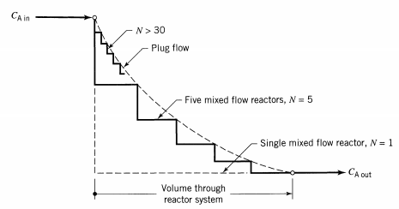
Figure 10.2 Concentration profile of N identical CSTRs in series compared with single PFR
In plug flow, the concentration of reactant decreases progressively through the system; in CSTR, the concentration drops immediately to a low value. Because of this fact, a plug flow reactor is more efficient than a CSTR for reactions whose rates increase with reactant concentration, such as n^{th} order irreversible reactions, n > 0. For N identical CSTRs connected in series, the concentration is uniform in each reactor at any position, but there is a change in concentration as fluid moves from reactor to reactor. This stepwise drop in concentration, which is illustrated in Figure 10.2, suggests that the larger the number of CSTRs in series, the closer should the behavior of the system approach plug flow.
Case 2: Different size CSTRs in series
Due to the nature of the reactants, mixing behavior, heat effect, conversion requirement and size reduction, there is a need to set up a reactor of different size. For arbitrary kinetics in CSTRs of different size, two types of questions may be asked: how to find the outlet conversion from a given reactor system, and the inverse question, how to find the best setup to achieve a given conversion.
Suppose N different sizes of CSTRs in series arrangement have volumes of V₁, V₂ … and V_{N,} respectively, and that the volumetric flow rate $υ_{0}$ through each CSTRs is the same. The space time in each CSTR is not identical ($τ_{1}≠τ_{2}≠τ_{3}…≠τ_{N})$.
Figure 10.3 shows N different sizes of CSTRs in series arrangement have volumes of V₁, V₂ and V_{N,} respectively, and that the volumetric flow rate $υ_{0}$ through each CSTR is the same (Levenspiel, 2011, pg. 131).
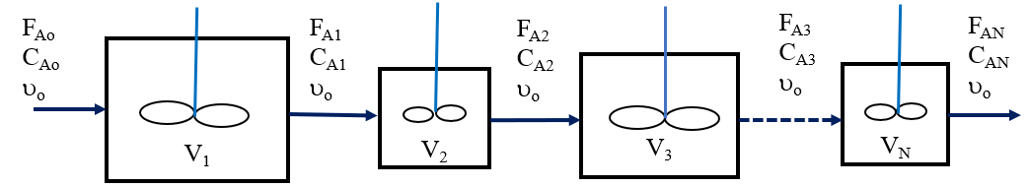
Figure 10.3 Different sizes of N number of CSTRs in series
The material balance equation for reactor 1 is given by:
$C_{A0}=C_{A1}+\left({-r}_{A1}\right)V_{1}/υ_{0}=C_{A1}+({-r}_{A1})τ_{1}$ (10.16)
For a first order reaction, the reaction rate for reactor 1 is given by:
${-r}_{A1}=kC_{A1}$ (10.17)
By substituting equation (10.17) into equation (10.16), you get:
$C_{A0}=C_{A1}+\left(kC_{A1}\right)τ_{1}$ (10.18)
Dividing both sides of equation (10.18) by C_{A1}, you get:
$\frac{{ C}_{A0}}{C_{A1}}=1+kτ_{1}$ (10.19)
This is the materials balance equation of reactor 1 for first order reaction.
Where: C_{Ao} is initial concentration of reactant A, C_{A1} is final concentration of reactant A for reactor 1, k is rate constant, and τ₁ is space time for reactor 1.
Similarly, the material balance equation for reactor 2 is given by:
$C_{A1}=C_{A2}+\left(kC_{A2}\right)τ_{2}$ (10.20)
Dividing both sides of equation (10.20) by C_{A2}, you get:
$\frac{{ C}_{A1}}{C_{A2}}=1+kτ_{2}$ (10.21)
This is the materials balance equation of reactor 2 for first order reaction.
Where: C_{A1} is feed concentration of reactant A for reactor 2, C_{A2} is final concentration of reactant A for reactor 2, k is rate constant, and τ₂ is space time for reactor 2.
The material balance equation for reactor 3 can be written as:
$C_{A2}=C_{A3}+\left(kC_{A3}\right)τ_{3}$ (10.22)
Dividing both sides of equation (10.22) by C_{A3}, you get:
$\frac{{ C}_{A2}}{C_{A3}}=1+kτ_{3}$ (10.23)
This is the materials balance equation of reactor 3 for first order reaction.
Where: C_{A2} is feed concentration of reactant A for reactor 3, C_{A3} is final concentration of reactant A for reactor 3, k is rate constant for reactor 3, and τ₃ is space time for reactor 3.
The material balance equation for reactor N can be written as:
$C_{A(N-1)}=C_{AN}+\left(kC_{AN}\right)τ_{N}$ (10.24)
Dividing both sides of equation (10.24) by C_{AN}, you get:
$\frac{{ C}_{A(N-1)}}{C_{AN}}=1+kτ_{N}$ (10.25)
This is the materials balance equation of reactor N for first order reaction.
Where: C_{A(N-1)} is feed concentration of reactant A for reactor N, C_{AN} is final concentration of reactant A for reactor N, k is rate constant for reactor N, and τ_{N} is space time for reactor N.
By multiplying the material balance equation for all N different sizes of CSTRs in series, you get:
$\frac{{ C}_{A0}}{C_{A1}}*\frac{{ C}_{A1}}{C_{A2}}*\frac{{ C}_{A2}}{C_{A3}}*…*\frac{C_{A\left(N-2\right)}}{C_{A\left(N-1\right)}}*\frac{C_{A\left(N-1\right)}}{C_{AN}}=\left(1+kτ_{1}\right)*\left(1+kτ_{2}\right)*\left(1+kτ_{3}\right)*…*\left(1+kτ_{N}\right)$ (10.26)
By re-arranging equation (10.26), or, the materials balance equation of N different sizes of CSTRs in series for first order reaction is given by:
$\frac{{ C}_{A0}}{C_{AN}}=\left(1+kτ_{1}\right)\left(1+kτ_{2}\right)\left(1+kτ_{3}\right)$…. *($\left(1+kτ_{N}\right)$ (10.27)
Where: C_{Ao} is feed concentration of reactant A for reactor 1, C_{AN} is final concentration of reactant A for reactor N, k is rate constant, and τ₁, τ₂, τ₃ … and τ_{N} are space time for reactor 1, 2, 3 … and N, respectively.
For different size CSTRs in series, reactors sequencing can affect conversion. Let’s consider two set up models of CSTRs in series having small and large size for best sequencing/arrangement for a given conversion as shown in Figure 10.4 (Levenspiel, 2011, pg. 133).
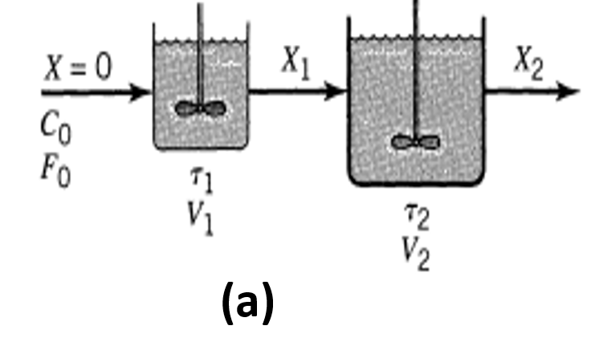 | 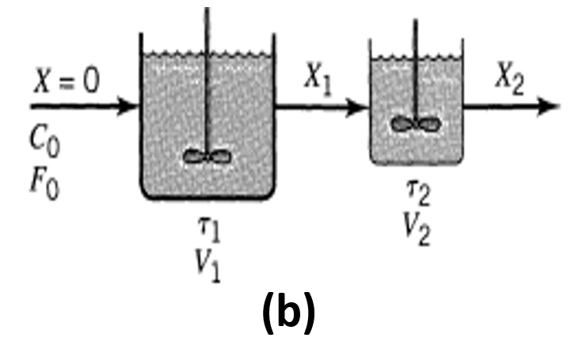
Figure 10. 4. Two CSTRs in series (a) smaller- larger, and (b) larger- smaller
The reactors sequencing decision should be drawn to arrange the reactor based on the kinetics of the reaction and on the conversion level. For first order reactions, equal-size reactors are best. For reaction orders n > 1, the smaller reactor should come first. For n < 1, the larger should come first and the smaller is second. Thus, overall economic consideration would nearly always recommend using equal-size reactors.
Where: n is order of reaction.
Activity 10.1
A liquid reactant stream with initial concentration of 1 mol/L passes through two CSTRs in series. The concentration of A at the exit of the first reactor is 0.5 mol/L. The volumetric flow rate is constant. The reaction is second order with respect to A, and the volume ratio of the second reactor to the first reactor is 2. The stochiometric equation of the reaction is given below. Find the concentration at the exit stream of the second reactor.
$$2A\underset{→}{k}P$$
Given: Two CSTRs in series, smaller- larger
C_{Ao}= 1 mol/L, C_{A1} = 0.5 mol/L, V₂ = 2V₁
Required:
C_{A2} =?
Solution:
The materials balance equation for CSTR 1 is given by:
$\frac{V_{1}}{F_{Ao}}=\frac{X_{A1}}{{-r}_{A1}}$, $X_{A1}=1-\frac{C_{A1}}{C_{Ao}}$; $F_{Ao}=C_{Ao}{}_{o}$, ${}_{1}=\frac{V_{1}}{{}_{o}}$, ${}_{2}=\frac{V_{2}}{{}_{o}}=\frac{2V_{1}}{{}_{o}}=2{}_{1}$
$${-r}_{A1}=k{C_{A1}}^{2}$$
For second order reaction the materials balance equation for CSTR1 can be written as:
$$C_{Ao}=C_{A1}+(k{C_{A1}}^{2}){}_{1}$$
$k_{1}=\frac{C_{Ao}-C_{A1}}{{C_{A1}}^{2}}=\frac{1-0.5}{{0.5}^{2}}=2$ L/mol
For second order reaction the materials balance equation for CSTR 2 can be written as:
$$C_{A1}=C_{A2}+(k{C_{A2}}^{2}){}_{2}$$
$k_{2}=2k_{1}=2*2=4$ L/mol
$$0.5=C_{A2}+4{C_{A2}}^{2}$$
$4{C_{A2}}^{2}+C_{A2}-0.5=0$
This is a quadratic equation of the form:
a$X^{2}+bX+C=0$
$$x=\frac{-b±\sqrt{b^{2}-4ac}}{2a}$$
$C_{A2}=+0.25 mol/L$, or $C_{A2}=-0.5 mol/L$
Concentration is a positive value. Therefore, the concentration at the exit stream of CSTR 2 is 0.25 mol/L.
10.3. Design of Isothermal CSTRs in Parallel Arrangement
For parallel arrangement of CSTRs, let’s consider Three cases:
Case 1: Identical size of CSTRs in parallel with equal split of volumetric flow rate
The identical size of CSTRs in parallel arrangement with equal volumetric flow rate split is shown in Figure 10.5 (Fogler, 2015, pg. 126). For the same space time, the conversion of each reactor is identical, which is equal to the overall conversion.
Identical size reactors and equal split of volumetric flow rate:
V₁ = V₂ = V₃ =…. = V_{N}
υ_{o1} = υ_{o2} = υ_{o3} = υ_{oN} = υ_{o}/N
τ₁ = τ₂ = τ₃ = τ_{N} = τ
X_{A} = XA₁ = X_{A2} = X_{A3} = …X_{AN} (10.28)
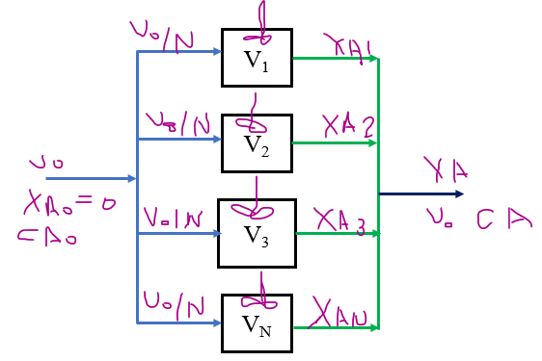
Figure 10.5. N number of identical size CSTRs in parallel with equal split of volumetric flow rate
Case 2: Different size of CSTRs in parallel with proportional split of volumetric flow rate
The different size of CSTRs in parallel and the volumetric flow rate is split in proportion to each reactor volume is depicted in Figure 10.6. For the same space time, the conversion of each reactor is identical, which is equal to the overall conversion.
For different size reactors and proportional split of volumetric flow rate:
V₁ ≠V₂ ≠ V₃ ≠ …. ≠ V_{N}
υ_{o1} ≠ υ_{o2} ≠ υ_{o3} ≠ υ_{oN} ≠ υ_{o}/N
τ₁ = τ₂ = τ₃ = τ_{N} = τ
X_{A} = X_{A1} = X_{A2} = X_{A3} = …X_{AN} (10.29)
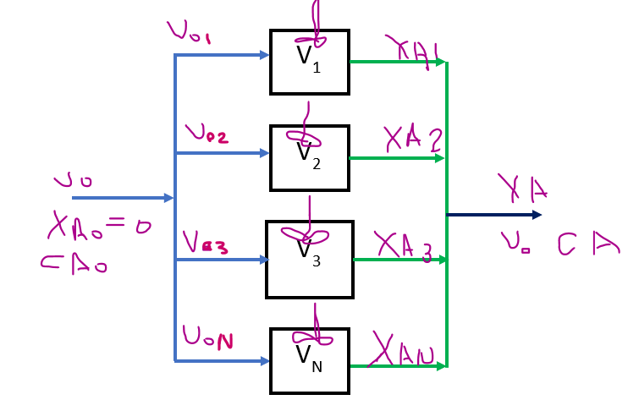
Figure 10.6. N number of different size CSTRs in parallel with proportional split of volumetric flow rate
Case 3: Different size of CSTRs in parallel and the split of volumetric flow rate is not proportional
The different size of CSTRs in parallel and the volumetric flow rate split is not in proportion to each reactor volume is depicted in Figure 10.7. i.e. space time is not the same. The conversion of each reactor is not identical, which is not equal to the overall conversion.
For different size reactors and the split of volumetric flow rate is not proportional to each reactor volume:
V₁ ≠V₂ ≠ V₃ ≠ …. ≠ V_{N}
υ_{o1} ≠ υ_{o2} ≠ υ_{o3} ≠ υ_{oN}… ≠ υ_{o}/N
τ₁ ≠ τ₂ ≠ τ₃ …≠ τ_{N} ≠ τ
X_{A} ≠ X_{A1} ≠ X_{A2} ≠ X_{A3} ≠ …X_{AN} (10.30)
The final conversion after mixing of streams from each reactor can be calculated as follows:
$X_{A}=\frac{υ_{01}X_{A1}+υ_{02}X_{A2}+υ_{0i}X_{Ai}+…+υ_{0n}X_{An}}{υ_{01}+υ_{02}+υ_{0i}+…+υ_{0n}}$ (10.31)
Figure 10.7. N number of different size CSTRs in parallel and volumetric flow rate split is not proportional to each reactor volume.
Activity 10.2
Two CSTRs are connected in parallel to produce product R from reactant A as shown in the stochiometric equation below. The first CSTR has a volume of V₁ and a second CSTR has a of volume V₂. The volume of the second CSTR is four times that of the first CSTR. The two reactors are operated at steady-state in parallel to carry out a liquid-phase reaction with a first-order reaction. The reaction in the first CSTR is characterized by kV₁/v_{o}= kτ₁ = 1. It is assumed that the feed rate (ʋ_{o} or F_{Ao}) is split so that 20% passes through the first CSTR and 80% passes through the second CSTR. Calculate the conversion of each reactor, and overall conversion when the exit streams from the two CSTRs are combined.
$$A\underset{→}{k}R$$
Given: Two CSTRs in parallel, first order reaction
CSTR₁: V₁, kV₁/υ_{o} = kτ₁=1, CSTR₂: V₂
V₂= 4V₁
The feed for CSTR₁: 20% F_{Ao} or 20% of υ_{o}, and the feed for CSTR₂: 80% F_{Ao} or 80% of υ_{o}
Required: Conversion (X_{A}) =?
The two CSTRs in parallel for activity 10.2 is depicted in Figure 10.8.
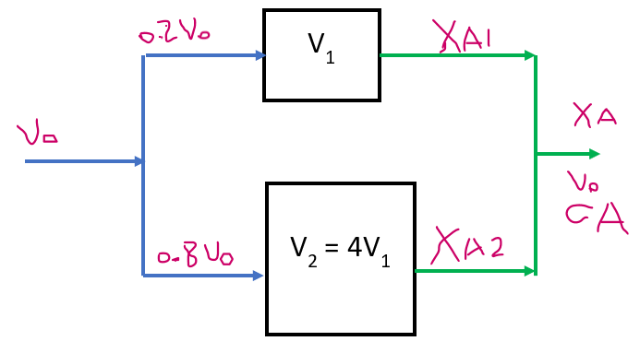
Figure 10. 8. Two CSTRs in parallel for activity 10.2
Solution:
For CSTR1, the rate of the reaction can be written as:
-r_{A1}= kC_{A1}= kC_{Ao} (1-X_{A1})
For CSTR 1, the volume of the reactor is given by:
$V_{1}={0.2F}_{A0}\frac{X_{A1}}{{-r}_{A1}}$; F_{Ao}= C_{Ao}υ_{o}
$V_{1}=0.2C_{Ao}{}_{o}\frac{X_{A1}}{\text{kC}\text{Ao}\text{ (1-XA}\text{1) }}=\frac{0.2{}_{o}}{k}$ $\frac{X_{A1}}{\text{ (1-XA}\text{1) }}$
$\frac{kV_{1}}{{}_{o}}=k1=0.2\frac{X_{A1}}{\text{(1-XA}\text{1) }}=1$
X_{A1} = 5/6 = 0.83
For CSTR 2, the rate of the reaction can be written as:
-r_{A2}= kC_{A2}= kC_{Ao} (1-X_{A2})
For CSTR 2, the volume of the reactor is given by:
$V_{2}={0.8F}_{A0}\frac{X_{A2}}{{-r}_{A2}}$; F_{Ao}= C_{Ao}υ_{o}, V₂ = 4V₁
${4V}_{1}=0.8C_{Ao}{}_{o}\frac{X_{A2}}{\text{kC}\text{Ao}\text{ (1-XA}\text{2) }}=\frac{0.8{}_{o}}{k}$ $\frac{X_{A2}}{\text{ (1-XA}\text{2) }}$
$$\frac{4kV_{1}}{{}_{o}}=4k1=0.8\frac{X_{A2}}{\text{(1-XA}\text{2) }}=4$$
X_{A2} = 5/6 = 0.83
The final conversion after mixing of streams from each reactor can be calculated as follows:
$$X_{A}=\frac{υ_{01}X_{A1}+υ_{02}X_{A2}}{υ_{01}+υ_{02}} =\frac{0.2 υ_{0}X_{A1}+{0.8υ}_{0}X_{A2}}{υ_{0}}$$
X_{A1}=X_{A2}= 0.83
$$X_{A}=0.2 υ_{0}X_{A1}+{0.8υ}_{0}X_{A2}=0.2*0.83+0.8*0.83=0.83$$
The results confirm that the overall conversion is equal to the individual reactor conversion since the feed is split proportional to the size of the reactors.
10.4. Design of Isothermal PFR-CSTR and CSTR-PFR in Series
Combining different types of reactors in series might bring size reduction, increasing yield, achieving high conversion, and sink the heat effect. From design equations of PFR and perfectly mixed CSTR, it is observed that the size of PFR is much smaller than CSTR with the same reaction conditions and conversion level, which are given in equations (10.32) and (10.33), respectively.
$\frac{V}{FA0}=\int_{XA0}^{XA}{\frac{dXA}{(-r_{A})}}$ (10.32)
Where: V is volume of PFR, F_{Ao} is feed mole flow rate, r_{A} is rate of reaction, and X_{A} is conversion of reactant A.
$\frac{V}{F_{A0}}=\frac{X_{A}}{{-r}_{A}}$ (10.33)
Where: V is volume of CSTR, F_{Ao} is feed mole flow rate, r_{A} is reaction rate, and X_{A} is conversion of reactant A.
CSTR is preferred over PFR to sink the heat effect due to perfect mixing.
The sequencing of different types of reactors (PFR-CSTR or CSTR-PFR) in series affects the final overall conversion. To get the highest overall conversion, should it be a PFR followed by a CSTR, or two CSTRs, then a PFR? These questions should be answered with scientific evidence to arrange the reactors in series to achieve the overall conversion. The arrangement depends on the shape of the Levenspiel plot and on the relative reactor sizes ( Levenspiel, 2011, pg. 135). The following general rules are considered for the most effective use of a given set of ideal reactors:
Rule 1: Reactors should be ordered so as to keep the concentration of reactant as high as possible if the rate-concentration curve is concave (n > 1), and as low as possible if the curve is convex (n < 1).
The sequencing /ordering should be PFR followed by CSTR for n > 1; the reverse order should be used when n < 1.
Rule 2: For reactions where the rate-concentration curve passes through a maximum or minimum, the arrangement depends on the actual shape of curve, the conversion level desired, and the reactors available.
Rule 3: Whatever may be the kinetics and the reactor system, an examination of the 1/(-r_{A}) vs. C_{A} curve is a good way to find the best arrangement of reactors.
For two reactors, PFR followed by CSTR in series is shown in Figure 10.9. If two reactors are connected in series, (PFR-CSTR), then the design equation is given by:
$V=V_{1}+V_{2}=FA0\int_{XA0}^{XA1}{\frac{dXA1}{(-r_{A1})}}+\frac{F_{A1}X_{A2}}{{(-r}_{A2})}=FA0(\int_{XA0}^{XA1}{\frac{dXA1}{(-r_{A1})}}+\frac{{(1-X}_{A1}{)X}_{A2}}{{(-r}_{A2})})$ (10.34)
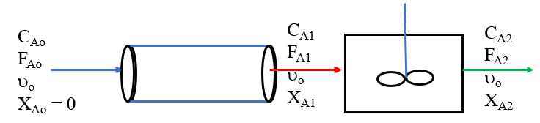
Figure 10.9. PFR- CSTR in series
Similarly, for two reactors, CSTR followed by PFR in series is shown in Figure 10.10. If two reactors are connected in series, (CSTR-PFR), then the design equation is given by:
$V=V_{1}+V_{2}=\frac{F_{Ao}X_{A1}}{{(-r}_{A1})}+FA1\int_{XA1}^{XA2}{\frac{dXA2}{(-r_{A2})}}=FA0(\frac{X_{A1}}{{(-r}_{A1})}{+(1-X}_{A1})(\int_{XA1}^{XA2}{\frac{dXA2}{\left(-r_{A2}\right)}}))$ (10.35)
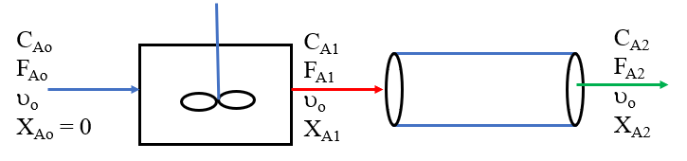
Figure 10.10. CSTR-PFR- in series
Activity 10.3.
An aqueous reactant of A with initial concentration of 4 mol/L enters into two series reactors of CSTR followed by PFR. The reaction is second-order with respect to A, and the volume of CSTR is three times that of PFR. The chemical reaction is conducted at isothermal condition, and the stochiometric equation is given below. Find the concentration at the exit of the PFR if the exit concentration in the CSTR is 1 mol/L.
$$2A\underset{→}{k}P$$
Given: CSTR-PFR in series, second order reaction, C_{Ao}= 4 mol/L, C_{A1}= 1 mol/L, V₁= 3V₂
Required:
C_{A2}=?
Solution:
The CSTR-PFR in series is depicted in Figure 10.11 for activity10.3.
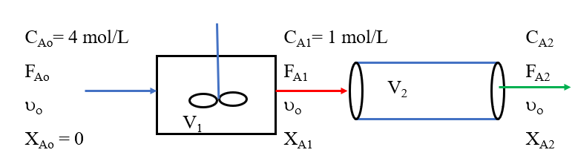
Figure 10.11. CSTR-PFR in series for activity 10.3
For second order reaction of CSTR, the material balance equation can be written as:
$kτ_{1}=\frac{{{ C}_{Ao}-C}_{A1}}{{C_{A1}}^{2}}=\frac{4-1}{1^{2}}=3$ L/mol
For second order reaction of PFR, the material balance equation can be written as:
$kτ_{2}=\frac{1}{{ C}_{A2}}-\frac{1}{{ C}_{A1}}$, but τ₂=1/3τ₁ since V₁= 3V₂
$$1=\frac{1}{{ C}_{A2}}-\frac{1}{1}$$
CA₂ = 0.5 mol/L
Activity 10.4.
An aqueous reactant of A with initial concentration of 4 mol/L enters into two series reactors of PFR followed by CSTR. The reaction is second-order with respect to A, and the volume of CSTR is three times that of PFR. The chemical reaction is conducted at isothermal condition, and the stochiometric equation is given below. Find the concentration at the exit of the CSTR if the exit concentration in the PFR is 1 mol/L.
$$2A\underset{→}{k}P$$
Given: PFR-CSTR in series, second order reaction, C_{Ao}= 4 mol/L, C_{A1}= 1 mol/L, V₂= 3V₁
Required:
C_{A2}=?
Solution: PFR-CSTR in series is depicted in Figure 10.12. for activity10.4.
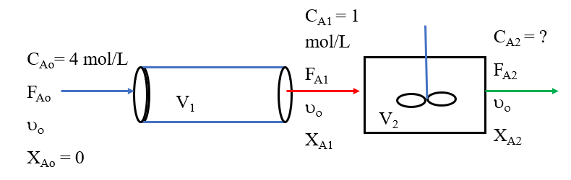
Figure 10.12. PFR-CSTR in series for activity 10.4
For second order reaction of PFR, the material balance equation can be written as:
$kτ_{1}=\frac{1}{{ C}_{A1}}-\frac{1}{{ C}_{Ao}}=\frac{1}{1}-\frac{1}{4}=0.75$ L/mol
For second order reaction of CSTR, the material balance equation can be written as:
$kτ_{2}=\frac{{{ C}_{A1}-C}_{A2}}{{C_{A2}}^{2}}$; but τ₂=3τ₁ since V₂= 3V₁
$kτ_{2}=\frac{{1-C}_{A2}}{{C_{A2}}^{2}}=3kτ_{1}=3*0.75=2.25 L/mol$
It is a quadratic equation of the form:
a$X^{2}+bX+C=0$
$$x=\frac{-b±\sqrt{b^{2}-4ac}}{2a}$$
$2.25{C_{A2}}^{2}+$ $C_{A2}-1=0$
$C_{A2}=0$.48 mol/L or $C_{A2}=-0.92 mol/L$
Concentration is a positive value; and the concentration at the exit of CSTR is 0.48 mol/L.
10.5. Summary
CSTRs in series arrangement is useful for enhancing conversion, improving selectivity, allowing flexibility in operation, and allowing better control over reaction kinetics. The larger the number of CSTRs in series, the behavior of the system approaches to plug flow reactor.
Parallel CSTRs can significantly increase overall production capacity by processing larger volumes of feed simultaneously. For different size of CSTRs in parallel and the volumetric flow rate is split in proportion to each reactor volume, the space time and conversion of each reactor are identical. Combining different types of reactors in series might bring size reduction, increasing yield, achieving high conversion, and sink the heat effect.
References
- Chemical Reaction Engineering, Levenspiel, O John Wiely & Sons, 3rd edition, 2011.
- Elements of Chemical Engineering, Fogler, HS Prentice- Hall Inc Prentice- Hall Inc, 5th edition, 2015.

