Chemical Reaction Engineering II- Reactor Design (ChEg 4101)
Prerequisite: Chemical Reaction Engineering I-Reaction Kinetics (ChEg3104)
Lecture 11: Design of Catalytic Reactors: Design of Packed (Fixed) Bed and Movable Bed Reactors
Week 11
Lecturer: Adamu Esubalew (PhD, ChEg)
Addis Ababa, Ethiopia

Lecture learning outcomes
At the end of the lecture, you will be able to:
- identify characteristics of catalytic reactors,
- describe the characteristics of packed bed and moving bed reactors,
- explain the design parameters for packed bed reactor,
- clarify the design parameters for moving bed reactor,
- design of packed bed reactor, and
- design of moving bed reactor.
11.1 Introduction to catalytic reactors
Catalytic reactors convert raw materials into products with the aid of catalysts. Catalytic reactors are used for heterogeneous phases. Designing a reactor in which a fluid reaction is promoted by a solid catalyst differs little from designing a reactor for homogeneous reactions. The heterogeneous reaction kinetics rate law is often more complex than a homogeneous one since it incorporates both mass transfer and reaction rates. This complexity can make the fundamental design equation more difficult to solve analytically. Numerical solution is mostly used to design reactors for catalytic reactions.
Catalytic reactors are commonly tubular reactors. In catalytic reactors, reactant fluid can be made to contact solid catalyst in many ways. Catalytic reactors can be fixed (packed) bed, moving bed and fluidized-bed reactors. In this lecture, fixed (packed) bed and moving bed reactors are discussed, and fluidized bed reactor will be covered in lecture 12.
Stirred tank reactors for solid-catalyzed fluid phase reactions are less frequently used because of the difficulty in separating the phases and agitating a fluid phase in the presence of solid particles. One type of continuous stirred tank used to study catalytic reactions is the spinning basket reactor, which has the catalyst embedded in the blades of the agitator.
11.2 Packed bed reactor characteristics and design parameters
11.2.1. Characteristics of packed bed reactor
Packed (fixed) bed reactor is a cylindrical tube, randomly filled with catalyst particles, which may be spheres or cylindrical pellets. Packed-bed reactor is tubular reactor filled with catalyst particles. In PBR, it is the weight of catalyst W that is important, rather than the reactor volume. A packed bed reactor is depicted in Figure 11.1 (Fogler, 2015, pg. 38). The reactant fluid flows in the void space around the catalyst pellets, and which reacts on surface and inside the pore of the catalyst pellets.
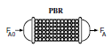
Figure 11.1. Packed bed reactor
PBR is needed where the conversion of reactants into products is facilitated by a catalyst. The fluid flow (gases flow) approximate plug flow. It provides efficient contacting of reactants with catalyst particles in a reactor. It gives the highest conversion per weight of catalyst for most reactions. It is suitable for a wide range of chemical reactions. It is well-suited for continuous processes, providing steady-state conditions for prolonged reactions.
PBR offers a large surface area for catalytic reactions, enhancing efficiency and more product formation due to increased reactant or catalyst contact. It is suitable for installations with space constraints and easy to build. It is particularly valuable in continuous operations, large-scale production, and processes requiring solid catalysts. In packed bed reactor, effective temperature control of large packed bed reactors can be difficult for exothermic reactions that causes hot spots or collapse of the catalyst. Very small sizes of catalyst particles cannot be used because of plugging and high-pressure drops.
The arrangement of packed bed reactor is shown in Figure 11.2 (Levenspiel, 2011, pg. 428). Figure 11.2a depicts that a packed bed reactor shows how the problem of hot spots can be occurred, but it requires less amount of catalyst. Figure 11.2b describes that a packed bed reactor shows how the problem of hot spots can be substantially reduced by increasing the cooling surface. Figure 11.2c illustrates that a packed bed reactor shows how intercooling can still further control the temperature.
- In the first stage where reaction is fastest, conversion is kept low by having less catalyst present than in the other stages.
- Multistage cooling units can all be incorporated in a single shell or can be kept separate with heat exchanges between stages.
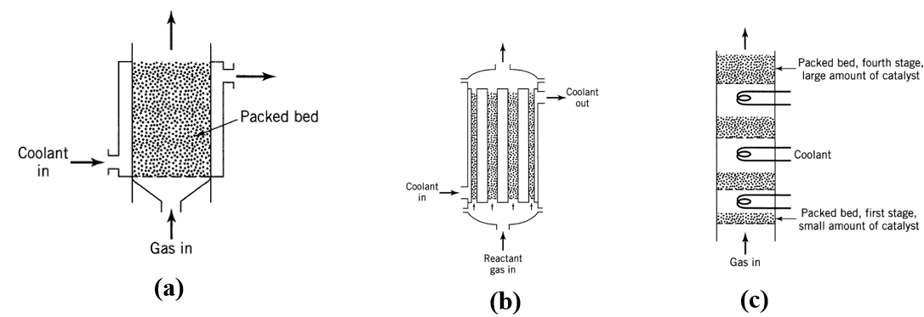
Figure 11.2. Packed bed reactor (a) single stage catalyst, (b) horizontal multistage, and (c) vertical multistage arrangements
11.2.2. Packed bed reactor design parameters
Designing a catalytic fixed or packed bed reactor includes several critical parameters that influence the reactor's performance, efficiency, and overall effectiveness. Some of the design parameters are the followings:
Catalyst characteristics: The type of catalyst, particle size, shape, and surface area are required characteristics of a catalyst. The choice of catalyst affects activity, selectivity, and stability. The smaller particles enhance mass transfer but may increase pressure drops. The common shapes include pellets, spheres, or extrudates, which determine the surface area available. A higher surface area increases reaction rates but may also lead to increased pressure drops.
Flow rate: The volumetric flow rate of reactants influences residence time and conversion. The fluid dynamics, laminar vs. turbulent flows regimes, which affect mass transfer and pressure drops.
Phase of fluids: The phase of the reactants influences flow patterns and heat transfer.
Temperature: The reactor should be designed to maintain optimal temperatures for the reaction, often requiring heating or cooling systems. Understanding how temperature varies along the bed is crucial for maximizing reaction rates and preventing hot spots.
Pressure: The reactor should be designed to withstand the operating pressure, which can affect reaction rates for gas-phase reactions. Determining the pressure drops across the bed is essential to ensure adequate flow while minimizing energy costs.
Catalyst bed configuration: Depending on the reaction and scale, multiple beds may be used in series or parallel to enhance conversion and selectivity.
Flow patterns: Co-current, counter-current, or cross-flow configurations can be selected based on desired performance.
Therefore, the design of a catalytic fixed bed reactor is required careful consideration of multiple parameters to achieve the desired conversion, selectivity and yield.
11.3. Moving bed reactor characteristics and design parameters
11.3.1. Characteristics of moving bed reactor
In moving bed reactor, the catalyst is in the form of a free-flowing bed and is continuously circulated through the reactor. It has plug flow characteristics. It is suitable for both exothermic and endothermic reactions, gas-solid and liquid-solid reactions. It has high catalyst activity, maximizing reaction rates. The moving-bed reactor is an intermediate case between packed-bed reactor (PBR) and fluidized-bed reactor (FBR). It requires additional equipment for catalyst circulation and separation. It is exposed for catalyst attrition. i.e. breakdown/ deactivation of catalysts. Fluid reactants may bypass catalyst bed.
Moving bed reactor is illustrated in Figure 11.3 (Levenspiel, 2011, pg. 429). In a moving bed reactor, the catalyst particles are in motion, either continuously or periodically, which helps to maintain a uniform distribution and enhances contact between the reactants and the catalyst. The catalyst may be moved by gravity to ensure consistent catalyst performance and minimize channeling.
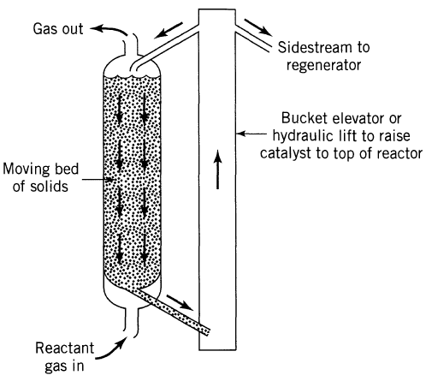
Figure 11.3. Moving bed reactor
The movement of catalyst particles improves the mass transfer rate between the gas or liquid phase and the catalyst surface, resulting in higher reaction rate. The continuous movement of catalyst allows for effective heat controlling, which is fundamental for exothermic reaction. Moving bed reactor is designed for continuous operation, which enhances productivity and reduces downtime. However, moving bed reactor catalyst can be exposed for deactivation.
11.3.2. Moving bed reactor design parameters
For design of a catalytic moving bed reactor (MBR), several parameters are considered to ensure desired conversion, efficiency, and safe operation. Some of the design parameters of MBR are described in the following paragraphs:
Catalyst properties: The catalysts particle size, density and shape influence the design of MBR. The catalysts particle size distribution affects flow behavior, pressure drops, and reaction rates. The density of the catalyst influences the bed dynamics and movement of the catalyst. The catalysts shapes (spherical or irregular) can affect flow characteristics and packing efficiency.
Velocity of fluid: The fluid velocity affects mass transfer rate. The minimum fluid velocity required to keep the catalyst particles in motion. The actual fluid velocity during operation should be optimized for effective mass transfer without excessive energy consumption.
Heat transfer area: It affects the heat exchange rate, and overall performance of the reactor. Design of MBR should accommodate heat exchangers for exothermic reaction or endothermic reaction. It is serious for maintaining desired temperature profiles within the reactor.
Diffusion coefficient: It determines rate of mass transfer. It is relevant for gas-solid phase reactions.
Catalyst activity: The activity of the catalyst determines the overall conversion and performance of the reactor. The design of MBR should allow for periodic regeneration of catalyst to maintain activity over time. The regeneration conditions are also considered to maintain the activity of the catalyst.
Therefore, the design of a catalytic MBR requires careful consideration of various parameters that influence its performance and efficiency.
11.4. Design of packed bed reactor
The design of packed bed reactor (PBR) is analogous of plug flow reactor (PFR), the volume (V) of PFR is replaced by weight of catalyst(W) for PBR. In PBR, it is the weight of catalyst W that is important, rather than the reactor volume. The design equations for PBR are materials balance, pressure drop and energy balance. The design equations of PBR are determined using differential weight of catalyst since concentration, pressure and temperature vary with the bed length of the catalyst. The materials balance equation of PBR can be expressed based on weight of catalyst, volume of catalyst or surface area of the catalyst.
The reactor design involving fluid-solid heterogeneous reactions is that the reaction takes place on the catalyst bed or surface of the catalyst. However, for homogeneous reactions, the reaction is taking placed in the volume of the reactor. For PBR, the greater the mass of a given catalyst, the greater the reactive surface area. Consequently, the reaction rate is based on mass of solid catalyst, W, rather than on reactor volume, V. For a fluid–solid heterogeneous system, the rate of reaction of a species A is defined as:
Rate of reaction= mol A reacting/(time x mass of catalyst)
${{-r}^{'}}_{A}=mol of A reacting/( time xW)$ (mol/ g.s) (11.1)
By multiplying the heterogeneous reaction rate (-r_{A}′) by the bulk catalyst density (ρ_{b}), you can obtain the homogeneous reaction rate (-r_{A}).
${{{(-r}_{A})=(-r}^{'}}_{A}){}_{b}$ (g/dm³)(mol/ g.s) = (mol/ dm³.s) (11.2)
11.4.1. Materials balance equation
The derivation of the design equation for a packed-bed catalytic reactor (PBR) will be carried out in a manner analogous to the development of the PFR design equation. Let’s consider the differential weight of catalyst pellets of PBR or volume of PBR filled by catalyst particles as shown in Figure 11.4 (Fogler, 2015, pg. 19). The PBR is operated at steady state condition.
The material balance equation of species A for PBR is given by:
Rate of input- Rate of output + rate of generation = 0
$F_{A}W-F_{A}W+W+{r^{'}}_{A}W=0$ (11.3)
The unit of ${r^{'}}_{A}$ is mol/ (time. mass of catalyst) (mol/ g.s)
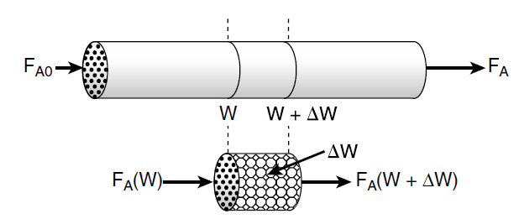
Figure 11.4. Packed bed reactor with differential weight of catalyst
By re-arranging equation (11.3), you get:
$\frac{(F_{A}W-F_{A}W+W)}{W}$=${{-r}^{'}}_{A}$ (11.4)
By taking the limit of the differential weight of catalyst goes to zero, the materials balance equation can be written as:
$\lim_{W→0}{\frac{(F_{A}W-F_{A}W+W)}{W}}$ = $\frac{{dF}_{A}}{dW}=$ ${r^{'}}_{A}$ (11.5)
$F_{A}=F_{Ao}(1-X_{A})$ (11.6)
By differentiating equation (11.6), you get:
${dF}_{A}={-F}_{Ao}{dX}_{A}$ (11.7)
By substituting equation (11.7) into equation (11.5), you get:
$\frac{{-F}_{Ao}{dX}_{A}}{dW}=$ ${r^{'}}_{A}$ (11.8)
By re-arranging and integrating equation (11.8), you get:
$\frac{W}{F_{A0}}=\int_{0}^{X_{A}}{\frac{{dX}_{A}}{{{-r}^{'}}_{A}}}$ (11.9)
It is the design equation of PBR based on weight of catalyst.
Where: W is weight of catalyst, F_{Ao} is feed mole flow rate of reactant A, ${r^{'}}_{A}$ is rate of reaction in the weight of the catalyst, and X_{A} is conversion of reactant A.
Similarly, based on surface area of the catalyst, the materials balance equation for PBR is given by:
$F_{A0}{dX}_{A}=\left({{-r}^{''}}_{A}\right)dS$ (11.10)
By re-arranging and integrating equation (11.10), you get
$\frac{S}{F_{A0}}=\int_{0}^{X_{A}}{\frac{{dX}_{A}}{{{-r}^{''}}_{A}}}$ (11.11)
It is the design equation of PBR based on surface area of solid catalyst.
Where: S is surface area of catalyst, F_{Ao} is feed mole flow rate of reactant A, ${r^{''}}_{A}$is rate of reaction in the surface area, and X_{A} is conversion of reactant A.
Activity 11.1
A researcher plans to convert methylamine to dimethylamine using a silica-alumina catalyst. The molar flow rate of the feed into a packed-bed reactor is 24 mol/s, and the volumetric flow rate is 6 L/s. Assume there is no pressure drop or temperature change in the reactor. The stochiometric equation and the reaction rate are given below. How many kilograms of catalyst is loaded into a packed bed reactor to obtain a conversion of 60% of methylamine?
$$\text{2CH}\text{3}\text{NH}\text{2} \text{ (CH}\text{3}\text{)}\text{2}\text{NH + NH}\text{3}$$
$$\text{2A }\underset{→}{k^{'}}\text{ B + C}$$
${{{-r}_{A}}^{'}={k'C}_{A}}^{2}$
$k'=4.25*{10}^{-2}$L²/mol.kg.s
Given:
Packed bed reactor, second order reaction
F_{Ao}= 24 mol/s, υ_{o}= 6L/s; C_{Ao}= F_{Ao}/ υ_{o}
$${{{-r}_{A}}^{'}={k'C}_{A}}^{2}=k'C_{Ao}2\left(1-X_{A}\right)2$$
$k'=4.25*{10}^{-2}$L²/mol.kg.s, X_{A}= 60% = 0.60
Required:
W = ?
Solution:
$\frac{W}{F_{A0}}=\int_{0}^{X_{A}}{\frac{{dX}_{A}}{{{-r}^{'}}_{A}}}$ (11.9)
W$=F_{A0}\int_{0}^{X_{A}}{\frac{{dX}_{A}}{{{-r}^{'}}_{A}}}=$ $\frac{F_{A0}}{k'C_{Ao}2}\int_{0}^{X_{A}}{\frac{{dX}_{A}}{\left(1-X_{A}\right)2 }=}\frac{F_{Ao}}{k'{C^{2}}_{Ao}}(\frac{1}{1-X_{A}}$)⎢${X_{A}=0.60 \atop X_{A}=0}=$ $\frac{2_{o}}{k'F_{A0}}(\frac{1}{1-X_{A}}$)⎢${X_{A}=0.60 \atop X_{A}=0}$
W$=$ $\frac{62}{24*4.25*{10}^{-2}}\left(\frac{1}{1-0.6}-1\right)=52.9453 kg$
11.4.2. Pressure drops across the catalyst bed
The differential form of the design equations should be used when analyzing reactors that have a pressure drop along the length of the reactor. The liquid flow pressure drops across a tube for constant density liquids is given by:
$\frac{dP}{dZ}=-$ρg (11.12)
Where: P is pressure, g is acceleration due to gravity, ρ is density of liquid, and Z is length of a tube in liquid flows.
For PBR, the fluids are gases which are compressible, and the pressure drops across solid catalyst bed must account the characteristics of the fluids. Hence, Ergun equation is often used to calculate pressure drop in a packed porous catalyst bed for gas reactants (Fogler, 2015, pg. 171-174).
The Ergun equation that can be used to calculate pressure drop in a packed porous bed is given by:
$\frac{dP}{dZ}=-\frac{G}{ρd_{p}}(\frac{1-ϕ}{ϕ^{3}})[\frac{150\left(1-ϕ\right)µ}{d_{p}}+1.75G]$ (11.13)

Where: P is pressure, d_{P} is diameter of particle in the bed, μ is viscosity of gas passing through the bed, Z is length down the packed bed of pipe, ρ is gas density, and G is superficial mass velocity.
From equation (11. 13), term 1 is dominant for laminar flow, and term 2 is dominant for turbulent flow. The Ergun equation shows variation of pressure drop across the length of the reactor.
$ϕ=porosity=\frac{volume of void}{total bed volume}=void fraction$ (11.14)
$1-ϕ=\frac{volume of solid}{total bed volume}=solid fraction$ (11.15)
For tubular packed-bed reactors, we are more interested in catalyst weight rather than the distance z down the reactor. The weight/ mass of solid catalyst related with volume of catalyst is given by:
W$=ρcVs(1-ϕ)$ (11.16)
Where: W is weight of catalyst, V_{s} is volume of solid catalyst, ρ_{c} is density of catalyst, and ϕ is void faction of the solid catalyst.
The volume of solid catalyst related with the cross-sectional area and length of catalyst bed can be written as.
$V_{s}=A_{c}Z$ (11.17)
By substituting equation (11.17) into equation (11.16), you get:
The weight/ mass of solid catalyst related with catalyst bed cross-sectional area, length, density and void fraction can be written as:
W$=ρcA_{c}Z(1-ϕ)$ (11.18)
By re-arranging equation (11.18), the length of the catalyst bed can be expressed as:
$Z=\frac{W}{ρcA_{c}(1-ϕ)}$ (11.19)
Where: W is weight of catalyst, A_{c} is cross-sectional area of catalyst bed, Z is length of catalyst bed, catalyst, ρ_{c} is density of catalyst, and ϕ is void faction of the solid catalyst.
By differentiating equation (11.19), you get:
$dZ=\frac{dW}{ρcA_{c}(1-ϕ)}$ (11.20)
By substituting equation (11.20) into equation (11.13), you get:
$\frac{dP}{dW}=-\frac{G}{ρcA_{c}\left(1-ϕ\right)ρd_{p}}(\frac{1-ϕ}{ϕ^{3}})[\frac{150\left(1-ϕ\right)µ}{d_{p}}+1.75G]$ (11.21)
The bulk density of the catalyst, ρ_{b} (mass of catalyst per volume of reactor bed), is just the product of the density of the solid catalyst particles, ρ_{c} , and the fraction of solids, (1 – ϕ):
$ρ_{b} = ρ_{c} (1 - ϕ)$ (11.22)
By substituting equation (11.22) into equation (11.21), you get:
$\frac{dP}{dW}=-\frac{G}{A_{c}ρ_{b}ρd_{p}}(\frac{1-ϕ}{ϕ^{3}})[\frac{150\left(1-ϕ\right)µ}{d_{p}}+1.75G]$ (11.23)
From Ergun equation for steady state process, the only parameter that varies with pressure on the right-hand side of equation (11.23) is the gas density, ρ. Since the PBR is operated at steady state, the mass flow rate at any point down the reactor, $\dot{m}$ (kg/s), is equal to the entering mass flow rate, ${\dot{m}}_{0}$.
${\dot{m}}_{0}=\dot{m}$ (11.24)
$ρ_{0}υ_{0}=ρυ$ (11.25)
$ρ=ρ_{0}\frac{υ_{0}}{υ }$ (11.26)
From ideal gas law: $\text{P}\text{ = FRT}$ (11.27)
In the ideal gas law, the feed stream volumetric flow rate is given by:
$\text{o}=\frac{\text{F}\text{o}\text{RT}\text{o }}{\text{P}\text{o }}$ (11.28)
Similarly, the outgoing stream volumetric flow rate is given by:
$=\frac{\text{FRT} }{\text{P} }$ (11.29)
By substituting equations (11.28 & 11.29) into equation (11.26), you get:
$ρ=ρ_{o}\frac{F_{o}}{F}\frac{P}{P_{o}}\frac{T_{o}}{T}$ (11.30)
Now, let’s substitute equation (11.30) into equation (11.23), the Ergun equation can be written as:
$\frac{dP}{dW}=-\frac{G}{A_{c}ρ_{b}ρ_{o}d_{p}}(\frac{1-ϕ}{ϕ^{3}})[\frac{150\left(1-ϕ\right)µ}{d_{p}}+1.75G]\frac{F}{F_{o}}\frac{P_{o}}{P}\frac{T}{T_{o}}$ (11.31)
The outgoing stream mole flow rate is expressed in terms of feed stream mole flow rate and conversion as follows:
$\text{F = }F_{o}\text{( 1+}\text{X)}$ (11.32)
Where: F is outgoing stream mole flow rate, F_{o} feed stream mole flow rate, ε is volume fraction, and X is conversion.
By substituting equation (11.32) into equation (11.31), you get:
$\frac{dP}{dW}=-\frac{G}{A_{c}ρ_{b}ρ_{o}d_{p}}(\frac{1-ϕ}{ϕ^{3}})[\frac{150\left(1-ϕ\right)µ}{d_{p}}+1.75G] \text{( 1+}\text{X)}\frac{P_{o}}{P}\frac{T}{T_{o}}$ (11.33)
This equation shows that conversion is dependent on pressure drop across the catalyst weight for PBR.
Therefore, to find the conversion of reactants in catalytic PBR, equation (11.8) and equation (11.33) should be solved simultaneously since both are interdependent.
11.4.3. Energy balance equation
PBR is operated at steady state condition. Energy balance equation for PBR is analogous of plug flow reactor (PFR). The energy balance equation derivation details for non-isothermal PFR is found in lecture 6 (Refer lecture 6). The energy balance equation in terms of molar flow rate is given by:
$\frac{dT}{dW}=\frac{{r_{A}}^{'} {∆H}_{Rx}(T)-\frac{Ua}{ρ_{b}}(T-T_{a})}{\sum{F_{i}C_{P_{i}}}}$ (11.34)
Where: T is temperature, r_{A}′ is rate of reaction, ΔH_{Rx} is change in heat of reaction, W is weight of catalyst, F_{i} is molar flow rate of species i, U is overall heat transfer coefficient, a is surface area per unit volume, ρ_{b} is catalyst bulk density, C_{pi} is specific heat capacity of species i, and T_{a} is temperature of heat supply.
The energy balance equation in terms of conversion can be written as:
$\frac{dT}{dW}=\frac{{r_{A}}^{'} {∆H}_{Rx}(T)-\frac{Ua}{ρ_{b}}(T-T_{a})}{F_{A0}(\sum{{}_{i}C_{P_{i}}}+∆C_{P}X_{A})}$ (11.35)
Weight of catalyst = bulk density of catalyst * volume of reactor bed
$W=ρ_{b}*V$ (11.36)
$dW=ρ_{b}*dV$ (11.37)
Where: T is temperature, r_{A}′ is rate of reaction, ΔH_{Rx} is change in heat of reaction, W is weight of catalyst, F_{Ao} is feed flow rate of species A, Φ_{i} is ratio of molar flow of species i to species A, X_{A} is conversion of species A, U is overall heat transfer coefficient, a is surface area per unit volume, ρ_{b} is catalyst bulk density, C_{pi} is specific heat capacity of species i, and T_{a} is temperature of heat supply.
11.5 Design of moving bed reactor
Moving bed reactor design is developed using materials balance equation and catalyst activity deactivation rate equation. The catalyst moves with a fluid which prevents hotspot formation and the temperature of the reactor is considered as isothermal. Reaction systems with significant catalyst decay require the continual regeneration and/or replacement of the catalyst. Moving bed reactor is operated at steady state condition. The materials balance equation for moving bed reactor is analogous of PBR. A moving bed reactor with differential weight of catalyst is shown in Figure 11.5 (Fogler, 2015, pg. 468).
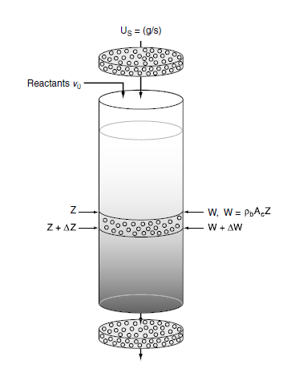
Figure 11.5. Moving bed reactor with differential weight of catalyst
The material balance equation of species A for moving bed is given by:
Rate of input- Rate of output + rate of generation = 0
$F_{A}W-F_{A}W+W+{r^{'}}_{A}W=0$ (11.38)
By re-arranging equation (11.38), you get:
$\frac{(F_{A}W-F_{A}W+W)}{W}$=${{-r}^{'}}_{A}$ (11.39)
$\lim_{W→0}{\frac{(F_{A}W-F_{A}W+W)}{W}}$ = $\frac{{dF}_{A}}{dW}=$ ${r^{'}}_{A}$ (11.40)
$F_{A}=F_{Ao}(1-X_{A})$ (11.41)
By differentiating equation (11.41), you get:
${dF}_{A}={-F}_{Ao}{dX}_{A}$ (11.42)
By substituting equation (11.42) into equation (11.40), you get:
$F_{Ao}\frac{{dX}_{A}}{dW}=$ ${{-r}^{'}}_{A}$ (11.43)
The unit of rate of reaction is mol/ (time*mass of catalyst)
The rate of reaction at any time t is given by:
${{-r}^{'}}_{A}=a\left(t\right)[{{-r}^{'}}_{A}\left(t=0\right)]$ (11.44)
Where: a(t) is activity of catalyst at any time t.
By substituting equation (11.44) into equation (11.43), the materials balance design equation can be written as:
$\frac{{dX}_{A}}{dW}=$ $F_{Ao}a\left(t\right)[{{-r}^{'}}_{A}\left(t=0\right)]$ (11.45)
The activity is a function of the time the catalyst has been in contact with the reacting gas stream. The catalyst activity decay rate law is given by:
$-\frac{da}{dt}=k_{d}a^{n}$ (11.46)
Where: a is activity of catalyst, t is contact time, k_{d} is decay rate constant, and n is order of decay of activity.
The activity of catalyst has values from 0 to 1. The activity is found both in materials balance and decay rate law. Now, it is needed to relate the contact time to the weight of the catalyst. Let’s consider a point z in the reactor (Figure 11.5), where the reactant gas has passed concurrently through a catalyst weight W. Since the solid catalyst is moving through the bed at a rate U_{s} (mass per unit time), the time t that the catalyst has been in contact with the gas when the catalyst reaches a point z is:
$t=\frac{W}{U_{s}}$ (11.47)
Where: t is contact time, W is weight of catalyst, and Us is catalyst moving rate through catalyst bed.
By differentiating equation (11.47), you get:
$dt=\frac{dW}{U_{s}}$ (11.48)
By substituting equation (11.48) into equation (11.46), the activity decay can be written as:
$-\frac{da}{dW}=\frac{k_{d}}{U_{s}}a^{n}$ (11.49)
The two coupled differential equations (11.45 & 11.49) are numerically solved simultaneously with an ordinary differential equation solver. e.g. Polymath.
Activity 11.2
The two reactants A and B are converted into product C in catalytic moving bed reactor as shown below in the stochiometric equation. The volumetric flow rate of the reactants is 0.25 L/min and the initial concentration of reactant A is 4.5 mol/L. It is assumed that reactants A and B are entered to the reactor with equimolar ratio. The reaction rate is second order with respect to A, and the rate constant is 0.125 L²/ mol .kg. min. The solid weight of the catalyst initially entered to the reactor is 0.15 kg and increased to 3 kg due to deactivation of the solid catalyst. The density of the catalyst is 1.78 kg/L. The deactivation rate of the solid catalyst is assumed second order and the rate constant is 0.25 min⁻¹. The catalyst activity is initially 1.0. Based on the given data, plot the profiles of conversion of reactants and activity of the catalyst when the weight of the catalyst is increased from 0.15 to 3 kg.
$A+B\underset{→}{k^{}}$C
Given:
Catalytic moving bed reactor, second order reaction, equimolar of reactant A and reactant B
υ_{o}= 0.25 L/min, C_{Ao}= C_{Bo}= 4.5 mol/L, k′= 0.125 L²/ mol .kg. min.
W= 0.15-3.0 kg
The density of the catalyst is 1.78 kg/L.
The deactivation rate of the solid catalyst is assumed second order
k_{d} = 0.25 min⁻¹.
Activity, a(t = 0) = 1.0
Required:
Plot the profiles of conversion and activity as a function of weight of catalyst.
Solution:
$\frac{{dX}_{A}}{dW}=$ $F_{Ao}a\left(t\right)[{{-r}^{'}}_{A}\left(t=0\right)]$ (11.45)
$\frac{da}{dW}=\frac{k_{d}}{U_{s}}a^{n}$ (11.49)
The two coupled differential equations (11.45 & 11.49) are numerically solved simultaneously with an ordinary differential equation solver. Let’s use polymath (polymath 6.10 professional – trial version) ordinary differential equation solver to plot conversion and catalyst activity profiles.
Polymath program: Conversion and activity of catalyst as a function of weight of catalyst.
d(a) / d(w) = -(k_{d}*a*a)/U_{s} #Catalyst deactivation
a(0) = 1
k_{d}= 0.5 # min⁻¹
d(X_{A}) / d(W) = (-r_{A})/ F_{A0} # Moving bed reactor design equation using materials balance
X_{A}(0) = 0
r_{A}=- k′*C_{A0}*C_{A0}*(1-X_{A})*(1-X_{A})
F_{A0}=υ_{o}*C_{A0}
C_{A0}=4.5 # mol/L
υ_{o}= 0.25 # L/min
k′=0.125 # L2/ mol .kg. min.
U_{s}=ρ*υ_{o}
ρ = 1.780 #kg/L
W(0)= 0.15 #kg
W(f)=3# kg
The conversion and activity of catalyst as a function of weight of catalyst is shown in Figure 11.6.
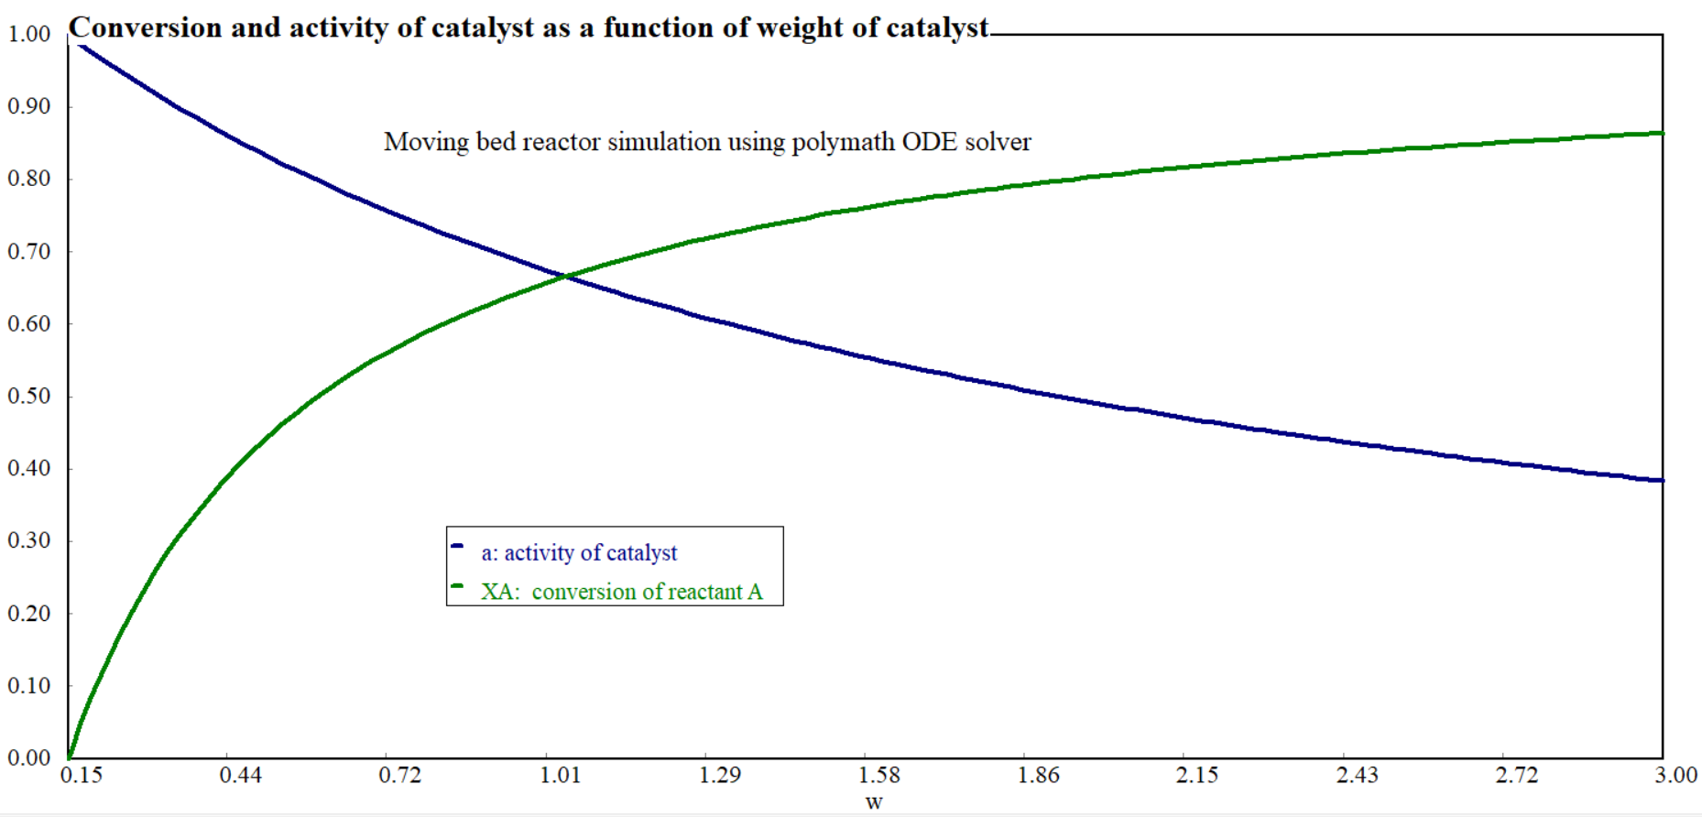
Figure 11.6. Conversion and activity of catalyst as a function of weight of catalyst
Simulation results (Figure 11.6) confirms that the conversion of reactant A is increased exponentially with weight of catalyst from 0.15 to 3 kg. The weight of the catalyst is increased from 0.15 to 3 kg due to catalyst deactivation to achieve the desired conversion. The activity of the catalyst is decreased exponentially with weight of catalyst from 0.15 to 3 kg. The conversion of reactant and activity of catalyst decay curves cross each other at 1.01 kg weight of catalyst.
11.5 Summary
Catalytic reactors convert raw materials into products with the aid of catalysts. Packed-bed reactor is tubular reactor filled with catalyst particles. The materials balance equation of PBR can be expressed based on weight of catalyst, volume of catalyst or surface area of the catalyst. To find the conversion of reactants in catalytic PBR, material balance, pressure drop and energy balance equations should be solved simultaneously since all are interdependent. In moving bed reactor, the catalyst moves with a fluid which prevents hotspot formation. For moving bed reactor, the materials balance and activity of catalyst equations should be solved simultaneously since both are mutually dependent.
References
- Chemical Reaction Engineering, Levenspiel, O John Wiely & Sons, 3rd edition, 2011.
- Elements of Chemical Engineering, Fogler, HS Prentice- Hall Inc Prentice- Hall Inc, 5th edition, 2015.

