Chemical Reaction Engineering II- Reactor Design (ChEg 4101)
Prerequisite: Chemical Reaction Engineering I-Reaction Kinetics (ChEg3104)
Lecture 13: Non-Ideal Flows of Fluids and Reactor Models: Non-ideal Flows of Fluids
Week 13
Lecturer: Adamu Esubalew (PhD, ChEg)
Addis Ababa, Ethiopia

Lecture learning outcomes
At the end of the lecture, you will be able to:
- identify non-ideal flows of fluids,
- describe fluid flow residence time distribution (RTD),
- explain characteristics of tracers for RTD measurement,
- construct the curves for C(t), E(t) and F(t) using tracer test responses, and
- determine the mean residence time (t_{m}).
13.1. Introduction to non-ideal flows of fluids
In ideal reactors, fluid flow patterns can be categorized into plug flow and mixed flow on the basis of size of reactor, mixing, and distribution of concentration. But, in real reactors the fluid flow pattern deviates from these ideal reactors. There are three factors that affect the contact or flow pattern of fluids in real reactors. These factors are:
- the state of segregation of the flowing material, its tendency to clump and for a group of molecules to move about together,
- the earliness and lateness of mixing of material in the vessel, and
- the residence time distribution (RTD) of material which is flowing through the vessel.
Deviation from the two ideal flow patterns can be caused by channeling of fluid, by recycling of fluid, or by creation of stagnant regions in the vessel. Figure 13.1 shows this behavior (Levenspiel, 2011, pg.258).
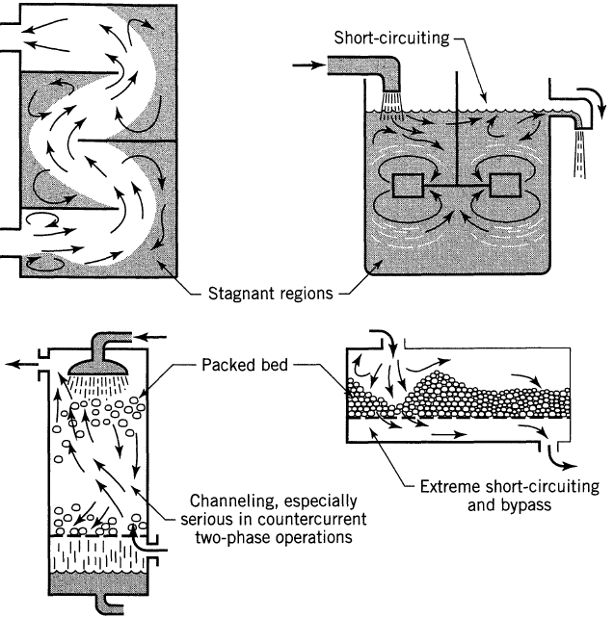
Figure 13.1. Non-ideal flow patterns which may exist in process equipment
In all types of reactors, this type of flow should be avoided since it always lowers the performance of the reactors. If we know precisely what is happening within the vessel and we have a complete velocity distribution map for the fluid in the vessel, then we will, in principle, be able to predict the behavior of a vessel as a reactor. Let’s be less ambitious and see what it is that we actually need to know how long the individual molecules stay in the vessel, the distribution of residence times of the flowing fluid. This information can be determined easily and directly by a widely used method of inquiry, the stimulus-response experiment.
13.2 Segregation of the flow stream
Flowing material is in some particular state of aggregation, depending on its nature. In the extremes these states can be called microfluids and macrofluids, as sketched in Figure 13.2 (Levenspiel, 2011, pg. 259).
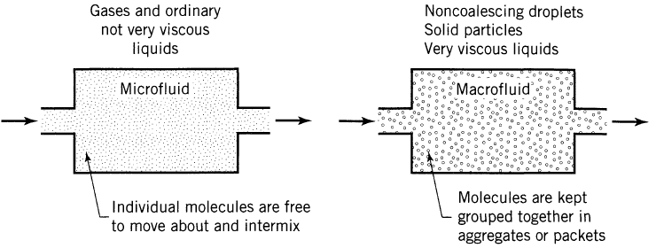
Figure 13.2. Two extremes of aggregation of fluid
For two-phase systems, a stream of solids always behaves as a macrofluid, but for gas reacting with liquid, either phase can be a macro- or microfluid depending on the contacting scheme being used. The sketches of Figure 13. 3 (Levenspiel, 2011, pg. 259) show completely opposite behavior.
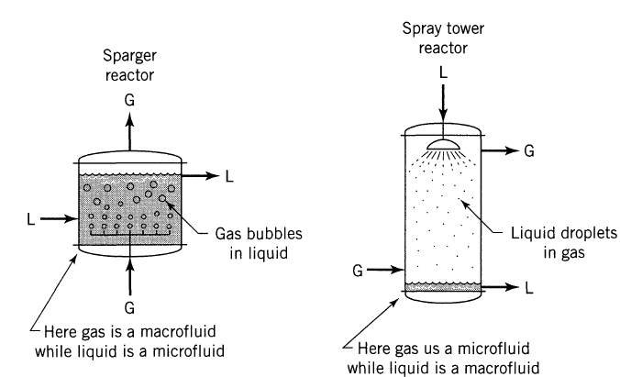
Figure 13.3. Examples of macro- and microfluid behavior
The problem associated with the mixing of fluids during reaction is important for extremely fast reactions in homogeneous systems, as well as for all heterogeneous systems. This problem has two overlapping aspects:
- the degree of segregation of the fluid, or whether mixing occurs on the microscopic level (mixing of individual molecules) or the macroscopic level (mixing of clumps, groups, or aggregates of molecules), and
- the earliness of mixing, or whether fluid mixes early or late as it flows through the vessel.
When a microfluid containing reactant A is treated in mixed flow reactor as shown in Figuree 13. 4 (Levenspiel, 2011, pg. 351), the reactant concentration everywhere drops to the low value prevailing in the reactor.
Figure 13.4. Difference in behavior of microfluids and macrofluids in mixed flow reactors
When a microfluid containing reactant A is treated in mixed flow reactor as shown in Figuree 13.4, the reactant concentration everywhere drops to the low value prevailing in the reactor. No clump of molecules retains its high initial concentration of A. We may characterize this by saying that each molecule loses its identity and has no determinable past history. In other words, by examining its neighbors we cannot tell whether a molecule is a newcomer or an old-timer in the reactor. For this system the conversion of reactant is found by the usual methods for homogeneous reactions.
When a macrofluid enters a mixed flow reactor, the reactant concentration in an aggregate does not drop immediately to a low value but decreases in the same way as it would in a batch reactor. Thus, a molecule in a macrofluid does not lose its identity, its past history is not unknown, and its age can be estimated by examining its neighboring molecules. For this system the conversion of reactant is found by considering the effect of aggregates of molecules in macrofluids.
The difference in behavior of microfluids and macrofluids in the reaction of A and B is shown in Figure 13.5 (Levenspiel, 2011, pg. 362). When two miscible fluids A and B are mixed; we normally assume that they first form a homogeneous mixture which then reacts. However, when the time required for A and B to become homogeneous is not short with respect to the time for reaction to take place, reaction occurs during the mixing process, and the problem of mixing becomes important.
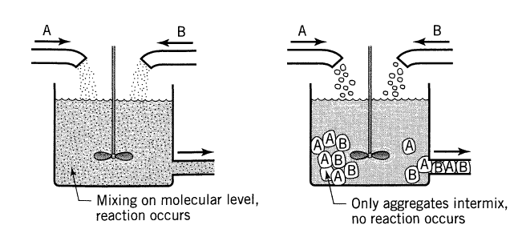
Figure 13.5. Difference in behavior of microfluids and macrofluids in the reaction of A and B
13.3. Earliness or lateness of mixing of fluids
The fluid elements of a single flowing stream can mix with each other either early or late in their flow through the vessel, as shown in Figure 13.6 (Levenspiel, 2011, pg. 260). Usually, this factor has little effect on overall behavior for a single flowing fluid.
Figure 13.6. Examples of early and of late mixing of fluid
However, for a system with two entering reactant streams early or late mixing affects reactor behavior can be very important on overall behavior, as depicted in Figure 13.7 (Levenspiel, 2011, pg. 260).
Figure 13.7. Early or late mixing affects reactor behavior
Activity 13.1.
- What are the factors that affect the contact or flow pattern of fluids in real reactors?
- How does the real flow pattern of fluids deviate from two ideal flow (CSTR & PFR) patterns?
Answers:
1. What are the factors that affect the contact or flow pattern of fluids in real reactors?
The factors that affect the contact or flow pattern of fluids in real reactors are:
- the state of segregation of the flowing material, its tendency to clump and for a group of molecules to move about together,
- the earliness and lateness of mixing of material in the vessel, and
- the residence time distribution (RTD) of material which is flowing through the vessel.
2. How does the real flow pattern of fluids deviate from two ideal flow (CSTR& PFR) patterns?
The deviation from the two ideal flow patterns can be caused by channeling of fluid, by recycling of fluid, or by creation of stagnant regions in the vessel.
13.4. Residence time distribution (RTD) in reactors
The residence time distribution (RTD) of a chemical reactor is a probability distribution function which describes the amount of time that a fluid element could spend inside the reactor. The distribution of these times for the stream of fluid leaving the vessel is called the exit age distribution E, or the residence time distribution RTD of fluid. The exit age distribution (E) has the units of time⁻¹. The two major uses of the residence time distribution to characterize non-ideal reactors are:
- to diagnose problems of reactors in operation.
- to predict conversion or effluent concentrations in existing/available reactors when a new chemical reaction is used in the reactor.
The residence time distribution (RTD) of a reactor is a characteristic of the mixing that occurs in the chemical reactor The RTD function, residence time distribution, E(t), measures the time that various fractions of `fluid element' reside in the reactor (macro mixing). It gives no information about the mixing details at a molecular level (micro mixing). Chemical Engineers employ the RTD to characterize the mixing and flow within reactors, and to compare the behavior of real reactors to their ideal models.
Measurement of RTD using tracers
The RTD is determined experimentally by injecting an inert chemical, molecule, or atom, called a tracer, into the reactor at some time t = 0 and then measuring the tracer concentration, C, in the effluent stream as a function of time.
The basic requirements of tractors are the followings:
- Tracers should be non-reactive;
- The tracers should be easily detectable;
- Tracers should not be adsorbed on the walls or other surfaces in the reactor; and
- Tracer should be completely soluble in the mixture and have physical properties similar to those of the reacting mixture.
The latter requirements are needed to ensure that the tracer’s behavior will reliably reflect that of the material flowing through the reactor. Colored and radioactive materials along with inert gases are the most common types of tracers.
The two most commonly used methods of injection are pulse input and step input. Typical concentration–time curves at the inlet and outlet of an arbitrary reactor are shown in Figure 13.8 (Fogler, 2015, pg.772).
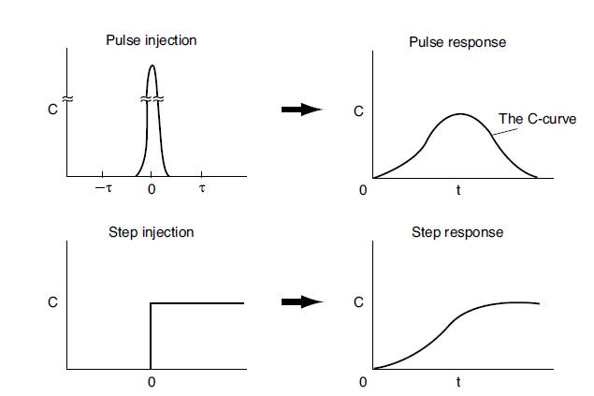
Figure 13.8. RTD measurements
13.4.1. Pulse input experiment
In a pulse input, an amount of tracer N₀ is suddenly injected in one shot into the feed stream which is entering into the reactor in a short a time. The outlet concentration is then measured as a function of time. The effluent of the tracer concentration versus time curve is referred to as the C-curve in RTD analysis. Firstly, the injection of a tracer pulse for a single-input and single-output system shall be analyzed in which only flow carries the tracer material across system boundaries. i.e., no dispersion. It is chosen an increment of time t sufficiently small that the concentration of tracer, C(t), exiting between time t and time (t +∆t) is essentially the same.
The amount of tracer material, ∆N, leaving the reactor between time t and t+∆t is given by:
ΔN= C(t)υΔt (13.1)
If we now divide the amount of material exiting the reactor by the total amount of material that was injected into the reactor, N₀, we obtain,
$\frac{∆N}{N_{o}}=\frac{C(t)}{N_{o}}∆t$ (13.2)
Where: N_{o} is initially injected tracer, ʋ is the effluent volumetric flow rate; ∆N is the amount of material exiting the reactor that has spent an amount of time between t and t+∆t in the reactor, and t is time.
Thus, equation (13.2) which represents the fraction of material that has a residence time in the reactor between time t and t + ∆t.
For pulse injection, RTD function is defined as:
$E\left(t\right)=\frac{C(t)}{N_{o}}$ (13.3)
By substituting equation (13.3) into equation (13.2), you get:
$\frac{∆N}{N_{o}}=E(t)∆t$ (13.4)
The quantity E(t) is called the residence time distribution function.
It is the function that describes in a quantitative manner how much time different fluid elements have spent in the reactor. The quantity E(t)dt is the fraction of fluid exiting the reactor that has spent between time t and t + dt inside the reactor.
The experimental set up to determine E(t) is shown in Figure 13.9 (Fogler, 2015, pg.771). If N₀ is not known directly, it can be obtained from the outlet concentration measurements by summing up all the amounts of materials, ∆N, between time equal to zero and infinity.
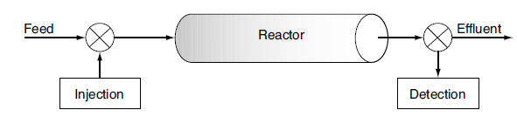Figure 13.9. Experimental set up to determine E(t)
The differential form of equation (13.2) can be written as:
$dN=C\left(t\right)dt$ (13.5)
By integrating of equation (13.5), you get:
$N_{o}=\int_{0}^{∞}{C\left(t\right)dt}$ (13.6)
The volumetric flow rate is usually constant; it can be out of the integration, and equation (13.6) can be written as:
$N_{o}=\int_{0}^{∞}{C\left(t\right)dt}$ (13.7)
The area under the curve of C(t) versus t is the ratio of initial tracer to volumetric flow rate. i.e. initial concentration of tracer. The plot of C-curve and E-curve is shown in Figure 13.10 (Fogler, 2015, pg. 772). The plot of C(t) versus t is called the C-curve, it is depicted in Figure 13.10a.
For constant volumetric flow rate, E(t) is defined as:
$E\left(t\right)=\frac{C(t)}{\int_{0}^{∞}{C\left(t\right)dt}}$ (13.8)
For constant volumetric flow rate, the E-curve is just the C-curve divided by the area under the C-curve as shown in Figure 13.10b.
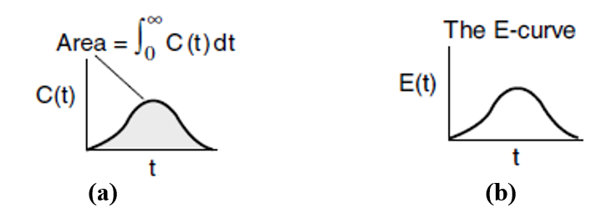
Figure 13.10 (a) C-curve, and (b) E-curve
The RTD function, E(t), is found from the tracer concentration C(t). An alternative way of interpreting the residence time function is in its integral form:
$\text{Fraction of material leaving the reactor for a time between t}\text{1}\text{ and }t_{2}=\int_{t_{1}}^{t_{2}}{E\left(t\right)dt}$ (13.9)
Eventually all guests must leave. We know that the fraction of all the material that has resided for a time t in the reactor between t = 0 and t = ∞ is 1; therefore
$\int_{0}^{∞}{E\left(t\right)dt=1}$ (13.10)
13.4.2. Step tracer experiment
The inlet concentration most often takes the form of either a perfect pulse input (Dirac delta function), imperfect pulse injection (Figure 13.8), or a step input. Just as the RTD function E(t) can be determined directly from a pulse input, the cumulative distribution F(t) can be determined directly from a step input. The cumulative distribution gives the fraction of material F(t) that has been in the reactor at time t or less. Consider a constant rate of tracer addition to a feed that is initiated at time t= 0. Before this time, no tracer is added to the feed.
The concentration of tracer in the feed to the reactor is kept at this level until the concentration in the effluent is indistinguishable from that in the feed; the test may then be discontinued.
$C_{out}\left(t\right)=\{\begin{matrix}0 \\ C_{o}\end{matrix}$ $\begin{matrix}t<0 \\ t≥0\end{matrix}$ (13.11)
Because the inlet concentration is a constant with time, C₀, we can take it outside the integral sign; that is
$C_{out}\left(t\right)=C_{o}\int_{o}^{t}{E\left(t\right)dt}$ (13.12)
By dividing equation (13.12) by C_{o}, you get:
[$\frac{C_{out}(t)}{C_{o}}]_{step}$=$\int_{o}^{t}{E\left(t\right)dt}$=F(t) (13.13)
By differentiating equation (13.13) with respect to time, you can obtain RTD function E(t):
$E\left(t\right)=\frac{dF(t)}{dt}=\frac{d}{dt}$[$\frac{C_{out}(t)}{C_{o}}]_{step}$ (13.14)
Advantages of step input over pulse input
- The positive step is usually easier to carry out experimentally than the pulse test.
- In step input experiment, the total amount of tracer in the feed over the period of the test does not have to be known as it does in the pulse test.
Disadvantages of step input tracer experiment
- It is sometimes difficult to maintain a constant tracer concentration in the feed.
- To find RTD, it involves differentiation of the data and lead to large errors.
- It requires large amount of tracer which increases cost of experiment.
Therefore, if the tracer is very expensive, a pulse test is used to minimize the cost.
13.4.3. Characteristics of the RTD
It is the distribution functions connected with reactor analysis because it characterizes the lengths of time various atoms spend at reaction conditions. The fraction of the exit stream that has resided in the reactor for a period of time shorter than a given value t is equal to the sum over all times less than t of E(t) ∆t, or expressed continuously, by integrating E(t) between time t = 0 and time, t. The cumulative RTD function F(t) is given by:
$F\left(t\right)=\int_{0}^{t}{E\left(t\right)dt}$ (13.15)
Where: F(t) is the fraction of effluent that has been in reactor for less that time t.
The fraction of effluent that has been in reactor for longer than time t is given by:
$1-F\left(t\right)=\int_{t}^{∞}{E\left(t\right)dt}$ (13.16)
Because t appears in the integration limits of these two expressions, equations (13.15) and (13.16) are both functions of time. Danckwerts defined equation (13.15) as a cumulative distribution function, F(t). The cumulative distribution function, F(t) is calculated at various times t from the area under the curve of a plot of E(t) versus t. i.e. the E-curve.
A typical shape of the F(t) curve is shown in Figure 13.11 (Fogler, 2015, pg. 778). It depicts that F(t) = 0.8 means that 80% of the molecules spend 8 minutes or less in the reactor, and 20% of the molecules [1- F(t)] spend longer than 8 minutes in the reactor.
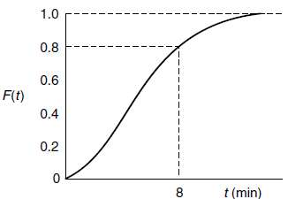
Figure 13.11. Cumulative distribution curve, F(t)
13.4.4. Mean residence time (t_{m})
In previous chapters treating ideal reactors, a parameter frequently used was the space time, τ, which was defined as being equal to (V/v). In the absence of dispersion, and for constant volumetric flow (v = v₀), no matter what RTD exists for a particular reactor, ideal or non-ideal, this nominal space time, τ, is equal to the mean residence time, t_{m}. Mean residence time in real reactors is the average time a fluid element spends inside the reactor, which accounts fluid flow irregularities and mixing. The mean residence time is the first moment of RTD function. The mean value of the variable is equal to the first moment of the RTD function, E(t). Thus, the mean residence time is given by:
$t_{m}=\frac{\int_{0}^{∞}{tE\left(t\right)dt}}{\int_{0}^{∞}{E\left(t\right)dt}}=\int_{0}^{∞}{tE\left(t\right)dt}$ (13.17)
From equation (12.10), $\int_{0}^{∞}{E\left(t\right)dt}=1$
Where: t_{m} is mean residence time, t is any time t, E(t) is RTD function.
The first moment gives the average time the effluent molecules spent in the reactor. For constant volumetric flow rate, the mean residence time is equal to the space time.
$t_{m}=$ (13.18)
This result is true only for a closed system. i.e. no dispersion across boundaries. The exact reactor volume is determined from the equation:
$V=ut_{m}$ (13.19)
Other moments of the RTD
Variance(σ²): It is the second moment of the RTD. The variance, σ² is square of the standard deviation. The magnitude of this moment is an indication of the “spread” of the distribution; the greater the value of this moment is, the greater a distribution’s spread will be. The variance is defined as:
${\text{σ}}^{2}=\int_{0}^{∞}{{(t-tm)}^{2}}$E(t)dt (13.20)
Where: σ² is variance, t is time, t_{m} is mean residence time, and E(t) is RTD function.
Skewness (s³): It is the third moment of the RTD. Skewness is defined as:
$s^{3}=\frac{1}{{\text{σ}}^{3/2}}\int_{0}^{∞}{{(t-tm)}^{3}}$E(t)dt (13.21)
The magnitude of the third moment measures the extent that a distribution is skewed in one direction or another in reference to the mean. Rigorously, for a complete description of a distribution, all moments must be determined.
Practically, these three moments (t_{m}, σ², and s³) are usually sufficient for a reasonable characterization of a RTD.
Activity 13.2
- What is residence time distribution (RTD) in reactors?
- Identify the two major use of the residence time distribution to characterize non-ideal reactors.
- Describe the basic requirements for tracer selection to test the performance of real reactors.
Answers:
1. What is residence time distribution (RTD) in reactors?
The residence time distribution (RTD) of a chemical reactor is a probability distribution function which describes the amount of time that a fluid element could spend inside the reactor.
2. Identify the two major use of the residence time distribution to characterize non-ideal reactors.
The two major uses of the residence time distribution to characterize non-ideal reactors are:
- to diagnose problems of reactors in operation.
- to predict conversion or effluent concentrations in existing/available reactors when a new chemical reaction is used in the reactor.
3. Describe the basic requirements for tracer selection to test the performance of real reactors.
Th basic requirements for tracers are the followings:
- Tracers should be non-reactive;
- The tracers should be easily detectable;
- Tracers should not be adsorbed on the walls or other surfaces in the reactor; and
- Tracer should be completely soluble in the mixture and have physical properties similar to those of the reacting mixture.
Activity 13.3
It is planned to convert reactant A to product R using a 10-cm-diameter and 6.36 m length tubular reactor. The reaction is shown in stoichiometry equation below. Assume that the volumetric flow rate is constant. To diagnose the reactor performance, a tracer test is carried out. The tracer test results effluent concentration (C) as a function of time (t) is given by:
C (t) = -t²+10t; where: the unit of time is min.
$A→R$
Based on the given information: (a) Construct curves for concentration, C(t), residence time distribution function, E(t), and cumulative distribution function, F(t) as a function of time, (b) calculate the fraction of fluid that spends 5 minutes or less in the reactor, and (c) calculate the mean residence time (t_{m}), volumetric flow rate (υ) and the variance (σ²).
Given: Tracer test response: C(t)= -t²+10t
Reactor diameter, D = 10 cm= 0.1m, and reactor length, L=6.36m
Required:
- C(t), E(t) and F(t) curves
- F(t) when t ≤ 5 min
- t_{m}, υ & σ² =?
Solution:
(a) From equation (13.8), the RTD function is given by:
$$E\left(t\right)=\frac{C(t)}{\int_{0}^{∞}{C\left(t\right)dt}}$$
C(t)= -t²+10t
To find the minimum and maximum time to integrate the tracer test response function, let’s take when the concentration of tracer becomes zero.
C(t) = -t²+10t = t(10-t) = 0; t = 0 or t = 10
The plot of the C(t) -curve is shown in Figure 13.12.
Figure 13.12. Tracer test response C(t) -curve
$$E\left(t\right)=\frac{C(t)}{\int_{0}^{∞}{C\left(t\right)dt}}=\frac{\text{-t}\text{2}\text{+10t }}{\int_{0}^{10}{(\text{-t}\text{2}\text{+10t}\text{ )}dt}}=\frac{\text{-t}\text{2}\text{+10t }}{\frac{\text{-t}\text{3}}{3}\text{+5t}\text{2}|\begin{matrix}10 \\ 0\end{matrix}}=\frac{\text{-t}\text{2}\text{+10t}}{166.7}$$
The plot of the E(t)-curve is illustrated in Figure 13.13.
Figure 13.13. The E(t)-curve
$F(t)=\int_{0}^{∞}{E\left(t\right)dt}=$ $\int_{0}^{10}{\left(\frac{\text{-t}\text{2}\text{+10t}}{166.7}\right)dt=\frac{1}{166.7}(\frac{\text{-t}\text{3}}{3}\text{+5t}\text{2}|\begin{matrix}10 \\ 0\end{matrix})=1}$
The plot of F(t)- curve is depicted in Figure 13.14.
Figure 13.14. The F(t)-curve
(b) $F(t)=\int_{0}^{t}{E\left(t\right)dt}=$ $\int_{0}^{5}{\left(\frac{\text{-t}\text{2}\text{+10t}}{166.7}\right)dt=\frac{1}{166.7}\left(\frac{\text{-t}\text{3}}{3}\text{+5t}\text{2} | \begin{matrix}5 \\ 0\end{matrix}\right)=0.5}$
This result shows that 50% of the fluid spends 5 minutes or less in the reactor.
- The mean residence time from equation (13.17) is given by:
$t_{m}=\frac{\int_{0}^{∞}{tE\left(t\right)dt}}{\int_{0}^{∞}{E\left(t\right)dt}}=$ $\int_{0}^{∞}{tE\left(t\right)dt}=\int_{0}^{10}{\left(\frac{\text{-t}\text{3}\text{+10t}\text{2}}{166.7}\right)dt=\frac{1}{166.7}\left(\frac{\text{-t}\text{4}}{4}\text{+}\frac{\text{10t}\text{3}}{3} | \begin{matrix}10 \\ 0\end{matrix}\right)=5 min}$
The volumetric flow rate is the ratio of volume of reactor divided by the mean residence time.
The reactor volume is Area of reactor * length of reactor.
$V=π\frac{D^{2}}{4}*L=π*\frac{{0.1}^{2}}{4}*6.36=0.05$m³
$=\frac{V}{t_{m}}=\frac{0.05}{5}=0.01m3/min$ = 10 L/min
From equation (13.20), the variance is given by:
$${\text{σ}}^{2}=\int_{0}^{∞}{{(t-tm)}^{2}}\text{E(t)dt}=\frac{1}{166.7}\int_{0}^{10}{(t2-10t+25)(-t2+10t)}\text{dt}$$
${\text{σ}}^{2}=\frac{1}{166.7}(\frac{{-t}^{5}}{5}$+5$t^{4}-\frac{{15t}^{3}}{3}+125t^{2})|\begin{matrix}10 \\ 0\end{matrix}=5$
13.5. Summary
The factors that affect the contact or flow pattern of fluids in real reactors are: the state of segregation, earliness and lateness of mixing of material in the vessel, and the residence time distribution (RTD) of material which is flowing through the vessel. The deviation from the two ideal flow patterns can be caused by channeling, recycling, or by creation of stagnant regions in the vessel. The residence time distribution (RTD) of a chemical reactor is a probability distribution function which describes the amount of time that a fluid element could spend inside the reactor. The two major uses of the RTD to characterize non-ideal reactors are: to diagnose problems of reactors in operation, and to predict conversion in existing reactors when a new chemical reaction is used. The basic criteria for tractors selection: non-reactive & easily detectable, not be adsorbed, completely soluble in the mixture and have physical properties similar to those of the reacting mixture. The cumulative RTD function is the fraction of effluent that has been in reactor for less that time t.
References
- Chemical Reaction Engineering, Levenspiel, O John Wiely & Sons, 3rd edition, 2011.
- Elements of Chemical Engineering, Fogler, HS Prentice- Hall Inc Prentice- Hall Inc, 5th edition, 2015.

