Basic Principles of Process Calculations in Chemical Engineering (ChEg2106)
Prerequisites: No prerequisite for this course
Lecture 4: Material Balances without Chemical Reaction
Week 4
Lecturer: Adamu Esubalew (PhD, ChEg)
Addis Ababa, Ethiopia
Lecture learning outcomes
At the end of the lecture, you will be able to:
- identify the purposes of material balances in processes design
- describe problem-solving techniques for material balances calculations, and
- determine material balances without chemical reaction for steady state processes.
4.1. Introduction to material balances
Material balances refer to determination of the quantity of materials present / flows in any physical and chemical processes. Mass conservation law is used to determine quantity of material flows. Conservation law states that mass is neither created nor destroyed. i.e. the mass of any isolated system is constant. Material balances are the prerequisite to solve both simple and complex chemical engineering problems.
To perform materials balances calculations, it is required to consider the key terms, such as system, system boundary, open system, closed system, isolated system, steady state and unsteady state.
- System: It is an arbitrary portion or whole of a process considered for analysis.
- System boundary: It is circumscribed the process itself to give attention the system to be isolated in each problem you work.
- Open system: It is a system in which there are both material and energy transfer across system boundaries.
- Closed system: It is a system in which there is no material transfer across the system boundary. But energy can transfer in the form of heat and work done across system boundaries.
- Isolated system: It is a system in which there is no both material and energy transfer across system boundaries.
- Unsteady state process: The value of process variables in the system changes with time.
- Steady state process: The value of process variables in the system does not change with time.
Material balances are the basis of process design. Material balances will determine the quantities of raw materials required and products produced. Material balances over individual process units set the process stream flows and compositions. A good understanding of material balance calculations is essential in process design. Practice is needed to develop expertise in handling what can often become very involved calculations (Coulson & Richardson’s, 1999, pg. 35-57).
The use of material balances in a process allows you to calculate the values of the flows of species in the streams that enter and leave the plant equipment. You may want to find out how much of each raw material is used and how much of each product (along with some wastes) is produced by the plant. For process industries, material balances assist planning for process design, economic evaluation of proposed and existing processes, process control and process optimization.
4.2. Problem-solving techniques for material balances without chemical reaction
Material balances calculations require understanding of key problem-solving techniques. Some of the key problem-solving techniques for material balances are the followings (Himmelblau, 2023, pg. 129-136):
- Read the problem carefully and understand it,
- Draw the process system diagram with system boundaries,
- Write all given values and required unknowns on the diagram,
- Determine the number of unknown variables and the number of independent equations to check that the numbers of degree of freedom (NDF) is zero,
- Collect additional data, if needed,
- Check all units are consistent by converting all units to the same consistent units,
- State all your assumptions to the problem,
- Identify and write the appropriate material balances equation,
- Define all the symbols used in the material balances equation,
- Solve the problem using appropriate equation, and
- Analyze your final result and write your conclusion based on the results.
4.3. Material balances without chemical reaction
Material balances equation: It is an equation which is used to determine the quantity of materials transferred across system boundaries, accumulation within the system, generation/ consumption in the system (Richard M. Felder, 2005, pg. 85). The general material balances flow through a system is shown in Figure 4.1. The dashed line denotes system boundary in which material balances can be written.
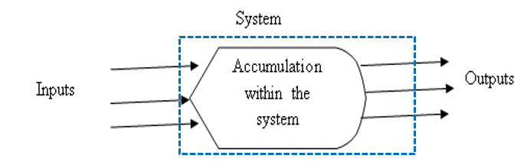
Figure 4.1. General material balances

The general material balances equation is given by:
Rate of accumulation= rate of inputs - rate of outputs
± rate of generation/ consumption (4.1)
- If the material balance is done with respect to total mass, the rate of generation/ consumption terms will be zero.
- If material balance is done with respect to elements, the rate of generation/consumption terms will be zero.
- If material balance is done with respect to total moles without chemical reaction, the rate of generation/ and consumption terms will be zero.
- If the rate of generation/ consumption is zero, the material balances equation (4.1) can be reduced to equation (4.2).
Rate of accumulation = rate of inputs - rate of outputs (4.2)
Material balances without chemical reaction can be a single system or multiple subsystems.
4.3.1. Material balances without chemical reaction for a single system
Material balances without chemical reactions refers to the materials balances of physical processes, such as mixing, distillation, physical absorption, physical adsorption, evaporation and drying.
If there is no chemical reaction, the rate of generation/ consumption term will be zero, and equation (4.2) will be used to determine the material balances for a single system.
If a process is in a steady state, then the rate of accumulation will be zero, and equation (4.2) will be reduced to equation (4.3).
Rate of inputs = Rate of outputs (4.3)
Consider the following single system of material balances without chemical reaction, as depicted in Figure 4.2. It is assumed that the system has three input streams and one output stream. The feed streams may have many components (chemical compounds).
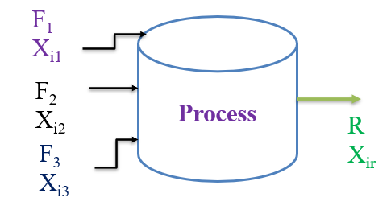
Figure 4.2. Material balances without chemical reaction for a single system
To determine the material balances for Figure 4.2, it is assumed that the process is in a steady state. The overall material balances and component balances are performed using equation (4.3).
- Overall materials balance:
Rate of inputs = Rate of outputs
$F_{1}+F_{2}+F_{3}=R$ (4.4)
Where: F₁, F₂ and F₃ are feed rates of streams 1, 2 and 3, respectively; and R is rate of output stream.
(ii) Components materials balances:
Rate of inputs = Rate of outputs
${X_{i1}*F}_{1}+X_{i2}*F_{2}+{X_{i3}*F}_{3}=X_{ir}*R$ (4.5)
Where: X_{i1}, X_{i2} and X_{i3} mass/ mole fractions of species i in the feed streams 1, 2 and 3, respectively; and X_{ir} is mass/mole fraction of species i in the output stream.
To solve equation (4.4) and equation (4.5), the number of unknowns and the number of independent equations should be equal, the numbers of degree of freedom should be zero.

Activity 4.1
- A liquid adhesive, which is used to make laminated boards, consists of a polymer dissolved in a solvent. The amount of polymer in the solution has to be carefully controlled for this application. An adhesive dealer receives an order for 8, 000 kg of adhesive solution containing 20% polymer by weight. An adhesive dealer has stocks of: (i) 2000 kg of 10% polymer solution, (ii) very large quantities of 40% polymer solution, and (iii) a pure solvent. Determine the mass of each of the stocks that must be blended together to fulfill the order.
- A solution composed of 50% ethanol (EtOH), 10% methanol (MeOH), and 40% water (H₂O) is fed into a separator at the rate of 100 kg/hr that produces one stream at the rate of 60 kg/hr with the composition of 80% EtOH, 15% MeOH, and 5% H₂O, and a second output stream of unknown composition and flow rate. Calculate the mass fractions of the three compounds in the second output stream and its flow rate in kg/hr. (Compositions are given in mass fraction).
- For crystallization operation, 5,000 kg of aqueous solution of sodium sulfate with concentration 30% is fed to a crystallizer. The solution is cooled to crystallize out sodium sulfate with a concentration of 75%, and the remaining solution (the mother liquor) is separated with concentration of 10% sodium sulfate. Calculate the mass of the final crystal sodium sulfate and mother liquor. (Compositions are given in mass fraction).
# Q₁, Answer:
Given: Three feed streams, and one output stream.
Feed 1 stream = 2000 kg with 10% polymer; Feed 2 = unknown quantity with 40 % polymer
Feed 3 = unknown quantity with a pure solvent; product = 8, 000 kg with 20 % polymer.
All fractions are in mass basis
Required: The mass of feed streams in 2 & 3.
Assumption: Mixing process is carried out at steady state condition.
The mixing process flow diagram is depicted in Figure 4.3.
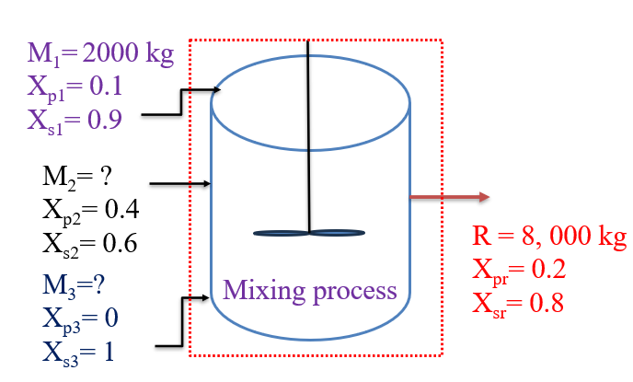
Figure 4.3. Mixing process flow diagram for Activity 4.1 #Q₁
- Overall material balances:
Using equation (4.4), the overall material balances is given by:
$M_{1}+M_{2}+M_{3}=R$ (4.6)
But M₁= 2,000 kg, and R= 8, 000 kg
By substituting the values of M₁ = 2, 000 kg, and R = 8, 000 kg into equation (4.6), we get:
$M_{2}+M_{3}=R-M_{1}=8,000-2, 000=6,000$ (4.7)
Where: M₁, M₂, and M₃ are masses of input stocks in streams 1, 2 and 3, respectively; and R is the mass of the output stream.
(ii) Components material balances: using equation (4.5), the components material balances are given by:
${X_{i1}*M}_{1}+{X_{i2}*M}_{2}+X_{i3}{*M}_{3}=X_{ir}*R$ (4.8)
Where: X_{i1}, X_{i2} and X_{i3} mass/mole fractions of species i in the feed streams 1, 2 and 3, respectively; and X_{ir} is mass/mole fraction of species i in the output stream.
Component balance on polymer is given by:
${X_{p1}*M}_{1}+{X_{p2}*M}_{2}+X_{p3}{*M}_{3}=X_{pr}*R$ (4.9)
Where: X_{p1}, X_{2p2} and X_{p3} mass/mole fractions of polymer in the feed streams 1, 2 and 3, respectively; and X_{pr} is mass/mole fraction of polymer in the output stream.
Component balance on solvent is given by:
${X_{1s}*M}_{1}+{X_{2s}*M}_{2}+X_{3s}{*M}_{3}=X_{rs}*R$ (4.10)
Where: X_{s1}, X_{s2} and X_{s3} mass/mole fractions of solvent in the feed streams 1, 2 and 3, respectively; and X_{rs} is mass/mole fraction of solvent in the output stream.
Since polymer is present only in the two streams of the feed stock, determine component material balances on polymer first, using equation (4.9).
${X_{p1}*M}_{1}+{X_{p2}*M}_{2}+X_{p3}{*M}_{3}=X_{pr}*R$
$0.1*2,000+{0.4*M}_{2}+0{*M}_{3}=0.2*8, 000$
$200+{0.4*M}_{2}=1, 600$
${0.4*M}_{2}=1,600-200=1, 400$
$M_{2}=\frac{1,400}{0.4}=3, 500 kg$
Now, you can calculate the mass in the feed stream 3 (M₃), using equation (4.7)
$M_{2}+M_{3}=6, 000$
The value of M₂ is 3, 500 kg
by substituting the value of M₂ = 3, 500 kg into equation (3.7), you can get the value of M₃.
$M_{3}=6, 000-M_{2}=6000-3, 500=$ 2, 500 kg
Therefore, the stocks of the feed streams should be 2, 000 kg, 3, 500 kg and 2, 500 kg for stream 1, 2 and 3, respectively.

# Q₂, Answer:
Given: Separation of ethanol, methanol and water mixtures
One input stream with total feed rate = 100 kg/ hr, and two output streams.
Mass fractions in the feed 0.5, 0.1 and 0.4, for EtOH, MeOH and H₂O, respectively.
Top side flow rate is 60 kg/hr with 0.8, 0.15 and 0.05 for EtOH, MeOH and H₂O.
Required: Bottom side output flow rate and the mass fractions of EtOH, MeOH and H₂O
Assumption: Separation is carried out at steady state condition.
The separation process flow diagram of the given problem is shown in Figure 4.4.
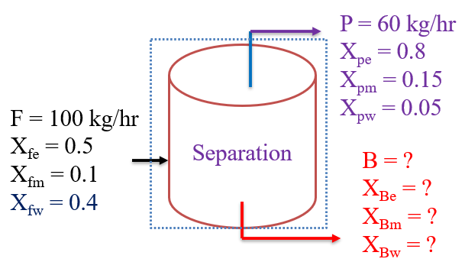
Figure 4.4. Separation process flow diagram for Activity 4.1 #Q₂
To determine the four unknowns, you need four independent equations. One independent equation is the overall material balances, and three independent components material balances with respect to EtOH, MeOH and H₂O.
- Overall material balances:
The overall material balance is given by:
$F=P+B$ (4.11)
Where: F is mass flow rate of the input, P is mass flow rate of top side output stream, and B is mass flow rate of bottom side output stream.
(ii) Components material balances:
Component material balance for ethanol is given by:
$X_{Fe}*F=X_{Pe}*P+X_{Be}*B$ (4.12)
Component material balance for methanol is expressed by:
$X_{Fm}*F=X_{Pm}*P+X_{Bm}*B$ (4.13)
Component material balance for water is described by:
$X_{Fw}*F=X_{Pw}*P+X_{Bw}*B$ (4.14)
Where: X_{Fe}, X_{Fm} & X_{Fw} are feed stream mass fractions of EtOH, MeOH and H₂O, respectively; X_{Pe}, X_{Pm} & X_{Pw} are top side output stream mass fractions of EtOH, MeOH and H₂O, respectively; and X_{Be}, X_{Bm} & X_{Bw} are bottom side output stream mass fractions of EtOH, MeOH and H₂O, respectively.
Using equation (4.11), the overall material balance is given by:
$F=P+B$
By substituting the values of F = 100 kg/ hr, and P = 60kg/hr into equation (4.11), you get:
$B=F-B=100-60=40$ kg/hr
To determine the mass fraction of ethanol in the bottom side output stream (X_{Be}), use component balance of ethanol equation (4.12):
$X_{Fe}*F=X_{Pe}*P+X_{Be}*B$
Substitute the values of F = 100 kg/hr, P = 60 kg/hr, B = 40 kg/hr, X_{Fe} = 0.5 and X_{Pe} = 0.8
$0.5*100=0.8*60+X_{Be}*40$
$40X_{Be}=50-48$
$X_{Be}=\frac{2}{40}=0.05$
To calculate the mass fraction of methanol in the bottom side output stream (X_{Bm}), use component balance of methanol equation (4.13):
$X_{Fm}*F=X_{Pm}*P+X_{Bm}*B$
Substitute the values of F = 100 kg/hr, P = 60 kg/hr, B = 40 kg/hr, X_{Fm} = 0.1 and X_{Pm} = 0.15
$0.1*100=0.15*60+X_{Bm}*40$
$40X_{Bm}=10-9$
$X_{Bm}=\frac{1}{40}=0.025$
To calculate the mass fraction of water in the bottom side output stream (X_{Bw}), use component balance of methanol equation (4.14):
$X_{Fw}*F=X_{Pw}*P+X_{Bw}*B$
By substituting the values of F = 100 kg/hr, P = 60 kg/hr, B = 40 kg/hr, X_{Fw} = 0.4 and X_{Pw} = 0.05
$0.4*100=0.05*60+X_{Bw}*40$
$40X_{Bw}=40-3$
$X_{Bw}=\frac{37}{40}=0.925$

# Q₃, Answer:
Given: Crystallization operation, and one stream feed with total quantity of 5, 000 kg, and two output streams (mother liquor and final crystal)
Mass fraction of sodium sulfate in the feed is 0.3, and mass fractions of the final crystal and mother liquor are 0.75 and 0.10, respectively.
Required: Calculate the mass of the final crystal and the mother liquor.
Assumption: The crystallization operation is done at steady state condition; and water is a solvent with sodium sulfate solution
The crystallization process flow diagram is shown in Figure 4.5.
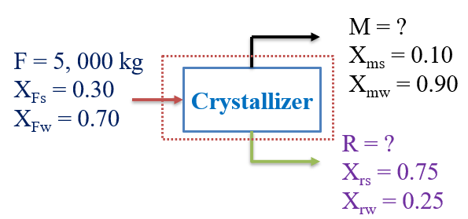
Figure 4.5. Crystallization process flow diagram for Activity 4.1 #Q₃
To calculate the two unknowns, you require two independent equations. One independent equation is the overall material balances, and another one independent equation is the components material balances with respect to sodium sulfate or H₂O.
The overall material balance is given by:
$F=R+M$ (4.15)
Where: F is mass of the input (feed) stream, M is mass of mother liquor (top side) output stream, and R is mass of final crystal of sodium sulfate (bottom side output) stream.
Component balance for sodium sulfate is given by:
$X_{Fs}*F=X_{ms}*M+X_{rs}*R$ (4.16)
Where: X_{Fs} is mass fraction of sodium sulfate in the input (feed) stream, X_{ms} is mass fraction of sodium sulfate in the mother liquor (top side) output stream, and X_{rs} is mass fraction of sodium sulfate in the final crystal of sodium sulfate (bottom side output) stream.
The overall material balance is expressed by equation (4.15):
$F=R+M$
By substituting the values of F = 5, 000 kg into equation (4.15), you get:
$R=F-M=5, 000-M$ (4.17)
The component balance on sodium sulfate is given by equation (3.16):
$X_{Fs}*F=X_{ms}*M+X_{rs}*R$
By substituting the values of F= 5, 000 kg, X_{Fs}= 0.30, X_{ms}= 0.10, and X_{rs}= 0.75, you can get:
$0.30*5,000=0.10*M+0.75*R$
$0.10*M+0.75*R=1,500$ (4.18)
To determine the values of R and M, you solve equations (4.17) and (4.18) simultaneously by substitution method. By substituting equation (4.17) into equation (4.18), you get:
$0.10*M+0.75*(5,000-M)=1,500$
$M=\frac{2,250}{0.65}=3,461.5 kg$
Now, let’s calculate the mass of the final crystal sodium sulfate from over all material balances using equation (4.17).
$R=5, 000-M$
The value of M is 3, 461.5 kg
$R=5, 000-M=5, 000-3, 461.5=1, 538.5 kg$
Therefore, the mass of final crystal sodium sulfate and mother liquor are 1, 538.5 kg and 3, 461.5 kg, respectively.
4.3.2. Material balances without chemical reaction for multiple subsystems
Physical operations can be carried out using multiple subsystems. Material balances for multiple subsystems refers to a system having two or more subunits to be considered for material balances calculation (Richard M. Felder, 2005, pg. 104). In real application unit operations and unit processes, multiple subsystems are interconnected. To determine the material balances, you can apply the same techniques discussed so far for a single system.
First, consider the whole process flow sheet as a single unit. Then, divide the flowsheet into subsystems to analyze one unit at a time. If more than one piece of equipment or junction point is involved in the problem, you can write material balances for each piece of equipment and a balance around the whole process. However, not all the balances you might write will be independent since the overall balance is nothing more than the sum of the balances about each piece of equipment.
Consider the flow sheet of multiple subsystems which comprise of many interconnected equipment as shown in Figure 4.6.

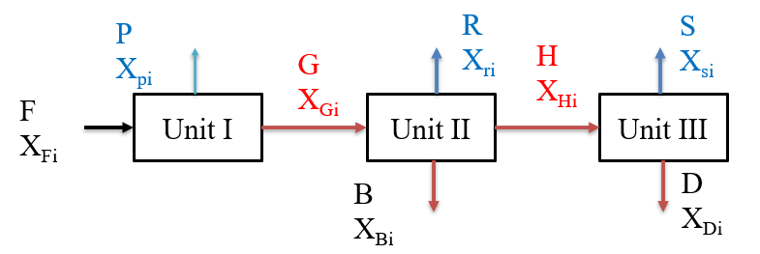
Figure 4.6 Process flow sheet of multiple subsystems
Let’s draw a boundary line around the multiple subsystems to determine the overall materials balances and components balances as shown in Figure 4.7.
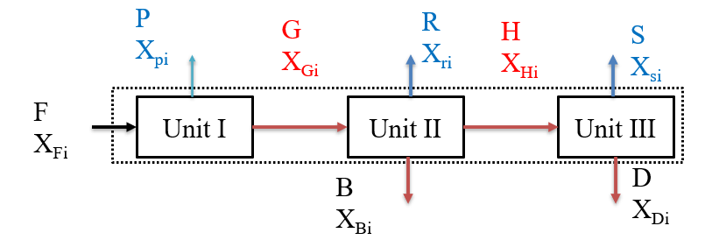
Figure 4.7 Process flow sheet of multiple subsystems with system boundary
From, Figure 4.7, the overall material balance is given by:
$F=P+R+S+B+D$ (4.19)
Where: F is the quantity of material in the input for unit I; P, R and S are the quantity of material outputs in the top sides for unit I, II & III, respectively; and B and D are the quantity of material outputs in the bottom sides for unit II & III, respectively.
The components material balances are expressed by:
$X_{Fi}*F=X_{pi}*P+X_{ri}*R+X_{si}*S+X_{Bi}*B+X_{Di}*D$ (4.20)
Where: X_{Fi} is mass fraction of species i in the input for unit I; Xpi, X_{ri} and X_{si} are mass fractions of species i in the top sides for unit I, II & III, respectively; and X_{Bi} and X_{Di} are mass fractions of species i in the bottom sides for unit II & III, respectively.
To determine the materials balance between each interconnected process equipment, let’s subdivide the process flow of Figure 4.7 into three subunits (I, II & III). Figure 4.8 depicts the process flow diagram of unit I.
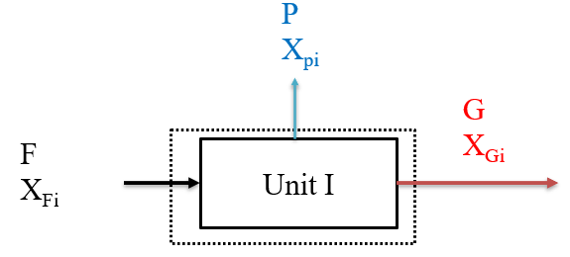
Figure 4.8 Process flow diagram of unit I
Materials balance on unit I:
Overall materials balance is given by:
$F=P+G$ (4.21)
Where: F is quantity of input, and P & G are quantity of outputs.
The component balances is expressed by:
$X_{Fi}*F=X_{pi}*P+X_{Gi}*G$ (4.22)
Where: X_{Fi} is fraction of species i in the input, X_{pi} and X_{Gi} are fractions of species in the P and G output streams.
Figure 4.9 shows the process flow diagram of unit II
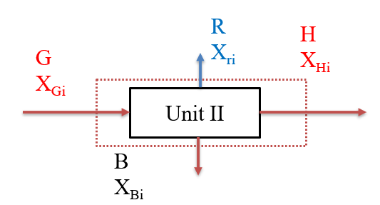
Figure 4.9 Process flow diagram of unit II
Materials balance on unit II:
Overall material balance is given by:
$G=B+H+R$ (4.23)
Where: G is quantity of input, and B, H & R are quantity of outputs.
The components balance is expressed by:
$X_{Gi}*G=X_{Bi}*B+X_{Hi}*H+X_{ri}*R$ (4.24)
Where: X_{Gi} is fraction of species i in the input, X_{Bi} X_{Hi}, and X_{ri} are fractions of species in the B, H and R output streams.
For unit III, the process flow diagram is depicted in Figure 4.10.
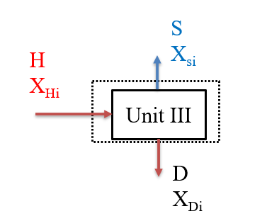
Figure 4.10 Process flow diagram of unit III
Materials balance on unit III:
Overall materials balance is written as:
$H=D+S$ (4.25)
Where: H is quantity of input, and D & S are quantity of outputs.
The component balance is given by:
$X_{Hi}*H=X_{Di}*D+X_{si}*S$ (4.26)
Where: X_{Hi} is fraction of species i in the input, and X_{Di} & X_{si} are fractions of species in the D and S output streams.
Activity 4.2
- In a petroleum refining industry, a distillation column separates 20,000 kg/hr. of a 50wt% benzene and 50wt% toluene mixture. The top product (D) recovered from the condenser at the top of the column contains 95wt% benzene and the bottom product (W) at the column contains 96wt% toluene. The vapor stream (V) enters to the condenser from the top of the column with a mass flow rate of 11,730 kg/hr. A portion of the product from the condenser is returned to the column as a reflux and the rest is withdrawn as top product (D). Determine: (a) the mass flow rates of the top product (D) and the bottom product (W), (b) the mass flow rate of the recycled reflux (R), and (c) the ratio of the amount of refluxed (R)to the top product(D).
Answer:
Given: distillation column to separate benzene and toluene mixture.
Feed stream: F= 20, 000 kg/hr., X_{FB}= 0.5, X_{FT}= 0.5
Top product stream: D= ?, X_{DB}= 0.95, X_{DT}= 0.05; Vapor stream: V= 11,730 kg/hr.
Bottom product: B=?, X_{WB}= 0.04, X_{WT}= 0.96
Required: (a) D= ?, W=?, (b) R=?, and (c) R/D =?
Assumption: The separation process is in a steady state.
The process flow diagram with system boundary is shown in Figure 4.11.

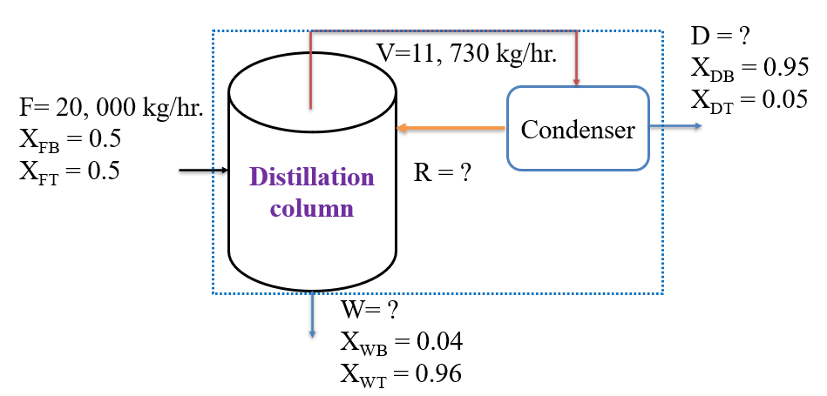
Figure 4.11 Process flow diagram for Activity 4.2
(a) The flow rate of top product (D) & bottom product (W):
From Figure 4.11, the overall material balances can be determined using equation (4.27):
$F=D+W$ ; F = 20, 000 kg/hr.
$D=F-W=20,000-W$ (4.27)
Where: F is mass flow rate of feed as input, D is mass flow rate of top product as output, and W is mass flow rate of bottom product as output.
In equation (4.27), there are two unknowns with one independent equation.
Now, you can find one independent equation from components material balances. The components material balances can be calculated using equation (4.26). You can do components balance on benzene or toluene. Let’s do component balance on benzene.
$X_{FB}*F=X_{DB}*D+X_{WB}*W$ (4.28)
Where: X_{FB} is mass fraction in the input (feed), X_{DB} is mass fraction of benzene in the top product, and X_{WB} is mass fraction of bottom product.
By substituting the values of X_{FB}= 0.5, X_{DB}= 0.95 and X_{WB}= 0.04 into equation (4.28), you can get:
$0.5*20,000=0.95*D+0.04*W$
$0.95D+0.04W=10,000$ (4.29)
To find the value of W, substitute equation (4.27) into equation (2.29).
$0.95(20,000-W)+0.04W=10,000$
$W=\frac{9,000}{0.91}=9,890$ kg/hr.
From equation (4.27), D = F-D = 20, 000-9,890 = 10, 110 kg/hr.
(b) to calculate the amount of reflux rate (R), divide the process into two subunits, and consider the condenser part as shown in Figure 4.12. Overall material balance on condenser is given by:$R=V-D=11,730-10,110=1,620$ kg/hr.
(c) the reflux ratio over top product (R/D) = 1, 620/10,110 = 0.16
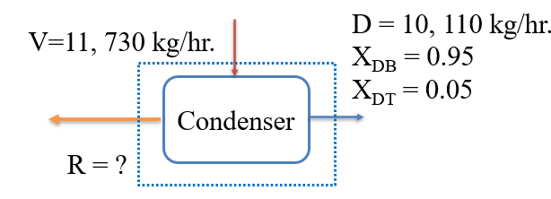
Figure 4.12 Process flow diagram of condenser for Activity 4.2
4.4. Summary
Material balances without chemical reaction refers to physical process mass transfer calculations of material inputs and outputs at steady state condition. For process industries, material balances assist planning for process design, economic evaluation of proposed and existing processes, process control and process optimization. To determine material balances, the number of unknowns and the number of independent equations must be equal, the numbers of degree of freedom must be zero. The material balances calculation is performed using overall material balance and components balance.
References
- Basic Principles and Calculations in Chemical Engineering, Himmelblau, Pearson Education Inc, 9th edition, 2023.
- Chemical Engineering Design, Volume 6, Coulson & Richardson’s, R. K. Sinnott, 3rd edition, 1999.
- Elementary Principles of Chemical Processes, Richard M. Felder, John Wiley & Sons, 3rd edition, 2005.

