Basic Principles of Process Calculations in Chemical Engineering (ChEg2106)
Prerequisites: No prerequisite for this course
Lecture 7: Material Balances for Multiple Systems
Week 7
Lecturer: Adamu Esubalew (PhD, ChEg)
Addis Ababa, Ethiopia

Lecture learning outcomes
At the end of the lecture, you will be able to:
- identify the characteristics of recycle, purge and bypass streams in multiple systems, and
- determine material balances for multiple systems with recycle, purge and bypass streams
7.1. Introduction to material balances for multiple systems
Material balances are fundamental tools in chemical engineering and process design, which is used to account for the quantity of materials entering and leaving a system. When dealing with multiple systems, it requires consideration of the interactions between different processes or units. This lecture focuses on material balances applied to multiple systems with recycle, purge and bypass streams. To determine material balances for multiple systems, you can use problem solving techniques discussed in the previous lectures 4 & 5 (See lecture 4 & 5).
Additionally, the following problem-solving techniques shall be considered to determine material balances for multiple systems:
- Consider the whole process of multiple systems as a single system, and write overall and component material balance equations.
- Dividing the multiple systems into several single subsystems by drawing boundary lines, and writing material balances on each single system.
When solving multiunit problems, choose appropriate equations to ensure that the resulting set of equations are independent.
7.2. Material balances for multiple systems with recycle stream
A recycle system is a system that includes one or more recycle streams. The stream containing the recycled material is known as a recycle stream. Recycle refers to the portion of the material that is returned to the process after being separated or treated (unreacted feed). Recycle stream can be used in reactive or non-reactive systems. For reactive systems, recycle refers to unreacted materials that are returned to the reactor. For non-reactive systems, recycle refers to some portion of the materials which are returned to the main process for size reduction or separation processes.
7.2.1. Recycle system without chemical reaction
Recycling of material occurs in a variety of processes that do not involve chemical reaction, including distillation, crystallization, and heating and refrigeration systems. A reflux (recycle stream) in the distillation column is shown in Figure 7.1 (Himmelblau, 2023, pg. 288).
A portion of the exit flow from the accumulator is recycled into the column as liquid reflux while the reboiler vaporizes part of the liquid in the bottom of the column to create the vapor flow up the column. The recycle of vapor from the reboiler and return of the liquid from the accumulator into the column maintain good vapor and liquid contact on the trays inside the column. The vapor and liquid contact on the trays inside the column make it possible to concentrate the more volatile components into the overhead vapor stream, and concentrate the less volatile components into the liquid collected in the bottom of the column.

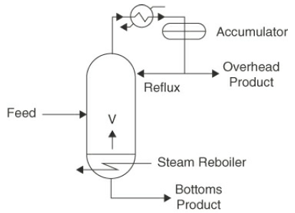
Figure 7.1 A reflux (recycle stream) in distillation column
7.2.2. Recycle system with chemical reaction
The most common application of recycle for systems involving chemical reaction is the recycle of reactants, an application that is used to increase the overall conversion in a reactor. A system of recycle with chemical reaction, you will encounter two different types of conversions that can be applied to processes in which reaction occurs (Himmelblau, 2023, pg. 291-296; Richard M. Felder, 2005, pg. 135-138):
- Overall conversion: It is based on what enters and leaves the overall process.
- Single-pass conversion: It is based on what enters and leaves the reactor.
The overall conversion is determined by the moles of limiting reactant in the fresh feed and moles of limiting reactant in the output of the overall process. The overall conversion is given by:
$X_{oc}=\frac{{(n}_{lF}-n_{lp})}{n_{lF}}$ (7.1)
Where: X_{OC} is overall conversion, n_{lF} is moles of limiting reactant in the fresh feed and n_{lp} is moles of limiting reactant in the output of the overall process.
If the moles of limiting reactant in the output of the overall process is zero, then the overall conversion will be one.
A single-pass conversion is determined based on what enters and leaves the reactor. A single-pass conversion is given by:
$X_{SP}=\frac{{(n}_{lRF}-n_{lG})}{n_{lRF}}$ (7.2)
Where: X_{sp} is single-pass conversion, n_{lRF} is moles of limiting reactant fed into the reactor, and n_{lG} is moles of limiting reactant exiting the reactor (gross process).
When the fresh feed (FF) consists of more than one reactant, the conversion can be expressed for a defined single component, usually the limiting reactant, or the most important (expensive) reactant. Conversion in a reactor (the single-pass conversion) can be limited by chemical equilibrium and/or chemical kinetics. On the other hand, the overall conversion is strongly dependent upon the efficiency of the separator in separating compounds to be recycled from the other compounds.
The overall conversion and a single-pass conversion are related with extent of reaction.
$\frac{(-X)n_{lRF}}{v_{l}}$ (7.3)
Where: is extent of reaction in moles, X is conversion (overall or single-pass), n_{lRF} is moles of limiting reactant fed into the reactor, and v_{l} is stoichiometric coefficient of a limiting reactant.
The overall conversion using extent of reaction can be written as:
$X_{OC}=\frac{-v_{l}}{n_{FF}}$ (7.4)
A single-pass conversion using extent of reaction is given by:
$X_{SP}=\frac{-v_{l}}{n_{RF}}$ (7.5)
Where: X_{SP} is a single-pass conversion, n_{RF} is the total feed rate of the limiting reactant to the reactor (limiting reactant in fresh feed plus limiting reactant in recycle stream), ξ is extent of reaction in moles, n_{FF} is moles of limiting reactant fresh fed into the reactor, and v_{l} is stoichiometric coefficient of a limiting reactant.
If you solve Equations (7.4) and (7.5) for the extent of reaction, equate the extents of reaction, and use a material balance at the junction of the fresh feed and the recycle stream (a mixing point), you can obtain the following relationship between overall and single-pass conversion:
$\frac{X_{SP}}{X_{OC}}=\frac{n_{FF}}{n_{RF}}$ (7.6)
$n_{RF}=n_{FF}+n_{R}$ (7.7)
Where: n_{FF} is moles of limiting reactant in the fresh feed, n_{R} is moles of limiting reactant in the recycle stream, and n_{RF} is moles of limiting reactant in the fresh feed plus in the recycle stream.
Consider the following reactive system with a recycle stream as shown in Figure 7.2.
Where: n_{FF} is moles of limiting reactant in the fresh feed, n_{R} is moles of limiting reactant in the recycle stream, n_{RF} is moles of limiting reactant in the fresh feed and recycle stream, n_{G} is moles of limiting reactant in a gross product, and n_{p} is moles of limiting reactant in a product.
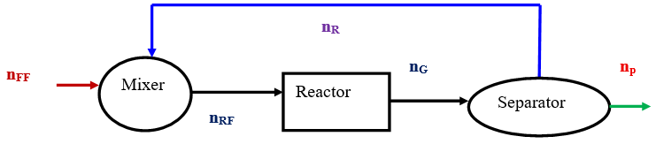
Figure 7.2 Process flow of reactive system with a recycle stream
The material balance can be determined by considering the whole system as a single system and by dividing the multiple system into three single systems. To determine the overall material balance of the limiting reactant by considering the whole system as a single unit with system boundary line is shown in Figure 7.3.
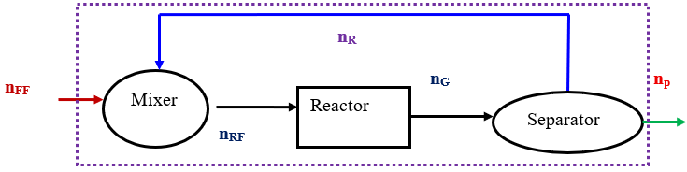
Figure 7.3 Overall material balances for multiple systems with recycle stream
For the whole system, the overall material balance can be written as:
$n_{P}=n_{FF}+v_{l}$ (7.8)
Where: n_{p} is the moles of limiting reactant in a product, n_{FF} is the moles of limiting reactant in the fresh feed, v_{l} is stoichiometric coefficient of the limiting reactant, and ξ is extent of reaction.
By dividing the multiple systems into single units, the material balance with a recycle stream can be determined as follows:
System I: The mixer is considered as a single system as shown in Figure 7.4. There is no chemical reaction in the mixer.
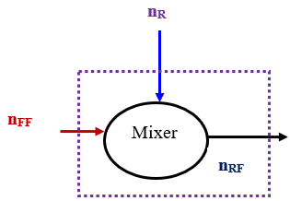
Figure 7.4 Material balances on the mixer
The moles of the limiting reactant entering to the mixer is equal to the moles of limiting reactant leaving from it. The material balance of the limiting reactant on the mixer is given by:
$n_{RF}=n_{FF}+n_{R}$ (7.9)
Where: n_{RF} is the moles of limiting reactant in the fresh feed and recycle stream, n_{FF} is the moles of limiting reactant in the fresh feed, and n_{R} is the moles of limiting reactant in the recycle stream.
System II: The reactor is considered as a single system as shown in Figure 7.5. There is a chemical reaction in the reactor. The generation of products/consumption of reactants must be accounted for in the material balance calculations.
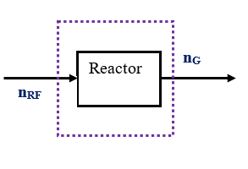
Figure 7.5 Material balances on the reactor
The material balance of the limiting reactant on the reactor is given by:
$n_{G}=n_{RF}+v_{l}$ (7.10)
Where: n_{RF} is the moles of limiting reactant in the fresh feed and recycle stream, n_{G} is the moles of limiting reactant in a gross product, and v_{l} is stoichiometric coefficient of the limiting reactant, and ξ is extent of reaction.
System III: The separator is considered as a single system as shown in Figure 7.6. There is no chemical reaction in the separator.
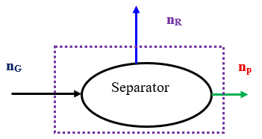
Figure 7.6 Material balances on the separator
The moles of the limiting reactant entering into the separator is equal to the moles of limiting reactant leaving from it. The material balance of the limiting reactant on the separator is given by:
$n_{G}=n_{P}+n_{R}$ (7.11)
Where: n_{G} is the moles of limiting reactant in a gross product, n_{P} is the moles of limiting reactant in a product, and n_{R} is the moles of limiting reactant in the recycle stream.
Activity 7.1
- Propane is dehydrogenated to form propylene in a catalytic reactor. The balanced chemical reaction is given by:
$C_{3}H_{8}→C_{3}H_{6}+H_{2}$ (7.12) (Richard M. Felder, 2005, pg. 135)
The process is to be designed for a 95% overall conversion of propane with 100 mol fresh feed. The reaction products are separated into two streams: the first, which contains H₂, C₃H₆, and 0.5% of the propane that leaves the reactor, is taken off as product; the second stream, which contains the balance of the unreacted propane and 5% of the propylene in the first stream, is recycled to the reactor. Calculate the composition of the product, moles of each stream, single-pass conversion, and moles ratio of recycled to fresh feed.

#Q₁, Answer:
Given: Fresh feed propane (C₃H₈) = 100 mol; Overall conversion = 95% = 0.95
Balanced chemical reaction equation: $C_{3}H_{8}→C_{3}H_{6}+H_{2}$
Stream one (product): H₂, C₃H₆, and 0.5% of the propane that leaves the reactor
Stream two (recycle stream): unreacted C₃H₈ and 5% of propylene in the product
Required: Calculate the composition of the product, moles of each stream, the single-pass conversion, and the ratio (moles recycled)/ (mole fresh feed).
Assumption: Steady state process.
The material balance process flow sheet is given in Figure 7.7.
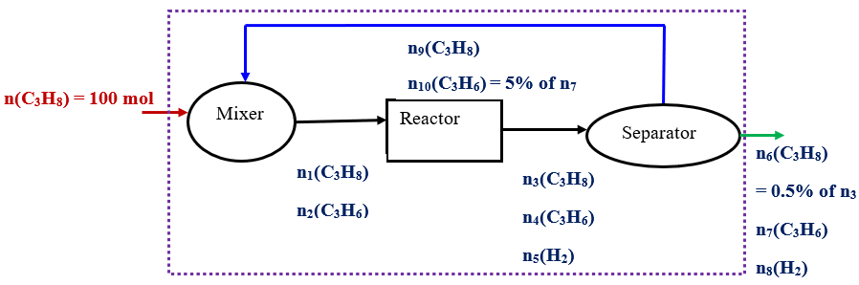
Figure 7.7 Process flow of propylene formation with a recycle stream
By considering the whole system as a single unit, the component material balance is determined. To determine propane (C₃H₈) in the product stream, the material balance is given by:
$n_{6}\left(C_{3}H_{8}\right)=n\left(C_{3}H_{8}\right)+v$ξ (7.13)
It is given that n (C₃H₈) = 100 mol; 95% conversion; the stoichiometric coefficient of propane is one (negative for reactant). i.e. v = -1
$n_{6}\left(C_{3}H_{8}\right)=0.05*100=5$ mol
The extent of reaction (ξ) = 100 -5 = 95 mol.
It is given that n₆(C₃H₈) = 0.5% of n₃(C₃H₈)
$n_{3}\left(C_{3}H_{8}\right)=\frac{n_{6}\left(C_{3}H_{8}\right)}{0.005}=\frac{5 mol}{0.005}=1,000$ mol
To determine the product propylene, the material balance is given by:
$n_{7}\left(C_{3}H_{6}\right)=+v$ξ (7.14)
The stoichiometric coefficient is one (positive for product). i.e. v = 1
$n_{7}\left(C_{3}H_{6}\right)=+$ξ = 95 mol
It is given that the recycle propylene is equal to 5% of propylene in the product stream
$n_{10}\left(C_{3}H_{6}\right)=5\% of n_{7}\left(C_{3}H_{6}\right)$= 0.05* 95 = 4.75 mol
To determine hydrogen molecule (H₂) in the product, the material balance is given by:
$n_{8}\left(H_{2}\right)=+v$ξ (7.15)
The stochiometric coefficient is one (positive for product). i.e. v = 1
$n_{8}\left(H_{2}\right)=+$ξ = 95 mol
To determine the moles of each component between the reactor and the separator, the process flow diagram of the separator is shown in Figure 7.8.
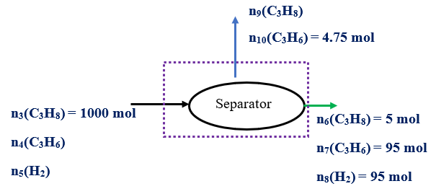
Figure 7.8 Materials balance on the separator
In the separator, there is no chemical reaction. i.e. there is no generation/consumption term in the material balance equation.
The propane (C₃H₈) material balance on the separator is given by:
n₃(C₃H₈) = n₆(C₃H₈) + n₉(C₃H₈)
1000 mol = 5 mol +n₉(C₃H₈)
n₉(C₃H₈) = 995 mol
The propylene (C₃H₆) material balance on the separator is given by:
n₄(C₃H₆) = n₇(C₃H₆) + n₁₀(C₃H₆)
n₄(C₃H₆) = 95 mol + 4.75 mol = 99.75 mol
The hydrogen molecule (H₂) material balance on the separator is expressed by:
n₅(H₂) = n₈(H₂)
n₅(H₂) = 95 mol
To determine the moles of each component entering the reactor, the material balance calculation is performed on the mixer. The process flow diagram of the mixer is shown in Figure 7.9.
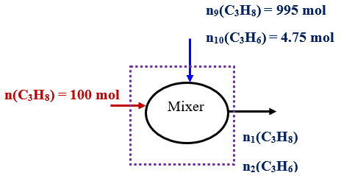
Figure 7.9 Materials balance on the separator
The propane (C₃H₈) material balance on the mixer is expressed by:
n(C₃H₈) + n₉(C₃H₈) = n₁(C₃H₈)
n₁(C₃H₈) = 100 mol + 995 mol =1, 095 mol
The propylene (C₃H₆) material balance on the mixer is given by:
n₁₀(C₃H₆) = n₂(C₃H₆)
n₂(C₃H₆) = 4.75 mol
The single-pass conversion (X_{SP}) is given by:
$X_{SP}=\left(\frac{n_{1}(C_{3}H_{8})-n_{3}(C_{3}H_{8}) }{n_{1}(C_{3}H_{8}) }\right)*100\%=\left(\frac{1, 095-1, 000}{1, 095}\right)*100\%=8.7\%$
Moles of recycled(n_{R}) = n₉(C₃H₈) + n₁₀(C₃H₆) = 995 mol + 4.75 mol = 999.75 mol ≈ 1, 000 mol
Moles of fresh feed (n_{FF}) = 100 mol
The moles ratio of recycled to fresh feed (n_{R}/n_{FF}) is given by:
$\frac{n_{R}}{n_{FF}}=\frac{n_{9}(C_{3}H_{8})+n_{10}(C_{3}H_{6}) }{n(C_{3}H_{8}) }=\frac{1, 000}{100}=10$
The recycle ratio is very large since the single-pass conversion is very small.
The overall material balances in mass units are summarized as follows:
The input stream:
n(C₃H₈) = 100 mol; M_{w}(C₃H₈) = 44 g/mol; m = n*M_{w} = 100 mol *44 g/mol = 4, 400 g
Output stream:
n₆(C₃H₈) = 5 mol; m₆= n₆*M_{w} = 5 mol *44 g/mol = 220 g
n₇(C₃H₆) = 95 mol; M_{w}(C₃H₆) = 42 g/mol; m₇ = n₇*M_{w} = 95 mol *42 g/mol = 3, 990 g
n₈(H₂) = 95 mol; M_{w}(H₂) = 2 g/mol; m₈= n₈*M_{w} = 95 mol *2 g/mol = 190 g
Total output mass = 4, 400 g
7.3. Material balances for multiple systems with purge stream
Purge: It refers to a stream being released to remove an accumulation of inert/unwanted material that will build up in the recycle stream (Coulson & Richardson’s, 1999, pg. 52-53). A purge system is a mechanism used to remove a portion of material from a process to control concentrations, prevent buildup of undesired components in the process recycle stream, or maintain system performance. It helps to ensure that the process operates within optimal conditions by removing excess materials, and mitigating risks associated with hazardous materials that could accumulate in the system.
The process flow sheet of multiple systems with a purge stream and boundary line is shown in Figure 7.10 (Himmelblau, 2023, pg. 300-305).
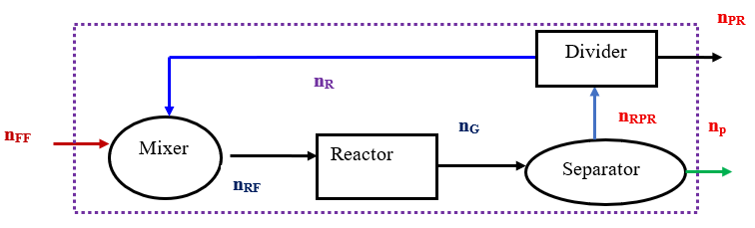
Figure 7.10 Multiple systems with a purge stream
Where: n_{FF} is moles of limiting reactant in the fresh feed, n_{R} is moles of limiting reactant in the recycle stream, n_{RF} is moles of limiting reactant in the fresh feed and recycle stream, n_{G} is moles of limiting reactant in a gross product, n_{p} is moles of limiting reactant in a product, and n_{PR} is moles of limiting reactant in a purge stream, and n_{RPR} is the moles of limiting reactant entering into a divider.
For reactive system material balances, it is mandatory to account the generation of products/consumption of reactants using the limiting reactant stoichiometric coefficient and extent of reaction (Richard M. Felder, 2005, pg. 138-142).
For the whole system, the overall material balance can be written as:
$n_{P}+n_{PR}=n_{FF}+v_{l}$ (7.16)
Where: n_{p} is the moles of limiting reactant in a product, n_{PR} is moles of limiting reactant in a purge stream, n_{FF} is the moles of limiting reactant in the fresh feed, v_{l} is stochiometric coefficient of the limiting reactant, and ξ is extent of reaction.
The material balance on the mixer and reactor can be determined using the equations (7.9 and 7.10) as described in the recycle systems.
The material balances on the separator and divider are used to determine the quantity of purge. To determine material balance on the separator, the separator is considered as a single system as depicted in Figure 7.11.
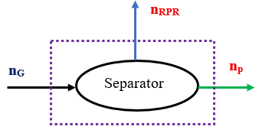
Figure 7.11 Material balances on the separator
There is no chemical reaction in the separator. The moles of the limiting reactant entering into the separator and leaving from it are equal. The material balance of the limiting reactant on the separator is given by:
$n_{G}=n_{P}+n_{RPR}$ (7.17)
Where: n_{G} is the moles of limiting reactant in a gross product, n_{P} is the moles of limiting reactant in a product, and n_{RPR} is the moles of limiting reactant in the recycle and purge streams.
Similarly, the material balance on the divider is used to determine the quantity of a purge stream as shown in Figure 7.12.
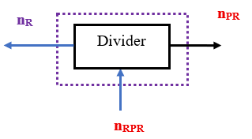
Figure 7.12 Material balances on the divider

In the divider, there is no chemical reaction. The material balance of the limiting reactant on the divider can be written as:
$n_{RPR}=n_{PR}+n_{R}$ (7.18)
Where: n_{RPR} is the moles of limiting reactant entering into a divider (moles of limiting reactant in the recycle and purge streams), n_{PR} is moles of limiting reactant in a purge stream, and n_{R} is moles of limiting reactant in a recycle stream.
7.4. Material balances for multiple systems with bypass stream
A bypass system is a configuration where a portion of the input stream is directed around a specific unit operation instead of through it. A bypass system allows a portion of the feed to avoid a unit operation or part of the process, which can be used for various reasons including operational flexibility, process control, composition control, or maintenance. Bypass stream can be used to manage flow rates or concentrations, or to reduce wear on equipment (Coulson & Richardson’s, 1999, pg. 53-54).
Bypass stream is commonly used for non-reactive systems. The material balances (MBs) for non-reactive systems can be performed using mass basis since there is no generation of products/consumption of reactants in the MBs equation. For a steady state process, there is no accumulation of materials in the system. i.e. the quantity of material in the inputs is equal to the quantity of material in the outputs. The presence of a bypass stream modifies the material balances equation by splitting the input into two streams (one that goes through the unit operation and the other one that bypasses it). The process flow sheet of multiple systems with a bypass stream is shown in Figure 7.13.

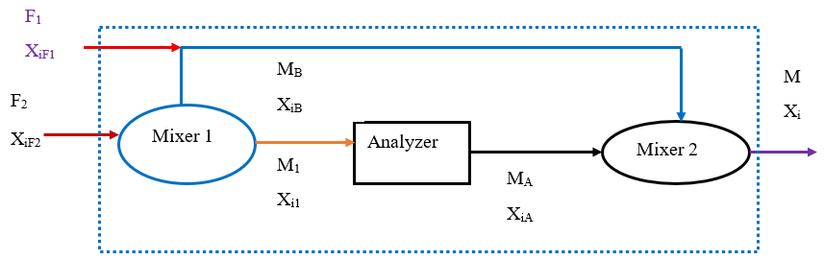
Figure 7.13 Multiple systems with a bypass stream
As shown in Figure 7.13, the material balances of multiple systems with a bypass stream can be determined by considering the whole process as a single system, and by dividing the multiple systems into single subsystems. By considering the whole process as a single unit, the overall material balance is given by:
$F_{1}+F_{2}=M$ (7.19)
Where: F₁ is mass in feed stream1, F₂ is mass in feed stream 2, and M is mass in the output.
For the whole system as a single unit, the components material balance for species i is given by:
${X_{iF1}*F}_{1}+X_{iF2}*F_{2}=X_{i}*M$ (7.20)
Where: F₁ is mass in feed stream1, F₂ is mass in feed stream 2, M is mass in the output, X_{iF1} is mass fraction of species i in the feed stream 1, X_{iF2} is mass fraction of species i in the feed stream 2, and X_{i} is mass fraction of species i in the output.
To quantify the bypass stream, you can divide the multiple systems into single subsystems, and determine the material balances on mixer 1 with bypass junction and/or mixer 2. The material balance on mixer 1 and bypass junction is shown in Figure 7.14.
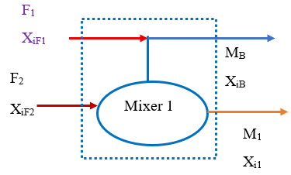
Figure 7.14 Material balances on mixer 1 and bypass junction
The overall material balances on mixer 1 and bypass junction can be written as:
$F_{1}+F_{2}=M_{1}+M_{B}$ (7.21)
Similarly, the component material balance for species i is given by:
${X_{iF1}*F}_{1}+X_{iF2}*F_{2}=X_{i1}*M_{1}+X_{iB}*M_{B}$ (7.22)
Where: F₁ is mass in feed 1, F₂ is mass in feed 2, M_{B} is mass in bypass stream, M₁ is the mass of mixer 1 output, X_{iF1} is mass fraction of species i in feed 1, X_{iF2} is mass fraction of species i in feed 2, X_{iB} is mass fraction of species i in the bypass stream, and X_{i1} is mass fraction of species i on mixer 1 output.
Activity 7.2
1. Ammonia is produced from H₂ and N₂ with suitable catalysts using the famous Haber process. The balanced chemical reaction is given by:
${3H}_{2}+N_{2}→{2NH}_{3}$ (7.23) (Himmelblau, 2023, pg. 302)
The fresh feed entering the overall process is 100 mol. The fresh feed of gas composed of 75.16%H₂, 24.57%N₂, and 0.27%Ar is mixed with recycled gas and enters the reactor with a composition of 79.52% H₂. There is a purge stream to remove Ar from the system. The gas stream leaving the separator as purge and recycle each contains 80.01%H₂ and no NH₃.The product is pure NH₃. Determine (a) moles of purged, NH₃ product & recycled, and (b) moles entering to the reactor & leaving from it.
#Q₁, Answer:
Given: Fresh feed (H₂, N₂ & Ar) = 100 mol
X_{F}(H₂) = 0.7516; X_{F}(N₂) = 0.2457; X_{F}(Ar) = 0.0027
Balanced chemical reaction equation: ${3H}_{2}+N_{2}→{2NH}_{3}$
Product stream: pure ammonia; Purge stream: unreacted (H₂ & N₂), and Ar
Required: (a) the moles of purged, NH₃ product & recycled, and (b) the moles entering to the reactor & leaving from it.
- The moles of purged, NH₃ product & recycled:
The process flow sheet of ammonia production is shown in Figure 7.15.
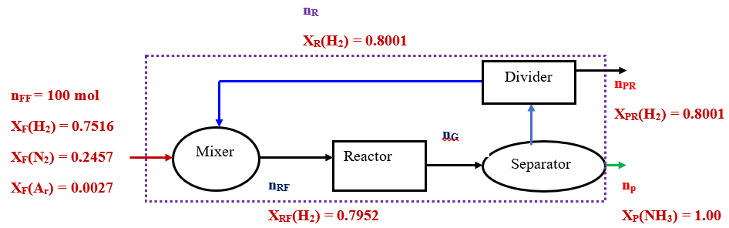
Figure 7.15 Ammonia production process flow sheet for activity 7.2
By considering the whole process as a single system, the material balance of each component is determined.
Material balance of hydrogen is given by:
$n_{PR}\left(H_{2}\right)=n_{FF}\left(H_{2}\right)+v$ξ
$n_{PR}\left(H_{2}\right)=75.16-3$ (7.24)
For nitrogen, the material balance is expressed by:
$n_{PR}\left(N_{2}\right)=n_{FF}\left(N_{2}\right)+v$ξ
$n_{PR}\left(N_{2}\right)=24.57-$ (7.25)
For argon, the material balance is expressed by:
$n_{PR}\left(Ar\right)=n_{FF}\left(Ar\right)=0.27$ (7.26)
By adding together equations (7.23-7.26), you get:
$n_{PR}\left(H_{2}\right)+n_{PR}\left(N_{2}\right)+n_{PR}\left(Ar\right)=n_{PR}=100-4$ (7.27)
It is given that the purge stream has 80.01% of H_{2,} and the balance of hydrogen is given by:
$n_{PR}\left(H_{2}\right)=75.16-3 *n_{PR}$ (7.28)

By substituting equation (7.27) into equation (7.28), and solve for the extent of reaction (), you get:
$=\frac{4.85}{0.2004}=24.2$ mol
From equation (7.26), the total mole of the purge (n_{PR}) is determined.
$n_{PR}=100-4=100-4*24.2=3.2$ mol
Material balance of ammonia is given by:
$n_{P}\left({NH}_{3}\right)=+2$ξ
$n_{P}\left({NH}_{3}\right)=2*24.2 = 48.4$ mol
Now, determine material balance on the mixer to find the moles in the recycle stream. The process flow sheet on the mixer is shown in Figure 7.16.
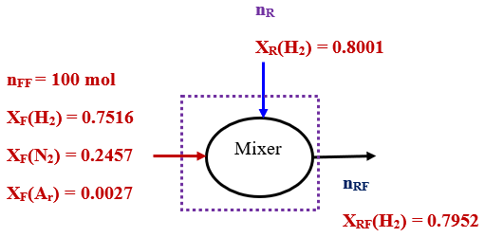
Figure 7.16 Process flow sheet on the mixer for activity 7.2
There is no chemical reaction in the mixer. The total material balance on the mixer is given by:
$n_{FF}+n_{R}=n_{RF}$
$n_{RF}=100+n_{R}$ (7.29)
The hydrogen material balance on the mixer is expressed by:
${X_{F}\left(H_{2}\right)* n}_{FF}+X_{R}\left(H_{2}\right){*n}_{R}={X_{RF}\left(H_{2}\right)*n}_{RF}$
$75.16+0.8001{*n}_{R}={0.7952*n}_{RF}$ (7.30)
By substituting equation (7.29) into (7.30), and solve for the recycle stream (n_{R}), you can get:
$n_{R}=\frac{4.36}{0.0049}=890$ mol
(b) the moles entering & leaving to the reactor:
From equation (7.29), the mole in the reactor feed (n_{RF}) is calculated as:
$n_{RF}=100+890=990$ mol
The mole of the output in the reactor (n_{G}) is the sum of recycled, purge and product
$n_{G}=n_{R}+n_{PR}+n_{P}=890+3.2+48.4=941.6$mol
7.5. Summary
Recycle stream can be used in reactive or non-reactive systems. A system of recycling with chemical reaction provides single-pass and overall conversions. Multiple systems with recycle and purge streams for reactive systems, the material balances must be determined using mole units to account generation of products/ consumption of reactants. A purge stream helps to ensure optimal process operation by removing unwanted materials, and mitigate risks associated with hazardous materials that could accumulate in the system. A bypass stream helps to control the exit composition or system temperature.
References
- Basic Principles and Calculations in Chemical Engineering, Himmelblau, Pearson Education Inc, 9th edition, 2023.
- Chemical Engineering Design, Volume 6, Coulson & Richardson’s, R. K. Sinnott, 3rd edition, 1999.
- Elementary Principles of Chemical Processes, Richard M. Felder, John Wiley & Sons, 3rd edition, 2005.

