Basic Principles of Process Calculations in Chemical Engineering (ChEg2106)
Prerequisites: No prerequisite for this course
Lecture 9: Energy Balances without Chemical Reaction for Open Systems
Week 9
Lecturer: Adamu Esubalew (PhD, ChEg)
Addis Ababa, Ethiopia

Lecture learning outcomes
At the end of the lecture, you will be able to:
- explain the importance of performing energy balances,
- identify energy balances problem-solving techniques for open systems,
- develop energy balance equations for open systems, and
- determine energy balances without chemical reaction for open systems.
9.1. Introduction energy balances for open systems
Open systems: Systems in which there are both mass and energy transfer across system boundaries. i.e. both mass and energy exchanges between open systems and the surroundings. In open systems, mass can flow in and out of the system boundaries, which complicates the energy balance equations as compared with closed systems. Most processes in the refining and chemical industries are open, steady-state systems. However, biological processes are more likely to be closed systems (e.g., batch systems). The energy balances for open systems can be expressed using the control volume approach.
An open system with energy entering to a system and leaving from a system is shown in Figure 9.1 (Coulson & Richardson’s, 1999, pg. 62). Materials enter to the inlet (1) a system with initial energy and outgoing from a system in the outlet (2) with initial energy. There are also other energies such as heat added to the system and work done by the system.
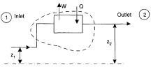
Figure 9.1 An open system with steady state process
An open system with heat exchange between cold and hot streams is shown in Figure 9.2 (Himmelblau, 2023, pg. 517). The cold-water stream gains energy, and the hot water stream loses its energy due to heat exchange. The heat gained by the cold-water steam is equal to the heat lost by the hot water stream.
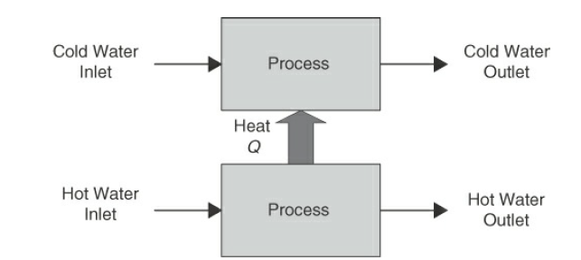
Figure 9.2 An open system heat exchange between cold and hot streams
Energy balances for open systems are fundamental concepts in chemical engineering for the analysis of processes where mass and energy can enter or leave systems. An open system allows for the exchange of both mass and energy with its surroundings. The first law of thermodynamics is used to determine energy balances for open systems. In turbines, compressors, heat exchangers, distillation columns, and other processes where mass and energy transfer are critical. Understanding the process is crucial to identify energy flows to perform energy balances for open systems.
9.2. Importance of performing energy balances
There are several key reasons highlighting the importance of conducting energy balances. Some of the importance for performing energy balances are the followings:
To understand the system behavior: Energy balances help to understand how energy is transferred and transformed within a system. Understanding a system is crucial for predicting how systems will respond to changes in operating conditions. For open systems both mass and energy transfer across system boundaries, which interact with external factors. Energy balance is foundational for developing mathematical models and simulations of processes. Mathematical models can predict system behavior under various scenarios, facilitating research and development.
To design and optimize processes: Performing energy balances provides critical information about energy consumption and efficiency for designing and optimizing processes. It facilitates the integration of various processes within a plant, optimizing overall energy use across interconnected systems. This enables engineers to design and optimize processes for maximum efficiency, reducing operational costs and improving sustainability.
To identify energy efficiency and sustainability: Performing energy balances helps to identify the areas of energy loss or inefficiency, which can guide improvements that lead to reduced energy consumption. It helps to assess the efficiency of processes and their environmental impact, leading to more sustainable practices. Reducing energy consumption is essential for developing sustainable practices and minimizing environmental impacts.
To perform cost estimation and economic analysis: Performing energy balances provides insights into the operational costs associated with energy use. Identifying energy use can lead to significant cost savings and reduced operational expenses. For existing processes, energy balance data is key for economic analysis and decision-making to take corrective actions when the operational cost of energy use is very high. It is also crucial for economic analysis and decision-making regarding investments in new technologies or processes.
To perform safety analysis: Performing energy balances plays a key role in safety assessments by identifying potential hazards related to energy accumulation or release. Understanding energy flows can help to prevent accidents related to overheating and pressure buildup in various process systems. If potential hazards are identified, proactive measures will be taken to prevent accidents. Performing energy balances is crucial for developing control strategies to maintain desired operating conditions.
To maintain regulatory compliance requirements: Performing energy balances provides a framework for monitoring and evaluating the performance of equipment and processes over time. Many industries are subject to national or local government regulations regarding energy use and emissions to the environment. Performing energy balances helps to ensure regulatory compliance requirements for energy use and environment safety, avoiding legal issues and potential penalties.
9.3. Energy balance problem-solving techniques for open systems
For open systems, enthalpy, kinetic energy, potential energy, heat energy and work can transfer across system boundaries. For open systems, energy balance problem-solving techniques may have several procedures (Richard M. Felder, 2005, pg. 329-330). The common problem-solving techniques are described as follows:
Read carefully and understand the given problem: Identify the processes taking place within the system, such as heating or cooling. Identify the type of energy flows what enters and exits the system.
Draw the process flow diagram/ process flow sheet and define system boundaries: Draw the process flow diagram with appropriate flow directions, given values and symbols. Define the symbols used in the process flow diagram. It is also required to clearly identify the boundaries of the system you are analyzing.
Identify the unknowns: Identify the unknows in the given problem, and count how many unknowns are there in the given problem.
Identify the appropriate equations: Identify the appropriate energy balance equations for open systems.
Check units’ consistency, and the numbers of degree of freedom: It is required to check that both the left-hand side and the right-hand side of energy balance equations must have consistent units. The numbers of unknowns in the given problem and the number of independent energy balance equations must be equal. i.e. the numbers of degree of freedom must be zero.
Collect additional data: Collect relevant additional tabulated data if any for the given problem.
State assumptions: Identify the process states (steady state or unsteady state). Identify the forms of energy shall be accounted or ignored the given problem. The assumptions are used to simplify the problem-solving procedures by eliminating less effect energy forms from energy balance equations.
Perform energy balance calculations: Solve the problem using the identified appropriate energy balance equations to find the unknowns.
Analyze the results: Analyze the results and write the conclusion based on the results analysis. Using the above problem-solving techniques, you can effectively solve energy balance problems for open systems and analyze the results.

Activity 9.1
1. Identify the reasons of performing energy balances.
2. Explain the importance of energy balance problem-solving techniques for open systems.
Q₁, Answer:
Performing energy balances is essential to understand the system behavior, design and optimize processes, identify energy efficiency and sustainability, perform cost estimation and economic analysis, perform safety analysis, and maintain regulatory compliance.
Q₂, Answer:
Energy balance problem-solving techniques for open systems are crucial for effective designing, analyzing, and optimizing processes where mass and energy transfer occur.
9.4. Energy balances without chemical reaction for open systems
For open system energy can be transfer across system boundaries in the form of enthalpy, kinetic energy, potential energy, heat added to the systems and work done by the systems. In this lecture, the energy balance for open systems can be expressed using the control volume approach with macroscopic point of view. At a steady state condition, the open system energy balance equation is expressed by:
$Energy inputs=enenrgy outputs$ (9.1)
The energy inputs refer to the total rate of transport of kinetic energy, potential energy, and internal energy by all process input streams plus the rate at which energy is transferred in as heat energy. The change in internal energy can be obtained due to temperature change in open systems. The rate of heat energy transferred to the system can be supplied by a single or multiple heat energy.
The energy outputs denote the total rate of energy transport by the output streams plus the rate at which energy is transferred out as work. The total work done by the system on its surroundings equals the shaft work plus the flow work (Richard M. Felder, 2005, pg. 320-321).
To determine the energy balance without chemical reaction for an open system, consider the following single system process flow sheet as depicted in Figure 9.3.
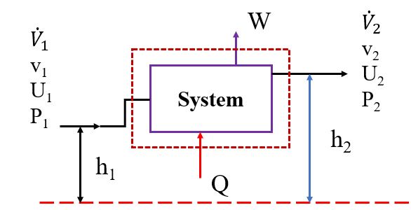
Figure 9.3 Energy balances for open system

Where: subscript “1” refers to the inputs, and subscript “2” refers to the outputs.
U, Q, W, P, $\dot{V}$, v and h refer to internal energy, the heat addition, work done by the system, pressure, volumetric flow rate, velocity of flowing fluid, and elevation, respectively.
At a steady state condition, the open system energy balance equation is expressed by:
$U_{1}+P_{1}{\dot{V}}_{1}+{KE}_{1}+{PE}_{1}+Q=U_{2}+P_{2}{\dot{V}}_{2}+{KE}_{2}+{PE}_{2}+W$ (9.2)
Where: KE, PE and $P\dot{V}$are kinetic energy, potential energy and flow energy, respectively (Richard M. Felder, 2005, pg. 322-324).
A steady state condition, the input volumetric flow rate is equal to the output volumetric flow rate.
${\dot{V}}_{1}={\dot{V}}_{2}=\dot{V}$ (9.3)
By substituting equation (9.3) into equation (9.2), you get:
$U_{1}+P_{1}\dot{V}+{KE}_{1}+{PE}_{1}+Q=U_{2}+P_{2}\dot{V}+{KE}_{2}+{PE}_{2}+W$ (9.4)
${H_{1}=U}_{1}+P_{1}\dot{V}$ (9.5)
${H_{2}=U}_{2}+P_{2}\dot{V}$ (9.6)
where: H is enthalpy of open system.
Enthalpy is the total heat content of the system, which is equal to the sum of internal energy and flow energy.
By substituting equations (9.5 & 9.6) into equation (9.4), you get:
$H_{1}+{KE}_{1}+{PE}_{1}+Q=H_{2}+{KE}_{2}+{PE}_{2}+W$ (9.7)
By rearranging equation (9.7), you get:
${H_{2}-H}_{1}+{{KE}_{2}-KE}_{1}+{PE}_{2}{-PE}_{1}=Q-W$ (9.8)
This equation (9.8) shows that the difference between energy outputs and energy of inputs, which is the energy balance equation for an open system at steady state conditions. The energy balance equation for an open system at steady state conditions can be written as:
$∆H+∆KE+∆PE=Q-W$ (9.9)
Where: ΔH is the change in enthalpy, ΔKE is the change in kinetic energy, ΔPE is the change in potential energy, Q is the heat added to a system, and W is work done by the system.
For multiple open systems, the energy balance equations are developed in a similar manner with a single system. To develop energy balance equations, you will have two techniques:
- considering the multiple systems as a single system, you can perform energy balance, and
- dividing the multiple systems into single systems, and perform energy balance for each.
The energy balance equations you will develop shall be independent, and the number of independent equations and the number of unknowns must be equal.
To determine the energy balances without chemical reaction for open systems, consider the following multiple systems process flow sheet as depicted in Figure 9.4.
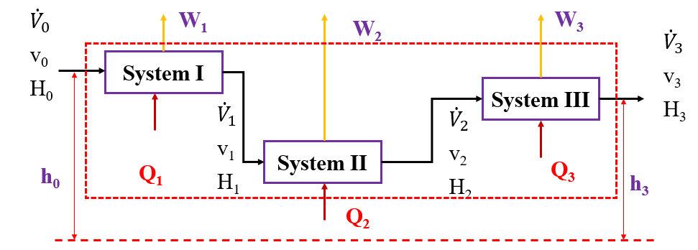
Figure 9.4 Energy balances for multiple open systems
Where: the subscript “0” is the input for system I, and the subscripts “1, 2 & 3” are outputs from system I, system II and system III, respectively.
H, Q, W, $\dot{V}$, v and h denote to enthalpy, the heat addition, work done by the system, volumetric flow rate, velocity of flowing fluid, and elevation, respectively.
To determine the energy balances for multiple open systems given in Figure 9.4, first you consider the whole systems as a single system; and you can divide the multiple systems into three single systems.
- Multiple systems as a single system:
The energy balances equation for whole systems as single system is given by:
${H_{3}-H}_{0}+{{KE}_{3}-KE}_{0}+{{PE}_{3}-PE}_{0}=Q_{1}+Q_{2}+Q_{3}-W_{1}-W_{2}-W_{3}$ (9.10)
This equation (9.10) shows that the difference between energy outputs and energy of inputs is the change in energy for different forms.
$∆H+∆KE+∆PE=Q_{1}+Q_{2}+Q_{3}-W_{1}-W_{2}-W_{3}$ (9.11)
Where: ΔH is the overall change in enthalpy, ΔKE is the overall change in kinetic energy, ΔPE is the overall potential energy, Q₁, Q₂ and Q₃ are the heat added to system I, system II and system III, respectively, and W₁, W₂ and W₃ are work done by system I, system II and system III, respectively.

(b) divide the multiple systems into three single systems:
In each single unit develop energy balance equations to find the energy flows between each system.
System I: The energy balances for a single open system I is depicted in Figure 9.5.
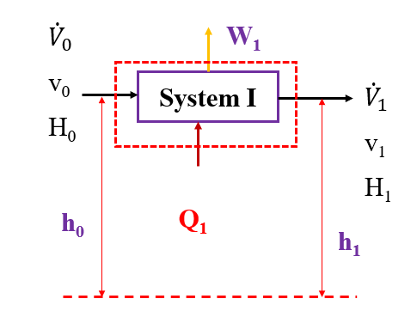
Figure 9.5 Energy balances for a single open system I
The energy balances equation for a single open system I is given by:
${H_{1}-H}_{0}+{{KE}_{1}-KE}_{0}+{{PE}_{1}-PE}_{0}=Q_{1}-W_{1}$ (9.12)
This equation (9.12) shows that the difference between energy outputs and energy of inputs in a single open system (I) is the change in energy of different forms.
${∆H}_{1}+{∆KE}_{1}+{∆PE}_{1}=Q_{1}-W_{1}$ (9.13)
Where: ΔH₁ is change in enthalpy, ΔKE₁ is change in kinetic energy, ΔPE₁ is change in potential energy, Q₁ is the heat added, and W₁ is work done by the system.

System II: The energy balances for a single open system II is shown in Figure 9.6.
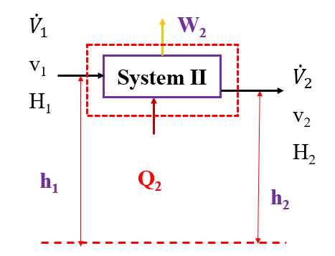
Figure 9.6 Energy balances for a single open system II

The energy balances equation for a single open system II is given by:
${H_{2}-H}_{1}+{{KE}_{2}-KE}_{1}+{{PE}_{2}-PE}_{1}=Q_{2}-W_{2}$ (9.14)
By rearranging (9.14), you can get:
${∆H}_{2}+{∆KE}_{2}+{∆PE}_{2}=Q_{2}-W_{2}$ (9.15)
Where: ΔH₂ is the change in enthalpy, ΔKE₂ is the change in kinetic energy, ΔPE₂ is the change in potential energy, Q₂ is the heat added, and W₂ is work done by the system.

System III: The energy balances for a single open system III is depicted in Figure 9.7. 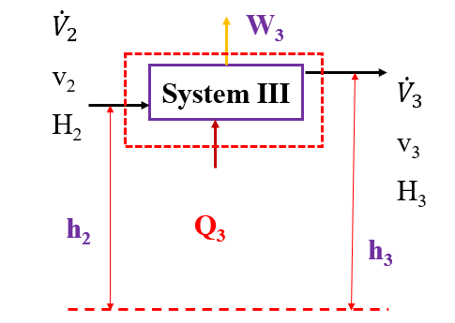
Figure 9.7 Energy balances for a single open system III
The energy balances equation for a single open system (III) is given by:
${H_{3}-H}_{2}+{{KE}_{3}-KE}_{2}+{{PE}_{3}-PE}_{2}=Q_{3}-W_{3}$ (9.16)
By rearranging (9.16), the energy balance equation for system III can be written as:
${∆H}_{3}+{∆KE}_{3}+{∆PE}_{3}=Q_{3}-W_{3}$ (9.17)
Where: ΔH₃ is the change in enthalpy, ΔKE₃ is the change in kinetic energy, ΔPE₃ is the change in potential energy, Q₃ is the heat added, and W₃ is work done by the system.
Activity 9.2
1. Water is supplied to a heater through the pipe at an inlet flow rate of 0.05m³/s. The outlet flow rate of the water is 0.05m³/s at the height of 3.5m below the inlet stream. External heat energy is supplied to the system at a rate of 60kJ/s to increase the temperature of water. If the internal diameter of the pipe is 0.2m, what will be the rate of change in enthalpy of the system?
2. For an edible oil refining industry, the hot oil with a volumetric flow rate of 500L/h is cooled at the cooler collect the required product refined oil. Water is used as a coolant. The hot oil has an inlet temperature of 85ºC and the outlet temperature is 30ºC. However, the inlet temperature of water is 25ºC with a volumetric flow rate of 360L/h. Assume that there is no heat loss due to the material resistance. The density of water and density of oil are 0.9 kg/L and 1.0 kg/L, respectively. The specific heats of oil and water at the given temperature ranges are 1.5kJ/kg.ºC and 4.18kJ/kg.ºC, respectively. Based on the given data, determine:(a) the outlet temperature of water, and (b) heat gained by water.
3. Water flows through pipes to multiple systems which consist of three single systems in series. Water enters to the first system at temperature of 25ºC with a flow rate of 10kg/s for preheating of industrial application. The heat added rates to system (I), system (II) and system (III) are 750kJ/s, 980kJ/s and 1, 200kJ/s, respectively. The inlet and outlet flow of water for each system is at the same position. Water flows at constant volumetric flow rate, and the diameters of pipes is constant. The specific heat capacity of water is 4.18kJ/kg.ºC. Determine:(a) the change in enthalpy of the overall systems, and (b) the outlet temperatures from each system.
Q₁, Answer:
Given: An open system, volumetric flow rate of water in the inlet and outlet is constant, $\dot{V}$= 0.05m³/s
Diameter of pipe is constant, d = 0.2m
The outlet stream height is below inlet stream, h₂-h₁= -3.5m
Heat added to the system, Q = 60 kJ/s
Required: The rate of change in enthalpy of the system.
Assumptions: The process is steady state, and there is no chemical reaction.
There is no work done, W = 0
Density of water is constant, ρ =1, 000 kg/m³, and acceleration due to gravity is 9.81 m/s².
The inlet and outlet pressure is the same, P₁= P₂= P
It is given that the inlet and outlet volumetric flow rate is constant, $\dot{V}$= 0.05m³/s
The velocity of water is the ratio of volumetric flow rate to cross-sectional area.
$v_{1}=v_{2}=\frac{\dot{V}}{A}=\frac{4\dot{V}}{πd^{2}}=\frac{4*0.05}{π*0.2*0.2}=1.6$m/s
An open system process flow sheet for energy balance calculation is depicted in Figure 9.8.
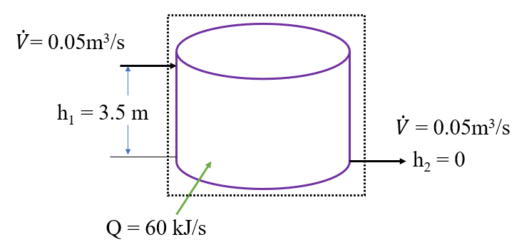
Figure 9.8 An open system process flow sheet for activity 9.2, #Q₁
The rate of change in enthalpy is determined using an open system energy balance equation (9.9):
$\text{ΔH+ΔKE+ΔPE = Q-W}$
It is assumed that there is no work done, W= 0.
Since the inlet velocity and outlet velocity are the same, the change in kinetic energy is zero, ΔKE = 0
$\text{ΔH+ΔPE = Q }$ (9.18)
The change in potential energy is given by:
$∆PE=\dot{m}g\left(h_{2}-h_{1}\right)=ρ\dot{V}g\left(h_{2}-h_{1}\right)$
$∆PE=ρ\dot{V}g\left(h_{2}-h_{1}\right)=1000*0.05*9.81\left(-3.5\right)=$ -1717 J/s= -1.717 kJ/s
By rearranging equation (9.18), you get:
$∆H=Q-∆PE$ (9.19)
$∆H=60-\left(-1.717\right)=60+1.717=61.717$ kJ/s $62$ kJ/s
Therefore, the rate of change in enthalpy of the system is 62 kJ/s.
Q₂, Answer:
Given: Open system with two streams (hot stream and cold stream).
Hot stream (Oil): ρ_{o} = 0.9 kg/L, and ${\dot{V}}_{o}$=500 L/h
Inlet temperature (T_{o1}) = 85ºC, and outlet temperature (T_{o2}) = 30ºC.
Specific heat capacity is 1.5 kJ/kg.ºC
Cold stream (water): ρ_{w}= 1 kg/L, and ${\dot{V}}_{w}$=360 L/h
Inlet temperature (T_{w1}) = 25ºC, and specific heat capacity is 4.18 kJ/kg.ºC
Required: determine (a) the outlet temperature of water, and (b) the heat gained by water.
Assumptions: The process is steady state; there is no chemical reaction; and there is no work done by the system, W = 0
There is no heat loss due to material resistance between cold and hot streams.
The change in potential energy and the change in kinetic energy both are negligible.
The quantity of heat lost by the hot stream is equal to the quantity of heat gained by the cold stream. The process flow sheet of hot and cold streams heat exchange is shown in Figure 9.9 (Himmelblau, 2023, pg. 515).
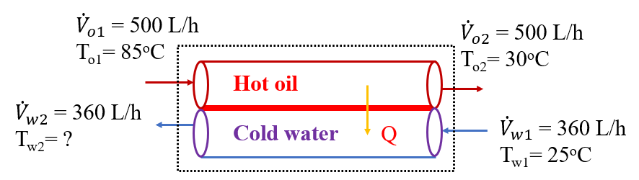
Figure 9.9 Process flow sheet of hot and cold streams heat exchange
(a) the outlet temperature of water:
To determine the outlet temperature of water (cold) stream, the overall energy balance on both hot and cold streams is given by:
$m_{o}C_{po}\left(T_{o1}-T_{o2}\right)=m_{w}C_{pw}\left(T_{w2}-T_{w1}\right)$ (9.20)
$T_{w2}=T_{w1}+\frac{m_{o}C_{po}\left(T_{o1}-T_{o2}\right)}{m_{w}C_{pw}}=$ $25+\frac{0.9*500*1.5\left(85-30\right)}{1.0*360*4.18}=50$ºC
Hence, the outlet temperature of water is 50ºC.
(b) the heat gained by water:
The heat gained by water (Q_{w}) is equal to the heat lost by hot oil (Q_{o}), which have opposite sings.
$Q_{w}={-Q}_{o}$
${Q_{o}=m}_{o}C_{po}\left(T_{o2}-T_{o1}\right)={}_{o}{\dot{V}}_{o}C_{po}(T_{o2}-T_{o1})$
$Q_{o}={}_{o}{\dot{V}}_{o}C_{po}\left(T_{o2}-T_{o1}\right)=0.9*500*1.5\left(30-85\right)=-37, 125$ kJ/h
$Q_{w}={-Q}_{o}=-\left(-37, 125\right)=37, 125$ kJ/h
Q₃, Answer:
Given: Multiple open systems, mass flow rate of water is constant, $\dot{m}$= 10kg/s.
Diameter of pipes is constant.
All systems are at the same position.
The heat added to the systems (I, II & III):
Q₁ = 750 kJ/s, Q₂ = 980kJ/s; and Q₃ =1, 200 kJ/s
Specific heat capacity of water, Cp = 4.18 kJ/ kg.ºC.
Required: (a) the change in enthalpy of the overall systems, and (b) the outlet temperatures from systems (T₁, T₂ and T₃).
Assumptions: Steady state process, and there is no chemical reaction.
There is no work done, W = 0
The specific heat capacity of water is constant.
Water flows with constant velocity, and the same positions, ΔKE = 0, and ΔPE = 0
The process flow sheet of multiples open systems for energy balance calculation is depicted in Figure 9.10.
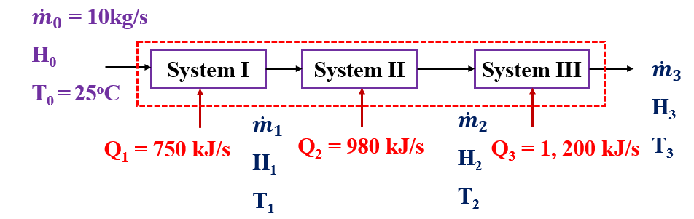
Figure 9.10 Multiple systems process flow sheet for activity 9.2, #Q₃
(a) the change in enthalpy of the overall systems:
The energy balances equation for the whole systems as single system is given by:
$∆H=Q_{1}+Q_{2}+Q_{3}$ (9.21)
$∆H=Q_{1}+Q_{2}+Q_{3}=750+980+1, 200=2,930 \text{kJ/s}$
(b) the outlet temperature from all systems (T₁, T₂ & T₃):
To determine the outlet temperature from system III (T₃), the overall change in enthalpy is given by:
$∆H={\dot{m}C}_{p}(T_{3}-T_{0})$ (9.22)
By rearranging equation (9.22) and solve for T₃, you get:
$T_{3}=T_{0}+\frac{∆H}{{\dot{m}C}_{p}}=25+\frac{2, 930}{10*4.18}=95$ºC
Thus, the outlet temperature from system III is 95ºC.
To determine the outlet temperatures from system I & II, you divide the multiple systems into three single systems. The process flow sheet of energy balances for system (I) is shown in Figure 9.11.
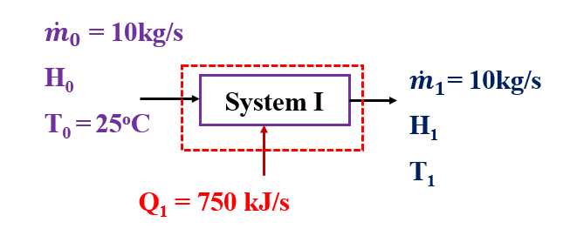
Figure 9.11 Process flow of energy balances for system (I) of activity 9.2, #Q₃
The change in enthalpy for system (I) is given by:
${∆H}_{1}=Q_{1}$ (9.23)
${∆H}_{1}=Q_{1}=750$ kJ/s
To determine the outlet temperature (T₁) from system (I), the change in enthalpy can be written as:
${∆H}_{1}={\dot{m}C}_{p}(T_{1}-T_{0})$ (9.24)
By rearranging equation (9.24) and solve for T₁, you get:
$T_{1}=T_{0}+\frac{{∆H}_{1}}{{\dot{m}C}_{p}}=25+\frac{750}{10*4.18}=43$ºC
Hence, the outlet temperature from system I is 43ºC.

The process flow sheet of energy balances for system (II) is shown in Figure 9.12.
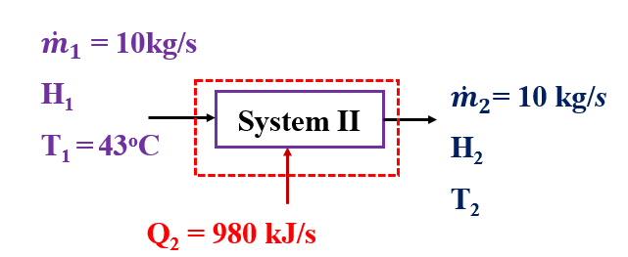
Figure 9.12 Process flow of energy balances for system (II) of activity 9.2, #Q₃
The change in enthalpy for system (II) is expressed by:
${∆H}_{2}=Q_{2}$ (9.25)
${∆H}_{2}=Q_{2}=980$ kJ/s
To determine the outlet temperature (T₂) from system (II), the change in enthalpy can be written as:
${∆H}_{2}={\dot{m}C}_{p}(T_{2}-T_{1})$ (9.26)
By rearranging equation (9.26) and solve for T₂, you get:
$T_{2}=T_{1}+\frac{{∆H}_{2}}{{\dot{m}C}_{p}}=43+\frac{980}{10*4.18}=66.5$ºC
Therefore, the outlet temperature from system II is 66.5ºC.

9.5. Summary
Performing energy balances is essential to understand the system behavior, design and optimize processes, identify energy efficiency and sustainability, perform cost estimation and economic analysis, perform safety analysis, and maintain regulatory compliance. For open system, energy flows across system boundaries can be in the form of enthalpy, kinetic energy, potential energy, heat added to the system and work done by the system. To determine the energy balances for multiple open systems, you consider the whole systems as a single system; and you can divide the multiple systems into several single systems.
References
- Basic Principles and Calculations in Chemical Engineering, Himmelblau, Pearson Education Inc, 9th edition, 2023.
- Chemical Engineering Design, Volume 6, Coulson & Richardson’s, R. K. Sinnott, 3rd edition, 1999.
- Elementary Principles of Chemical Processes, Richard M. Felder, John Wiley & Sons, 3rd edition, 2005.

