Basic Principles of Process Calculations in Chemical Engineering (ChEg2106)
Prerequisites: No prerequisite for this course
Lecture 12: Integrated Material and Energy Balances for Multiple Systems
Week 12
Lecturer: Adamu Esubalew (PhD, ChEg)
Addis Ababa, Ethiopia

Lecture learning outcomes
At the end of the lecture, you will be able to:
- identify the characteristics of multiple systems,
- develop integrated material and energy balances equations for multiple systems without chemical reactions and with chemical reactions, and
- determine material and energy balances for multiple systems without chemical reactions and with chemical reactions.
12.1. Introduction to integrated material and energy balances for multiple systems
Integrated material and energy balances for multiple systems involve a comprehensive approach to analyze the flow of materials and energy within interconnected processes. Integrated material and energy balances for multiple systems consider multiple systems as a whole rather than in isolation, allowing for a better understanding of interactions and dependencies of interconnections to account the exchange of materials and energy between different systems. The multiple systems can be interconnections of reactors, separators, and heat exchangers, which require integrated material and energy balances determination (Himmelblau, 2023, pg. 265-272).
Multiple systems have their own characteristics to be considered to determine integrated material and energy balances. Some of the key characteristics multiple systems are:
Require holistic approach: Integrated material and energy balances for multiple systems follows holistic approach by considering multiple systems as a whole rather than in isolation.
Need to account for multiple components: Integrated material and energy balances must consider multiple chemical species or components, each with its own properties and behaviors, and the heat of reactions associated with chemical reactions. Chemical reactions can alter the composition of materials, requiring a careful accounting of reactants and products, and temperature of reactors and other interconnected process units.
Need software tools: Integrated material and energy balances are commonly complex to perform calculations manually, which requires relevant software tools to simulate the balances for complex calculations. Software tools can also facilitate optimization of processes for efficient resource utilization, improved process efficiency, and reduced waste disposal to the environment.
Data requirement: The inputs require accurate data on flow rates, compositions, energy requirements, and operational conditions, which are essential for reliable integrated material and energy balances. Integrated material and energy balances analysis can provide a sign to incorporate feedback mechanisms that adjust operations based on realistic data to optimize operational processes. Integrated material and energy balances can help in evaluating the economic feasibility of processes by considering material and energy costs.
In this lecture, integrated material and energy balances for multiple systems without chemical reactions and with chemical reactions are discussed.
12.2. Integrated material and energy balances for multiple systems without chemical reactions
Integrated material and energy balances without chemical reactions can be determined using mass units since there is no generation of products/ consumption of reactants. Integrated material and the energy balance equations are developed in a similar approach with single systems discussed in lecture 11 (See lecture 11). For multiple systems you will have two sequential approaches:
- Develop integrated material and energy balance equations, and determine balances by considering multiple systems as a single system, and
- Develop integrated material and energy balance equations, and determine balances by dividing multiple systems into single systems.
To determine integrated material and energy balances without chemical reaction for multiple systems, consider the following multiple systems as shown in Figure 12.1(Coulson & Richardson’s, 1999, pg. 62).
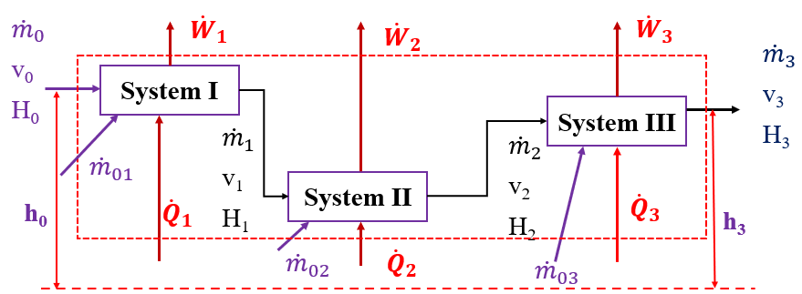
Figure 12.1 Integrated material and energy balances for multiple systems
Where: the subscript “0” is the input for system I, II & III, and the subscripts “1, 2 & 3” are input and outputs of system I, II and III, respectively; and $\dot{H}$, $\dot{Q}$, $\dot{W}$, $\dot{m}$, v and h are the rates of enthalpy, the heat addition, work done by the system, mass flow rate, velocity of fluid, and elevation of streams, respectively.
To determine integrated material and energy balances for multiple systems, you can consider the whole system as a single system; and divide the multiple systems into three single systems.
(A) Consider multiple systems as a single system:
Material balance equation: By considering the whole process as a single system, the material balances equation is given by:
${\dot{m}}_{0}+$ ${\dot{m}}_{01}+{\dot{m}}_{o2}+{\dot{m}}_{03}={\dot{m}}_{3}$ (12.1)
Where: ${\dot{m}}_{0}$ and ${\dot{m}}_{01}$are mass flow rates enter to system I, ${\dot{m}}_{02}$, and ${\dot{m}}_{03}$ are mass flow rates enter to system II and system III, respectively, and ${\dot{m}}_{3}$ is mass flow rate leaves from system III.
Energy balance equation: Similarly, by considering the whole systems as single system, the energy balances equation is given by:
$∆\dot{H}+∆\dot{KE}+∆\dot{PE}=({\dot{Q}}_{1}+{\dot{Q}}_{2}+{\dot{Q}}_{3})-({\dot{W}}_{1}+{\dot{W}}_{2}+{\dot{W}}_{3})$ (12.2)
Where: $∆\dot{H}$is the rate of change in enthalpy, $∆\dot{KE}$is the rate of change in kinetic energy, $∆\dot{PE}$is the rate of potential energy, ${\dot{Q}}_{1}$, ${\dot{Q}}_{2}$ and ${\dot{Q}}_{3}$ are the rates of heat added to system I, system II and system III, respectively, and ${\dot{W}}_{1}$, ${\dot{W}}_{2}$ and ${\dot{W}}_{3}$ are the rates of work done by system I, system II and system III, respectively (Richard M. Felder, 2005, pg. 322-324).
(B) Dividing multiple systems into three single systems: The integrated material and energy balance equations for each system can be determined sequentially as follows:
System I: The integrated material and energy balances for system I is depicted in Figure 12.2.
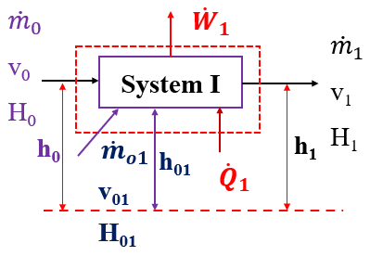
Figure 12.2 Integrated material and energy balances for system I
Material balances equation: The material balances equation for system I is expressed by:
${\dot{m}}_{o}+{\dot{m}}_{o1}={\dot{m}}_{1}$ (12.3)
Where: ${\dot{m}}_{o}$ and ${\dot{m}}_{o1}$ are mass flow rates in the input streams, and ${\dot{m}}_{1}$ is mass flow rate in the output stream for system I.
Energy balances equation: The energy balances equation for system I is given by:
${∆\dot{H}}_{1}+{∆\dot{KE}}_{1}+{∆\dot{PE}}_{1}={\dot{Q}}_{1}-{\dot{W}}_{1}$ (12.4)
Where: ${∆\dot{H}}_{1}$is the rate of change in enthalpy, ${∆\dot{KE}}_{1}$is the rate of change in kinetic energy, ${∆\dot{PE}}_{1}$is the rate of change in potential energy, ${\dot{Q}}_{1}$ is the rate of heat addition, and ${\dot{W}}_{1}$ is the rate of work done by the system for system I.
The rate of change in enthalpy can be written as:
${∆\dot{H}}_{1}={\dot{m}}_{1}H_{1}-\left({\dot{m}}_{o}H_{o}+{{\dot{m}}_{o1}H}_{o1}\right)$ (12.5)
Where: ${∆\dot{H}}_{1}$ is the rate of change in enthalpy, ${\dot{m}}_{1}$ and $H_{1}$ are mass flow rate and specific enthalpy of the output stream, respectively, and ${\dot{m}}_{0}$, ${\dot{m}}_{o1}$, $H_{o}$ and $H_{o1}$ are mass flow rates and specific enthalpies in the input streams, respectively for system I.
The rate of kinetic energy is determined using velocity and mass flow rate of flowing fluids.
The rate of change in kinetic energy can be written as:
${∆\dot{KE}}_{1}=\frac{1}{2}{[\dot{m}}_{1}{v^{2}}_{1}-\left({\dot{m}}_{o}{v^{2}}_{o}+{\dot{m}}_{o1}{v^{2}}_{o1}\right)$] (12.6)
Where: ${∆\dot{KE}}_{1}$is the rate of change in kinetic energy, ${\dot{m}}_{1}$ and $v_{1}$ are mass flow rate and velocity of the output stream, respectively, and ${\dot{m}}_{0}$, ${\dot{m}}_{o1}$, $v_{o}$ and $v_{o1}$ are mass flow rates and velocities in the input streams, respectively for system I.
The rate of potential energy is determined using elevation difference, acceleration due to gravity and mass flow rate of flowing fluids.
The rate of change in potential energy is also given by:
${∆\dot{PE}}_{1}=g{[\dot{m}}_{1}h_{1}-\left({\dot{m}}_{o}h_{o}+{\dot{m}}_{o1}h_{o1}\right)$] (12.7)
Where: ${∆\dot{PE}}_{1}$is the rate of change in potential energy, ${\dot{m}}_{1}$ and $h_{1}$ are mass flow rate and elevation of the output stream, respectively, and ${\dot{m}}_{0}$, ${\dot{m}}_{o1}$, $h_{o}$ and $h_{o1}$ are mass flow rates and elevations in the input streams, respectively for system I.
System II: The integrated material and energy balances are shown in Figure 12.3.
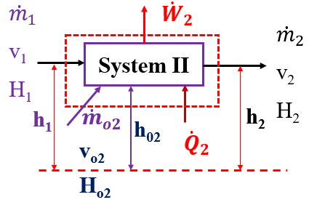
Figure 12.3 Integrated material and energy balances for system II
Material balances equation: The material balances equation for system II is given by:
${\dot{m}}_{1}+{\dot{m}}_{o2}={\dot{m}}_{2}$ (12.8)
Where: ${\dot{m}}_{1}$ and ${\dot{m}}_{o2}$ are mass flow rates in the input streams, and ${\dot{m}}_{2}$ is mass flow rate in the output stream for system II.
Energy balances equation: The energy balances equation for system II is expressed by:
${∆\dot{H}}_{2}+{∆\dot{KE}}_{2}+{∆\dot{PE}}_{2}={\dot{Q}}_{2}-{\dot{W}}_{2}$ (12.9)
Where: ${∆\dot{H}}_{2}$is the rate of change in enthalpy, ${∆\dot{KE}}_{2}$is the rate of change in kinetic energy, ${∆\dot{PE}}_{2}$is the rate of change in potential energy, ${\dot{Q}}_{2}$ is the rate of heat addition, and ${\dot{W}}_{2}$ is the rate of work done by the system for system II.
The rate of change in enthalpy for system II can be written as:
${∆\dot{H}}_{2}={\dot{m}}_{2}H_{2}-\left({\dot{m}}_{1}H_{1}+{{\dot{m}}_{o2}H}_{o2}\right)$ (12.10)
Where: ${∆\dot{H}}_{2}$ is the rate of change in enthalpy, ${\dot{m}}_{2}$ and $H_{2}$ are mass flow rate and specific enthalpy of the output stream, respectively, and ${\dot{m}}_{1}$, ${\dot{m}}_{o2}$, $H_{1}$ and $H_{o2}$ are mass flow rates and specific enthalpies in the input stream, respectively for system II.
The rate of change in kinetic energy can be written as:
${∆\dot{KE}}_{2}=\frac{1}{2}{[\dot{m}}_{2}{v^{2}}_{2}-\left({\dot{m}}_{1}{v^{2}}_{1}+{\dot{m}}_{o2}{v^{2}}_{o2}\right)$] (12.11)
Where: ${∆\dot{KE}}_{2}$is the rate of change in kinetic energy , ${\dot{m}}_{2}$ and $v_{2}$ are mass flow rate and velocity of the output stream, respectively, and ${\dot{m}}_{1}$, ${\dot{m}}_{o2}$, $v_{1}$ and $v_{o2}$ are mass flow rates and velocities in the input streams, respectively for system II.
The rate of change in potential energy can be written as:
${∆\dot{PE}}_{2}=g{[\dot{m}}_{2}h_{2}-\left({\dot{m}}_{1}h_{1}+{\dot{m}}_{o2}h_{o2}\right)$] (12.12)
Where: ${∆\dot{PE}}_{2}$is the rate of change in potential energy, ${\dot{m}}_{2}$ and $h_{2}$ are mass flow rate and elevation of the output stream, respectively, and ${\dot{m}}_{1}$, ${\dot{m}}_{o2}$, $h_{1}$ and $h_{o2}$ are mass flow rates and elevations in the input streams, respectively for system II.
System III: The integrated material and energy balances are shown in Figure 12.4.
Figure 12.4 Integrated material and energy balances for system III
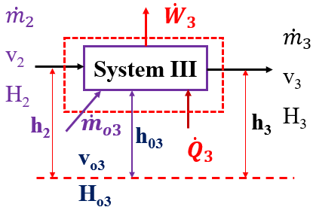
Figure 12.4 Integrated material and energy balances for system III
Material balances equation: The material balances equation for system III is given by:
${\dot{m}}_{2}+{\dot{m}}_{o3}={\dot{m}}_{3}$ (12.13)
Where: ${\dot{m}}_{2}$ and ${\dot{m}}_{o3}$ are mass flow rates in the input streams, and ${\dot{m}}_{3}$ is mass flow rate in the output stream for system III.
Energy balances equation: The energy balances equation for system III is expressed by:
${∆\dot{H}}_{3}+{∆\dot{KE}}_{3}+{∆\dot{PE}}_{3}={\dot{Q}}_{3}-{\dot{W}}_{3}$ (12.14)
Where: ${∆\dot{H}}_{3}$is the rate of change in enthalpy, ${∆\dot{KE}}_{3}$is the rate of change in kinetic energy, ${∆\dot{PE}}_{3}$is the rate of change in potential energy, ${\dot{Q}}_{3}$ is the rate of heat addition, and ${\dot{W}}_{3}$ is the rate of work done by the system for system III.
The rate of change in enthalpy for system III can be written as:
${∆\dot{H}}_{3}={\dot{m}}_{3}H_{3}-\left({\dot{m}}_{2}H_{2}+{{\dot{m}}_{o3}H}_{o3}\right)$ (12.15)
Where: ${∆\dot{H}}_{3}$ is the rate of change in enthalpy, ${\dot{m}}_{3}$ and $H_{3}$ are mass flow rate and specific enthalpy of the output stream, respectively, and ${\dot{m}}_{2}$, ${\dot{m}}_{o3}$, $H_{3}$ and $H_{o3}$ are mass flow rates and specific enthalpies in the input stream, respectively for system III.
For system III, the rate of change in kinetic energy can be expressed by:
${∆\dot{KE}}_{3}=\frac{1}{2}{[\dot{m}}_{3}{v^{2}}_{3}-\left({\dot{m}}_{2}{v^{2}}_{2}+{\dot{m}}_{o3}{v^{2}}_{o3}\right)$] (12.16)
Where: ${∆\dot{KE}}_{3}$is the rate of change in kinetic energy, ${\dot{m}}_{3}$ and $v_{3}$ are mass flow rate and velocity of the output stream, respectively, and ${\dot{m}}_{2}$, ${\dot{m}}_{o3}$, $v_{2}$ and $v_{o3}$ are mass flow rates and velocities in the input streams, respectively for system III.
The rate of change in potential energy can be written as:
${∆\dot{PE}}_{3}=g{[\dot{m}}_{3}h_{3}-\left({\dot{m}}_{2}h_{2}+{\dot{m}}_{o3}h_{o3}\right)$] (12.17)
Where: ${∆\dot{PE}}_{3}$is the rate of change in potential energy, ${\dot{m}}_{3}$ and $h_{3}$ are mass flow rate and elevation of the output stream, respectively, and ${\dot{m}}_{2}$, ${\dot{m}}_{o3}$, $h_{2}$ and $h_{o3}$ are mass flow rates and elevations in the input streams, respectively for system III.
Activity 12.1
1. Water is supplied into multiple systems at temperature of 45ºC with a mass flow rate of 700kg/s. In the process, 15% and 30% of the feed mass flow rate is discharged from system I and system II outlet streams, respectively, as shown in Figure 12.5. The supply energy rates into system I, II and III are 10,000kJ/s, 12,000kJ/s and 14, 000kJ/s, respectively. Assume that the specific heat capacity of water is 4.2kJ/kg.ºC which is constant for all temperatures, and the reference temperature is 25ºC. Determine: (a) the mass flow rates of each stream of system I, II & III, (b) the outlet temperatures from system I, II & III, and (c) the rate of overall change in enthalpy of multiple systems. The process flows sheet of Activity 12.1 is depicted in Figure 12.5.
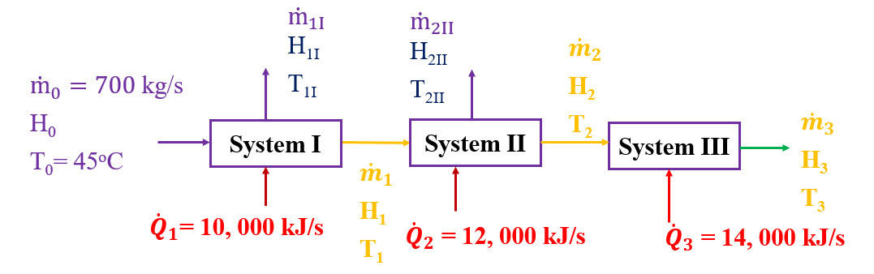
Figure 12.5 Integrated material and energy balances for multiple systems
Where: ${\dot{m}}_{0}$, H_{o} and T_{o} are mass flow rate, specific enthalpy and temperature of feed to system I, respectively; ${\dot{Q}}_{1}$, ${\dot{Q}}_{2}$, and ${\dot{Q}}_{3}$ are rates of heat addition to system I, II & III, respectively; ${\dot{m}}_{1I}$, H_{1I} and T_{1I} are mass flow rate, specific enthalpy and temperature of water leaves from system I, respectively; ${\dot{m}}_{1}$, H₁ and T₁ are mass flow rate, specific enthalpy and temperature water of leaves from system I and enters to system II, respectively; ${\dot{m}}_{2II}$, H_{2II} and T_{2II} are mass flow rate, specific enthalpy and temperature of water leaves from system II, respectively; ${\dot{m}}_{2}$, H₂ and T₂ are mass flow rate, specific enthalpy and temperature of water leaves from system II and enter to system III, respectively; and ${\dot{m}}_{3}$, H₃ and T₃ are mass flow rate, specific enthalpy and temperature of water leaves from system III, respectively.
#Q₁, Answer:
Given: Multiple systems without chemical reaction.
Input streams: ${\dot{m}}_{0}=700$ kg/s, T_{o}= 45ºC, ${\dot{Q}}_{1}=10, 000$ kJ/s, ${\dot{Q}}_{2}=12, 000$ kJ/s,
${\dot{Q}}_{3}=14, 000$ kJ/s
Output streams: ${\dot{m}}_{1I}=0.15*{\dot{m}}_{0}=0.15*700=105$ kg/s, ${\dot{m}}_{2II}=0.30*{\dot{m}}_{0}=0.30*700=210$ kg/s
Required: (a) the mass flow rates of each stream of system I, II & III, (b) the outlet temperatures from system I, II & III, and (c) the rate of overall change in enthalpy of multiple systems
To determine integrated material and energy balances, you have to state your assumptions.
Assumptions:
- The operation is carried out at steady state conditions.
- There is no chemical reaction.
- The specific heat capacity of water is constant in all temperatures.
- The rates of change in kinetic energy, potential energy, and work done by the system all are negligible as compared with rates of heat addition and change in enthalpy.
The process flows sheet for Activity 12.1 with boundary line is illustrated in Figure 12.6.

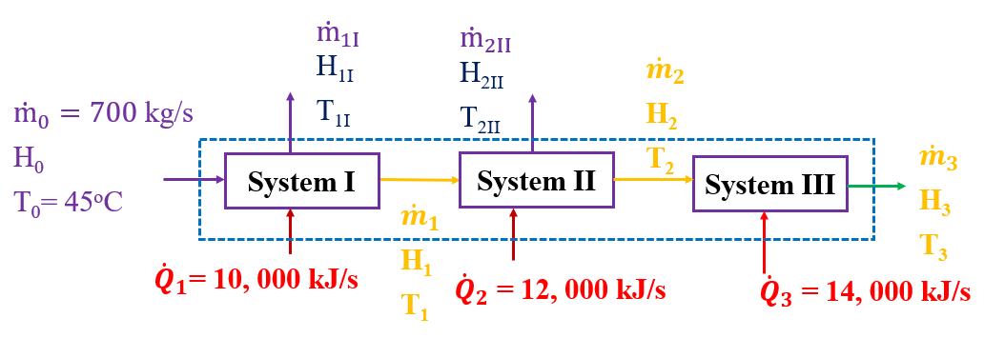
Figure 12.6 Integrated material and energy balances of multiple systems for Activity 12.1

Overall material balances equation: The overall material balance equation is given by:
${\dot{m}}_{0}={\dot{m}}_{1I}+{\dot{m}}_{2II}+{\dot{m}}_{3}$ (12.18)
By rearranging equation (12.18), you can get:
${\dot{m}}_{3}={\dot{m}}_{o}-({\dot{m}}_{1I}+{\dot{m}}_{2II})$ (12.19)
By substituting the values of ${\dot{m}}_{0}=700$ kg/s, ${\dot{m}}_{1I}=105$kg/s and ${\dot{m}}_{2II}=210$ kg/s into equation (12.19), the of mass flow rate of water leaves from system III is calculated as:
${\dot{m}}_{3}=700-\left(105+210\right)=385$ kg/s
Hence, the mass flow rate of water leaves from system III is 385 kg/s.
Overall energy balances equation: The overall energy balance equation is given by:
$∆\dot{H}={\dot{Q}}_{1}+{\dot{Q}}_{2}+{\dot{Q}}_{3}$ (12.20)
Where: $∆\dot{H}$is the rate of change in enthalpy, ${\dot{Q}}_{1}$, ${\dot{Q}}_{2}$ and ${\dot{Q}}_{3}$ are the rates of heat added to system I, system II and system III, respectively.
By substituting the values of ${\dot{Q}}_{1}=10, 000$ kJ/s, ${\dot{Q}}_{2}=12, 000$kJ/s and ${\dot{Q}}_{3}=14, 000$ kJ/s into equation (12.20), the rate of change in enthalpy is calculated as:
$∆\dot{H}={\dot{Q}}_{1}+{\dot{Q}}_{2}+{\dot{Q}}_{3}=10, 000+12, 000+14, 0000=36, 000$ kJ/s
Hence, the rate of overall change in enthalpy is 36, 000 kJ/s.
System I: Integrated material and energy balances on system I for Activity 12.1 is depicted in Figure 12.7.
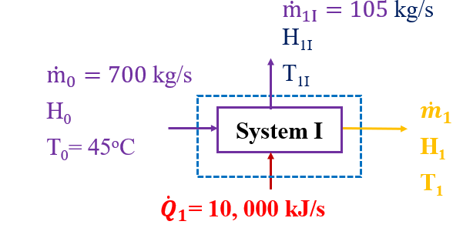
Figure 12.7 Integrated material and energy balances on system I for Activity 12.1
Material balance equation: The material balance equation for system I is expressed by:
${\dot{m}}_{1}={\dot{m}}_{o}-{\dot{m}}_{1I}$ (12.21)
Where: ${\dot{m}}_{0}$, ${\dot{m}}_{1I}$ and ${\dot{m}}_{1}$ are mass flow rates of water enters to system I, and leaves from it, respectively.
By substituting the values of ${\dot{m}}_{o}=700$ kg/s and ${\dot{m}}_{1I}=105$ kg/s into equation (12.21), the mass flow rate of water leaves from system I and enters to system II (${\dot{m}}_{1}$) is determined as:
${\dot{m}}_{1}={\dot{m}}_{o}-{\dot{m}}_{1I}=700-105=595$ kg/s
Energy balance equation: The energy balance equation for system I is expressed by:
${∆\dot{H}}_{1}=\left({\dot{m}}_{1}H_{1}+{{\dot{m}}_{1I}H}_{1I}\right)-{\dot{m}}_{o}H_{o}={\dot{Q}}_{1}$ (12.22)
But, H₁ = H_{1I} and T₁= T_{1I} since they are the same source.
$H_{1}=H_{1I}=C_{pw}(T_{1}-T_{R})$ (12.23)
$H_{o}=C_{pw}(T_{o}-T_{R})$ (12.24)
Where: C_{pw} is specific heat capacity of water, T₁ is outlet temperature of steam I and T_{R} is reference temperature.
By substituting equations (12.23& 12.24) into equation (12.22), and solving for the outlet temperature (T₁), you can get:
$T_{1}=T_{o}+ \frac{{\dot{Q}}_{1}}{{\dot{m}}_{o}C_{pw}}$ (12.25)
By substituting the values of T_{o}= 45ºC, ${\dot{m}}_{o}=700$ kg/s, C_{pw}= 4.2 kJ/kg.ºC and ${\dot{Q}}_{1}=10, 000$ kJ/s into equation (12.25), the outlet temperature (T₁) is calculated as:
$T_{1}=T_{o}+ \frac{{\dot{Q}}_{1}}{{\dot{m}}_{o}C_{pw}}=45+\frac{10, 000}{700*4.2}=48.4$ºC
System II: Integrated material and energy balances for system II for Activity 12.1 is depicted in Figure 12.8.
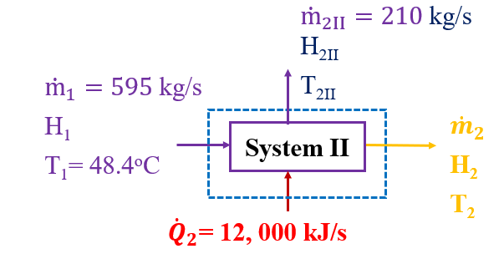
Figure 12.8 Integrated material and energy balances on system II for Activity 12.1
Material balance equation: The material balance equation on system II is expressed by:
${\dot{m}}_{2}={\dot{m}}_{1}-{\dot{m}}_{2II}$ (12.26)
By substituting the values of ${\dot{m}}_{1}=595$ kg/s and ${\dot{m}}_{2II}=210$ kg/s into equation (12.26), the mass flow rate of water leaves from system II and enters to system III (${\dot{m}}_{2}$) is determined as:
${\dot{m}}_{2}={\dot{m}}_{1}-{\dot{m}}_{2II}=595-210=385$ kg/s
Energy balance equation: The energy balance equation for system II is expressed by:
${∆\dot{H}}_{2}=\left({\dot{m}}_{2}H_{2}+{{\dot{m}}_{2II}H}_{2II}\right)-{\dot{m}}_{1}H_{1}={\dot{Q}}_{2}$ (12.27)
But, H₂ = H_{2II} and T₂= T_{2II} since they are the same source.
$H_{2}=H_{2II}=C_{pw}(T_{2}-T_{R})$ (12.28)
$H_{1}=C_{pw}(T_{1}-T_{R})$ (12.29)
Where: C_{pw} is specific heat capacity of water, T₂ is outlet temperature of system II and T_{R} is reference temperature.
By substituting equations (12.28& 12.29) into equation (12.27), and solving for the outlet temperature (T₂), you can get:
$T_{2}=T_{1}+ \frac{{\dot{Q}}_{2}}{{\dot{m}}_{1}C_{pw}}$ (12.30)
By substituting the values of T₁= 48.4ºC, ${\dot{m}}_{1}=595$ kg/s, C_{pw}= 4.2 kJ/kg.ºC and ${\dot{Q}}_{2}=12, 000$ kJ/s into equation (12.30), the outlet temperature (T₂) is calculated as:
$T_{2}=T_{1}+ \frac{{\dot{Q}}_{2}}{{\dot{m}}_{1}C_{pw}}=48.4+\frac{12, 000}{595*4.2}=53.2$ºC
System III: Integrated material and energy balances for system III for Activity 12.1 is depicted in Figure 12.9.
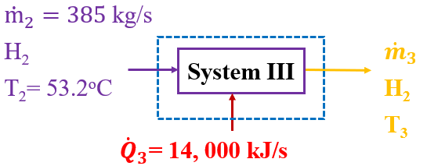
Figure 12.9 Integrated material and energy balances on system III for Activity 12.1
Material balance equation: The material balance equation for system III is expressed by:
${\dot{m}}_{2}={\dot{m}}_{3}$ (12.31)
By substituting the values of ${\dot{m}}_{2}=385$ kg/s into equation (12.31), the mass flow rate of water leaves from system III (${\dot{m}}_{2}$) is obtained as:
${\dot{m}}_{2}={\dot{m}}_{3}=385$ kg/s
Energy balance equation: The energy balance equation for system III is expressed by:
${∆\dot{H}}_{3}={\dot{m}}_{3}H_{3}-{\dot{m}}_{2}H_{2}={\dot{Q}}_{3}$ (12.32)
$H_{2}=C_{pw}(T_{2}-T_{R})$ (12.33)
$H_{3}=C_{pw}(T_{3}-T_{R})$ (12.34)
By substituting equations (12.33 & 12.34) into equation (12.32), and solving for the outlet temperature (T₃), you can get:
$T_{3}=T_{2}+ \frac{{\dot{Q}}_{3}}{{\dot{m}}_{2}C_{pw}}$ (12.35)
By substituting the values of T₂= 53.2ºC, ${\dot{m}}_{2}=385$ kg/s, C_{pw}= 4.2 kJ/kg.ºC and ${\dot{Q}}_{3}=14, 000$ kJ/s into equation (12.35), the outlet temperature (T₃) is calculated as:
$T_{3}=T_{2}+ \frac{{\dot{Q}}_{3}}{{\dot{m}}_{2}C_{pw}}=53.2+\frac{14, 000}{385*4.2}=61.9$ºC
12.3. Integrated material and energy balances for multiple systems with chemical reactions
Material balances shall account for the rate of generation of products/consumption of reactants (See lecture 5-7). Energy balances with chemical reactions shall consider the heat generated by exothermic reactions or absorbed by endothermic reactions (See lecture 10). To determine integrated material and energy balances with chemical reaction, it is compulsory to account the rate of generation of products /consumption of reactants in the material balance equation, and heat of reaction released by exothermic reactions or heat absorbed by endothermic reactions. To develop integrated material and energy balance equations, consider the following multiple systems with chemical reaction as shown in Figure 12.10.
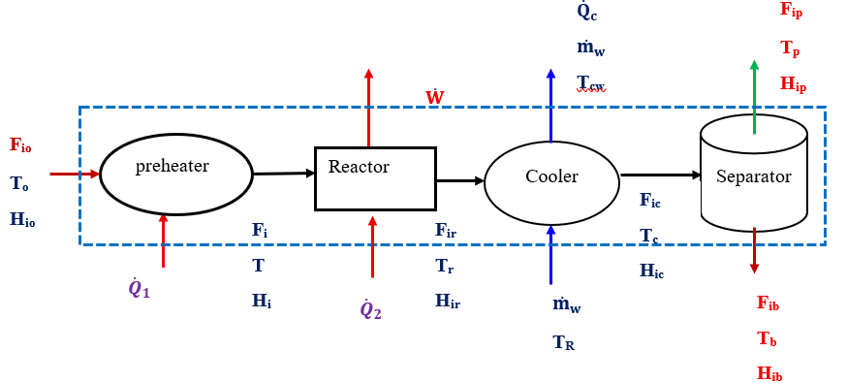
Figure 12.10 Multiple systems with chemical reaction
Where: F_{io} F_{ir}, F_{ic}, F_{ip} and F_{ib} are mole flow rates of species i enter to the reactor, leave from the reactor, leave from cooler and leave from separator in the top product and bottom product, respectively; ${\dot{Q}}_{1}$and ${\dot{Q}}_{2}$ are rate of heat addition to the preheater and reactor, respectively; $\dot{W}$ is work done by the reactor; T_{o}, T, T_{r}, T_{c}, T_{p} and T_{b} are temperatures enter to preheater, enter to the reactor, leave from the reactor, leave from cooler, and leave from separator to product and bottom product, respectively; H_{io}, H_{i}, H_{ir}, H_{ic}, H_{ip} and H_{ib} are specific enthalpies enter to preheater, enter to the reactor, leave from the reactor, leave from cooler, and leave from separator to top product and bottom product, respectively; and ${\dot{Q}}_{c}$, ${\dot{m}}_{w}$, T_{R} and T_{cw} are rate of heat removal by the cooler, mass flow rate of cooling water, input temperature of cooling water, and cooling water outlet temperature, respectively.
To develop integrated material and energy balance equations, first you have to state assumptions, and then you can consider the whole process as a single system, and divide the multiple systems into single systems.
Assumptions:
- The whole process is operated at steady state condition.
- The rates of the change in kinetic energy and potential energy are assumed negligible as compared with heat addition and heat of reaction.
- There is no heat loss due to materials resistance.
- Water at reference temperature is used as a coolant fluid.
- Chemical reaction is only carried out in the reactor.
A) Overall material and energy balances
By considering multiple systems as a single system, the material and energy balance equations are developed as follows:
Material balance equation: The overall material balance equation can be written as:
$F_{iP}+F_{ib}=F_{io}+v_{i}$ (12.36)
Where: F_{ip} is the mole rate of species i in the top product, F_{ib} is the mole rate of species i in the bottom product, F_{io} is the mole rate of species i in the feed, v_{i} is stochiometric coefficient of species i, and ξ is extent of reaction.
Energy balance equation: The overall energy balance equation is given by:
${\dot{Q}}_{1}+{\dot{Q}}_{2} +F_{io}H_{io}=F_{ip}H_{ip}+F_{ib}H_{ib}+{\dot{Q}}_{c}+\dot{W}$ (12.37)
Where: ${\dot{Q}}_{1}$and ${\dot{Q}}_{2}$ are rates of heat addition to preheater and reactor, respectively; $\dot{W}$ is rate of work done by the reactor; F_{io} F_{ip} and F_{ib} are mole flow rates of species i enter to the reactor, leave from separator in top product and bottom product, respectively; H_{io}, H_{ip} and H_{ib} are specific enthalpies enter to preheater, and leave from separator to top product and bottom product, respectively; and ${\dot{Q}}_{c}$ is rate of heat removal by the cooler (Himmelblau, 2023, pg. 568-571).
B) Integrated material and energy balances for each system
Preheater: Integrated material and energy balances on the preheater is shown Figure 12.11.
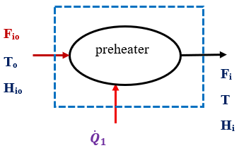
Figure 12.11 Integrated material and energy balances on the preheater
Material balance equation: The material balance equation on the preheater is given by:
$F_{io}=F_{i}$ (12.38)
Energy balance equation: The energy balance equation on the preheater is expressed by:
${\dot{Q}}_{1}+F_{io}H_{io}=F_{i}H_{i}$ (12.39)
Where: ${\dot{Q}}_{1}$ is rate of heat addition; Fio and F_{i} are the mole rates of species i in the input and output of the preheater, respectively; and H_{io} and H_{i} are the specific enthalpies of species i in the input and output streams of the preheater, respectively.
Reactor: Integrated material and energy balances across reactor boundary line is shown Figure 12.12.
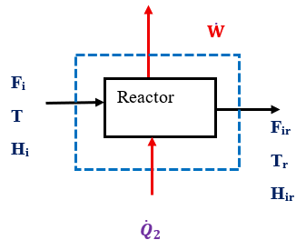
Figure 12.12 Integrated material and energy balances on the reactor
Material balance equation: The material balance equation on the reactor can be written as:
$F_{ir}=F_{i}+v_{i}$ (12.40)
Energy balance equation: The energy balance equation on the reactor can be written as:
${\dot{Q}}_{2}+F_{i}H_{i}=F_{ir}H_{ir}+\dot{W}$ (12.41)
Where: ${\dot{Q}}_{2}$ is rate of heat addition; $\dot{W}$ is rate of work done; F_{i} and F_{ir} are the mole rates of species i in the input and output of the reactor, respectively; v_{i} is stochiometric coefficient of species i; ξ is extent of reaction; and H_{i} and H_{ir} are the specific enthalpies of species i in the input and output streams of the reactor, respectively.
Cooler: Integrated material and energy balance flows across cooler boundary line is depicted Figure 12.13.
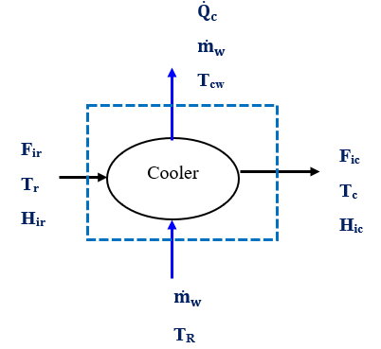
Figure 12.13 Integrated material and energy balances on the cooler
Material balance equation: The material balance equation on the cooler is expressed by:
$F_{ir}=F_{ic}$ (12.42)
Energy balance equation: The energy balance equation on the cooler is given by:
$F_{ir}H_{ir}=F_{ic}H_{ic}+{\dot{Q}}_{c}$ (12.43)
Where: ${\dot{Q}}_{c}$ is rate of heat removed by the cooler; F_{ir} and F_{ic} are the mole rates of species i in the input and output of the cooler, respectively; and H_{ir} and H_{ic} are the specific enthalpies of species i in the input and output streams of the cooler, respectively.
The rate of heat removal by the cooler is given by:
${\dot{Q}}_{c}={\dot{m}}_{w}*C_{pw}(T_{cw}-T_{R})$ (12.44)
Where: ${\dot{Q}}_{c}$ is rate of heat removed by the cooler; ${\dot{m}}_{w}$is mass flow rate of cooling water, C_{pw} is specific heat capacity of water, T_{cw} is temperature of cooling water after cooling operation, and T_{R} is the input temperature of cooling water (reference temperature).
Separator: Integrated material and energy balance flows across separator boundary line is illustrated Figure 12.14.
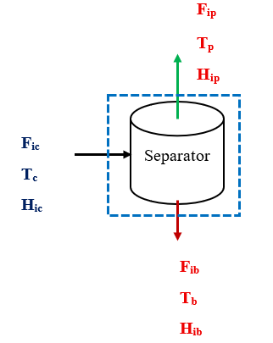
Figure 12.14 Integrated material and energy balances on the separator
Material balance equation: The material balance equation on the separator is given by:
$F_{ic}=F_{ip}+F_{ib}$ (12.45)
Energy balance equation: The energy balance equation on the separator is given by:
$F_{ic}H_{ic}=F_{ip}H_{ip}+F_{ib}H_{ib}$ (12.46)
Where: F_{ic}, F_{ip} and F_{ib} are the mole rates of species i in the input of separator, and output of the separator top product and bottom product, respectively; and H_{ic}, H_{ip} and H_{ib} are the specific enthalpies of species i in the input of separator, and output of the separator top product and bottom product, respectively.
Activity 12.2
1. The dehydrogenation of ethanol to form acetaldehyde is given by:
$C_{2}H_{5}OH(v)→{CH}_{3}CHO(v)+H_{2}$(g) (12.47)
The ethanol dehydrogenation reaction is carried out with the feed entering at 300ºC. The feed contains 90% ethanol and the balance acetaldehyde and enters the reactor at a rate of 150 mol/s. To keep the temperature from dropping too much and thereby decreasing the reaction rate to an unacceptably low level, heat is transferred to the reactor. When the heat addition rate is 2,440kJ/s, the outlet temperature is 253ºC. After the reaction, the outlet stream is passed through a cooler recover heat using water as a coolant.
Water is used as a coolant and enters to a cooler at 25ºC, and the cooling water temperature is increased by 30ºC. Calculate the change in enthalpy, the extent of reaction, the mole flow rates of each component in the reactor outlet stream, and mass flow rate of cooling water.
Additional data: The specific enthalpy of ethanol (H_{1F}) at 300ºC = -212. 19 kJ/mol, and the specific enthalpy of acetaldehyde (H_{2F}) at 300ºC = -147. 07 kJ/mol; and the specific enthalpy of ethanol (H_{1P}) at 253ºC = -216. 81 kJ/mol, the specific enthalpy of acetaldehyde (H_{2P}) at 253ºC = -150. 90 kJ/mol, and the specific enthalpy of hydrogen molecule (H_{3P}) at 253ºC = 6.595 kJ/mol (Richard M. Felder, 2005, pg. 458-460).
#Q₁, Answer:
Given: Chemical reaction with balanced stoichiometric equation:
$C_{2}H_{5}OH(v)→{CH}_{3}CHO(v)+H_{2}$(g)
Input stream: Feed is a mixture of ethanol and acetaldehyde with total feed rate of 150 mol/s, and 90% ethanol and 10% acetaldehyde at 300ºC.
Heat added to the reactor 2, 440 kJ/s.
The specific enthalpy of ethanol (H_{1F}) at 300ºC = -212. 19 kJ/mol, and the specific enthalpy of acetaldehyde (H_{2F}) at 300ºC = -147. 07 kJ/mol.
Reactor output stream: The outlet temperature for the reactor is 253ºC. The specific enthalpy of ethanol (H_{1p}) at 253ºC = -216.81 kJ/mol, the specific enthalpy of acetaldehyde (H_{2p}) at 253ºC = -150.90 kJ/mol, and specific enthalpy of hydrogen molecule (H_{3p}) at 253ºC = 6.595 kJ/mol.
Cooler output stream: The specific enthalpy of ethanol (H_{1c}) at 125ºC = -108.4 kJ/mol, the specific enthalpy of acetaldehyde (H_{2c}) at 125ºC = -75.45 kJ/mol, and the specific enthalpy of hydrogen molecule (H_{3c}) at 125ºC = 3.280 kJ/mol.
Required: Calculate $∆\dot{H}$, ξ, F and ${\dot{m}}_{w}$.

Assumptions:
- The reaction and cooling process is carried out at steady state condition.
- The specific heat capacity of water (C_{pw}= 4.2 kJ/ kg.ºC), which is constant.
- It is assumed that the rates of the change in kinetic energy, potential energy, and work done by the system are neglected.
The process flow diagram of integrated material and energy balances with chemical reaction is shown in Figure 12.15.
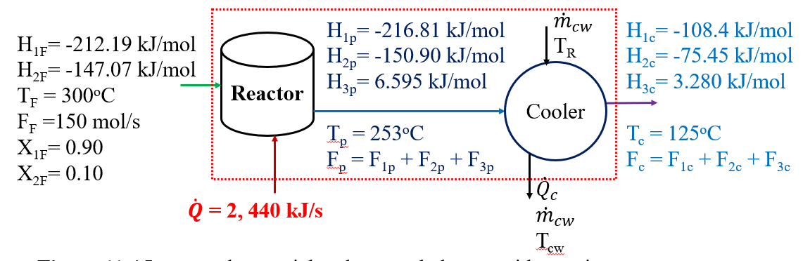
Figure 12.15 Integrated material and energy balances with reaction
Where: The subscripts “1, 2 and 3” refer to ethanol, acetaldehyde, and hydrogen molecule, respectively; the subscripts “F, p and c” refer to the feed stream, product stream and cooling stream, respectively; F_{F}, F_{P} and F_{c} are the mole flow rates for feed, product and cooling streams, respectively; T_{F}, T_{p} and T_{c} are temperatures of feed, product and cooling streams, respectively; and H_{F}, H_{p} and H_{c} are specific enthalpies in the feed, product and cooling streams, respectively.
Material balance: The feed rate of ethanol: $F_{1F}=X_{1F}*F_{F}=0.90*150=135$ mol/s
The material balance equation of ethanol for the reactor is given by:
$F_{1P}=135-$ (12.48)
Where: F_{1P} is the mole flow rate of ethanol in the product, and ξ is the extent of reaction.
The feed rate of acetaldehyde to the reactor: $F_{2F}=X_{2F}*F_{F}=0.10*150=15$ mol/s
The material balance equation of acetaldehyde for the reactor is given by:
$F_{2P}=15+$ (12.49)
Where: F_{2P} is mole flow rate of acetaldehyde in the product, and ξ is the extent of reaction.
The material balance equation for hydrogen molecule of the reactor is given by:
$F_{3P}=$ (12.50)
Where: F_{3P} is mole flow rate of hydrogen molecule for product stream, and ξ is extent of reaction.
Energy balances: The energy balance on the reactor is given by:
$\dot{Q}={\dot{H}}_{R}$ (12.51)
Where: $\dot{Q}$ is rate of heat addition, and Δ${\dot{H}}_{R}$is the rate of change in enthalpy in the reactor.
It is given that the rate of heat addition is 2, 440 kJ/s.
Δ${\dot{H}}_{R}=\dot{Q}=2, 440$ kJ/s
The rate of change in enthalpy on the reactor can be written as:
${\dot{H}}_{R}={(F}_{1p}*H_{1p}+F_{2p}*H_{2p}+F_{3p}*H_{3p})-(F_{1F}*H_{1F}+F_{2F}*H_{2F}+F_{3F}*H_{3F})$ (12.52)
The given values of the specific enthalpies, rate of heat addition, and mole flow rates are:
H_{1F}= -212. 19 kJ/mol, H_{2F} =-147. 07 kJ/mol, H_{3F} = 0 (since no hydrogen molecule in the feed), H_{1P} = -216. 81 kJ/mol, H_{2P} = -150. 90 kJ/mol, and H_{3P} = 6.595 kJ/mol, $\dot{Q}=2, 440$ kJ/s,
F_{1F}= 135 mol/s, and F_{2F}= 15 mol/s
By substituting the above values into equation (12.52), the energy balance equation becomes:
${216.81*F}_{1p}+150.90{*F}_{2p}-6.595{*F}_{3p}=28, 411.7$ (12.53)
To determine the extent of reaction, you can substitute the material balance equations (12.48- 12.50) into energy balance equation (12.53).
$216.81*\left(135-\right)+150.90*\left(15+\right)-6.595*=28, 411.7$
$72.505=3, 121.15$
$=\frac{3, 121.15}{72.505}=43$ mol/s
Now, you can use the value of extent of reaction to calculate the mole flow rates of each component in the product stream.
The mole flow rate of ethanol in the product stream (F_{1p}) is calculated using equation (12.48) as: $F_{1P}=135-= 135-43= 92$ mol/s
The mole flow rate of acetaldehyde in the product is also determined using equation (12.49) as: $F_{2P}=15+= 15+43= 58$ mol/s
Similarly, the mole flow rate of hydrogen molecule in the product stream is determined using equation (12.50) as: $F_{3P}= = 43$ mol/s
To find the mass flow rate of cooling water required, you can determine integrated material and energy balance on the cooler as shown in Figure 12.16.
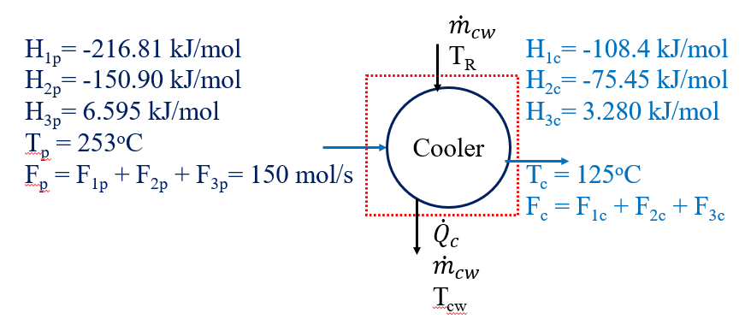
Figure 12.16 Integrated material and energy balances on the cooler
Material balances: during cooling process, there is no chemical reaction.
The mole rate of inputs is equal to the mole rate of outputs.
Ethanol balance: $F_{1P}=F_{1c} = 92$ mol/s
Acetaldehyde balance: $F_{2P}=F_{2c} = 58$ mol/s
Hydrogen molecule balance: $F_{3P}=F_{3c}= 43$ mol/s
Energy balances: The energy balance equation on the cooler is given by:
${\dot{Q}}_{c}={\dot{H}}_{c}$ (12.54)
Where: ${\dot{Q}}_{c}$ is rate of heat addition, and Δ${\dot{H}}_{c}$is the rate of change in enthalpy in the cooler.
The rate of change in enthalpy through the cooler is expressed by:
${\dot{H}}_{c}=F_{1p}*\left(H_{1c}-H_{1p}\right)+F_{2p}*\left(H_{2c}-H_{2p}\right)+F_{3p}*(H_{3c}-H_{3p})$
${\dot{H}}_{c}=92*\left(-108.4+216.81\right)+58*\left(-75.45+150.9\right)+43\left(3.280-6.595\right)=14, 207.28$ kJ/s
From equation (12.54), you can get:
${\dot{Q}}_{c}={\dot{H}}_{c}=14, 207.28 kJ/s$
The mass flow rate of cooling water is given by:
${\dot{m}}_{cw}=\frac{{\dot{Q}}_{c}}{C_{pw}(T_{cw}-T_{R})}$ (12.55)
${\dot{Q}}_{c}=14, 207.28$ kJ/s, $C_{pw}=4.2$ kJ/kg.ºC, and ΔT = T_{cw}-T_{R} = 30ºC
By substituting the above values into equation (12.55), you can get mass flow rate of cooling water as:
${\dot{m}}_{cw}=\frac{{\dot{Q}}_{c}}{C_{pw}(T_{cw}-T_{R}}=\frac{14, 207.28}{4.2*30}=112. 8$ kg/s
12.4. Summary
Integrated material and energy balances for multiple systems involve a comprehensive approach to analyze the flow of materials and energy within interconnected processes. The multiple systems can be interconnections of reactors, separators, and heat exchangers, which require integrated material and energy balances determination. Careful review is required to avoid redundancy of equations when you develop integrated material and energy balance equations for multiple systems. Integrated material and energy balances are commonly complex to perform calculations manually, which requires relevant software tools to solve balance equations.
References
- Basic Principles and Calculations in Chemical Engineering, Himmelblau, Pearson Education Inc, 9th edition, 2023.
- Chemical Engineering Design, Volume 6, Coulson & Richardson’s, R. K. Sinnott, 3rd edition, 1999.
- Elementary Principles of Chemical Processes, Richard M. Felder, John Wiley & Sons, 3rd edition, 2005.

