Basic Principles of Process Calculations in Chemical Engineering (ChEg2106)
Prerequisites: No prerequisite for this course
Lecture 13: Introduction to Unsteady-State Material and Energy Balances
Week 13
Lecturer: Adamu Esubalew (PhD, ChEg)
Addis Ababa, Ethiopia

Lecture learning outcomes
At the end of the lecture, you will be able to:
- identify the characteristics of unsteady-state process,
- develop unsteady-state material and energy balance equations without chemical reactions and with chemical reactions, and
- determine unsteady-state material and energy balances without chemical reactions and with chemical reactions.
13.1. Introduction to unsteady-state material and energy balances
For unsteady-state condition the value of any system variable changes with time. Batch and semi-batch process systems are always unsteady-state processes. In batch and semi-batch systems at least the mass of the system contents must vary with time. Continuous systems can be transient when they are started-up and shut-down, and they become transient at other times due to planned or unexpected changes in operating conditions (Himmelblau, 2023, pg. 651-657).
The unsteady-state behavior of a process is important when considering the process start-up and shut-down, and the response to process upsets. The procedure for the solution of unsteady state balances is to set up balances over a small increment of time, which will give a series of differential equations describing the process. For simple problems differential equations can be solved analytically whereas for more complex problems computer methods are used (Coulson & Richardson’s, 1999, pg. 54).
Unsteady-state balance equations are similar to steady-state balance equations except that the unsteady-state equation has an additional term: accumulation. For unsteady-state process balances are differential equations. Accumulation is equal to the increase or decrease of the balance item in the system. For a material balances, accumulation is equal to the increase or the decrease of materials in the system. For an energy balance, the accumulation is equal to the increase or decrease in the thermal energy in the system (Richard M. Felder, 2005, pg. 543-560). Unsteady-state processes have numerous characteristics. Some of the key characteristics of unsteady-state balances are:
- Time dependency: Unsteady-state processes are characterized by changes in system properties over time, and the balances are differential equations.
- Accumulation rate: The rates of change of mass and energy in the system over time.
- Variable flow rates: The rates of material and energy entering into the systems and leaving from the system can vary over time.
- Mathematical complexity: Unsteady-state material and energy balances lead to differential equations that may require advanced mathematical techniques.
13.2. Unsteady-state material and energy balances without chemical reactions
The material balance equation without chemical reaction can be written using mass unit since there is no rate of generation of products/ consumption of reactants.
The material balance equation for unsteady-state process without chemical reaction is given by:
$Rate of accumulation=rate of inputs-rate of ouputs$
$\frac{dm}{dt}={\dot{m}}_{o}-{\dot{m}}_{f}$ (13.1)
Where: m is mass, t is operation time, ${\dot{m}}_{o}$ and ${\dot{m}}_{f}$ are mass flow rates in the input and output streams, respectively (Himmelblau, 2023, pg. 653).
The energy balance equation for unsteady-state process is expressed by:
$Rate of accumulation=rate of inputs-rate of ouputs$
$\frac{dE}{dt}={\dot{E}}_{o}-{\dot{E}}_{f}$ (13.2)
Where: E is energy, t is operation time, ${\dot{E}}_{o}$ and ${\dot{E}}_{f}$ are rates of energy in the input and output streams, respectively (Himmelblau, 2023, pg. 657).
The energy forms can be internal energy, enthalpy, kinetic energy, potential energy, heat addition to the system/ removal from the system, and work done by the system. To determine unsteady-state material and energy balances, various cases can be considered.
Case I: A liquid is continuously entered into the cylindrical tank with a volumetric flow rate of ${\dot{V}}_{o}$ at initial temperature of T_{o} and specific enthalpy H_{o}. A liquid is accumulated in the tank with time, and there is no withdrawal of a liquid from the tank. The tank has an internal diameter of D and height of h. The rate of heat supply to the tank is $\dot{Q}$, and the rate of work done is $\dot{W}$as shown in Figure 13.1.
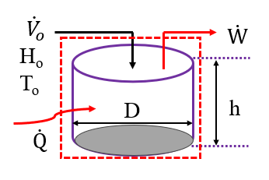
Figure 13.1. Unsteady state process of liquid accumulation in the tank
To develop material and energy balance equations, you have to state your assumptions.
Assumptions:
- The process is unsteady-state without chemical reaction.
- The density of liquid is constant.
- The change in kinetic energy and potential energy both are negligible as compared to heat energy and change in enthalpy.
- For liquids, the specific heat capacity at constant volume is equal to the specific heat capacity at constant pressure.
Material balance equation: The material balance equation is given by:
$Rate of accumulation=rate of input$
$\frac{dm}{dt}={\dot{m}}_{o}$ (13.3)
Where: m is mass, t is operation time, and ${\dot{m}}_{o}$ is mass flow rate in the input streams.
Mass is the product of density and volume.
$m=ρV$ (13.4)
The mass flow rate is the product of density and volumetric flow rate.
${\dot{m}}_{o}=ρ{\dot{V}}_{o}$ (13.5)
Where: $ρ$ is density of a liquid, ${\dot{V}}_{o}$ is volumetric flow rate of a liquid in the input stream, and V is volume of a liquid.
The volume of the tank is the product of cross-section area and height of the tank.
$V=A_{c}h$ (13.6)
Where: V is volume of the tank, $A_{C}$ is cross-sectional area of the tank and h is height of the tank.
By substituting equations (13.4- 13.6) into equation (13.3), you can get:
$\frac{dV}{dt}={\dot{V}}_{o}$ (13.7)
Where: $V$ is volume of a liquid, t is operation time, and ${\dot{V}}_{o}$ is volumetric flow rate of a liquid.
Again, by substituting equation (13.6) into equation (13.7), the material balance equation can be written as:
$\frac{A_{c}dh}{dt}={\dot{V}}_{o}$ (13.8)
Where: $A_{c}$ is cross-sectional area of the tank, t is operation time, h is height of the tank, and ${\dot{V}}_{o}$ is volumetric flow rate of a liquid.
The cross-sectional area of cylindrical tank is given by:
$A_{C}=π\frac{D^{2}}{4}$ (13.9)
Where: D is internal diameter of the tank.
By substituting equation (13.9) into equation (13.8), you can get:
$\frac{dh}{dt}=\frac{4{\dot{V}}_{o}}{{πD}^{2}}$ (13.10)
This is a differential equation, which shows that the level of liquid increases with time.
Where: h is height of the tank, D is internal diameter of the tank, t is operation time, and ${\dot{V}}_{o}$ is volumetric flow rate of a liquid.
The material balance equation (13.10) indicates that the rate of accumulation of a liquid is directly proportional to the volumetric flow rate, and it is inversely proportional to the square of internal diameter of the tank.
The time required to fill the tank is determined by integrating equation (13.10).
The integration equation can be written as:
$\int_{h_{o}}^{h}{dh}=\frac{4{\dot{V}}_{o}}{{πD}^{2}}\int_{0}^{t}{dt}$ (13.11)
By integrating equation (13.11) and solve for time (t), you can get:
$t=\frac{(h-h_{o}){πD}^{2}}{4{\dot{V}}_{o}}$ (13.12)
Where: $h≥h_{0};$ at t = 0, h = $h_{0};$ and at t > 0, h > $h_{0}$
Energy balance equation: The energy balance equation is expressed by:
$\frac{ρA_{c}hC_{p}dT}{dt}=ρ{\dot{V}}_{o}H_{o}+\dot{Q}-\dot{W}$ (13.13)
Where: T is temperature, t is operation time, C_{p} is specific heat capacity of a liquid, $ρ$ is density of a liquid, $A_{c}$ is cross-sectional area of the tank, h is height of the tank, ${\dot{V}}_{o}$ volumetric flow rate in the input stream, $H_{o}$ is specific enthalpy in the input stream, $\dot{Q}$ is rate of heat addition, and $\dot{W}$ is work done by the system.
By rearranging the energy balance equation (13.13), and solve for temperature change, you can get:
$\frac{dT}{dt}=\frac{ρ{\dot{V}}_{o}H_{o}+\dot{Q}-\dot{W}}{ρA_{c}hC_{p}}$ (13.14)
This equation shows that the temperature change is dependent on the level of a liquid.
To determine the temperature change in the tank with time, both material balance and energy balance equations must be solved simultaneously using numerical techniques or appropriate software tools.
Case II: A liquid is continuously discharged from the cylindrical tank with a volumetric flow rate of ${\dot{V}}_{f}$ at a temperature of T and specific enthalpy H. The quantity of a liquid in the tank decreases with time, and there is no input of a liquid into the tank. The tank has an internal diameter of D and height of h. The rate of heat supply to the tank is $\dot{Q}$, and $\dot{W}$ is the rate of work done as shown in Figure 13.2.
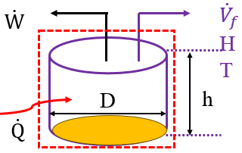
Figure 13.2. Unsteady state process of liquid discharged from the tank
To develop material and energy balance equations, you shall state your assumptions.
Assumptions:
- The process is unsteady-state without chemical reaction.
- The density of liquid is constant.
- The change in kinetic energy and potential energy both are negligible as compared to heat energy and change in enthalpy.
- For liquids, the specific heat capacity at constant volume is equal to the specific heat capacity at constant pressure.
Material balance equation: The material balance equation can be written as:
$\frac{dh}{dt}=-\frac{4{\dot{V}}_{f}}{{πD}^{2}}$ (13.15)
This is a differential equation, which shows that the level of liquid decreases with time.
Where: h is height of the tank, D is internal diameter of the tank, t is operation time, and ${\dot{V}}_{f}$ is volumetric flow rate of a liquid leave from the tank.
The material balance equation (13.15) indicates that the rate of decrease of a liquid level is directly proportional to the discharge volumetric flow rate, and it is inversely proportional to the square of internal diameter of the tank.
By integrating equation (13.15), you can determine the time required to discharge a liquid that makes the tank is empty.
The integration equation can be written as:
$\int_{h_{o}}^{h}{dh}=-\frac{4{\dot{V}}_{f}}{{πD}^{2}}\int_{0}^{t}{dt}$ (13.16)
By integrating equation (13.16) and solve for time (t), you can get:
$t=-\frac{(h-h_{o}){πD}^{2}}{4{\dot{V}}_{f}}$ (13.17)
Where: $h≤h_{0};$ at t = 0, h = $h_{0};$ and at t > 0, h < $h_{0}$
Energy balance equation: The energy balance equation is given by:
$\frac{ρA_{c}hC_{p}dT}{dt}=-ρ{\dot{V}}_{f}H+\dot{Q}-\dot{W}$ (13.18)
Where: T is temperature, t is operation time, C_{p} is specific heat capacity of a liquid, $ρ$ is density of a liquid, $A_{c}$ is cross-sectional area of the tank, h is height of the tank, ${\dot{V}}_{f}$ volumetric flow rate in the output stream, H is specific enthalpy in the output stream, $\dot{Q}$ is rate of heat addition, and $\dot{W}$ is work done by the system.

By rearranging the energy balance equation (13.18), and solve for temperature change, you can get:
$\frac{dT}{dt}=\frac{-ρ{\dot{V}}_{f}H+\dot{Q}-\dot{W}}{ρA_{c}hC_{p}}$ (13.19)
This equation shows that the temperature change is dependent on the level of a liquid.
Hence, both material balance and energy balance equations must be solved simultaneously using numerical techniques or appropriate software tools to determine the temperature change in the tank with time.
Case III: A liquid is continuously entered to the cylindrical tank with a volumetric flow rate of ${\dot{V}}_{o}$ at a temperature of T_{o} and specific enthalpy H_{o}, and discharged from it with a volumetric flow rate of ${\dot{V}}_{f}$ at a temperature of T and specific enthalpy H. The quantity of a liquid in the tank increases with time. The tank has an internal diameter of D and height of h. The rate of heat supply to the tank is $\dot{Q}$, and the rate of work done is $\dot{W}$as shown in Figure 13.3.
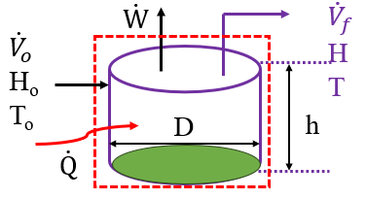
Figure 13.3. Unsteady-state process of liquid accumulation in the tank with input and output streams
Assumptions:
- The process is unsteady-state without chemical reaction.
- The density of liquid is constant.
- The change in kinetic energy and potential energy both are negligible as compared to heat energy and change in enthalpy.
- For liquids, the specific heat capacity at constant volume is equal to the specific heat capacity at constant pressure.
Material balance equation: The material balance equation can be written as:
$\frac{dh}{dt}=\frac{4{\dot{V}}_{o}}{{πD}^{2}}-\frac{4{\dot{V}}_{f}}{{πD}^{2}}$ (13.20)
This is differential equation, which shows that the level of liquid will increase with time if ${\dot{V}}_{o}$ > ${\dot{V}}_{f}$
Where: h is height of the tank, D is internal diameter of the tank, t is operation time, ${\dot{V}}_{o}$ is volumetric flow rate of liquid in the input stream, and ${\dot{V}}_{f}$ is volumetric flow rate of a liquid leave from the tank.
To integrate the differential equation (13.20), you have to know the relationship between the input volumetric flow rate and output volumetric flow rate.
Energy balance equation: The energy balance equation is given by:
$\frac{ρA_{c}hC_{p}dT}{dt}=ρ{\dot{V}}_{o}H_{o}-ρ{\dot{V}}_{f}H+\dot{Q}-\dot{W}$ (13.21)
Where: T is temperature, t is operation time, C_{p} is specific heat capacity of a liquid, $ρ$ is density of a liquid, $A_{c}$ is cross-sectional area of the tank, h is height of the tank, ${\dot{V}}_{o}$ is volumetric flow rate in the input stream, ${\dot{V}}_{f}$ is volumetric flow rate in the output stream, $H_{o}$ is specific enthalpy in the input stream, H is specific enthalpy in the output stream, $\dot{Q}$ is rate of heat addition, and $\dot{W}$ is work done by the system.
By rearranging the energy balance equation (13.21), and solve for temperature change, you can get:
$\frac{dT}{dt}=\frac{ρ{\dot{V}}_{o}H_{o}-ρ{\dot{V}}_{f}H+\dot{Q}-\dot{W}}{ρA_{c}hC_{p}}$ (13.22)
This equation shows that the temperature change is inversely proportional to the level of a liquid.
Hence, both material balance and energy balance equations are differential equations, which must be solved simultaneously using numerical techniques or appropriate software tools to determine the temperature change in the tank with time.
Activity 13.1
1. A 2.5m³ tank is being filled with water at a rate of 0.050m³/min. At a moment when the tank contains 1.20m³ of water, a bottom leak develops and gets progressively worse with time. The rate of leakage can be approximated as 0. 0025t (m³/min), where t (min) is the time from the moment the leak begins. Based on the given data, (a) write a mass balance equation on the tank, (b) plot the volume of water as a function of time, and (c) determine the time when the tank can be empty (Richard M. Felder, 2005, pg. 548).
2. Water is entered to the tank at a rate of 0.1m³/ min with inlet temperature of 45ºC. Heat is supplied to the tank at the rate of 6, 000 kJ/min to heat water for washing services. Density of water is 1, 000 kg/m³. The specific heat capacity of water is 4.2 kJ/kg.ºC, which is constant in the process. The diameter of the tank is 1.0 m and the height of the tank is 1.5 m. The level of water is 0.25 m in the tank at the beginning of the process. Based on the given data, develop material and energy balance equations and plot the graphs for the level of water accumulation as a function of time, and the temperature rise as a function of time.
#Q₁, Answer:
Given: unsteady state process with input and output streams, input volumetric flow rate (${\dot{V}}_{o})$ is 0.05m³/min; output volumetric flow rate (${\dot{V}}_{f})$ is 0.0025tm³/min. Initial volume of water (V_{o}) is 1.20 m³.
Required: (a) write a mass balance equation on the tank, (b) plot the volume of water as a function of time, and (c) determine the time when the tank can be empty
Assumption: The process is unsteady-state, and density of water is constant.
(a) material balance equation: The material balance equation is given by:
$\frac{dV}{dt}={\dot{V}}_{o}-{\dot{V}}_{f}=0.05-0.0025 t$ (13.23)
Where: V is volume of water over time, and t is operation time.
(b) Plot the volume of water as a function of time: To plot the function, you can use software tools.
The polymath program using polymath 6.10- trial version software tool is shown below:
d(V) / d(t) = 0.05-0.0025*t #Rate of accumulation of water.
V(0) = 1.2 # m³
t(0) = 0 # min
t(f) = 60 # min
The simulation result of volume of water with time is depicted in Figure 13.4.
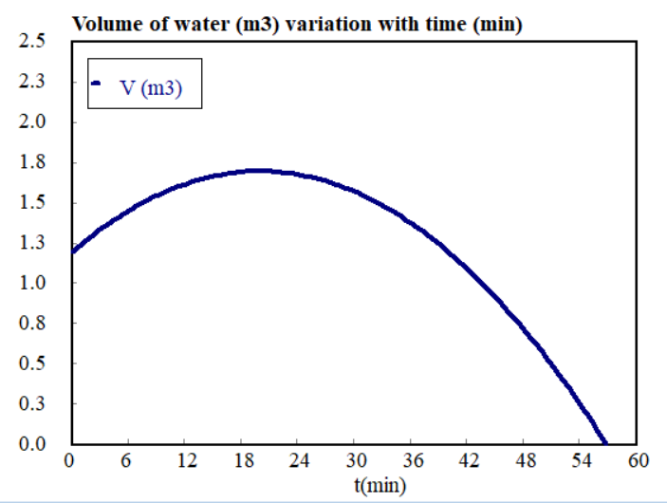
Figure 13.4 Volume of water as a function of time
Observations of the simulation result:
- In Figure 13.4, the graph shows that the volume of water is a quadratic function of time.
- The volume of water increases with time up to 20 min.
- The volume of water is increased 1.7m³ when operation time is reached 20 min, which is attained maximum accumulation of water at 20 min.
- The volume of water is decreased after 20 min, and the tank become empty when time is reached to 57 min.
(c) determine the time when the tank can be empty: The time is determined when the tank becomes empty by integrating equation (13.23) and solve for time (t).
$\frac{dV}{dt}={\dot{V}}_{o}-{\dot{V}}_{f}=0.05-0.0025 t$
$\int_{V_{o}=1.2}^{V=0}{dV}=\int_{0}^{t}{(0.05-0.0025t)dt}$
$V-V_{o}=0-1.2=0.05t-0.00125t^{2}$
$0.00125t^{2}-0.05t-1.2=0$ (13.24)
The equation (13.24) is the quadratic equation of the form:
$ax^{2}+bx+c=0$
x$=$ $\frac{-b±\sqrt{b^{2}-4ac}}{2a}$
From equation (13.24), a = 0.00125; b = 0.05; and c = -1.2
t$=$ $\frac{-0.05±\sqrt{{0.05}^{2}-4*0.00125*(-1.2)}}{2*0.00125}=57$ min
Therefore, the tank becomes empty when time is approximately reached to 57 min
#Q₂, Answer:
Given: Water heating process.
Inlet stream: volumetric flow rate, ${\dot{V}}_{o}=0.1$ m³/min, temperature, T_{o} = 45ºC, rate of heat addition, $\dot{Q}$ = 6, 000 kJ/min, and specific heat capacity C_{pw} = 4.2 kJ/kg.ºC
Output stream: There is not output stream (it is closed in the output stream).
Required: Develop material and energy balance equations and plot the graphs for the level of water accumulation as a function of time, and the temperature rise as a function of time.
Assumptions:
- The process is operated with unsteady-state condition without chemical reaction.
- Specific heat capacity and density of water are constant.
- The rates of change in kinetic energy, potential energy, and work done are negligible as compared with the rates of heat addition and change in enthalpy.
The process flow diagram of Activity 13.1(#Q₂) material and energy flows across system boundary is shown in Figure 13.5.
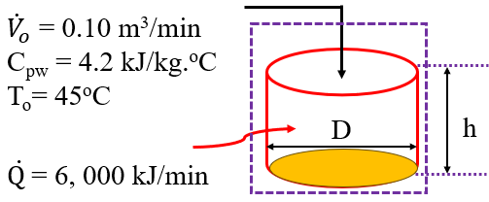
Figure 13.5 Unsteady-state process flow diagram for Activity 13.1, #Q₂
Material balance equation: The material balance equation for unsteady-state process is given by:
$\frac{dh}{dt}=\frac{4{\dot{V}}_{o}}{{πD}^{2}}=\frac{4*0.1}{{π1.0}^{2}}=$ 0.1274 (13.25)
Where: h is height (level) of water, and t is operation time.
Energy balance equation: The energy balance of unsteady-state process is expressed by:
$\frac{dT}{dt}=\frac{ρ{\dot{V}}_{o}H_{o}+\dot{Q}}{ρA_{c}hC_{pw}}=$ (13.26)
For constant specific heat capacity, the specific enthalpy of water in the input stream is given by:
$H_{0}=C_{pw}(T_{o}-T_{R})$ (13.27)
$H_{0}=C_{pw}\left(T_{o}-T_{R}\right)=4.2*\left(45-25\right)=84$ kJ/kg
$A_{c}=π\frac{D^{2}}{4}=π\frac{1^{2}}{4}=0.785$ m² ; $ρ=1,000$ kg/m³; ${\dot{V}}_{o}=0.1$m³/min; $C_{pw}=4.2$ kJ/ kg.ºC
$\frac{dT}{dt}=\frac{ρ{\dot{V}}_{o}H_{o}+\dot{Q}}{ρA_{c}hC_{pw}}=\frac{8,400+6, 000}{3, 297h}=\frac{14,400}{3, 297h}$ (13.28)
Where: T is temperature, t is operation time, and h is level of water.
Now, the material balance equation (13.25) and energy balance equation (13.28) can be plotted using polymath program.
The polymath program using polymath 6.10- trial version software tool is shown below:
d(h) / d(t) = 0.1274 # Material balance equation for constant density of water
h(0) = 0.25 # Initial level of water (m)
d(T) / d(t) = 14400/(3297*h) # Energy balance equation
T(0) = 45 # ºC
t(0) = 0 # min
t(f) = 10 # min
The simulation plot of material balance equation, which is the level of water with time is illustrated in Figure 13.6. The material balance equation simulation result shows that the tank becomes full of water when the operation time is reached to 10 min. The level of water is increased linearly with operation time.
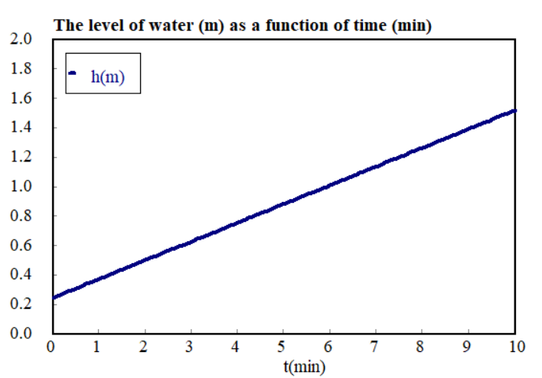
Figure 13.6 The level of water as a function of time
The simulation plot of energy balance equation, which is the temperature of water as a function of operation time is shown in Figure 13.7. The simulation result depicts that the temperature of water is increased exponentially with operation time. The temperature of water is increased to 107ºC when the operation time is reached to 10 min and the tank becomes full of water.
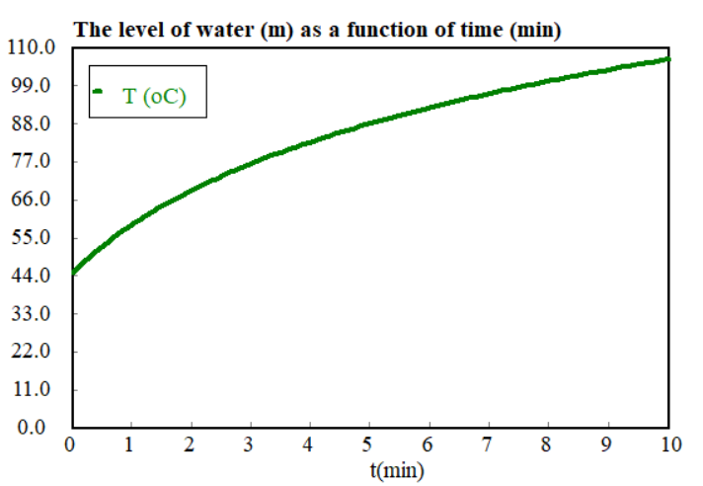
Figure 13.7 Temperature of water as a function of time
13.3. Unsteady-state material and energy balances with chemical reactions
Consider a reactant species i is continuously entered into semi-batch reactor with a mole flow rate of $F_{io}$ at initial temperature of T_{o} and specific enthalpy H_{io}. A reaction is carried out in the reactor with time, and there is no withdrawal of products from the reactor. The rate of heat supply to the tank is $\dot{Q}$, and the rate of work done is $\dot{W}$as shown in Figure 13.8.
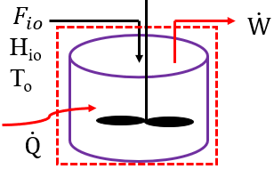
Figure 13.8 Unsteady-state process with chemical reaction
The unsteady-state material and energy balances with chemical reaction shall be performed in mole units to account the rate of generation of products/consumption of reactants, and heat generated by exothermic reactions/heat absorbed by endothermic reactions (Richard M. Felder, 2005, pg. 440).
Assumptions:
- Unsteady-state process with chemical reaction.
- The rates of change in kinetic energy and potential energy are negligible.
- Semi-batch reaction with only feed stream of materials.
Material balance equation: The material balance equation is given by:
$\frac{dn_{i}}{dt}=F_{io}+v_{i}$ξ (13.29)
Where: n_{i} is mole of species i, t is reaction time, F_{io} is mole flow rate in the input stream, v_{i} is stoichiometric coefficient of species i, and ξ is extent of reaction.
Energy balance equation: The energy balance equation is given by:
$\frac{d(n_{i}H_{i})}{dt}=F_{io}H_{io}+\dot{Q}-\dot{W}$ (13.30)
This is a differential equation, which shall be simultaneously solved with material balance equation using analytical integration or numerical techniques.
Where: n_{i} is mole of species i, t is reaction time, F_{io} is mole flow rate in the input stream, H_{io} is specific enthalpy of species i in the feed, H_{i} is specific enthalpy of species i inside the reactor, $\dot{Q}$ is rate of heat addition, and $\dot{W}$ is rate of work done.
The left-hand side of equation (13.30) can be written as:
$\frac{d(n_{i}H_{i})}{dt}=n_{i}\frac{{dH}_{i}}{dt}+H_{i}\frac{dn_{i}}{dt}$ (13.31)
Where: n_{i} is mole of species i in the reactor, H_{i} is specific enthalpy of species i in the reactor, and t is reaction time.
By substituting the material balance equation (13.29) into equation (13.31), you can get:
$\frac{d(n_{i}H_{i})}{dt}=n_{i}\frac{{dH}_{i}}{dt}+H_{i}(F_{io}+v_{i}$ξ) (13.32)
The specific enthalpy equation in the input stream at T_{o} for species i is given by:
$H_{io}={H^{0}}_{i}(T_{R})+\int_{T_{R}}^{T_{0}}{C_{Pi}}dT$ (13.33)
In the same way, the specific enthalpy equation inside the reactor at a temperature T for species i is expressed by:
$H_{i}={H^{0}}_{i}(T_{R})+\int_{T_{R}}^{T}{C_{Pi}}dT$ (13.34)
Where: H_{io} and H_{i} are specific enthalpies for species i, in the input stream and inside the reactor, respectively, Hº_{i} is specific enthalpy at standard state, C_{pi} is specific heat capacity of species i, T_{R} is the reference temperature, T_{o} is input temperature, and T is reaction temperature (Coulson & Richardson’s, 1999, pg. 67).
By differentiating equation (13.34) with respect to time, you can get:
$\frac{{dH}_{i}}{dt}=C_{pi}\frac{dT}{dt}$ (13.35)
By substituting equation (13.35) into equation (13.32), you can get:
$\frac{d(n_{i}H_{i})}{dt}=n_{i}C_{pi}\frac{dT}{dt}+H_{i}(F_{io}+v_{i}$ξ) (13.36)
Again, by substituting equation (13.35) into energy balance equation (13.30), you can get:
$n_{i}C_{pi}\frac{dT}{dt}+H_{i}(F_{io}+v_{i}=F_{io}H_{io}+\dot{Q}-\dot{W}$ (13.37)
By rearranging equation (13.37), the energy balance equation can be written as:
$n_{i}C_{pi}\frac{dT}{dt}=F_{io}{{(H}_{io}{-H}_{i})-v}_{i}H_{i}+\dot{Q}-\dot{W}$ (13.38)
This is an ordinary differential equation.
The term: $v_{i}H_{i}$ is the change in heat of reaction for species i, $F_{io} {(H}_{io}{-H}_{i})$ is the change in enthalpy due to mole flow rate of species i.
The temperature change in the reactor can be written as:
$\frac{dT}{dt}=\frac{F_{io}{{(H}_{io}{-H}_{i})-v}_{i}H_{i}+\dot{Q}-\dot{W}}{n_{i}C_{pi}}$ (13.39)
For all species involved in the chemical reaction, the energy balance equation can be written as:
$\frac{dT}{dt}=\frac{-\sum_{i=1}^{N}{\left(F_{io}{{(H}_{i}{-H}_{io})-v}_{i}H_{i}\right)+\dot{Q}-\dot{W}}}{\sum_{i=1}^{N}{n_{i}C_{pi}}}$ (13.40)
Where: T is temperature inside the reactor, t is reaction time, N is number of species i, F_{io} is mole flow rate of species i in the input stream, H_{io} and H_{i} are specific enthalpies of species i in the input stream and inside the reactor, respectively, v_{i} is stoichiometric coefficient of species i, ξ is extent of reaction, $\dot{Q}$ is rate of heat addition, $\dot{W}$ is the rate of work done, n_{i} is mole of species i, and C_{pi} is specific heat capacity of species i.
At constant specific heat capacity, the change in specific enthalpy is given by:
$H_{i}{-H}_{io}=C_{pi}(T-T_{o})$ (13.41)
By substituting equation (13.41) into equation (13.40), you can get:
$\frac{dT}{dt}=\frac{-\sum_{i=1}^{N}{\left(F_{io}{C_{pi}(T-T_{o}) -v}_{i}H_{i}\right)+\dot{Q}-\dot{W}}}{\sum_{i=1}^{N}{n_{i}C_{pi}}}$ (13.42)
Where: T is temperature inside the reactor, t is reaction time, N is number of species i, F_{io} is mole flow rate of species i in the input stream, v_{i} is stoichiometric coefficient of species i, ξ is extent of reaction, $\dot{Q}$ is rate of heat addition, $\dot{W}$ is the rate of work done, n_{i} is mole of species i, and C_{pi} is specific heat capacity of species i.
Activity 13.2
1. A natural gas containing 80% methane (CH₄) and the balance ethane (C₂H₆) is burned with 20% excess air in a boiler furnace. The natural gas enters to the furnace at the rate of 150 mol/ min. The fuel gas enters the furnace at 298 K, and the air is preheated to 423 K. The heat capacities of the stack gas components may be assumed to have constant values: CO₂: C_{p}= 50.0 J/mol.K, H₂O(v): C_{p}= 38.5 J/mol.K, O₂: C_{p}= 33.1 J/mol. K, and N₂: C_{p}= 31.3 J/mol. K; and the specific heat capacities of methane and ethane are 57.44 J/mol.K and 108.25 J/ mol.K, respectively. The combustion reaction equations of methane and ethane with oxygen are shown below:
$CH_{4}+2O_{2}→CO_{2}+2H_{2}O$ (13.43)
$C_{2}H_{6}+\frac{7}{2}O_{2}→2CO_{2}+3H_{2}O$ (13.44)
The combustion reaction releases heat. It is assumed that 90% of the natural gas is reacted with oxygen. Based on the given data, plot the material balance equation (the moles of the species as a function of time) and energy balance equation (temperature of combustion reaction as a function of time).
The molecular weights are: C = 12, O = 8, N = 14, H =1
#Q₁, Answer:
Given: Natural gas combustion reaction with air, and combustion reaction balanced equations:
$CH_{4}+2O_{2}→CO_{2}+2H_{2}O$
$C_{2}H_{6}+\frac{7}{2}O_{2}→2CO_{2}+3H_{2}O$
Input stream: F_{o}= 150 mol/ min, F_{o}(CH₄) = 0.8 F_{o}= 0.8*150= 120 mol/min, and F_{o}(C₂H₆) = 0.2 F_{o}= 0.2*150= 30 mol/min
A total of 20% excess air is used for combustion reactions.
Required: Plot the material balance equation (the moles of the species as a function of time) and energy balance equation (temperature of combustion reaction as a function of time).
Assumptions:
- Combustion reaction is conducted at an unsteady-state condition.
- The air is a mixture of oxygen and nitrogen only, 21% and 79%, respectively.
- The rates of heat addition, work done, change in kinetic energy and potential energy are negligible.
Oxygen required for the two reactions, F(O₂) = 2*120 + 3.5*30 = 345 mol/min
The required air, F(air)= 345/ 0.21= 1, 642.857 mol/min
Total air supply, F_{o}(air) = required air + excess air = F(air) *(1.2) = 1, 971.429 mol/ min
Total oxygen supply, F_{o}(O₂) = 0.21* 1, 971.429 = 414 mol/min
Total nitrogen supply, F_{o}(N₂) = 0.79* 1, 971.429 = 1, 557.429 mol/min
Material balance equation: The material balance equation is given by:
$\frac{dn_{i}}{dt}=F_{io}+\sum_{j}{v_{ij}{}_{j}}$ (13.45)
Where: n_{i} is mole of species i, t is reaction time, F_{io} is mole flow rate in the input stream, v_{ij} is stoichiometric coefficient of species i in the j^{th} reaction, and ${}_{j}$is the extent of reaction for the j^{th} reaction.
Let’s represent, CH₄= A, C₂H₆= B, O₂ = C, CO₂ = D, H₂O = E and N₂ = I
It is given that ${}_{1}=0.9*120=108$ mol/ min
The material balance equation for CH₄ is given by:
$\frac{dn_{A}}{dt}=F_{Ao}-{}_{1}=$ $120-108=12$ (13.46)
It is given that ${}_{2}=0.9*30=27$ mol/ min
The material balance equation for C₂H₆ is given by:
$\frac{dn_{B}}{dt}=F_{Bo}-{}_{2}=$ $30-27=3$ (13.47)
Where: n_{A} is mole of CH₄, F_{Ao} is mole flow rate of CH₄ in the input stream, n_{B} is mole of C₂H₆, F_{Bo} is mole flow rate of C₂H₆ in the input stream, and ${}_{1}$ and ${}_{2}$ are the extent of reactions for the first and second reactions, respectively.
The material balance equation for O₂ is given by:
$\frac{dn_{C}}{dt}=F_{Co}-{\text{2}}_{1}-{\text{3.5}}_{2}=$ $414-216-24.5=$ 173.5 (13.48)
The material balance equation for CO₂ is given by:
$\frac{dn_{D}}{dt}={}_{1}+ {\text{2}}_{2}=$ $108+2*27=162$ (13.49)
Where: n_{C} is mole of O₂, F_{Co} is mole flow rate of O₂ in the input stream, n_{D} is mole of CO₂, and ${}_{1}$ and ${}_{2}$ are the extent of reactions for the first and second reactions, respectively.
The material balance equation for H₂O is given by:
$\frac{dn_{E}}{dt}={\text{2}}_{1}+{\text{3}}_{2}=$ $2*108+3*27=$ 297 (13.50)
The material balance equation for N₂ is given by:
$\frac{dn_{I}}{dt}=F_{Io}=$ $1,557.429$ (13.51)
Where: n_{E} is mole of H₂O, F_{Io} is mole flow rate of N₂ in the input stream, n_{I} is mole of N₂, and ${}_{1}$ and ${}_{2}$ are the extent of reactions for the first and second reactions, respectively.
Energy balance equation: The energy balance equation is given by:
$\frac{dT}{dt}=\frac{-\sum_{i=1}^{N}{F_{io}C_{pi}\left(T-T_{o}\right)-\sum_{i=1}{v_{ij}H_{i}{}_{j}}}}{\sum_{i=1}^{N}{n_{i}C_{pi}}}$ (13.52)
Where: T is temperature inside the reactor, t is reaction time, N is number of species i, F_{io} is mole flow rate of species i in the input stream, v_{ij} is stoichiometric coefficient of species i in the j^{th} reaction, ξ_{j} is extent of reaction in the j^{th} reaction, H_{i} is specific enthalpy of species i due to heat of reaction, n_{i} is mole of species i, and C_{pi} is specific heat capacity of species i.
The change in heat of reaction is given by:
$\sum_{i=1}{v_{ij}H_{i}{}_{j}}={∆H}_{Rx}(T)={{∆H}^{o}}_{Rx}(T_{R})+\sum_{i=1}{v_{ij}{}_{j}}C_{pi}(T-T_{R})$ (13.53)
Standard heat of reactions: ${H^{o}}_{A}=$ -74.85 kJ/mol, ${H^{o}}_{B}$= -84.67 kJ/mol, ${H^{o}}_{D}=$-412.9 kJ/mol, and ${H^{o}}_{E}=$-285.84 kJ/mol; ${{∆H}^{o}}_{Rx}=-141,414$ kJ/min
By substituting the given values into equation (13.53), you can get:
$\sum_{i=1}{v_{ij}H_{i}{}_{j}}=$ ${{∆H}^{o}}_{Rx}\left(T_{R}\right)+((T-T_{R})$ [${\text{(}}_{1}+ {\text{2}}_{2})C_{pD}+\left({\text{2}}_{1}+{\text{3}}_{2}\right)C_{pE}-{}_{1}C_{pA}-{}_{2}C_{pB}-{\text{(2}}_{1}+{\text{3.5}}_{2})C_{pC}]$
$\sum_{i=1}{v_{ij}H_{i}{}_{j}}=$ $-141, 414+0.131(T-T_{R})$ (13.54)
By substituting equation (13.53) into equation (13.51), you can get:
$\frac{dT}{dt}=\frac{-[\left(T-T_{o}\right)\left[F_{Co}C_{pC}+F_{Io}C_{pI}\right]+\left(T-T_{R}\right)\left[F_{Ao}C_{pA}+F_{Bo}C_{pB}]\right]-[-141, 414+0.131(T-T_{R})]}{n_{A}C_{pA}+n_{B}C_{pB}+n_{C}C_{pC}+n_{D}C_{pD}+n_{E}C_{pE}+n_{I}C_{pI}}$ (13.55)
By substituting the given values into equation (13.55), you can get:
$\frac{dT}{dt}=\frac{-62.45\left(T-423\right)-10.14\left(T-298\right)-[-141, 414+0.131(T-298)]}{{0.05744n}_{A}+0.10825n_{B}+{0.0331n}_{C}+{0.050n}_{D}+{0.0385n}_{E}+0.0313n_{I}}$ (13.56)
Material and energy balances equations polymath program are shown below:
d(n_{A}) / d(t) = 12 # Methane balance, mol/min
n_{A}(0) = 120 # mol
d(n_{B}) / d(t) = 3 # Ethane balance, mol/min
n_{B}(0) = 30 # mol
d(n_{C}) / d(t) = 173.5 # Oxygen balance, mol/min
n_{C}(0) = 414 # mol
d(n_{D}) / d(t) = 162 # carbon dioxide balance, mol/min
n_{D}(0) = 0 # mol
d(n_{E}) / d(t) = 297 # water vapor balance, mol/min
n_{E}(0) = 0 # mol
d(n_{I}) / d(t) = 1557.429 # Nitrogen balance, mol/min
n_{I}(0) = 1557.429 # mol
d(T)/d(t)=(-62.45*(T-423)-10.14*(T-298)-(-141414+0.131*(T-298)))/( 0.05744*n_{A}+0.10825*n_{B}+0.0331*n_{C}+0.050*n_{D}+0.0385*n_{E}+0.0313*n_{I}) # Energy balance équation, K/ min
T(0) = 298 # K
t(0)=0 # min
t(f)= 10 # min
The material balance equations simulation results are shown in Figure 13.9. The results confirm that the accumulation of moles of all species are increased linearly with reaction time in the semi-batch reactor.
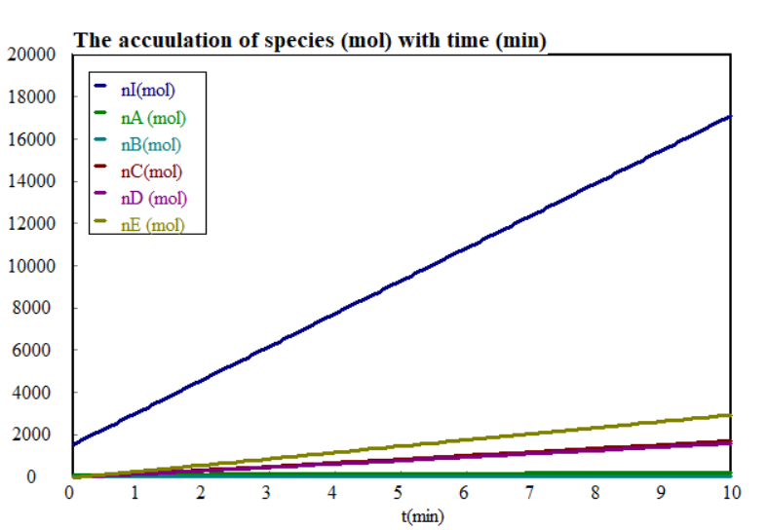
Figure 13.9 Accumulation of moles of species as a function of time
Similarly, the energy balance equation (reaction temperature as a function of time) simulation result is illustrated in Figure 13.10. The result shows that reaction temperature is increased exponentially with reaction time in the semi-batch reactor, which is reached to the value of 2, 188K at 10 min.
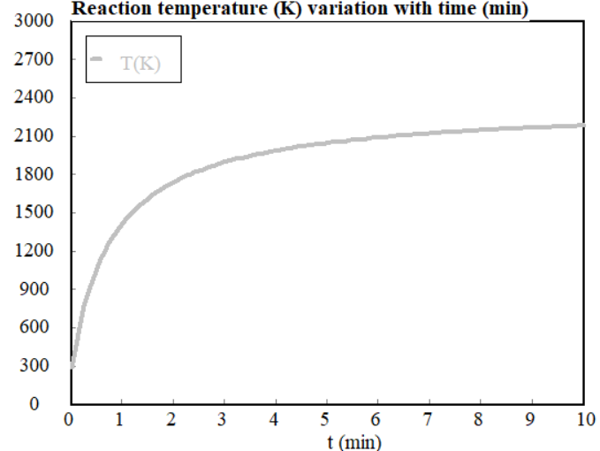
Figure 13.10 Reaction temperature variation as a function of time
13.4. Summary
The unsteady-state behavior of a process is important when considering the process start-up and shut-down, and the response to process upsets. Unsteady-state balance equations are similar to steady-state balance equations except that the unsteady-state equation has accumulation term. Accumulation is equal to the increase or decrease of the balance item in the system. For a material balances, accumulation is equal to the increase or the decrease of materials in the system.; and for an energy balance, the accumulation is equal to the increase or decrease in the thermal energy in the system. Unsteady-state material and energy balances are differential equations, which require numerical techniques or software tools to solve them simultaneously.
References
- Basic Principles and Calculations in Chemical Engineering, Himmelblau, Pearson Education Inc, 9th edition, 2023.
- Chemical Engineering Design, Volume 6, Coulson & Richardson’s, R. K. Sinnott, 3rd edition, 1999.
- Elementary Principles of Chemical Processes, Richard M. Felder, John Wiley & Sons, 3rd edition, 2005.

