Course: International Trade and Policy
Week 2: Supply and Demand in Global Markets
University: Tajik State University of Commerce
Lecturer: Abduvaliev Mubinzhon, PhD

1. Introduction

1.1 The Foundation of Global Trade
The global economy operates as a complex web of transactions. While microeconomics introduces us to supply and demand within a single, closed economy, the reality of the 21st century is one of open economies. To understand how goods flow across borders, we must extend the basic supply and demand framework to a global scale.
In this lecture, we will explore the mechanics of world market equilibrium. We will move beyond the concept of "domestic price" and introduce the concept of a "world price" determined by the interaction of international forces. We will dissect what drives a country to import a good versus export it, a decision fundamentally rooted in comparative advantage and price differentials.
We will then introduce the critical role of government policy. Tariffs (taxes on imports) and quotas (quantity limits) are ubiquitous tools of trade policy. However, their effects are not uniform. A central theme of this lecture is the distinction between a small country (a price taker in global markets) and a large country (a price maker capable of influencing global prices). This distinction dictates the welfare consequences of trade policy, impacting trade volume, domestic welfare, and a crucial concept known as the terms of trade.
By the end of this lecture, you will possess the analytical tools to evaluate the winners and losers from trade policies and understand the strategic dynamics of international trade negotiations.

2. The Framework - From Autarky to Global Trade (Part 1)

2.1 The Closed Economy Equilibrium
Before we introduce trade, we must establish the baseline: autarky (economic self-sufficiency). In a closed economy, the price of a good is determined solely by domestic supply and demand (see Figure 1).
Figure 1. Autarky Equilibrium in a Closed Economy
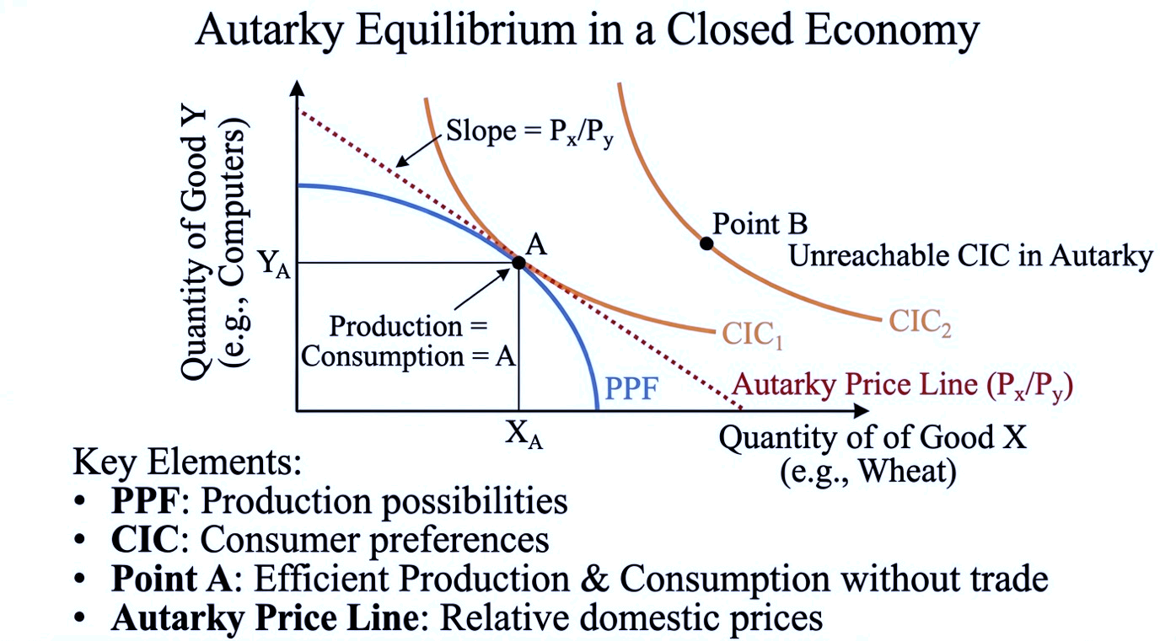
Source: Created by the author
Figure 1 indicate that a closed economy operates under conditions of complete self-sufficiency, wherein all goods consumed must be produced domestically. This equilibrium is graphically represented by the tangency point between the economy's Production Possibility Frontier (PPF) and the highest attainable Community Indifference Curve (CIC). This point, denoted as Point A in the diagram, signifies that the economy allocates its resources efficiently to align production with domestic consumption preferences, such that domestic production exactly equals domestic consumption.
At this equilibrium, the slope of the price line tangent to both the PPF and the CIC at Point A determines the relative domestic prices (PX​/PY​). These prices reflect the internal opportunity cost of producing one good in terms of the other, capturing the trade-offs inherent in the allocation of scarce resources.
Because the economy is isolated from international markets, it remains physically constrained by its own PPF. It cannot attain higher indifference curves, such as CIC2, which would represent a superior level of welfare. Thus, the autarky diagram establishes a crucial baseline: in the absence of trade, a nation’s consumption possibilities are strictly limited by its domestic production capacity. In contrast, opening the economy to international trade enables the price line to pivot reflecting new world prices and allows the country to reach a level of utility previously unattainable under autarky.

2.2 Defining the World Market
The world market is not a physical location but rather a conceptual framework representing the aggregation of all national markets for a particular good or service. In this framework, the forces of global demand and global supply interact to determine a single world price and the total volume of international trade. Global demand is the sum of the demand from all countries at each possible price, while global supply is the sum of the supply from all producing nations. However, in international trade theory, it is often more analytically convenient to approach the world market through the lens of excess demand and excess supply: the world equilibrium occurs where one country’s import demand (the excess of domestic demand over domestic supply) exactly matches another country’s export supply (the excess of domestic supply over domestic demand). This intersection establishes the equilibrium world price and the quantity of goods traded across borders.
The world market functions as the arbitrage mechanism that eliminates price differentials across countries, subject to trade costs and policy barriers. In a frictionless environment, if a good is priced lower in one country than another, profit-seeking traders will purchase it in the low-price market and sell it in the high-price market, driving prices toward convergence. The resulting single world price reflects the underlying conditions of comparative advantage, resource endowments, and technology across nations. Importantly, the degree to which a country influences the world market depends on its size: a small country faces the world price as an exogenous given, whereas a large country exerts sufficient market power to affect the world price through its import or export decisions. Thus, the world market serves as the central clearinghouse that allocates goods internationally, determining both the terms on which nations trade and the distribution of gains from globalization.
Figure 2 indicate that conceptually bridges the transition from a closed national economy to the international marketplace by integrating the autarky framework with the world market equilibrium through the lens of excess demand and excess supply. The left panel depicts the autarky equilibrium of a single country, where point A represents the state of self-sufficiency characterized by domestic supply equating with domestic demand. The slope of the price line at this intersection determines the internal relative price. The "aggregation" arrow signifies the conceptual step of consolidating the domestic supply and demand schedules of all countries to derive, at each price level, the aggregate surplus available for export or the aggregate deficit requiring import.
Figure 2. General Equilibrium of World Trade
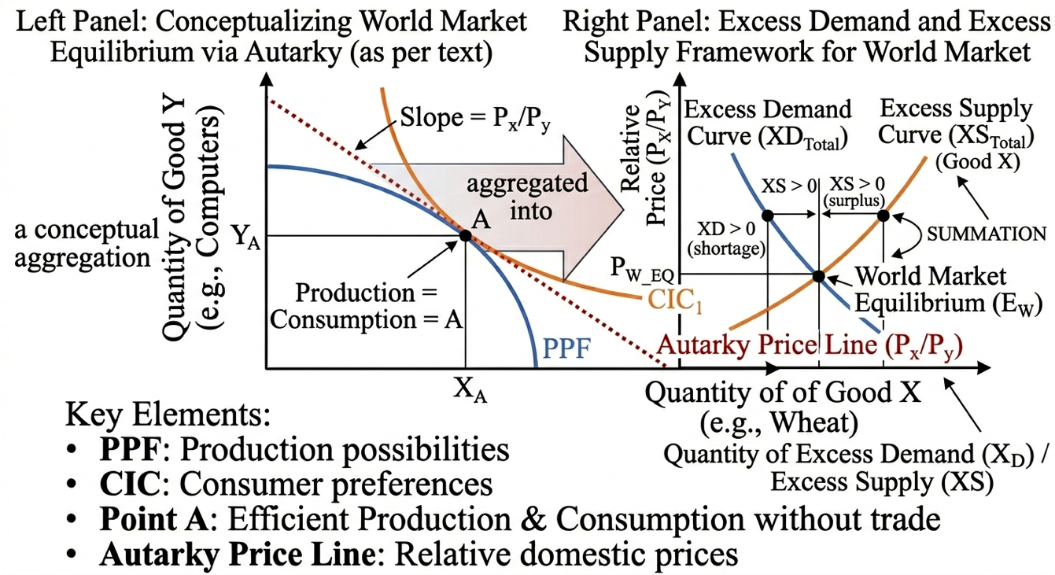
Source: Created by the author
The right panel shifts focus from total production and consumption to trade volume, presenting the excess supply (XS) and excess demand (XD) curves. The excess supply curve represents countries that produce more than they consume at a given price; as the world price rises, these nations are willing to export larger quantities. Conversely, the excess demand curve represents countries whose consumption exceeds domestic production; as the world price falls, their import demand increases. The intersection of these two curves establishes the world market equilibrium (EW), the global clearing price at which the quantity exporters wish to supply exactly equals the quantity importers wish to demand.
Two key insights emerge from this framework. First, the world market is not a physical entity but a conceptual aggregation the mathematical outcome of the interaction among all nations' autarky positions. Second, the world equilibrium price typically diverges from any single country's autarky price; this differential creates the fundamental incentive for trade. For economists, the right-side framework of excess demand and excess supply serves as an essential analytical tool for calculating welfare gains specifically, how much better off a country becomes by engaging in international trade relative to remaining at its autarky equilibrium (point A).

3. Deriving Import Demand and Export Supply

3.1 Import Demand Curve
The Import Demand Curve shows the quantity of a good a country wishes to import at each world price. It is derived from the gap between domestic demand and domestic supply.
The import demand curve, defined as M(P)=D(P)−S(P), captures the quantity a country wishes to import at a given world price. When the world price falls below the autarky price, domestic demand exceeds domestic supply, and the resulting gap represents imports. The curve slopes downward because a lower world price simultaneously increases domestic consumption and reduces domestic production, thereby widening the import gap.
The import demand curve is derived by measuring the horizontal gap between the domestic demand and domestic supply curves at each price level below the autarky equilibrium. As the world price declines, this gap widens because consumers demand more while domestic producers supply less, yielding a downward-sloping import demand curve that reflects the quantity of imports desired at each possible world price (see Figure 3).
Figure 3. Import Demand Curve Derivation: Domestic Gap vs World Price
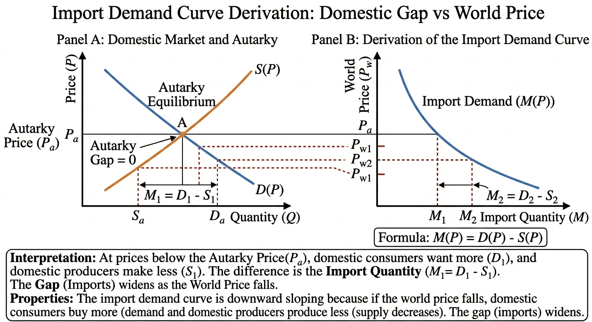
Source: Created by the author

This figure illustrates the derivation of the Import Demand Curve, which demonstrates how a country's need for foreign goods increases as the world price falls.
Panel A: The Domestic Market (The Source of the Gap)
The left panel presents a standard supply and demand graph for a single country. At Point A (Autarky) , the equilibrium price Pa​ equates domestic supply with domestic demand, resulting in a gap of zero no imports are required. When the world price falls below the autarky price, as shown at Pw1​, two effects occur: consumers increase their quantity demanded (moving along the demand curve to D1​), while producers reduce their quantity supplied (moving along the supply curve to S1​). The horizontal distance between S1​ and D1​ represents the domestic shortage, denoted as M1​, which is precisely the quantity the country must import.

Panel B: The Import Demand Curve (The Trade Result)
The right panel translates these domestic gaps into a single trade curve, M(P). At the autarky price Pa​, the import quantity is zero. As the world price declines from Pw1​ to Pw2​, the domestic gap in Panel A widens, resulting in a larger import quantity M2. This relationship explains why the import demand curve slopes downward: a lower price leads to higher import demand. The curve is formally expressed as M(P)=D(P)−S(P).
The Import Demand (MD) curve illustrates how a country's internal shortage creates a demand for foreign goods. When the world price falls below a nation's autarky price, local consumers buy more while local producers cut back, creating a gap. This gap is plotted as the MD curve, which slopes downward because a lower price makes imports more attractive and necessary to satisfy domestic demand.

Figure 4. The Derivation of the Import Demand Curve
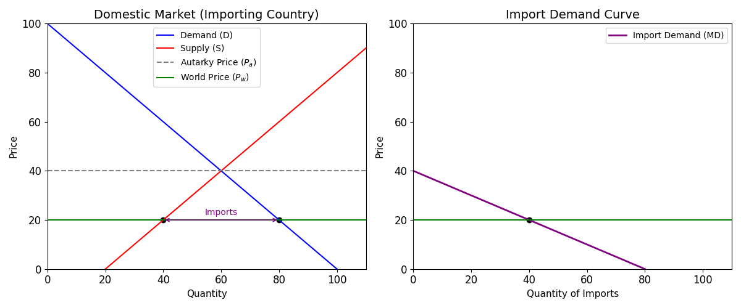
Source: Created by the author
Figure 4 indicate that when a country’s local price drops below its self-sufficient (autarky) price, consumers want more than local factories can produce. This shortage is filled by buying goods from abroad. The Import Demand Curve maps this out: the lower the world price, the larger the domestic shortage, and the more the country wants to buy from the rest of the world.

3.2 Export Supply Curve

The Export Supply (XS) curve represents the quantity a country is willing to export at each world price, derived from the gap between domestic supply and domestic demand, expressed as X(P)=S(P)−D(P). The XP curve shows how a country's internal surplus is offered to the global market. When the world price rises above the autarky price, domestic production exceeds domestic consumption, leaving a surplus. This surplus is plotted as the XS curve, which slopes upward because higher prices incentivize domestic firms to produce more for the world market while discouraging local consumption.
Figure 5. The Derivation of the Export Supply Curve
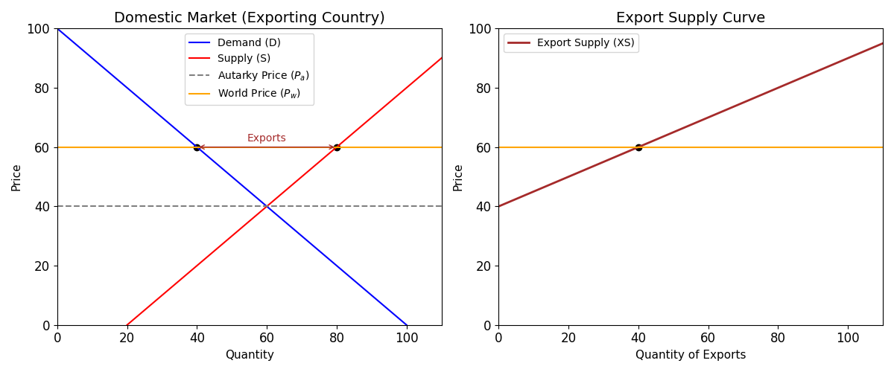
Source: Created by the author

Digarm 5 indicates that when a country’s local price rises above its self-sufficient level, factories produce more than local consumers can afford. This surplus is sold to foreign buyers. The Export Supply Curve maps this out: the higher the world price, the larger the domestic surplus, and the more goods the country is eager to sell abroad.

3.3. World Market Equilibrium

World market equilibrium is achieved when the desired purchases of the importing country exactly match the desired sales of the exporting country. This occurs at the intersection where Home's import demand equals Foreign's export supply, expressed as MHome​(PW​)=XForeign​(PW​). The world price (PW​) is the price at which the global market clears, meaning there is neither excess demand nor excess supply in the international market. The trade volume (QT​) represents the quantity of goods physically moved from the exporting country to the importing country at this equilibrium price (See Figure 6).

Figure 6. Partial Equilibrium Model of International Trade. The Intersection

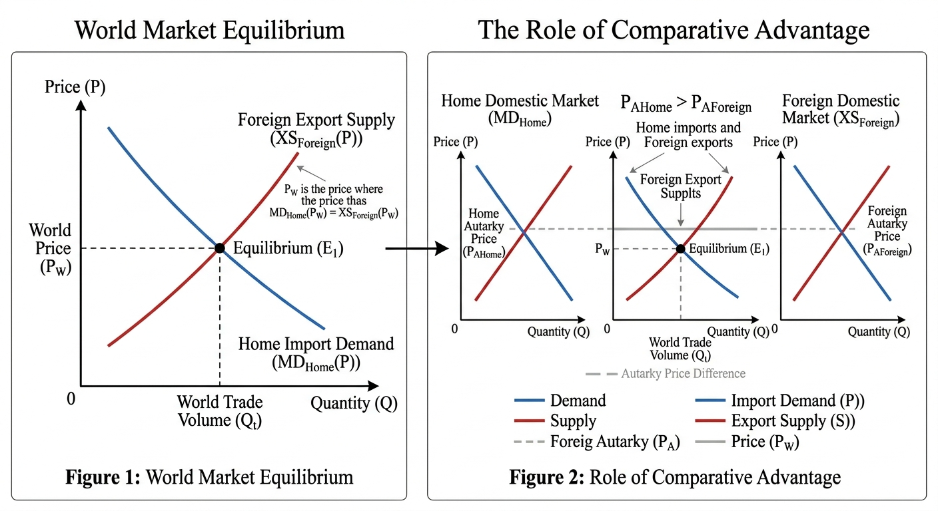
Source: Created by the author

Figure 6 argue that the world market equilibrium is achieved when the desired purchases of the importing country exactly match the desired sales of the exporting country. This occurs at the intersection where Home's import demand equals Foreign's export supply, expressed as MHome​(PW​)=XForeign​(PW​). The world price (PW​) is the price at which the global market clears, meaning there is neither excess demand nor excess supply in the international market. The trade volume (QT) represents the quantity of goods physically moved from the exporting country to the importing country at this equilibrium price.

In addition, the model explains the fundamental reason for trade based on price differentials between countries. Trade occurs only if there exists a gap between autarky prices specifically, if Pa,Home​>Pa,Foreign​. If the autarky prices were identical, there would be no incentive to trade, as neither country would gain from exchanging goods. Once trade opens, the world price (PW​) settles between the two autarky prices​. This price convergence determines the direction of trade: the country with the lower autarky price (Foreign) possesses the comparative advantage and becomes the exporter, while the country with the higher autarky price (Home) becomes the importer.

4. Determinants of Import Demand and Export Supply

4.1 Determinants of Import Demand

A shift in the import demand curve is driven by three primary factors. First, changes in domestic demand, such as an increase in consumer income (for normal goods) or a shift in tastes toward the good, raise domestic demand, widen the gap between demand and supply, and shift the import demand curve outward (more imports at every price). Second, changes in domestic supply, such as a technological improvement that lowers production costs, shift the domestic supply curve rightward, narrowing the gap between demand and supply and shifting import demand inward (less reliance on imports). Third, changes in substitutes, specifically a decrease in the price of a domestic substitute, reduce the demand for imports, thereby shifting the import demand curve inward.

4.2 Determinants of Export Supply

A rightward shift in the export supply curve indicating greater exports at every price can result from three primary factors. First, positive changes in domestic supply, such as a bumper crop or technological innovation, increase the surplus available for export. Second, a decrease in domestic demand, often caused by a recession or falling incomes, reduces local consumption and frees up goods for international markets. Third, a depreciation of the domestic currency makes domestically produced goods cheaper for foreign buyers, effectively expanding export supply at each price level (see Figure 7).

Figure 7. The Rightward Shift in Export Supply and its Three Primary Drivers: Positive Supply Shock, Decrease in Domestic Demand, and Domestic Currency Depreciation.

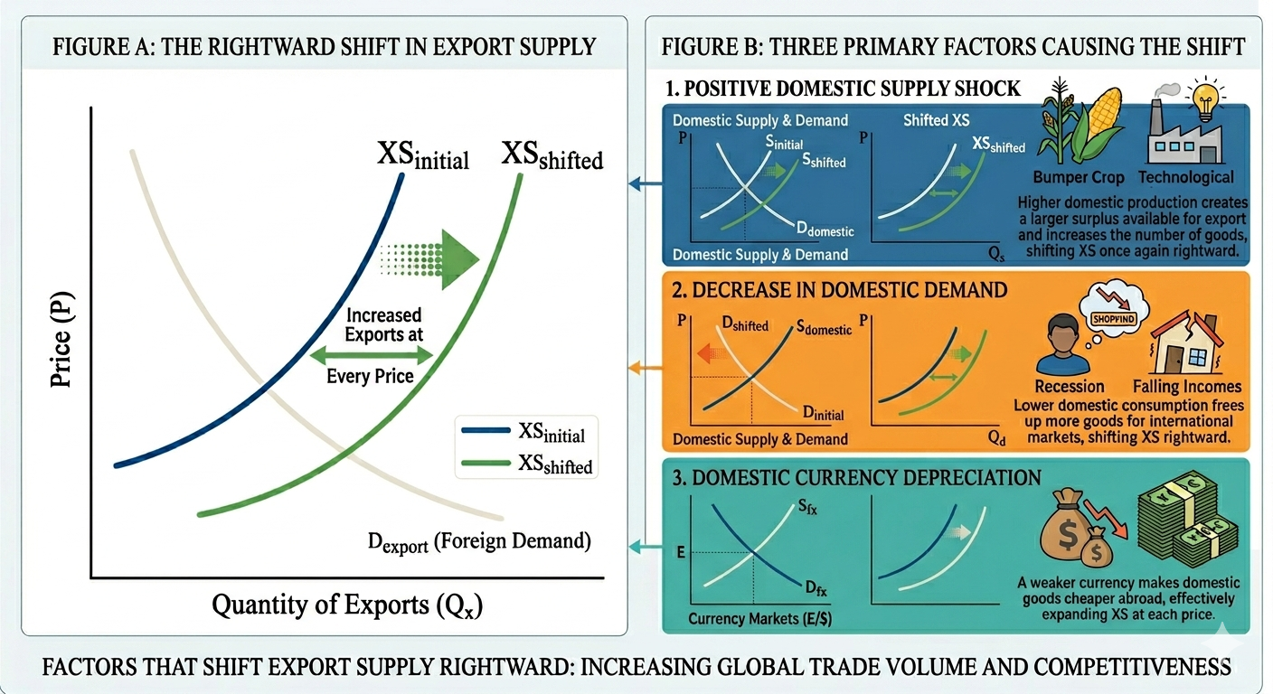
Source: Gemini created foto" (Google, April, 2026)

5. Trade Policy – Tariffs (Part II)

Governments intervene in international trade for a variety of strategic and economic reasons. Revenue generation is a primary motive, particularly in developing economies where tariffs provide a reliable source of government income. Protecting domestic industries is another common objective, as tariffs shield local firms from foreign competition, preserving jobs and fostering industrial development. Additionally, governments may employ trade intervention for strategic leverage, using tariffs as a tool in diplomatic negotiations or to pressure trading partners on non-trade issues such as labor standards, environmental policies, or national security concerns. Regardless of the motivation, the most common policy instrument used to achieve these goals is the tariff a tax imposed on imported goods.

5.1. The Small Country Case (Tariff)
A small country faces a perfectly elastic export supply curve. It is a "price taker." Its imports are an infinitesimal fraction of the world market, so its purchasing decisions do not affect the world price (PWPW​).

5.2 Effects of a Tariff in a Small Country

To analyze the effects of a tariff, it is essential to distinguish between two distinct prices that emerge after the policy is imposed. The domestic price (PDomestic​) represents the price that domestic consumers pay and domestic producers receive for the good. The world price (PWorld​) represents the price that foreign exporters receive for the same good. The tariff creates a wedge between these two prices, formally expressed as PDomestic​=PWorld​+t, where t denotes the per-unit tariff. This wedge has critical implications for welfare analysis, as it determines how the burden of the tariff is distributed between domestic consumers, domestic producers, foreign exporters, and the government. Understanding this price divergence is fundamental to evaluating the economic consequences of trade policy in both small and large country contexts.

5.3 Welfare Analysis (Small Country)
Figure 8 illustrates the welfare effects of a tariff in a small country, where a "small country" is defined as one that cannot influence world prices and therefore takes the world price (PW​) as given. Before the tariff is imposed, the country imports goods at the world price. When the government imposes a tariff (T), the domestic price rises to Pt​=PW​+T. This price increase serves as the foundation for all subsequent welfare changes, affecting four distinct areas within the domestic market.
The welfare analysis identifies four distinct areas that capture the distributional effects of the tariff. Area aa represents the producer surplus gain. Because the domestic price has risen, domestic producers expand their output from Qs1​ to Qs2​. The higher price allows them to earn additional revenue on all units sold, resulting in a transfer of surplus from consumers to producers.

Figure 8. Welfare Analysis of a Tariff in a Small Country

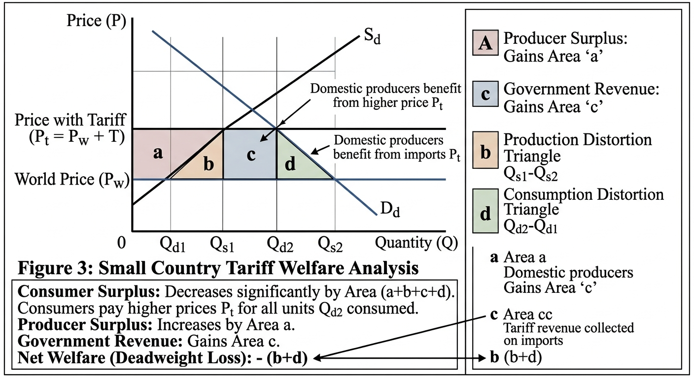
Source: Created by the author

Area c represents government revenue. This rectangular area is calculated by multiplying the tariff amount (T) by the total volume of imports after the tariff is imposed, which is the difference between the new quantity demanded (Qd2​) and the new quantity supplied (Qs2​). This revenue is collected by the government and can be used for public expenditures or tax reductions elsewhere in the economy.
Areas b and d represent the deadweight loss, which constitutes the net cost to society that is not recovered by any economic agent. Area b is the production distortion the inefficiency arising from domestic firms producing goods that could have been purchased more cheaply from foreign suppliers. This represents resources diverted from potentially more efficient uses. Area d is the consumption distortionthe loss experienced by consumers who are priced out of the market entirely because they cannot afford the higher domestic price Pt​, forcing them to either forgo consumption or switch to less desirable substitutes.
The overall impact on national welfare is calculated by summing the gains and losses across all groups in the economy. Consumers lose the entire area a+b+c+d, as they now pay higher prices for all units consumed and lose access to some units entirely. Producers gain area aa, capturing the surplus transferred from consumers. The government gains area cc in the form of tariff revenue. Summing these changes yields a net welfare change of (b+d), which is negative.
Summarize, for a small country, a tariff always results in a net national loss equal to the sum of the two triangles (b+d). The losses incurred by consumers outweigh the combined gains received by producers and the government, making the tariff an inefficient policy from the perspective of overall national welfare. This result holds regardless of the specific size of the tariff or the particular elasticities of supply and demand, given the small country assumption that world prices remain unchanged.

6. The Large Country Case (Tariff)

6.1 Definition

A large country has monopsony power in the import market. Its import demand is a significant share of world demand. When it imposes a tariff, its reduced import demand lowers the world price (PW​).

6.2 The Terms of Trade Effect as the Crucial Distinction
The fundamental distinction between a small country and a large country lies in the terms of trade effect. When a large country imposes a tariff, it possesses sufficient market power to influence world prices, unlike a small country that simply accepts the world price as given. As a result, when the large country reduces its import demand by imposing a tariff, the world price falls. Consequently, the domestic price rises, but by less than the full amount of the tariff because the decline in the world price partially offsets the tariff's impact.

6.3. Price Dynamics Under a Large Country Tariff
Let PW∗ represent the new, lower world price faced by foreign exporters after the tariff is imposed. The domestic price is then determined by the sum of this new world price and the tariff, expressed as PDomestic​=PW+t. Because PW​ is lower than the original world price, the increase in the domestic price is smaller than the tariff amount t. This partial pass-through distinguishes the large country case from the small country case, where the domestic price rises by the full tariff.

Definition and Improvement of the Terms of Trade
The large country gains a terms of trade improvement as a result of this price dynamic. The terms of trade (ToT) are defined as the ratio of a country's export prices to its import prices, formally expressed as:
Terms of Trade (ToT)=Price of Imports/Price of Exports​
This ratio measures the quantity of imports a country can obtain per unit of its exports. For an importing country, a fall in the price of imports improves the terms of trade because the denominator decreases, making the ratio larger. This means the country can purchase more imports with the same volume of exports, representing a real gain in purchasing power. Thus, when a large country imposes a tariff and successfully lowers the world price of its imports, it secures a terms of trade gain that partially or fully offsets the deadweight losses associated with the tariff.

6.4 Welfare Analysis (Large Country)

Figure 9 illustrates the welfare analysis of a tariff in a large country. Unlike a small country, a "large country" possesses sufficient market power such that its trade policies can force foreign exporters to lower their prices to maintain access to its market. When a large country imposes a tariff tt, it creates a price wedge, but the domestic price does not rise by the full amount of the tariff. The domestic price (Pt) that home consumers pay rises, but by less than in the small country case. Simultaneously, the foreign price (′Pw′​) falls because home, being a large buyer, exerts downward pressure on world prices as its import demand contracts. This reduction in the price paid to foreigners the difference between the original world price (Pw​) and the new lower price (′Pw′​) represents a terms of trade gain for the home country.

Figure 9. Large Country Tariff Welfare Analysis
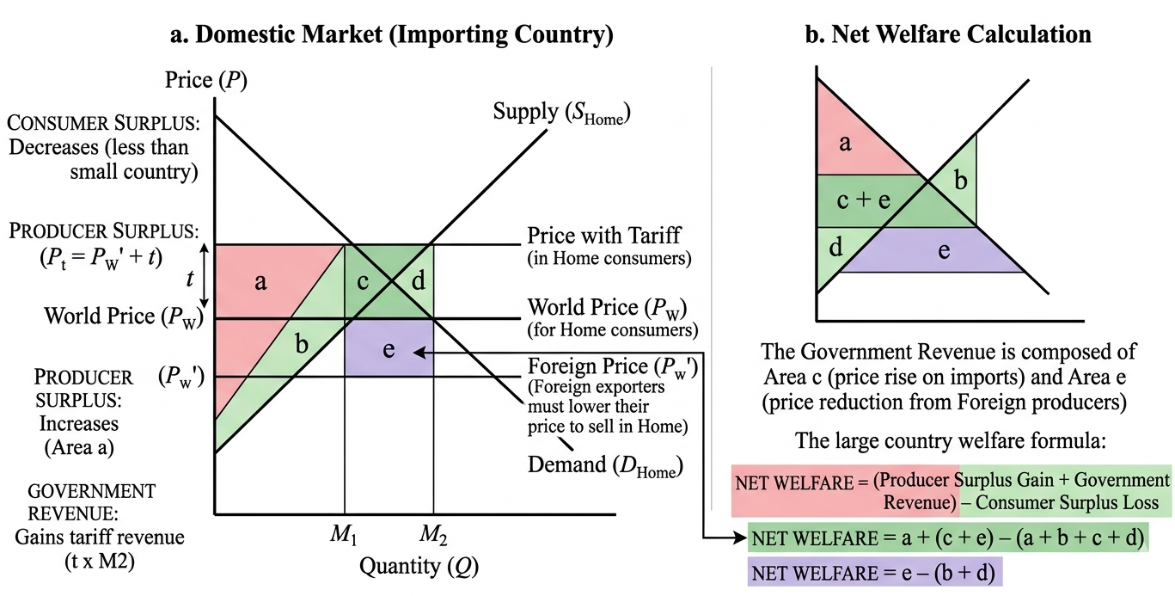
Source: Created by the author
The welfare analysis identifies several distinct areas that capture the distributional effects of the tariff. Area a represents the producer surplus gain: domestic producers benefit from the higher domestic price (Pt​), allowing them to expand output and capture additional surplus. Area (a+b+c+d) represents the consumer surplus loss: consumers are worse off because they pay a higher price and consume less than under free trade. Area (c+e) represents government revenue. The government collects the tariff t on all remaining imports (M2​). This revenue is divided into two components. Area c represents the portion of tariff revenue that is effectively paid by domestic consumers through the higher price they face. Area eerepresents the portion "paid" by foreign exporters this is the terms of trade gain, as it captures the reduction in the price home pays for each unit of imports that continues to be purchased.
The net effect on national welfare is calculated by summing all gains and losses. The gains consist of producer surplus (a) plus government revenue (c+e). The losses consist of consumer surplus (a+b+c+d). Canceling the common terms (a and c) yields a net change of e−(b+d).
The summary table clarifies the composition of this net effect:
- Area b represents the production distortion an efficiency loss from domestic firms producing goods that could be obtained more cheaply from abroad.
- Area d represents the consumption distortion an efficiency loss from consumers who are priced out of the market.
- Area e represents the terms of trade gain a transfer from foreign exporters to the home country.

6.5. The Optimal Tariff
If the terms of trade gain exceeds the deadweight loss, the large country can increase its national welfare through a tariff. This leads to the concept of the optimal tariff the tariff rate that maximizes the difference between the terms of trade gain and the deadweight loss. However, this comes with a caveat: the gain for the home country comes at the expense of the foreign country (who receives a lower price for their exports). This is a "beggar-thy-neighbor" policy, likely to provoke retaliation.

7. Trade Policy – Quotas (Part III)
A quota is a physical limit on the quantity of a good that can be imported. While tariffs generate revenue, quotas restrict volume.
In theory, a tariff and a quota can have the same effect on price and quantity if the quota is set at the post-tariff import level. However, in practice, they differ significantly.

7.2 The Small Country Quota
For a small country, a binding quota sets a maximum import level Q. Domestic supply becomes SDomestic​+Q. This shifts the effective supply curve horizontally. The result:
- Domestic price rises to PQ​.
- Quantity consumed falls; domestic production rises.
- The difference from a tariff is the distribution of the "quota rent."

7.3 Quota Rents
When a quota is imposed, the right to import the limited quantity becomes valuable. The difference between the high domestic price and the low world price on the restricted quantity is the quota rent (analogous to tariff revenue, but private).
Rent: (PQ​−PW​)×Q
Who gets this rent? It depends on how the government administers the quota:
- Auction: If the government auctions import licenses, it captures the rent. This is functionally equivalent to a tariff (the rent becomes government revenue).
- Free Distribution: If licenses are given to domestic importers, the rent accrues to private firms as excess profit.
- Voluntary Export Restraint (VER): If the foreign government administers the quota (often to avoid a tariff), the rent accrues to foreign exporters. This is the worst-case scenario for the importing country, as it suffers the deadweight loss plus transfers wealth to foreigners.

Small vs. Large Country Effects (Comparative Summary)
This table summarizes the core differences between small and large country outcomes.
Feature | Small Country | Large Country
Market Power | None (Price Taker) | Significant (Price Maker)
Export Supply Elasticity | Perfectly Elastic (Flat) | Upward Sloping (Normal)
Tariff Impact on World Price | No change | World price falls
Tariff Impact on Domestic Price | Rises by full t | Rises by <t<t
Welfare Effect (Tariff) | Loss (Deadweight loss) | Ambiguous (Loss if DWL > ToT gain; Gain if ToT gain > DWL)
Policy Implication | Free trade is optimal | Optimal tariff is theoretically possible but risky

8. Trade Volume

8.1 Determinants of Trade Volume
Trade volume refers to the quantity of goods traded across borders (e.g., M or X in equilibrium). It is determined by:
- Differences in Autarky Prices: Larger differences between domestic and foreign autarky prices lead to larger trade volumes.
- Country Size: When countries are similar in size (and have similar supply/demand elasticities), trade volume tends to be higher than when one country is very large and one is very small. (The "home market effect").
- Trade Costs: Tariffs, quotas, transportation costs, and transaction costs reduce trade volume by widening the gap between the price paid by the importer and the price received by the exporter.

8.2 Gravity Model of Trade
While not strictly part of supply/demand microeconomics, the empirical reality of trade volume is best described by the Gravity Model:
Tij​=A×Dij​Yi​×Yj​​
Where T is trade volume between country i and j, Y is economic size (GDP), D is distance, and A is a constant. This model shows that trade volume is proportional to the product of the two economies and inversely proportional to distance (a proxy for trade costs).

9. Terms of Trade

9.1 Definition and Significance
The Terms of Trade (ToT) is arguably the most important macroeconomic indicator of a country’s trade well-being.
If the terms of trade increase, the country can purchase more imports for the same quantity of exports. This improvement indicates that export prices have risen relative to import prices, enhancing the country's real income and purchasing power. Consequently, national welfare increases, assuming full employment and holding other factors constant (See figure 10).
Figure 10. Terms of Trade (ToT) and Welfare Effects.
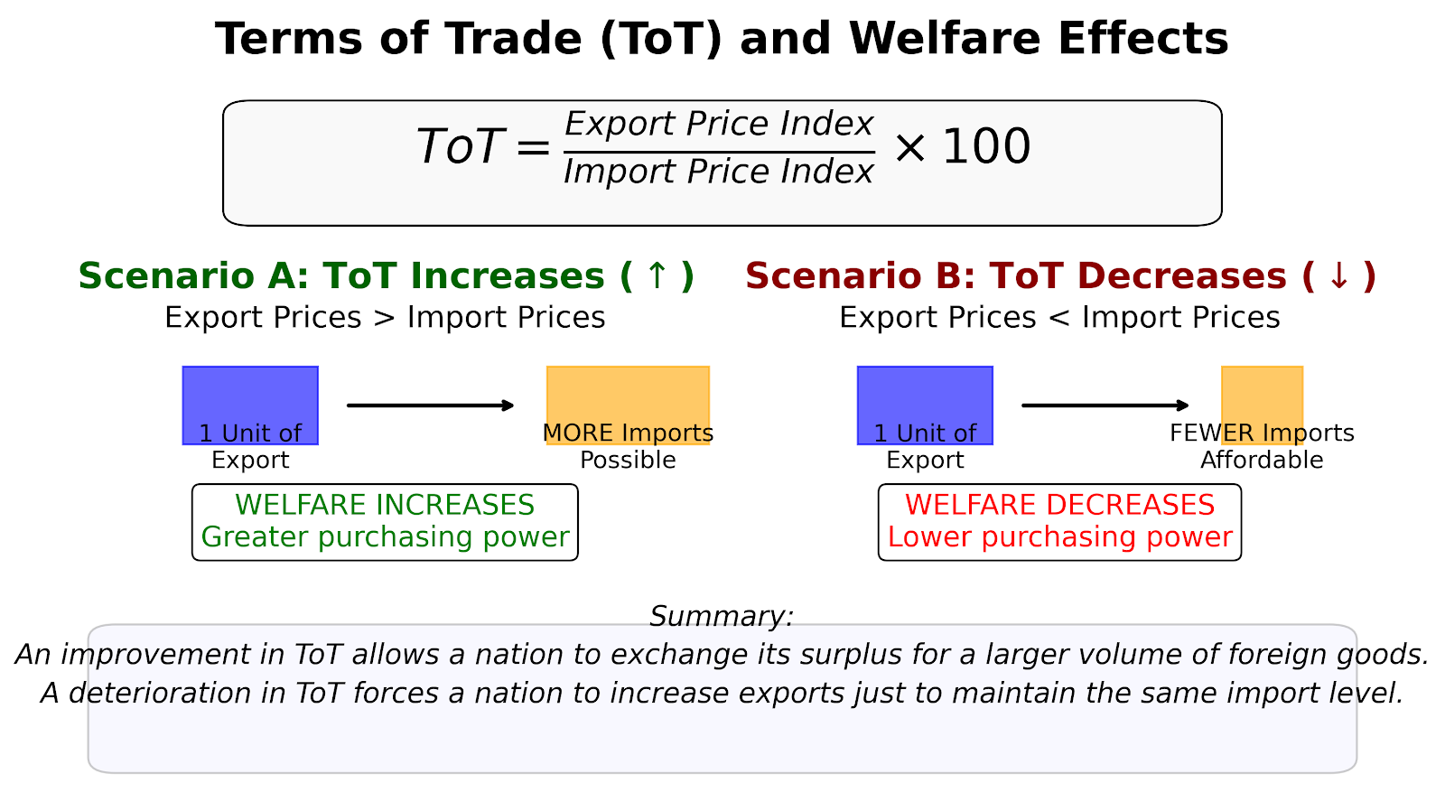
Source: Created by the author

If the terms of trade decrease, the country must export a larger volume to afford the same quantity of imports. This deterioration implies that export prices have fallen relative to import prices, reducing the real value of export earnings. As a result, national welfare decreases, as the country effectively receives less value for its goods sold abroad.

9.2 Determinants of Terms of Trade
- Growth: Export-biased growth (growth that expands the export sector) worsens the terms of trade (supply increases, price falls). Import-biased growth (growth that reduces demand for imports) improves the terms of trade.
- Trade Policies: As we saw with the large country tariff, restricting imports improves the terms of trade (by lowering import prices). Export subsidies worsen the terms of trade (by increasing export supply, lowering export prices).
- Exchange Rates: A depreciation of the domestic currency tends to lower the terms of trade in the short run (export prices fall in foreign currency, import prices rise in domestic currency) before the J-curve effect takes hold.

9.3 Terms of Trade and Welfare
A large country can use a tariff to exploit its monopsony power to improve its terms of trade. However, this is a transfer of welfare from the foreign country to the home country. If the foreign country retaliates with its own tariffs, both countries may end up with worse terms of trade and lower trade volume a classic "prisoner’s dilemma" of trade policy.

10. Case Study Application

The U.S. Steel Tariffs (2002/2018)
To solidify these concepts, consider the case of a large economy (the United States) imposing tariffs on steel imports.
- Context: The U.S. argued that foreign (especially Chinese and other Asian) steel was being "dumped" or subsidized, threatening domestic jobs.
- Small vs. Large Country Dynamic: The U.S. is a large steel importer. According to theory, the tariff should have lowered the world price of steel. Indeed, global steel prices fell relative to what they would have been without the tariff.
- Welfare: Domestic steel producers (e.g., Nucor, U.S. Steel) gained significant producer surplus. However, domestic consumers of steel (automotive manufacturers, construction firms) faced higher input costs.
- Terms of Trade: The U.S. arguably gained a terms of trade improvement (lower import prices), but the deadweight loss (production inefficiency and consumption inefficiency) was estimated to be significant.
- Retaliation: In the 2018 case, the U.S. imposed tariffs under Section 232 (national security). Major trading partners (EU, Canada, Mexico) retaliated with tariffs on U.S. agricultural products (soybeans, bourbon). This retaliation harmed U.S. exporters, negating any potential terms of trade gains and reducing overall welfare.
Lesson: Even for a large country, the strategic use of tariffs invites retaliation, often resulting in a net loss for all parties involved.

11. Graphical Synthesis

The Metzler Paradox (Advanced Note)
While we have covered standard theory, a nuance exists for large countries: the Metzler Paradox. It is theoretically possible that for a large country, a tariff can actually cause the domestic price of the importable good to fall. This happens if the foreign export supply curve is very steep (inelastic) and the tariff causes such a dramatic fall in the world price that the domestic price (PW​+t) ends up lower than the original free trade price. While rare in practice, it highlights the complexity of large-country dynamics.
The Figure 11 defines the key components in the large country tariff analysis. PW​ represents the initial world price prevailing before the tariff is imposed. PW​ denotes the new, lower price paid to foreign exporters after the large country imposes a tariff, reflecting the decline in world prices due to the country's market power. t is the specific tariff amount levied per unit of imports. QT​ indicates the quantity of goods traded globally in equilibrium. Finally, b and d represent the efficiency losses specifically, the production distortion from inefficient domestic expansion and the consumption distortion from consumers priced out of the market, respectively.

Diagram A:

The world market equilibrium is depicted on a graph with quantity on the horizontal axis and price on the vertical axis. The foreign export supply curve slopes upward, while the home import demand curve slopes downward; their intersection determines the equilibrium world price PW​ and global trade volume QT​. A shift in foreign supply, such as a technological boom that increases production capacity, shifts the export supply curve to the right, causing the world price to fall and the equilibrium trade volume to rise.
Figure 11. Comparative Analysis of Trade Equilibria and Tariff Welfare Effects.
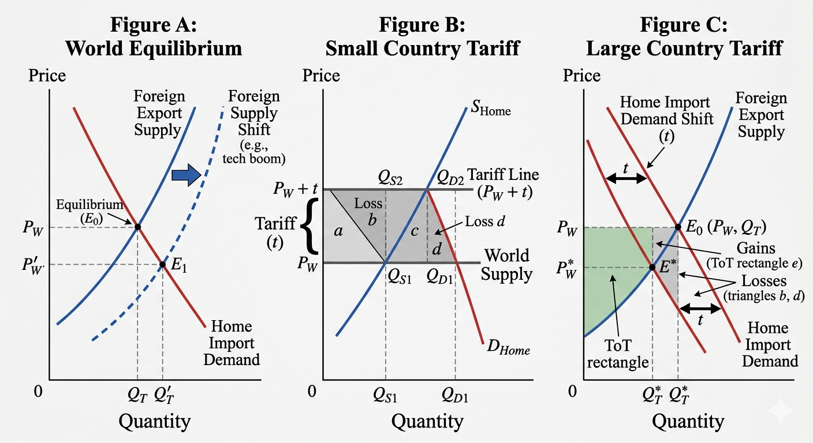

Source: Gemini created foto" (Google, April, 2026)

Diagram B:

In the small country tariff diagram, the x-axis represents quantity and the y-axis represents price. The world supply curve is horizontal at the world price PW​, reflecting the small country's status as a price taker. The imposition of a tariff raises the relevant supply line to PW​+t, as the domestic price increases by the full amount of the tariff. The resulting welfare loss is represented by the two triangles bb and dd, which capture the production distortion from inefficient domestic expansion and the consumption distortion from consumers priced out of the market, respectively.
Diagram C:

The diagram depicts the large country tariff analysis with quantity on the horizontal axis and price on the vertical axis. The Home import demand curve slopes downward, while the Foreign export supply curve slopes upward. The imposition of a tariff shifts the import demand curve downward by the amount tt, because at any given world price, the domestic price is tt higher, thereby reducing the quantity of imports demanded. The new intersection of the shifted import demand curve with the Foreign export supply curve yields a lower world price PW​. Welfare analysis reveals a trade-off between gains from the terms of trade improvement (represented by a rectangle) and losses from production and consumption distortions (represented by triangles).

12. Policy Implications and Contemporary Debates

12.1 Is Free Trade Always Optimal?
For a small country, the theoretical answer is "yes." Free trade maximizes national welfare by allowing consumers to purchase at the world price, maximizing consumer surplus.
For a large country, theory suggests an "optimal tariff" exists. However, in practice, policymakers rarely know the precise elasticities to calculate this tariff. Furthermore, the threat of retaliationmakes the pursuit of optimal tariffs highly risky. The post-World War II trend (GATT/WTO) has been toward multilateral reductions in tariffs precisely to avoid this destructive cycle.

12.2 Non-Economic Objectives
Governments impose tariffs and quotas for reasons beyond economic efficiency:
- National Security: Protecting domestic industries (steel, semiconductors) deemed vital for defense.
- Infant Industry Argument: Protecting young industries until they gain economies of scale to compete globally.
- Political Economy: Tariffs often protect concentrated industries (with well-organized lobbyists) even at the expense of diffuse consumer interests.

12.3 Modern Challenges: Supply Chains
The traditional supply/demand analysis assumes goods are finished products. However, modern global supply chains mean that components cross borders multiple times. A tariff on "imported steel" might hurt domestic auto manufacturers. This complexity has led to the rise of tariff engineering and debates about reshoring.

13. Conclusion and Review Questions
In this lecture, we expanded the microeconomic toolbox to analyze global markets. We learned:
- Import Demand and Export Supply curves are derived from domestic fundamentals and determine the world price and trade volume.
- Tariffs create a wedge between domestic and world prices.
- The size of the country matters: small countries lose from tariffs; large countries might gain via improved terms of trade, but risk retaliation.
- Quotas are similar to tariffs but raise the issue of rent allocation.
- Trade volume is influenced by economic size, distance, and policy.
- Terms of trade are a critical measure of a nation’s economic welfare from trade.

14. Review Questions
- Using a diagram, illustrate why a small country loses welfare when it imposes a tariff. Identify the producer surplus gain, consumer surplus loss, and the deadweight loss triangles.
- Explain the difference between a small country and a large country in the context of an import tariff. How does the large country’s ability to affect world prices change the welfare outcome?
- A large country imposes a quota on imports. Compare the welfare outcomes if the government auctions the import licenses versus if it gives them away to domestic importers.
- How does export-biased growth in a large country affect its terms of trade? How does this differ from import-biased growth?
- Discuss the political economy factors that might lead a government to impose a tariff even when it creates a net national welfare loss.

Suggested Readings
- Krugman, P., Obstfeld, M., and Melitz, M. (2022). International Economics: Theory and Policy. (Chapters on Standard Trade Model, Tariffs, and Quotas).
- Feenstra, R. C., and Taylor, A. M. (2021). International Trade. (Chapters on Import Tariffs and Quotas).
- Salvatore, D. (2019). International Economics (13th ed.). Wiley.
- Appleyard, D. R., Field, A. J., and Cobb, S. L. (2019). International Economics (9th ed.). McGraw-Hill.
- Carbaugh, R. J. (2019). International Economics (17th ed.). Cengage Learning.
- WTO (World Trade Organization). (2022). World Trade Report 2022: Climate Change and International Trade. WTO Publications.
- Feenstra, R. C., and Taylor, A. M. (2021). International Trade (5th ed.). Worth Publishers.
- Mankiw, N. G. (2021). Principles of Economics (9th ed.). Cengage Learning.

