Course: International Trade and Policy
Week 3. Comparative Advantage and Factor Endowments
University: Tajik State University of Commerce
Lecturer: Abduvaliev Mubinzhon, PhD

1. Introduction: Why Do Countries Trade?
The study of international trade seeks to answer fundamental economic questions:
- Why do countries trade? What is the underlying cause of international exchange?
- What determines the pattern of trade? Which goods does a country export, and which does it import?
- Who gains from trade? Does trade benefit everyone in a country, or are there winners and losers?
- How does trade affect a country's economic structure, wages, and income distribution?
Over the centuries, economists have developed theoretical frameworks to answer these questions. The two most foundational theories are the Ricardian model and the Heckscher-Ohlin (H-O) model. These models form the bedrock of trade theory, and understanding them is essential for analysing more complex phenomena in modern trade.
The Core Insight: Comparative Advantage
The central insight of classical trade theory is that trade is driven by comparative advantage, not absolute advantage. A country has an absolute advantage in producing a good if it can produce it with fewer resources (e.g., labor hours) than another country. However, as David Ricardo demonstrated in the early 19th century, even if one country is more efficient at producing everything, there is still a basis for mutually beneficial trade based on comparative advantage.
Comparative advantage exists when a country can produce a good at a lower opportunity costthan another country. Opportunity cost is the value of the next best alternative foregone. Trade allows countries to specialize according to their comparative advantage, leading to a more efficient global allocation of resources and higher aggregate output.
This lecture note is divided into two main parts. The first revisits the Ricardian model, which attributes comparative advantage to international differences in labor productivity (technology). The second explores the Heckscher-Ohlin model, which explains comparative advantage by differences in countries' endowments of factors of production (e.g., capital, labor, land) and the different intensities with which these factors are used in producing goods.

2 The Ricardian Model of Comparative Advantage
The Ricardian model, named after the British political economist David Ricardo (1772-1823), is the simplest and most elegant model of international trade. Its core premise is that technological differences across countries are the primary driver of trade.
To build a tractable model, we make several simplifying assumptions. These will be relaxed in later, more advanced models.
Figure 1. Ricardian Model: Linear Prediction Possibility Frontier
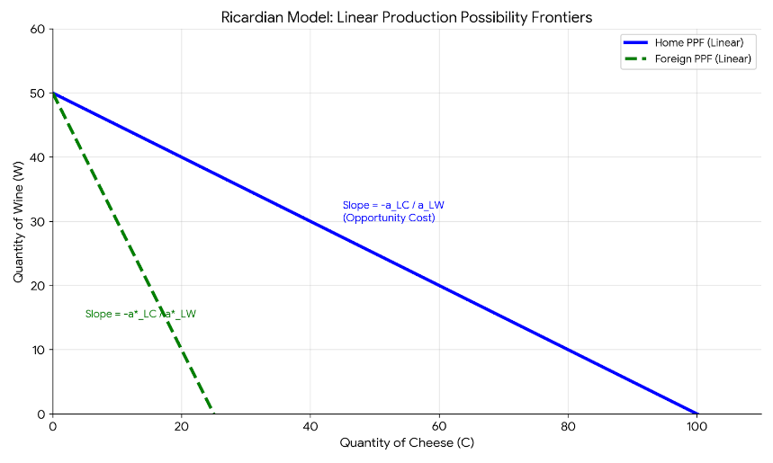
Source: Created by the author
In this simplified model of international trade, there are two countries (Home and Foreign) producing two goods (Wine and Cheese) using only labor, a single, homogeneous factor of production that is perfectly mobile between industries within each country but immobile across borders, leading to a uniform domestic wage. Production is characterized by constant returns to scale with technology differences reflected in unit labor requirements, and under conditions of perfect competition in both product and labor markets, zero profits, full employment, and the absence of any trade barriers like tariffs or transportation costs, the basis for trade is determined solely by cross-country differences in labor productivity.

Autarky Equilibrium in the Immobile Factor Model:
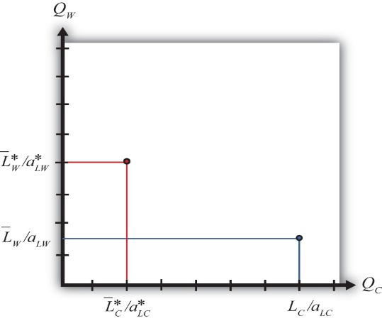
Source: Saylor Foundation. (n.d.). Autarky equilibrium in the immobile factor model. In International trade: Theory and policy. Retrieved March 1, 2026, from https://saylordotorg.github.io/text_international-trade-theory-and-policy/s07-06-autarky-equilibrium-in-the-imm.html
In the immobile factor model, autarky equilibrium occurs where a country produces and consumes at the same point on its production possibility frontier, as there is no trade. Since labor is immobile between sectors, the production mix is fixed by the initial allocation of workers to each industry. With identical homothetic preferences across countries, the autarky price ratio is determined by the condition that the ratio of goods demanded equals the ratio supplied. A country with an absolute advantage in a good such as the United States in cheese will produce relatively more of it, leading to a lower autarky price for that good compared to its trading partner. Thus, the pattern of absolute advantage (or differences in factor endowments) directly determines cross-country differences in autarky prices, which in turn establish the basis for comparative advantage and future trade.
2.3 The Concept of Opportunity Cost and Comparative Advantage
The Figure 2 illustrates the core logic of the Ricardian model using a two-country, two-good, one-factor framework. Home and Foreign both produce cheese and wine using labor only. Home requires 1 hour to produce a pound of cheese and 2 hours for a gallon of wine, while Foreign requires 6 hours for cheese and 3 hours for wine. Home therefore has an absolute advantage in both goods it is more efficient at producing everything. However, the basis for trade is not absolute advantage but comparative advantage, which is determined by opportunity cost.

Figure 2. The Determination of Comparative Advantage via Opportunity Costs.

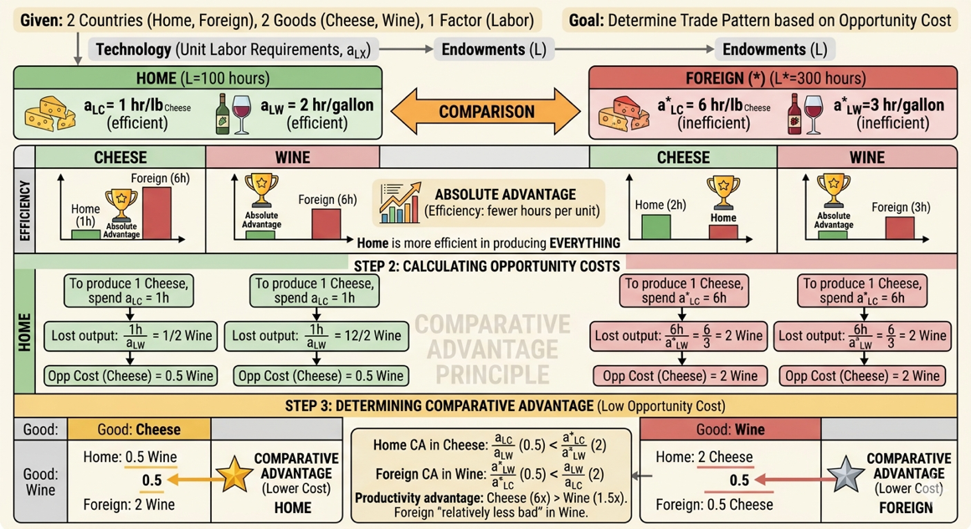
Source: Created by the author
Opportunity cost measures what a country must give up to produce one more unit of a good. For cheese, Home gives up only 0.5 gallons of wine per pound, whereas Foreign gives up 2 gallons. For wine, Home gives up 2 pounds of cheese per gallon, while Foreign gives up only 0.5 pounds. Thus, Home has a lower opportunity cost in cheese, and Foreign has a lower opportunity cost in wine. Each country has a comparative advantage in the good for which its opportunity cost is lower.
The reason for this pattern lies in the relative productivity differences. Home is six times more productive in cheese but only one and a half times more productive in wine. Its comparative advantage lies in the good where its productivity edge is greatest. Foreign, despite being less efficient in both sectors, is relatively less disadvantaged in wine. Therefore, under free trade, Home specializes in cheese and exports it, while Foreign specializes in wine and exports it. Both countries gain because they can consume beyond their own production possibilities by trading according to comparative advantage.
2.4 Free Trade Equilibrium: Specialization and Gains from Trade
The Figure 3, provides a comprehensive visual walkthrough of how international trade shifts an economy from isolation to global integration. In the first step, the diagram displays the Autarky (pre-trade) state for both Home and Foreign. By plotting their individual Production Possibility Frontiers (PPFs), it establishes that Home has a lower relative price for cheese (0.5) compared to Foreign (2). This price difference, rooted in their unit labor requirements, creates the "range of trade" where a mutually beneficial world price can be established.
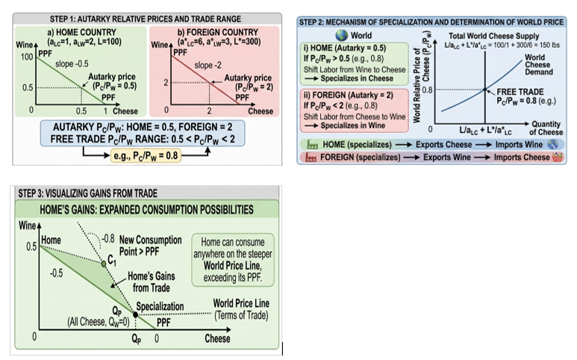
Figure 3. Ricardian Model: Free Trade Equilibrium, Specialization, and Gains from Trade.
Source: Created by the author
The second section illustrates the Mechanism of Specialization and the determination of the world price. It shows that once a world price (e.g., 0.8) is established between the two autarky prices, incentives change: Home finds it more profitable to produce only cheese, while Foreign finds it more efficient to produce only wine. This is represented by the "World Cheese Supply" curve, which shows the total global output when both countries shift their labor toward their respective comparative advantage goods, leading to Complete Specialization.
The third and fourth sections represent the most critical concept: the Gains from Trade. For the Home country, the diagram shows a "World Price Line" (or Terms of Trade line) that is steeper than its original PPF. This line originates from the specialization point QP​ (where Home produces only cheese) and extends outward, allowing Home to reach consumption point C1​. Because this point lies outside the green shaded area of the domestic PPF, it visually proves that trade allows Home to consume more of both goods than it ever could in isolation.
Similarly, the diagram for the Foreign country shows a mirrored gain. By specializing in wine and trading for cheese at the lower world price (0.8 instead of its domestic cost of 2), Foreign’s consumption possibilities also expand beyond its original frontier. The red shaded area represents the surplus of goods created by global efficiency. Together, these four panels demonstrate that trade is not a zero-sum game; rather, by rearranging labor toward more productive uses globally, the "economic pie" grows for everyone involved.
2.5 The Role of Wages and the Limits to Trade
Figure 4. The role of Wage and Limits of Trade

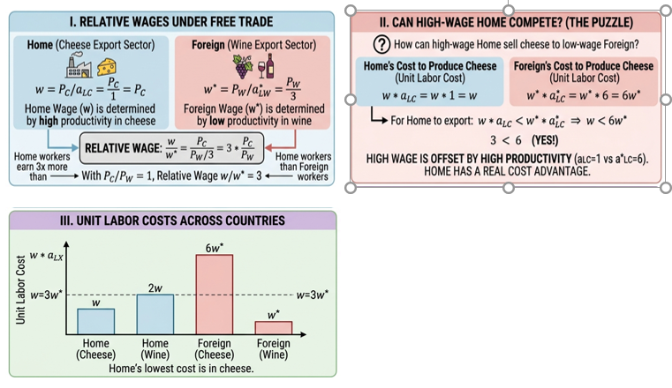
Source: Created by the author
Figure 4, provides a comprehensive visual breakdown of how relative wages are determined in a Ricardian model and how they interact with productivity to define the boundaries of international competitiveness. The diagram uses a multi-panel layout to move from theoretical wage derivation to practical cost comparison and finally to a graphical representation of trade limits, all based on a numerical example where the Home country is more productive overall but specializes in cheese.
The first panel, "I. Relative Wages Under Free Trade," establishes how domestic wages (w) are set once trade opens. In this model, wages are determined by productivity in the sector a country specializes in (its export sector). Because Home specializes in cheese, its wage is fixed by the price of cheese divided by the labor required (w=PC​/aLC​). Since aLC​=1(high productivity), Home’s wage is high. Conversely, Foreign specializes in wine, leading to a wage w∗=PW​/aLW∗​. As aLW∗​=3 (lower productivity), Foreign workers earn less. The crucial finding, highlighted in the central equation, is that the relative wage (w/w∗) is determined by the ratio of these productivities. In the example, with a world price of PC​/PW​=1, Home workers earn three times as much as Foreign workers (w/w∗=3).
The second panel, "II. Can High-Wage Home Compete?" directly addresses the central puzzle: how a high-wage country (Home) can sell to a low-wage country (Foreign). It proves that competitiveness depends not on raw wages, but on "Unit Labor Costs" the cost of labor needed to produce one unit of a good. For Home to export cheese, its unit labor cost (w⋅aLC​) must be lower than Foreign’s cost (w∗⋅aLC∗​). Even though Home’s wage (w) is three times higher than Foreign’s (w∗), Home’s productivity advantage is six times greater (aLC​=1 vs aLC∗​=6). The numerical check (3<6) confirms that Home has a real cost advantage. This panel demonstrates the vital economic principle that high productivity can easily offset high wages.
The panel, "III. Unit Labor Costs Across Countries" visualize these concepts and define where trade must stop. The bar chart in Panel III provides a snapshot comparison, illustrating that Home’s lowest unit cost is in cheese, confirming its specialization. Panel IV offers the definitive graphical synthesis. It plots relative wage on the vertical axis against the relative price on the horizontal axis. The blue "Free Trade Wage" line shows the sustainable range of wages. The shaded red area, "Home’s Cost Advantage Vanishes," defines the upper limit: if Home’s relative wage rises too high (beyond 6 in this example), its productivity advantage can no longer compensate for its labor costs, and trade would cease. This diagram effectively shows how productivity differences determine the sustainable boundaries of international wages.
2.6 Extensions and Limitations of the Ricardian Model
The Ricardian model has been extended in several important ways. The Dornbusch-Fischer-Samuelson (DFS) model expands the framework to a continuum of goods, ranking them by the ratio of unit labor requirements. A "cut" point determines the pattern of trade: goods with a low ratio (where Home's relative productivity is high) are produced in Home, while goods with a high ratio are produced in Foreign. Additionally, introducing non-traded goods such as services and housing helps explain why specialization is rarely complete in reality. Including transport costs further refines the model by creating a range of goods for which trade is not profitable, remaining non-traded.
Despite its insights, the Ricardian model has notable limitations. It assumes only one factor of production labor thereby ignoring capital, land, and other inputs, and it predicts that trade has no impact on domestic income distribution since all workers are identical and earn the same wage, a prediction contradicted by empirical evidence. The model also assumes constant returns to scale, ruling out economies of scale that are central to modern trade patterns, and relies on perfect competition, ignoring market power. Furthermore, it assumes labor is mobile within countries but does not explain how trade affects returns to different factors, and it treats technology differences as exogenous without explaining why they arise.
The biggest shortcoming is its prediction about income distribution. In reality, trade often creates winners and losers within a country. This leads us to a more sophisticated model that distinguishes between different factors of production: the Heckscher-Ohlin model.
3 The Heckscher-Ohlin (H-O) Model: A General Equilibrium Approach
3.1 From Labor Productivity to Factor Endowments: Motivation
The Heckscher-Ohlin model, developed by Eli Heckscher (1919) and Bertil Ohlin (1933), represents a significant advance over the Ricardian model. While Ricardo emphasized technology differences, the H-O model proposes that the fundamental cause of comparative advantage is differences in countries' factor endowments—their relative supplies of labor, capital, land, etc.
The Ricardian model simplifies production by assuming only one factor of production—labor—but most goods actually require a combination of inputs, including labor, capital, and land. The Heckscher-Ohlin (H-O) model addresses this by introducing the concept of factor intensity: goods differ in how intensively they use these factors. For instance, bicycles are labor-intensive, automobiles are capital-intensive, and wheat is land-intensive. Similarly, countries differ in their factor endowments: China is labor-abundant, the United States is capital-abundant, and Canada is land-abundant.
Building on these ideas, the Heckscher-Ohlin theorem states that a country will export goods that use its abundant factors intensively and import goods that use its scarce factors intensively. This shifts the explanation for trade patterns from technological differences (as in Ricardo) to differences in countries’ relative endowments of factors of production.

3.2 Core Assumptions of the 2x2x2 H-O Model
Figure 5. Core Assumption of the 2x2x2 H-O Model
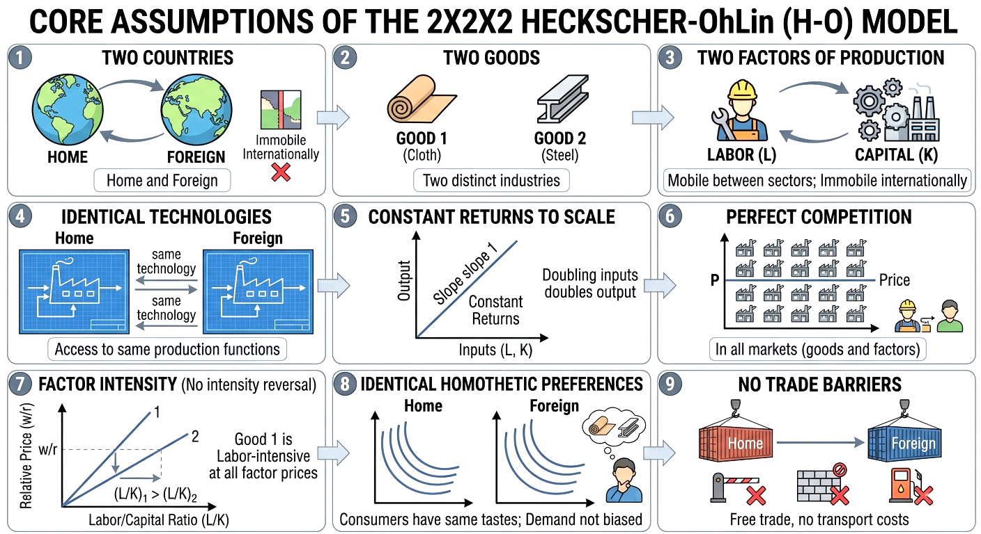
Source: Created by the author
This Figure 5, titled "Core Assumptions of the 2x2x2 Heckscher-Ohlin (H-O) Model," serves as a foundational checklist for understanding why countries trade based on resources rather than technology. It uses nine panels to isolate the specific variables that drive the model's conclusions.
The First Three Panels define the Dimensions of the Model. It establishes a "2x2x2" framework: two countries (Home and Foreign), two distinct goods (Cloth and Steel), and two factors of production (Labor and Capital). A key detail here is the "Factor Mobility" assumption: workers and machines can move freely between the cloth and steel factories within a country, but they cannot cross international borders. This ensures that trade in goods is the only way for countries to interact economically.
Panels 4 through 6 focus on the Production Environment. Unlike the Ricardian model, the H-O model assumes Identical Technologies, meaning both countries have the same "blueprints" for production. Any difference in efficiency must therefore come from the mix of resources used, not superior knowledge. This is paired with Constant Returns to Scale (doubling inputs doubles output) and Perfect Competition, ensuring that prices are driven by costs and that no single firm has market power to distort trade patterns.
The final three panels address Market Behavior and Constraints. Panel 7 illustrates Factor Intensity, showing that one good (Cloth) consistently requires more labor relative to capital than the other (Steel), regardless of the price of labor. Panel 8 assumes Identical Homothetic Preferences, which is a technical way of saying that people in both countries have the same tastes; this rules out "demand" as a reason for trade. Finally, Panel 9 assumes No Trade Barriers, creating a "frictionless" environment where goods move freely without the interference of tariffs or transport costs.
Taken together, the diagram illustrates that if technology, tastes, and competition are all identical, the only remaining reason for trade is the difference in Factor Endowments the fact that one country has more land, labor, or capital than the other. This isolation of variables allows the H-O model to prove that a country's natural resources are the ultimate architects of its international trade strategy.
3.3 Key Concepts: Factor Abundance and Factor Intensity
Factor abundance can be defined in two ways. The physical definition compares countries' relative endowments: a country is capital-abundant if its capital-to-labor ratio exceeds that of the other country. This is a relative concept—a country can be capital-abundant even if it has less total capital, as long as its ratio is higher. The price definition considers autarky factor prices: a country is capital-abundant if the rental rate of capital relative to the wage is lower than in the other country. Under identical technologies and tastes, this price definition aligns with the physical definition.
Factor intensity is also a relative concept. A good is capital-intensive compared to another if its capital-labor ratio is higher at any given factor price ratio. Conversely, a good is labor-intensive if its labor-capital ratio is higher than that of the other good. These definitions are always comparative a good is not inherently capital-intensive in isolation but only relative to another good.

Summary Table: Factor Abundance vs. Factor Intensity
Feature | Factor Abundance | Factor Intensity
Entity Described | The Country (Home vs. Foreign) | The Good (Cloth vs. Steel)
Physical Definition | The relative ratio of total endowments: K/L>K∗/L∗ | The relative ratio of inputs used: (K/L)_{Steel}​>(K/L)_{Cloth}​
Price Definition | The relative cost of factors in autarky: (r/w)<(r∗/w∗) | The relative share of total production costs attributed to a factor.
Nature of Concept | Relative: A country is abundant only in comparison to another country. | Relative: A good is intensive only in comparison to another good.
Key Question | Which resource does this nation have the most of? | Which resource does this product require the most of?
Role in H-O Theory | Determines the comparative advantage of the nation. | Determines which factor will see increased demandduring trade.
Example | Home has 100 machines and 50 workers (K/L=2); it is Capital-Abundant. | Steel requires 5 machines per worker; Cloth requires 1. Steel is Capital-Intensive.
Summarize, Factor abundance refers to what a country has—its relative supply of factors such as capital and labor. Factor intensity refers to what a country uses—the technology or production method that determines which factor is employed more heavily in producing a given good.
The Heckscher-Ohlin theorem simply links these two concepts: a country exports the good whose production intensity aligns with its most plentiful abundance. In other words, a capital-abundant country will export the capital-intensive good, and a labor-abundant country will export the labor-intensive good.
3.4 The Heckscher-Ohlin Theorem: The Basis for Trade
The Heckscher-Ohlin Theorem states:
A country will export the good that uses its abundant factor intensively, and import the good that uses its scarce factor intensively.
Derivation of the Theorem:
- Autarky Prices: Because countries have different factor endowments, their autarky relative prices will differ.
  - The capital-abundant country will have a lower autarky relative price of the capital-intensive good. Why? Because capital is relatively cheap in that country, making the production of the capital-intensive good relatively cheaper.
  - Conversely, the labor-abundant country will have a lower autarky relative price of the labor-intensive good.
- Comparative Advantage: The difference in autarky prices creates comparative advantage. The capital-abundant country has a comparative advantage in the capital-intensive good. The labor-abundant country has a comparative advantage in the labor-intensive good.
- Trade: When trade opens, countries will export the good in which they have a comparative advantage.
Example:
- Home: Capital-abundant.
- Foreign: Labor-abundant.
- Good 1: Cloth (labor-intensive).
- Good 2: Steel (capital-intensive).
According to the H-O theorem:
- Home (capital-abundant) will export Steel (capital-intensive).
- Foreign (labor-abundant) will export Cloth (labor-intensive).
This contrasts with the Ricardian model, where technology differences determine trade patterns. In the H-O model, with identical technologies, the pattern is determined by endowments.
3.5 The Factor Price Equalization (FPE) Theorem
The Factor Price Equalization (FPE) Theorem is a powerful and controversial implication of the H-O model. It was proven by Paul Samuelson (1948, 1949). It states:
Under the assumptions of the H-O model, free trade will equalize the prices of factors of production (e.g., the wage rate for labor and the rental rate for capital) across countries, even if factors are not mobile internationally.
Intuition:
Trade in goods acts as a substitute for factor mobility. When Home exports capital-intensive goods and imports labor-intensive goods, it is, in effect, exporting its capital services (embodied in goods) and importing labor services.
This process reduces the relative demand for the abundant factor at home and increases the relative demand for the scarce factor. The opposite happens in the foreign country. The price of factors (wages and rental rates) will converge until they are equalized.
Key Conditions for FPE:
- Both countries produce both goods after trade (i.e., incomplete specialization).
- Technologies are identical.
- Factor intensity reversal does not occur.
- Free trade in goods, no transport costs.
- Perfect competition.
Implications:
- FPE suggests that trade can lead to international wage equality. This is a strong prediction that is not observed in the real world (wages for similar labor differ vastly across countries). The failure of FPE in reality is due to violations of its assumptions, such as technology differences, trade barriers, and factor intensity reversals.
- However, the weaker version—that trade tends to narrow international factor price differences—is generally supported.
3.6 The Stolper-Samuelson Theorem: Income Distribution Effects
Perhaps the most important political economy implication of the H-O model is the Stolper-Samuelson Theorem (1941). It directly addresses the winners and losers from trade within a country.
An increase in the relative price of a good will increase the real return to the factor used intensively in its production, and decrease the real return to the other factor.
Intuition:
Consider the capital-abundant Home country that opens to trade. The relative price of steel (capital-intensive good) rises, while the relative price of cloth (labor-intensive good) falls.
- For the abundant factor (Capital): The increase in the demand for steel increases the demand for capital. Capital owners see their real income rise. They are winners.
- For the scarce factor (Labor): The decline in the relative price of cloth (or its absolute decline due to import competition) reduces the demand for labor. Workers see their real income fall. They are losers.
Conversely, in the labor-abundant Foreign country:
- The price of cloth (labor-intensive good) rises.
- Labor (the abundant factor) gains.
- Capital (the scarce factor) loses.
Magnification Effect:
A corollary of the theorem is that the change in factor prices is magnified relative to the change in the good price. If the relative price of steel rises by 10%, the rental rate on capital may rise by more than 10%, while the wage may fall by more than 10% (in real terms).
Implications:
This theorem is crucial because it shows that trade creates conflict of interest within a country. It is not true that "a rising tide lifts all boats." While the country as a whole gains from trade (Hicks-Kaldor compensation principle), there are clear distributional consequences. This explains why some groups lobby for free trade while others lobby for protection. The Stolper-Samuelson theorem forms the basis for understanding political economy debates on trade policy.
3.7 The Rybczynski Theorem: Growth and Output Mix
The Rybczynski Theorem (1955) explores how changes in factor endowments affect production. It is a key result for understanding how economic growth (an increase in a country's factor supply) impacts its industrial structure and trade patterns.
At constant relative goods prices, an increase in the endowment of a factor will increase the output of the good that uses that factor intensively, and decrease the output of the other good.
Intuition:
Imagine Home (capital-abundant) experiences an increase in its capital stock (e.g., through investment). If the prices of steel and cloth remain constant (as they would be fixed by world prices in a small open economy), how does the economy adjust?
- The increased capital makes the economy more suited to produce the capital-intensive good (steel).
- To produce more steel, resources must be drawn from the cloth sector.
- However, releasing labor from the cloth sector is straightforward, but releasing capital is not. Because cloth is labor-intensive, the cloth sector uses relatively little capital per worker. To free up enough labor for the expanding steel sector, the cloth sector must contract significantly. This contraction releases a disproportionate amount of capital relative to labor, which is exactly what the expanding steel sector needs.
- The net effect is that the output of the capital-intensive good (steel) rises by more than the increase in capital, and the output of the labor-intensive good (cloth) falls.
Application to Growth and Trade:
- Immiserizing Growth: This theorem suggests that if a country's growth is biased towards its export sector, it could lead to a deterioration of its terms of trade (if it is a large country) and potentially make it worse off.
- Dutch Disease: A discovery of a new resource (e.g., natural gas) increases the endowment of a factor used intensively in that sector, leading to a contraction in other tradable sectors (e.g., manufacturing).
- Trade Pattern Dynamics: As a country's factor endowments change over time (e.g., through capital accumulation or population growth), its comparative advantage will shift according to the Rybczynski effect.

Figure 10. The Rybczynski Theory: Growth of Labour

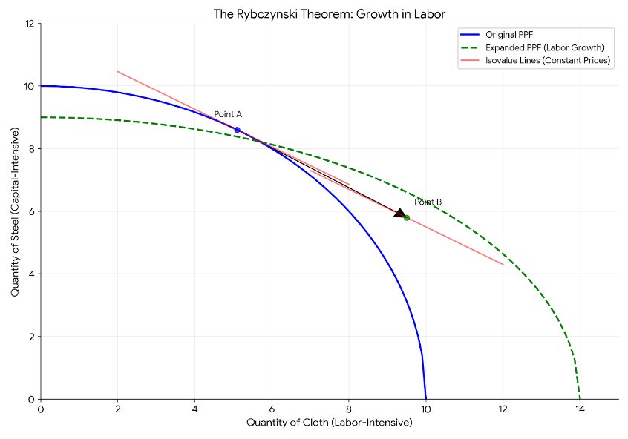
Source: Created by the author

4. A Unified Diagrammatic Analysis of the H-O Model
We now integrate the four core theorems (H-O, FPE, S-S, Rybczynski) using a unified set of diagrams. This helps to visualize the general equilibrium nature of the model.
Figure 11. Production Possibility Frontier with Isovalue Lines
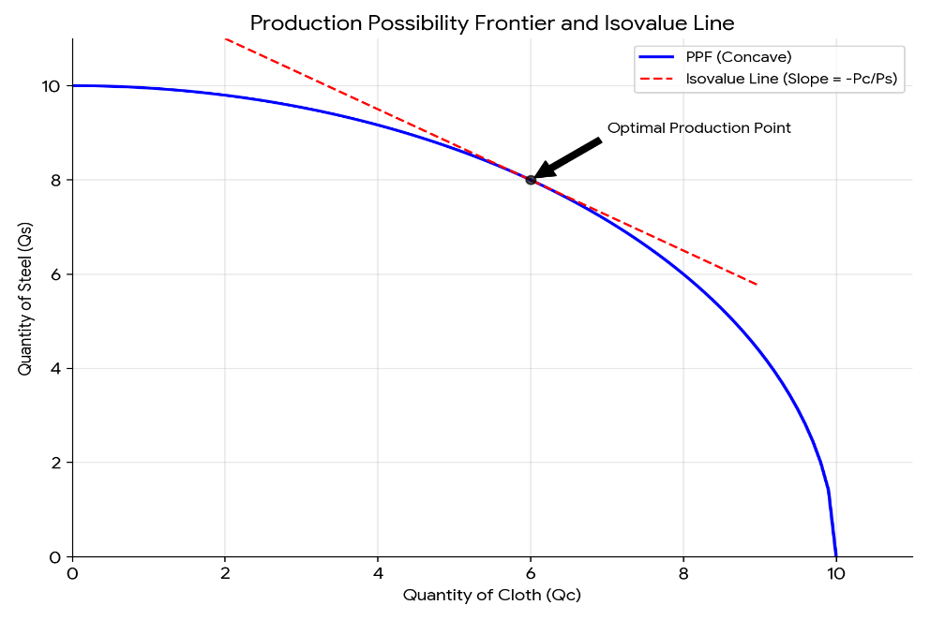
Source: Created by the author

The Figure 11 illustrates a production possibility frontier (PPF) that is concave to the origin, reflecting increasing opportunity costs in producing two goods likely cloth (Qc) and some other good (implied to be silks, Qs). The straight line represents an isovalue line, whose slope equals the negative price ratio (-Pc/Ps), indicating the market value of output combinations. The tangency point between the PPF and the isovalue line shows the optimal production point where the economy maximizes its output value given its resources and technology, balancing the marginal rate of transformation with the relative prices.

4.1 Autarky Equilibrium in H-O Model
Assumptions for the diagram:
- Home: Capital-abundant.
- Foreign: Labor-abundant.
- Good S: Steel (capital-intensive).
- Good C: Cloth (labor-intensive).
In autarky, Home produces and consumes the same bundle of goods with no international trade. Its production possibility frontier is curved and tilted toward steel, the capital-intensive good, reflecting Home’s abundance of capital. The economy reaches equilibrium where this frontier touches the highest possible community indifference curve, representing society’s preferences. At this point, the relative price of steel is low because Home’s abundant capital makes steel cheaper to produce. This low autarky price signals Home’s comparative advantage in steel, setting the stage for it to export steel once trade opens.
Figure 12: Autarky Equilibrium in Home (Capital-Abundant)
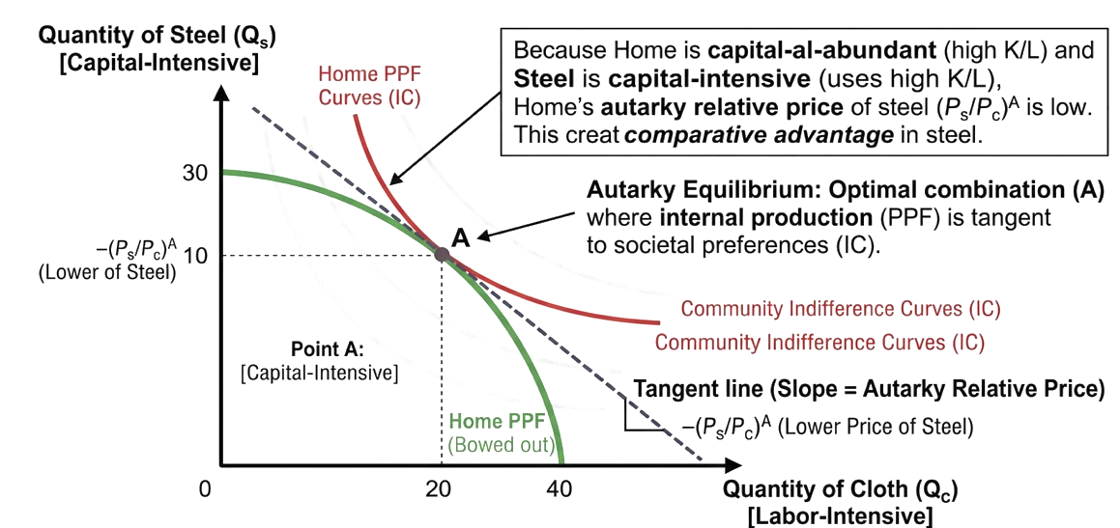
Source: Created by the author

Figure 12 illustrates the state of autarky a country operating without international trade using the Heckscher-Ohlin framework. The green curved Production Possibility Frontier (PPF) is concave rather than linear, reflecting diminishing returns as resources are reallocated between sectors. Because Home is capital-abundant, its PPF is biased toward the vertical axis, indicating a greater natural capacity to produce steel, the capital-intensive good. The red community indifference curves represent societal preferences, and the economy aims to reach the highest possible curve. Autarky equilibrium occurs at Point A, where the PPF is tangent to the highest attainable indifference curve. At this point, Home produces and consumes 30 units of steel and 20 units of cloth. The dashed price line tangent at A has a relatively flat slope, meaning the relative price of steel (PS/PC)A(PS​/PC​)A is low. This low price reflects Home's capital abundance: because steel is capital-intensive, abundant capital makes steel cheaper to produce domestically.
This diagram demonstrates the source of comparative advantage in the H-O model. Home's factor abundance its ample supply of capital directly lowers the autarky price of the capital-intensive good (steel). This low autarky price gives Home a natural price advantage in steel relative to countries that are less capital-abundant. Thus, comparative advantage is mathematically derived from the interaction of factor abundance and factor intensity. When trade opens, Home will export steel and import cloth, confirming the Heckscher-Ohlin theorem. The diagram effectively shows that comparative advantage is not random but emerges logically from the country's underlying factor endowments
4.1 Free Trade Equilibrium and the Pattern of Trade
When trade opens, the world relative price settles between the two countries’ autarky prices. In the capital-abundant Home country, the relative price of steel rises to match the world price, shifting production from the autarky equilibrium toward more steel and less cloth as resources reallocate to the capital-intensive sector. Consumption moves to a higher indifference curve along the new isovalue line, with Home exporting steel and importing cloth. The opposite occurs in the labor-abundant Foreign country, where the relative price of steel falls, prompting specialization in cloth and exports of the labor-intensive good. This confirms the Heckscher-Ohlin theorem: each country exports the good that uses its abundant factor intensively.
Figure 13 illustrate the transition from a closed economy (Autarky) to a globalized one within the Heckscher-Ohlin framework. In Figure a, the capital-abundant Home country faces a world price for steel (PS​/PC​)W that is higher than its domestic price. This price signal incentivizes a production shift from point A to point B, where Home produces more steel and less cloth. By exporting the surplus steel and importing cloth, Home reaches consumption point C on a higher indifference curve (IC2​), visually proving that trade allows the nation to consume beyond its domestic production capabilities.

Figure 13. From Autarky to Free Trade: Global Equilibrium

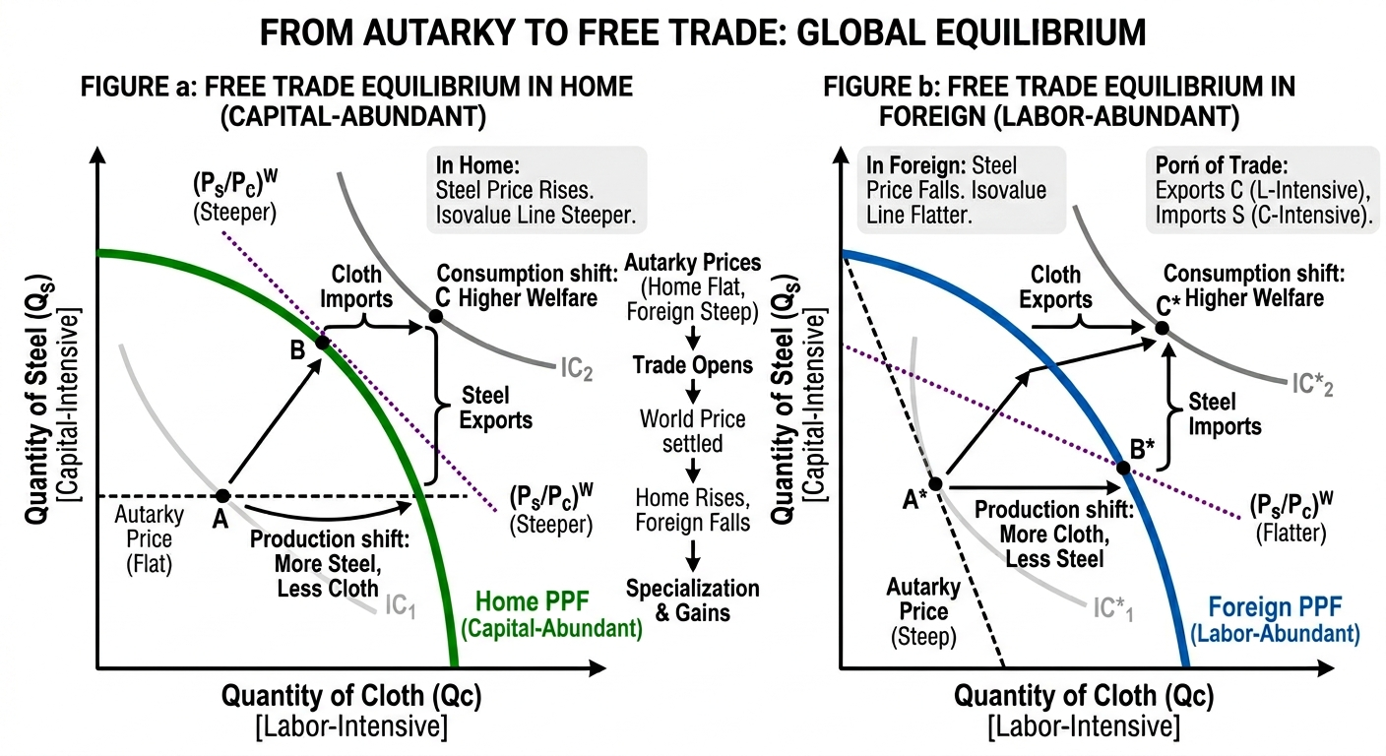
Source: Created by the author

Conversely, Figure b depicts the labor-abundant Foreign country, where the world price of steel is lower than its internal autarky price. Consequently, Foreign shifts its production from A* to B*, specializing in labor-intensive cloth. By exporting cloth and importing cheaper steel, Foreign similarly reaches a higher consumption point C*. Together, these figures demonstrate the Heckscher-Ohlin Theorem: countries specialize in and export goods that use their abundant factors intensively, resulting in a "win-win" scenario where both nations achieve a higher level of societal welfare than possible in isolation.
5. Comparing the Two Paradigms and Empirical Evidence
Summary of the Two Models
Feature | Ricardian Model | Heckscher-Ohlin Model
Basis of Trade | Differences in technology (labor productivity) | Differences in factor endowments
Number of Factors | One (labor) | Two or more (e.g., capital, labor, land)
Production Technology | Constant returns, linear PPF | Constant returns, concave PPF (diminishing returns)
Pattern of Trade | Based on comparative advantage in labor productivity | Based on comparative advantage in factor intensity
Gains from Trade | Yes, for both countries (overall) | Yes, for both countries (overall)
Income Distribution | No effect (all workers identical) | Stolper-Samuelson: Winners and losers within a country
Factor Prices | No prediction on international equality | Factor Price Equalization: Tendency towards equality
Empirical Evidence: The Leontief Paradox
The H-O model was the dominant paradigm in international economics for decades. In 1953, Wassily Leontief, a Nobel laureate, conducted a famous test of the H-O theorem using US data.
- Prediction: The US was widely believed to be the most capital-abundant country in the world. Therefore, the H-O model predicted the US would export capital-intensive goods and import labor-intensive goods.
- Finding (Leontief Paradox): Leontief found that US exports were less capital-intensive than US imports. In other words, the US was exporting labor-intensive goods and importing capital-intensive goods—the opposite of the H-O prediction.
Explanations for the Paradox:
- Human Capital: Leontief treated all labor as homogeneous. When labor is adjusted for skill and education (human capital), the US is actually abundant in human capital, a form of capital. The paradox largely disappears.
- Natural Resources: The US was a major importer of natural resources (e.g., oil, minerals). These are capital-intensive to extract. The H-O model, when extended to include land/natural resources, can resolve the paradox.
- Technology Differences: The Ricardian insight that technology matters remains relevant. The US may have a comparative advantage in high-tech, skill-intensive goods due to technological leadership, not just factor abundance.
- Trade Barriers and Non-Traded Goods: The assumptions of the basic H-O model are often violated in reality.
Modern Synthesis
Today, economists recognize that both technology differences (Ricardo) and factor endowment differences (H-O) matter. The dominant modern framework, the Ricardian-Heckscher-Ohlinsynthesis, incorporates:
- Comparative advantage driven by productivity differences (Ricardo).
- Factor proportions driving comparative advantage for goods with similar productivity levels (H-O).
- Imperfect competition and economies of scale (New Trade Theory) to explain trade between similar countries.
Conclusion
The Ricardian and Heckscher-Ohlin models are foundational. The Ricardian model teaches us that productivity and opportunity cost are the fundamental drivers of gains from trade. The Heckscher-Ohlin model deepens our understanding by showing how factor endowments determine the pattern of trade and, crucially, how trade creates distributional conflict within nations. Together, they provide the essential toolkit for understanding the complexities of international economic integration.

