Lecture Notes: Trade Theory II – Beyond Comparative Advantage
Table of Contents
- Introduction: The Limits of Comparative Advantage
- Module 1: The Specific-Factors Model (Short-Run Trade Effects)
- Module 2: Increasing Returns to Scale (IRS) and Trade
- Module 3: Monopolistic Competition and Intra-Industry Trade
- Module 4: The Gravity Model of Trade
- Synthesis: Putting It All Together
- Key Terms and Review Questions
- References

Section 1: Introduction – The Limits of Comparative Advantage
1.1 The Standard Model’s Successes and Failures
The standard theory of comparative advantage a cornerstone of international trade economics successfully explains many aggregate patterns of global commerce. For instance, it clarifies why labour-abundant countries tend to export labor-intensive goods, and it has guided trade policy for decades. However, the model systematically fails to account for several critical real-world phenomena: persistent wage disparities between nations, the role of increasing returns to scale, the dominance of intra-industry trade among similar economies, and the uneven distribution of gains that often leaves certain workers or regions worse off. These empirical shortcomings reveal that while comparative advantage illuminates why trade can be mutually beneficial in principle, it offers an incomplete picture of how trade actually functions. Hence, we need the extensions and critiques developed in subsequent sections.
The Ricardian (technology differences) and Heckscher-Ohlin (factor endowment) models form the bedrock of trade theory. They successfully explain inter-industry trade – the exchange of agricultural goods for manufactured goods (e.g., France trading wine for German machinery). However, by the mid-20th century, economists noticed three critical puzzles that comparative advantage could not solve:
- The Factor Price Equalization Puzzle: The Heckscher-Ohlin model predicts that wages and returns to capital should converge across trading countries. Reality? Persistent wage gaps between North and South.
- The Leontief Paradox (1953): Leontief found that US exports were less capital-intensive than US imports – the opposite of what Heckscher-Ohlin predicted for a capital-abundant country.
- The Rise of Intra-Industry Trade: Most trade today (over 60% in OECD countries) is between similar countries (e.g., Germany and France) in similar products (cars for cars). Comparative advantage predicts trade between dissimilar countries.
Thus, we need “Beyond Comparative Advantage” models.

Section 2: The Specific-Factors Model

2.1 Assumptions and Motivation
The specific-factors model (also known as the Ricardo-Viner model) relaxes the Heckscher-Ohlin assumption that factors are perfectly mobile between sectors. In the short run, some factors are specific to an industry.
2.2 The Structure: Specific vs. Mobile Factors
We assume the economy produces two goods: Manufacturing (M) and Agriculture (A). The factors of production are categorized by their ability to move:
- Mobile Factor (Labor, L): Labor is the “fluid” part of the economy. Workers can freely move from a farm to a factory or vice versa based on who pays a higher wage. Because of this mobility, a single equilibrium wage (*w*∗) eventually prevails across the entire economy.
- Specific Factors: These are “trapped” resources with no use in the other sector:
  - Capital (K): Specialized machinery used only in Manufacturing.
  - Land (T): Arable land used only for Agriculture.
2.3 The Production Function and Diminishing Returns
Since K and T are fixed in the short run, each sector’s output depends entirely on how much labor is hired. However, they follow the law of diminishing marginal returns: as more workers are added to a fixed amount of land or machinery, each additional worker adds less to total output than the previous one. Mathematically, the marginal product of labor (MPL) is downward-sloping.
Figure 1 – The Production Function and Diminishing Returns
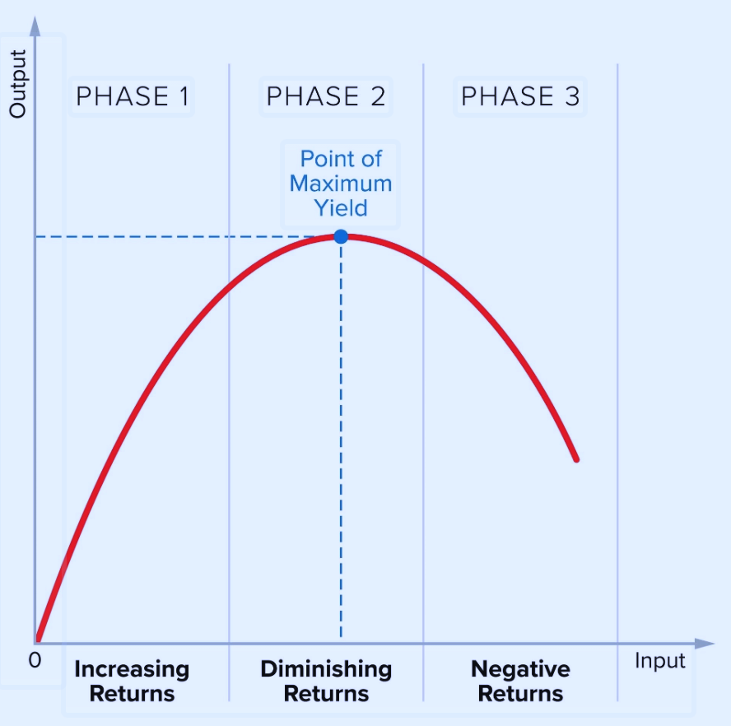
Source: Created by the author.
2.4 The Concave PPF
The combination of specific factors and diminishing returns creates a concave (bowed-out) PPF. If you want to produce more Manufacturing, you must take labor away from Agriculture. Because of diminishing returns, the labor taken from Agriculture was very productive there (fewer workers left), while labor added to Manufacturing becomes less productive (factories get crowded). This results in increasing opportunity cost: each additional car costs more and more “lost grain” to produce.
Figure 2 – The Concave PPF
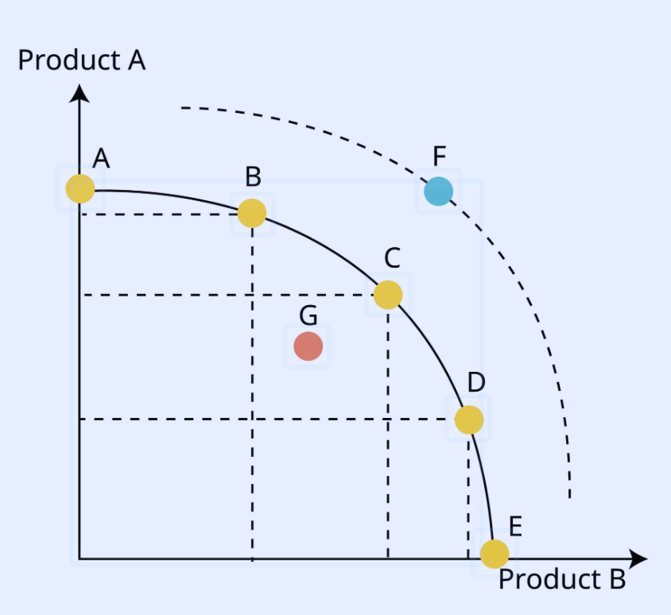
Source: Created by the author.

A graph with Product A (e.g., Agriculture) on the vertical axis and Product B (Manufacturing) on the horizontal axis. The PPF is bowed outward from the origin, indicating increasing opportunity cost. Points inside the curve are inefficient, points outside unattainable.
2.5 Why This Matters for Trade
The specific-factors model is a “short-run” model. It explains why trade creates winners and losers within a country:
- The export sector: If the price of Manufacturing rises (due to exports), the specific factor in that sector (capital owners) gains significantly.
- The import sector: The specific factor in the competing sector (land owners) loses significantly because their resource is stuck in a shrinking industry.
- Labor: The effect on workers is ambiguous, depending on whether they spend more of their income on the good that became cheaper or the one that became more expensive.

2.6 Labor Allocation and Wages
Figure 3 – Labor Allocation and Wage Determination in Equilibrium
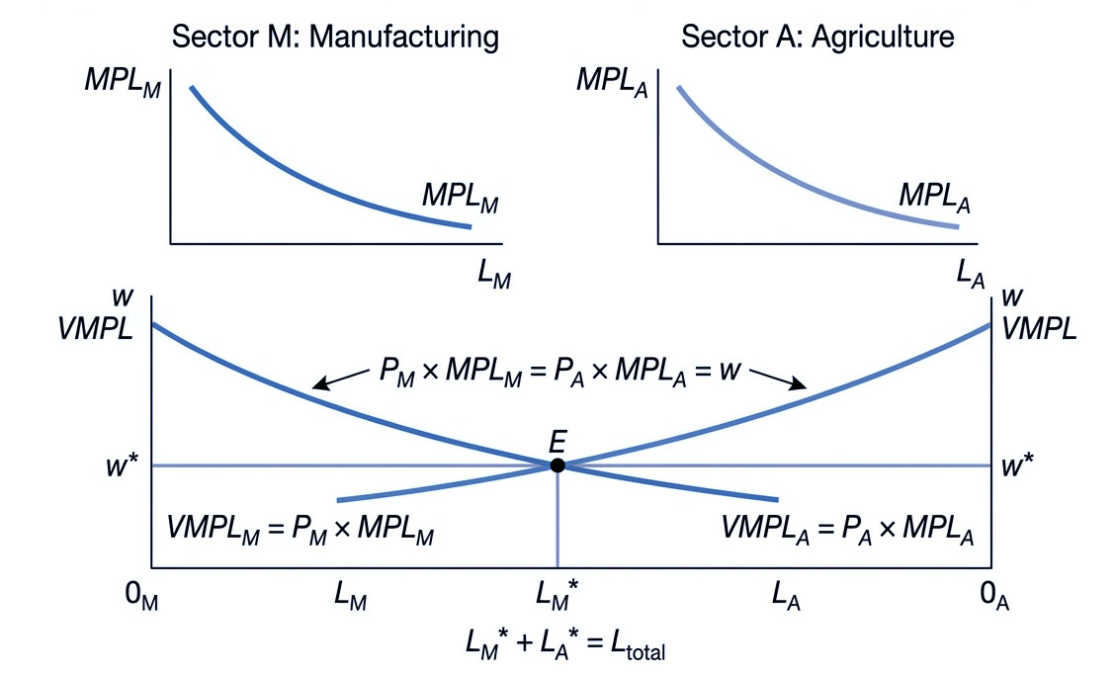
Source: Created by the author.
Figure 3 illustrates the labor allocation and wage determination between the manufacturing and agricultural sectors in equilibrium.
The top two panels display the downward-sloping marginal product of labor (MPL) for each sector, showing that additional workers yield diminishing returns.
The central diagram shows how equilibrium is reached. It combines the values of the marginal products (VMPL), where VMPL=P×MPL. The intersection point (E) determines the single economy-wide equilibrium nominal wage (w∗) and the specific allocation of labor (LM∗​ and LA∗​). At this point, the value of the last worker is equal in both sectors, satisfying the condition PM​×MPLM​=PA​×MPLA​=w∗.Where ww is the nominal wage.

2.7 Effects of Trade (Price Change)
Figure 4 – Effect of Trade (Price Change): Labor Relocation and Wage Determination
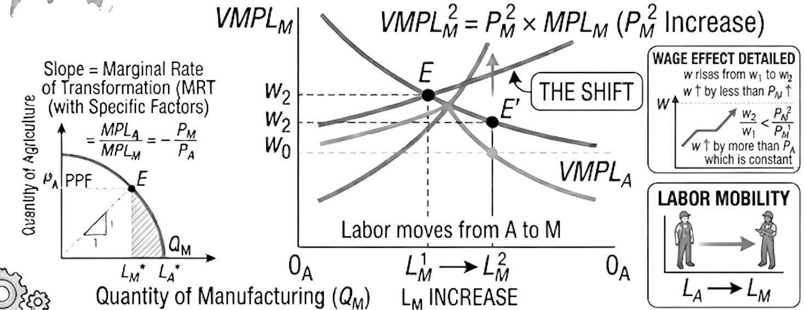
Source: Created by the author.

Figure describe that the passage describes the short-run economic effects of a country opening to international trade, specifically focusing on a situation where the global market price of manufactured goods (M) rises relative to the price of agricultural goods (A). This price change acts as a signal to domestic producers. In the short run, resources are not perfectly mobile between sectors, setting the stage for specific winners and losers. The analysis uses a specific-factors model, where labor can move between industries, but capital is only usable in manufacturing and land only in agriculture.
When the price of manufactured goods (P_M) rises (e.g., due to opening to trade), the value of the marginal product of labor in manufacturing (VMPL_M = P_M × MPL_M) shifts upward. Manufacturing firms hire more workers; labor migrates from agriculture to manufacturing. The new equilibrium nominal wage (*w*) is higher than before trade. Crucially, the wage increase is less than the increase in P_M but greater than the increase in P_A (which may not have risen).
Income Distribution: Winners and Losers
The passage identifies clear winners and losers based on which factor of production is specific to the booming sector.
1. Owners of capital (specific to manufacturing): They are clear gainers. Capital is stuck in the manufacturing sector, which now faces a higher price for its output. While wages have risen, they have risen by less, meaning the real return on capital (profits) unambiguously increases. These owners can buy more of both goods than before.
2. Owners of land (specific to agriculture): They are clear losers. Land is stuck in agriculture, where the relative price has not risen (or has fallen compared to manufacturing). Workers have left agriculture, but the remaining workers earn a higher wage, which eats into the rents earned by landowners. Additionally, the output price for agriculture hasn't increased enough (or at all) to compensate. Therefore, the real return on land falls.
3. Workers (mobile between sectors): Their fate is ambiguous. While the nominal wage ($w$) has risen, the real wage depends on what workers consume. If workers spend most of their income on agricultural goods (whose price has risen relatively little), their purchasing power may have increased. However, if their consumption basket is heavily weighted toward manufactured goods (whose price has risen significantly), the increase in the nominal wage may not be enough to cover the higher cost of manufactured goods, leaving them worse off in real terms. Thus, workers can either gain or lose depending on their spending habits.
2.8 Comparison with Heckscher-Ohlin
Table 1 – Comparison of Heckscher-Ohlin and Specific-Factors Models
Feature | H-O Model | Specific-Factors Model
Time horizon | Long run (full adjustment) | Short/medium run (partial adjustment)
Factor mobility | Perfect across sectors | Some factors immobile (specific), others mobile
Trade effects on factor prices | Factor prices equalize across countries | Factor prices diverge across countries
Winners/losers | By factor ownership (abundant vs. scarce) | By industry affiliation (export vs. import-competing)

Section 3: Increasing Returns to Scale (IRS) and Trade
3.1 Why IRS Matters for Trade
Increasing Returns to Scale (IRS) explain why countries trade even when they have similar resources or technology. By concentrating on a few products for the global market rather than many for a small local one, a nation can slide down the average cost curve, making its goods significantly cheaper. This leads to intra-industry trade, where countries swap similar goods, allowing each to maintain high-efficiency production levels.
For the global economy, IRS transforms the market from perfect competition into monopolistic competition. This provides a “double win” for consumers: prices drop, and product variety increases. It also highlights “first-mover” advantages.
Figure 5 – Economies of Scale and Average Cost (AC)
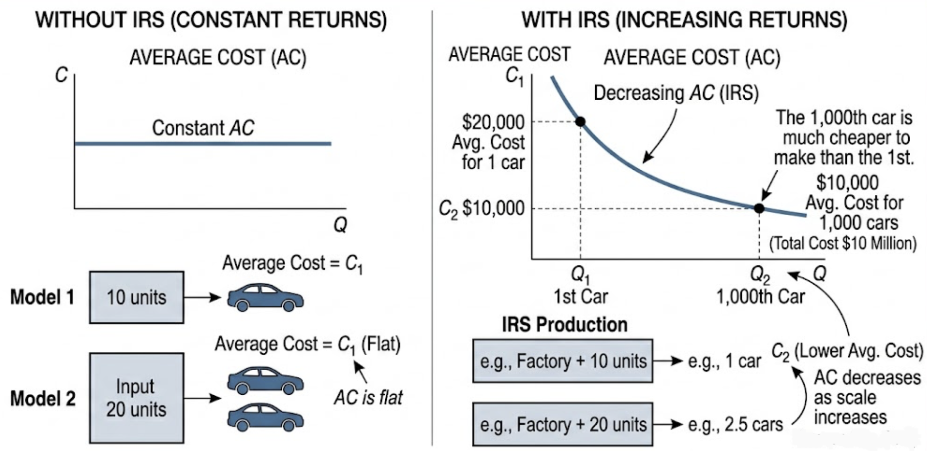
Source: Created by the author.
Figure indicate that the concept of Economies of Scale, or Increasing Returns to Scale (IRS), describes a situation where a company becomes more efficient as it grows. In a standard production model without these efficiencies, costs are "linear." If you want to double your output of cars, you double your inputs twice the steel, twice the labor, and twice the factory space. In this scenario, the Average Cost (AC) remains perfectly flat because the cost of every single car produced is identical, whether it is the 1st or the 1,000th.
When a firm experiences Increasing Returns to Scale, the relationship between input and output changes. As production scales up, output grows faster than inputs. For example, doubling your budget for materials and labor might actually result in 2.5 times as many cars. This happens because certain "fixed costs" such as the initial construction of a massive automated assembly line or the research and development of the car's engine stay the same regardless of how many cars are made. When you produce only one car, that single unit must "carry" the entire cost of the factory, making it incredibly expensive ($20,000 in our example).
3.2 Types of Economies of Scale
a. Internal Economies of Scale
Internal economies occur when a single firm’s own increase in output leads to a decrease in its average cost. This cost advantage is firm-specific.
How it works: AC = TC / Q. As Q increases, fixed costs are spread over more units.
Sources within a firm: Technical economies (efficient machinery), managerial economies (specialized experts), financial economies (lower interest rates), marketing economies (spreading ad costs), R&D economies (spreading development costs).
Market structure consequences: Internal economies lead to imperfect competition (monopoly or oligopoly) because new small firms cannot match low average costs.
Internal economies of scale refer to cost advantages that a single firm achieves as it expands its output. Technical economies arise from using more efficient machinery and specialized assembly lines, allowing high fixed costs (like a steel furnace) to be spread over millions of units. Managerial economies come from hiring specialized experts whose high salaries are offset by large-scale production, while their expertise boosts efficiency. Financial economies mean larger firms are viewed as less risky, securing lower interest rates and easier access to capital markets. Marketing economies occur when the fixed cost of a national ad campaign is spread over many units, lowering per-unit marketing costs. Finally, R&D economies involve massive upfront research costs (e.g., for a new drug) that, once incurred, result in very low marginal costs for each additional unit produced.
Figure 6 – Internal Economies of Scale
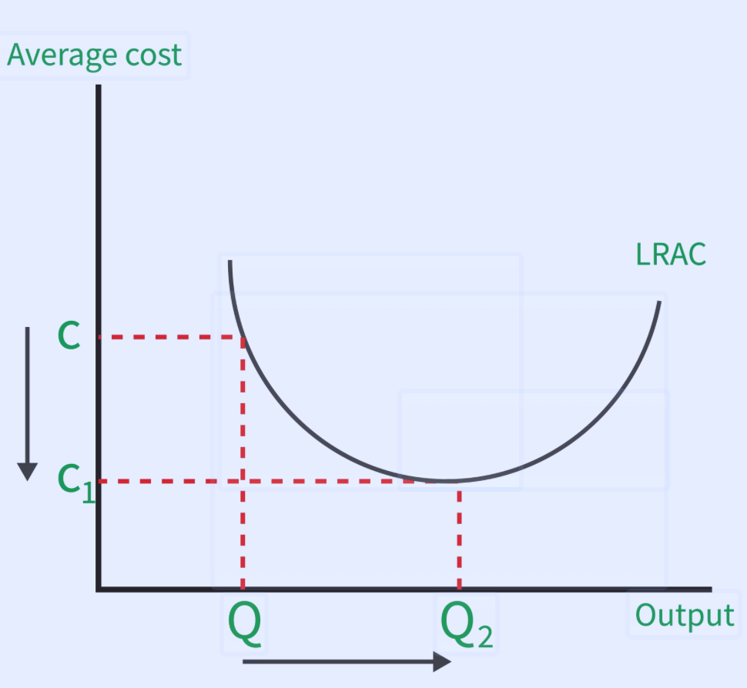
Source: Created by the author.
Market Structure Consequences
Internal economies of scale naturally lead to imperfect competition because they create significant barriers to entry. A new, small firm cannot compete on price because it lacks the volume to achieve the same low average costs as the incumbent.
Table 2. Market Structure
Market Type | Condition | Examples
Monopoly | Scale economies are so vast that one firm can serve the entire market more efficiently than two or more. | Water utilities, electricity grids.
Oligopoly | A few large firms achieve scale and dominate the industry. | Aircraft (Boeing vs. Airbus), CPUs (Intel vs. AMD).

Figure 8 – External Economies of Scale and Trade Path Dependence
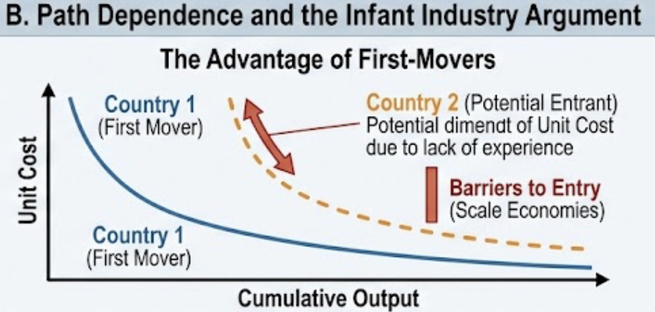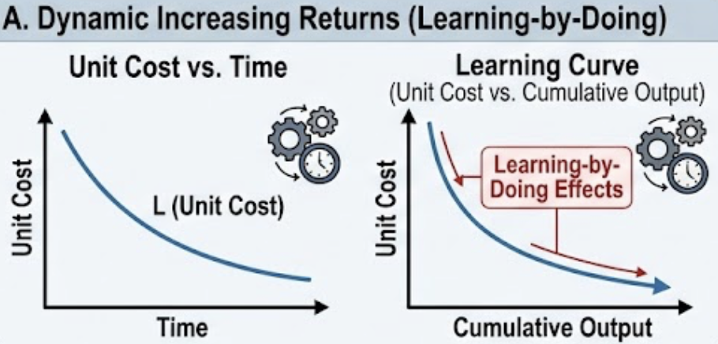
Source: Created by the author.

In this model, moving from autarky to international trade benefits both producers and consumers; a larger global market allows firms to increase output (Q), which directly reduces their average costs (AC) and enables them to lower prices. This framework is essential for understanding how trade leads to increased efficiency and a wider variety of goods even in industries where perfect competition might not exist.
External economies of scale, however, depend on the size and cumulative experience of the entire industry rather than an individual firm. This is often driven by "learning-by-doing," where unit costs fall as cumulative industry output grows over time, and by geographic clustering that provides access to specialized suppliers and knowledge spillovers. Because established industries in one country benefit from these deep-rooted network effects, they often create "path dependence," making it difficult for new entrants in other countries to compete without temporary support, a concept known as the infant industry argument.

Table 3. Comparison table: Internal vs. External Economies
Feature | Internal | External
Source of cost reduction | Firm’s own output level | Industry’s total output
Control | Within firm | Outside firm (cluster effect)
Barriers to entry | High | Low
Typical market structure | Imperfect competition | Perfect competition (many small firms)
Examples | Auto plant, aircraft manufacturer | Silicon Valley, Hollywood

3.3 Limitations of External Economies
- Congestion diseconomies: As a cluster grows too large, land prices, traffic, and pollution rise, eroding cost advantages. Example: San Francisco Bay Area’s high housing costs.
- Hard to appropriate knowledge spillovers: R&D investors cannot capture full returns, leading to underinvestment in innovation. Example: semiconductor industry free-rider problem.
- Not all industries benefit: External economies matter mainly for knowledge-intensive or complex-input industries.

Section 4: Monopolistic Competition and Intra-Industry Trade
4.1 The Puzzle of Intra-Industry Trade
Intra-industry trade (IIT) = simultaneous export and import of goods from the same industry (e.g., US exports Fords to Germany and imports BMWs). Traditional models cannot explain this easily.
Measurement: The Grubel-Lloyd Index
GL = 1 – ( |X – M| / (X + M) )
- GL = 1 → perfect IIT (exports = imports)
- GL = 0 → pure inter-industry trade (only exports or only imports)
For OECD countries, GL for manufactured goods is often > 0.6.

4.2 The Dixit-Stiglitz-Krugman Model (1977, 1979)
This model explains why similar countries trade: variety and efficiency are the drivers.
- Consumers love variety.
- Firms have economies of scale.
When countries trade: each country specializes in fewer varieties, produces at larger scale (lower average cost), and consumers gain access to more varieties.
Figure 7 – Krugman Trade Model
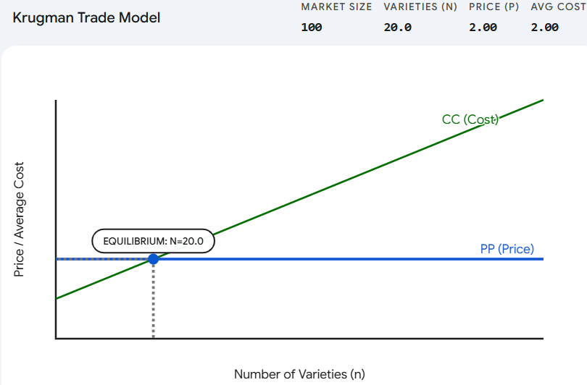
Source: Created by the author.
Figure 7 illustrate that The Dixit-Stiglitz-Krugman model explains intra-industry trade by combining monopolistic competition with economies of scale. It assumes that consumers have a "love of variety" and that firms face increasing returns to scale, meaning they become more efficient as they produce more. When countries trade, the effective market size increases, allowing firms to expand production and lower average costs (the scale effect) while simultaneously offering consumers a wider array of unique product varieties (the variety effect). Ultimately, the model proves that even identical countries will trade similar but differentiated goods to maximize efficiency and consumer choice, a concept that earned Paul Krugman the Nobel Prize. At this point, Price = Average Cost, meaning firms are making "zero economic profit." If n were lower (to the left), firms would be making a profit, attracting new competitors. If n were higher (to the right), firms would be losing money, causing some to go out of business

4.3 Helpman-Krugman Extensions
With differences in factor endowments, both inter- and intra-industry trade coexist:
- Inter-industry trade: capital-abundant country exports capital-intensive goods.
- Intra-industry trade: within each sector, countries exchange differentiated varieties.
Figure 8 – Trade Decomposition (Matrix)
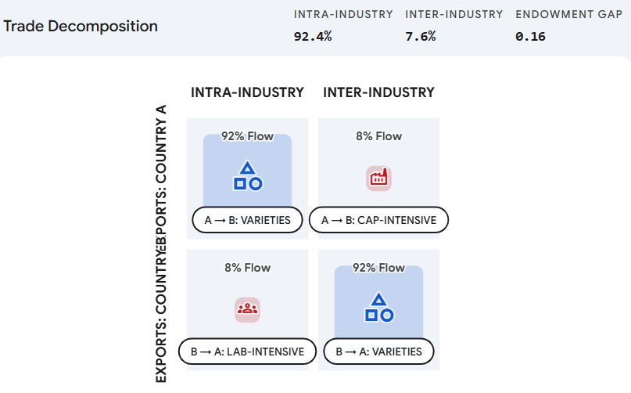
Source: Created by the author.
The matrix shown in Figure 8 serves as a bilateral trade decomposition tool, visually categorising global trade flows into two distinct layers. The diagonal cells represent intra-industry trade (IIT), where similar countries exchange differentiated varieties of the same types of goods such as two wealthy nations swapping different brands of automobiles driven by economies of scale and consumer demand for variety. Conversely, the off-diagonal cells represent inter-industry trade, which follows traditional comparative advantage, in which countries exchange entirely different categories of goods such as machinery for textiles based on their unique resource endowments, such as capital or labour. This matrix effectively demonstrates the Helpman-Krugman insight that as two countries become more similar in wealth and resources, their trade shifts from the off-diagonal cells toward the diagonal, moving from resource-based exchange to variety-based specialization.

Section 5: The Gravity Model of Trade
5.1 Historical Origin and Intuition
The gravity model predicts trade flows based on economic size and distance. The modern derivation (Anderson & van Wincoop, 2003) accounts for multilateral resistance.
Structural gravity equation:
X_ij = (Y_i Y_j / Y_w) × (t_ij / (Π_i P_j))^(1-σ)
Where:
- X_ij = trade flow from i to j
- Y_i, Y_j = GDP of i and j
- Y_w = world GDP
- t_ij = bilateral trade costs
- Π_i, P_j = multilateral resistance terms
Two countries trade more if they are both relatively isolated from the rest of the world.
Section 6: Synthesis – Putting It All Together
6.1 When to Use Which Model?
Research Question | Best Model
Who gains/loses from a tariff in the short run? | Specific-factors
Why do similar countries trade so much? | Monopolistic competition / IIT
Why do large economies trade more with each other? | Gravity + IRS
How does a new FTA affect trade volumes? | Gravity model
Why do industries cluster in one location? | External economies of scale

6.2 Policy Implications
- Adjustment assistance: Specific-factors model shows trade hurts some workers. Policy should include retraining and wage insurance, not just protection.
- Strategic trade policy: With IRS, subsidies to high-scale industries can shift profits from foreign to domestic firms (Brander-Spencer), but risks retaliation.
- Regional trade agreements: Gravity model predicts PTAs boost trade but may divert trade from more efficient non-members.
- Variety gains from trade: Monopolistic competition shows that even without price reductions, consumers gain from new imported varieties.
6.3 Limitations of “Beyond Comparative Advantage” Models
- Most models assume full employment and balanced trade (no role for finance).
- Increasing returns models struggle to predict which variety wins (multiple equilibria).
- Gravity model is excellent for prediction, weak on explaining why coefficients change over time.
- None fully explain global value chains (next lecture topic).

7. Review Questions
- Short answer: In the specific-factors model, why do landowners lose from a rise in manufactured goods prices? Be specific about real returns.
- Numerical: Two countries (Home, Foreign) have identical demand and cost conditions: F = 100, c = 10, σ = 3. Market size in autarky = 1000. Calculate autarky price and number of firms. Then with trade (market size 2000), recalculate. Show gains from trade.
- Graphical: Draw a diagram showing how labor allocation changes when the price of the import-competing good falls in the specific-factors model. Identify winners and losers.
- Data interpretation: The Grubel-Lloyd index for US-Japan auto trade is 0.7. Explain what this means and why it is higher than US-Mexico auto trade (0.2).
- Empirical: You run a gravity regression and find distance elasticity = –1.2. If distance between two countries increases by 10%, by what percentage does trade change? If GDP of both countries doubles, by what percentage does trade change?
- Policy essay: “The specific-factors model implies that free trade agreements need complementary domestic policies, while the Krugman model suggests that trade alone benefits everyone in the long run.” Critically evaluate.

References
- Ricardo, D. (1817). On the Principles of Political Economy and Taxation. (Ch. 7)
- Heckscher, E., & Ohlin, B. (1933). Interregional and International Trade.
- Leontief, W. (1953). Domestic Production and Foreign Trade. Proceedings of the American Philosophical Society.
- Samuelson, P. (1948). International Trade and the Equalisation of Factor Prices. Economic Journal.
- Jones, R. (1971). A Three-Factor Model in Theory, Trade, and History. Trade, Balance of Payments, and Growth.
- Krugman, P. (1979). Increasing Returns, Monopolistic Competition, and International Trade. Journal of International Economics, 9(4), 469-479.
- Krugman, P. (1980). Scale Economies, Product Differentiation, and the Pattern of Trade. American Economic Review, 70(5), 950-959.
- Helpman, E., & Krugman, P. (1985). Market Structure and Foreign Trade. MIT Press.
- Dixit, A., & Stiglitz, J. (1977). Monopolistic Competition and Optimum Product Diversity. American Economic Review, 67(3), 297-308.
- Tinbergen, J. (1962). Shaping the World Economy. Twentieth Century Fund.
- Anderson, J. (1979). A Theoretical Foundation for the Gravity Equation. American Economic Review, 69(1), 106-116.
- McCallum, J. (1995). National Borders Matter. American Economic Review, 85(3), 615-623.
- Anderson, J., & van Wincoop, E. (2003). Gravity with Gravitas. American Economic Review, 93(1), 170-192.
- Eaton, J., & Kortum, S. (2002). Technology, Geography, and Trade. Econometrica, 70(5), 1741-1779.

