INTERNATIONAL TRADE AND POLICY
WEEK 5 – TRADE POLICY INSTRUMENTS: TARIFFS AND
NON-TARIFF BARRIERS

University: Tajik State University of Commerce
Lecturer: Dr. Abduvaliev Mubinzhon

LEARNING OBJECTIVES
This lecture has several learning objectives. Students will be able to define tariffs and distinguish between specific, ad valorem, and compound tariffs. Students will analyze the welfare, revenue, and redistribution effects of a tariff in a small country and a large country setting. Students will explain the economic impact of quotas, voluntary export restraints, and tariff rate quotas. Students will compare and contrast tariffs and non-tariff barriers. Finally, students will evaluate real-world cases of trade policy instruments.

INTRODUCTION TO TRADE POLICY INSTRUMENTS
Governments intervene in international trade for multiple reasons. These reasons include protecting domestic industries, generating government revenue, correcting the balance of payments, or responding to foreign trade practices. The two broad categories of trade policy instruments are tariffs and non-tariff barriers. Tariffs are taxes on imported goods. Non-tariff barriers are regulations, quotas, or other restrictions not in the form of taxes. It is important to study these instruments because they affect consumer prices, producer profits, and government revenue. They also influence domestic employment, income distribution, and global welfare. Moreover, they are central to WTO negotiations and trade disputes.

TARIFFS DEFINITION AND TYPES
A tariff is a tax imposed on imported goods. Tariffs raise the domestic price of imports and make domestic products more competitive. There are three main types of tariffs.
The first type is the specific tariff. A specific tariff is a fixed monetary amount per unit of import. For example, ten dollars per ton of steel or five euros per pair of shoes. The advantages of a specific tariff are that it is easy to administer and provides stable revenue regardless of price fluctuations. The disadvantage is that protection declines if import prices rise because the tariff becomes a smaller percentage of the price. A real world example is the US tariff on imported tuna which is two cents per kilogram.
The second type is the ad valorem tariff. An ad valorem tariff is a percentage of the import value. For example, fifteen percent of the customs value. The advantages are that protection rises automatically with price inflation. The disadvantages are that it requires accurate valuation and is prone to fraud such as under invoicing. A real world example is the EU tariff on cars which is ten percent of value.
The third type is the compound tariff. A compound tariff combines a specific tariff and an ad valorem tariff. For example, five dollars per kilogram plus ten percent ad valorem. Compound tariffs are used for products with wide quality or price variation such as electronics and agricultural goods.

ECONOMIC EFFECTS OF A TARIFF PARTIAL EQUILIBRIUM
In a partial equilibrium framework, we analyze the tariff impact on a single market while assuming other markets are unaffected. For a small country, the country cannot affect world prices and is a price taker. When a small country imposes a tariff, the domestic price rises by the full amount of the tariff, the world price remains unchanged, and imports fall.
FIGURE 1: ECONOMIC EFFECTS OF A TARIFF IN PARTIAL EQUILIBRIUM
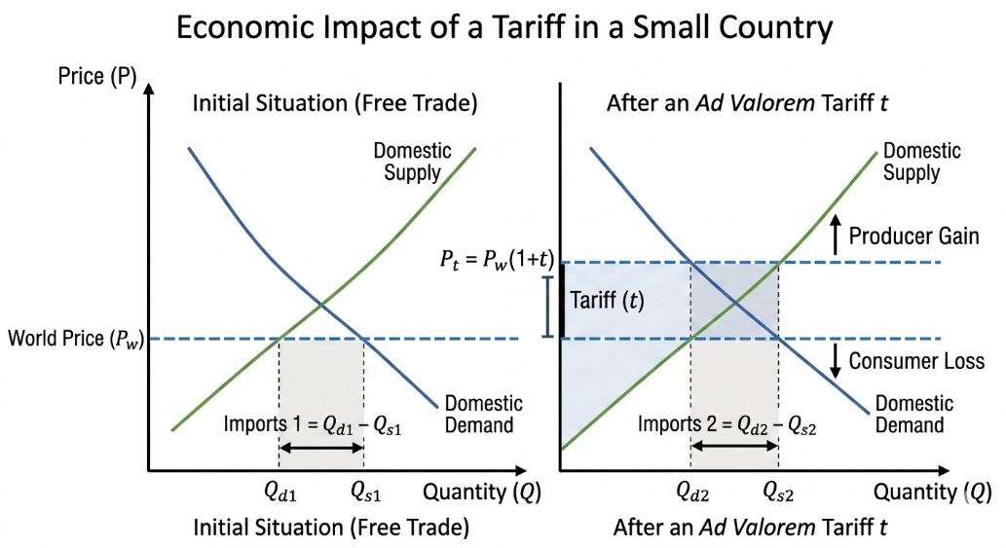
Source: Created by the author

This figure shows a standard supply and demand diagram. The demand curve slopes downward and the supply curve slopes upward. The world price is shown as a horizontal line. After the tariff, the domestic price rises to the world price plus the tariff. The figure illustrates the consumption effect where consumers buy less, the production effect where domestic producers supply more, the import effect where imports decrease, and the revenue effect where the government collects tariff revenue equal to the tariff times the quantity of imports.

WELFARE EFFECTS IN A SMALL COUNTRY
For a small country, a tariff creates deadweight loss with no terms of trade gain. Consumer surplus falls because the price rises. Domestic producers gain because the price rises. The government collects tariff revenue. However, there are two types of deadweight loss. The first is the production distortion loss which represents resources wasted on inefficient domestic production. The second is the consumption distortion loss which represents consumers foregoing beneficial consumption.
FIGURE 2: WELFARE EFFECTS OF A TARIFF IN A SMALL COUNTRY
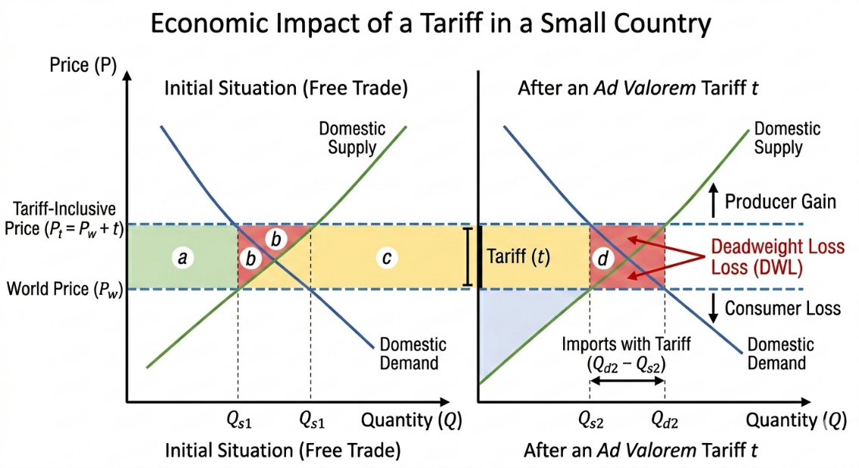
Source: Created by the author

This figure divides the welfare changes into four labeled areas. Area a represents the producer surplus gain. Area c represents government revenue. Areas b and d represent deadweight loss. The total consumer loss is the sum of areas a, b, c, and d. The net welfare change for the small country is negative because the deadweight loss areas b and d are not offset by any gain from trade. Therefore, in a small country, tariffs always reduce national welfare.
LARGE COUNTRY CASE AND THE OPTIMAL TARIFF ARGUMENT
A large country can affect world prices because its import demand is significant. When a large country imposes a tariff, its import demand falls, which causes the world price to fall. The domestic price rises but by less than the tariff because foreign exporters share the burden by lowering their prices. The welfare effects include consumer loss from higher prices, producer gain from higher prices, government revenue from the tariff, and a terms of trade gain because the country pays less for its imports. If the terms of trade gain is larger than the deadweight loss, then national welfare improves. This is known as the optimal tariff argument. The optimal tariff rate equals one divided by the foreign export supply elasticity. However, the risk is that trading partners may retaliate, leading to a trade war that reduces welfare for all countries.

FIGURE 3: LARGE COUNTRY CASE AND OPTIMAL TARIFF
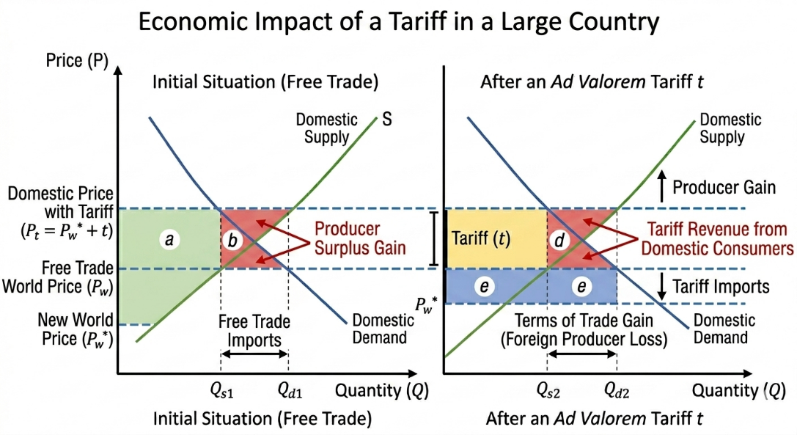
Source: Created by the author

This figure shows the domestic market and the foreign export supply curve. In the large country case, the foreign export supply curve is upward sloping. When the large country imposes a tariff, the world price falls. The figure illustrates the terms of trade gain as a rectangle that may exceed the deadweight loss triangles. The optimal tariff is the rate that maximizes the difference between the terms of trade gain and the deadweight loss. Beyond that point, further tariff increases reduce welfare.

TARIFF REDISTRIBUTION EFFECTS
Tariffs act as a regressive tax because lower income households spend a larger share of their income on tradable goods such as food, clothing, and electronics. The redistribution flows from consumers to domestic producers, to the government, and to inefficient firms. Consumers pay higher prices. Domestic producers receive higher profits and possibly higher wages in protected sectors. The government collects tariff revenue. Inefficient firms receive rent seeking opportunities. Rent seeking behavior means that firms may spend resources lobbying for tariff protection rather than improving efficiency. This is a hidden social cost. For example, the US sugar tariff benefits a few thousand sugar producers but costs consumers billions of dollars annually.

FIGURE 4: TARIFF REDISTRIBUTION EFFECTS
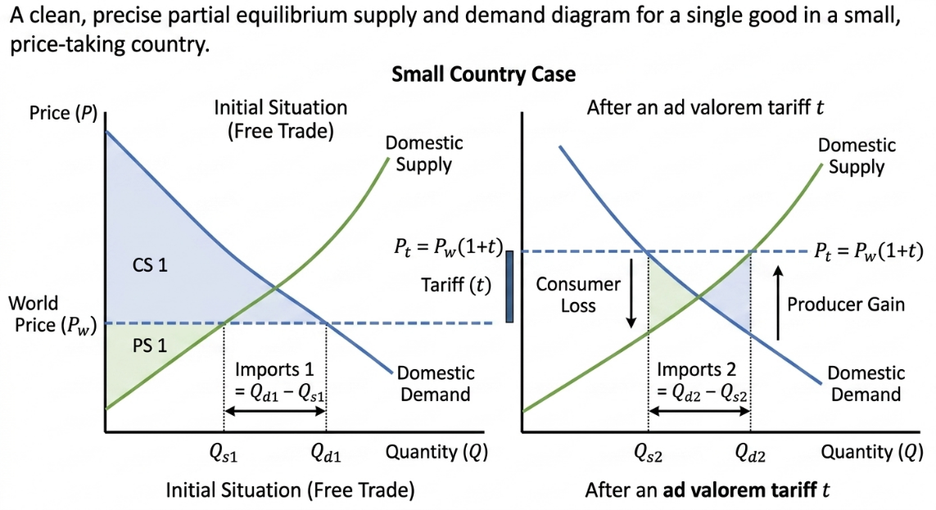
Source: Created by the author

This figure is a flow diagram showing the direction of redistribution. An arrow points from consumers to domestic producers representing higher profits. Another arrow points from consumers to the government representing tariff revenue. Another arrow points from consumers to inefficient firms representing rent seeking. The figure also shows a regressive tax burden where lower income households lose a larger percentage of their income compared to higher income households.

FIGURE 5: WELFARE EFFECTS SMALL COUNTRY REPEATED
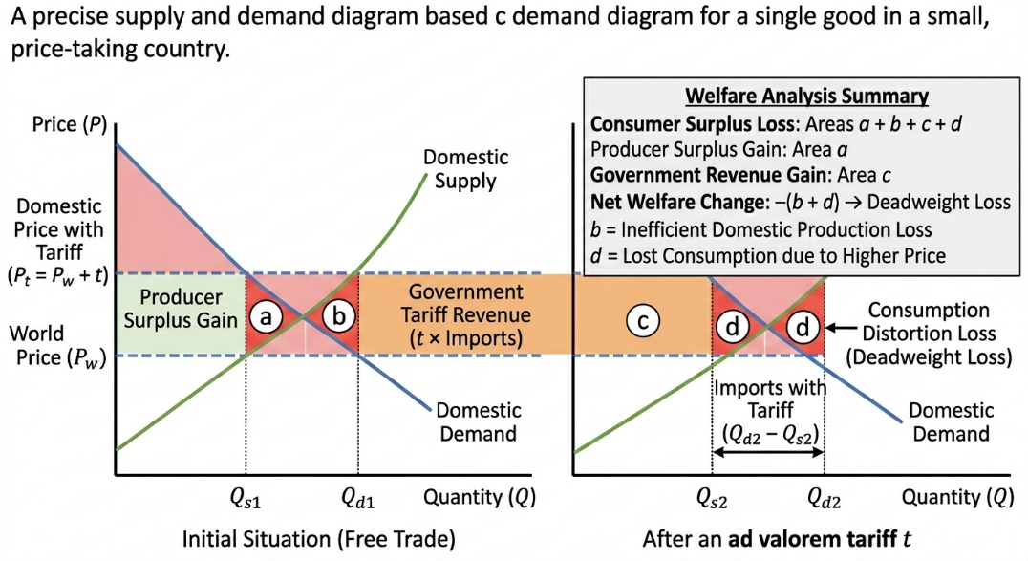
Source: Created by the author

This figure repeats the small country welfare diagram to emphasize that the redistribution effects are separate from the efficiency effects. The deadweight loss areas represent pure efficiency losses to society, while the transfer areas represent redistribution from consumers to producers and the government.

FIGURE 6: LARGE COUNTRY CASE REPEATED
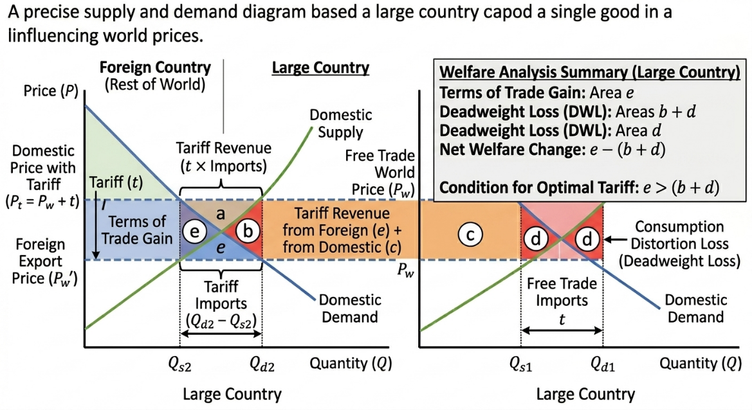
Source: Created by the author

This figure repeats the large country tariff diagram to emphasize the terms of trade gain. The figure shows that the net welfare effect for the large country can be positive if the terms of trade gain exceeds the deadweight loss. However, the figure also notes that this gain comes at the expense of the trading partner whose welfare declines.

NON TARIFF BARRIERS OVERVIEW
Non-tariff barriers are trade restrictions that do not involve explicit taxes. Since the WTO tariff reductions, non-tariff barriers have proliferated. They include quotas, voluntary export restraints, tariff rate quotas, technical barriers to trade, sanitary and phytosanitary measures, subsidies and countervailing duties, local content requirements, and customs delays with red tape. This lecture focuses on quantitative restrictions which are quotas, voluntary export restraints, and tariff rate quotas.

IMPORT QUOTAS
An import quota is a direct physical limit on the quantity of a good that can be imported during a specific period. The government sets a quota quantity. The domestic price rises until the quantity demanded equals domestic supply plus the quota. Quota rent is the extra profit earned by whoever has the right to import under the quota. Who gets the quota rent matters for welfare. If licenses are given to domestic firms, rents stay in the importing country. If licenses are auctioned, the government collects the rent. If licenses go to foreign exporters, rents go abroad which is the worst case for the importing country. The deadweight loss from a quota is the same as from a tariff, consisting of production distortion and consumption distortion.
FIGURE 7: IMPORT QUOTA
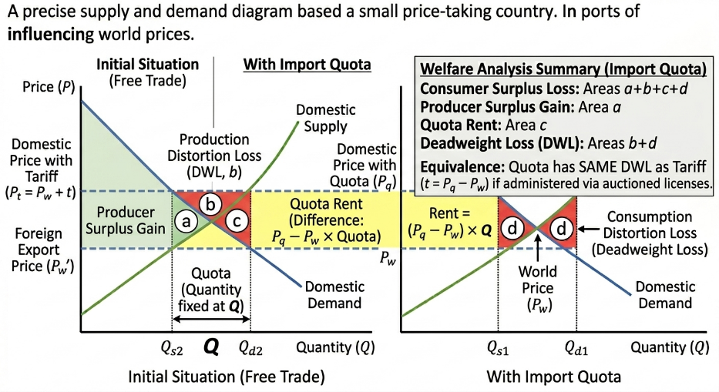
Source: Created by the author

This figure shows a supply and demand diagram for a quota. The domestic supply curve and demand curve are drawn. The world price is shown as a horizontal line. The quota is represented as a horizontal distance between the domestic supply curve and the demand curve. The new domestic price rises above the world price until the difference between quantity demanded and quantity supplied equals the quota. The area between the world price and the new domestic price over the quota quantity represents the quota rent. The deadweight loss triangles are identical to the tariff case.

QUOTA VERSUS TARIFF KEY DIFFERENCES
Several key differences exist between quotas and tariffs. A tariff generates government revenue, while a quota only generates revenue if licenses are auctioned. A tariff provides uncertainty about import volume because volume depends on demand elasticity, while a quota provides certainty about import volume. A tariff provides certainty about the price effect because price equals world price plus tariff, while a quota provides uncertainty about price because price adjusts to clear the market. A quota creates rent, while a tariff does not. Tariffs are more transparent than quotas. Tariffs are generally allowed under WTO rules, while quotas are restricted although some quotas are allowed.

VOLUNTARY EXPORT RESTRAINTS
A voluntary export restraint or VER is an export limit imposed by the exporting country at the importing country request. VERs were popular in the 1980s, for example Japanese auto exports to the United States. VERs are now illegal under WTO rules. Under a VER, the exporting country voluntarily limits its exports. The domestic price in the importing country rises. The quota rents go to foreign exporters because they can charge higher prices. For the importing country, there is consumer loss from higher prices and producer gain, but no government revenue. The rents are captured by foreign firms. Compared to an equivalent tariff, the VER is worse for the importing country because the rents go abroad. For the exporting country, the VER is better than a tariff because foreign firms get the rents. For global welfare, the VER is worse than a tariff because it creates the same deadweight loss but transfers rents inefficiently.

TARIFF RATE QUOTAS
A tariff rate quota or TRQ is a two tier tariff system. Imports within a specified quantity face a low tariff called the in quota rate. Imports above that quantity face a higher tariff called the over quota rate. The purpose of a TRQ is to allow minimum market access while protecting domestic producers beyond that level. TRQs are common in agriculture following the WTO Uruguay Round Agreement on Agriculture. For example, the European Union imports of beef allow one hundred thousand tons at ten percent tariff, but above that quantity the tariff is eighty percent. The economic effects of a TRQ are similar to a quota, but some imports can enter at the low tariff. The government collects revenue from both in quota and over quota imports. A TRQ is less distortionary than a pure quota. Politically, TRQs are appealing because they satisfy domestic producers with a high over quota tariff, satisfy foreign producers with access at a low tariff, and satisfy consumers with some cheap imports.

FIGURE 8: TARIFF RATE QUOTA
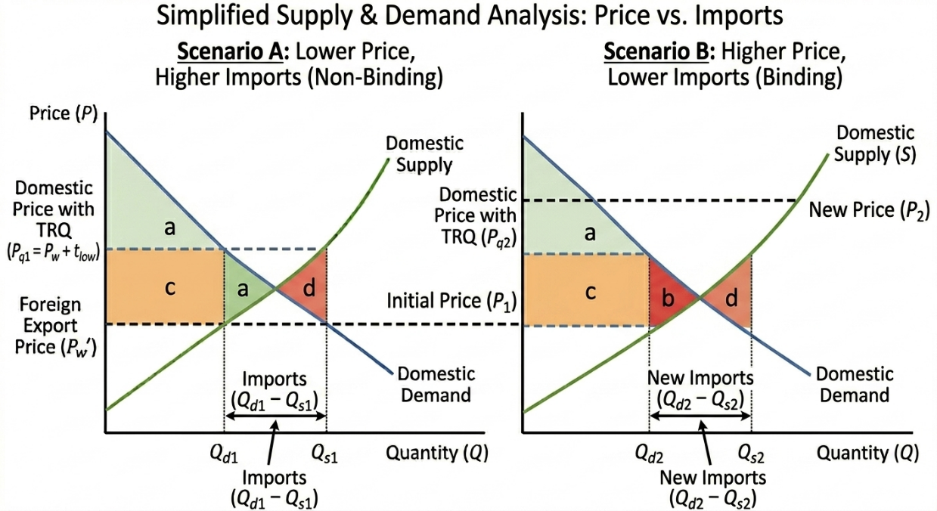
Source: Created by the author

This figure shows a supply and demand diagram with a two tier tariff. The in quota quantity is shown on the horizontal axis. Up to that quantity, the domestic price is the world price plus the low in quota tariff. Beyond that quantity, the domestic price jumps to the world price plus the high over quota tariff. The figure shows that the quantity demanded exceeds the quantity supplied plus the in quota quantity, so over quota imports occur at the higher tariff. The government revenue area has two parts, one from the low tariff and one from the high tariff. The deadweight loss is smaller than a pure quota that restricts imports to the in quota level.

COMPARISON OF TARIFFS AND NON TARIFF BARRIERS
Several criteria can be used to compare tariffs and non tariff barriers. Government revenue is generated by tariffs and by TRQs, but only conditionally by quotas and not at all by VERs. Rents go to domestic firms or government under tariffs and TRQs, but under quotas rents depend on license allocation, and under VERs rents go to foreigners. Transparency is high for tariffs, medium for quotas and TRQs, and low for VERs. WTO legality allows tariffs and TRQs, restricts quotas, and prohibits VERs. Certainty of quantity is low for tariffs, high for quotas and VERs, and medium for TRQs. Certainty of price is high for tariffs, low for quotas and VERs, and medium for TRQs. No single instrument is best for all situations. Policymakers choose based on political pressures, administrative capacity, WTO commitments, and retaliation risks.

REAL WORLD CASES AND DATA
Several real world cases illustrate trade policy instruments. The first case is US steel tariffs in 2002 and 2018. In 2002, the Bush administration imposed a thirty percent tariff on steel imports. The result was that job losses in steel using industries exceeded gains in steel production. The WTO ruled the tariff illegal, and the US removed the tariffs after the European Union threatened retaliation. In 2018, the Trump administration imposed a twenty-five percent tariff on steel under Section 232 national security grounds. The European Union and China retaliated with tariffs on US goods such as bourbon, motorcycles, and agricultural products. The net effect was a welfare loss for the US economy with only a small gain for steel producers.
The second case is the European Union banana regime from 1993 to 2012. The EU used a TRQ system favoring former European colonies. The United States supported by Chiquita and Dole challenged the regime, along with Latin American countries. The WTO ruled against the EU multiple times. The dispute was eventually resolved with a tariff only system.
The third case is the Japanese auto VER from 1981 to 1994. Japan voluntarily limited auto exports to the United States to 1.68 million cars per year. The effect was that US car prices rose by about one thousand dollars per car. Japanese firms earned higher profits. US consumers lost billions of dollars. US auto companies gained temporarily but did not become more efficient.

Data from the WTO Integrated Trade Intelligence Portal shows that the average global tariff declined from fifteen percent in 1995 to five percent in 2020. At the same time, the number of non-tariff barriers increased from about one thousand to over twenty-five thousand. Most non-tariff barriers are in agriculture, chemicals, and machinery.

POLICY IMPLICATIONS AND WTO RULES
Several WTO principles are relevant to tariffs and non tariff barriers. The first principle is binding commitments, which means that tariffs cannot exceed bound rates without compensation. The second principle is most favored nation or MFN, which means that a tariff applied to one WTO member must be applied equally to all WTO members except under free trade agreements. The third principle is national treatment, which means that internal taxes and regulations cannot discriminate against imports.

Specific WTO rules include the prohibition of VERs under the Agreement on Safeguards. Tariffication requires that quotas be converted to tariffs, especially in agriculture. TRQs are permitted for agriculture under market access commitments. Antidumping and countervailing duties are allowed under certain conditions. Countries can challenge trade measures through the WTO dispute settlement system. For example, the US China tariff war from 2018 to 2020 led to multiple WTO cases, although rulings are pending due to the appellate body crisis.

Policy advice for small countries is to avoid tariffs unless for revenue purposes in cases where other taxes are difficult to collect. Small countries should never use VERs. They should use TRQs only in agriculture if required by WTO commitments. They should focus on reducing non tariff barriers to attract foreign investment.

CONCLUSION
Several key takeaways emerge from this lecture. Tariffs are simple but harmful for small economies. For large economies, tariffs can improve terms of trade but risk retaliation. Specific tariffs are easy to administer but lose protection during inflation, while ad valorem tariffs adjust with inflation but require accurate valuation. Welfare effects always include deadweight loss for a small country, with redistribution from consumers to producers and government. Quotas limit quantity and create rents. Quotas are more distortionary than an equivalent tariff if the rents go abroad. VERs are the worst policy for an importing country because rents go to foreigners, and VERs are now illegal under WTO rules. TRQs represent a compromise between protection and market access and are common in agriculture.

DISCUSSION QUESTIONS

- Four discussion questions are provided for class discussion. First, why would a government use a VER instead of a tariff even though VERs are worse for national welfare? Possible answers include political pressure from domestic industries, historical avoidance of WTO disputes, or pressure from exporting countries to avoid tariffs.

- Second, compare the distributional effects of an ad valorem tariff versus a specific tariff during inflation. Ad valorem tariffs rise with inflation and maintain protection, while specific tariffs lose real value during inflation, reducing protection and benefiting consumers.

- Third, if a large country imposes an optimal tariff, why might its trading partners retaliate and what is the final equilibrium likely to be? Trading partners lose welfare from the tariff and retaliate to pressure the large country to remove it. The final equilibrium is a trade war where both countries end up worse off than under free trade, similar to a prisoner dilemma.

- Fourth, how does a TRQ differ from a simple quota and give an example where a TRQ might be preferred politically. A TRQ allows some imports at a low tariff while a simple quota blocks all imports beyond the limit. A TRQ is preferred politically for sensitive sectors like agriculture where domestic producers need protection but foreign access is required by WTO agreements.

PROBLEM SET
Problem one concerns a small country tariff. Demand is given by Qd equals one hundred minus P. Supply is given by Qs equals twenty plus P. The world price is twenty dollars. Part a asks to find free trade imports. At P equals twenty, Qd equals eighty and Qs equals forty, so imports equal forty units. Part b asks to impose a ten dollar specific tariff and find the new price, imports, consumer surplus loss, producer surplus gain, revenue, and deadweight loss. The new domestic price is thirty dollars. At P equals thirty, Qd equals seventy and Qs equals fifty, so new imports equal twenty units. Consumer surplus loss is seven hundred fifty. Producer surplus gain is four hundred fifty. Government revenue is two hundred. Deadweight loss is one hundred.

Problem two compares a quota to a tariff using the same demand and supply. Instead of a tariff, impose a quota of twenty units. Part a asks to find the domestic price. With a quota of twenty, the equation Qd minus Qs equals twenty gives one hundred minus P minus twenty plus P equals twenty, which simplifies to eighty minus two P equals twenty, so two P equals sixty and P equals thirty dollars. Part b asks to calculate the quota rent if licenses are given to domestic firms. The quota rent equals the domestic price minus world price times the quota, which is thirty minus twenty times twenty equals two hundred dollars. Part c asks to compare welfare with the tariff case. Consumer loss is seven hundred fifty, producer gain is four hundred fifty, government revenue is zero if licenses are given to firms or two hundred if licenses are auctioned, quota rent is two hundred to license holders, and deadweight loss is one hundred. If quota rents stay domestic, welfare is identical to the tariff. If rents go to foreigners, the quota is worse.

Problem three analyzes a VER using the same data. Assume the exporting country imposes a VER of twenty units. Calculate the welfare loss for the importing country compared to an equivalent tariff and state who gets the quota rents. Under the VER, the domestic price rises to thirty dollars, consumer loss is seven hundred fifty, producer gain is four hundred fifty, government revenue is zero, and quota rent of two hundred goes to foreign exporters. Compared to the tariff, the VER causes an additional welfare loss of two hundred dollars because the rents are transferred abroad. The quota rents go to foreign exporting firms or to the foreign government if licenses are auctioned.

CONCLUSION
This lecture has examined the main instruments of trade policy, including tariffs and non-tariff barriers, and their effects on welfare, income distribution, and market outcomes. Several key conclusions emerge from the analysis.
First, tariffs are the oldest and most transparent form of trade restriction. A specific tariff is easy to administer but loses its protective value during inflation because it becomes a smaller percentage of the price. An ad valorem tariff automatically adjusts with inflation but requires accurate customs valuation and is vulnerable to fraud. A compound tariff combines both forms and is useful for products with wide quality variation. Each type has advantages and disadvantages depending on the administrative capacity of the country and the characteristics of the imported good.

Second, the welfare effects of a tariff depend critically on the size of the importing country. For a small country that cannot influence world prices, a tariff always reduces national welfare. The deadweight loss comes from two sources, the production distortion where inefficient domestic firms expand output, and the consumption distortion where consumers pay higher prices for fewer goods. The redistribution effects transfer income from consumers to domestic producers and to the government, but these transfers do not offset the efficiency losses. For a large country that can affect world prices, a tariff may improve national welfare if the terms of trade gain exceed the deadweight loss. This is the optimal tariff argument. However, the optimal tariff invites retaliation from trading partners, and a trade war leaves all countries worse off than under free trade.
Third, tariffs act as a regressive tax. Lower income households spend a larger share of their income on tradable goods such as food, clothing, and electronics. Therefore, the burden of tariffs falls more heavily on the poor than on the rich. The redistribution flows from consumers to domestic producers, to the government, and to inefficient firms that engage in rent seeking. Rent seeking represents a hidden social cost because resources are wasted on lobbying for protection rather than on productive activities.
Fourth, non-tariff barriers have become more common as tariffs have fallen under WTO disciplines. Import quotas limit the quantity of imports directly. A quota creates quota rent, which is the extra profit from selling at the higher domestic price. Who receives the quota rent determines the welfare effect? If the rent stays in the importing country through auctioned licenses or domestic license holders, the quota is equivalent to a tariff. If the rent goes to foreign exporters, the quota is worse than a tariff. Quotas also introduce uncertainty about the domestic price and are less transparent than tariffs.
Fifth, voluntary export restraints are the worst policy for the importing country. Under a VER, the exporting country agrees to limit its exports at the request of the importing country. The domestic price rises, but the quota rent goes entirely to foreign exporters. The importing country suffers the same deadweight loss as a tariff but receives no government revenue and no quota rent. VERs are now illegal under WTO rules, but they were widely used in the 1980s, for example in Japanese auto exports to the United States.

Sixth, tariff rate quotas represent a political compromise. A TRQ allows a specified quantity of imports at a low tariff, while any imports above that quantity face a high tariff. This system provides minimum market access for foreign producers while protecting domestic producers beyond the quota limit. TRQs are common in agricultural trade and are permitted under WTO rules. They are less distortionary than pure quotas and generate government revenue from both the in quota and over quota imports.
Seventh, real world cases confirm these theoretical predictions. The US steel tariffs of 2002 and 2018 caused job losses in steel using industries that exceeded job gains in steel production, and they led to retaliation from trading partners. The EU banana regime created a long running trade dispute that required multiple WTO rulings to resolve. The Japanese auto VER raised car prices for US consumers and transferred rents to Japanese auto manufacturers.
Eighth, WTO rules reflect these economic insights. VERs are prohibited. Quotas must generally be converted to tariffs through tariffication. Tariff rate quotas are permitted for agriculture. Binding commitments, most favored nation treatment, and national treatment are core principles that constrain how countries can use trade policy instruments. The dispute settlement mechanism allows countries to challenge illegal trade measures.
In summary, trade policy instruments always create winners and losers. Tariffs and quotas protect domestic producers at the expense of domestic consumers. Non tariff barriers are often less transparent and more distortionary than tariffs.

REFERENCES
- Krugman, P. R., Obstfeld, M., and Melitz, M. J. 2023. International Trade Theory and Policy. 12th edition. Pearson. Chapter 9.
- Feenstra, R. C. and Taylor, A. M. 2021. International Trade. 5th edition. Macmillan International Higher Education. Chapter 8.
- Davies, W. and Chen, C. G. 2023. International Trade and FDI: An Advanced Introduction to Regulation and Facilitation. Business Expert Press. Chapters 2 and 3.
- Appleyard, D. R., Field, A. J., and Cobb, S. L. 2016. International Economics. 9th edition. McGraw Hill Education.
- World Trade Organisation. Integrated Trade Intelligence Portal I TIP. Online database.
- Laird, S. and Francois, J. F. 2012. Quantifying Commercial Policies. In J. F. Francois and K. A. Reinert editors. Applied Methods for Trade Policy Analysis. Cambridge University Press.

