International Trade and Policy – Week 6
Analysis of Trade Policy and Midterm Exam I Review
Course: International Trade and Policy
University: Tajik State University of Commerce
Lecturer: Abduvaliev M.H., PhD

PART 1: COSTS AND BENEFITS OF PROTECTION – WHY PROTECTION? THE CORE TENSION
Welcome, everyone. This is Week 6 of our International Trade and Policy course. Today's session covers the costs and benefits of protection, the effective rate of protection, the political economy of trade and lobbying, and a review for your first midterm exam.
Let us begin with Part 1: Costs and Benefits of Protection. First, we ask: Why protection? There is a core tension.
As we learned in Week 2, a small country always loses from a tariff. Why? Because a tariff drives a wedge between domestic and world prices, creating two inefficiencies:
- Production distortion – domestic firms produce more than the efficient level because they are shielded from competition.
- Consumption distortion – consumers buy less because the price is artificially high.
These two distortions create deadweight loss (DWL) – welfare that disappears and benefits no one. In a small country, the world price does not change when it imposes a tariff, so there is no terms-of-trade gain to offset the DWL. Hence, national welfare unambiguously falls.
Large country might gain but risks retaliation
In contrast, a large country might gain from a tariff – but only if it sets the optimal tariff. Because a large country has market power, its tariff reduces demand for imports, lowering the world price. This creates a terms-of-trade gain – the large country pays less per imported unit.
If this gain exceeds the DWL, national welfare increases. However, the strategy is risky: trading partners often retaliate with their own tariffs, triggering a trade war. In the Nash equilibrium of a trade war, both countries typically end up worse off than under free trade.
If free trade maximizes global welfare, why do all countries restrict trade?
Key question: If free trade maximizes global welfare, why do all countries restrict trade?
Answer (preview from political economy): Free trade maximizes total global welfare, but it does not make every individual or group better off. Trade creates winners and losers within each country. According to the Stolper-Samuelson theorem (Week 3), opening to trade benefits owners of abundant factors and hurts owners of scarce factors.
For example, in a capital-abundant country like the United States, trade benefits capital owners and skilled workers but hurts low-skilled workers in import-competing sectors such as textiles, steel, and furniture.
The losers face large, concentrated losses (job losses, factory closures, wage declines). Winners enjoy smaller, more diffuse gains (lower prices, export access). Because losses are concentrated and gains diffuse, losers have a stronger incentive to organize politically. This political asymmetry – not economic efficiency – explains the persistence of protectionism.
Figure 1 – Partial Equilibrium Analysis of a Small Country Tariff (Consumer and Producer Surplus Review)
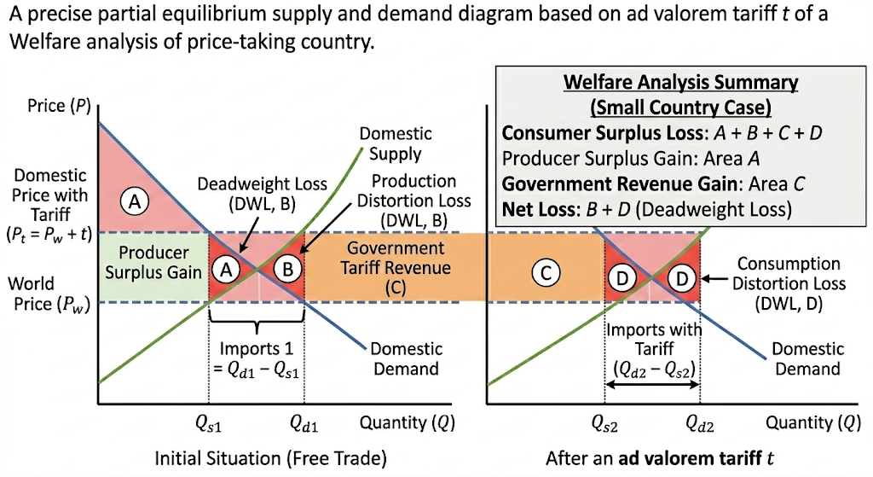
Source: Created by the author

Let us review consumer and producer surplus using Figure 1, which shows partial equilibrium analysis of a small country tariff.
Under free trade at world price Pw:
- Domestic demand = Qd
- Domestic supply = Qs
- Imports = Qd – Qs
After a tariff t:
- Domestic price rises to Pt = Pw + t
- Production expands to Qs₂
- Consumption contracts to Qd₂
- Imports fall to Qd₂ – Qs₂
Welfare changes:
- Consumer surplus loss = areas a + b + c + d
- Producer surplus gain = area a
- Government tariff revenue = area c
- Net welfare change = DWL = areas b + d
Area b = production distortion (inefficient domestic production). Area d = consumption distortion (lost value from reduced purchases). Thus, tariffs benefit producers and generate revenue but harm consumers more and create overall inefficiency.
Table 1 – Static Costs of Protection: Small Country Tariff Results
Change | Area | Who experiences it?
Consumer loss | A+B+C+D | All domestic consumers
Producer gain | A | Import-competing producers
Government revenue | C | Government
Net welfare change | –(B+D) | Entire economy
Triangle B = production distortion (domestic output at costs above world price). Triangle D = consumption distortion (consumption reduced due to artificially high price).
Figure 2 – Optimal Tariff and Terms of Trade in a Large Country
Source: Created by the author

Now Figure 2 illustrates the optimal tariff and terms-of-trade effect in a large country.
A large country can influence global markets. Its tariff reduces global demand, forcing foreign exporters to lower prices.
- Domestic price rises to Pt
- World price drops to Pw'
This creates a terms-of-trade advantage (area e) – the importing country shifts part of the tax burden to foreign producers.
Welfare changes:
- Consumer loss = a + b + c + d
- Producer gain = a
- Government revenue = c + e (e comes from foreign firms)
- DWL = b + d
Net welfare change = e – (b + d). If e > b + d, national welfare increases → optimal tariff. If e < b + d, the tariff causes a net loss.
Figure 3 – Terms-of-Trade Gain: Small vs. Large Country Tariff
Source: Created by the author

Figure 3 compares small and large country tariffs and the terms-of-trade effect.
When a large country imposes an ad valorem tariff, it can keep the domestic price constant while forcing foreign producers to absorb the tax via lower export prices. The larger the import quantity, the more the world price collapses – benefiting domestic consumers (who pay no more than before) and hurting foreign suppliers. This is the logic of the optimal tariff.
Quotas vs. Tariffs (from Week 2)
Now compare quotas and tariffs.
A quota is a physical limit on import quantity. It generates quota rents (extra profit for license holders) rather than government revenue.
- Under a tariff: government collects revenue.
- Under a quota: no revenue; instead, import licenses become valuable. The difference between domestic and world price times quota quantity = quota rent.
Who gets the rent?
- If licenses go to domestic firms → rent stays home (still DWL).
- If licenses go to foreign exporters → rent flows abroad → quota is worse than a tariff.
A Voluntary Export Restraint (VER) is even worse:
- Exporter "voluntarily" limits exports.
- Rents go entirely to foreign firms.
- Same DWL as quota + lost rents.
Classic example: 1980s U.S. VER on Japanese autos. Japanese firms raised prices, captured rents, and U.S. consumers bore the loss. VER is the most harmful trade restriction for the importing country.
Table 2 – Dynamic Costs of Protection (Beyond Static DWL)
Table 2 contrasts static vs. dynamic costs of protection. Static DWL often underestimates true costs.
Static Cost | Dynamic Cost | Explanation
Production DWL | X-inefficiency | Protected firms don't minimize costs
Consumption DWL | Reduced product variety | Fewer choices for consumers
(Not in static DWL) | Rent-seeking | Resources spent lobbying, not producing
(Not in static DWL) | Reduced innovation | Lack of competition slows progress
(Not in static DWL) | Retaliation risk | Trade wars reduce export opportunities
Dynamic costs – such as X-inefficiency, variety loss, rent-seeking, reduced innovation, and retaliation – are often larger, accumulate over time, and are omitted from simple welfare analysis.
Example: Rent-Seeking Costs – U.S. Steel Tariffs
Rent-seeking costs are estimated at up to 3–5% of GDP in highly protected sectors (Krueger, 1974). Firms spend on lawyers, lobbyists, and campaign contributions instead of R&D or expansion.
Example: U.S. steel tariffs in 2002 and 2018 saved about 10,000 steel jobs but cost downstream industries (auto parts, machinery, construction) about 200,000 jobs – a net job loss.
Benefits of Protection – The Standard Arguments
Now the standard arguments for protection – most are flawed:
- Infant industry – weak, protection hard to remove, subsidies superior (though South Korea succeeded).
- National security – often overused for non-strategic goods.
- Terms of trade – works only for large countries, invites retaliation.
- Second-best protection – inferior to direct subsidies.
- Anti-dumping – often disguises protectionism.

Empirical Evidence: U.S. Sugar Quotas
Empirical evidence: U.S. sugar quotas (since 1982).
- U.S. sugar price = 2–3 times world price.
- Consumer cost: approximately $3 billion per year.
- Jobs saved: about 4,000 sugar farms.
- Cost per job saved: approximately $750,000 per year (far above farmer's average wage).
- Downstream jobs lost: candy makers and food processors relocate overseas.
Table 3 – Summary: Costs vs. Benefits of Protection
Costs | Benefits
Deadweight loss (production & consumption triangles) | Potential terms of trade gain (large country only)
Rent-seeking & lobbying waste | Infant industry maturation (rare, requires good governance)
Higher prices for consumers & downstream firms | National security (narrowly defined – e.g., defense only)
Retaliation & trade wars | Political expediency (saving visible jobs)
Reduced innovation & X-inefficiency | Income transfer to specific groups (e.g., steel workers)
Net job loss in downstream sectors | Anti-dumping against genuine predation (rare)

Table 3 summarizes costs vs. benefits of protection. Most protectionist arguments fail cost-benefit analysis except in narrow, temporary, or large-country cases. Even then, a direct subsidy or adjustment assistance is usually superior.

PART 2: EFFECTIVE RATE OF PROTECTION (ERP) – WHY NOMINAL TARIFFS ARE MISLEADING
Now Part 2: Effective Rate of Protection (ERP).
Nominal tariffs on final goods underestimate true protection when imported intermediates face low or zero tariffs. In global supply chains, a high final-good tariff combined with low input tariffs magnifies protection for domestic value added – a key insight from Week 2.

Figure 4 – Effective Rate of Protection on Domestic Value Added: Car Example
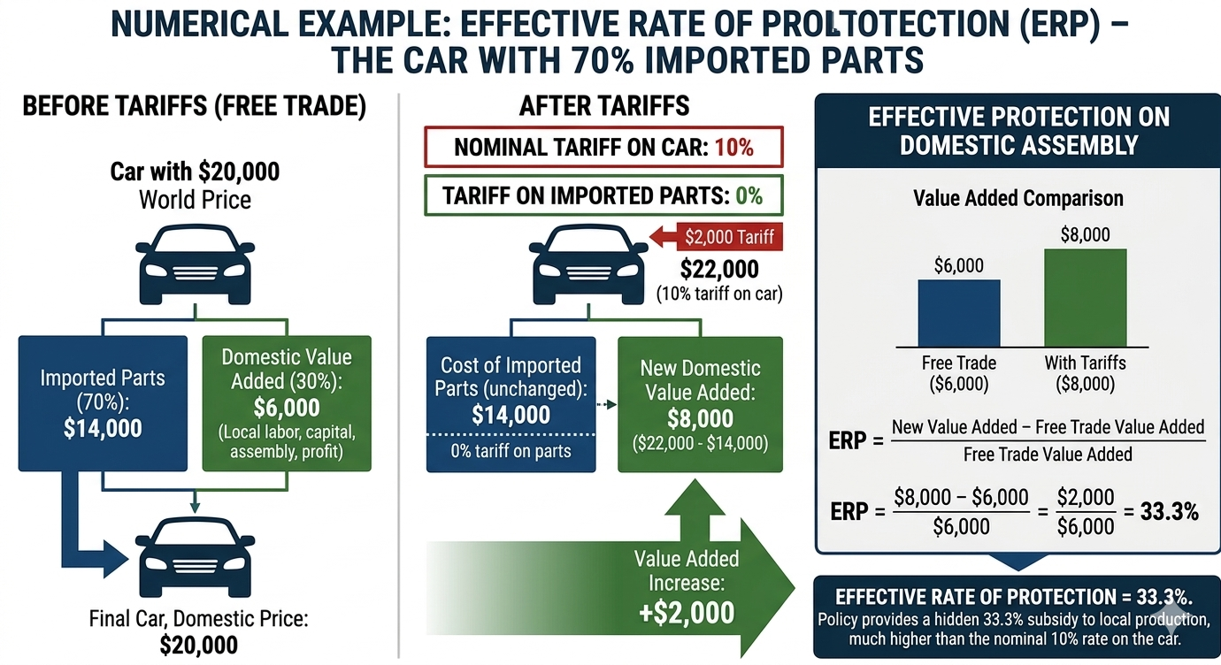
Source: Created by the author

Figure 4 shows ERP with a car example.
World price = $20,000
- Imported parts = $14,000 (70%)
- Domestic value added = $6,000 (30%)
Tariffs: 10% on finished cars, 0% on parts.
After tariffs:
- Car price = $22,000
- Parts still = $14,000
- New domestic value added = $22,000 – $14,000 = $8,000
ERP = (8,000 – 6,000) / 6,000 = 2,000 / 6,000 = 33.3%
Nominal tariff = 10%, but effective protection = 33.3%.
ERP Formula
ERP = (Vd – Vw) / Vw × 100
Where Vd = domestic value added under protection, Vw = domestic value added under free trade.
ERP can be negative if input tariffs exceed final-good tariffs. ERP can be extremely high if domestic value added is small. This is why ERP is the true measure of protection for producers.
Numerical Example 1 – ERP Greater Than Nominal (Shirt)
Shirt: World price = $100
Inputs: Fabric (50% of cost, tariff 0%), Buttons (10%, tariff 0%)
Shirt tariff = 20%
Free trade value added = 100 – (50+10) = 40
Protected value added = 120 – (50+10) = 60
ERP = (60–40)/40 = 20/40 = 50% (nominal tariff = 20%)
Low tariffs on inputs magnify protection on domestic value added.

Numerical Example 2 – Negative ERP (Disprotection) – Computer
Computer: World price = $1,000
Inputs: Chips (60% of cost, tariff 20%)
Computer tariff = 5%
Free trade value added = 1,000 – 600 = 400
Protected value added = 1,050 – 720 = 330
ERP = (330–400)/400 = –70/400 = –17.5% (negative protection)
A high tariff on inputs destroys domestic value added. This is called tariff escalation in reverse – it discourages domestic assembly.
Tariff Escalation and Policy Implications
Tariff escalation means higher tariffs on final goods than on intermediates. This is common in developed countries. It encourages domestic final production but hurts developing countries.
Example: Raw cocoa (0% tariff), cocoa powder (10% tariff), chocolate bars (20% tariff). Developing countries remain trapped exporting raw materials.
WTO negotiations: The Doha Round attempted but failed to reduce tariff escalation.
For policymakers: High ERP (over 50%) signals heavy, likely inefficient protection. Governments calculate ERP to identify heavily protected sectors.

Table 4 – ERP Summary for Exam
Condition | ERP relative to nominal | Interpretation
No imported inputs (∑ai=0∑ai​=0) | ERP = tf​ | Simple case – nominal = effective
Low input tariffs, high final tariff | ERP > tf​ | High effective protection (common in developed countries)
High input tariffs, low final tariff | ERP < tf​ (even negative) | Disprotection (common in developing countries)
tf=∑ait∑ai​ti​ | ERP = 0 | No protection of value added
ERP > 100% | Extremely high | Severe inefficiency; likely rent-seeking

Table 4 summarizes ERP for the exam:
- ERP measures protection on value added, not final price.
- ERP greater than nominal tariff occurs when input tariffs are lower than final-good tariffs.
- ERP less than nominal or negative occurs when input tariffs are higher than final-good tariffs.
- Tariff escalation protects domestic processing but harms developing country exports.

PART 3: POLITICAL ECONOMY OF TRADE AND LOBBYING – THE PUZZLE OF PERSISTENT PROTECTION
Now Part 3: Political Economy of Trade and Lobbying.
The puzzle: If protection reduces welfare, why does protectionism persist?
Answer: Concentrated benefits vs. diffuse costs (Mancur Olson, 1965).
Table 5 – Incentives to Organize
Group | Winners/Losers | Benefit per person | Incentive
Steel workers | Winners | High (thousands of dollars) | Strong
Consumers | Losers | Very low (pennies per year) | Weak (rational ignorance)
Rational ignorance: Consumers don't fight trade barriers because individual cost is tiny. Producers have large stakes and organize.
Figure 5 – "The Global Trade Puzzle" (Georgia Trend Magazine, March 1, 2019)

(Source: The Global Trade Puzzle, Georgia Trend Magazine, March 1, 2019),
As shown in Figure 5 the puzzle remains: protection persists despite efficiency losses.
Collective Action and Trade Policy
Collective action problem: Large groups with small individual stakes do not organize; small groups with large stakes do.
Implications for trade:
- Import-competing sectors (steel, sugar, textiles, autos) lobby hard for protection.
- Export sectors lobby for open markets abroad, but less intensely because their gains are more diffuse.
- Consumer groups are almost absent from trade debates.
Example: U.S. sugar program – 4,000 farmers gain hundreds of thousands of dollars each per year; 330 million consumers lose only about $9 each per year. No consumer lobby fights sugar quotas.
Recalling Stolper-Samuelson from Week 3: Trade hurts the scarce factor. In developed countries, labor (especially low-skilled) is the scarce factor. Workers in import-competing industries have strong incentives to lobby for protection.
Models of Trade Policy Determination – Stigler's Capture Theory, Grossman-Helpman
Two key models:
- Stigler's Capture Theory (1971) – Regulation (including trade policy) is sold to the highest-bidding interest group. Government officials prioritize political support over social welfare, so protection consistently goes to well-organized industries that lobby effectively.
- Grossman-Helpman 'Protection for Sale' model (1994) – Government maximizes a weighted sum of social welfare and campaign contributions. Organized sectors receive higher protection, especially those with high import penetration, low elasticity of import demand (consumers can't easily switch away), and few downstream users to oppose protection.

Who Lobbies for Protection?
Pro-protection lobbies:
- Import-competing firms (U.S. Steel, Nucor)
- Labor unions (United Steelworkers, UAW, textile unions)
- Specific industries (sugar, dairy, peanuts, steel, semiconductors, solar panels)
Pro-free trade lobbies:
- Export-oriented firms that need access to foreign markets (Boeing, Caterpillar)
- Multinational corporations with global supply chains (Apple, GM)
- Retailers that want low prices for consumers (Walmart, Target)
Consumer groups are rarely effective due to diffuse interests.

How Lobbying Works – Anti-Dumping as Disguised Protection
Lobbying instruments include: campaign contributions (PACs and Super PACs), grassroots mobilization ("Save our jobs" ads), administrative filings (anti-dumping petitions), the revolving door (former officials become lobbyists), and direct meetings with trade ministry or parliament.
Anti-dumping as disguised protection:
Dumping means selling below cost or below home market price. An anti-dumping duty is a tariff equal to the dumping margin. The problem is that anti-dumping is widely abused as a legal protectionist tool:
- Domestic firms file petitions to harass foreign competitors.
- Duties often last for decades.
- "Zeroing" artificially inflates margins.
The WTO allows anti-dumping with an injury test, yet abuse persists. For example, U.S. anti-dumping on Chinese steel since the 1990s, with each new Chinese firm facing separate investigations. Politically, anti-dumping petitions are a form of lobbying, allowing firms to secure protection without new legislation.
Table 6 – Institutions and Trade Policy (U.S. Context for Reference)
Institution | Role
Congress | Writes trade laws
USTR (United States Trade Representative) | Negotiates trade agreements
ITC (International Trade Commission) | Investigates injury from imports
Commerce Department | Conducts anti-dumping and countervailing duty investigations
WTO (World Trade Organization) | Provides dispute settlement (slow and under threat)
Summary of political economy: Concentrated benefits, diffuse costs – protectionism wins. Lobbying is rational. Institutions like anti-dumping are often captured by protectionist interests.

PART 4: MIDTERM EXAM I REVIEW
Exam Structure (90 minutes total)
Section | Weight | Content | Time allocation
Multiple choice | 20% | Definitions and small calculations | 20 minutes
Short answer | 30% | Explain concepts and draw diagrams | 25 minutes
Problems | 30% | Tariff welfare, ERP, comparative advantage, Heckscher-Ohlin | 30 minutes
Essay | 20% | Political economy or protection argument evaluation | 15 minutes
Key Concepts Checklist (Weeks 1–5)
Please review the following key concepts:
- Comparative advantage
- Heckscher-Ohlin theorem
- Stolper-Samuelson theorem
- Tariff analysis for small and large countries
- Deadweight loss
- Terms of trade
- Quota
- Voluntary Export Restraint (VER)
- Effective rate of protection (ERP)
- Tariff escalation
- Political economy of trade
- Collective action
- Rent-seeking
- Anti-dumping
Practice Problem 1 – Small Country Tariff
Demand: Qd = 100 – P
Supply: Qs = 20 + P
World price = $20
Specific tariff = $10
Solution:
- Free trade: P = 20, Qd = 80, Qs = 40, imports = 40
- Tariff: P = 30, Qd = 70, Qs = 50, imports = 20
- Deadweight loss = 0.5 × 10 × 10 + 0.5 × 10 × 10 = 50 + 50 = 100
Practice Problem 2 – ERP Calculation
Final good price = $200
Input A: 40% of cost, tariff 5%
Input B: 30% of cost, tariff 15%
Final good tariff = 25%
Solution:
- aA = 0.4, aB = 0.3, sum of ai = 0.7
- Numerator = 0.25 – (0.4×0.05 + 0.3×0.15) = 0.25 – (0.02 + 0.045) = 0.185
- Denominator = 1 – 0.7 = 0.3
- ERP = 0.185 / 0.3 = 0.6167 = 61.7%
Practice Problem 3 – Stolper-Samuelson
Country X is capital-abundant and labor-scarce. It opens to trade. Which factor gains? Which loses? Why?
Solution:
Country X exports capital-intensive goods according to the Heckscher-Ohlin theorem. Capital is abundant, so it gains – real return on capital rises. Labor is scarce, so it loses – real wage falls. This explains why workers in developed countries often oppose trade liberalization.

Final Note
Midterm Exam I questions are attached in Google Drive. Please access them and prepare thoroughly.
Thank you for your attention. Good luck with your studies and the exam.

