Lecture Note: International Trade and Policy -- Week 10
Factor Mobility and Global Value Chains / Midterm Exam II Review
Course: International Trade and Policy
University: Tajik State University of Commerce
Lecturer: Abduvaliev Mubinzhon, PhD

PART 1: FOUNDATIONS OF FACTOR MOBILITY AND GLOBAL VALUE CHAINS
Welcome to Week 10. In previous weeks, we analyzed strategic trade policy under oligopoly. This week, we move from trade in goods to the mobility of the factors of production—labor and capital—that makes modern global production possible. We will also connect these concepts to Global Value Chains (GVCs), which now dominate international trade.

1.1 What is Factor Mobility?
Definition: The movement of factors of production (labor, capital) across international borders.
Factor mobility is the engine of globalization. Unlike the trade of finished goods, factor mobility involves the relocation of productive capacity itself. It is divided into two primary types:
- Labor Mobility (Migration): The movement of people from their home country (source) to a host country (destination) for employment.
- Capital Mobility (Foreign Direct Investment, FDI): The movement of physical capital (machinery, factories), financial capital, and technology across borders, where the investor retains control.
Why it matters: Factor mobility directly affects wages, returns to capital, income distribution, and the efficiency of global production. It is the mechanism that allows production processes to be broken apart and spread across the globe.

1.2 What are Global Value Chains (GVCs)?
Definition: The full range of activities—from design and production to marketing, distribution, and final sale—that are required to bring a product from conception to the consumer, distributed across multiple countries.
GVCs represent the dominant mode of production in the 21st century. A single product is no longer made entirely in one country. Instead, its creation is fragmented into discrete "tasks" performed in different locations, each chosen for its specific advantages.
Example: The iPhone
- Design: United States (Apple headquarters, high-skilled engineering)
- Key Components (chips, display): South Korea (Samsung), Japan (various suppliers)
- Assembly: China (Foxconn, utilizing low-cost, high-productivity labor)
- Final Sales: Global

1.3 Connecting Factor Mobility to GVCs (Exam Tip)
Simple logic: Factor mobility enables GVCs.
- Labor moves → fills skill gaps abroad.
- Capital (FDI) moves → builds factories near low-cost labor.
- Fragmentation → splits production across borders.
- Trade in tasks → you don’t trade goods; you trade value-added activities.
The Big Picture for the Exam:
- Labor mobility supplies workers to GVC nodes.
- FDI provides capital and control to build offshore facilities.
- Outsourcing/offshoring operationalize fragmentation.
- Trade in tasks is the unit of analysis for GVCs.

PART 2: INTERNATIONAL LABOR MOBILITY & MIGRATION

2.1 Basics of Labor Mobility
Labor mobility is the movement of workers from a source country to a host country.
- Push Factors (Source Country): Low wages, high unemployment, political instability, lack of opportunity.
- Pull Factors (Host Country): Higher wages, better opportunities, political stability, established family networks.

2.2 Economic Effects: A Simple Model
Consider two countries: Home (labor-abundant, low wage) and Foreign (labor-scarce, high wage). When labor moves from Home to Foreign:
- In the Host Country (Foreign): The labor supply curve shifts right. Wages fall. Total output (GDP) increases because more workers are producing. The gain to firms (lower costs) and complementary factors (capital becomes more productive) outweighs the loss to competing domestic workers.
- In the Source Country (Home): The labor supply curve shifts left. Wages rise. Total output falls, but remaining workers are better paid. The critical gain is from remittances—money sent home by migrants—which often exceed total output lost.
The global outcome: World GDP increases because labor moves from a low-marginal-productivity setting (Home) to a high-marginal-productivity setting (Foreign). However, this gain is not distributed equally.

2.3 Winners and Losers from Migration
 | Host Country (e.g., Russia) | Source Country (e.g., Tajikistan)
Winners | Firms (lower labor costs); Complementary workers (capital owners, skilled labor) | Migrants (higher wages); Families receiving remittances; Returning migrants with new skills
Losers | Competing domestic workers (lower wages, job competition) | National economy (brain drain, labor shortage in key sectors)

2.4 Brain Drain vs. Brain Gain
- Brain drain: Loss of highly-skilled workers (doctors, engineers, scientists) from poor countries. This is a significant problem for developing nations that have invested in education only to see their talent leave.
- Brain gain: The positive effect of diaspora networks, which can send back remittances, knowledge, investment, and trade links.
Exam focus (new economics of migration): Remittances reduce poverty more than foreign aid. Household decisions to send a worker abroad are often a rational strategy to overcome risk and credit constraints at home.

2.5 Policy & Restrictions
Countries restrict labor mobility through:
- Immigration quotas: Numerical limits on visas.
- Skill-based points systems: (e.g., Canada, Australia) favoring educated, young, and employable workers.
- Guest worker programs: (e.g., Gulf States, EU Blue Card) allowing temporary labor without pathways to citizenship.
Economic impact of restrictions: They create inefficiency (labor cannot move to its highest-value use), fuel underground labor markets, and lead to a misallocation of talent.

2.6 Case Study: Migration from Tajikistan
Scale & Dependency: Personal remittances received in Tajikistan have historically represented a massive percentage of GDP. This makes Tajikistan one of the most remittance-dependent economies in the world. The primary destination is Russia. This creates a dependency on Russian economic health and exposes Tajikistan to external shocks.
Figure 1. Central Asian Countries personal remittances, received (% of GDP), 2005-2022

Source: Author calculation based on the World Development Indicator, 2023 data

2.7 Exam Questions – Labor Mobility
- Show wage convergence using supply-demand graphs.
- Explain why migration benefits global GDP but creates winners and losers.
- Define brain drain and give one real-world example (e.g., exodus of Syrian doctors or Filipino nurses).

PART 3: FOREIGN DIRECT INVESTMENT (FDI)

3.1 FDI vs. Portfolio Investment
This is a common point of confusion. The defining characteristic of FDI is control.
- Foreign Direct Investment (FDI): Investment to acquire a lasting interest (typically ≥10% ownership) and control in a foreign firm.
  - Greenfield FDI: Building a new factory, office, or facility from the ground up.
  - Brownfield FDI (Mergers & Acquisitions): Acquiring or merging with an existing foreign firm.
- Portfolio Investment: Purchase of stocks, bonds, or other financial assets in a foreign country purely for financial return, without any desire or ability to control the enterprise.

3.2 Motivations for FDI
- Market-seeking: Access large consumer markets and avoid tariffs.
- Resource-seeking: Access natural resources or cheap labor.
- Efficiency-seeking: Reduce costs by locating production optimally.
- Strategic asset-seeking: Acquire technology, brands, or R&D capacity.

3.3 Horizontal vs. Vertical FDI
 | Horizontal FDI | Vertical FDI
Goal | Market-seeking: Produce the same goods in multiple countries to serve local markets. | Efficiency-seeking: Break up the value chain to locate each stage where it is most cost-effective.
Example | Toyota makes cars in Japan, the US, and Germany. | Apple designs chips in the US, fabricates them in Taiwan, assembles phones in China.
Trade Effect | Often replaces trade (produce locally instead of exporting). | Creates trade (components flow between countries).

3.4 The OLI Eclectic Paradigm (Dunning) – Exam Favorite
This framework explains why a firm chooses FDI over other modes of entry (e.g., licensing or exporting). FDI occurs only when all three conditions are present.
- O – Ownership advantage: The firm must possess a unique, valuable asset that gives it a competitive advantage over local firms in the host country. Examples: proprietary technology, strong brand, unique business process, patents.
- L – Location advantage: The host country must offer specific advantages that make it more profitable to produce there rather than at home. Examples: low-cost labor, natural resources, favorable regulations, infrastructure, large local market.
- I – Internalization advantage: The firm must find it more profitable to keep the activity within the firm (via FDI) rather than contract with an independent firm (outsourcing) or license the technology. This avoids transaction costs, protects intellectual property, and maintains quality control.

3.5 Effects of FDI on Host & Home Countries
- Positive for Host Country (e.g., Tajikistan): Capital inflow, job creation, technology transfer (spillovers), increased tax revenue, access to global markets.
- Negative for Host Country: Crowding out local firms, profit repatriation (money leaves the country), environmental damage, political influence by MNCs.
- Positive for Home Country (e.g., China): Access to new markets, lower production costs, repatriated profits, control over resources.
- Negative for Home Country: Loss of domestic jobs (especially in manufacturing), hollowing out of industrial base.

3.6 Case Study: FDI in Tajikistan – The Rise of China
- Scale: Driven by a cumulative FDI stock of nearly 6billionsince2017thatheavilyeclipsesRussia′s6billionsince2017thatheavilyeclipsesRussia′s2 billion footprint, China surpassed Russia as Tajikistan's primary trading partner in 2025 for the first time in over two decades, with bilateral trade reaching $4.3 billion and expanding by 50% year-on-year in the first quarter of 2026.
- Top FDI Sectors (2024 data):
  - Critical Minerals: Antimony, gold, lithium, tungsten – for clean energy supply chains.
  - Infrastructure: Dushanbe-China highway, border posts, energy projects.
  - Digital/AI: Tajik-China Digital Business Connect – $647 million in deals.
  - Agriculture & Processing: Import substitution, new jobs.
- Mechanisms: Chinese FDI is often channeled through state-owned enterprises (SOEs) and policy banks, offering below-market loans in exchange for strategic assets.

3.7 Exam Questions – FDI
- Distinguish horizontal vs. vertical FDI with an example.
- Apply the OLI framework to explain why Tesla builds a factory in Germany.
- Discuss one positive and one negative effect of FDI for a developing country.

PART 4: OUTSOURCING, OFFSHORING & FRAGMENTATION

4.1 Key Definitions – Don’t Confuse!
This is the most common mistake on the exam.
- Outsourcing: A make-or-buy decision. Contracting a specific business task to an external firm (third party). The external firm could be in the same country (domestic outsourcing) or a different country (international outsourcing).
- Offshoring: A location decision. Relocating a business activity abroad. The foreign activity can be performed by a subsidiary (captive offshoring, which is also FDI) or by an external foreign firm (offshore outsourcing).
Key distinction: Outsourcing = external vs. internal. Offshoring = domestic vs. foreign. The two can and often do overlap.

4.2 The Offshoring Decision – Cost vs. Risk
- Benefits: Lower wages, lower taxes, weaker regulations.
- Costs: Coordination difficulties, transport costs, intellectual property risk, political risk.
- Trade-off: Cheaper labor versus longer, more fragile supply chains.

4.3 Fragmentation of Production
Definition: The splitting of a vertically integrated production process into discrete, separable tasks that can be performed in different locations.
Figure 2: Economic Effects – A Simple Model
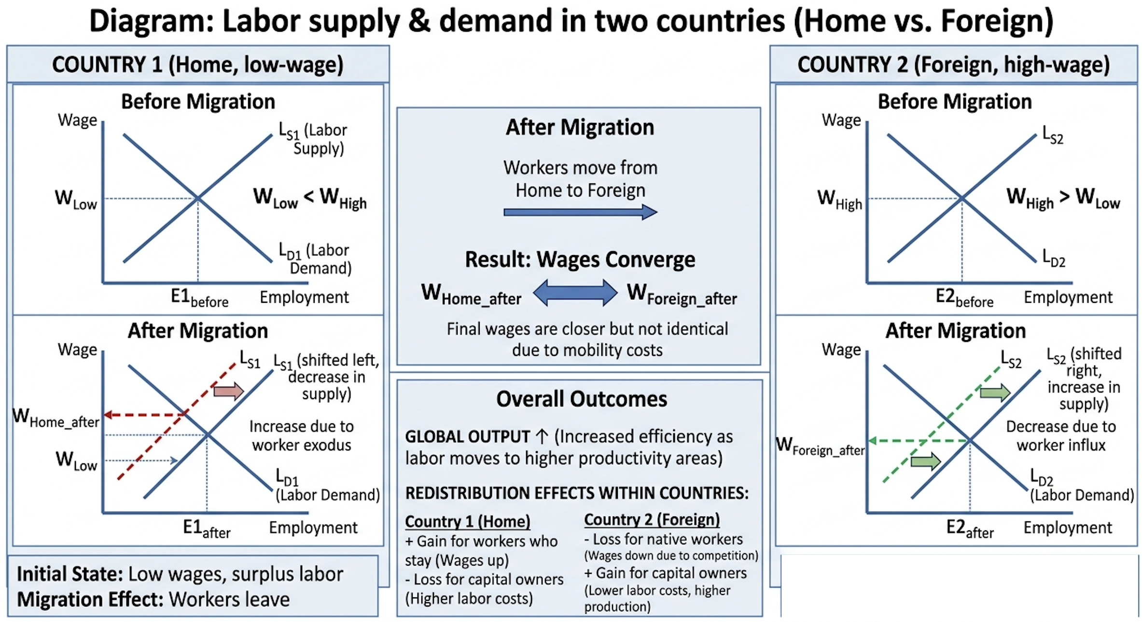
Source: Created by the author

Why Fragmentation Happens (Drivers):
- Technological progress: Information and communications technology (ICT) to coordinate complex chains, and container shipping to move goods cheaply.
- Liberal trade policies: Lower tariffs and fewer non-tariff barriers.
- Wage differentials: Massive cost savings from moving labor-intensive tasks to low-wage countries.
- Modular design: Products designed so that components can be made independently and easily assembled later.
Figure (described): Global value chains deconstruct the production process into R&D, design, manufacturing, marketing, and distribution across multiple countries.

4.4 Trade in Tasks (Baldwin, Grossman & Rossi-Hansberg)
This is the new paradigm for understanding trade.
- Old view (Ricardo, Heckscher-Ohlin): Countries trade finished goods. France exports wine, England exports cloth.
- New view (GVCs): Countries trade tasks (or value-added activities). A country's competitiveness is no longer defined by its industry (e.g., "Germany makes cars") but by the specific tasks it performs within a global chain (e.g., "Germany designs high-end engines; Poland assembles wiring harnesses").
Implication: Tasks, not industries, define competitiveness.
Examples:
- Call centers in India perform the "customer service task" for a US bank.
- Software coding in Ukraine performs the "development task" for a German software firm.

4.5 Real-World Examples of Fragmentation
- Electronics: Apple – design in California, chips in Taiwan, assembly in China, final sales global.
- Automotive: BMW – engines in Germany, wiring in Poland, assembly in the US and China.
- Clothing: Design in Italy, fabric in China, sewing in Bangladesh, labels in Portugal.

4.6 Risks of Fragmented GVCs
- Supply chain disruptions: Events like COVID-19 or the Suez Canal blockage can halt production globally.
- Geopolitical tensions: US-China decoupling forces firms to build redundant, parallel supply chains.
- Loss of domestic industrial base: Countries that outsource all manufacturing may lose capacity to innovate.
Responses: Reshoring (bringing production back home), nearshoring (moving to a nearby country), friend-shoring (moving to geopolitically allied nations).

4.7 Exam Questions – Outsourcing & Fragmentation
- Differentiate offshoring from outsourcing using real firms (e.g., Apple outsourcing to Foxconn, but offshoring to China).
- Explain how fragmentation changes the pattern of trade from goods to tasks.
- Draw a fragmented production chain (Smiley Curve) and label each country's task.

PART 5: SYNTHESIS & EXAM PREPARATION

5.1 The Big Picture – Connecting All Concepts
- Labor mobility supplies workers to GVC nodes.
- FDI provides the capital and control to build offshore facilities.
- Outsourcing/offshoring are the strategic decisions that operationalize fragmentation.
- Trade in tasks is the unit of analysis for measuring GVCs.

5.2 Review Table – Key Terms
Term | Definition | Example
Labor mobility | Workers cross borders | Mexican farmworkers in the US
FDI | Control investment abroad | Toyota plant in Kentucky
Offshoring | Move activity abroad | Call center to India
Fragmentation | Split production stages | iPhone supply chain
Trade in tasks | Buy/sell value chain steps | US design, China assembly

5.3 Possible Diagrams for the Exam
- Labor migration: Two-country wage convergence graph (labor supply shifts in source and host countries leading to wage equalization).
- FDI: OLI triangle (Ownership, Location, Internalization as three intersecting circles).
- Fragmentation: Smiley curve (value added per stage – high at design and marketing, low in manufacturing).
- Trade in tasks: Task trade vs. goods trade comparison table.

5.4 Sample Short Answer Question 1
Question: "Using the OLI paradigm, explain why a pharmaceutical company from Switzerland opens an R&D center in the US and a manufacturing plant in Vietnam."
Model Answer Structure:
- O: Proprietary drug patents.
- L (US): Skilled scientists, strong intellectual property protection.
- L (Vietnam): Low-cost labor, less regulation.
- I: Internalize to protect the formula from theft.

5.5 Sample Short Answer Question 2
Question: "How does fragmentation of production affect the demand for high-skilled vs. low-skilled labor in developed countries?"
Model Answer:
- High-skilled (winners): Gains because design, marketing, logistics, and R&D stay home. Their productivity and wages rise.
- Low-skilled (losers): Losses because assembly tasks move abroad. Wage inequality rises unless retraining occurs.

5.6 Sample Essay Outline (Exam)
Topic: "Global value chains have made factor mobility more important than ever." Agree or disagree?
- Introduction: Define GVCs and factor mobility. State your position (Agree).
- Body paragraph 1: Labor mobility supplies workers to GVC hubs.
- Body paragraph 2: FDI funds fragmentation across borders.
- Body paragraph 3: Offshoring depends on capital and labor movement.
- Counterargument: Digital tasks (e.g., software, AI training) need less physical labor mobility.
- Conclusion: Agree, but digital GVCs may reduce the need for physical labor mobility over time.

5.7 Common Mistakes to Avoid (Exam)
Mistake | Correction
Confusing outsourcing with offshoring. | Outsourcing = external. Offshoring = abroad.
Forgetting that FDI implies control. | <10% ownership is portfolio investment, not FDI.
Thinking migration only harms host countries. | It also lowers costs for firms and benefits complementary workers.
Treating trade in tasks as trade in goods. | Task trade focuses on value-added activities, not final products.

5.8 Study Tips for Midterm II
- Draw diagrams for labor mobility and FDI at least three times each.
- Memorize OLI + one example per letter.
- Learn one real GVC (Apple, Toyota, Zara) inside out.
- Practice defining key terms in one sentence each.

REFERENCES
- Bhagwati, J. N. (1984). Splintering and disembodiment of services and developing nations. The World Economy, 7(2), 133–144.
- Blomström, M., & Kokko, A. (1998). Multinational corporations and spillovers. Journal of Economic Surveys, 12(3), 247–277.
- Borjas, G. J. (2014). Immigration Economics. Harvard University Press.
- Dunning, J. H. (2000). The eclectic paradigm as an envelope for economic and business theories of MNE activity. International Business Review, 9(2), 163–190.
- Feenstra, R. C. (1998). Integration of trade and disintegration of production in the global economy. Journal of Economic Perspectives, 12(4), 31–50.
- Grossman, G. M., & Rossi-Hansberg, E. (2008). Trading tasks: A simple theory of offshoring. American Economic Review, 98(5), 1978–1997.
- World Bank. (2020). World Development Report 2020: Trading for Development in the Age of Global Value Chains. World Bank Group.

Annex: Global value chains: Deconstructed production process
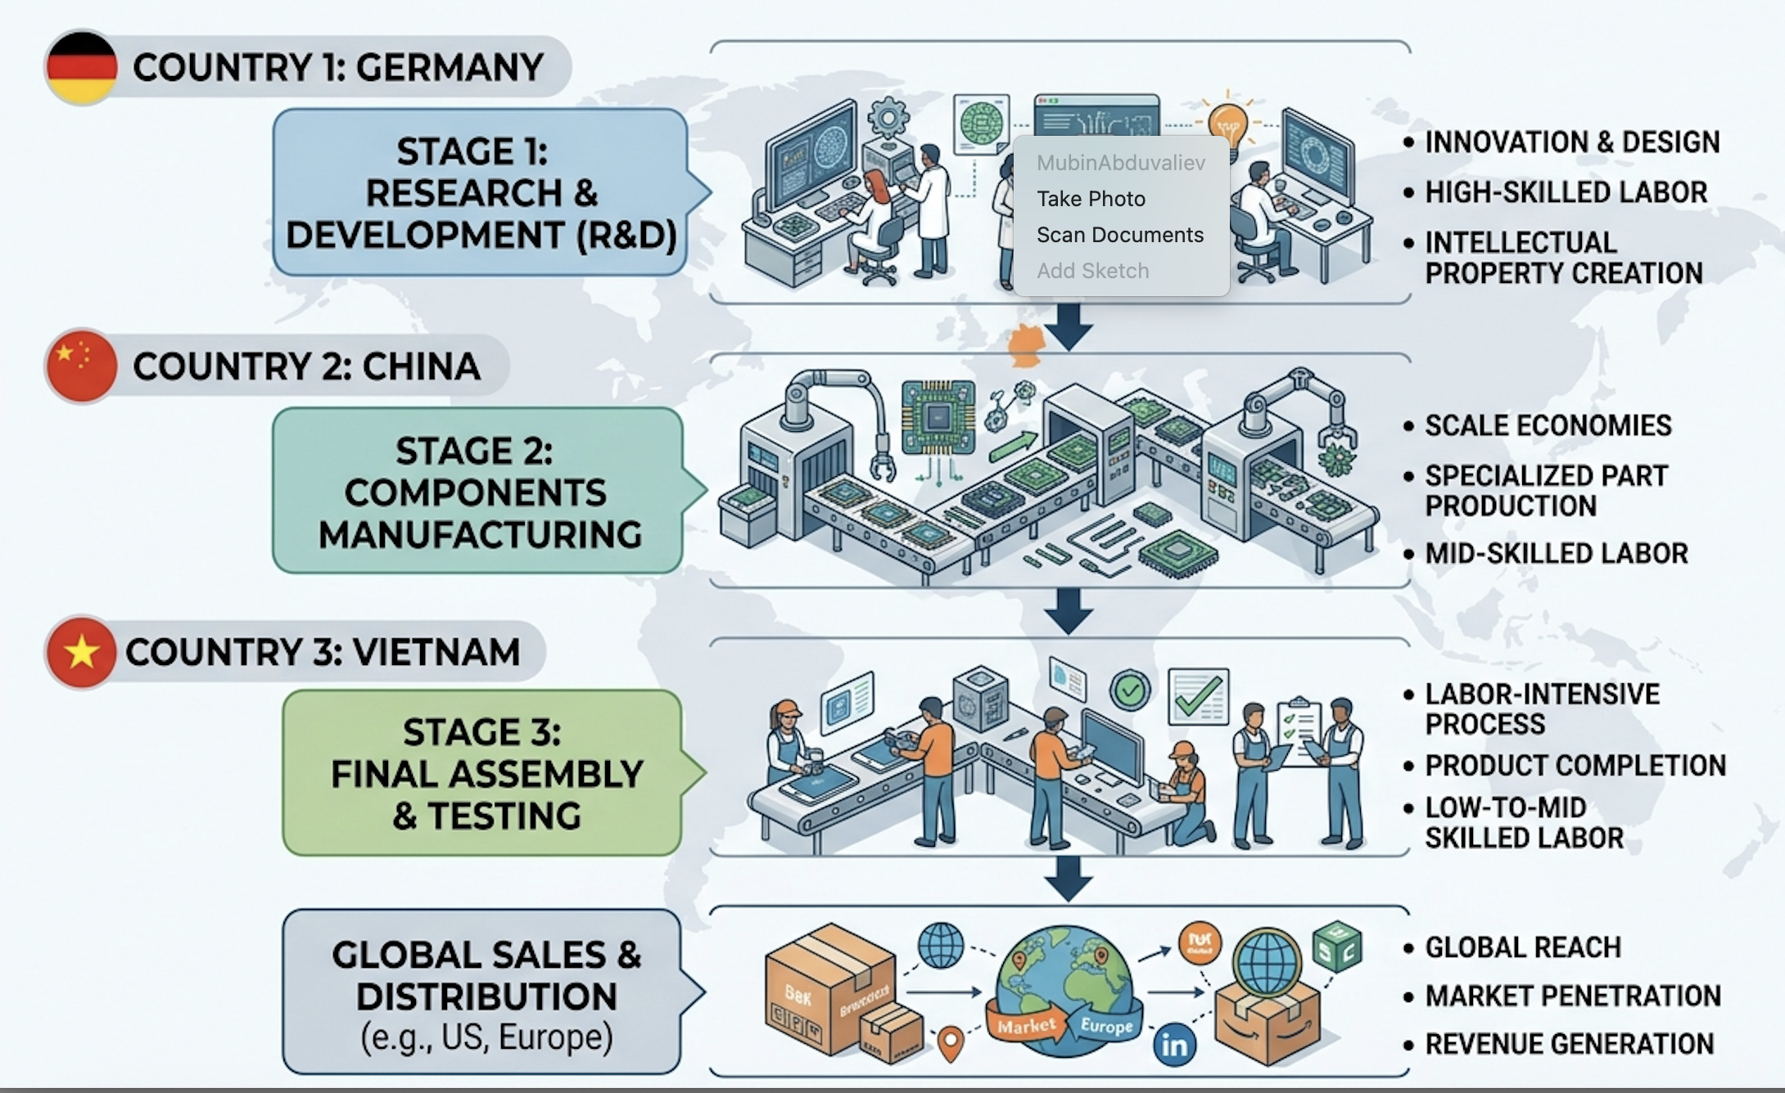
Source: Created by the author

