Organization Development
Lecture 10
Leading and managing change
Figure 34: Activity Contributing to Effective Change Management
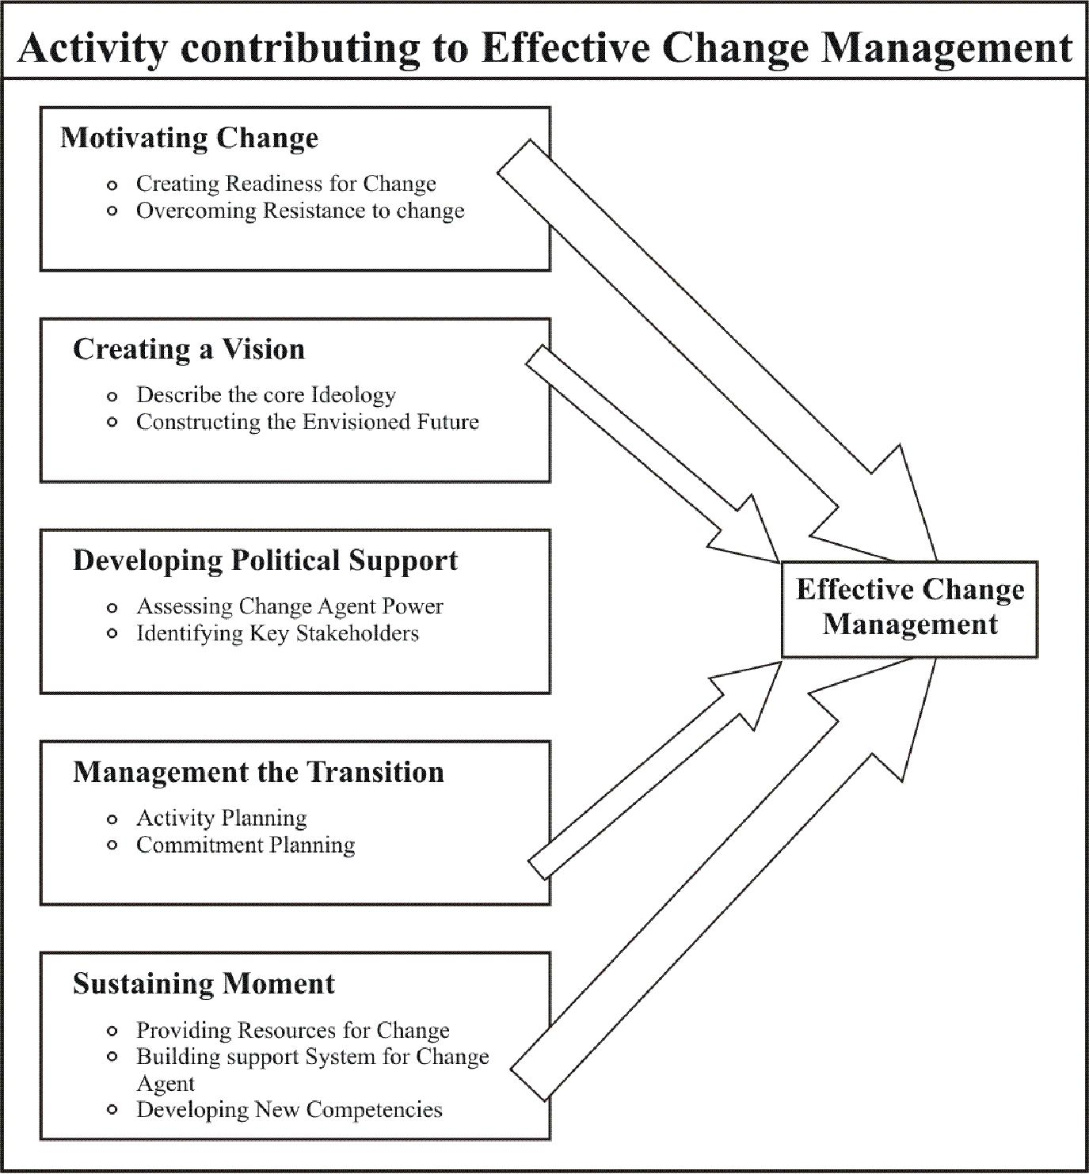

Creating a Vision:
The second activity in leading and managing change involves creating a vision of what members want the organization to look like or become. It is one of the most popular yet least understood practices in management. Generally, a vision describe the core values and purpose that guide the organization as well as an envisioned future toward which change is directed. It provides a valued direction for designing, implementing and assessing organization changes. The vision also can energize commitment to change by providing members with a common goal and a compelling rationale for why change is necessary and worth the effort. However, if the vision is seen impossible or promotes changes that the organization cannot implement, it actually can depress member motivation. For example, George Bush’s unfulfilled “thousand points of light” vision was emotionally appealing but it was too vague and contained little inherent benefit. In contrast, John Kennedy’s vision of “putting a man on the moon and returning him safely to the earth” was just beyond engineering and technical feasibility. In the context of the 1960s, it was bold, alluring and vivid; it provided not only a purpose but a valued direction as well. Recent research suggests that corporation with carefully crafted vision can significantly outperform the stock market over
long periods of time.

Creating a vision is considered a key element in most leadership frameworks. Organization or subunit leaders are responsible for effectiveness, and they must take an active role in describing a desired future and energizing commitment to it. In many cases, leaders encourage participation in developing the vision to gain wider input and support. For example, they involve subordinates and others who have a stake in the changes. The popular media frequently offer accounts of executives who have helped to mobilize and direct organizational change, including Nobuhiko Kawamoto of Honda and Jack Welch at General Electric. Describing a desired future is no less important for people leading change in small departments and work groups than for senior executives. At lower organizational levels, there are ample opportunities to involve employees directly in the visioning process.

Developing a vision is heavily driven by people’s values and preference for what the organization should look like and how it should function. The envisioned future represents people’s ideals, fantasies, or dreams of what they would like the organization to look like or become. Unfortunately, dreaming about the future is discouraged in most organization, because it requires creative and intuitive thought processes that tend to conflict with the rational, analytical methods prevalent there. Consequently, leaders may need to create special conditions in which to describe a desired future such as offsite workshop or exercise that stimulate creative thinking.
Research by Collins and Porras suggests that compelling visions are composed of two parts: (1) a relatively stable core ideology that describes the organization’s core values and purpose, and (2) an envisioned future with bold goals and a vivid description of the desired future state that reflects the specific change under consideration.

Describing the Core Ideology:
The fundamental basis of a vision for change is the organization’s core ideology. It describes the organization’s core values and purpose and is relatively stable over time. Core values typically include three to five basic principles or beliefs that have stood the test of time and best represent what the organization stands for. Although the vision ultimately describes a desired future, it must acknowledge the organization’s historical roots, the intrinsically meaningful core values and principles that have guided and will guide the organization over time. Core values are not “espoused values”; they are the “values in use” that actually inform members what is important in the organization. The retailer Nordstrom, for example, has clear values around the importance of customer service; toymaker Lego has distinct values around the importance of families; and the Disney companies have explicit values around wholesomeness and imagination. These values define the true nature of these firms and cannot be separated from them. Thus, core values are not determined or designed; they are discovered and described through a process of inquiry. Members can spend considerable time and energy discovering their organization’s core values through long discussion about organizational history, key events, founder’s beliefs, and the work people actually do, and the “glue” that holds the organization together. In many cases, organizations want the core values to be something they are not.

For example, many U.S firms want “teamwork” to be a core value despite strong cultural norms and organizational practices that reward individuality.

The organization’s core purpose is its reason for being the idealistic motivation that brings people to work each day. A core purpose is not a strategy. Purpose describes why the organization exists; strategy describes how an objective will be achieved. Organizations often create a slogan or metaphor that captures the real reason they are in business. For example, part of Disneyland’s return to prominence in the late 1980s and 1990s was guided by the essential purpose of “creating a place where people can feel like kids again”. Similarly, Apple’s original vision of “changing the way people do their work” describe well the benefits the organization was providing to its customers and society at large. Many Apple employees previously had experienced the drudgery of a boring job, an uninspired boss, or an alienating workshop, and it was alluring to be part of a company that was changing work into something more challenging, creative or satisfying.

The real power of an organization’s core ideology is its stability over time and the way it can help the organization change itself. Core values and purpose provide guidelines for the strategic choices that will work and can be implemented versus those that will not work because they contradict the real nature of the organizations identity. An envisioned future can be compelling and emotionally powerful to members only if it aligns with and supports the organization’s core values and purpose.
Constructing the Envisioned Future:
The core ideology provides the context for the envisioned future. Unlike core values and purpose, which are stable aspect of the organization and must be discovered, the envisioned future is specific to the change project at hand and must be created. The envisioned future varies in complexity and scope depending on the changes being considered. A relatively simple upgrading of a work group’s word processing software requires a less complex envisioned future than the transformation of a government bureaucracy.

The envisioned future typically includes the following elements that can be communicated to
organization members:

- Bold and valued outcomes. Descriptions of envisioned futures often include specific performance and human outcomes that the organization or unit would like to achieve. These valued outcomes can serve as goals for the change process and standards for assessing program. For example, BHAGs (Big, Hairy, and Audacious Goals) are clear, tangible, energizing targets that serve as rallying points for organization action. They can challenge members to meet clear target levels of sales growth or customer satisfaction, to overcome key competitors, to achieve role-model status in the industry, or to transform the organization in some meaningful way. For example, in 1990 Wal-Mart Stores made a statement of intent “to become a $ 125 billion company by the year 2000” (Net sales in 1999 exceeded $ 137.6 billion). Following the downsizing of the U.S. military budget, Rockwell proposed the following bold outcomes for its change efforts: “Transformation this company from a defense contractor into the best diversified high- technology company in the world.”

- Desired future state. This element of the envisioned future specified, in vivid detail, what the organization should look like to achieve bold and valued outcomes. It is a passionate and engaging statement intended to draw organization members into the future. The organizational features describe in the statement help define a desired future state toward which change activities should move. This aspect of the visioning process is exciting and compelling. It seeks to create a word picture that is emotionally powerful to members and motivates them to change.

Developing Political Support:
From a political perspective, organizations can be seen as loosely structured coalitions of individuals and groups having different preference and interests. For example, shop-floor workers may want secure, high-paying jobs, and top executives may be interested in diversifying the organization into new business. The marketing department might be interested in developing new products and markets, and the production department may want to manufacture standard products in the most efficient way. These different groups or coalitions compete with one another for scarce resources and influence. They act to preserve or enhance their self-interest while managing to arrive at a sufficient balance of power to sustain commitment to the organization and achieve overall effectiveness.

Given this political view, attempts to change the organization may threaten the balance of power among groups, thus resulting in political conflicts and struggles.

Individuals and groups will be concerned with how the changes affect their own power and influence, and they will act accordingly. Some groups will become less powerful; others will gain influence. Those whose power is threatened by the change will act defensively and seek to preserve the status quo. For example, they may try to act present compelling evidence that change is unnecessary or that only minor modification is needed. On the other hand, those participants who will gain power from the changes will push heavily for them, perhaps bringing in seemingly impartial consultants to legitimize the need for change. Consequently, significant organizational changes are frequently accompanied by conflicting interest, distorted information, and political turmoil.
Methods for managing the political dynamics of organizational change are relatively recent additions to OD. Traditional, OD has neglected political issues mainly because its humanistic roots promoted collaboration and power sharing among individuals and groups. Today, change agents are paying increased attention to power and political activity, particular as they engage in strategic change involving most parts and features of organizations. Some practitioners are concerned, however, about whether power and OD are compatible. A growing number of advocates suggest that OD practitioners can use power in positive ways. They can build their own power base to gain access to other power holders within the organization.
Without such access, those who influence or make decisions may not have the advantage of an OD perspective. OD practitioners can use power strategies that are open and aboveboard to get those in power to consider OD applications. They can facilitate processes for examining the uses of power in organizations and help power holders devise more creative and positive strategies than political bargaining, deceit, and the like. They can help power holders confront the need for change and can help ensure that the interests and concerns of those with less power are considered. Although OD professionals can use power constructively in organizations, they probably will continue to be ambivalent and tense about whether such uses promote OD values and ethics or whether they represent the destructive, negative side of power. That tension seems healthy, and one can hope that it will guide the wise use of power in OD.

Assessing Change Agent Power:
The first task is to evaluate the change agent’s own sources of power. This agent may be the leader of the organization or department undergoing change, or he or she may be the OD consultant if professional help is being used. By assessing their own power base, change agents can determine how to use it to influence others to support changes. They also can identify areas in which they need to enhance their sources of power.
Greiner and Schein, in the first OD book written entirely from a power perspective, identified three key sources of personal power in organizations (in addition to one’s formal position): knowledge, personality, and others’ support. Knowledge bases of power include having expertise that is valued by others and controlling important information. OD professional typically gain power through their expertise in organizational change. Personality sources of power can derive from change agents’ charisma, reputation, and professional credibility can wield considerable power by providing access to information and resource networks. Others also may use their power on behalf of the change agent. For example, leaders in organizational units undergoing change can call on their informal networks for resources and support, and encourage subordinates to exercise power in support of the change.

Identifying Key Stakeholders:
Having assessed their own power bases, change agents can identify powerful individuals and groups with an interest in the changes, such as staff groups, unions, departmental managers, and top-level executives. These key stakeholders can thwart or support change, and it is important to gain broad-based support to minimize the risk that a single interest group will block the changes. Identifying key stakeholders can start with the simple question “Who stands to gain or to lose from the changes?” Once stakeholders are identified, creating a map of their influence may be useful. The map could show relationships among the stakeholders in terms of who influences whom and what the stakes are for each party. This would provide change agents with information about which people and groups need to be influenced to accept and support the changes.

Managing the Transition:
Implementing organizational change involves moving from the existing organizational state to the desired future state. Such movement does not occur immediately but, as shown in figure 35, instead requires a transition state during which the organization learns how to implement the conditions needed to reach the desired future. Beckhard and Harris pointed out that the transition state may be quite different from the present state of the organization and consequently may require special management structures and activities. They identified three major activities and structures to facilitate organizational transition: activity planning, commitment planning and change-management structures.

Figure 35: Organization Change as a Transition State
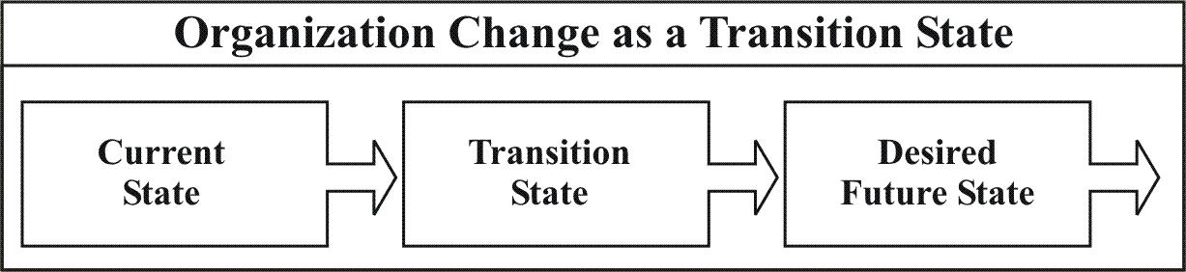

Activity Planning:
This involves the making a road map for change citing specific activities and events that must occur if the transition is to be successful. Activity planning should clearly identify, temporally orient, and discrete change tasks and should link these tasks to the organization’s change goals and priorities. Activity planning also should gain top-management approval, be cost effective, and remain adaptable as feedback is received during the change process.

An important feature of activity planning is that vision and desired future states can be quite general when compared with the realities of implementing change. As a result it may be necessary to supplement those with midpoint goals as part of the activity plan. Such goals represent desirable organizational conditions between the current state and the desired future state. For example, if the organization is implementing continuous improvement process, an important midpoint goal can be the establishment of a certain number of improvement teams focused on understanding and controlling key words process. Midpoint goals are clearer and more detailed than desired future states, and thus they provide more concrete and manageable steps and benchmarks for change. Activity plans can use in midpoint goals to provide members with the direction and security they need to work towards the desired future.

Commitment Planning:
This activity involves identifying key people and groups whose commitment is needed for change to occur and formulating a strategy for gaining their support. Although commitment planning is generally a part of developing political support, discussed above, specific plans for identifying key stakeholders and obtaining their commitment to change need to be made early in the change process.

Change-Management Structures:
Because organizational transitions tend to be ambiguous and to need direction, special structures for managing the change process need to be created. These management structures should include people who have the power to mobilize resources to promote change, the respect of the existing skills to guide the change process.

Alternative management structures include the following:

- The chief executive or head person manages the change effort.
- A project manager temporarily is assigned to coordinate the transition.
- The formal organization manages the change effort in addition to supervising normal operations.
- Representatives of the major constituencies involved in the change jointly manage the project.
- Natural leaders who have the confidence and trust of large numbers of affected employees are selected to manage the transition.
- A cross section of people representing different organizational functions and levels manages the change.
- A “kitchen cabinet” representing people whom the chief executive consults with and confides in manages the change effort.

Sustaining Momentum:
Once organizational changes are under way, explicit attention must be directed to sustaining energy and commitment for implementing them. The initial excitement and activity of changing often dissipate in the face of practical problems of trying to learn new ways of operating. A strong tendency exists among organization members to return to what is learned and well known unless they receive sustained support and reinforcement for carrying the changes through to completion. The following five activities can help to sustain momentum for carrying change through to completion: providing resources for change, building a support system for change agents, developing new competencies and skills, reinforcing new behaviors, and staying the course.

Providing resources for change:
Implementing organization change generally requires additional financial and human resources, particularly if the organization continues day-to-day operations while trying to change it. These extra resources are needed for such change activities as training, consultation, data collection and feedback, and special meetings.

Extra resources also are helpful to provide a buffer as performance drops during the transition period. Organizations can underestimate seriously the need for special resources devoted to the change process. Significant organizational change invariably requires considerable management time and energy, as well as the help of consultants. A separate “change budget” that exists along with capital and operating budgets can earmark the resources needed for training members in how to behave differently and for assessing progress and making necessary modifications in the change program. Unless these extra resources are planned for and provided, meaningful change is less likely to occur.

Building a support system for change agents:
Organization change can be difficult and filled with tension, not only for participants but for change agents as well. They often must give members emotional support, but they may receive little support themselves. They often must maintain “psychological distance” from others to gain the perspective needed to lead the change process. This separation can produce considerable tension and isolation, and change agents may need to create their own support system to help them cope with such problems. A support system typically consist of a network of people with whom the change agent has close personal relationships--- people who can give emotional support, serve as a sounding boards for ideas and problems, and challenge untested assumptions. For example, OD professionals often use trusted colleagues as “shadow consultants” to help them think through difficult issues with clients and to offer conceptual and emotional support. Similarly, a growing number of companies, such as Intel, Procter & Gamble, BHP-Copper, TRW, and Texas instruments, are forming internal networks of change agents to provide mutual learning and support.

Developing new competencies and skills:
Organizational changes frequently demand new knowledge, skills, and behaviors from organization members. In many cases, the changes cannot be implemented unless members gain new competencies. For example, employee-involvement programs often require managers to learn new leadership styles and new approaches to problem solving. Change agents must ensure that such learning occurs.

They need to provide multiple learning opportunities, such as traditional training programs, on-the-job counseling and coaching, and experiential simulations, covering both technical and social skills. Because it is easy to overlook the social component, change agents may need to devote special time and resources to helping members gain the social skills needed to implement changes. Ford’s new CEO, Jacques Nasser, is supporting the organization’s efforts to increase the speed of decision making through a concerted emphasis on “teaching”. Through small-group discussions of strategy, providing all employees with a computer, assignments to develop new ideas, and 360-degree feedback. Ford managers are learning new skills and a new mindset to support the organization’s need for faster decision making.

Reinforcing new behaviors:
In organizations, people generally do those things that bring them rewards. Consequently, one of the most effective ways to sustain momentum for change is to reinforce the kinds of behaviors needed to implement the changes. This can be accomplished by linking formal rewards directly to the desired behaviors. For example, Integra Financial encouraged more teamwork by designing rewards and recognition programs in which the best team players got both financial rewards and management attention, and a variety of behaviors aimed at promoting self-interest were directly discouraged. In addition, desired behaviors can be reinforced more frequently through informal recognition, encouragement, and praise. Perhaps equally important are the intrinsic rewards that people can experience through early success in the change effort. Achieving identifiable early successes can make participants feel good about themselves and their behaviors, and thus reinforce the drive to change.

Staying the course:
Change requires time, and many of the expected financial and organizational benefits from change lag behind its implementation. If the organization changes again too quickly or abandons the change before it is fully implemented, the desired results may never materialize. There are two primary reasons that managers do not keep a steady focus on change implementation. First, many managers fail to anticipate the decline in performance, productivity, or satisfaction as change is implemented.

Organization members need time to practice, develop, and learn new behaviors; they do not abandon old ways of doing things and adopt a new set of behaviors overnight. Moreover, change activities, such as training, extra meetings, and consulting assistance, are extra expenses added on to current operating expenditures. There should be a little surprise, therefore, that effectiveness declines before its get better. However, perfectively good change projects often are abandoned when questions are raised about short term performance decline. Patience and trust in the diagnosis and intervention design work are necessary.

Second, many managers don’t keep focused on a change because they want to implement the next big idea that comes along. When organizations change before they have to in response to the latest management fad, a “flavor-of-the-month” cynicism can develop. As a result, organization members provide only token support to change under the (accurate) notion that the current change won’t last. Successful organizational change requires persistent leadership that doesn’t waiver unnecessarily.

OD in Practice: Values drive Culture and Operations at Levi Strauss
Levi Strass and Company, one of the world’s largest makers of blue jeans and other apparel, has been engaged in a culture change effort that began in 1985. Following a meeting with a small number of minority and women managers who believed there were invisible barriers to advancement, the CEO, Robert D. Haas, the great-great-grandnephew of founder Levi Strauss organized an off-site retreat that paired white senior managers with minority and women managers. The two-and- one-half days of discussions produced painful realizations about how the firm treated its people. What the small group had identified was not so much a diversity problem as a leadership and culture problem.

Today, Levi Strauss is focused on managing in a way that balances concerns with a set of values that honor diversity, empowerment, and openness. The company has “struggled mightily” to live up to a vision of how to run a modern corporation – a vision set forth by Haas who has demonstrated unswerving commitment to it for more than ten years. As part of a mission of “responsible commercial success,” the following Aspiration Statement hangs on office and factory walls throughout the organization and guides all major decisions.
Aspiration Statement
We all want a company that our people are proud of and committed to where all employees have an opportunity to contribute, learn, grow, and advance based on merit, not politics, or background. We want our people to feel respected, treated fairly, listened to, and involved. Above all, we want satisfaction from accomplishments and friendships, balanced personal and professional lives, and to have fun in our endeavors When we describe the kind of Levi Strauss and Company we want in the future what we are talking about is building on the foundation we have inherited: affirming the best of our Company’s traditions, closing gaps that may exist between principles and practices, and updating some of our values to reflect contemporary circumstances.
What type of Leadership is necessary to make our aspirations a reality?

New Behaviors: Leadership that exemplifies directness, openness to influence, commitment to the success of others, and willingness to acknowledge our own contributions to problems, personal accountability, teamwork, and trust. Not only must we model these behaviors, but we must coach others to adopt them.
Diversity: Leadership that values a diverse workforce (age, ethnic group, etc.) at all levels of the organization, diversity in experience, and diversity in perspectives. We have committed to taking full advantage of the rich backgrounds and abilities of all our people and to promote a greater diversity in positions of influence. Differing points of view will be sought; diversity will be valued and honestly rewarded, not suppressed.

Recognition: Leadership that provides greater recognition – both financial and psychic – for individuals and teams that contributes to our success. Recognition must be given to all who contribute: those who create band innovate and those who continually support day-to-day business requirements.
Ethical management practices: Leadership that epitomizes the stated standards of ethical behavior: We must provide clarity about our expectations and must enforce these standards throughout the corporation. Communications: Leadership that is clear about company, unit, and individual goals and performance. People must know what is expected of them and receive timely, honest feedback on their performance and career aspirations.
Empowerment: Leadership that increases the authority and responsibility of those closest to our products and customers. By actively pushing the responsibility, trust, and recognition into the organization, we can harness and release the capabilities of all our people.
Haas believes that successful corporations are more than strategies and structures. “This is where values come in. In a more volatile and dynamic business environment, the controls have to be conceptual… Values provide a common language for aligning a company’s leadership and its people” to the strategy. He set out to make each of his workers, from the factory floor on up, feel as if they are the integral part of the making and selling of blue jeans. All views on all issues – no matter how controversial – are encouraged, heard, and respected. The chairman does not tolerate harassment of any kind. Nor will he do business with suppliers or customers who violate the company’ (Levi’s) strict standards regarding work environment and ethics. For example, Levi’s board voted unanimously to pull its business out of China in protest of human rights violations even though it cost about $40 million of revenues.

“We are not doing this because it makes us feel good – although it does. We are not doing this because it is politically correct. We are doing this because we believe in the interconnection between liberating the talents of our people and business success.” However, the simple truth is, living up to a value system as comprehensive as Levi’s is difficult. It takes hours and hours of work by both managers and organization members.

To implement this vision, Haas began at the top. The first responsibility for me and for my team was to examine critically our own behaviors and management styles in relation to the behaviors and values that we profess and to work to become more consistent with the values that we are articulating…You can’t be one thing and say another. People have unerring direction systems for fakes, and they won’t put up with them. They won’t put values into practice if you’re not.” The most difficult changes were in behaviors that had made managers successful in the past. Activities that were productive under the old culture were counterproductive in the flatter, more responsive, and empowered organization that top management was trying to implement.
To push his vision into the organization, Haas commissioned a set of training courses, such as leadership week, making ethical decisions, and managing diversity. Specifically designed not to be “skill-building” courses, the sessions were more likely highly experiential seminars.
During the sessions, managers and employees grappled with their own prejudices, attempted to make difficult decisions using the aspirations statement as a guide, and built a support network that helped in applying the ideas in the workplace. To reinforce the importance of the training, senior management attended the courses, came back to teach in them, and in some cases, went through the courses again as participants to gain additional insights and ideas.
In addition, aspirations management was given some teeth by making it an important part of the performance management system. It includes a 360-degree-like feedback process; each manager develops an “aspirational objective”; and one-third of an employee’s evaluation is based on “aspirational” behavioral. The aspirations statement has also affected the way work is designed. A new team-based organization and incentive pay system means that a worker’s appraisals and compensation depend on other workers. Although more aligned with the values of the organization, the work design produces difficult tests for management. For example, when workers think that someone is faking sick days or lollygagging on a sewing machine, tempers flare. Employee ABC says that if someone calls attention to a worker’s laziness, the worker will just “flip him off.” Supervisor D says that “it gets tough out there.” She finds herself intervening to prevent “big fights.” Says plant manager EF “Peer pressure can be vicious and brutal.” Empowerment and teamwork can be alien, uncomfortable concepts for those in the manufacturing plant who have spent their working lives taking orders. After ten years of work, Haas is a long way from realizing his vision. “We are only a few steps along in our journey,” he agrees. “We are far from perfect. We are far from where we want to be. But the goal is out there, and it’s worth striving for.”

